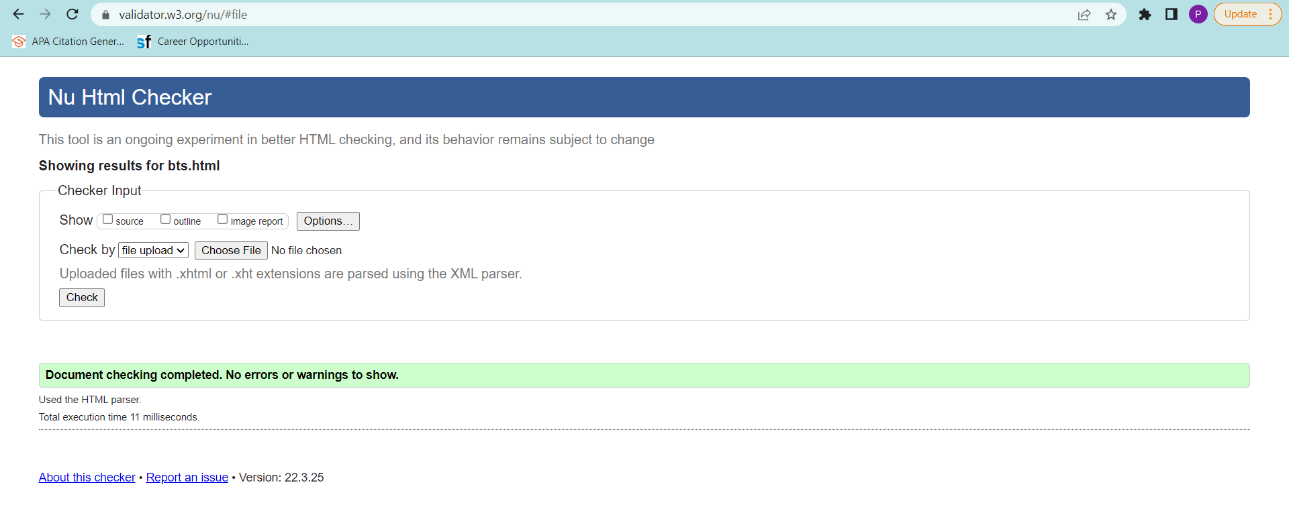

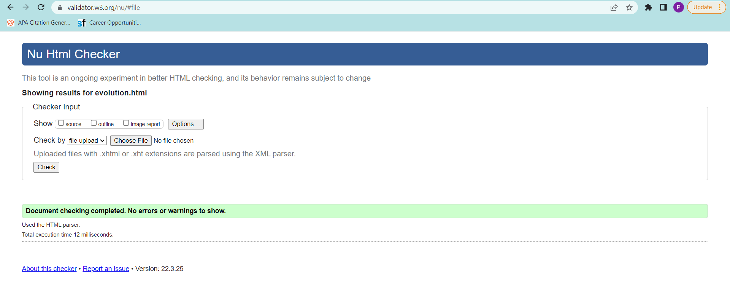

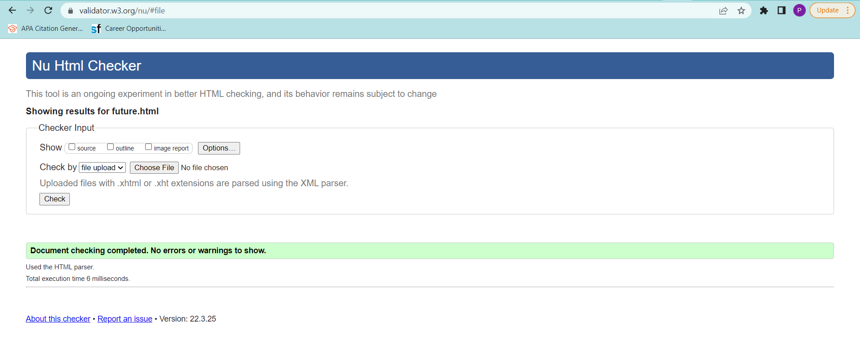

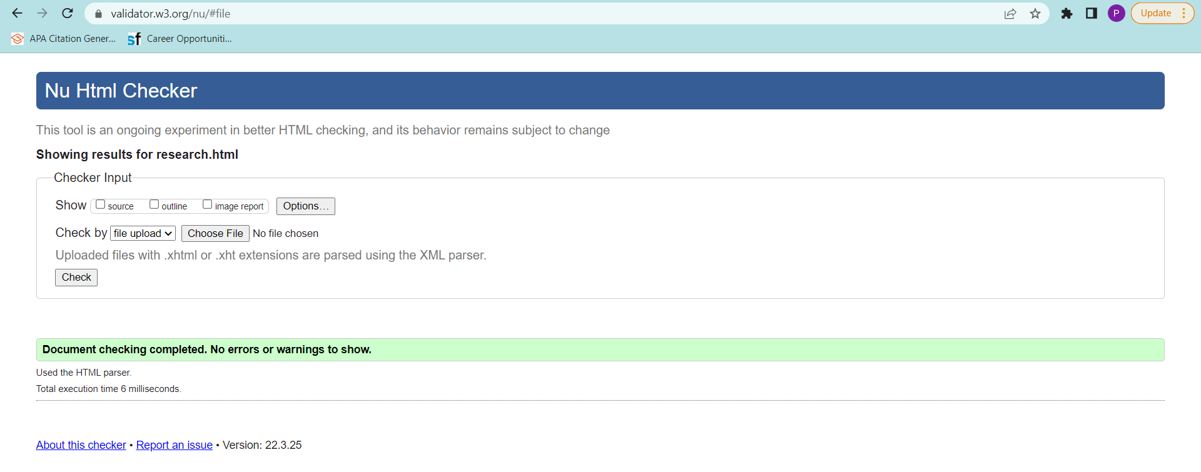

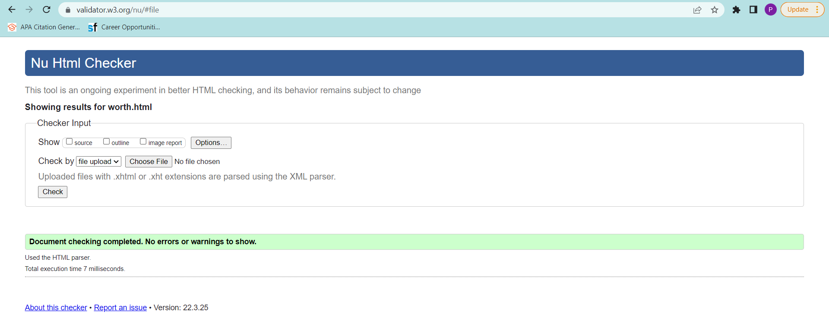

Sources:

* <https://toppng.com/uploads/preview/car-11549451816vveciq8qbi.png>
* <https://www.latticesemi.com/-/media/LatticeSemi/Images/Blogs/2021/Automotive_Security_Blog.ashx?h=260&la=en&mh=432&mw=768&w=370>

Home Page

* <https://i.iinfo.cz/images/513/pripojena-auta-shutterstock-1.jpg>
* <https://pictures.topspeed.com/IMG/crop/202008/10-must-have-car-fea-8_1600x0w.jpg>
* <https://i0.wp.com/semiengineering.com/wp-content/uploads/Synopsys_safety-security-for-auto-SoCs-ARC-processor-fig1.jpeg?w=640&ssl=1>
* https://www.defensivedriving.org/dmv-handbook/11-ways-your-car-can-be-hacked/

Evolution

* <https://www.sdautomuseum.org/sites/default/files/inline-images/Nicolas%20Joseph%20Cugnot3.jpg>
* <https://754419.smushcdn.com/1500089/wp-content/uploads/2020/06/robert-anderson-first-electric-car.jpg?lossy=1&strip=1&webp=1>
* <https://group.mercedes-benz.com/bilder/konzern/tradition/geschichte/anfaenge-des-automobils/motorkutsche-1886-c23227-w768xh432-cutout.jpg>
* <https://media.gettyimages.com/photos/threewheeled-benz-motor-car-1886-karl-benz-german-engineer-and-car-picture-id463915833?s=612x612>
* <https://static.wikia.nocookie.net/tractors/images/a/a6/George_b_selden_road-engine_549%2C160.png/revision/latest/scale-to-width-down/528?cb=20130223023013>
* <https://images.fineartamerica.com/images/artworkimages/mediumlarge/2/1895-duryea-road-vehicle-gray-patent-print-greg-edwards.jpg>
* <https://www.loc.gov/everyday-mysteries/item/who-invented-the-automobile/>

Behind the Scenes

* <https://s3.us-east-1.amazonaws.com/sectigo-sites-web/global/images/Sectigo/blog/_1200x630_crop_center-center_82_none/behind_the_code_social_v2-10_2021-08-12-024135_pdmi.png?mtime=1628741473>
* <https://www.teslarati.com/wp-content/uploads/2019/03/tesla-model-s-autopilot-hw2-5-1024x664.jpg>
* <https://media.istockphoto.com/photos/red-screen-with-code-and-inscription-error-picture-id941715768?k=20&m=941715768&s=170667a&w=0&h=QYg3D-MLMZS6_udEs4tZitbJK_656wi5pake-HzWEzE=>
* <https://www.vehicledynamicsinternational.com/features/vehicle-cybersecurity-control-the-code-control-the-road.html>
* <https://labs.sogeti.com/how-many-defects-are-too-many/>