Kavach (Netrika-Trace)
System Architecture

Flowcharts of every framework and package, with the workflow explained in simple words
One master flowchart of all frameworks, focused diagrams for each layer, the end-to-end workflow, and a plain-language description of every package.

Prepared 29 October 2026.
Diagram images are also saved as PNG files in the diagrams folder for use in slides.

Table of Contents
Part 1: The Architecture at a Glance
1.1 In one paragraph
1.2 What is in this document
1.3 Master picture: every framework in one view
1.4 The same system as a flow of layers
Part 2: The Workflow in Simple Words
2.1 The story of one message
2.2 Three ways in
2.3 Decisions in plain words
Part 3: Layer-by-Layer Diagrams
3.1 Interception: how the text is caught
3.2 Backend: the coordinator
3.3 The pipeline and the tools each stage uses
3.4 The detectors inside the Forensic stage
3.5 The layered scanner
3.6 Storage and live updates
3.7 The dashboard (frontend)
3.8 Deployment with Docker
Part 4: Packages and Frameworks in Simple Words
4.1 Backend core
4.2 Pipeline and AI tools
4.3 The layered scanner's own building blocks
4.4 Interception
4.5 Data and messaging
4.6 Security
4.7 Reports, alerts and the legacy panel
4.8 Frontend
4.9 Packaging and testing
4.10 Listed in requirements.txt but not imported by the code
Part 5: Quick Reference
5.1 One line per technology
5.2 Honest notes to keep in mind
In Word, press Ctrl+A then F9 (or accept the update prompt) to fill in page numbers.

Part 1: The Architecture at a Glance

1.1 In one paragraph
Kavach checks what employees are about to send to AI tools. Two interceptors catch the text: a Chrome extension inside the browser and a proxy on the network. Both hand the text to a Python backend, which runs it through a five-stage pipeline. The pipeline uses several detector libraries to look for personal data, secrets, code and suspicious random strings, then gives a score and a decision: allow, warn or block. The result is saved in a database (type and count only, never the secret), announced live over WebSocket, and shown on a React dashboard.

1.2 What is in this document
Part | What you get
1. Architecture at a glance | The master picture of every framework, and the same system as layers
2. The workflow in simple words | The story of one message, the three ways in, the decisions
3. Layer-by-layer diagrams | Interception, backend, pipeline, detectors, scanner, storage, dashboard, Docker
4. Packages and frameworks | What each package is and what it does here, in plain words
5. Quick reference | One line per technology and honest notes

The diagrams are also saved as PNG files in the diagrams/ folder (master_architecture.png is the big one) so you can paste them into slides.

1.3 Master picture: every framework in one view
Read it from top to bottom. Each coloured band is one layer; each box names the tool or framework that does the job. A message travels down through the layers.
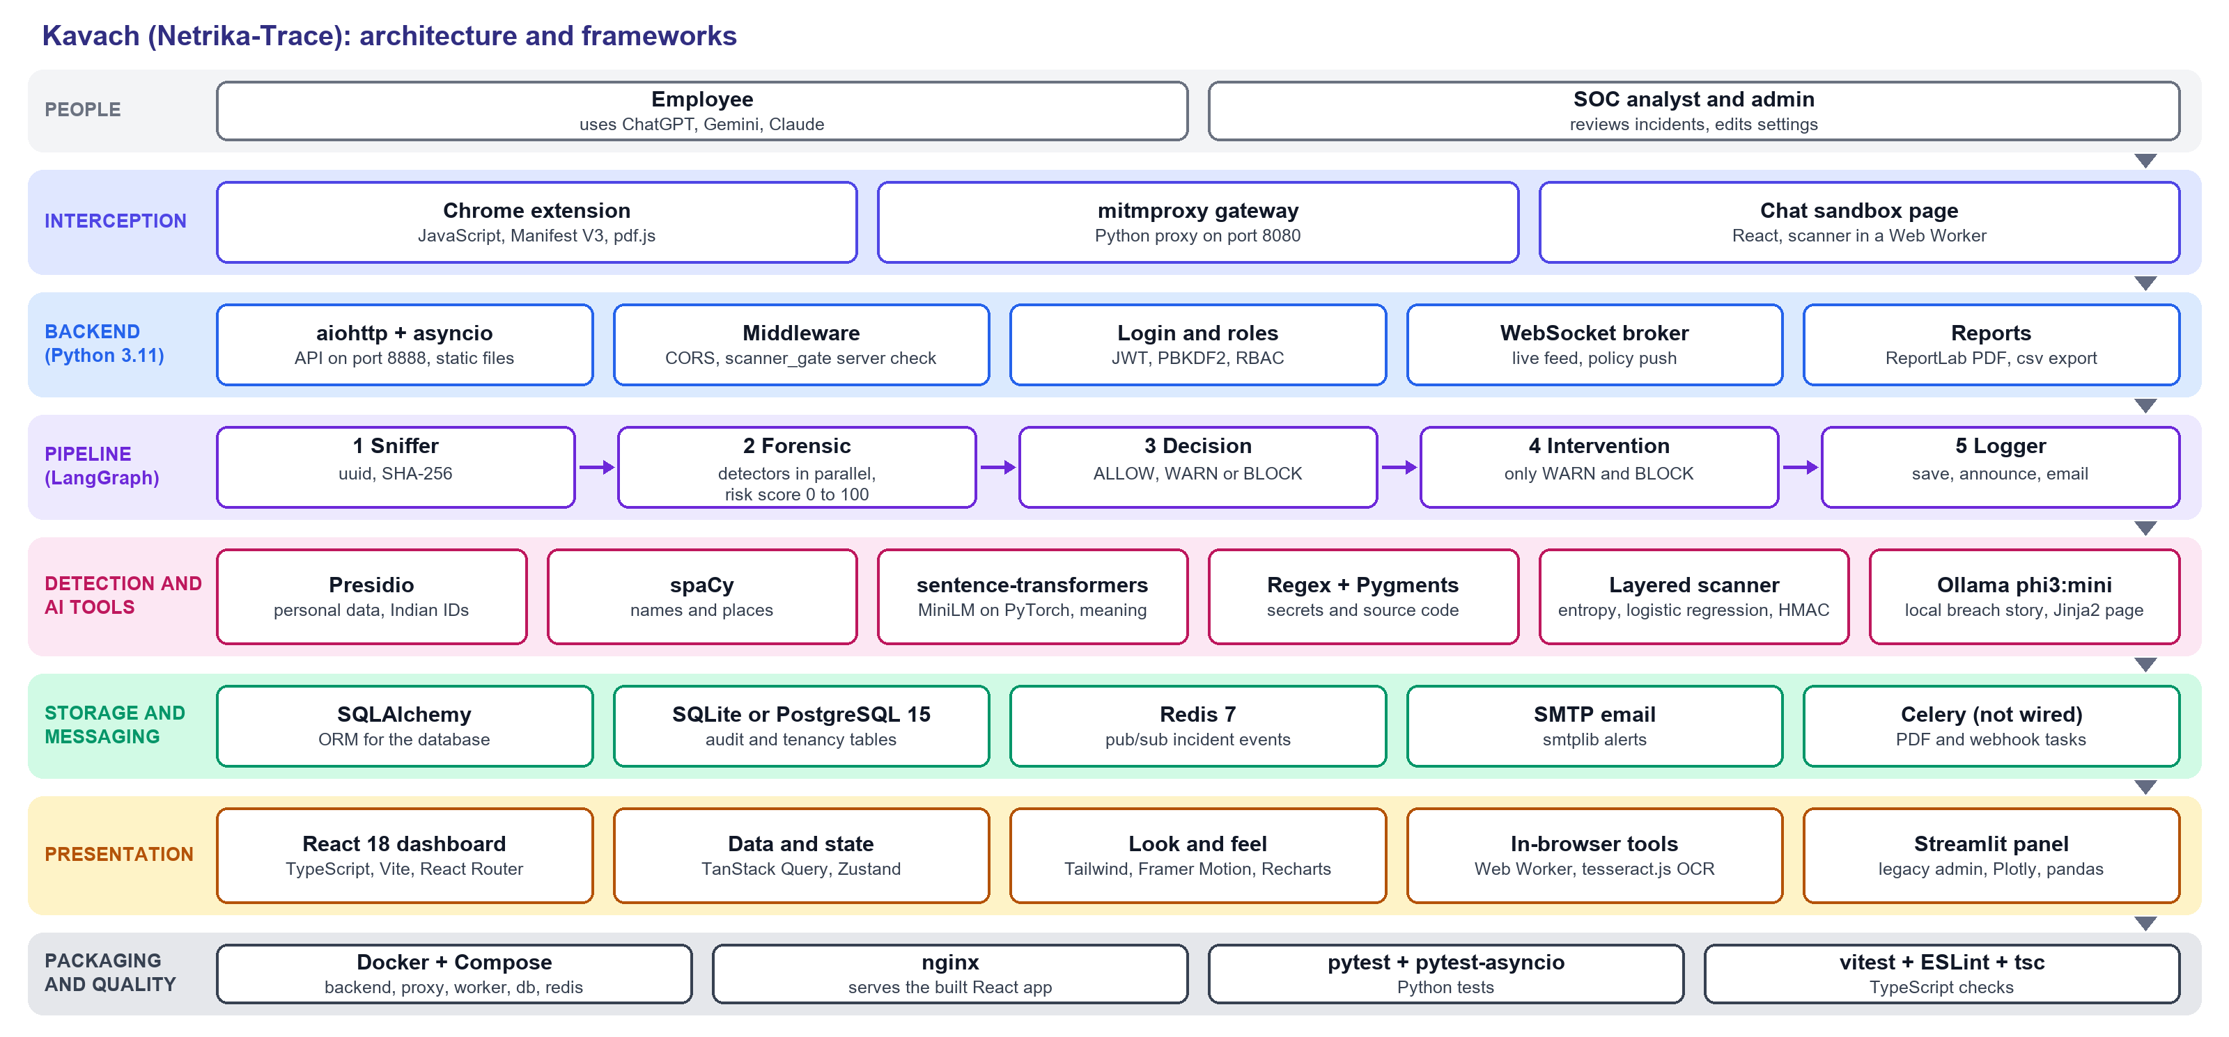
What each layer does
Layer | Meaning
People | Employees send text; analysts and admins review it
Interception | Catches the request before it leaves: browser extension, network proxy, or the demo chat page
Backend | The Python API that coordinates: web server, checkpoints, login, live feed, reports
Pipeline | The five stages that decide what to do with the text
Detection and AI tools | The libraries that look for sensitive data and write the teaching story
Storage and messaging | Where records are kept and where news of new events travels
Presentation | The React dashboard and its helper libraries, plus the older Streamlit panel
Packaging and quality | Docker to run everything the same way, and the test tools

The dashboard also asks the backend for data over normal REST calls (with a login token) and receives live events over a WebSocket.

1.4 The same system as a flow of layers
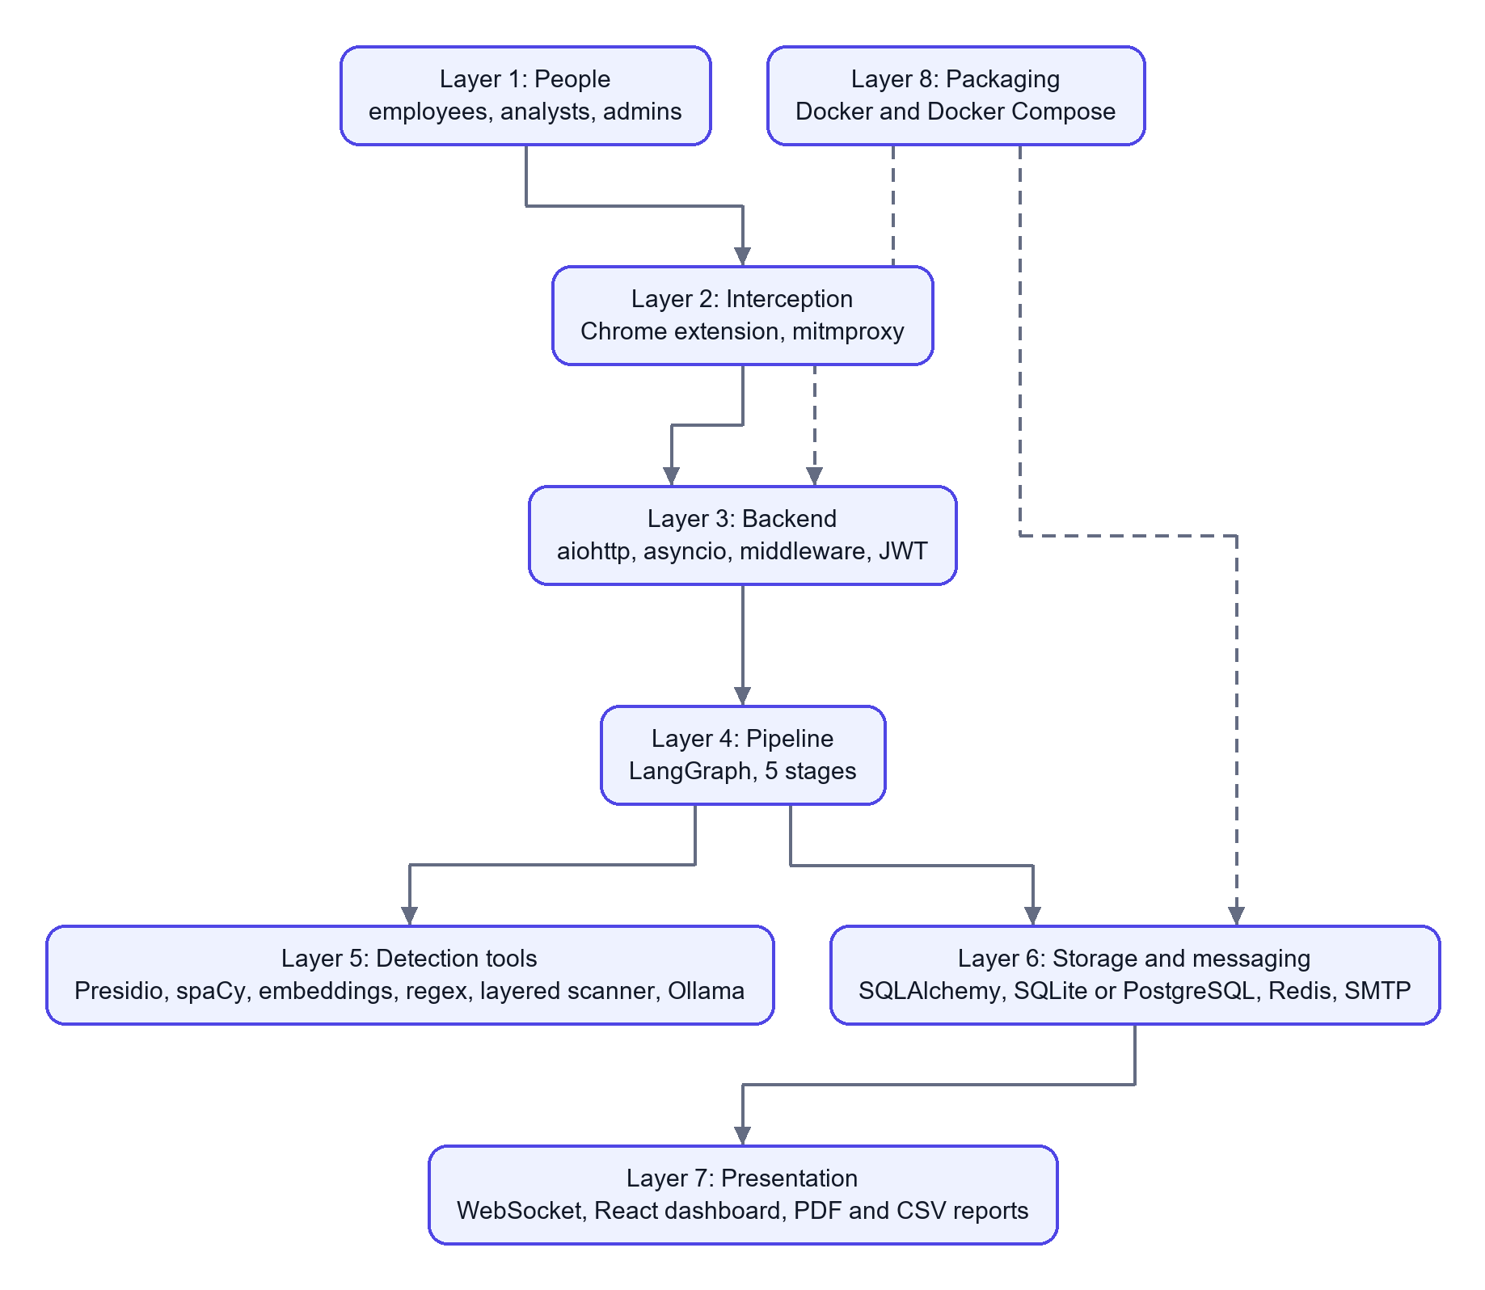

Part 2: The Workflow in Simple Words

2.1 The story of one message
Imagine an employee pastes a customer's Aadhaar number into ChatGPT.
- Catch it. The Chrome extension (or the network proxy) notices the message is about to leave for an AI website.
- Pull out the text. If it was a PDF or Word file, the text is extracted first (pdf.js in the browser, PyPDF2 and python-docx on the server).
- Send it to the backend. The Python backend (aiohttp) receives it. A middleware checks the user is signed in and, for chat messages, runs a second scan on the server so nobody can skip the browser check.
- Run the pipeline. LangGraph runs five stages in order:
- Sniffer gives the request an ID and a SHA-256 fingerprint.
- Forensic runs the detectors at the same time and computes a risk score.
- Decision turns the score into ALLOW, WARN or BLOCK.
- Intervention (only for WARN and BLOCK) asks a local AI to write a short "how an attacker could misuse this" story.
- Logger saves the record and announces it.
- Act on the decision. The extension lets the message go, shows a warning, or shows a blocked screen. The proxy does the equivalent.
- Record and announce. The database gets a row with the type and count (not the number itself). A live message goes to the dashboard through a WebSocket, and an email can be sent.
- Review. A security analyst sees the incident appear, opens it, adds notes and exports a report.

2.2 Three ways in
Path | Used for | How it reaches the pipeline
Browser extension | Typing, pasting, file uploads on AI websites | Extension, then service worker, then backend API, then pipeline
Network proxy | Any app or script sending to an AI host | Proxy addon calls the pipeline directly
Chat sandbox (web app) | Demo chat page with a live scanner | React page, then API with the server gate, then pipeline, then a (mock) AI reply

2.3 Decisions in plain words
- BLOCK: the message is stopped. Used when an Aadhaar, PAN, UPI ID, bank code, AWS key, private key, database password or similar is found, or when the score reaches 70.
- WARN: the user is told and may choose to continue. Score 40 or more.
- ALLOW: nothing sensitive found.
- The scanner can also REDACT (hide the value) or TOKENIZE (swap it for a placeholder such as [SECRET_1] and restore it on the user's screen).

Part 3: Layer-by-Layer Diagrams

3.1 Interception: how the text is caught
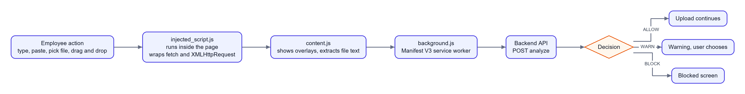
In simple words: three small scripts cooperate. One lives inside the page and sees the action, one draws the overlay, and one (the service worker) is allowed to call the backend. The network proxy does the same job for traffic that never touches a browser.

3.2 Backend: the coordinator
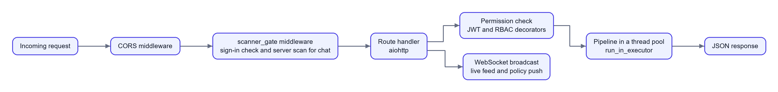
In simple words: every request passes through two checkpoints before the real work. Heavy analysis runs in a thread pool so one slow scan does not freeze the server.

3.3 The pipeline and the tools each stage uses
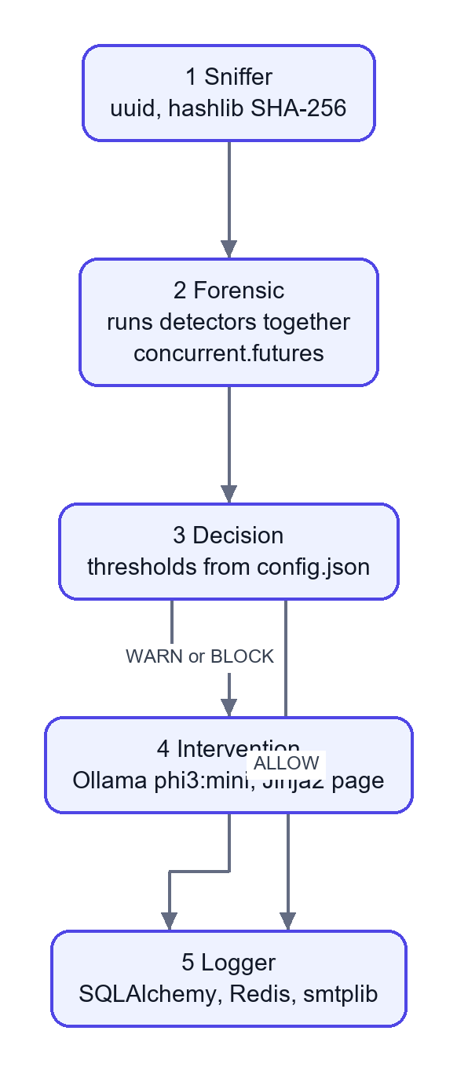
Stage | Tools | Work in simple words
Sniffer | uuid, hashlib | Gives the request an ID and a fingerprint, trims huge text
Forensic | Presidio, spaCy, sentence-transformers, regex, Pygments, layered scanner, ThreadPoolExecutor | Runs the detectors, then computes the risk score
Decision | config.json | Compares the score with limits and applies special rules
Intervention | Ollama, Jinja2 | Writes the teaching story and builds the warning page
Logger | SQLAlchemy, redis-py, smtplib | Saves the record, announces it, optionally emails

3.4 The detectors inside the Forensic stage
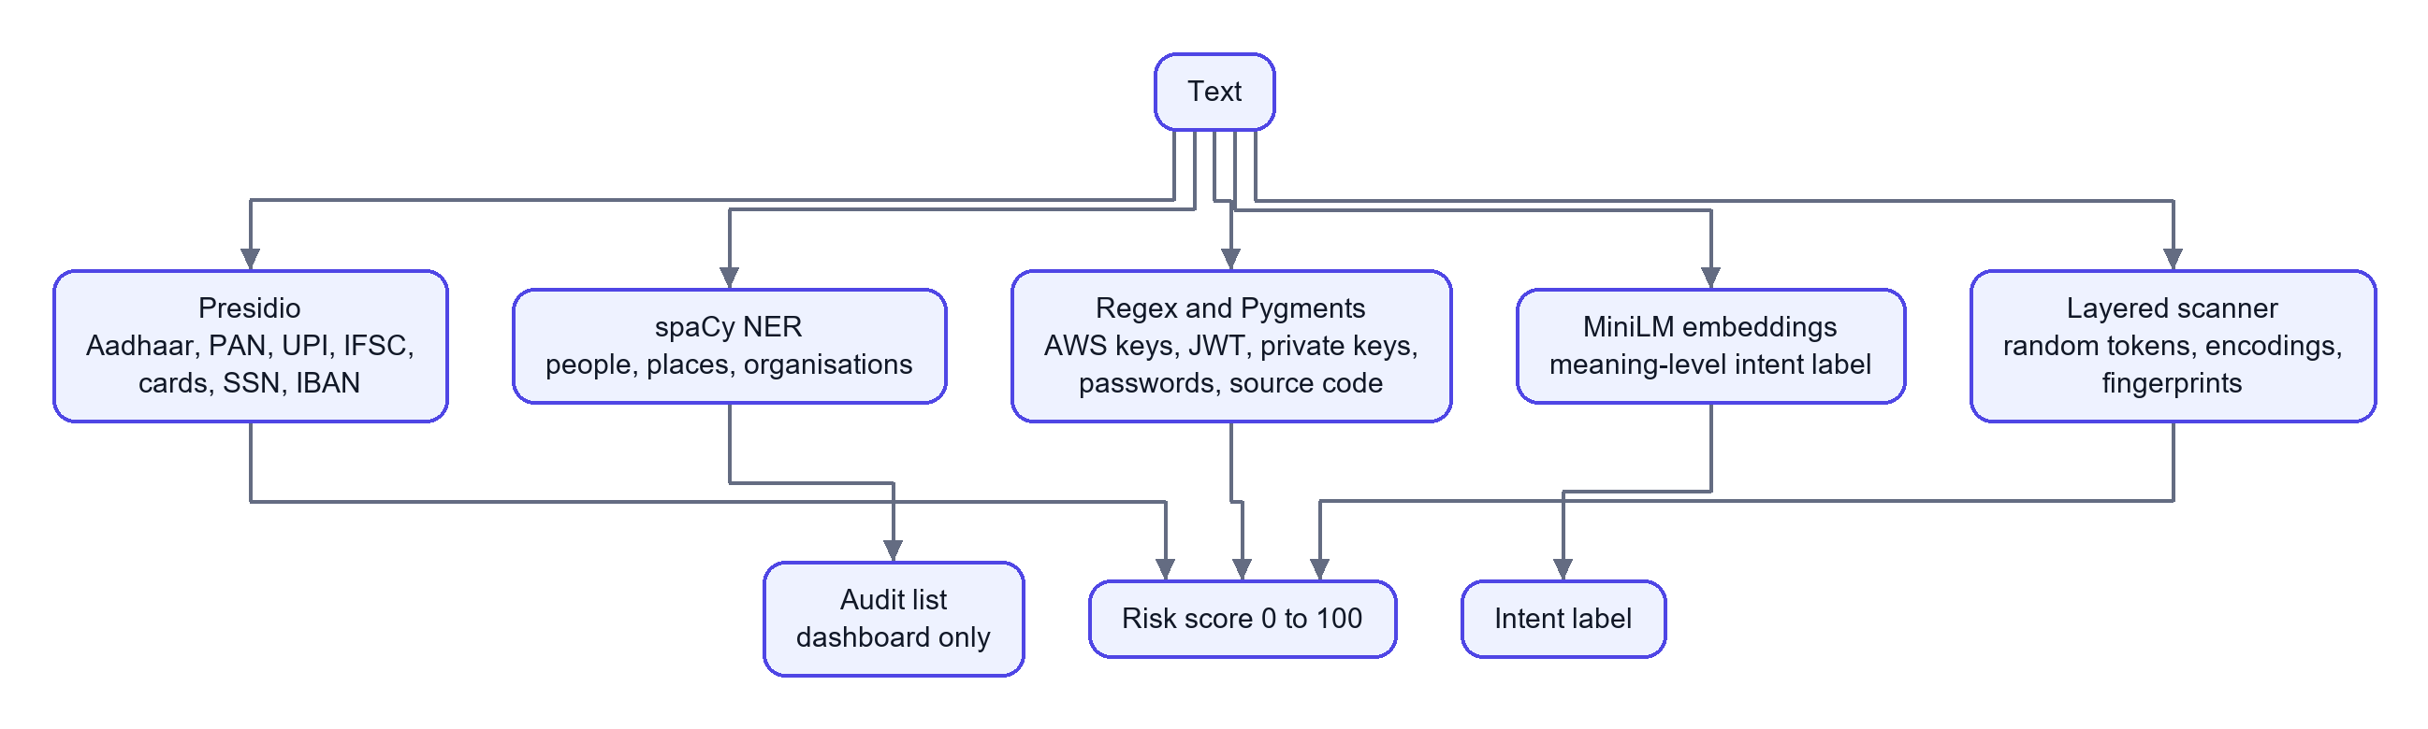
In simple words: several different "detectives" read the same text. Presidio, the regex detector and the layered scanner can raise the score. spaCy only adds notes for the dashboard. The embedding model only sets a label such as "PII leak" or "safe".

3.5 The layered scanner
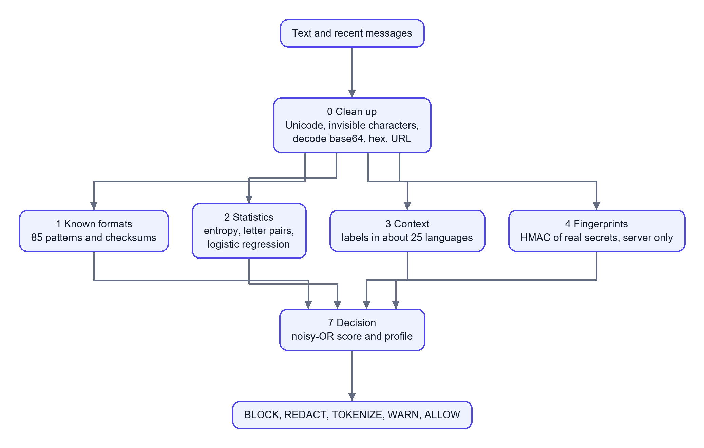
In simple words: first make hidden text visible, then ask four different questions about each piece (does it look like a known secret, does it look random, is there a label, is it one of our real secrets), then combine the answers.

3.6 Storage and live updates
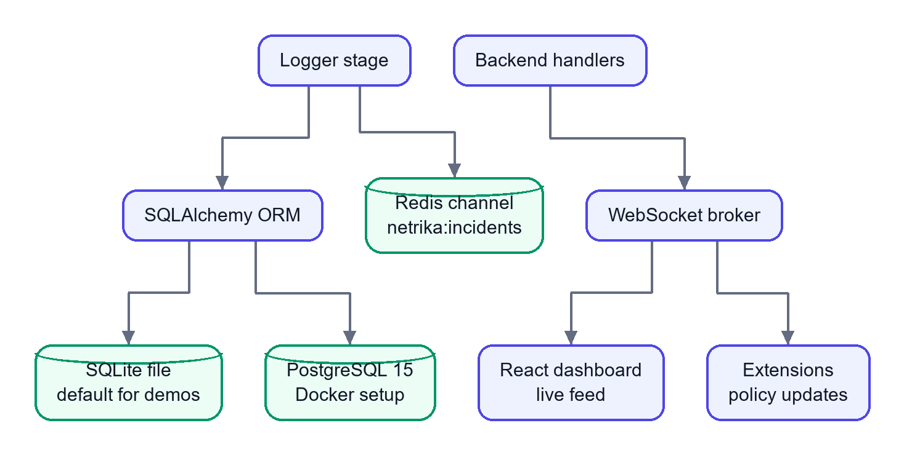
In simple words: the database keeps history; Redis and WebSockets carry news of new events. The database stores only what kind of data was found and how many, plus a hash, never the data.

3.7 The dashboard (frontend)
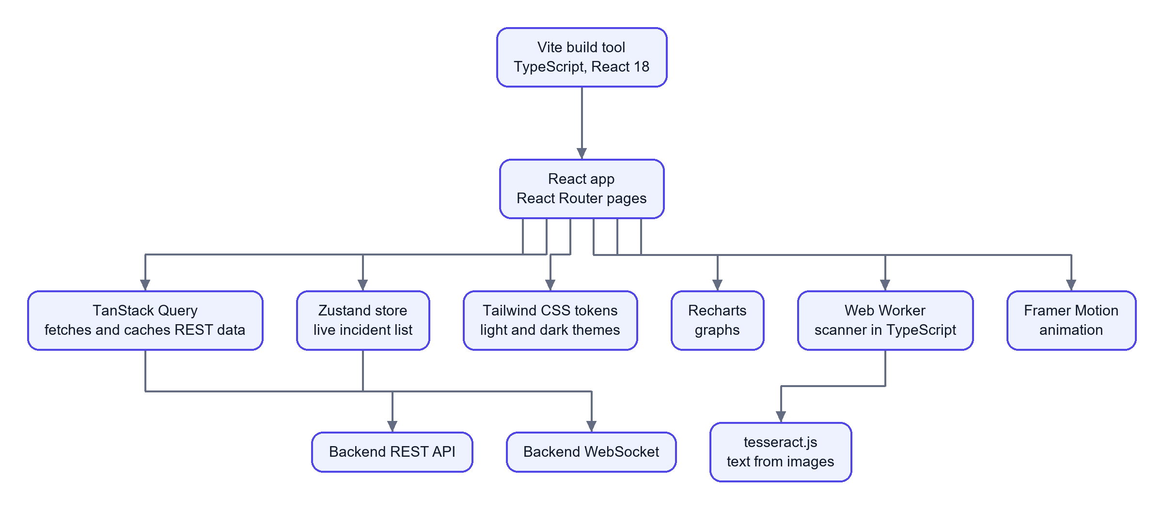
In simple words: React draws the screens. TanStack Query fetches data, Zustand holds the live feed, Tailwind and Framer Motion handle the look, and a Web Worker runs the scanner so typing never lags.

3.8 Deployment with Docker
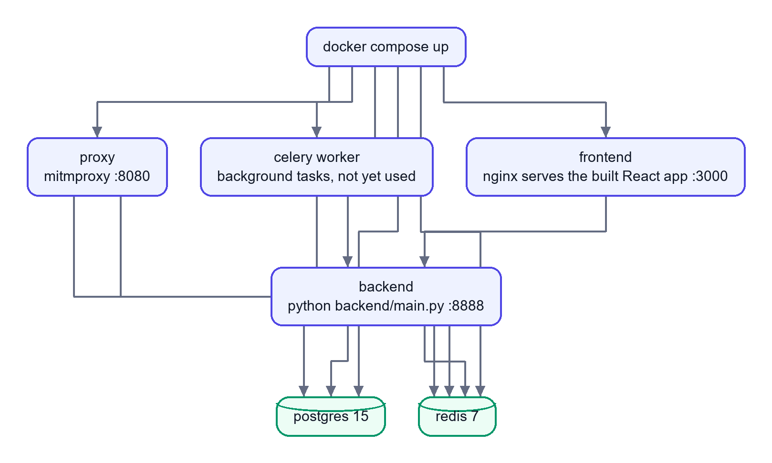
In simple words: one command starts six containers. The Docker image bundles Python, the libraries and the spaCy model, so every machine runs the same setup. Ollama runs on the host machine, outside Docker.

Part 4: Packages and Frameworks in Simple Words

4.1 Backend core
Package | What it is | What it does here, simply
Python 3.11 | The programming language | Everything on the server is written in it
asyncio | Python's built-in tool for doing many things while waiting | Lets one server handle many connections
aiohttp | An asynchronous web framework | Receives requests, serves the API, keeps WebSocket connections open
python-dotenv | Reads settings from a .env file | Loads configuration such as ports and URLs
concurrent.futures | Standard library thread pools | Runs the detectors side by side
json, uuid, hashlib, hmac, smtplib | Standard library | Data format, unique IDs, hashing, keyed hashing, sending email

4.2 Pipeline and AI tools
Package | What it is | What it does here, simply
LangGraph and langchain-core | A library for flowcharts of steps sharing one state | Runs the five stages in order, with one branch
Presidio (analyzer, anonymizer) | Microsoft's personal-data finder | Finds cards, SSNs, IBANs and, with custom rules, Aadhaar, PAN, UPI IDs and IFSC codes
spaCy (en_core_web_sm) | A language-processing library | Spots names, places and organisations for the dashboard
sentence-transformers (MiniLM) | Turns sentences into number lists that capture meaning | Compares the message with "dangerous" and "safe" examples to label its intent
PyTorch and transformers | The deep-learning engine and model library underneath | Needed to run the MiniLM model
Pygments | A syntax-highlighting library | A second opinion on whether the text is source code
Regular expressions (re) | Pattern matching built into Python | Finds secrets with a fixed shape, such as AWS keys
Ollama (Python client) with phi3:mini | Runs a small language model on your own computer | Writes the teaching story without sending data to the cloud
Jinja2 | A templating engine | Fills the blocked-page and warning-banner HTML
PyPDF2 and python-docx | Read PDF and Word files | Extract text from uploaded documents on the server

4.3 The layered scanner's own building blocks
Idea | In simple words
Unicode normalisation | Turns look-alike and invisible characters into plain ones so tricks stop working
Decoding views | Opens base64, hex and URL-encoded text to see what is inside
Checksums (Luhn, Verhoeff, IBAN) | Maths checks that tell a real card or Aadhaar number from random digits
Entropy and a letter-pair model | Measure how random a string looks compared with real words
Logistic regression | A tiny model that turns those measurements into a probability
HMAC fingerprints | Secret-key hashes of the company's real secrets, so they can be recognised without being stored
Noisy-OR | A way to combine several pieces of evidence into one score

4.4 Interception
Package | What it is | What it does here, simply
mitmproxy | A scriptable proxy that can read HTTPS | Sits on the network, watches traffic to AI hosts and calls the pipeline
Chrome Manifest V3 | Chrome's extension platform | Hosts the scripts that watch the browser
pdf.js (lib/pdf.min.mjs) | Mozilla's PDF reader in JavaScript | Reads text out of PDFs in the browser before upload

4.5 Data and messaging
Package | What it is | What it does here, simply
SQLAlchemy 2 | Python library that maps database tables to classes | Saves and reads incidents, users, devices and policies
SQLite | A database in one file | Default storage, needs no setup
PostgreSQL 15 | A full database server | Storage in the Docker setup
psycopg | PostgreSQL driver for Python | Lets SQLAlchemy talk to PostgreSQL
Redis 7 and redis-py | A very fast in-memory store with messaging | Carries "new incident" messages
Celery | A background task queue | Two tasks are defined (PDF, webhook) but not called yet

4.6 Security
Package | What it is | What it does here, simply
PBKDF2-HMAC-SHA256 (from hashlib) | Slow, salted password hashing | Stores passwords safely
JWT (hand-written with hmac) | A signed login token | Proves who you are on each request
RBAC (own code) | Permissions by role | SUPER_ADMIN, ORG_ADMIN, ANALYST, EMPLOYEE
SHA-256 | A one-way fingerprint | Fingerprints each payload without storing it

4.7 Reports, alerts and the legacy panel
Package | What it is | What it does here, simply
ReportLab | A PDF generator for Python | Builds incident and compliance PDFs
csv | Standard library | Exports incidents as CSV
smtplib | Standard library email sender | Sends alert emails when SMTP is configured
Streamlit, Plotly, pandas | Quick dashboards, charts, tables | The older admin panel on port 8501

4.8 Frontend
Package | What it is | What it does here, simply
React 18 and react-dom | UI library | Builds the screens from components
TypeScript | JavaScript with types | Catches data mistakes before running
Vite | Build tool and dev server | Fast development and the production build
React Router | Page navigation | Dashboard, incidents, devices, detection, reports, chat
TanStack Query | Data fetching and caching | Loads REST data with loading and error states
Zustand | A very small state store | Keeps the live incident list
Tailwind CSS (with PostCSS and Autoprefixer) | Utility-class styling | One colour and spacing system, light and dark themes
Framer Motion | Animation library | Screen transitions and the animated characters
Recharts | Chart library | Dashboard graphs
lucide-react | Icon set | Line icons everywhere
canvas-confetti | Confetti effect | Small celebration moments
tesseract.js | OCR in the browser | Reads text from images, locally
Web Worker | Browser background thread | Runs the scanner without freezing typing
vitest, ESLint | Test runner, code linter | Checks the TypeScript code

4.9 Packaging and testing
Tool | What it is | What it does here, simply
Docker | Packages an app and its dependencies | Same environment everywhere
Docker Compose | Starts several containers together | Runs database, Redis, backend, proxy, worker, frontend
nginx | A fast web server | Serves the built React app in Docker
pytest, pytest-asyncio | Python test tools | Test detectors, API, scanner and safety rules

4.10 Listed in requirements.txt but not imported by the code
These are installed but the code does not import them directly, so do not claim they are used.
Package | Note
google-generativeai | The chat reply is a mock, so Gemini is never called
PyJWT, passlib, bcrypt | Authentication uses hand-written code (hashlib, hmac) instead
pydantic | Request data is checked by hand
aiosqlite | The database layer is synchronous SQLAlchemy

psycopg and torch are used indirectly (SQLAlchemy loads the PostgreSQL driver by URL; sentence-transformers uses PyTorch).

Part 5: Quick Reference

5.1 One line per technology
Job | Technology
Catch text in the browser | Chrome extension (Manifest V3, JavaScript)
Catch text on the network | mitmproxy
Serve the API and WebSockets | Python, aiohttp, asyncio
Run the stages | LangGraph
Find personal data | Presidio
Find names and places | spaCy
Judge meaning | sentence-transformers (MiniLM, PyTorch)
Find secrets and code | Regex, Pygments
Find random passwords and disguised secrets | The layered scanner
Write the teaching story | Ollama, phi3:mini
Store records | SQLAlchemy with SQLite or PostgreSQL
Announce events | Redis pub/sub, WebSocket
Log in and permissions | JWT, PBKDF2, RBAC
Reports and alerts | ReportLab, csv, smtplib
Dashboard | React, TypeScript, Vite, Tailwind
Package and run | Docker, Docker Compose, nginx
Test | pytest, vitest

5.2 Honest notes to keep in mind
- The chat sandbox reply is a mock; the scanning around it is real.
- The semantic model only sets a label; it does not change the score with the shipped settings.
- The Celery worker and the Slack and Teams alerts exist in code but are not called yet.
- The ports are 8888 (backend), 8080 (proxy), 3000 (frontend in Docker), 8501 (legacy Streamlit panel), 5432 (PostgreSQL), 6379 (Redis).

