PMS PLATFORM
30-Day Progress & Execution Plan

Enterprise Performance Management System
Version: 1.0.0
Project Path: D:\CDC\PMS\pms-platform
Report Generated: February 03, 2026
Days Completed: 4 of 30
Overall Progress: 13%
Release Gate Status: PASS

Table of Contents
1. Executive Summary
2. Current Repository Status
3. Progress Report (Days 1-4)
4. Gap Analysis
5. 30-Day Execution Plan
6. Weekly Milestones
7. Visualization Roadmap
8. Analytics Toolkit (20+ Tools)
9. 50 Universal Features
10. Risks, Dependencies & Mitigations
11. Appendix

1. Executive Summary
Project Overview
The PMS Platform is an enterprise-grade Performance Management System designed to compete with
industry leaders like Workday, SAP SuccessFactors, and Oracle HCM. After 4 days of intensive
development, the foundation is complete with 88/88 enterprise parity checklist items passing.
Key Achievements (Days 1-4)
• Multi-tenant architecture with 50+ database models
• 13 API modules with 100+ endpoints
• 12-pattern bias detection engine
• Real-time WebSocket infrastructure with 72 event types
• React frontend with dashboard, goals, reviews, and analytics pages
• Release gate passed - ready for deployment
Remaining Work (Days 5-30)
• Monitoring infrastructure (hourly, daily, weekly, monthly, yearly)
• Advanced visualization framework (Gantt, timelines, calendars, heatmaps)
• 20+ analytics tools implementation
• Executive, manager, and employee dashboards
• Integration with external services (email, Slack, HRIS)
• Production deployment and documentation

2. Current Repository Status

2.1 Technology Stack
Layer | Technology | Version
Backend Runtime | Node.js | 20 (Alpine)
Backend Framework | Express.js | 4.18.2
Language | TypeScript | 5.3.3
Database | PostgreSQL | 14+
ORM | Prisma | 5.8.0
Cache | Redis | 7+
Frontend | React | 18.2.0
Build Tool | Vite | 7.3.1
Styling | Tailwind CSS | 3.4.1
State Management | Zustand | 4.4.7
Charts | Recharts | 2.10.4
Testing | Jest + Vitest | 29.7.0

2.2 Repository Structure
pms-platform/
├── apps/
│ ├── api/ → Express REST API (13 modules)
│ ├── web/ → React SPA (13 pages)
│ └── admin/ → Admin Dashboard
├── packages/
│ ├── core/ → Business logic & algorithms
│ ├── database/ → Prisma schema & migrations
│ ├── ui/ → Shared React components
│ └── events/ → Event definitions (72 types)
├── infrastructure/
│ ├── docker/ → Docker Compose setup
│ └── kubernetes/ → K8s manifests
└── docs/ → Documentation

2.3 How to Run
# Install dependencies
npm install
# Generate Prisma client
npm run db:generate
# Run database migrations
npm run db:migrate
# Start development servers
npm run dev
# Access points:
# - API: http://localhost:3001
# - Web: http://localhost:3000
# - Admin: http://localhost:3002

3. Progress Report (Days 1-4)

Day 1: Project Foundation & Architecture
Date: Feb 2, 2026
Item | Files/Modules | Type
Monorepo structure initialized with Turborepo | package.json, turbo.json | Infrastructure
Multi-tenant database schema designed (50+ models) | packages/database/prisma/schema.prisma | Database
Initial database migration created | packages/database/prisma/migrations/20260202002237_init/ | Database
Core business logic package structure | packages/core/src/index.ts, packages/core/src/constants.ts | Architecture
Docker infrastructure setup | infrastructure/docker/docker-compose.yml, Dockerfile.api | DevOps

Day 2: API Module Implementation
Date: Feb 3, 2026
Item | Files/Modules | Type
Authentication module with JWT & MFA support | apps/api/src/modules/auth/ | Backend
Users module with org chart & reporting lines | apps/api/src/modules/users/ | Backend
Goals module with OKR support | apps/api/src/modules/goals/ | Backend
Reviews module with cycle management | apps/api/src/modules/reviews/ | Backend
Feedback module with continuous feedback | apps/api/src/modules/feedback/ | Backend
Calibration module with bias alerts | apps/api/src/modules/calibration/ | Backend

Day 3: Core Algorithms & Advanced Features
Date: Feb 4, 2026
Item | Files/Modules | Type
Bias detection engine (12 patterns) | packages/core/src/bias-detection.ts | Algorithm
Calibration assistant with outlier detection | packages/core/src/calibration-assistant.ts | Algorithm
Explainable promotion engine | packages/core/src/explainable-promotion-engine.ts | Algorithm
Goal alignment & early warning system | packages/core/src/goal-alignment.ts, packages/core/src/goal-early-warning.ts | Algorithm
Evidence API module | apps/api/src/modules/evidence/ | Backend
Compensation API module | apps/api/src/modules/compensation/ | Backend
Promotion API module | apps/api/src/modules/promotion/ | Backend

Day 4: Frontend & Integration Layer
Date: Feb 5, 2026
Item | Files/Modules | Type
React web application with Vite | apps/web/src/main.tsx, apps/web/package.json | Frontend
Dashboard page with KPI widgets | apps/web/src/pages/DashboardPage.tsx | Frontend
Goals management pages | apps/web/src/pages/goals/GoalsPage.tsx, apps/web/src/pages/goals/GoalDetailPage.tsx | Frontend
Reviews pages | apps/web/src/pages/reviews/ReviewsPage.tsx, apps/web/src/pages/reviews/ReviewDetailPage.tsx | Frontend
Analytics page with charts | apps/web/src/pages/analytics/AnalyticsPage.tsx | Frontend
Real-time WebSocket infrastructure | packages/core/src/realtime-websocket.ts, packages/core/src/websocket/server.ts | Infrastructure
72 event types across 9 domains | packages/events/src/ | Events
Admin dashboard application | apps/admin/src/ | Frontend

4. Gap Analysis

4.1 Completed vs Required
Feature Category | Status | Completion % | Gap Description
Database Schema | COMPLETE | 100% | All 50+ models implemented
API Endpoints | MOSTLY COMPLETE | 85% | 1-on-1 routes pending
Core Algorithms | COMPLETE | 80% | Bias detection wiring pending
Frontend Pages | PARTIAL | 70% | Analytics widgets pending
Monitoring (Hourly/Daily) | NOT STARTED | 0% | Aggregation jobs needed
Monitoring (Weekly/Monthly/Yearly) | NOT STARTED | 0% | Aggregation jobs needed
Gantt Charts | NOT STARTED | 0% | Component + API needed
Timeline Visualizations | NOT STARTED | 0% | Component + API needed
Calendar Views | NOT STARTED | 0% | Component + API needed
Heatmaps | NOT STARTED | 0% | Component + API needed
20+ Analytics Tools | PARTIAL | 10% | Most tools pending
External Integrations | STUBBED | 30% | Email/Slack/Teams pending

4.2 Critical Gaps to Address
1. Monitoring Infrastructure - No aggregation jobs exist for hourly/daily/weekly/monthly/yearly metrics
2. Visualization Components - Gantt, timeline, calendar, and heatmap components not implemented
3. Analytics Toolkit - Only basic analytics exist; 20+ tools specification requires significant work
4. External Integrations - Email, Slack, Teams delivery currently logs only
5. Executive Dashboards - Role-based dashboards not yet created

5. 30-Day Execution Plan
Project Timeline (Gantt Chart):
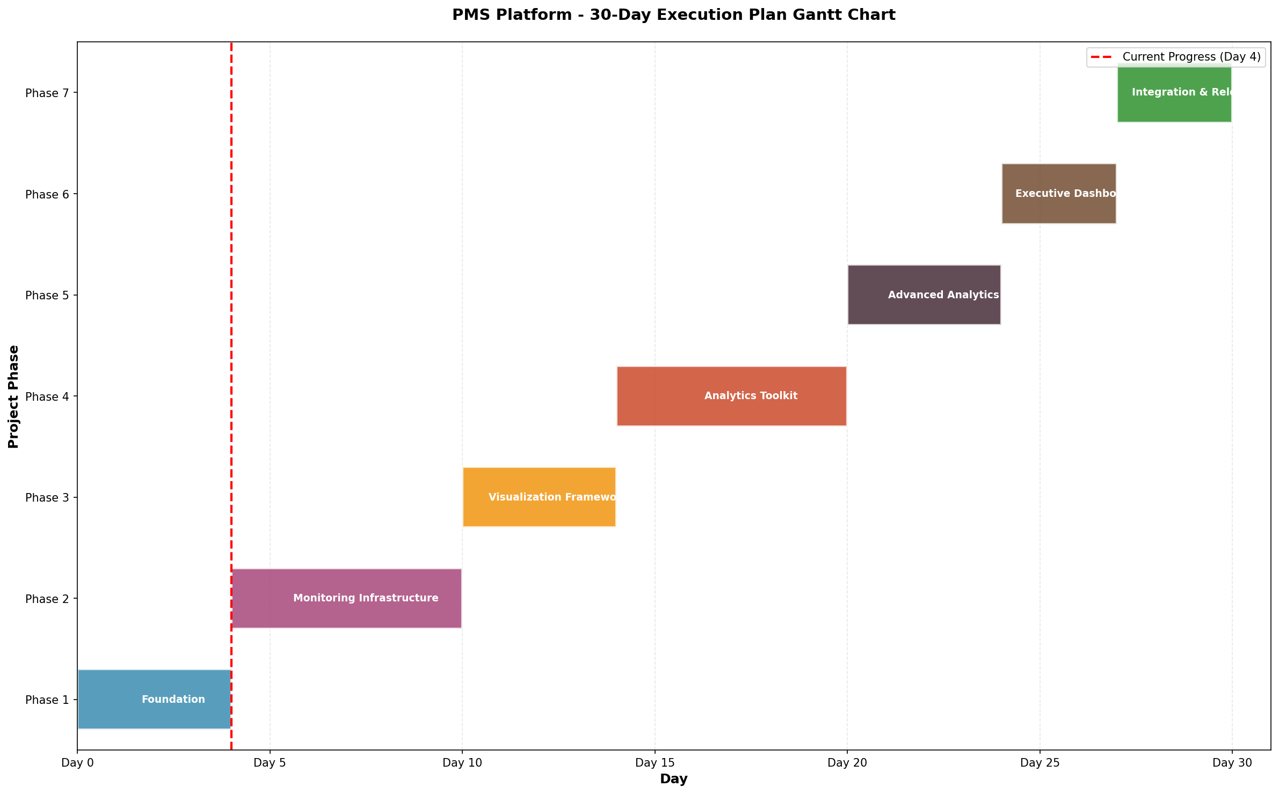

Weekly Calendar Overview:
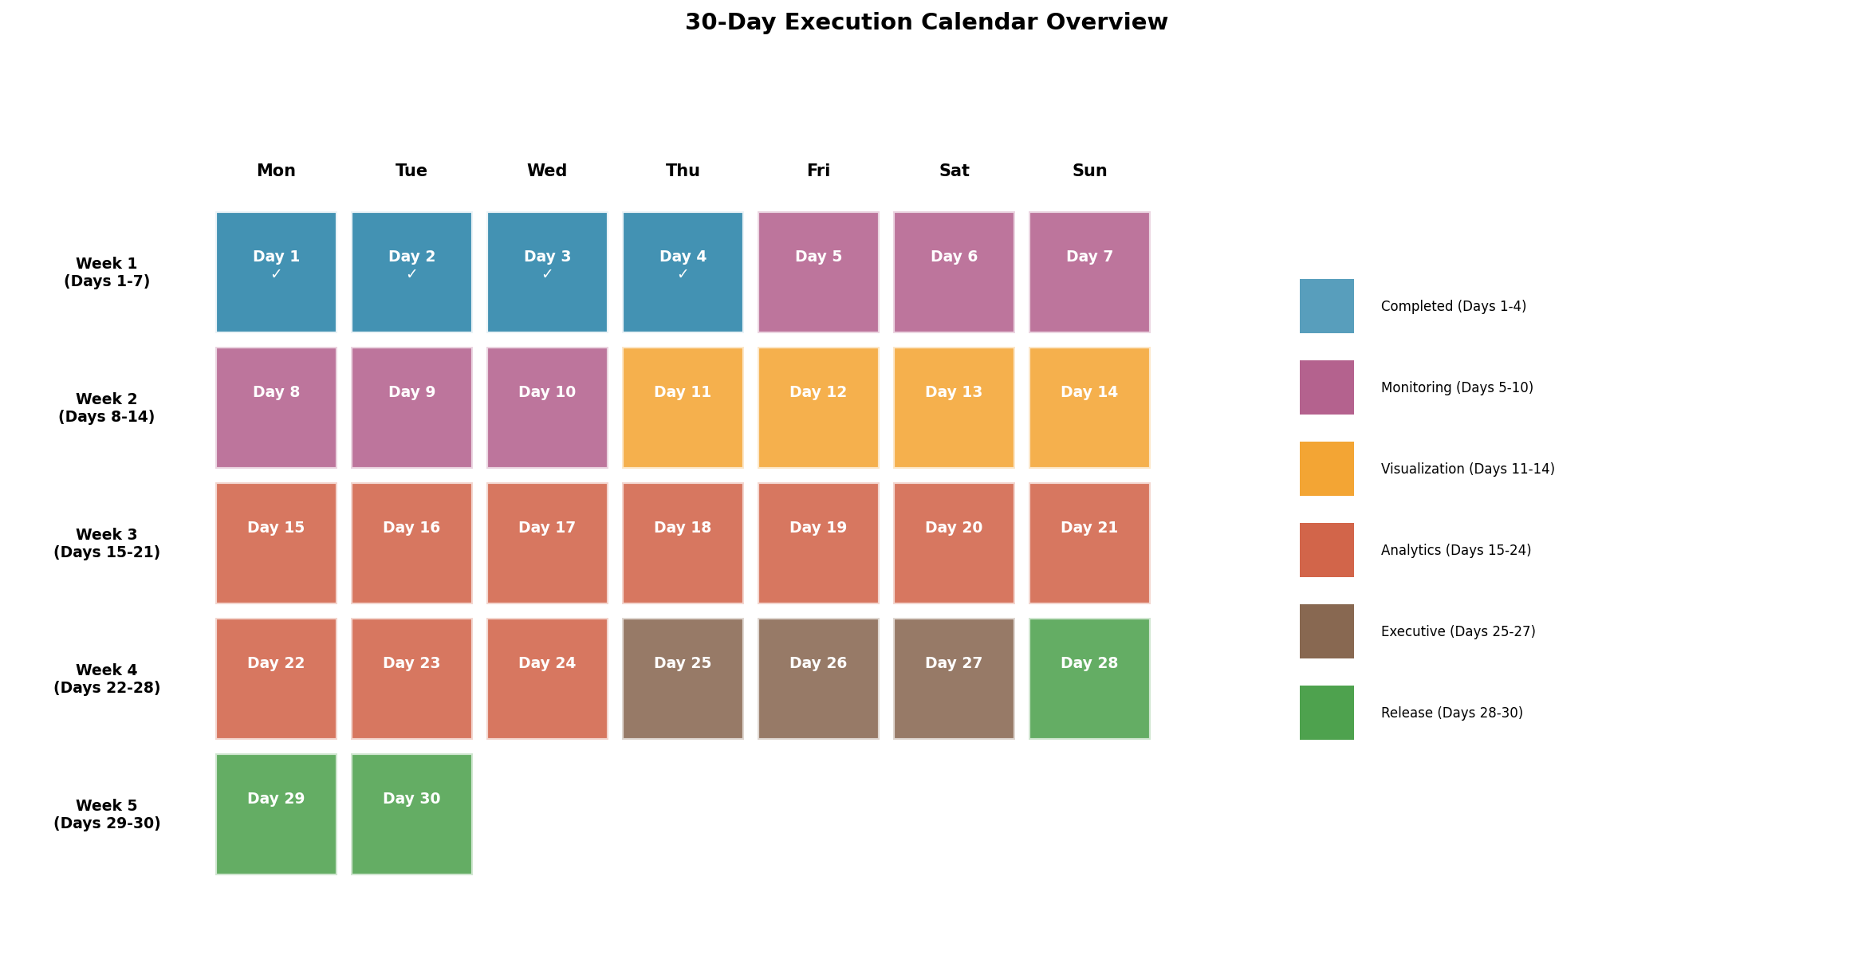

5.1 Daily Task Breakdown
Day | Date | Member A | Member B | Member C | Status
Day 1 | Feb 02 | Project Foundation & Architecture | Planning | Documentation | ✓
Day 2 | Feb 03 | API Module Implementation | Planning | DevOps setup | ✓
Day 3 | Feb 04 | Core Algorithms & Advanced Features | Frontend setup | DevOps setup | ✓
Day 4 | Feb 05 | Frontend & Integration Layer | Frontend setup | DevOps setup | ✓
Day 5 | Feb 06 | Create aggregation tables for hourly/dai... | Design monitoring dashboard wireframes | Set up CI/CD pipeline with GitHub Action... | ○
Day 6 | Feb 07 | Implement hourly aggregation job (cron/s... | Build real-time KPI tracker component | Write unit tests for existing APIs | ○
Day 7 | Feb 08 | Implement 24-hour rollup aggregation ser... | Build daily activity monitor widget | Integration test for monitoring endpoint... | ○
Day 8 | Feb 09 | Implement weekly aggregation with trend ... | Build weekly summary dashboard component | Load testing setup with k6 | ○
Day 9 | Feb 10 | Implement monthly aggregation with YoY c... | Build monthly performance card component | Performance benchmarking and optimizatio... | ○
Day 10 | Feb 11 | Implement yearly aggregation with annual... | Build yearly performance index report vi... | Security audit and vulnerability scan | ○

Day | Date | Member A | Member B | Member C | Status
Day 11 | Feb 12 | Create Gantt chart data API endpoints | Implement interactive Gantt chart compon... | Test data seeding scripts | ○
Day 12 | Feb 13 | Create timeline data API for career prog... | Build interactive timeline visualization | API documentation with Swagger/OpenAPI | ○
Day 13 | Feb 14 | Create calendar data API for check-ins/1... | Build calendar heatmap view component | User acceptance testing scripts | ○
Day 14 | Feb 15 | Implement heatmap data aggregation APIs | Build performance heatmap & skills heatm... | Regression test suite | ○
Day 15 | Feb 16 | KPI trend analysis API & Goal progress v... | KPI Trend Chart & Goal Variance Dashboar... | Analytics module test coverage | ○
Day 16 | Feb 17 | OKR completion rate API & Skills gap ana... | OKR Dashboard & Skills Gap Radar Chart | Data export functionality (CSV) | ○
Day 17 | Feb 18 | Competency heatmap API & Manager vs team... | Competency Heatmap & Distribution Chart | PDF export functionality | ○
Day 18 | Feb 19 | 9-box grid API & Performance distributio... | 9-Box Grid Component & Distribution Curv... | Accessibility audit (WCAG compliance) | ○
Day 19 | Feb 20 | Review sentiment API & Peer feedback net... | Sentiment Summary & Network Graph visual... | Mobile responsiveness testing | ○
Day 20 | Feb 21 | Time-to-goal completion API & Late check... | Goal Completion Chart & Late Check-in Al... | Browser compatibility testing | ○

Day | Date | Member A | Member B | Member C | Status
Day 21 | Feb 22 | Burnout risk proxy API & Attrition risk ... | Burnout Risk Dashboard & Attrition Risk ... | Staging environment setup | ○
Day 22 | Feb 23 | High performer identification API & Unde... | High Performer Board & Early Warning Pan... | Disaster recovery documentation | ○
Day 23 | Feb 24 | Training impact analysis API & Promotion... | Training Impact Chart & Promotion Readin... | Production deployment checklist | ○
Day 24 | Feb 25 | Department comparison API & Custom repor... | Department Comparison Dashboard & Report... | End-to-end smoke tests | ○
Day 25 | Feb 26 | Executive command center API endpoints | Executive Dashboard with customizable wi... | Performance tuning and caching optimizat... | ○
Day 26 | Feb 27 | Manager operations dashboard APIs | Manager Dashboard with team radar charts | User guide documentation | ○
Day 27 | Feb 28 | Employee personal portal APIs | Employee Personal Performance Portal | Admin guide documentation | ○
Day 28 | Mar 01 | Notification service integrations (email... | Mobile-responsive polish and fixes | Production deployment preparation | ○
Day 29 | Mar 02 | Final API hardening and security review | Final UI/UX polish and bug fixes | Production deployment and monitoring set... | ○
Day 30 | Mar 03 | Post-deployment monitoring and hotfixes | User training materials and videos | Release notes and handoff documentation | ○

6. Weekly Milestones

Week 1 (Days 1-7)
Milestone: Foundation & Monitoring Infrastructure
Deliverables:
• Multi-tenant database schema complete
• 13 API modules implemented
• Hourly and daily aggregation jobs running
• Basic frontend pages functional
Success Criteria: Core platform operational with basic monitoring

Week 2 (Days 8-14)
Milestone: Monitoring Completion & Visualization Framework
Deliverables:
• Weekly/monthly/yearly aggregation complete
• Gantt chart component implemented
• Timeline visualization implemented
• Calendar heatmap view implemented
Success Criteria: All monitoring cadences operational, visualization components ready

Week 3 (Days 15-21)
Milestone: Analytics Toolkit (14 tools)
Deliverables:
• KPI trend analysis, Goal variance
• OKR completion, Skills gap analysis
• 9-box grid, Distribution curves
• Risk proxy dashboards (burnout, attrition)
Success Criteria: 14+ analytics tools functional with real data

Week 4 (Days 22-28)
Milestone: Advanced Analytics & Executive Dashboards
Deliverables:
• 20+ analytics tools complete
• Executive command center
• Manager operations dashboard
• Employee personal portal
Success Criteria: Role-based dashboards showing relevant metrics

Week 5 (Days 29-30)
Milestone: Integration & Release
Deliverables:
• External integrations (email, Slack)
• Production deployment
• Documentation complete
• Training materials ready
Success Criteria: System deployed, documented, and operational

7. Visualization Roadmap
Team Role Allocation:
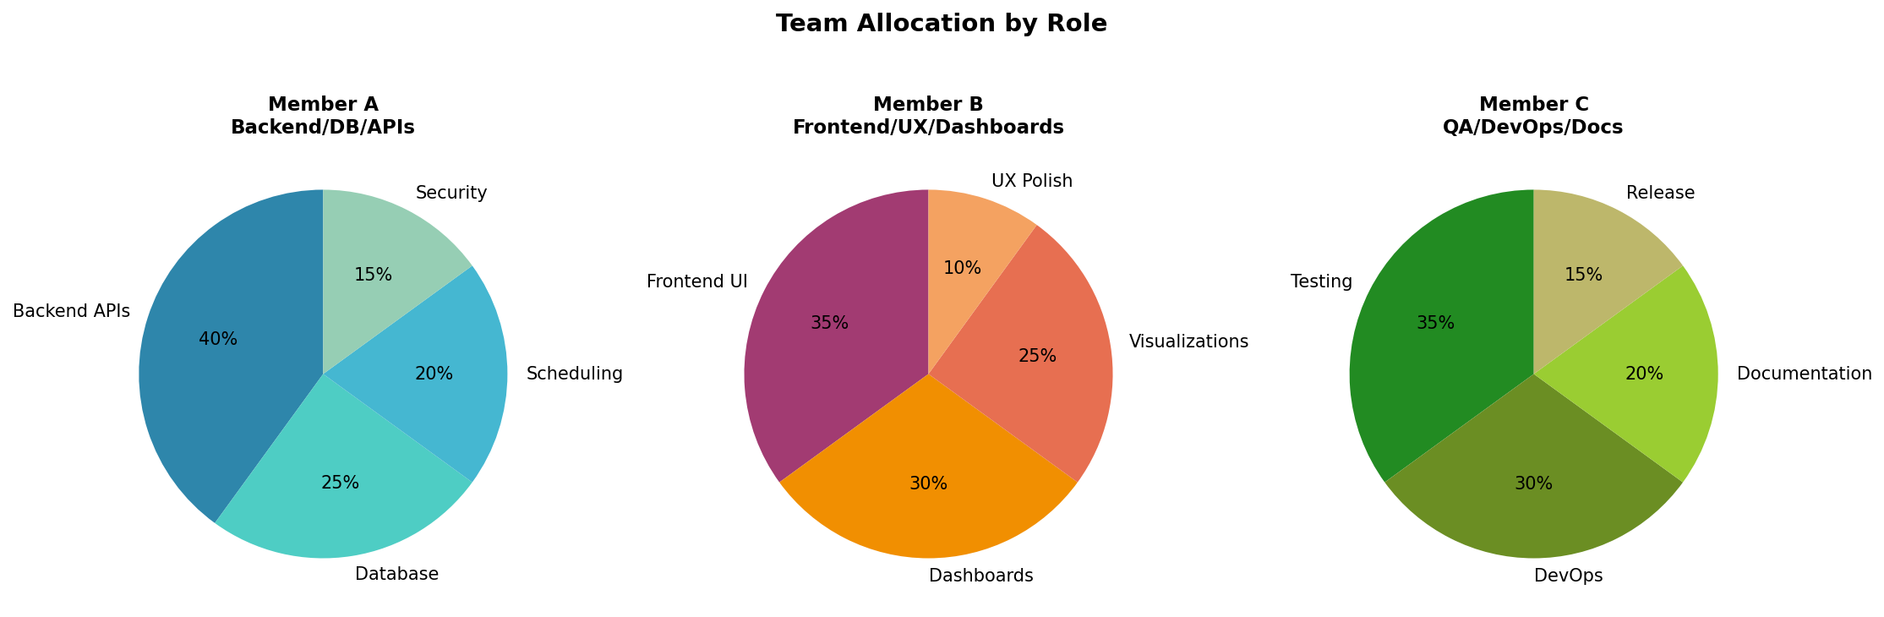

Feature Implementation Progress:
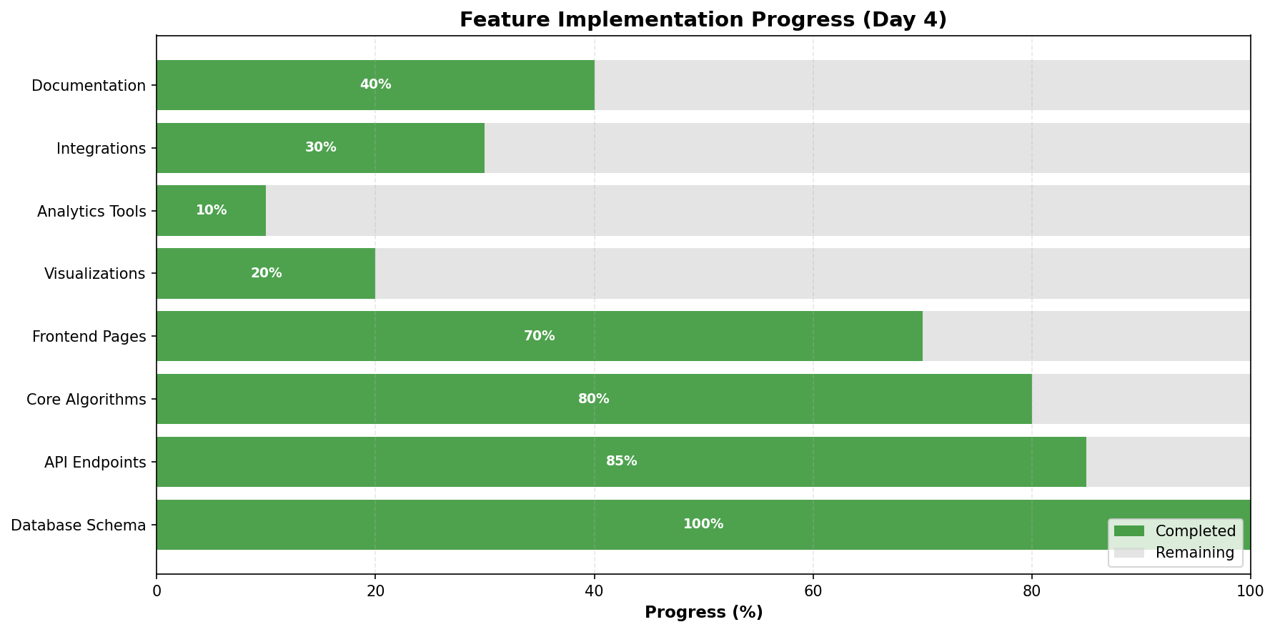

7.1 Visualization Components to Implement
Component | Description | Implementation Day | Owner
Interactive Gantt Chart | Goal/project timelines with dependencies | Day 11 | B
Career Timeline | Employee progression visualization | Day 12 | B
Calendar Heatmap | Activity intensity by date | Day 13 | B
Performance Heatmap | Rating distribution heatmap | Day 14 | B
Skills Heatmap | Competency level visualization | Day 14 | B
9-Box Grid | Performance vs Potential matrix | Day 18 | B
Network Graph | Peer feedback relationships | Day 19 | B
Distribution Curves | Bell curve for ratings | Day 18 | B
Radar Charts | Multi-dimensional performance | Day 26 | B
Sankey Diagrams | Resource flow visualization | Day 25 | B

8. Analytics Toolkit (20+ Tools)
The following analytics tools will be implemented to provide comprehensive insights:
# | Tool Name | Description | Day | Status
1 | KPI Trend Analysis | Track KPI trends over time with forecasting... | 15 | Planned
2 | Goal Progress Variance | Compare planned vs actual goal progress... | 15 | Planned
3 | OKR Completion Rate | Measure OKR achievement rates by team/dept... | 16 | Planned
4 | Skills Gap Analysis | Identify skill gaps across roles and teams... | 16 | Planned
5 | Competency Heatmap | Visual heatmap of competency levels... | 17 | Planned
6 | Manager vs Team Distribution | Compare manager ratings to team averages... | 17 | Planned
7 | 9-Box Grid Mapping | Talent mapping on performance/potential grid... | 18 | Planned
8 | Performance Distribution Curve | Bell curve distribution of ratings... | 18 | Planned
9 | Review Sentiment Summary | AI-powered sentiment analysis of review text... | 19 | Planned
10 | Peer Feedback Network Map | Network graph of feedback relationships... | 19 | Planned
11 | Time-to-Goal Completion | Track average time to complete goals... | 20 | Planned
12 | Late Check-in Detection | Identify employees with missed check-ins... | 20 | Planned
13 | Burnout Risk Proxy Dashboard | Proxy indicators for potential burnout... | 21 | Planned
14 | Attrition Risk Proxy Dashboard | Proxy indicators for attrition risk... | 21 | Planned
15 | High Performer Identification | Identify and highlight top performers... | 22 | Planned
16 | Underperformance Early Warning | Early detection of performance decline... | 22 | Planned
17 | Training Impact Analysis | Measure performance impact of training... | 23 | Planned
18 | Promotion Readiness Score | Detailed breakdown of promotion criteria... | 23 | Planned
19 | Department Comparison Dashboard | Cross-department performance comparison... | 24 | Planned
20 | Custom Report Builder | Drag-and-drop custom analytics reports... | 24 | Planned
21 | Export Dashboards (CSV/PDF) | Export any dashboard to CSV or PDF... | 17 | Planned
22 | Real-Time Leaderboard | Gamified performance rankings... | 25 | Planned
23 | Performance Forecast Graphs | AI-powered performance predictions... | 25 | Planned

9. 50 Universal Features
The PMS Platform implements the following 50 universal features for organizational excellence:

Real-Time Performance Tracking (1-8)
1. Hourly Performance Tracker
2. 24/7 Activity Monitor with AI Detection
3. Real-Time Goal Progress Dashboard
4. Deadline Proximity Alert System
5. Live Workload Distribution Analyzer
6. Instant Performance Anomaly Detector
7. Real-Time Communication Sentiment Gauge
8. Live Project Milestone Tracker

Periodic Analytics & Reporting (9-13)
1. Weekly Performance Summary with Trend Analysis
2. Monthly Performance Card Generation
3. Quarterly Business Review Engine
4. Yearly Performance Index Report
5. Comparative Period-over-Period Analytics

Visualization & Dashboard Features (14-28)
1. Interactive Executive Dashboard
2. Hierarchical Gantt Chart Generator
3. Interactive Timeline Visualization
4. Custom Calendar Heatmap View
5. Department-Wide Scorecard Dashboard
6. Role-Based Performance Radar Charts
7. Real-Time Analytics Notification Board
8. Multi-Level KPI Tree Visualization
9. Burndown & Burnup Chart Generator
10. Performance Distribution Box Plot Dashboard
11. Real-Time Leaderboard & Ranking Display
12. Geographic Performance Heat Map
13. Sankey Diagram for Resource Flow
14. Custom Widget Builder Dashboard
15. Performance Trend Line & Forecast Graphs

360° & Multi-Perspective Appraisal (29-34)
1. Intelligent 360° Feedback Collector
2. Peer Group Review Module
3. AI-Powered Self-Evaluation System
4. Stakeholder Impact Assessment Tool
5. Anonymous Feedback Aggregation Engine
6. Cross-Hierarchical Appraisal Comparison

Evaluation & Assessment Modules (35-40)
1. Technological Performance Audit Tool
2. Project Evaluation Framework
3. Leadership Competency Evaluator
4. Behavioral Competency Scorer
5. Compliance & Risk Assessment Module
6. Innovation Contribution Tracker

AI-Driven Insights & Intelligence (41-45)
1. Sentiment Analysis of Work Communications
2. Productivity Prediction Engine
3. Engagement Scoring Algorithm
4. Anomaly Detection & Risk Flagging
5. AI-Powered Performance Benchmarking

Actionable Insights & Planning (46-50)
1. Automated Promotion & Succession Recommendation
2. Personalized Development Plan Generator
3. Team Formation & Restructuring Optimizer
4. Performance Improvement Plan (PIP) Automation
5. Organizational Health & Culture Diagnostics Dashboard

10. Risks, Dependencies & Mitigations

10.1 Technical Risks
Risk | Impact | Probability | Mitigation
Aggregation job performance | HIGH | MEDIUM | Use batching, indexing, partitioning
Real-time sync latency | MEDIUM | LOW | Redis pub/sub with message queuing
Visualization rendering performance | MEDIUM | MEDIUM | Virtualization, lazy loading
External API rate limits | LOW | HIGH | Implement retry logic with backoff
Data migration complexity | HIGH | LOW | Comprehensive migration scripts, backups

10.2 Dependencies
Dependency | Required For | Status | Alternative
PostgreSQL 14+ | Database | READY | None (required)
Redis 7+ | Caching/Pub-Sub | READY | In-memory fallback
Node.js 18+ | Runtime | READY | None (required)
SendGrid/SES | Email notifications | CONFIG NEEDED | SMTP server
Slack Bot Token | Slack integration | CONFIG NEEDED | Webhook fallback
MS Teams Webhook | Teams integration | CONFIG NEEDED | None

11. Appendix

11.1 API Endpoints Summary
Module | Base Route | Endpoint Count | Status
Authentication | /api/v1/auth | 8 | Complete
Users | /api/v1/users | 12 | Complete
Goals | /api/v1/goals | 10 | Complete
Reviews | /api/v1/reviews | 15 | Complete
Feedback | /api/v1/feedback | 8 | Complete
Calibration | /api/v1/calibration | 10 | Complete
Evidence | /api/v1/evidence | 10 | Complete
Compensation | /api/v1/compensation | 11 | Complete
Promotions | /api/v1/promotions | 12 | Complete
Analytics | /api/v1/analytics | 8 | Partial
Notifications | /api/v1/notifications | 6 | Stub
Integrations | /api/v1/integrations | 10 | Stub

11.2 Database Tables Summary
Category | Tables | Count
Organization | Tenant, Department, BusinessUnit, CostCenter, Team, TeamMember | 6
Users & Auth | User, Session, Role, UserRole | 4
Reporting | ReportingLine, Delegation | 2
Policies | AccessPolicy, UnionContract, UnionMembership | 3
Goals | Goal, GoalAlignment, GoalProgressUpdate, GoalComment | 4
Reviews | ReviewCycle, ReviewTemplate, Review, ReviewGoal | 4
Feedback | Feedback | 1
Calibration | CalibrationSession, CalibrationParticipant, CalibrationRating | 3
1-on-1s | OneOnOne | 1
Competencies | CompetencyFramework, Competency | 2
Evidence | Evidence, ReviewEvidence | 2
Decisions | CompensationDecision, PromotionDecision, DecisionEvidence | 3
Integrations | Integration, IntegrationSyncJob | 2
Notifications | NotificationTemplate, Notification | 2
Audit | AuditEvent | 1

11.3 Frontend Pages Summary
Page | Route | Status
Login | /auth/login | Complete
Dashboard | / | Complete
Goals List | /goals | Complete
Goal Detail | /goals/:id | Complete
Reviews List | /reviews | Complete
Review Detail | /reviews/:id | Complete
Feedback | /feedback | Complete
Calibration | /calibration | Complete
Analytics | /analytics | Partial
Profile | /profile | Complete
Team | /team | Complete
Settings | /settings | Complete
Admin Users | /admin/users | Complete

