Iteration Plan Week 2:

The second iteration our plan is to:
  - Clean up the UI so there are fewer windows.
  - Allow the instructor to specify his/her preferences for groups
  - Allow the instructor to edit the number of students in groups
  - Groups will be sorted based on students' GPA

This iteration is an extension of our implementation of our first Use Case, wherein the instructor specifies the parameters. These features are necessitated by our description of the alternate and main paths of the Use Case 1, in particular, 5.11, for skill-based (GPA) groups, and 3.2, the instructor editing the number of students for groups.
We still choose to only have implementation of Use Cases 1 and 3, as these are by far the most crucial part of our software. We need to implement more of Use Case 3 in order to account for the fact that our groups will now be based on the GPA of their students

Features
Features already implemented in iteration one have been crossed off the list. The underlined features will be implemented by the end of the second iteration.

- System is able to generate groups of students based on maximum group size.
- Allows instructor to specify the maximum number of students per group.
- Instructor is able to edit, override, and verify the groups after the system has generated them.
- Allows instructor to specify collections of students which must work together or must not work together. This is taken into account in group creation
- Students are able to specify collections of students they would and would not like to work with. This is taken into account in group creation
- Students are notified of deadline and what information they must submit.
- Disables students ability to edit information after the specified deadline has passed.
- System is able to retrieve students university information including grades and class schedule.
- Students are able to enter a personal schedule. This is taken into account in group generation.
- Instructor specifies whether group creation is based on skill or not, if it is based on skill, group will take into account students grades and questionnaire.
- If instructor specified that groups are based on skill, instructor may create a questionnaire which the students are able to answer.
- Allows instructor the ability to edit whether groups are based on skill, maximum number of students, questionnaire, collections of preferred partners to group and keep separate.
- Allows student the ability to edit questionnaire if supplied, personal timetable, collection of students they would like to work with or not work with.

New Architecture
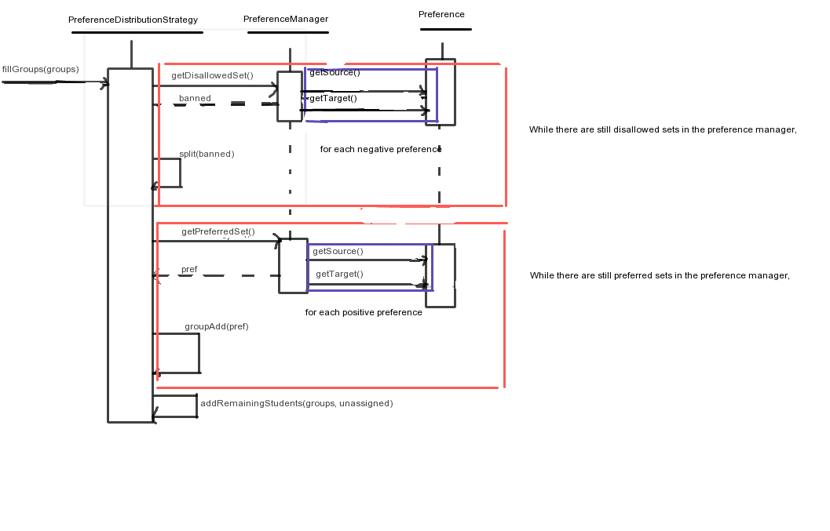
Since we are implementing the instructor preference feature, we needed to add a new Strategy class to deal with sorting the students into groups. The following sequence diagram explains the interactions between this class and the PreferenceManager and Preference classes as it tries to add students to the groups.

