**Ranchi Province Management System**



**DEPARTMENT OF COMPUTER SCIENCE**

**LOYOLA COLLEGE (AUTONOMOUS)**

**CHENNAI – 600034**

**BY**

**Prawin Minj**

**(DEPT NO:18-UCA-040)**

**Under the Guidance of**

**PROF.A. JOYLIN ZEFFORA M.Sc., MBA., NET**

**Ranchi Province Management System**

**Abstract**

Ranchi province management system is about developing a web-based ERP system mainly for personnel management. This web-based ERP system will allow Ranchi Province to record personal and congregational details of an individual, manage personnel recruitment, appointment and transfer from one place to the other, update current status of a member and generate individual report of a province man as well as overall report of the province.

**Frontend** – Laravel (PHP-framework)

**Backend** – MySQL

**SYSTEM ANALYSIS**

**Problem Definition:**

An extensive study of existing system was carried out. There is an existing system available in Ranchi Province. The system is running manually. It is very difficult to recorded different activities and details of a province man and keep all the records for future reference. Thus, I came to know the essential need to digitalize and automate different activities and processes of the province to reduce the workload.

**Existing System:**

Ranchi province is central zone Jesuit province in India which comes under Jharkhand state. In the existing manual system, it is very difficult to record and maintain, personal and congregational details of each province man in the province and keep all the records for future reference. The province also makes yearly transfers and appointments of its personnel within and outside the province for different ministries like study, spiritual direction, teaching in common houses, etc.

Finding out any data of a province man is a tedious process. Keeping track of the past and future events are all the more difficult when done manually. It is difficult to record, manage and maintain numbers of activities manually, in an efficient, effective and timely manner by a few province men.

**Proposed System:**

Ranchi province management system is a web base ERP system. It keeps records and manages each priest’s and scholastic’s personal data, their different formation stages, appointments, placements, ministries. It also displays Ranchi province personnel catalogue, which is updated automatically when a priest or a scholastic receives a new appointment for a new ministry and is placed in a new community. The socius to provincial will be able to view, manage, and generate report for placements and appointments of priests and scholastics for new ministries in the province.

The admin will have full access over the Ranchi province management system. Using admin privileges and different access control, the head of the province like the provincial and socius to the provincial will be able to fill in, update, read and delete both personal and congregational data of all province men. Using the online portal, priests and scholastics will be able to login, fill in and update their personal data. They can view their personal and congregational details and current status in province.

**System requirements**

**Hardware Requirements:**

• Processor : Intel i3 Dual Core 2.21GHz

• Ram : 2GB RAM

• Hard Disk Size : 500GB

**Software Requirements:**

• Front End : Laravel (php framework)

• Local Server : : Wamp server (v3.2.3)

• Database : MYSQL Server

• Operating system : Windows 10

**Personnel Management**

**Sub-modules**

**Recruitment Management:**

* This module takes care of Recruiting new members and adding their personal and congregational details in Ranchi Province Management system database. It also gives them a personal login id and password.

**Basic detail entries management:**

* This module adds and manages all the basic entire required to manage transfer. For instance, adding parishes, institutions, communities, community address, districts, states, countries and so on.

**New appointment**

* This module manages new appointments for newly recruited members for formation or ministry.

**Transfer management**

* This module is responsible for making yearly transfers of personnel from one place to the other within or out of the province.

**Individual report**

* This module generates individual report of an individual province man in Ranchi Province.

**Province report**

* This module gives an over view of province personnel, communities, parishes, institutions, ministries in different districts of different states in India and in foreign countries.

This module also displays the current status of each province man like current community, current ministry and designation in Ranchi province

**SYSTEM DESIGN**

**Database Design**

**Table Design**

**Table name:** users

|  |  |  |  |  |
| --- | --- | --- | --- | --- |
| **Sl. No.** | **Field** | **Datatype** | **Constraint** | **Allow Null** |
|  | id | bigint(20) | PK | No |
|  | name | varcahr(191) |  | No |
|  | email | varcahr(191) |  | No |
|  | password | varcahar(255) |  | No |
|  | created_at | timestamp |  | Yes |
|  | updated_at | timestamp |  | Yes |

**Table name:** ranchi_jesuit_details

|  |  |  |  |  |
| --- | --- | --- | --- | --- |
| **Sl. No.** | **Field** | **Datatype** | **Constraint** | **Allow Null** |
| 1. | id | bigint(20) | PK | No |
| 2. | user_id | Bigint(20) | FK | Yes |
| 3. | first_name | varcahr(20) |  | No |
| 4. | middle_name | Varchar(20) |  | Yes |
| 5. | sur_name | varcahr(20) |  | No |
| 6. | email | varcahar(255) |  | No |
| 7. | mobile_number1 | Varchar (15) |  | Yes |
| 8. | mobile_number2 | Varchar(15) |  | Yes |
| 9. | birth_date | date |  | No |
| 10. | entry_date_sj | date |  | No |

**Table name:** personal_detalis

|  |  |  |  |  |
| --- | --- | --- | --- | --- |
| **Sl.No.** | **Field** | **Data type** | **Constraint** | **Allow Null** |
| 1. | id | bigint (20) | PK | No |
| 2. | ranchi_jesuit_detail_id | Bigint(20) | FK |  |
| 2. | father | varchar (30) |  | Yes |
| 3. | mother | varchar (30) |  | Yes |
| 4. | siblings | varchar (255) |  | Yes |
| 4. | village_town_colony | varchar (30) |  | Yes |
| 5. | parish | varchar (30) |  | Yes |
| 6. | dioses | varchar (30) |  | Yes |
| 7. | district_id | int (10) | FK | Yes |
| 9. | pincode | varchar (15) |  | Yes |
| 10. | post_office | varchar(30) |  | Yes |
| 11. | post_box_number | varchar(30) |  | Yes |
| 13. | state_id | int(10) | FK | Yes |
| 14. | country_id | int(10) | FK |  |



**Table name:** formation_stages

|  |  |  |  |  |
| --- | --- | --- | --- | --- |
| **Sl. No.** | **Field** | **Datatype** | **Constraint** | **Allow Null** |
|  | id | Int(10) | PK | No |
|  | formation_transaction_id | Bigint(20) | FK |  |
|  | stage _name | varchar (30) |  | No |
|  | stage_description | Text(100) |  | Yes |
|  | stage_duration | Varchar(30) |  | Yes |

**Table name:** formation_transctions

|  |  |  |  |  |
| --- | --- | --- | --- | --- |
| **Sl. No.** | **Field** | **Datatype** | **Constraint** | **Allow Null** |
|  | id | bigint(20) | PK | No |
|  | ranchi_jesuit_detail_id | bigint(20) | FK | Yes |
|  | concerned_authoriity | varchar(30) |  | Yes |
|  | community_id | Int (10) | FK | Yes |
|  | start_date | date |  | Yes |
|  | end_date | date |  |  |

**Table name:** event_types

|  |  |  |  |  |
| --- | --- | --- | --- | --- |
| **Sl. No.** | **Field** | **Datatype** | **Constraint** | **Allow Null** |
|  | id | Int(10) | PK | No |
|  | event_transction_id | Int(10) | FK | Yes |
|  | event_name | varchar (20) |  | No |
|  | event_description | text |  | Yes |

**Table name:** event_transctions

|  |  |  |  |  |
| --- | --- | --- | --- | --- |
| **Sl. No.** | **Field** | **Datatype** | **Constraint** | **Allow Null** |
|  | id | int(10) | PK | No |
|  | ranchi_jesuit_detail_id | bigint(20) | FK | Yes |
|  | community_id | int(10) | FK | Yes |
|  | personal_address_id | bigint(20) | FK | Yes |
|  | held_on | date |  | Yes |
|  | Presided_over_by | Varchar(30) |  | Yes |

**Table name:** ministries

|  |  |  |  |  |
| --- | --- | --- | --- | --- |
| **Sl. No.** | **Field** | **Datatype** | **Constraint** | **Allow Null** |
|  | id | Int(10) | PK | No |
|  | ministry _name | varchar (30) |  | No |



**Table name:** designations

|  |  |  |  |  |
| --- | --- | --- | --- | --- |
| **Sl. No.** | **Field** | **Datatype** | **Constraint** | **Allow Null** |
|  | id | Int(10) | PK | No |
|  | designation_name | varchar (50) |  | No |
|  | designation_abbreviation | varchar(10) |  | Yes |



**Table name:** parishes

|  |  |  |  |  |
| --- | --- | --- | --- | --- |
| **Sl. No.** | **Field** | **Datatype** | **Constraint** | **Allow Null** |
| 1 | id | Int(10) | PK | No |
| 2 | parish _name | varchar (30) |  | No |
| 3 | zone | Varchar(30) |  | Yes |



**Table name:** institutions

|  |  |  |  |  |
| --- | --- | --- | --- | --- |
| Sl. No. | **Field** | **Datatype** | **Constraint** | **Allow Null** |
|  | id | Int(10) | PK | No |
|  | institution _name | varchar (50) |  | No |
|  | institution _place | Varchar(55) |  |  |

**Table name:** communities

|  |  |  |  |  |
| --- | --- | --- | --- | --- |
| **Sl. No.** | **Field** | **Datatype** | **Constraint** | **Allow Null** |
| 1. | id | Int | PK | No |
| 2 | community_name | varchar (100) |  | No |
| 3. | community_address_id | int(10) | FK | Yes |
| 3. | province_id | int(10) | FK | Yes |
| 4. | district_id | int(10) | FK | Yes |
| 5. | institution_id | int(10) | FK | Yes |
| 6. | parish_id | int(10) | FK | Yes |

**Table name:** community_address

|  |  |  |  |  |
| --- | --- | --- | --- | --- |
| **Sl. No.** | **Field** | **Datatype** | **Constraint** | **Allow Null** |
| 1. | id | Int | PK | No |
| 2. | community_contact_number | varchar(15) |  |  |
| 3. | district_id | int(10) | FK | Yes |
| 4. | area_or_village_street_colony | Varchar(3) |  | Yes |
| 4. | pincode | varchar(15) |  | No |
| 6. | post_office | varchar(30) |  | Yes |
| 7. | town_or_city | varchar(30) |  | Yes |
| 8. | post_box_number | varchar(30) |  | Yes |
| 9. | state_id | int(10) | FK | No |
| 10s. | country_id | int(10) | FK | No |



**Table name:** provinces

|  |  |  |  |  |
| --- | --- | --- | --- | --- |
| **Sl. No.** | **Field** | **Datatype** | **Constraint** | **Allow Null** |
| 1. | id | Int(10) | PK | No |
| 2 | province_name | varchar (30) |  | No |

**Table name:** districts

|  |  |  |  |  |
| --- | --- | --- | --- | --- |
| **Sl. No.** | **Field** | **Datatype** | **Constraint** | **Allow Null** |
|  | id | Int(10) | PK | No |
|  | district _name | Varchar (30) |  | No |



**Table name:** states

|  |  |  |  |  |
| --- | --- | --- | --- | --- |
| **Sl. No.** | **Field** | **Datatype** | **Constraint** | **Allow Null** |
|  | id | Int(10) | PK | No |
|  | state _name | Varchar (30) |  | No |



**Table name:** countries

|  |  |  |  |  |
| --- | --- | --- | --- | --- |
| **Sl. No.** | **Field** | **Datatype** | **Constraint** | **Allow Null** |
| 1. | id | Int | PK | No |
| 2 | country_name | varchar (30) |  | No |
| 3. | country_abbreviation | varcahr(7) |  | Yes |

**Table name:** transfers

|  |  |  |  |  |
| --- | --- | --- | --- | --- |
| **Sl. No.** | **Field** | **Datatype** | **Constraint** | **Allow Null** |
|  | id | int | PK | No |
|  | ranchi_jesuit_detail_id | Bigint(20) | FK | No |
|  | ministry _id | int (10) | FK | No |
|  | designation_id | Int (10) |  | Yes |
|  | institution_id | Int (10) | FK | Yes |
|  | parish_id | Int (10) | FK | Yes |
|  | community_id | Int (10) | FK | Yes |
|  | any_comment | varchar (100) |  | Yes |

**Table name:** departures

|  |  |  |  |  |
| --- | --- | --- | --- | --- |
| **Sl. No.** | **Field** | **Datatype** | **Constraint** | **Allow Null** |
|  | id | bigint (20) | PK | No |
|  | departure_type | enum(20) |  | Yes |
|  | departure_date | date |  | No |
|  | departure_reason | varchar(30) |  |  |
|  | community_id | Int (10) | FK | Yes |
|  | ranchi_jesuit_detail_id |  | FK |  |



**Table name:** roles

|  |  |  |  |  |
| --- | --- | --- | --- | --- |
| **Sl. No.** | **Field** | **Datatype** | **Constraint** | **Allow Null** |
|  | id | bigint (20) | PK | No |
|  | name | varchar(255) |  | Yes |



**Table name:** role_user

|  |  |  |  |  |
| --- | --- | --- | --- | --- |
| **Sl. No.** | **Field** | **Datatype** | **Constraint** | **Allow Null** |
|  | id | bigint (20) | PK | No |
|  | role_id | unsignedBigInteger | FK | Yes |
|  | user_id | unsignedBigInteger | FK | Yes |

**Data Flow Diagram**

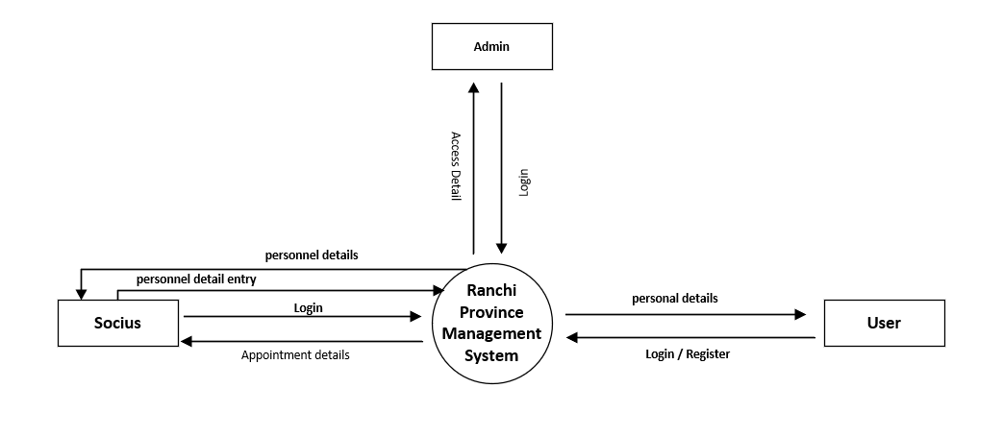**Level 0 tabl**

**Level 1 DFD**

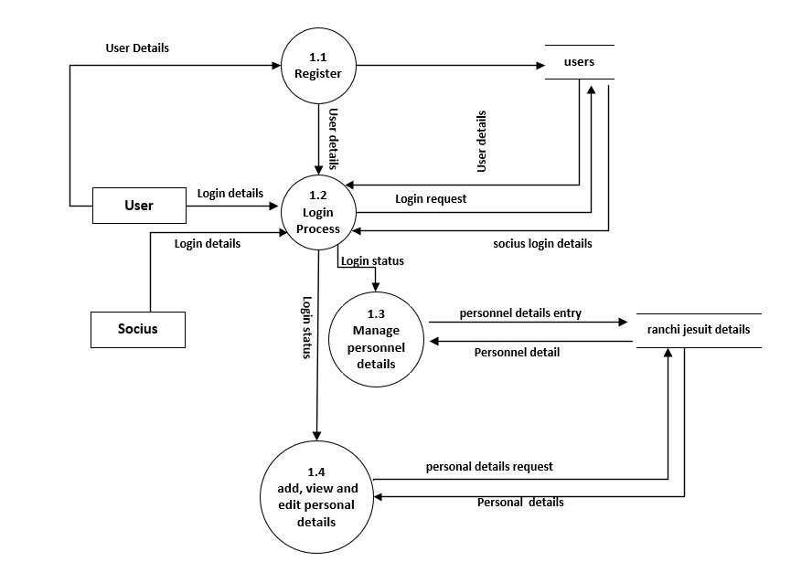

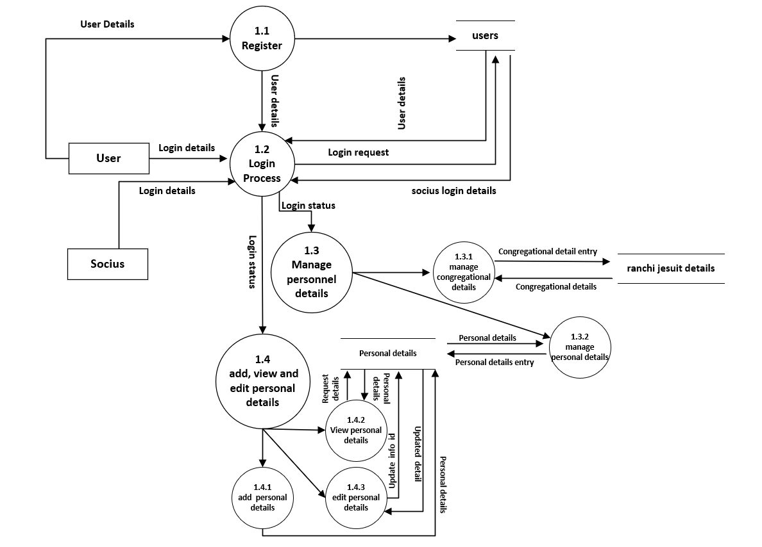**Level 2 DFD**

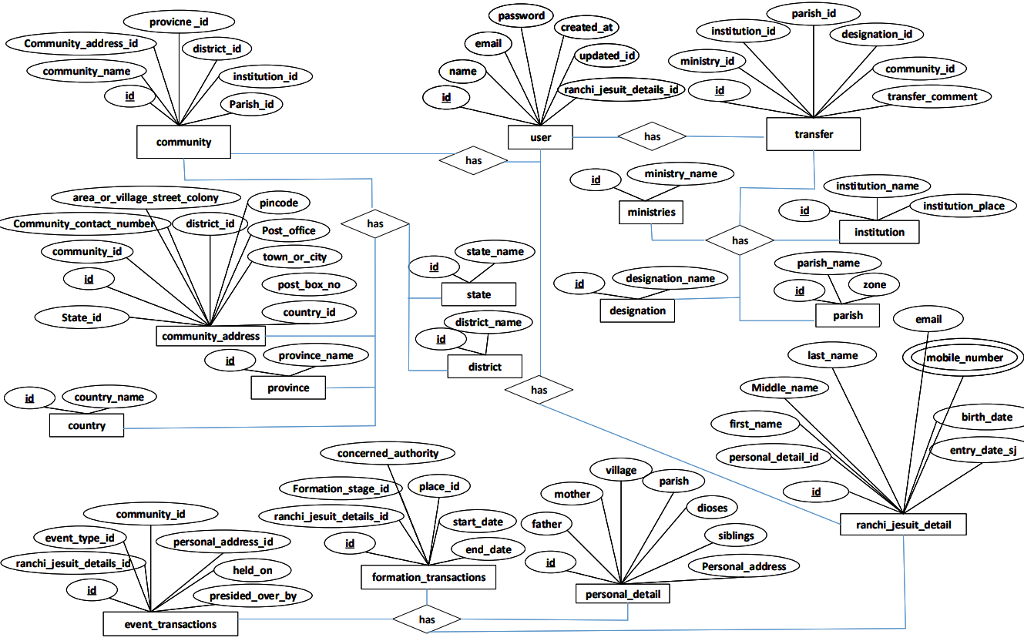**Entity Relationship Diagram**

**GUI Design**

**Registration**

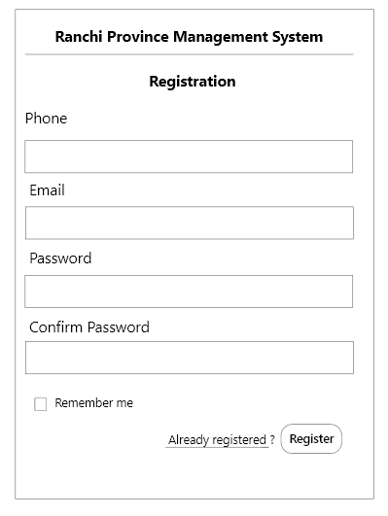

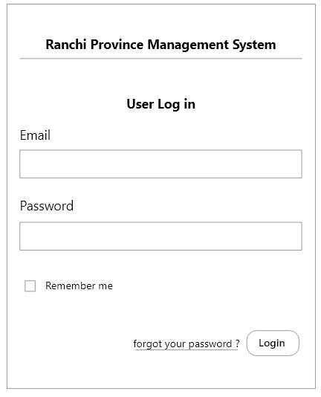**User Login**

**Admin Dashboard**

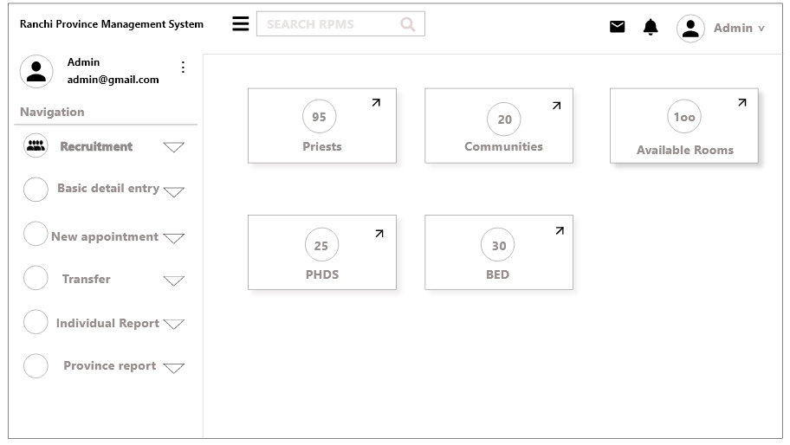

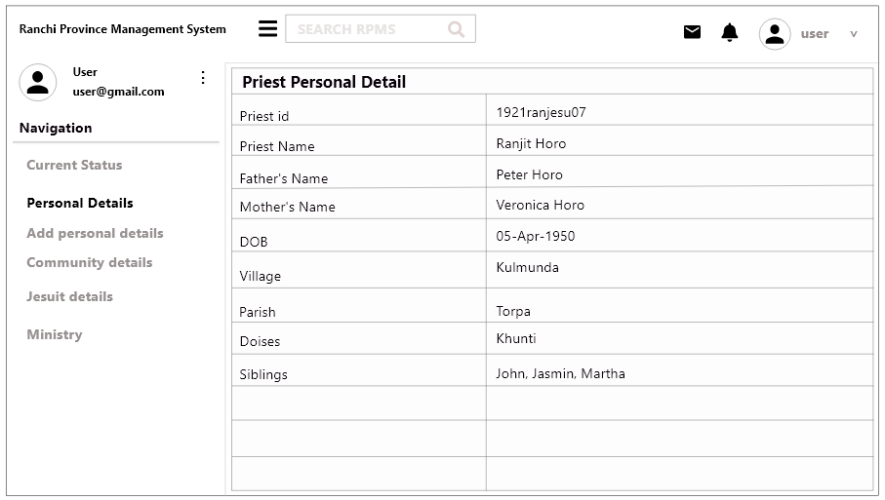**User Dashboard**

**Personal details form**

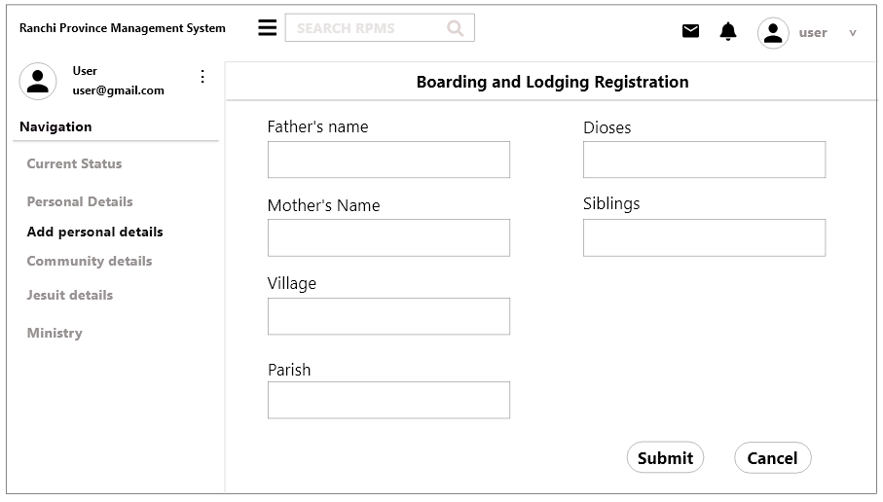

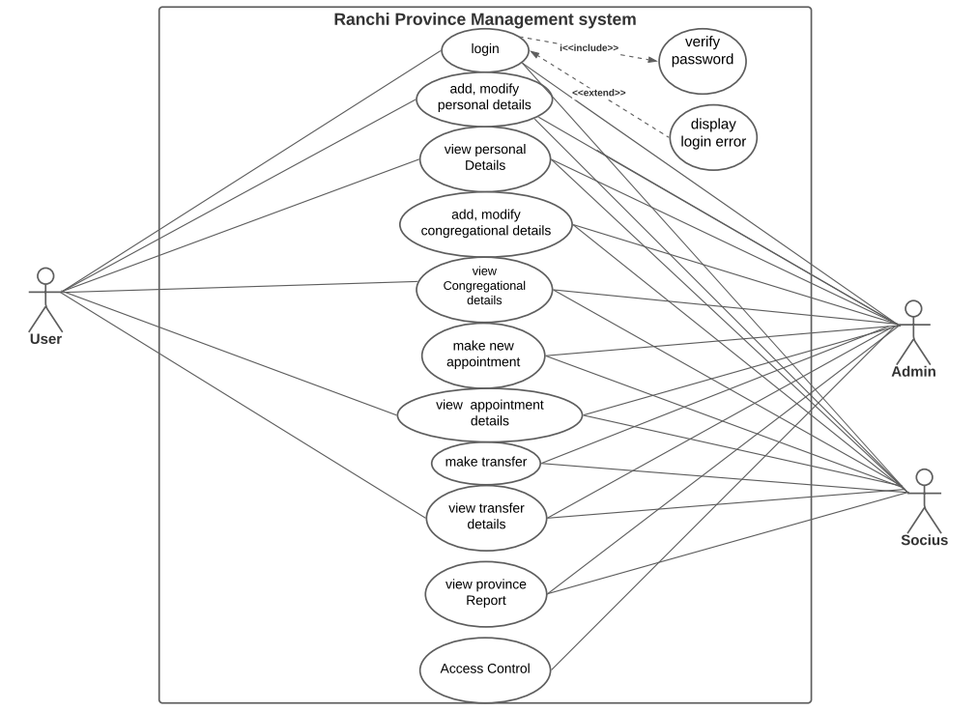**Use case diagram:**