 | Training Document
MOI - TFS

Table of Contents
1 Document Management 3
1.1 Document Versioning 3
1.2 Document Sign-off 3
1.3 Document Acceptance 3
1.4 Document Distribution 3
2 Document Overview & Purpose 4
3 Production Baseline 4
4 Branches 4
4.1 Definitions: 5
5 Test Environments 8
6 Local Setup 8
7 Check-in Check-out 9
8 Merging 9
9 Deployments 9
10 Release Planning 9
11 Appendix A: TFS Team Explorer 2010 Installation 10

Document Management

Document Versioning
Version Author | No | Date | Reason for change
Ebru Cucen | 0.1 | 01/01/2012 | New document for TFS

Document Sign-off
Approver Role | Name | Version | Approval | Date
Team Member | Mark Matten
Team Member | Paul Brian

Document Acceptance
Approver Role | Name | Version | Approval | Date
MOI Development Manager | Adrian Pilcher
MOI Application Service Manager | Robert Burton
Project Sponsor | Puneet Kumar
Test Manager | Jigar Shah
Test Engagement Manager | Donna Chidzey
Scrum Lead | Alison Saunders

Document Distribution
Function | Names
Service Support
Implementation
Programme
Business

Document Overview & Purpose
This document is to explain how to use TFS from a developer’s perspective and a configuration team perspective.
With Process Improvement Scrum, MOI team has a baseline for ERwin, Cognos, ODI, and Userviews. Using TFS as the choice, we will be able to
-trace any change in the environments
-own a repeatable, measurable deployment process
-promote changes on demand
-develop against repeatable set of tests.

Production Baseline
There are 4 types of development being done across all MOI teams to be deployed to 6 test environments as a baseline:

 | Stable-NP-BICC | Unstable-NP-BICC | Stable-NP-IDW | Unstable-NP-IDW | Stable-P | Unstable-P
ODI | PROD [11R4] | PROD [11R4]  +  BICC Changes | PROD [11R4] | PROD [11R4]  +  IDW Changes | PROD [11R4] | PROD [11R4]
COGNOS | PROD [11R4] | PROD [11R4] | PROD [11R4] | PROD [11R4] | PROD [11R4] | PROD [11R4]
ERwin | PROD [11R4] | PROD [11R4] | PROD [11R4] | PROD [11R4]+  IDW-DevHead | PROD [11R4] | PROD [11R4]
UserViews | PROD [11R4] | PROD [11R4] | PROD [11R4] | PROD [11R4] | PROD [11R4] | PROD [11R4]

Branches
There will be 9 branches:
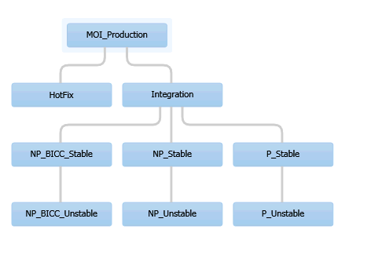
- Production Branch
  - Hotfix Branch [child branch of Production Branch]
  - Integration Branch [child branch of Production Branch]
    - NonProgram BICC Stable Branch [child branch of Integration Branch]
      - NonProgram BICC Unstable Branch [child branch of NonProgram BICC Stable Branch]
    - NonProgram Stable Branch [child branch of Integration Branch]
      - NonProgram Unstable Branch [child branch of NonProgram Stable Branch]
    - Program Stable Branch [child branch of Integration Branch]
      - Program Unstable Branch [child branch of Program Stable Branch]

Definitions:
Unstable Branch: Used by scrums [specific per each release, i.e. IDW, BAU, BICC, Program], all developers and testers. This is the place to store the source code and test files for all developers and testers. Users will get latest to start working on a project, modify the source code, and write the tests and check in the changes to this unstable branch.
Stable Branch: Depending on the decision* the code will be merged into Stable branch from Unstable branch and deployed to Stable Environment. This is for Scrum testers and other testers
Integration Branch: In TFS merges happen between the branches having child-parent relationship. To be able to merge NonProgram and Program [stable] branches to each other, we need a parent other than production branch. As the production branch can only reflect the live code.

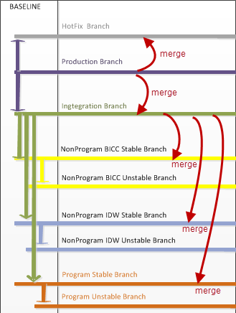
Workspace: For each branch, we need a local folder storing source files which will be a reflection of TFS Server source files. This is your own working copy, so you can work with the files as much as you like.
Check-in: When your modifications/development is ready, your unit tests are green; you can check-in your local files into common repository, i.e. your unstable branch.
Check-out: When you want to modify a file from the TFS Server, you need to tell the server by right-click, check-out.
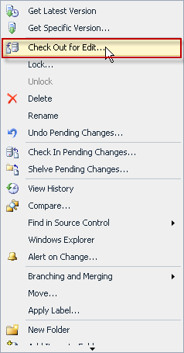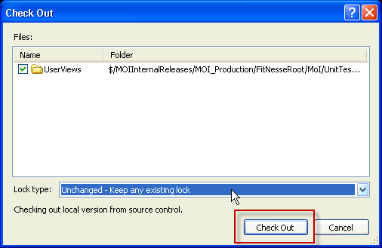
The next window will ask for Lock type, don’t change the default lock type, which is “Unchanged – Keep any existing lock”, and then click Check Out.
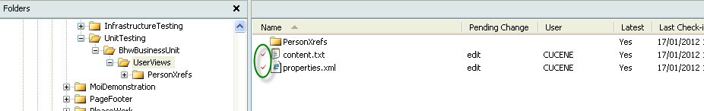
As shown with the green circle, it will place red tick to each file checked-out. By default TFS source repository is read-only, so every check out makes file write-able, ready for modifications.

Test Environments
There will be 10 environments.
- Hotfix Team:
  - Hotfix Environment:
Full size production environment to implement only hot fixes checked into Hot Fix branch.
- IDW Team:
  - IDW Unstable Environment
  - IDW Stable Environment
  - IDW UAT Environment
- BICC Team:
  - BICC Unstable Environment
  - BICC Stable Environment
Please note that there is no existing UAT Environment for BICC.
- Program Team:
  - Program Unstable Environment
  - Program Stable Environment
  - Program UAT Environment

Local Setup
You need to have TFS Team Explorer Shell Client installed on your PC. Please refer to Appendix AAppendix AAppendix AAppendix AAppendix A.
\\vmstamoibld01\Setup
Then, you can run SetupMyLocalWorkspace.bat in this folder.
This will set up 5 workspaces, 5 local folders, and map them as follows:
TFS Server Url | WorkSpace Name | Local Folder
$/MOIInternalReleases/MOI_Production | computerName_Prod | C:\MOI\Production
$/MOIInternalReleases/Configuration | ? | C:\MOI\Configuration
$/MOIInternalReleases/NP_Unstable | computerName_IDW | C:\MOI\IDW
$/MOIInternalReleases/NP_BICC_Unstable | computerName_BICC | C:\MOI\BICC
$/MOIInternalReleases/P_Unstable | computerName_Program | C:\MOI\Program

Check-in Check-out

Merging

Deployments

Release Planning

Appendix A: TFS Team Explorer 2010 Installation
A. Requirements:
- Administrative privileges to install programs.
If you don’t have rights for installation, call service desk to have TFS 2010 Client Shell to be installed
- Space: 2 GB space on C drive
- Memory: Minimum 1 GB RAM
- OS: Windows XP/2003
- Windows Imaging Components [Step 2 explains how to]
- Will need a restart during installation
B. Installation:
- Run setup.exe on \\vmstamoibld01\TeamExplorer2010\ . This is the TFS Shell Client which will be enough to check-out, check-in and display TFS Work Items.
- If you don’t have Windows Imaging Component, it will display error message [Figure1]
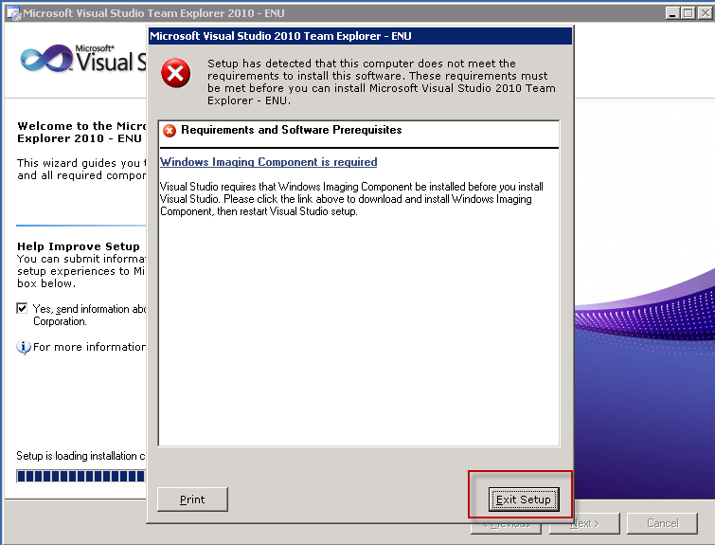
Figure 1: WIC is missing
  - Click Exit Setup
  - Run wic_x86_enu.exe from : \\vmstamoibld01\Setup\WIC
  - Click I Agree, and then Next. [Figure 2]
  - Click Finish.
  - Re-run Setup.exe from \\vmstamoibld01\TeamExplorer2010

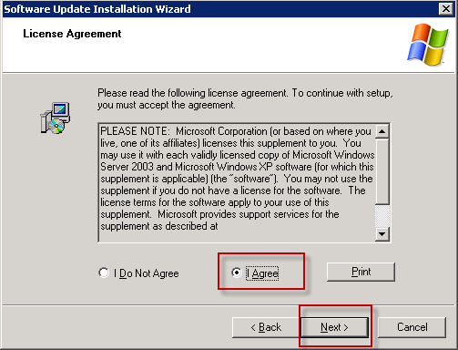
Figure 2: Licence Agreement

- Click Next on initial set up screen [Figure 3]
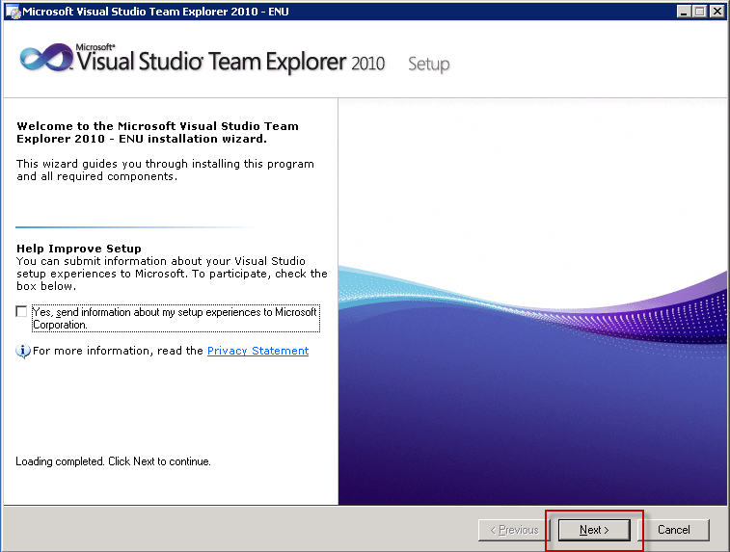
Figure 3: Initial Setup
- On the licence terms page, select Accept option and click Next. [Figure 4]
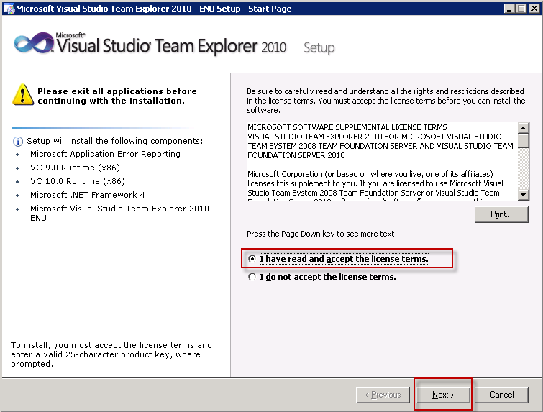
Figure 4: Licence Terms
- On the Setup Screen, Select Install, DO NOT CHANGE THE DRIVE C [Figure 5]
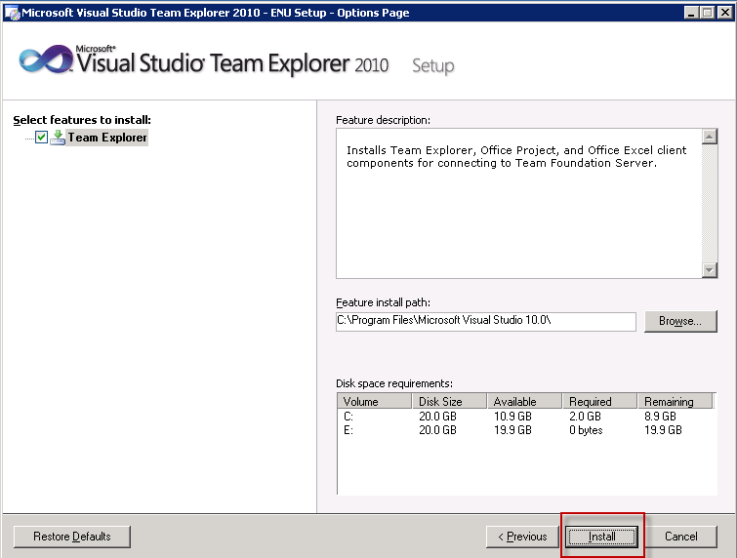
Figure 5: Setup Screen

- After .NET Framework 4 is installed, you need to restart your PC. [Figure 6]
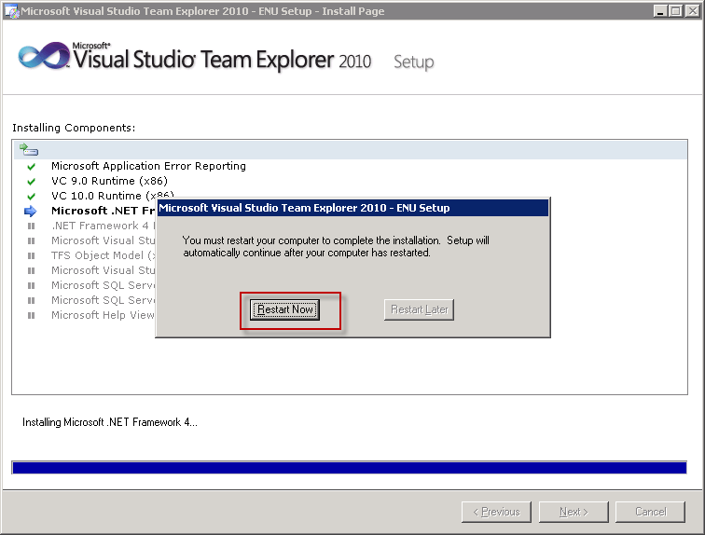
Figure 6: Restart Request
- It will continue to installing components
- When the Finish screen appears, click Finish. [Figure 7]
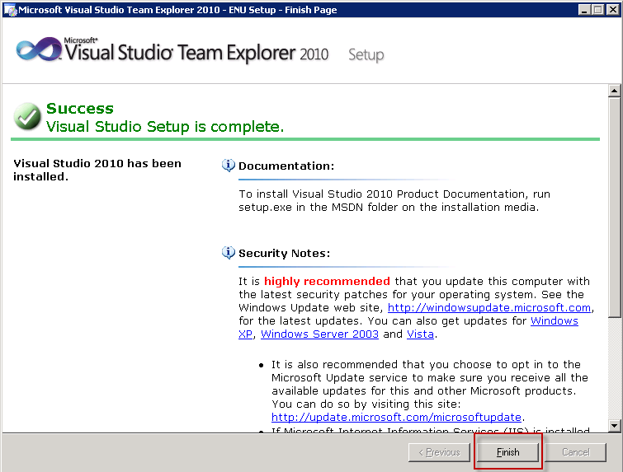
Figure 7: Completion Screen

Appendix B: Teradata Fastload Installation
Map a network drive to:

\\stafs04\oneplandev2

Navigate to the folder

<mapped drive>\MOI\Software\Teradata\Teradata\V13.10.02\TTU131002_LOADUNLD_V1\Windows

Run “ttu.exe”.

Select “fastload” (it will also select pre-requisites) then install it to the default path.

