Câu 1:

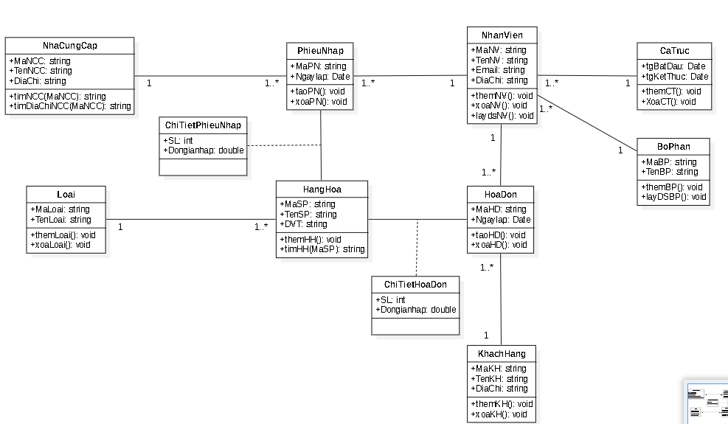

Sơ đồ luận lý:

* NhaCungCap(**MaNCC**,TenNCC,DiaChi)
* Loai(**MaLoai**,TenLoai)
* HangHoa(**MaSP**,TenSP,DVT*,MaLoai*)
* BoPhan(**MaBP**,TenBP)
* CaTruc(**tgBatDau,tgKetThuc**)
* NhanVien(**MaNV**,TenNV,Email,DiaChi,*MaBP,tgBatDau,tgKetThuc*)
* KhachHang(**MaKH**,TenKH,DiaChi)
* PhieuNhap(**MaPN**,Ngaylap*,MaNCC,MaNV*)
* ChiTietPhieuNhap(***MaPN,MaHH,***SL,Dongiannhap)
* HoaDon(**MaHD**,Ngaylap*,MaNV,MaKH*)
* ChiTietHoaDon(***MaSP,MaHD,***SL,Dongianhap)

Câu 2:

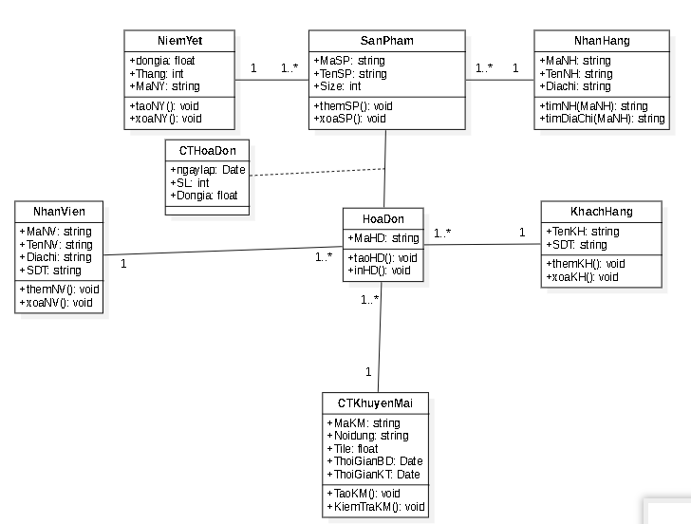

Sơ đồ luận lý:

* NhanVien(**MaNV**,TenNV,DiaChi,SDT)
* KhachHang(**TenKH,SDT**)
* NhanHang(**MaNH**,TenNH,Diachi)
* NiemYet(**MaNY**,Dongia,Thang)
* CTKhuyenMai(**MaKM,**Noidung,Tile,ThoiGianBD,ThoiGianKT)
* SanPham(**MaSP,**TenSP,Size,*MaNY,MaNH*)
* HoaDon(**MaHD,***MaNV,MaKM,TenKH,SDT*)
* CTHoaDon(**MaHD,MaSP**,ngaylap,SL,Dongia)

Câu 3:

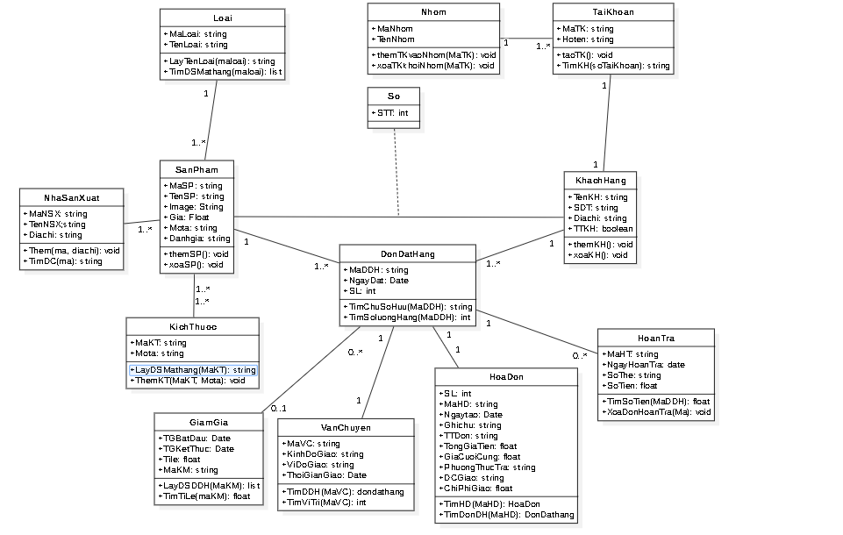

Sơ đồ luận lý:

* NhaSanXuat(**MaNSX,**TenNSX**,**Diachi)
* Loaihang(**MaLoai,**TenLoai)
* MatHang(**MaSP,**TenSP,Image,Gia,Mota,Danhgia,*MaNSX,MaLoai*)
* GiamGia(**TGBatDau,TGKetThuc**,Tile)
* VanChuyen(**MaVC**,KinhDoGiao,ViDoGiao,ThoiGianGiao)
* Nhom(**MaNhom**,TenNhom)
* KhachHang(**TenKH,SDT**, DiaChi,TTKH,*MaNhom*)
* So(**STT**)
* HoaDon(**MaHD**,Ngaytao,Ghichu,TTDon,TongGiaTien,GiaCuoiCung,PhuongThucTra,DCGiao,ChiPhiGiao,*TenKH,SDT,TGBatDau,TGKetThuc,MaVC*)

Ràng buộc tham chiếu:

* SanPham(*MaNSX,MaLoai*) 🡪 NhaSanXuat(**MaNSX**), Loai(**MaLoai**)
* KhachHang(*MaNhom*) 🡪 Nhom(**MaNhom)**
* HoaDon(*TenKH,SDT,TGBatDau,TGKetThuc,MaVC*) 🡪KhachHang(**TenKH,SDT),** GiamGia(**TGBatDau,TGKetThuc**), VanChuyen(**MaVC)**
* CTHoaDon(*MaSP,MaHD*) 🡪 SanPham(**MaSP),** HoaDon(**MaHD)**