ZONAL APP DEVELOPMENT DOCUMENT

1. Component requirement
2. Virtual environment development (SiL)
3. Real hardware deployment (HiL)
3.1. Connect zonal ECU to Airbag ECU via USB-CAN-FD-B device

Connection diagram
CAN Loopback test connection
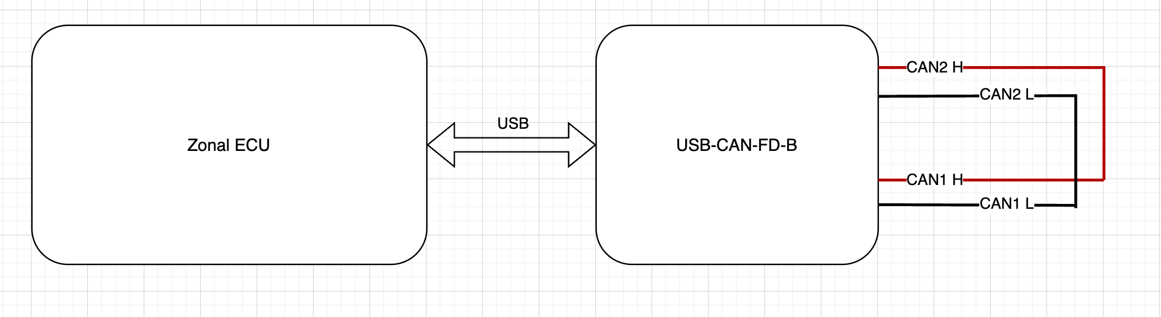

Airbag ECU connection

