The Academic Interaction

Web development - Part 2

12/7/2014

DT0249/3 2014/2015

Pedro Mauricio Tavares

D12123176

Table of Contents

INTRODUCTION 4

The Web Site 4

About the website 4

Tools Used 4

THE WEB SITE ESTRUCTURE 4

THE DATABASE 4

Articles: 4

Articles_likes: 4

Article_comments: 5

Videos: 5

Category: 5

Status: 5

Users: 5

Group_users: 5

THE USERS HIERARCHY 5

THE PHP FILES 5

Index.php: 5

About_us.php: 5

Articles.php 5

Media_list.php: 5

Contact.php: 5

Search_articles.php 5

Article.php: 5

Register.php: 6

Register_ex.php: 6

Activation.php: 6

Add_articles.php: 6

Add_videos.php: 6

Edit_profile.php: 6

Update_videos.php 6

Update_video_page.php 6

Reports.php: 6

Forgot_password.php: 6

Logout.php: 6

Errormsg.php: 6

FOLDERS 6

ADMIN: 6

IMAGES: 6

INCLUDES: 6

CSS: 6

FUNCTIONS: 7

JS: 7

THE ADMIN PHP FOLDER AND FILES 7

OVERVIEW: 7

THE PHP FILES: 7

THE FOLDERS: 7

HOW TO USE THE WEBSITE 8

As a Non-Registered User 8

Email Activation: 9

Login: 9

Forgot Password 10

Session Expires 10

Articles Features 10

Users Menu 11

ADMINISTRATION 13

OVERVIEW 13

ADMINISTRATION MENU 13

REFERENCES: 13

# INTRODUCTION

## The Web Site

### About the website

This website is what we call a web interaction website. It has the purpose to display the users articles and videos, keeping the others users as well as non-users updated about the contents related on the application.

Any non-user will be entitle to register on the website in order publish his(her) article. The registration process is very simple. The user just has to register on the registration page. After that, the user will receive an confirmation email at which will be used to activate his(her) account. When the user activate its account, he(she) can log in and add articles, add videos, update its profile, update added articles or videos etc.

### Tools Used

This web site was created using just the notepad++ as the main tool to create the HTML Tags. No type of Content Management System was required to develop it.   
 All the style is in plain CSS. JavaScript is the client side language used in order to validate some the forms the users will be using in order to edit or add contents. Some Jquery libraries was also used to give some nice effects on the main Page. I also used AJAX in some parts of the website. To Change the user password and for registering are two examples of the AJAX usage.   
PHP is the language to make the website a 3 tier architecture and make the connection as well as all the queries to the database, which was developed using the PHPMYADMIN tool.  
This website is only for academic purpose, therefore has no means of profit. However, no part of this publication may be reproduced, distributed, or transmitted in any form or by any means, including photocopying, recording, or other electronic or mechanical methods, without the prior written permission of the publisher, except in the case of brief quotations embodied in critical reviews and certain other non-commercial uses permitted by copyright law.

# THE WEB SITE ESTRUCTURE

## THE DATABASE

As the database structure and design is not the focus of this documentation, we assumed that is not worth go into details about it, however, is worth showing a general overview of the tables used on this project.

The database is called Academyint. It consist of 8 tables:

Articles: The table with all the information about every single article posted by the registered users.

Articles_likes: The table which will register if a certain user like determined article or not.

Article_comments: This table will hold all the comments made by the users towards some articles.

Videos: Alike the articles table, the videos table will have all the information about the videos posted by the users.

Category: Here will be all the category that will classify the articles or videos.

Status: Here is that will “give life” to the article. Every single article will be in a certain status, which can be changed when the time goes by. “ready”, “waiting” and “blocked” are some examples of the possible articles status.

Users: This table will have the information about the registered users. This will be mainly used by the administration.

Group_users: Here will be the table that will control the hierarchy of the users. Admin, super_user and user are some examples of the user hierarchy.

## THE USERS HIERARCHY

In order to keep control of the articles and users, not all users will be capable to do “everything” on the website. Some users will be restrict just to add and edit articles, other users can add and update users. The data to keep the control of “who can do what” will come from the table Group_users. Basically, this control is classified as follows:

Admin: Can ADD, EDIT, UPDATE and DELETE articles, videos and any user;

Super User: Can ADD, EDIT, UPDATE and DELETE articles, videos and any user except the Admin;

User: Can ADD and EDIT articles and UPDATE his own information.

## THE PHP FILES

Index.php: The index file contains the main slide images show, the latest articles added by the users, the main 3 featured articles and all the links available to navigate on the website.

About_us.php: This is a static page that contains the necessary information about the business and its goals. This page also shows the team and some comments from users.

Articles.php: This page shows a list of the latest articles added. An option for searching articles by title or content is available on the right top side of the page.

Media_list.php: This is a page that hold links to some the videos that the users add on the website.

Contact.php: Where all the information of how the contact the business all the site administrator is.

Search_articles.php: This file is the one responsible to handle the query that is done when the search option on the right top of the page Articles.php is launched, displaying all the articles from the database. The articles have links to display their detail, which brings the user to article.php page.

Article.php: This file display one single article in detail from the search_articles.php file. The data passed in order to get the article data comes from a GET request.

Register.php: This file is responsible to gather the information of the user when on the registration process and send to the page Register_ex.php.

Register_ex.php: Get all the the data sent by the Register.php and process the php queries in order to register the user. The php code for registering is based in this file. After registering, the user still has to be activate in order to make login etc.

Activation.php: This file is responsible to activate the user when he clicks on the link that is sent to his email after successfully registered. After doing this, the user is able to login, edit his profile, add articles etc.

Add_articles.php: This page get the information given by the user about any article he wants to add and then, send the data to the add_article_ex.php page to handle the PHP queries to insert articles in the database.

Add_videos.php: This page get the information given by the user about any video he wants to add and then, send the data to the add_video_ex.php page to handle the PHP queries to insert video in the database.

Edit_profile.php: If the user wants to edit his profile, this article gets all his information and send to update_ex.php file, where the PHP queries are processed to make updates.

Update_videos.php and Update_articles.php: This two pages list all the videos and articles, respectively, that the user can select one he intends to update. When the article (or video) is selected, the data about it is sent to update_video_page.php or update_article_page.php in order to the user makes the changes.

Update_video_page.php and Update_article_page.php: These two pages do similar as the edit_profile.php page. Both gather data from the user in order to update his video and articles pages respectively, and send the data to update_ex.php file, to process the queries.

Reports.php: This page consist of the php code that handles the requests in order to process AJAX code.

Forgot_password.php: This page automaticly generates a new password and send to the user email when requested. The user can change the password later in the edit_profile.php page.

Logout.php: Self Explanatory. This page destroy the sessions and log out the user.

Errormsg.php: This page display errors messages and gives the user some information of what has happened. More errors message can be placed there or edit by the developer.

## FOLDERS

ADMIN: The administration page of the site.

IMAGES: This folder contains all the images shown on the main website. Users images, articles, videos etc, all of them, separated by other subfolders.

INCLUDES: This folder contains the PHP files that are used to be included in other pages in order to avoid repetition, for instance, site_header.php for the Header, site_footer.php for the Footer etc.

CSS: The main style file for the site.

FUNCTIONS: PHP useful functions to handle information and request are in this folder. The main file to connect to the database is in there as well.

JS: All the JavaScript form handle, AJAX, JQuery slides etc. are in here.

## THE ADMIN PHP FOLDER AND FILES

### OVERVIEW:

This folder is accessible only by the administrator of the system, no others users are capable to execute or access any files in this folder.   
In there, we have other sub-folders with other PHP files.

### THE PHP FILES:

Each PHP file from the ADMIN folder has an specific job. Everything the administrator is able to do is handle by those files. As follow is some examples:   
Edit, Add and Delete users;  
Edit, Add and Delete articles;  
Edit, Add and Delete videos;

These PHP files are modelled on Object Oriented style.

### THE FOLDERS:

Images: This folder contains the images from the admin page.

Js: This folder contains any JavaScript or Ajax code for the administration page.

Libs: This folder contains all the PHP classes used on the admin part of the website.

CSS: The CSS style for the administration page.

Includes: The PHP files that need to be included on the other files in order to execute some operations correctly. The header, footer and Connect are some examples.  
  
THE HTACCESS FILE

Both the main and the admin folder have this file. For the moment this file has only use for two things, however, i could have implement more:  
1 – Index ignore: To prevent any directory to listen the files.   
2 – Establish a custom 404 file for not found pages.

# HOW TO USE THE WEBSITE

## As a Non-Registered User

As a non-registered user is able to navigate, read the articles, check the videos, search for articles etc on the website without restrictions. However, this user is not able add articles, add videos, like other users articles, update his profile etc. For being allowed to do so, he has to be registered.

Another thing the non-registered can do is sending information through the contact form on the Contact pages:  
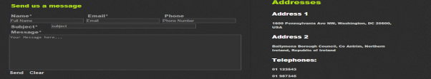  
Registering on the website

In order to register on the website and enjoy all the services it provides, the non-registered has to register. This is achieved in two ways:  
1 – At right top of the page, when clicking on the logging button, an option to register will appear.  
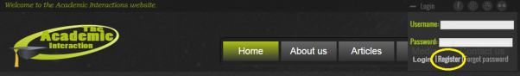

2 – Or on the Vertical Menu at footer of the page, on the link “Register”:  
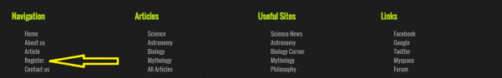

In both ways, the register page will show up and then, the user can start registering:  
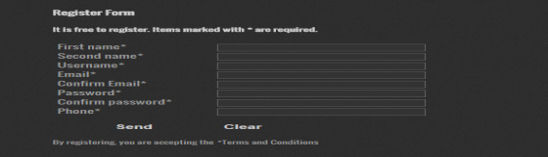

**NOTE**: Some user are already registered. You can log in using the following:  
**User: admin – Password: pedro – Group: Administrator;  
User: pedro – Password: pedro – Group: user;  
User: tavares – Password: tavares – Group: user.**

When the user tries to do something against the form police, some JavaScript code is launched in order to validate the data on the client side. Some fields cannot be left blank or the password and confirmation must match, for instance.

This form also consist of some **AJAX** code. For instance, when the user type the username he wants, the AJAX checks automatically if the username is already taken or not. The same thing happens on the email field.

**TRY:** Try to enter an existing user or email. The username “pedro” or the email “pedro@dit.ie” is already taken. A message will appear besides these two fields. This is part of the AJAX code.  
You can also try to put the email and confirmation email different as well as the password and its confirmation. This features are part o the JavaScript code.

If everything goes ok, the code on the server side (PHP) will also validate the fields and make sure the user fulfilled the requirements to register. The validation in PHP is to make sure some malicious users will not deactivate their JavaScript.

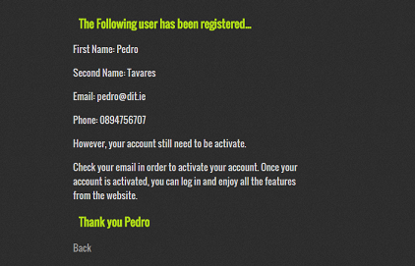

### Email Activation:

After successfully been registered, an email is sent to the user in order to activate his account.

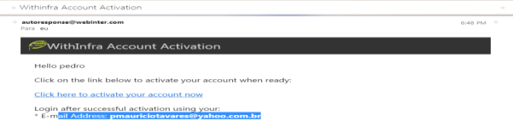  
When the user click on the link (on blue), his account is activated, therefore, he can starting adding, commenting, rating articles and videos as well as updating his profile.

**NOTE:** This Feature does not work on localhost, just online. For this project, this feature were tested on a real web hosting. Check: www.withinfra.com/dt249. to see this feature.

### Login:

After activating the account, the user is allowed to log in. On the top of every page, besides the social links, the link to make to log in is available:  


Just click on the link and the menu will slide down:

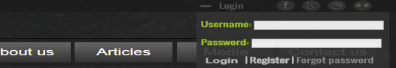

The user can input his username and password and then click on the login button.

### Forgot Password

If the user forgot his password, he can recovery it by clicking on the button “Forgot password ” that is based beside the login and Register button on the right top corner (See image above). By doing so, a new password will be send to his registered email. This Password can be changed later by the user on his profile page.

**NOTE:** This Feature does not work on localhost, just online. For this project, this feature were tested on a real web hosting. Check: www.withinfra.com/dt249. to see this feature.

### Session Expires

After being logged in, the user will have just a certain amount of time to do his job. A function that expires the session after 60 min was implemented. See the **util.php** file in the **functions** folder.

### Articles Features

Once the user is logged in, he is able to like and comment any article of the web site.

**Like:** In order to like an article, the user just need to click on the image besides the views number on the top of the selected article.

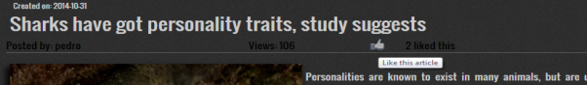

**Comment:** In order to comment an article, the user just need to use the fields below the article. If the user is not logged in, this option is not available.

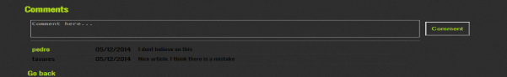

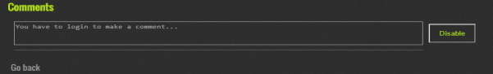

Implementation: The part of the comments were implemented using **AJAX** code as well. The user can make a comment and the comment will appear without refreshing the page. The code to change the password as well.

### Users Menu

Once logged in, a new menu will be available for the user.

**TRY**: Log in, click on the Articles Menu, see the new Menu.



Every single user’s menu is self explanatory. Add new article, Edit existing articles, Add new video, edit existing videos and update profile. The screen are as follows:

**Add new Article:**

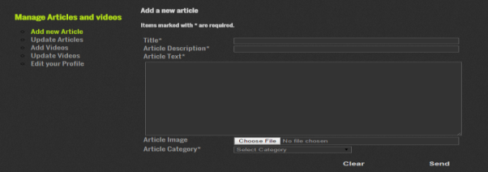

**Update Articles:**

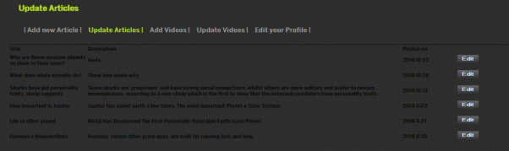

**Add Videos:**

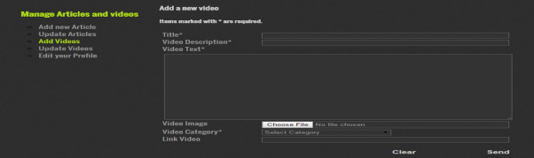

**Update Videos:**

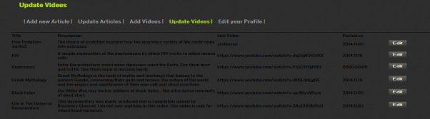

**Edit Profile**

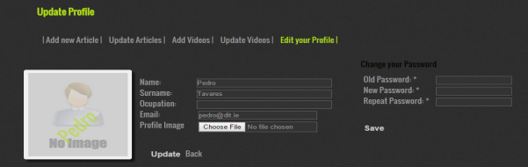

## ADMINISTRATION

### OVERVIEW

The administration part of the website is straightforward and self explanatory. In there, the administrator is capable to manage all the Articles, Videos and Users.

In order to have access to this part of the website, you must be loggedin and have administration permission, otherwise, you will not be able to access.

**TRY:** To access this part of the site, just type “/admin” at end of the address in the URL. The URL would be: “Localhost/webapp/admin”. If you are logged in as an administrator, you will be able to use this part, otherwise, you will be redirect to the main page of the application, even though you are loggedin as a normal user.

### ADMINISTRATION MENU

Follow is a screen shot of the administration menu:

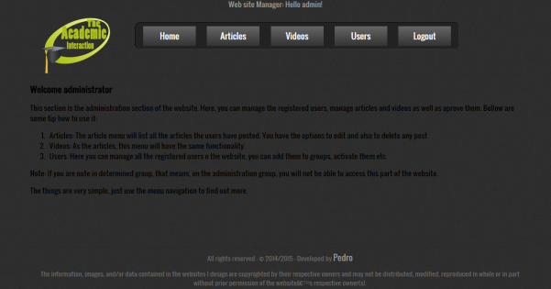

As said before, this part of the website is self explanatory. The menu articles bring the administrator to manage the articles added by all the users, as well as the videos menu. The users menu bring you to manage all the users (activated or not) of the system.

## REFERENCES:

Ullman, Larry. PHP 6 and MYSQL 5 for dynamic websites. Peachpit Press, 2008.  
Powers, David. PHP Solutions, dynamic website made easy. Apress, 2010.  
Nixon, Robin. PHP, MYSQL, JavaScript and CSS. 2rd ed. O’Reilly. 2012.  
Easttom, Chuch. Advanced JavaScript. 3rd ed. Wordware Publishing Inc, 2008.   
Zakas, Nicolas. Professional Java Script for webdevelopers. 3rd ed. Wrox, 2011.  
Crane, Dave. Ajax in action. 2rd ed. Manning, 2007;