Designing a 2D truss structure and evaluating it using finite element methods

Mubeen Padaniya (215480536)

Subject: ESSE 4370 Introduction to FEM Methods

Department of Earth and Space Science and Engineering

Lassonde School of Engineering, York University, Toronto, CA

*(Submitted 4th April 2020)*

Code and .cae files available at GitHub: <https://github.com/pmubeen/ESSE4370CP.git>

# Abstract

This report describes using finite element method to evaluate truss structures for a 2D planar loading problem with a restricted design space and material choices. The problem design space is 3x3 m, material choices are steel and aluminum and three downward loading force vectors of each are specified. These force vectors are equally spaced at , and coordinates and as assumed as concentrated forces. Three truss-structure prototypes are developed with different geometries. Prototype 1 uses steel whereas the other two use aluminum. FEA software ABAQUS and self-developed MATLAB programs are used to produce the nodal displacements, stresses and reaction forces. The results are visualized in the form of contour plots and plots of deformed/undeformed shapes. The MATLAB code failed to accurately calculate the forces and stresses, but nodal displacement values had small error compared to the ABAQUS calculations. Prototype 2 is chosen as the best truss structure for the problem due to its good performance and design goal of mass efficiency.

# 1. Introduction

## 1.1 Finite Element Method

Finite element method (FEM) or sometimes known as finite element analysis (FEA) is a process that is used to solve boundary value problems in engineering. This is a mathematical problem where in one or more dependent variables have to satisfy the boundary conditions specified. Sometimes in these problems, due to complexity, it is difficult to obtain a closed-algebraic expression, the desired solution. FEA is used to utilize computational and numerical techniques for these problems. The process can be broken down in the following steps:

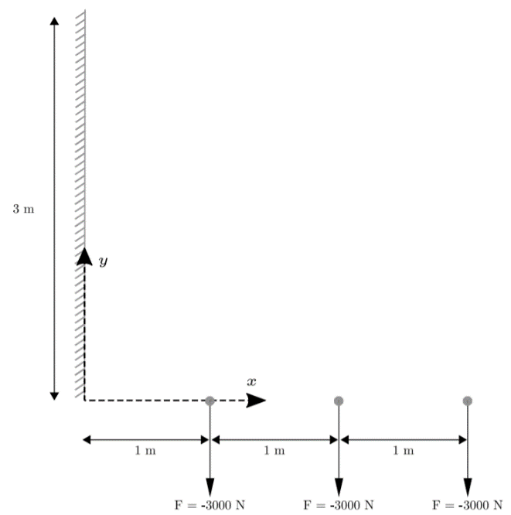

**Figure 1:** The loading and design envelope provided by the problem.

**1. Discretizing the continuum:** The problem is divided into a set of elements that can be described using simplified geometries (triangles, rectangles and quadrilaterals)

**2. Deriving element equations:** Each element’s response is described using an equation that assures that: i. assumed displacement within each element is dependent upon nodal value; ii. equilibrium and compatibility are enforced within each element using the assumed displacement to derive element equation; iii. equivalent nodal loads are established using principle of virtual work.

**3. Assembling the element equations:** All the element equations are assembled to obtain the equilibrium equations to the entire problem.

**4. Applying the boundary conditions:** Using the boundary conditions, the equilibrium equations can be reduced.

**5. Solving the equilibrium equations:** The reduced system of equations can be used systematically to obtain the solution for nodal displacements and reactionary forces

**6.**  **Calculate stresses and strains:** Using the forces and displacements found, material properties, the elemental stress and strains can be found.

**7. Post processing:** Presenting the stresses and strains calculated in meaningful to manner to determine the mechanical performance of the material under loading.

## 1.2 Problem Description

The problem provided is the to design a structure that can bear the loads shown in Figure 1.

**Assumptions being made:**



**Table 1:** Material properties for steel and aluminium (as provided)

1. 2D solution: No stresses, strains, and forces in , planes.

**Figure 2:** Drawings of prototypes 1, 2 and 3 respectively.

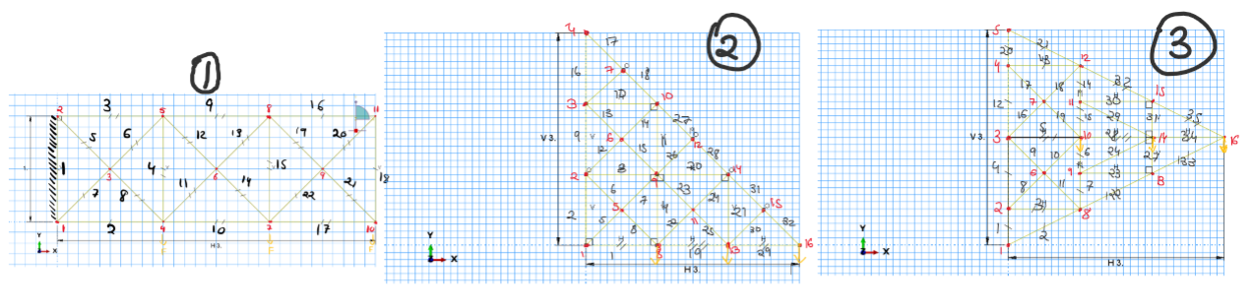

2. Discretized loading: Loading forces defined at the nodes only. That is no uniform loading.

3. Three active degrees of freedom for all the nodes: U1 – displacement in x direction, U2 – displacement in y direction and UR-3 – rotation about z direction.

**Design Requirements:**

1. Same material to be used for all the elements, i.e. same Young’s modulus and Poisson ratio .

2. Same beam to be used for all the elements, i.e. same beam type and cross-sectional area .

3. Material chosen can either be aluminum or steel with the properties described in Table 1.

4. Structure should lie within the described design space: the m enclosure.

**Design goal:**

Provide the most mass efficient structure that can withstand the loading.

## 1.3 Prototypes developed

Based the on the problem described, three prototypes were designed. All the designs will use an Euler-Bernoulli beam with square crossection.

### 1.3.1 Basic Criss-Cross Truss

The first design as shown in Figure 2, are three simple boxed sections that each have cross-connections. The element 1 will be fixed in all three degrees of freedom. The material used is steel and a beam with the cross-sectional area . This gives us a total mass of

### 1.3.2 Angled Truss

The second design shown in Figure 2, is made of right angled triangle, with the opposite and adjacent sides trisected. The nodes are connected through the cross-connections shaped in similar box sections. The elements 1-4 are fixed in all three degrees of freedom. This design utilizes aluminum beams that have a cross-sectional area . This gives us a total mass of

### 1.3.3 Double Angled Truss

The third design shown in Figure 2 utilizes two right angle triangles mirrored along . These right angles are trisected on the hypotenuse and adjacent sides. The nodes are connected using cross connections. The elements 1-5 are fixed in all three degrees of freedom. This design utilizes aluminum beams that have a cross-sectional area . This gives us a total mass of



**Table 2:** The Von Mises stress and reaction forces calculated for each prototype (ABAQUS)

# 2. Methods

Two methods are used to perform FEA, the software Abaqus and programming in MATLAB.

## 2.1 Abaqus

Abaqus is a finite element analysis software that is used for engineering problems like structural analysis, failure analysis and non-linear analysis.

There are different modules that helped with preprocessing steps. Using the part module, the sketch and geometric model of the structure is realized. In the property module, the material and beam properties are defined and assigned to the structure. The assembly module is used to combine different parts into an assembly. The step module creates steps to signify different environments for the structure. Interaction module is used to create interactions between the parts, however this will not be used. The loads and boundary conditions are applied using the load module. Finally the part is meshed using the mesh module and a job is instantiated using the job module. The job is submitted as input file. The results are visualized in the visualization module. This is where the post-processing will be done.

## 2.2 MATLAB

Using MATLAB to compute large matrix calculations, the stresses, displacements and reaction forces for each prototype is found. The code implemented for each prototype takes in the given values of material (Young’s Modulus, Poisson ratio), geometry of the structure to determine the elemental equations. These equations are assembled in to a global system of equations for each node. By applying the boundary conditions this system of equations can be reduced and solved for nodal displacements and reaction forces. These forces and displacements are used to calculated the element stress and strain.



**Table 3:** Displacement calculated at each node for each prototype. (ABAQUS)

# 3. Results

Using Abaqus and MATLAB, the stresses and displacements are found. In post-processing, deformed shapes and contours of the prototypes are plotted for displacement and Von Mises stress. The maximum and minimum displacement, reaction forces and stress is also extracted.

## 3.1 Abaqus

For each of the plots and calculations, averaged element values are used to interpolate the discretized nodal values.

### 3.1.1 Stress contour plot on the deformed shape

The Von Mises stresses faced by each prototype is displayed as contour plot on the deformed shape, seen in Figure 3.

### 3.1.2 Displacement contour plot on the deformed shape.

The nodal displacement undergone by each prototype is displayed as contour plot on the deformed shape. seen in Figure 3.

### 3.1.3 Table of Reaction forces, Stress and Displacement

The max and min stress and the applicable reaction force components are displayed in Table 2. The nodal, max and min displacements for each prototype is shown in Table 3.

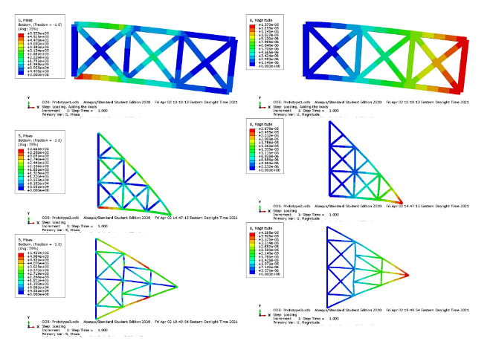

**Figure 3** Contour plots of Von Mises stress and the displacement for all three prototypes (ABAQUS)

## 3.2 MATLAB

Unlike Abaqus, the MATLAB results are discretized based on the nodal values.

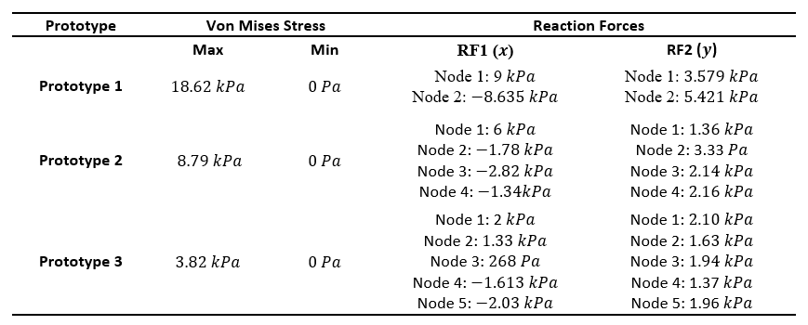

**Table 4:** Von Mises Stresses and Reaction Forces (MATLAB)

### 3.1.1 Deformed and Undeformed shape

The original shape with all the elements and deformed shape using calculated deformed node and scaled by a factor, are superimposed on the same plot. Seen in Figure 4. The color gradient from red to pink signifies the magnitude of the nodal displacement.

### 3.2.2 Table of Reaction forces, Stress and Displacement

The max and min stress and the applicable reaction force components are displayed in Table 4. The nodal, max and min displacements for each prototype is shown in Table 5.

# 4. Discussion

## 4.1 Comparison of MATLAB and Abaqus

Both MATLAB and Abaqus show intuitively satisfying results. There are no observed concerning abnormalities that might point a glaring error in calculation. Even the global stiffness matrix assembled by MATLAB adhered to the symmetry requirement for a good solution. This is a qualitative assessment, but the quantitatively there are significant variations in both calculations.

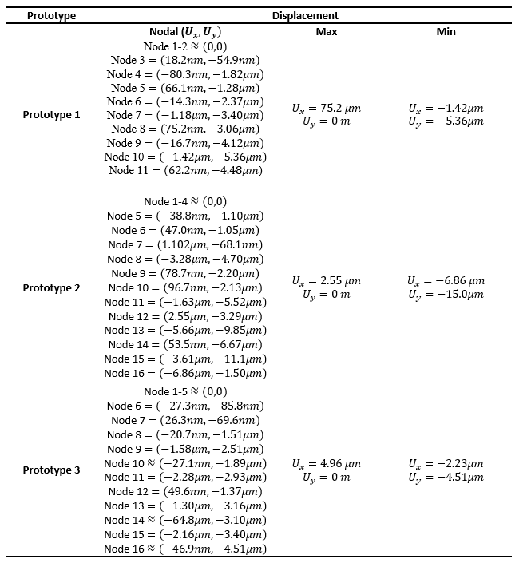

**Table 5:** Nodal displacements for each prototype (MATLAB)

### 4.1.1 Contour shapes

As seen in Figure 3 and Figure 4, the deformed shapes seem pretty similar. However the biases of the scales chosen will might play a role here.

### 4.1.2 Displacement, Stress and Reaction forces

To see the difference between values calculated by the MATLAB code and Abaqus, the values of prototype 1’s displacement is used to compute the error between the two sets.

As you can see in Figure 6 the average error of the nodal displacement is relatively small as compared to the error in reaction forces, since it is scaled by the large young’s modulus values. The Von Mises stresses calculated by MATLAB and Abaqus are absurdly different for all three prototypes, with an average error exceeding .

## 4.2 Performance of each prototype

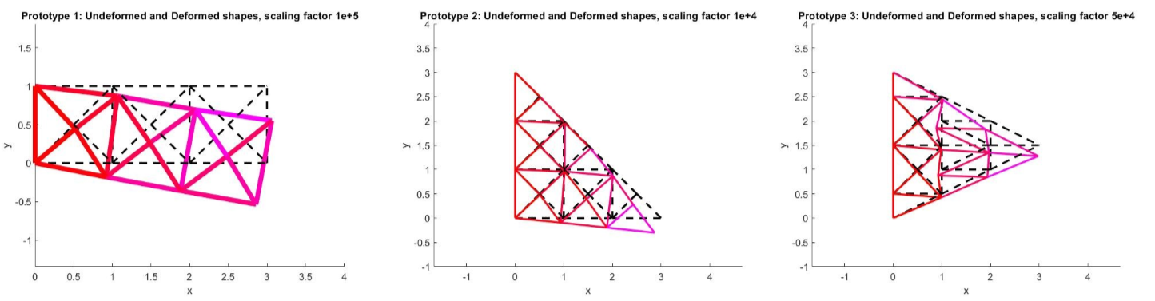

**Figure 4:** Deformed and Undeformed shape for each prototype (MATLAB)

### 4.2.1 Maximum and Minimum stress

Since the Maximum and Minimum stress calculated by MATLAB is too low, only the Abaqus’s results are used for performance assessment. Accordingly, both steel-based prototype 1 and aluminum based prototype 3 has a maximum stress of over , the latter being the worst of the two. Prototype 2 performs better than both, with about 25-30% less maximum stress. This obviously shows that prototype 2 would be the least likely for mechanical failure or plastic deformation.

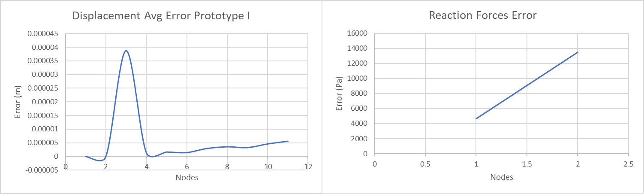

**Figure 5:** Error in ABAQUS and MATLAB calculations for prototype 1

### 4.2.2 Nodal Displacement

If a rigid structure is required, nodal displacement becomes a judge of this. And accordingly, the prototype with the least , i.e. seems to be the winner in this category. But it is also noted that the higher importance is the contour plot of the nodal displacement which allows us to see a structure level view of the deformation.

Since there is significant difference between the MATLAB and Abaqus, albeit not irrational, results of both will be included. Firstly, using values outputted Abaqus, prototype 3 has the highest between min and max displacements values of , followed by prototype 2 at and third by prototype 1 at . Based on the Abaqus’s results, prototype 1 seems to the be forefront in this assessment.

But the results based on the MATLAB calculations draw a different conclusion. Here prototype one seems to be the worst performer at of , followed by a distant second with prototype 2 at . The close third is prototype 3 at . Based on MATLAB the front-runner is prototype 3.

# 5. Conclusion

Considering all the aspects of this study, prototype 2 seems to be the best performer of the all three for this given problem. It has the least maximum stress, in both sets it was a relatively rigid structure with reasonable deformation. Although it is not as mass efficient as prototype 3 but it is reasonably better when compared to prototype 1.

# 6. Suggestions for Improvement

When compared quantitatively, it seems that the MATLAB code results were significantly off than analysis done using Abaqus. As the latter is much more resilient and trusted, it is easily determined that there are some calculation errors, lower amount of nodes or difference of algorithm that would make the code unreliable. To increase its reliability, the algorithm behind Abaqus is to be understood and a better translation of the FE method into linear algebra calculations, that are easier to implement in MATLAB, would be right way to improve the quality of this study.