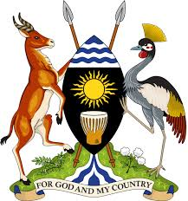

**HIGHER EDUCATION SCIENCE AND TECHNOLOGY**

**Internship Logbook**

Student Name: **MULINDWA PETER**

Month: September

|  |  |  |  |
| --- | --- | --- | --- |
| Target | Achievements | Challenges | Lessons Learnt |
| **Week I**   * Discover and Document findings i.e. weaknesses and strength of the current HEST web-system. * Creating a frame work/plan for the Abercom (U) Technologies website. |  |  |  |
| **Week II**   * Design the framework of HEST web system. * Design the Abercom logo. * Design of the Abercom website. * Make a research on various companies ICT usage and dependence in relation to business profitability. |  |  |  |
| **Week III**   * Design the back end of the UMA HEST web system. * Find and Document information on Rena Beverages Company. * Design the Rena Beverages website |  |  |  |
| **Week IV**   * Design the front end of the HEST web system * Link the front end to the back end of the HEST web system. |  |  |  |

**Supervisors Comment:……………………………………………………………………………………………………………………………………………………………………………………**

**Signature: ……………………………………………………………………………………………………………………………………………………………………………………………………………………….**