HR_C6000 User Manual

DISCLAIMER

NO IMPLICIT OR EXPLICIT WARRANTY IS GIVEN WITH THIS TRANSLATION. THE TRANSLATOR TAKES NO RESPONSIBILITY FOR ANY INACCURACY OF THIS DOCUMENT AND FOR ANY DAMAGE FOLLOWING AN INAPPROPRIATE USE OF THE DEVICE. FOR ANY USE FOLLOW THE ORIGINAL MANUFACTURER INSTRUCTIONS.

THIS TRANSLATION IS PROVIDED “AS IS”. IF YOU DON’T UNDERSTAND SOMETHING, LOOK AT THE ORIGINAL DOCUMENT. CHAPTER NUMBERING IS MAINTAINED THROUGHOUT THE WHOLE DOCUMENT FOR CONVENIENCE.

This version: 0.3 – Sep 2019

Andrea - M6KDU

# Characteristics

DMR

* Protocol design in accordance with ETSI TS102 361 (DMR) Tier I/II/III standard
* Support physical layer, data link layer and call control layer independent control
* Support true dual-slot sync header detection
* Supports full-duplex, half-duplex voice, data communication and simultaneous digital messaging services using TDMA technology
* Support IP data services
* Support single frequency, dual frequency relay
* Support 4.8Kbps and 9.6Kbps data transmission
* Support digital-analog intelligent detection
* Support for relay voice and data functions
* Support voice encryption

Modem and channel codec

* High performance 4FSK modem
* Channel codec specified by the integration protocol

Vocoder support

* Support HR_V3000 (Hongrui AMBE+2), SELP vocoder (Tsinghua), AVDS vocoder (712)
* Wait for the SPI interface vocoder to provide an interface for digital recording, playback and prompt input
* Seamless docking AMBE3000, AMBE1000, WT3000 and other vocoders, automatically by HR_C6000
* Complete the configuration of the vocoder and control the data exchanged with the vocoder
* Support for digital voice encryption

RF interface

* Transmit RF interface with single-ended output, support baseband IQ, intermediate frequency, two-point modulation
* Receive RF interface with differential input, supporting baseband IQ, IF and AF
* Send two signal offsets, the amplitude can be adjusted independently
* Support user configuration GPIO control RF channel

Analog FM

* Support 12.5KHz/25KHz channel communication
* Support aggravation, de-emphasis
* Support compression, decompression
* Support CDCSS/CTCSS sub-tone processing
* Support 2-tone/5-tone processing
* Support for DTMF processing
* Support for analog squelch
* Support MSK modulation and demodulation

Built-in high performance IP

* High performance ADC/DAC
* DC-DC, powered by 3.3V
* High performance PLL
* High-performance Codec with differential or single-ended Mic input and Line_out output
* Support for external Codec 2 I S interface
* With low power design, the typical power consumption of the chip is less than 40mW
* Available in LQFP-80 package

# Application block diagram

*OMISSIS*

# Introduction

The HR_C6000 chip independently developed by Hongrui complies with the ETSI TS102 361 (DMR) digital intercom standard, while supporting digital PDT cluster intercom, analog intercom and analog cluster intercom application is a terminal chip for high-end applications.

The chip integrates a high-performance 4FSK modem, MSK modem, analog intercom channel, sub-audio, DTMF, 2-Tone, 5-Tone and other analog functions, channel coding code, protocol processor, physical layer, data link layer and call control layered design, users can directly use the three-layer protocol to develop DMR-compliant digital walkie-talkies, greatly reduced the development workload and shorten the development time; users can also perform PDT based on the HR_C6000 Layer 2 protocol.

Development of protocols, DMR TierIII or custom protocols to meet the needs of high-end users. The chip is suitable for digital intercoms, dedicated cluster terminals, as well as low-speed data and voice transmission terminal applications, support relay and terminal applications in a centralized mode.

The chip has built-in AD/DA, CodeC, DC-DC and other IP to effectively reduce the user's peripheral devices. At the same time, it can sewing and docking AMBE3000, WT3000, AMBE1000, HR_V3000, SELP, AVDS and other vocoders, two-point modulation transmission, low IF reception, compatible with the original analog walkie-talkie RF channel, reducing the workload of user RF development.

The chip is powered by 3.3V and has a built-in power management module for low power design.

The product is available in the LQFP-80 package.

Table of Contents

Characteristics 3

Application block diagram 4

Introduction 4

1Chip block diagram 7

2Chip pin 8

2.1Pin map 8

2.2Pin list 9

2.3Package size 13

3Chip characteristic 13

3.1Static characteristic 13

3.2Dynamic characteristics 13

3.3Power consumption parameter 13

3.4Performance parameter 13

4Application note 14

4.1Chip reset 14

4.1.1Power-on reset 14

4.1.2Software reset 14

4.2Chip power supply 14

4.3Chip working clock block diagram and description 15

4.3.1Clock circuit 15

4.3.2Clock configuration 15

4.4Chip parameter configuration interface 16

4.5Use of Codec 19

4.5.1Built-in Codec 19

4.5.2Use external Codec 19

4.6Vocoder 20

4.6.1Interface definition with Hongrui HR_V3000 vocoder 20

4.7Transmitter module 22

4.7.1Baseband IQ modulation 23

4.7.2Two-point modulation 23

4.7.3IF IQ modulation 23

4.7.4IF modulation 23

4.8Receiving module 23

4.8.1Baseband IQ 23

4.8.2IF mode 23

5Hierarchical function description 23

5.1Interrupt use instructions 24

5.1.1Interrupt use description 24

5.2Interface read and write instructions 27

5.3HR_C6000 RAM allocation definition 28

5.4Support frame type 30

5.4.1Time slot framing 30

5.4.2Framing mode 36

5.4.3Frame definition and use 37

5.4.4Working mode description 39

5.4.5Application examples 43

5.4.6Bit error rate test 45

6FM application 46

6.1FM send 47

6.1.1CTCSS send 49

6.1.2CDCSS send 49

6.1.3DTMF sending 50

6.1.42-tone send 50

6.1.55-tone send 50

6.2FM reception 51

6.2.1CTCSS reception 51

6.2.2CDCSS reception 52

6.2.3DTMF reception 52

6.2.42-tone reception 53

6.2.55-tone reception 53

7MSK application note 53

7.1MSK send 53

7.2MSK receiving 53

7.3MCU instructions 54

7.3.1MCU workflow 54

7.3.1.1Initialization 54

7.3.1.2Send control 54

7.3.1.3Receiving control 55

7.3.2Reset operation 55

7.4Parameter configuration 55

7.4.1Basic parameter configuration 55

7.4.2MAC Delivered parameter configuration 56

# Chip block diagram

*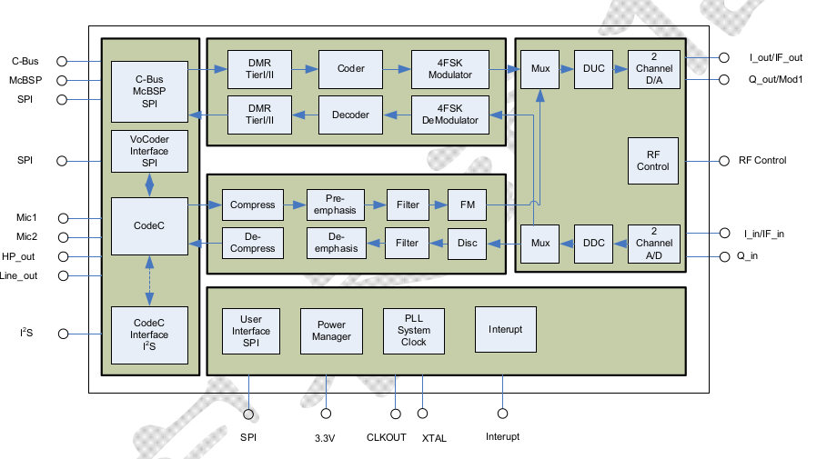OMISSIS*

# Chip pin

## Pin map

*OMISSIS*

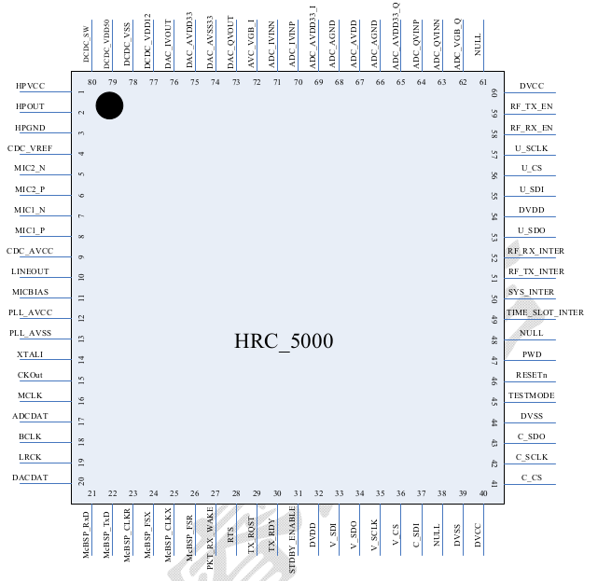

HR_C6000 pin diagram picture is missing

## Pin list

***Table 2.1*** *Pin Arrangement Diagram*

|  |  |  |  |
| --- | --- | --- | --- |
| Pin Number | Name | Type | Pin Description |
| 1 | HPVCC | AP | The headphone output amplifier simulates a 3.3V power supply. |
| 2 | LINEOUT1 | AO | Headphone output. |
| 3 | HPGND | AG | Built-in Codec analog ground. |
| 4 | CDC_VREF | AO | Built-in Codec reference power supply. |
| 5 | MIC_P | AI | The positive side of the differential input of the microphone. |
| 6 | MIC_N | AI | The negative side of the differential input of the microphone. |
| 7 | LINEIN1 | AI | Microphone single-ended input 1. |
| 8 | LINEIN2 | AI | Microphone single-ended input 2. |
| 9 | CDC_AVCC | AP | Codec simulates a 3.3V power supply. |
| 10 | LINEOUT2 | AO | Line-out output, need to add external amplifier drive. |
| 11 | VREFL | AG | The external reference of the microphone is connected to the analog ground. |
| 12 | PLL_VDD33 | AP | The PLL simulates a 3.3V supply. |
| 13 | PLL_VSS33 | AG | The PLL simulates ground. |
| 14 | XTALI | DI | System clock, active crystal input. |
| 15 | CLKOUT | DO | HR_C6000 output clock, when output by PLL clock divider is obtained, the division ratio is matched by reg0xBB Set. Available for external Codec or external vocoder use.  External Codec interface working clock, which is clocked by CLKOUT is provided if the external Codec is not used CLKOUT, the clock needs to be external Codec's working clock; also multiplexed as a radio The digital control of the sender is enabled. |
| 16 | MCLK/RF_ANT_EN | DIO | Codec's working clock; also multiplexed as a radio digital control of the sender is enabled. |
| 17 | LRCK/RF_3TC_EN | DO | External Codec left and right channel selection enable; multiplexing  Digital control is enabled as the RF transmitter. |
| 18 | BCLK/RF_3RC_EN | DO | External Codec bit clock; multiplexed as RF  Receiver digital control is enabled. |
| 19 | ADCDAT/RF_5TC_EN | DIO | External Codec audio ADC sampling data; multiplexing As the RF transmitter is digitally enabled, this time For output characteristics. |
| 20 | DACDAT/RF_5RC_EN | DO | External Codec audio DAC data; reuse as  Digital control at the RF receiver is enabled. |
| 21 | VSS12 | G | The kernel is digitally ground. |
| 22 | McBSP_Rxd/CHS_DI | DO | AMBE3000: HR_C6000 by McBSP  The data sent by the interface to the AMBE3000;  AMBE1000: HR_C6000 through CHS string  The frame input data sent to the AMBE1000 by the port. |
| 23 | McBSP_TxD/CHS_DO | DI | AMBE3000: HR_C6000 by McBSP  The interface receives data sent by the AMBE3000;  AMBE1000: HR_C6000 through CHS string  The port receives the frame output data of the AMBE1000. |
| 24 | McBSP_CLKR/CHS_O_CLK | DO | AMBE3000: McBSP connection of HR_C6000  Port output clock;  AMBE1000: CHS interface clock of AMBE1000. |
| 25 | McBSP_FSX | DI | AMBE3000: HR_C6000 by McBSP Interface receives synchronization of AMBE3000 output data signal. |
| 26 | McBSP_CLKX | DI | AMBE3000: McBSP connection of HR_C6000 Port input clock. |
| 27 | McBSP_FSR/CHS_I_STRB | DO | AMBE3000: HR_C6000 by McBSP The data synchronization letter sent by the interface to the AMBE3000 number;  AMBE1000: CHS_DI port data is valid Enable. |
| 28 | PKT_RX_WAKE/CHS_O_STRB | DO | AMBE3000: Invert McBSP_FSR, Used to wake up the McBSP interface;  AMBE1000: CHS_DO port data is valid Enablement. |
| 29 | RTS/DPE | DI | AMBE3000 : AMBE3000 is allowed to pass  The McBsp interface writes data, which is low effective;  AMBE1000: AMBE1000 decoding packet is empty. |
| 30 | TX_RDY/EPR | DI | AMBE3000: AMBE3000 sends a packet Ready to complete, high effective;  MBE1000: AMBE1000 encoding standard Ready. |
| 31 | STDB_ENB/RESET_AMBE1000 |  | AMBE3000: AMBE3000 Standby Mode Enable, active high;  AMBE1000: AMBE1000 RESET, Low effective. |
| 32 | VDD12 | P | Core digital 1.2V power supply. |
| 33 | VSS12 | G | The kernel is digitally ground. |
| 34 | (C_SDI/I2S_RX) – supposed | DI | As an SPI interface: the vocoder SPI port Serial data input to HR_C6000, SPI operation In the main mode. |
| 35 | C_SDO/I2S_TX | DO | As an I2S interface: can work in master/slave mode formula. If working in master mode, read from the vocoder Take PCM serial data to HR_C6000; if Working in slave mode, the vocoder will write PCM data Go to HR_C6000.  As an SPI interface: HR_C6000 will Output voice data from CodecADC to vocoding SPI port. |
| 36 | C_SCLK/I2S_CK | DO/DI | As an I2S interface: can work in master/slave mode formula. If working in master mode, if working in Main mode, the I2S master that is provided to the vocoder Clock; if working in slave mode, for vocoder When working with the I2S interface of the HR_C6000 bell As an SPI interface: a slice of the vocoder SPI port selected. |
| 37 | C_CS/I2S_FS | DO/DI | As an I2S interface: can work in master/slave mode formula. If working in master mode, provide vocoding Read and write I2S left and right channel data enable; Fruit work is provided from the mode, the vocoder HR_C6000 reads and writes the left and right channels of serial data  Enable. |
| 38 | TEST_MODE | DI | Test mode configuration pin, 1 is test mode, 0 for normal working mode. |
| 39 | RESETn | DI | System reset signal, active low. |
| 40 | VSS33 | P | Digital IO 3.3V power supply. |
| 41 | V_SDI | DI | Universal vocoder SPI port serial data input. |
| 42 | V_SDO | DO | Universal vocoder SPI port serial data output. |
| 43 | V_SCLK | DI | Universal vocoder SPI port serial clock. |
| 44 | V_CS | DI | Universal vocoder SPI port chip select |
| 45 | DBIST_IN | DI | NC. Connect to ground. |
| 46 | DBIST_OUT | DO | NC |
| 47 | PWD | DI | Chip PowerDown control pin, high level activates the PowerDown state. |
| 48 | TIME_SLOT_INTER | DO | 30ms time slot interrupt. |
| 49 | SYS_INTER | DO | System control is interrupted. |
| 50 |  | DO | The radio end sends related parameters to configure interrupts, such as sending the mixer frequency configuration. |
| 51 |  | DO | The radio end receives the relevant parameter configuration interrupt, such as receive the mixer frequency configuration. |
| 52 | VSS12 | G | The kernel is digitally ground. |
| 53 | VDD12 | P | Core digital 1.2V power supply. |
| 54 | VDD33 | P | Digital IO 3.3V power supply. |
| 55 | U_SDO | DO | MCU accesses HR_C6000 register or RAM  SPI data output from the memory area. |
| 56 | U_SDI | DI | MCU accesses HR_C6000 register or RAM  SPI data input for the bank. |
| 57 | U_SCLK | DI | MCU accesses HR_C6000 register or RAM  The SPI serial clock for the bank. |
| 58 | U_CS | DI | MCU accesses HR_C6000 register or RAM  SPI chip select for the bank. |
| 59 | RF_RX_EN | DO | Control the RF receiving switch to enable, when receiving status,  Output high level. The signal will not be  RF_TX_EN is valid at the same time. |
| 60 | RF_TX_EN | DO | Control the RF transmit switch enable, when sending status,  Output high level. The signal will not be  RF_RX_EN is valid at the same time. |
| 61 | ADC_VBG_Q | AIO | Q-channel ADC channel external decoupling bandgap voltage |
| 62 | ADC_QVINN | AI | Q The negative side of the ADC channel differential input. |
| 63 | ADC_QVINP | AI | Q Positive side of the ADC channel differential input. |
| 64 | ADC_AVDD12_Q | AP | The Q-channel ADC channel simulates a 1.2V power supply. |
| 65 | ADC_AGND_Q | AG | Q-channel ADC channel analog ground. |
| 66 | ADC_AVDD33_Q | AP | ADC Analog 3.3V Power Supply |
| 67 | ADC_AVDD33_I | AP | ADC Analog 3.3V Power Supply |
| 68 | ADC_AGND_I | AG | I-channel ADC channel analog ground |
| 69 | ADC_AVDD12_I | AP | The I-channel ADC channel simulates a 1.2V power supply. |
| 70 | ADC_IVINP | AI | I-channel ADC channel differential input positive terminal, or medium  Signal access terminal in frequency receiving mode. |
| 71 | ADC_IVINN |  | I-channel ADC channel differential input negative terminal, intermediate frequency.  The port is grounded or other fixed in receive mode  Pressure. |
| 72 | ADC_VBG_I |  | The bandgap voltage of the external decoupling of the I-channel ADC channel. |
| 73 | DAC_AVSS33 | AG | The DAC simulates ground. |
| 74 | DAC_QVOUT/MOD2 | AO | Q channel DAC channel output signal.  Two-point modulation MOD2 port in send mode. |
| 75 | DAC_IVOUT/MOD1 | AO | I DAC channel output signal.  MOD1 port in two-point modulation transmit mode. |
| 76 | DAC_AVDD33 | AP | The DAC simulates a 3.3V power supply. |
| 77 | DCDC_VDD12 | AO | DC-DC 1.2V output. |
| 78 | DCDC_VSS | G | DC-DC digital ground. |
| 79 | DCDC_VDD33 | P | DC-DC 3.3V power supply. |
| 80 | DCDC_SW | O | DC-DC internal switch. |

## Package size

*OMISSIS*

# Chip characteristic

## Static characteristic

***Table 3.1*** *HR_C6000 Static Parameters*

*OMISSIS*

## Dynamic characteristics

*OMISSIS*

## Power consumption parameter

*OMISSIS*

## Performance parameter

*OMISSIS*

# Application note

## Chip reset

### Power-on reset

The HR_C6000 can be powered on and reset using resistors and capacitors. The reference circuit is as follows.

*OMISSIS*

***Figure 4.1*** *Chip Power-on Reset Reference Circuit*

To ensure a successful power-on reset, the reset time is required to be kept to a minimum of 0.1μs. As shown, 0-0.8V is stable low power flat voltage range, 2.0-3.3V is a stable high-level voltage range.

*OMISSIS*

***Figure 4.2*** *Chip power-on reset timing diagram*

It is recommended to use the same reset chip as the CPU or the GPIO of the CPU as the reset pin.

### Software reset

In addition to the automatic reset process during power-on, the HR_C6000 can also pass the MCU according to the actual application needs.

Software reset the chip. The software reset operation is implemented by Bit7 of the configuration register Reg0x00. Will be Reg0x00

After Bit7 is configured as 0, a soft reset of HR_C6000 is completed, and the reset time is a Sys_Clk pulse width, that is, 1/9.8304 uS. After this bit is configured as 0, it is not necessary to reconfigure to 1 to resume normal operation mode through the MCU. The HR_C6000 automatically sets Bit to 1.

*OMISSIS*

***Figure 4.3*** *Chip Software Reset Timing Diagram*

## Chip power supply

The HR_C6000 requires 3.3V power supply and the built-in DCDC module outputs 1.2V for digital and analog cores. By outside The circuit separates the analog 3.3V, digital 3.3V and analog 1.2V, digital 1.2V power supplies. Digital 1.2V and digital 3.3V

The power supply shares digital ground; all analog 3.3V common ground; all analog 1.2V common ground.

The power supply network is shown in the figure, where VCC33 provides the total power supply for the system and AVDD33 is the chip to simulate the 3.3V power supply.

The DVDD33 is a chip digital 3.3V power supply. AVDD33 provides on-chip DCDC module for conversion of output chip 1.2V analog power supply AVDD12 and digital power supply DVDD12.

*OMISSIS*

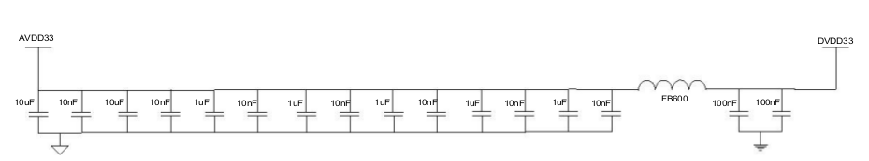

***Figure 4.4*** *HR_C6000 power reference circuit*

## Chip working clock block diagram and description

### Clock circuit

The HR_C6000 requires an optimum bias of 1.5V for the crystal. At this bias, the crystal output requires Vpp ≥ 2V. Chip The clock is input by the XTALI pin.

*OMISSIS*

***Figure 4.5*** *HR_C6000 clock reference circuit*

### Clock configuration

Configure the relevant registers of the built-in PLL of the chip, so that the input clock is locked to CLK via PLL (recommended value is 49.152MHz), and the internal frequency of the chip is Sys_clk, Clk_codec, CLKOUT. The Sys_clk is the system working clock. Configuration register 0xB9 is obtained, Sys_clk is 9.8304MHz; Clk_codec is the built-in Codec working clock, which is configured by register 0xBA and has a frequency of 12.288MHz. CLKOUT can provide working clock for external Codec or vocoder. The clock frequency can pass 0xBB register. Configure and additionally configure bit 0 (ClkOut_enb) of Register 0x0A to control whether to output the CLKOUT clock and output a valid clock when high.

When the HR_C6000 is powered on, the internal working clock is directly provided by the external crystal oscillator by default, that is, bit7 of 0x0A is 1. After changing the configuration reg0x0B and reg0x0C, it needs to wait for more than 500μs. Wait for the PLL output to be stable enough before switching the internal clock back from the crystal oscillator. PLL output.

*OMISSIS*

***Figure 4.6*** *Chip Operating Clock Block Diagram*

The built-in PLL of the chip is configured through the 0x0B, 0x0C registers. The specific calculation formula is as follows:

CLK=XTALI×PLLM / PLLN / NO;

among them:

NO=2 PLLDO

1M<XTAL/ PLLN<25MHz;

200MHz<CLK×NO<1000MHz;

PLLM>1;PLLN>1;

By setting bit 7 of the 0x0C register to 1, the PLL can be bypassed. At this time, the PLL output is CLK=XTALI;

Configure bit 0 of 0x0C to 1 or the PWD pin of the chip is pulled high to put the PLL into sleep state. At this time, the PLL has no clock output.

Configure bit 7 (Clk_in_sel) of Register 0x0A as 1, and CLK does not select the output clock of the PLL. Instead, choose XTALI directly, which is CLK=XTALI.

***Table 4.1*** *Recommended two typical PLL output clock configuration parameters*

|  |  |  |  |  |
| --- | --- | --- | --- | --- |
| XTALI | PLL configuration parameters | PLL output  clock | System clock configuration  parameter | System output clock |
| 12.288M | Reg0x0B = 0x40  Reg0x0C = 0x32 | 49.152M | Reg0xB9 = 0x05  Reg0xBA = 0x04  Reg0xBB = 0x02 | Sys_clk=9.8304  Clk_codec=12.288M  CLKOUT=24.576M |
| 29.4912M | Reg0x0B = 0x28  Reg0x0C = 0x33 | 49.152M | Reg0xB9 = 0x05  Reg0xBA = 0x04  Reg0xBB = 0x02 | Sys_clk=9.8304  Clk_codec=12.288M  CLKOUT=24.576M |

## Chip parameter configuration interface

The MCU uses the U_SPI port to perform parameter configuration, status control information, and write/receive data to and from the HR_C6000, and performs corresponding interrupt processing according to the TIME_SLOT_INTER, SYS_INTER, RF_TX_INTER, and RF_RX_INTER interrupts given by the HR_C6000. The MCU can also control the Sleep state of the chip through the GPIO pins. Its interface is shown below.

*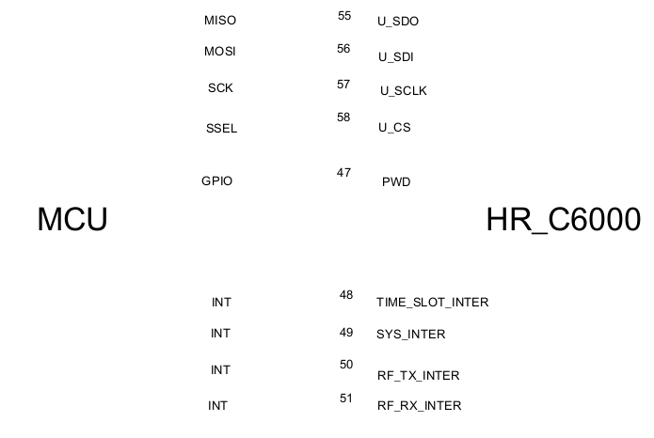OMISSIS*

***Figure 4.7*** *Interface between MCU and HR_C6000*

The chip's U_SPI interface operates in Slave mode, and the interface timing is shown in the figure below.

*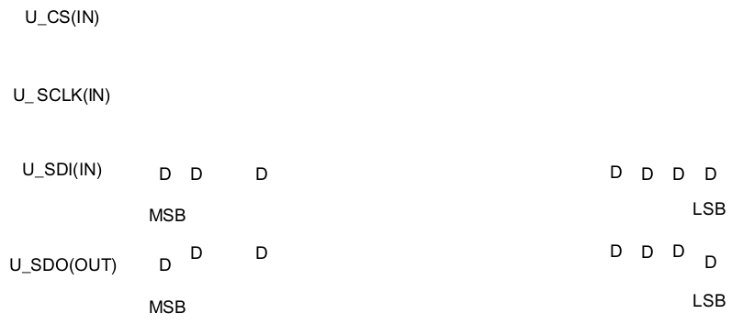OMISSIS*

***Figure 4.8*** *U_SPI Interface Read and Write Timing*

SCLK supports up to 4MHz clock rate.

The MCU can control the Sleep state of the HR_C6000 through the GPIO pin. When the GPIO is pulled high, the chip is in the Sleep state, and all clocks in the HR_C6000 are turned off.

When the GPIO is pulled low again, the chip is in normal operation mode. In this case, the ByPass internal PLL needs to be used to provide the clock through the crystal XTALI direct HR_C6000. After waiting for more than 500μs, switch to the internal PLL to provide the HR_C6000 working clock.

As shown in the figure, XTALI is the crystal input clock signal, PWD is the sleep signal of HR_C6000, Sys_clk is the working clock of HR_C6000; PLL_Sys_clk is the clock obtained by dividing the frequency of HR_C6000 after the PLL output.

The MCU configuration PWD is high, and the PWD is stable after 100ns. At this time, the HR_C6000 internal clock is all cleared. After the PWD is pulled low again, the working clock needs to be switched to XTALI. After waiting for the PLL to stabilize the output of the divided PLL_Sys_clk, switch to the PLL. The divided output clock has a settling time greater than 500μs.

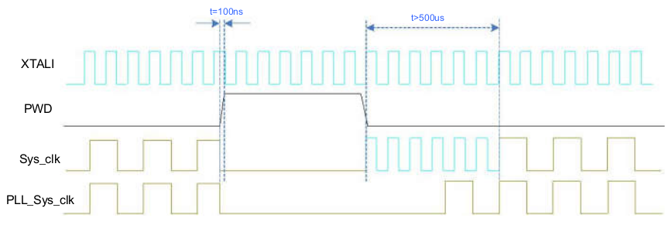

***Figure 4.9*** *Schematic diagram of PWD control timing and working clock switching requirements*

HR_C6000 provides 4 interrupt pins, the interrupt low pulse is valid, the pulse width is 3 system working clocks (Sys_clk, 9.8304MHz), SYS_INTER is to receive the indication interrupt of the system receiving and transmitting information, and the sending process and receiving process prompt the MCU status or control. TIME_SLOT_INTER is a 30ms time slot interrupt. This interrupt is generated cyclically after the HR_C6000 establishes a synchronization time slot. It is used to establish a TDMA time slot structure for the MCU. RF_TX_INTER and RF_RX_INTER are RF transceiver switching control interrupts. It is generated during the switching process to facilitate accurate and timely control of the RF channel by the MCU. RF_TX_INTER and RF_RX_INTER are alternately generated according to the period of 30ms. In order to facilitate the early start of the RF transmission control, register Reg0x12 can be set to control RF_TX_INTER and register Reg0xC0 to control RF_RX_INTER. The advance of 0ms can be configured with respect to the 30ms boundary.

*OMISSIS*

***Figure 4.10*** *Schematic diagram of RF_TX_INTER and RF_RX_INTER generation*

***Table 4.2*** *RF_TX_INTER Interrupt Control Register Address Description*

|  |  |
| --- | --- |
| address | function |
| 0x12 | Bit[5:0] configures the RF transceiver switching interrupt RF_TX_INTER relative to the 30ms boundary advance, in increments of 100μs. Bit[5:0] configures the RF transceiver switching interrupt RF_RX_INTER relative to the 30ms boundary advance, in increments of 100μs. |

## Use of Codec

HR_C6000 built-in CodeC for Mic input and LINEOUT output, Mic gain control and LINEOUT

The volume control effectively reduces the user's peripheral devices. At the same time, the standard I2S interface is configured for the external CodeC, and the user can also select the appropriate Codec according to his own needs.

### Built-in Codec

*OMISSIS*

### Use external Codec

*OMISSIS*

***Figure 4.13*** *Interface circuit with external Codec*

When the HR_C6000 uses an external Codec, data is exchanged with Codec through the I2S interface. The interface timing is as follows.

*OMISSIS*

***Figure 4.14*** *I2S Interface Timing*

among them:

1. The LRCK clock frequency is determined by the Codec clock frequency and registers 0x32, 0x33. By default, the LRCK clock frequency is 8KHz.

LRCK clock frequency = Codec clock frequency / [2 * (parameter value + 1)], where the parameter value is derived from {register 0x32 value, register 0x33 value}.

1. The BCLK clock frequency is determined by the Codec clock frequency and registers 0x30, 0x31.

BCLK clock frequency = Codec clock frequency / [2 * (parameter value + 1)], where the parameter value is derived from {register 0x30 value, register 0x31 value}.

1. If the default external Codec (ALC5621) is used, LRCK is 8KHz and BCLK is 512KHz. At the same time, the chip CLKOUT pin needs to be connected to the chip MCLK pin, and CLKOUT outputs a 24.576MHz clock for the internal I2S operation of the chip. Connect the CLKOUT pin of the chip to the working clock input pin of Codec. When using the chip built-in Codec, the chip CLKOUT pin is not connected to the chip MCLK pin.

All pins of the external Codec can be reused as digital IO output, which can be used to control the high and low switching of the RF and the main control chip. The high and low switching time can be configured with reference to the delay of 30ms slot boundary or within 6ms in advance. The step size is 100us.

***Table 4.4***

|  |  |
| --- | --- |
| Address | Function |
| 0xC7/C8 | Control LRCK pin multiplexing, where Bit7 of C7 is multiplexed control enabled, Bit6 confirms high level with respect to 30ms slot boundary advance or delay, 0 is advanced, 1 is delayed; Bit5-0 is controlled early or delayed Quantity, the step size is 100us. Bit8 of C8 confirms that the low level is ahead or delayed relative to the 30ms time slot boundary, 0 is advanced, 1 is delayed; Bit5-0 is controlled early or delayed, and the step is 100us |
| 0xC9/CA | Control ADCDAT pin multiplexing. The definition is the same as LRCK multiplexing. |
| 0xCB/CC | Control MCLK pin multiplexing. The definition is the same as LRCK multiplexing. |
| 0xCD/CE | Control BCLK pin multiplexing. The definition is the same as LRCK multiplexing. |
| 0xCF/D0 | Control DACDAT pin multiplexing. The definition is the same as LRCK multiplexing. |

As shown in the figure below, the control of the LRCK pin is taken as an example to illustrate the control diagram of the high and low levels. The other pin control methods are the same as this.

*OMISSIS*

***Figure 4.15*** *LRCK pin multiplexing for general IO control interface timing*

## Vocoder

HR_C6000 can seamlessly interface with vocoder chips such as AMBE3000 and AMBE1000 with McBSP and CHS serial interface, and provide standard SPI and IS interfaces, and with Macro Rui HR_V3000 vocoder, Tsinghua SELP vocoder, 712 factory AVDS vocoder. Splicing docking, support for encrypted voice, data interface, and provide interface for digital voice recording, playback and prompt tone input.

### Interface definition with Hongrui HR_V3000 vocoder

HR_V3000 and HR_C6000 transmit the compression-encoded digital voice stream or the digital voice stream to be decoded through V_SPI, and transmit PCM data through the I 2 S interface and the vocoder. The 2 IS interface of HR_C6000 works in the master mode; the MCU passes the UART interface. Transfer the voice encryption/decryption key or voice frame synchronization information with HR_V3000. The interface timing of the V_SPI port is shown in the figure below.

*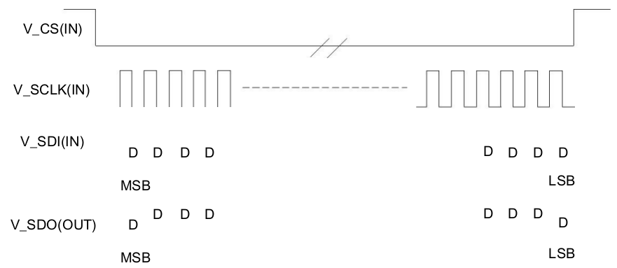****Figure 4.16*** *Using the V_SPI Interface to Read (Write) Timing*

The SCLK supports up to 4MHz clock rate.

The frame format of V_SPI is shown below. What needs to be explained is:

The V_SPI interface can only perform one operation at a time, read or write.

When performing a read operation, Cmd=0x83, Addr=0x00, and read 27 individual Data(byte).

When writing, Cmd=0x03, Addr=0x00, and write 27 individual Data(byte).

*OMISSIS*

Cmd Addr Data0 Data1… Datan

***Figure 4.17*** *V_SPI frame format*

To communicate with the Hongrui HR_V3000 vocoder via the V_SPI interface HR_C6000, simply configure the HR_C6000 register reg0x06 to 0x24. The connection diagram of HR_V3000 and HR_C6000 and MCU is shown in the figure.

*OMISSIS*

***Figure 4.18*** *HR_V3000 vocoder and HR_C6000 connection block diagram*

*OMISSIS*

***Figure 4.19*** *shows the interface timing of I2S.*

I2S operates in master mode and needs to configure the I2S_CK_M clock frequency via Register 0x2F, calculated as codec operating frequency / (2* (Register 0x2F value + 1)). The I2S_FS_M clock frequency is configured by Register 0x32, 0x33 (the configured I2S_FS_M clock frequency must be 8KHz), calculated as codec operating frequency / (2 * ({Register 0x32 value, 0x33 value} +1)). At the same time, the I2S_CK_M frequency is >34* I2S_FS_M frequency, and the codec clock frequency is >=6*I2S_CK_M frequency.

When I2S is operating in Master mode, the I2S_CK_M, I2S_FS_M signals can be turned off via Register 0x36[6]. When 0x36[6]=0, these two signals are turned on, otherwise the two signals are turned off.

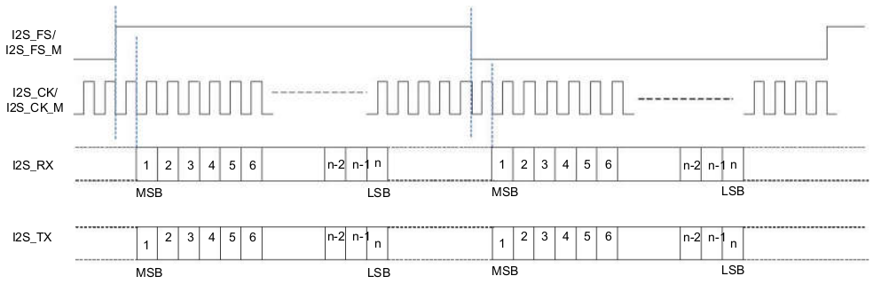

***Figure 4.19*** *I2S Interface Timing*

For details on the use of the HR_V3000 vocoder, please refer to the HR_V3000 vocoder instructions doc.

## Transmitter module

The HR_C6000 has two high-performance DACs with single-ended output and supports RF interfaces such as baseband IQ, intermediate frequency and two-point modulation. The amplitude and offset of the two signals are adjustable.

The user can select the corresponding transmit interface through the configuration register, the two output signal offsets and the amplitude of the two output signals.

In addition, to control the power consumption of the chip, the user can turn it off when the DAC is not working by setting the 0x25 register. Bit3 and Bit2 of 0x25 can be selected by HR_C6000 to automatically control the DAC according to the transmission time slot, or the MCU can control the working state of the DAC by configuring Bit5 and Bit4.

***Table 4.5*** *HR_C6000 Baseband Transmit Control Register Address*

|  |  |
| --- | --- |
| Address | Function |
| 0x01 | Bit7 selects the correspondence between the HR_C6000 transmit port and the RF transmit port; Bit[5:4] selects one of the four transmit modes. 2'b00 means to send the intermediate frequency mode, 2'b10 means to send the baseband IQ mode, and 2'b11 means to send the two-point modulation mode. |
| 0x02 | The offset value of the baseband transmit output I path. |
| 0x04 | The baseband transmits the offset value of the output Q path. |
| 0x07 | IF frequency word height 8bit |
| 0x08 | IF frequency word 8bit |
| 0x09 | IF frequency word low 8bit |
| 0x12 | Bit7 configuration smoothing enable; bit6 configures two-point modulation test square wave output  Can; bit[5:0] radio frequency interrupt advance, the incremental step size is about 100μs. |
| 0x25 | DAC work control word. |
| 0x2E | Send the advance configuration value. Because the RF channel delay is different, to ensure that the airborne DMR signal is strictly corresponding to the slot boundary transmission, configuring this register can offset the delay amount, and the step is 100μs. The internal channel has a fixed delay of 400μs, so this register should be configured as 0x04 when there is no delay on the RF side. |
| 0x45 | Adjust the amplitude of the two-point modulation MOD2 (DAC_IVOUT) |
| 0x46 | Adjust the amplitude of the two-point modulation MOD1 (DAC_QVOUT) |
| 0x47 | Define two-point modulation offset adjustment value, a total of 10bit, where the high 2bit is defined in the lower 2bit of reg0x48. |
| 0x48 | Bit[1:0] defines two-point modulation offset adjustment value, a total of 10bit, of which the lower 8bit is defined in reg0x47 |

### Baseband IQ modulation

*OMISSIS*

### Two-point modulation

*OMISSIS*

### IF IQ modulation

*OMISSIS*

### IF modulation

*OMISSIS*

## Receiving module

*OMISSIS*

### Baseband IQ

*OMISSIS*

### IF mode

*OMISSIS*

# Hierarchical function description

HR_C6000 adopts a flexible layered design model to flexibly open different levels for users to meet different user needs.

The layered design uses a three-tier architecture as shown.

Control and data services Voice service

* Call control layer
* Data link layer
* Physical layer

*OMISSIS*

***Figure 5.1*** *HR_C6000 three-tier open architecture*

The one-layer mode mainly solves the channel filtering of the baseband or low-IF signal and the modulation and demodulation process of the signal, as defined in the green dotted box in the above figure. The user needs to solve the channel codec and the processing of all communication protocol stacks by using one layer mode, which has the greatest development flexibility and development workload.

The second layer mode is mainly based on the opening of one layer of all content, completes the coding and decoding of the channel, and interleaves, deinterleaves and checksums, etc., as defined in the gray dashed box in the above figure. The user only needs to solve the processing flow of the communication protocol stack, and has greater development flexibility and moderate development workload.

The three-layer mode refers to all the application functions defined by the HR_C6000 according to the DMR protocol, and completes the modulation and demodulation, codec, and protocol stack design of all standardized application functions, all the functions defined in the blue dotted box in the above figure.

Users use these application functions, and only need to configure the corresponding function registers, so that all DMR protocol customized voice and data services can be quickly and conveniently used.

The HR_C6000 is mainly developed based on the Layer 2 mode. The user does not need to pay attention to the codec interleaving of the channel and the underlying modulation and demodulation process.

## Interrupt use instructions

### Interrupt use description

The corresponding interrupt of the three-layer function is **sys_inter**. The interrupt consists of two sub-interrupts. After receiving the interrupt, the MCU reads the interrupt status register 0x82. The corresponding interrupt can be masked by register 0x81, and the corresponding interrupt is cleared by register 0x83. A list of bit interrupt signals that yields 8 types of interrupts, including:

Bit7:  
 In DMR mode, it **indicates** that this transmission request is rejected because the channel is busy.  
This interrupt has no substatus registers.

Bit6:

In DMR mode: indicates the start of transmission;

In MSK mode: indicates that the ping-pong buffer is half-full interrupted.   
  
In DMR mode, the sub-status register 0x84 is transmitted at the beginning, and the corresponding interrupt can be masked by 0x85. The sub-status registers indicate seven interrupts that initiate the transmission, including:

Bit7: Voice transmission starts

Bit6: OACSU requests to send interrupts, including first-time send and resend requests.

Bit5: End-to-end voice enhanced encryption interrupt, including EMB72bits update interrupt and voice 216bits key update interrupt, which are distinguished by Bit5~Bit4 of Register 0x88, where 01 indicates EMB72bits update interrupt and 10 indicates voice 216bits key update interrupt.

Bit4: The Vocoder configuration returns an interrupt (this interrupt is sent by the HR_C6000 to the MCU when the MCU manually configures the AMBE3000). This interrupt is only valid when using the external AMBE3000 vocoder.

Bit3: Data transmission starts

Bit2: Data partial retransmission

Bit1: Data retransmission

Bit0: The vocoder is initialized to an interrupt. This interrupt is only valid when using an external AMBE3000 or AMBE1000 vocoder.

In MSK mode, there is no sub-interrupt status.

Bit5:

In DMR mode: indicates the end of transmission;

In MSK mode: indicates the end of transmission (there is no substate interrupt)

In DMR mode, there is a sub-status register 0x86 at the end of the transmission, and the corresponding interrupt can be masked by 0x87.

The sub-status register indicates six interrupts that generate the end of the transmission, including:

Bit7: indicates that the service transmission is completely terminated, including voice and data. The MCU distinguishes whether the voice or data is sent this time. Confirming that the data service is received is the response packet that receives the correct feedback.

Bit6: Indicates that a Fragment length confirmation packet is sent in the sliding window data service without immediate feedback.

Bit5: Voice OACSU wait timeout

Bit4: The Layer 2 mode handles the interrupt. The MCU sends the configuration information to the last processing timing of the chip to control the interrupt. If after the interrupt, the MCU has not written all the information to be sent in the next frame to the chip, the next time slot cannot be Configured to send time slots. This interrupt is only valid when the chip is operating in Layer 2 mode.

Bit3: indicates that a Fragment that needs to be fed back confirms the completion of the data packet transmission. The interrupt is mainly applied to the acknowledgment message after all the data packets have been sent or the data packet that needs to be fed back in the sliding window data service is sent to the MCU to start waiting for the timing of the Response packet. Device.

Bit2 : ShortLC Receive Interrupt

Bit1: BS activation timeout interrupt

Bit4:

In DMR mode: indicates the access interruption; (no sub status register)

In MSK mode: indicates that the response is interrupted. (no sub status register)

In DMR mode, the access interrupt. After receiving the interrupt, it indicates that the access voice communication mode is post-access.

Bit3:

In DMR mode: indicates that the control frame parsing completion interrupt;

In MSK mode: indicates the receive interrupt.( no substate interrupts.)

In DMR mode, this interrupt has no sub-status register, but the error and receive type of its received data is given by the 0x51 register.

The DLLRecvDataType, DLLRecvCRC are used to indicate the received data type and the error status, and the MCU accordingly performs the corresponding status.

Display, you can also block the corresponding interrupt.

The FMB frame's EMB information parsing completion prompt is also the completion of the interrupt, which is distinguished by judging the 0x51 register SyncClass=0.

Bit2:

In FM mode: indicates FM function detection interrupt.

In DMR mode: indicates service data reception interrupt; (sub-status register 0x90 )

Sub-status register 0x90, has three types: *(possibly means 3 possible values)*

1. 0x80 indicates that the entire information is received and verified. After the service data is verified, the MCU extracts the data after the address 0x30 in the RX terminal 1.2KRAM through the SPI port. The length of the data is defined by the corresponding field of the received frame header.
2. 0x00 indicates the entire information reception check error;
3. 0x40 indicates that a non-confirmed SMS abnormal interrupt is generated;

In FM mode, the interrupt has sub-status register 0x90, and the sub-status register has 1 type:

1. 0x10 indicates that the FM function detection interrupt is matched. When the FM interrupt is detected in the FM mode, the corresponding analog sound output is turned on.

Bit1:

In DMR mode: indicates that the voice is abnormally exited;

In DMR mode, the cause of the abnormality in DMR mode is the unexpected abnormal voice interrupt generated inside the state machine.

The corresponding voice exception type is obtained through Bit2~Bit0 of register address 0x98.

Bit0: physical layer separate work reception interrupt

The physical layer works independently to receive interrupts without a sub-status register. The interrupt is generated in the physical layer single working mode. After receiving the data, the interrupt is generated, and the MCU is notified to read the corresponding register to obtain the received data. This interrupt is typically tested in bit error rate or other performance in physical layer mode.

The system interrupt is handled as follows. The specific response tree is shown below (the FM mode is not included):

Waiting for interruption

Received a system outage

Read 0x82

|  |  |  |  |  |  |  |  |
| --- | --- | --- | --- | --- | --- | --- | --- |
| Send request rejection | Send start | End of sending | Post access | Receive data | Receive information | Abnormal exit | Physical layer alone |
| Bit7 | Bit6 | Bit5 | Bit4 | Bit3 | Bit2 | Bit1 | Bit0 |
|  | Read 0x84 to get 7 kinds of content | Read 0x86 to get 6 kinds of end content |  | Read 0x51 to get the status of received data | Read 0x90 to get the receiving result |  |  |

Write 0x83 corresponding bit clear interrupt

Waiting for interruption

*OMISSIS*

***Figure 5.2*** *Interrupt Response Tree*

The Time_slot_inte interrupt is a TDMA time slot interrupt. When the synchronization time slot of HR_C6000 is established, the interrupt is continuously given at intervals of 30ms, until the synchronization is lost.

## Interface read and write instructions

The user accesses through the general U_SPI includes the register system parameter table, register schedule, TX side 1.2KRAM and RX end 1.2KRAM. The access frame format is:

|  |  |  |  |  |
| --- | --- | --- | --- | --- |
| Cmd | Addr | Data0 | Data1... | Datan |

*OMISSIS*

***Figure 5.3*** *U_SPI Access Frame Format*

***Table 5.1*** *Cmd indicates the read and write status of the SPI port and the corresponding address space*.

|  |  |  |  |  |
| --- | --- | --- | --- | --- |
| **Cmd** | W | IsRead | Bit7 | 1 means the operation is read, 0 means the operation is write |
|  |  | Read and write initial address extension | Bit6 | 0 does not expand, 1 expands |
|  |  |  | Bit5-Bit3 | Reserved |
|  |  | OPMode | Bit2-Bit0 | 000 reserved  001 indicates the operation auxiliary parameter configuration table.  010 means to write the write end RAM, read the receive end RAM,  100 represents the operating system parameter table,  101 means to configure the AMBE3000 register  110 means the operation writes the RAM, reads the RAM,  111 means to configure the AMBE1000 register |

The **Cmd** highest bit selects whether this is a read operation or a write operation, and the lower 3 bits selects the category of this read/write operation.

**Addr** is the starting address of this read/write. The data that is subsequently written (or read) will start from the starting address and will be accumulated one by one. It will continue to accumulate every time CS is valid.

When Cmd[6]=1'b0, Addr represents 8bits (high order first), and the read/write start address is Addr;

When Cmd[6]=1'b1, Addr indicates 16bits (high order first), and the read/write start address is {Addr[2:0], Addr[15:8]}.

1. Write 0x01 to register 0x80 of the register system parameter table. The format is:

|  |  |
| --- | --- |
| Cmd | Data |
| 8’b 0 0000 100 | 8’b1000 0000 |

2, read the end 1.2KRAM from 0x30 2 bytes of data (data content is 0x01, 0x02) format:

|  |  |  |  |
| --- | --- | --- | --- |
| Cmd | Addr | Data0 | Data1 |
| 8’b 1 0000 010 | 8’b0011 0000 | 8’b0000 0001 | 8’b0000 0010 |

In addition, the OPMode bit of Cmd is 101, 111 is configured for different types of external vocoder registers, and 011 is for reading and writing tones or other prompts.

## HR_C6000 RAM allocation definition

***Table 5.2*** *Space allocation definition of TX side 1.2KRAM in the second layer working mode*

|  |  |  |
| --- | --- | --- |
| Frame type | Address | Description |
| Voice LC Header | 0x00~0x0b | 0x00~0x08: A total of 72bit is the control letter; |
|  |  | 0x09~0x0b: A total of 24 bits is the check information, and the MCU is optional. |
| Voice PI Header | 0x00~0x0b | 0x00~0x09: A total of 80 bits is the control information; |
|  |  | 0x0a~0x0b: A total of 16 bits is the check information, and the MCU is optional. |
| Voice EMB | 0x00~0x09 | 0x00~0x08: A total of 72bit is the control letter; |
|  |  | 0x09: bit7-bit3 A total of 5 bits is the check information, and the MCU is optional. |
|  |  | The information here is prepared at the same time as the speech frame A is to be sent. |
| Voice A | 0x30~0x4a | A total of 216 bits is voice frame information. |
| Voice B | 0x30~0x4a | A total of 216 bits is voice frame information. |
| Voice C | 0x30~0x4a | A total of 216 bits is voice frame information. |
| Voice D | 0x30~0x4a | A total of 216 bits is voice frame information. |
| Voice E | 0x30~0x4a | A total of 216 bits is voice frame information. |
| Voice F | 0x30~0x4a | A total of 216 bits is voice frame information. |
| RC Frame | 0x00~0x01 | 0x00, bit7-bit5 of 0x01, total 11bit information |
| Voice Terminator | 0x00~0x0b | 0x00~0x08: A total of 72bit is the control letter; |
|  |  | 0x09~0x0b: A total of 24 bits is the check information, and the MCU is optional. |
| CSBK | 0x00~0x0b | 0x00~0x09: A total of 80 bits is the control information; |
|  |  | 0x0a~0x0b: A total of 16 bits is the check information, and the MCU is optional. |
| MBC Header | 0x00~0x0b | 0x00~0x09: A total of 80 bits is the control information; |
|  |  | 0x0a~0x0b: A total of 16 bits is the check information, and the MCU is optional. |
| MBC Intermedia | 0x00~0x0b | 0x00~0x0b: A total of 96 bits is the control information; |
| MBC Last | 0x00~0x0b | 0x00~0x0b: A total of 96 bits is the control information; |
| DataHeader | 0x00~0x0b | 0x00~0x09: A total of 80 bits is the control information; |
|  |  | 0x0a~0x0b: A total of 16 bits is the check information, and the MCU is optional. |
| DataRate1_2 | 0x00~0x0b | 0x00~0x0b: A total of 96 bits is data information; |
| DataRate3_4 | 0x00~0x11 | 0x00~0x11: A total of 144 bits is data information; |
| DataRate1 | 0x00~0x17 | 0x00~0x17: A total of 192 bits is data information; |
| Idle | 0x18~0x23 | 0x18~0x23: A total of 96 bits is the control information; |
| Short LC | 0x24~0x28 | 0x24~0x26, bit7-bit4 of 0x27: total 28bit control information; |
|  |  | 0x28 : A total of 8bit check information. |
| Voice F frame EMB | 0x29~0x2C | Voice F frame fill information |
|  |  | Or 0x29 stores the superframe number (KeyID), 0x2A high 3bit stores the encryption serial number (ALOG ID) |
| Data control frame EMB RC | 0x4b~0x50 | Data control frame embedded 48bit RC information or 0x4b, 0x4c |
|  |  | High 11bit RC encoder input |
| C_RC frame (PDT) | 0x00~0x0a | 0x00, bit7-bit5 of 0x01: total 11bit RC information; |
|  |  | 0x02~0x08: Total 56 bit control information; |
|  |  | 0x09~0x0a: Total 16 bit check information; |
| 196 message/information | 0x30~0x48 | 196bit control information |
| Test send | 0x00~0x48 | Send mode test to store data address |
| FM data address 1 | 0x030~0x22f | A total of 512 bytes of data information. You can send voice data for externally written FM or internally send voice data from Codec |
| FM data address 2 | 0x230~0x42f | A total of 512 bytes of data information. You can send voice data for externally written FM or internally send voice data from Codec |
| Encryption key stream data storage | 0x495~0x4af | A total of 216bit, 27 bytes |

***Table 5.3*** *Space allocation definition of RX terminal 1.2KRAM in the two-layer working mode*

*OMISSIS*

|  |  |  |
| --- | --- | --- |
|  |  |  |

## Support frame type

### Time slot framing

For slot framing, there are three modes: voice slot packets, data slot packets, and RC packets.

SYNC(48) Voice(108)

27.5ms

*OMISSIS*

***Figure 5.3*** *Voice Slot Packet with Sync Head*

CC PI LCSS

*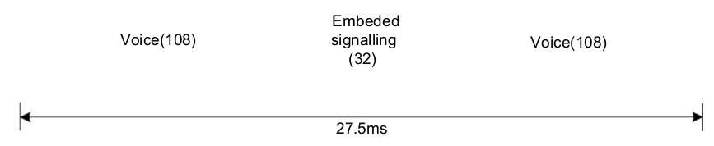OMISSIS*

***Figure 5.4*** *Voice Slot Packet with EMB Data*

1. Support six voice slot group group frames, and according to the superframe rule, determine the synchronization header or LC or Null in the voice frame, and set A (SYNC), B (LC), C (LC), D according to the standard. LC), E (LC), F (Null) superframe. Details include:

1. Support sync header opt-in;
2. Support EMB 7bit join, QR (16,7,6) encoding for EMB;
3. Supports LC 72bit join, adds 5bit CS code, performs variable length BPTC encoding, interleaving, and joins into 4 time slots (128bit);

***Table 5.3*** *Group Call 72bit LC Information Sheet*

|  |  |  |
| --- | --- | --- |
| Information element | Length | Remark |
| Protect Flag (PF) | 1 |  |
| Reserved | 1 | This bit shall be set to 0 |
| Full Link Control Opcode (FLCO) | 6 | Shall be set to 000000 |
| Feature set ID (FID) | 8 | Shall be set to 00000000 |
| Service Option | 8 |  |
| Group address | 24 |  |
| Source address | 24 |  |

***Table 5.4*** *Call 72bit LC Information Sheet*

|  |  |  |
| --- | --- | --- |
| Information element |  | Remark |
| Protect Flag (PF) | 1 |  |
| Reserved | 1 | This bit shall be set to 0 |
| Full Link Control Opcode (FLCO) | 6 | Shall be set to 000011 |
| Feature set ID (FID) | 8 | Shall be set to 00000000 |
| Service Option | 8 |  |
| Group address | 24 |  |
| Source address | 24 |  |

1. Support for Null time slot join;

|  |  |
| --- | --- |
| CC | DataType |
| FEC Parity | |
| FEC Parity |  |

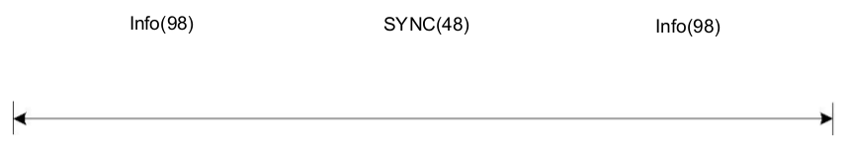

*OMISSIS*

***Figure 5.5*** *Data and control frame structure*

2. Support for LC packet

1. Support to join 72bit LC, CRC24bit check, and add CRC mask (Header and Terminator difference), BPTC (196,96) encoding, set up voice Head frame;
2. Supports the construction of ShortLC packets with 72bitLC information for embedding into the EMB area of voice;
3. Support for dynamic update of LC packages;

3. CSBK packages, MBC packages, and data packets are supported; detailed internals include:

1. Support to join Slot Type (20bit), including CC, DataType, for Golay (20, 8) encoding;
2. Support SYNC to join;
3. Supports adding 80bit CSBK, CRC16bit checksum and adding CRC mask for BPTC (196,96) encoding and interleaving;

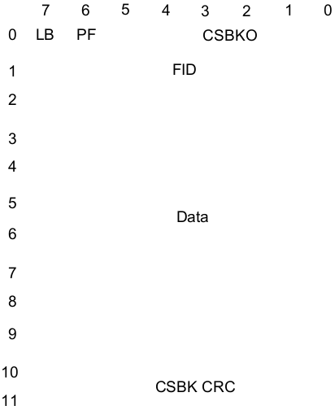

***Figure 5.6*** *CSBK 80bit infographic*

1. Support to join 96bit Idle for BPTC (196, 96) encoding and interleaving;
2. Supports adding 80bit MBC header, CRC16bit check, adding CRC mask, performing BPTC (196, 96) encoding and interleaving;
3. Supports the addition of 96bit MBC data for BPTC (196, 96) encoding and interleaving;
4. Support for adding 80bitMBC lastBlock, performing CRC16bit check, BPTC (196, 96) encoding and interleaving;
5. Support data packet header, add 80bit data, perform CRC16bit check, add CRC mask, perform BPTC (196, 96) encoding and interleaving;

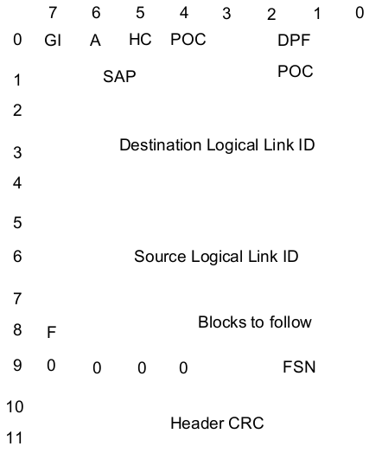

***Figure 5.7*** *Unconfirmed packet header*

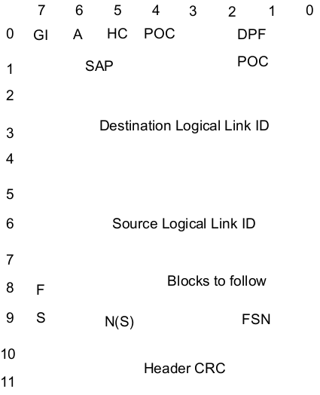

***Figure 5.8*** *Confirm Packet Header*

1. Support for rapid generation based on application needs Unconfirmed data header, Confirmed data header, Response data header, Proprietary data header, Status/Precoded short data header, Raw short data header, Defined short data header with Unified Data transport data header;
2. Supports the data format of the Rate 1/2 mode, adds 96-bit data, and performs BPTC (196, 96) encoding and interleaving;
3. Supports the last slot data of Rate 1/2 mode, adds 64-bit data, performs 32-bit CRC check (checks all data), performs BPTC (196, 96) encoding and interleaving;
4. Supports the data format of Rate 3/4 mode, adds 96-bit data, performs Trellis encoding and interleaving;
5. Supports the last slot data of Rate 3/4 mode, adds 64-bit data, performs 32-bit CRC check (checks all data), performs Trellis encoding and interleaving;
6. Supports the data format of Rate 1 mode and adds 96-bit data;
7. Supports the last slot data of Rate 1 mode, adds 64-bit data, and performs 32-bit CRC check (checksum contains all data);
8. Supports three types of confirmed data transmission, joins 7bit SN, performs 9-bit CRC check, adds masks (different rates, different masks), encodes and interleaves at different rates, and adds 32-bit CRC to the data;
9. Support feedback packet data time slot, add 1-2 data feedback packets, perform overall 32-bit CRC check, perform BPTC (196, 96) encoding and interleaving;
10. Support UDT's last block, perform 16-bit CRC check on data, perform BPTC (196, 96) encoding and interleaving;

|  |  |  |
| --- | --- | --- |
| CC | PI | LCSS |
| RC Info + FEC Parity | | |
| RC Info + FEC Parity | | |
| SYNC | | |
| SYNC | | |
| SYNC | | |
| SYNC | | |
| SYNC | | |
| SYNC | | |
| RC Info + FEC Parity | | |
| RC Info + FEC Parity | | |
| EMB Parity | | |
| SYNC(48) | | |
| 10ms | | |
| 30ms | | |

*OMISSIS*

***Figure 5.9*** *Independent RC frame structure*

4. Supports RC signals for time slots RC and EMB;

1. Support for adding 7bitEMB for QR (16, 7, 6) encoding;
2. Support for adding 11bit RC signals, performing variable length BPTC, interleaving 32bit, and adding to RC unit;

5. Receiving the content type of the frame determined according to SYNC, determining the type of the received frame according to Slot Type, FLCO, CSBKO, LB, DPF, and then performing deinterleaving, decoding, and verifying corresponding to the transmission according to the received frame type.

### Framing mode

Continuous mode:

*OMISSIS*

Slot mode:

1. Supports voice superframe framing, which can be set to LC Header, PI Header or PI Header mode only, and automatically constitutes a superframe and joins LC Terminator;
2. Support 4.8kbps framing for various data types, adding data LC Header, data and LC Terminator;

### Frame definition and use

The configuration register

reg0x10 is 0x68, and the system works in Layer 2 mode; the configuration register

reg0x40 is 0x43, and

reg0x41 is 0x40.

The system is configured in the passive receive state by default. Other configurations are OK by default.

The transmit frame type configuration is specified by the reg0x50 register.

***Table 5.5*** *Frame Type Coding Correspondence*

|  |  |  |
| --- | --- | --- |
| Slot frame type | LocalDataType | Whether voice |
| Voice LC Header | 0001 | 0 |
| Voice PI Header | 0000 | 0 |
| Voice A | 0000 | 1 |
| Voice B | 0001 | 1 |
| Voice C | 0010 | 1 |
| Voice D | 0011 | 1 |
| Voice E | 0100 | 1 |
| Voice F | 0101 | 1 |
| RC Frame | 0110 | 1 |
| Voice Terminator | 0010 | 0 |
| CSBK | 0011 | 0 |
| MBC Header | 0100 | 0 |
| MBC Intermedia | 0101 | 0 |
| MBC Last | 0101 | 0 |
| DataHeader | 0110 | 0 |
| DataRate1_2 | 0111 | 0 |
| DataRate3_4 | 1000 | 0 |
| DataRate1 | 1010 | 0 |
| Idle | 1001 | 0 |
| Reserved | 1011 | 0 |
|  | 1100 | 0 |
|  | 1011 | 0 |
|  | 1110 | 0 |
|  | 1111 | 0 |

To transmit data in Layer 2 mode, the user needs to prepare the content of the data frame to be sent in the next time slot according to the type of the transmitted frame.

If it is the frame type already defined in the above table, the user can determine the user to complete the verification process corresponding to these frame types or the check digit generation process of the frame automatically by HR_C6000 through the bit 3 of the configuration register Reg 0x40.

If it is automatically completed by HR_C6000, the checksum generation process is strictly in accordance with the DMR protocol standard

If the user performs verification in the MCU, the HR_C6000 does not need to care about the verification mode and the check code content, but directly according to the original data.

The next step is encoding.

For example, if the user needs to have an MCU to complete a CSBK verification process, it needs to first generate 80bit CSBK data information, and then generate a 16-bit parity bit according to a self-defined verification method, and write a total of 96 bits of information to the address of the transmission RAM of the HR_C6000. - Address 11, then HR_C6000 takes this data directly for BPTC encoding and subsequent framing. If it is a user-defined frame type, the verification information bits generated by the verification are stored in the specified location of the RAM space of the transmitting end, and the HR_C6000 uses the verification information as part of the transmission information bit to enter the subsequent encoding and Framing processing. The schematic diagram of the sending process is shown below.

|  |  |  |  |  |  |  |
| --- | --- | --- | --- | --- | --- | --- |
|  | Idle |  |  |  | Configuration completed waiting |  |
|  | send request |  | Waiting to send |  | Sys_inter |  |
| Configure the send frame type and send the data to the RAM space. | Send enable open time slot establishment |  | Time_slot_  inter |  | Identification interruption | By reading Reg0x82 information |
|  | Send configuration preparation |  | sending |  | Send start interrupt |  |
|  | Configuration completed |  | Time_slot_  inter |  | Identify subinterrupt type | By reading Reg0x86 information |
|  | Configuration completed waiting | Correct | Send completed | Deny | Layer 2 mode transmission preparation interrupt |  |
|  |  | Idle |  | Send configuration preparation | Enable the next time slot transmission enable |  |

***Figure 5.10*** *Flow chart of the Layer 2 sending process*

### Working mode description

Working in Layer 2 mode, the synchronization time axis of the 30ms time slot required in the whole machine is provided by HR_C6000, while the HR_C6000 provides 30ms time axis.

There are two modes, one is generated by HR_C6000 own clock, which provides 30ms stably. Interrupt, called active mode, the other is that the 30ms interrupt provided by HR_C6000 will continuously adjust its 30ms (approximate) interrupt output according to the signal received by HR_C6000 (including the sync head signal), which is called passive mode.

Active mode: CPU setting HR_C6000 Active mode (Register reg0x40 Bit5 is configured to 1, 1 of Bit6 and Bit7 must be 1), establish a time slot, and provide 30ms interrupt to the MCU.

Passive mode: CPU setting HR_C6000 register reg0x40 Bit5 is configured as 0 (where Bit6 and Bit7 must have one). HR_C6000 enters the receiving state. The system starts to establish synchronization according to the synchronization information of the received signal, and continues to receive synchronization information according to the received information. To adjust the synchronization timeline to provide a 30ms (approximate) interrupt to the MCU.

After the complete time axis is established, the chip has the conditions for sending and receiving. On this basis, the chip will provide the CPU time slot interrupt Time_slot_inter, which is used to inform the CPU of the middle position of the time slot of the entire time axis. The CPU plans the corresponding according to the time axis. Receive, send, and perform correct control and data transmission.

Bit 7 of Register 0x40 is the transmission, and Bit6 is the reception. This is the control signal that the CPU tells the chip to transmit or receive. Only when one of the two signals is valid, the time axis will be established, but these two signals will not be independently controlled. The transmission and reception of time slots is enabled, and the control of time slot transmission and reception is Bit 7 (send) and Bit 6 (receive) in register 0x41.

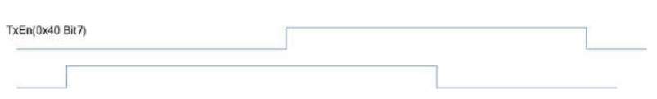

***Figure 5.11*** *Schematic diagram of Layer 2 interrupt distribution*

In Layer 2 mode, once the time axis is established (whether passive or active), the chip will continue to give the TIME_SLOT_INTER and Rdy_lst_inter shown in the figure above for 30ms.

Rdy_lst_inter is not a separate interrupt pin.

The terminal multiplexes an interrupt pin output with Sys_inter.

The multiplexing mode is the same as the three-layer interrupt usage description in 5.1.1.

The

t1 time is the start time of the code sending framing frame,

t2 is the software preparation data and the configuration transceiver control command time, and

t3 is the time from the end of the time slot to the Sys_inter interrupt to the CPU.

The chip is in position 1 or position 2, giving TIME_SLOT_INTER or Rdy_lst_Inter.

The CPU can set the time slot 2 to be transmitted or received according to one of the two interrupts (0x41, Bit7, Bit6).

If time slot 1 is received, then at position 4 the CPU can read the data received in that time slot and provide a decision basis for the next action of the CPU.

Assuming that time slot 1 is received, and time slot 2 is set to transmit after the position 1 (TIME_SLOT_INTER interrupt) and before position 2 (Rdy_lst_inter interrupt), the chip will give RF_TX_INTER for the CPU to set the RF channel correlation. parameter.

Assuming that time slot 1 is a transmission, and time slot 2 is set to receive after the position 1 (TIME_SLOT_INTER interrupt) and before position 2 (Rdy_lst_inter interrupt), the chip will give RF_RX_INTER for the CPU to set the RF channel correlation. parameter.

According to the active-passive mode established by the time axis, the transmission and reception mode control of the time slot of the whole machine is combined into a working mode:

1. **Active sending**

Active sending means that the system is currently in an out-of-synchronization state, initiates a call, and generates synchronization information locally. This situation is mainly applied to the HR_C6000 initiative to initiate single and duplex transmission.

MCU setting send register 0x40 turn on active send 0xA3; (10100011)

*Note (RC). We seem to use 0xE3 (11100011), and are enabling receive as well as Tx, but this doesn’t seen to be necessary*

The establishment of this flag bit will cause the chip to generate active transmission synchronization information, and send a 30ms interval interrupt to the MCU through TIME_SLOT_INTER;

After receiving the 30ms interrupt, the MCU reads the 0x42 status bit7-5 and judges the current time slot transmission and reception:

001 indicates that the current time slot is a working time slot, but the transceiver is fully closed;

101 indicates that the current time slot is a working time slot, and the sending is enabled;

011 indicates that the current time slot is a working time slot, and reception is enabled.

xx0 indicates that the current time slot is a non-working time slot, and the transceiver does not need to be opened;

The MCU obtains the time slot transmission and reception status of the HR_C6000 to determine the operation requirement of the next time slot according to the protocol.

After the 30ms synchronization time slot is established, if the next time slot needs to be sent,

write framing is required in t2 (including 196bit rate 1 data stream, 144bit rate 3/4 data stream, 96bit rate 1/2 data stream, 96bit Custom control information frame, 80bit data frame header or CSBK data frame, 72bit voice frame header, end of frame data, data format and content requirements are designed according to DMR protocol standard.

When receiving Rdy_lst_inter interrupt, set the value of register 0x41.

To determine whether the next time slot is sent 0x80 (send), 0x00 (not sent); if the Rdy_lst_inter interrupt is masked, the 0x41 register can be directly configured in the 30ms interrupt

(TIMER_SLOT_INTER, position 1 in the figure), that is, the configuration is sent and not sent first. For data writing, this requires the user to ensure that all data preparations that require framing are completed within t2.

The chip reads the Bit7 flag of 0x40 at the beginning of the t1 time. If it is 1, the data in the data buffer will be mapped and sent in t1 time.

The CPU can configure the relevant RF channel for transmission according to the RF_Tx_Inter interrupt.

1. Active reception (active full duplex)

|  |  |  |  |  |  |  |  |
| --- | --- | --- | --- | --- | --- | --- | --- |
|  |  | transmit | Receive |  | transmit | Receive | TIME_SLOT_INTER |
| T2 | T1 |  |  | t3 |  |  | Rdy_lst_Inter software preparation data last time interrupt prompt  Sys_Inter  t1=1.7ms,t2=27ms,t3=4ms |
| The t1 time is the start time of the chip sending code group frame, t2 is the software preparation data and the configuration transceiver control command time, and t3 is the interrupt for providing data to the mcu after the chip parsing data is completed. In addition, the Sys_inter interrupt indicated by the red arrow indicates that the decoded data stream is ready to be completed in the layer 2 mode, and the 264 or 288 bit data obtained in the physical layer mode is ready to be completed. | | | | | | | |

***Figure 5.12*** *Active full-duplex transceiver interrupt diagram*

Active reception occurs at the time of active full-duplex.

Active full-duplex means that the call initiator first sends a request, and the MCU configuration register 0x40 turns on the transmission enable, and actively establishes a 30ms time slot interrupt. After the synchronization time slot is established, the MCU configuration register 0x41 allocates the transmission time slot and the reception time slot of the HR_C6000, thereby realizing full-duplex communication.

Active and active reception, active full duplex by controlling 0x41 TxNxtSlotEn (Bit7) and RxNxtSlotEn (Bit6). The received synchronization slot does not update the synchronization of the system.

Reception in this mode is called active reception.

1. Passive reception

*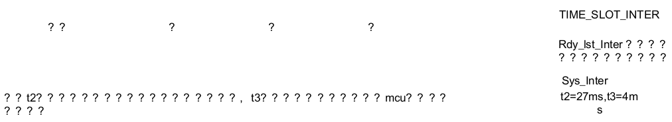****Figure 5.13*** *Schematic diagram of passive reception interrupt – OMISSIS*

**Passive mode**

Passive reception means that the synchronization information of the MS is obtained by receiving, and the transmission synchronization information of the local is updated by the reception. Mainly used for passive reception of single and duplex.

The MCU sets the receive register to enable passive mode

0x40 is set to 0x43;

The HR_C6000 starts receiving, but before receiving the interrupt,

The received register

0x41 needs to be set to 0x40,

and enters the continuous receiving state (called blind reception).

After receiving the receiving interrupt, the internal synchronization mechanism of the chip will establish and receive signals.

Consistent synchronization mechanism, so according to the received data to determine whether the next time slot is received, the recommended way is to read the cc of 0x52 after receiving the Sys_inter interrupt, to determine whether the synchronization is established.

If cc does not match, configure

0x41 as 0x20 Re-acquisition of synchronization information.

If cc matches, determine the transmission and reception of the next time slot according to the contents of 0x51 register.   
*(Register 0x51 contains the frame type etc, so I presume this means, to check the frame and use the appropriate Rx code e.g for Voice or Data)*

If the data is correct, write 0x41 to 0x00 to close the reception, and then turn on the reception when TIME_SLOT_INTER interrupt arrives, the chip will generate

The corresponding RF_rx_inter interrupt uses the interrupt to control the RF module.

In the passive mode, the synchronization mechanism guarantees that if there is receiving synchronization information and the gap with the existing local synchronization is within 1.25ms, real-time synchronization adjustment will be performed, if the reception synchronization disappears (the reception signal disappears, and the control does not control 0x41 for reception), the chip According to the existing local synchronization information, the 30ms is counted and the TIME_SLOT_INTER interrupt is provided until the MCU turns off TxEn (0x40 Bit7) and RxEn (0x40 Bit6); at this time, the MCU can be determined to be passive or active according to the actual situation;

The parsing frame content of the current receiving time slot (including 196 bit rate 1 data stream, 144 bit rate 3/4 data stream, 96 bit rate 1/2 data stream, 96 bit custom control information frame, 80 bit data frame header or CSBK data frame, 72 bit voice) The frame header and the end of the frame will give the Sys_Inter interrupt after the t3 time of the next time slot. The MCU can judge the receive interrupt type according to the interrupt read frame type register 0x82. The 0x51 register determines the received data frame type and check information, and the 0x52 register judges The CC match result indicates that the MCU can take the corresponding deframe information from the RX side RAM space.

1. **Passive transmission (passive full duplex)**

The passive mode also occurs at the time of full duplex. At this time, full duplex means that the synchronization information of the MS is obtained by receiving, the system establishes a synchronization time slot, performs full duplex communication, and is always in the local transmission synchronization by using the reception synchronization information. Information status.

Passive full-duplex is a combination of passive and passive transmission implemented by MCU control 0x41.

The specific operation mode is the same as the passive reception and passive transmission modes.

|  |  |  |  |  |  |  |
| --- | --- | --- | --- | --- | --- | --- |
|  |  | Transmit | Receive | Transmit | Receive | TIME_SLOT_INTER |
| T2 | T1 |  |  |  |  | Rdy_lst_Inter software preparation data last time interrupt prompt |
| The t1 time is the start time of the chip sending code group frame, t2 is the software preparation data and the configuration transceiver control command time, and t3 is the interrupt for providing data to the mcu after the chip parsing data is completed. | | | | | | Sys_Inter |
|  | | | | | | t1=1.7ms,t2=27ms,t3=4ms |

***Figure 5.14*** *Passive full duplex transceiver*

### Application examples

The default services in Layer 2 mode include voice transmission, data transmission, voice reception, and data reception.

**Data transmission:**

1. Configure reg0x10 to be 0x6A at power-on and set the system to Layer 2 non-relay mode.
2. After receiving the send request (button or other means),   
   configure reg0x40 to 0xA3 and set it to active mode.
3. After receiving a 30ms interrupt, the MCU configures   
   reg0x41 to be 0x80 and   
   reg0x50 to 0x60.   
   Then, the 80bit data frame header information to be sent is written to the 1.2KRAM 0x00~0x09 address space of the HR_C6000 sender.
4. When the next 30ms interrupt arrives,   
   configure reg0x41 to 0x00, and idle one time slot is not sent;
5. After the next 30ms interrupt arrives,   
   configure reg0x41 to 0x80,   
   reg0x50 to 0x70,   
   and then write the 96bit data information to be sent to the 0x00~0x0b space of 1.2KRAM.
6. Repeat steps 4 and 5 in sequence until all required data frames and CRC32 check bits at the end of the frame are sent.
7. After the next one or several 30ms of data frame transmission is completed, configure reg0x40 to 0x03 to disable the transmission enable and end the transmission.

**Data reception:**

1. On power-on, configure reg0x10 to 0x6A and set the system to Layer 2 non-relay mode; reg40 to 0x43 and reg41 to 0x40, and the system is busy.
2. when receiving sys_inter, read reg0x51 and reg0x52, if reg0x51[7:4] is equal to local cc (default is 0x01), and reg0x51[7:4] is equal to 0x06, and reg0x51[2] is equal to 0, then read Take the low 7bit information of the 0x08 address in the receiving RAM, determine the total number of frames to be received next (if the total number of frames to be received is increased by 1), and the address information in the 80 bits in the RAM matches the local address to determine whether it is the data header to be received. ;
3. When the next 30ms interrupt arrives, configure reg0x41 to 0x00. The next time slot is not the received working time slot, and the reception is closed.
4. When the next 30ms interrupt arrives, configure reg0x41 to 0x40. The next time slot is the receive time slot, open the reception, and decrement the number of receptions.
5. Repeat 3 and 4 in turn, and the reception is decremented to 0 at this time.
6. In the next 30ms interrupt, configure reg0x41 to 0x40 to be in the busy state again. If you want to turn off reception, configure reg0x40 to 0x03 and reg0x41 to 0x20 and then to 0x00.

In addition, each time sys_inter is received, reg0x52 and reg0x51 are read to determine the state and nature of each frame of data, and the 96-bit data of 0x00~0x0B of the receiving end RAM is read to obtain the content of the received data frame.

**Voice transmission:**

1. On power-on, configure  
   register 0x10 to 0x6A, set the system to Layer 2 non-relay mode, and   
   register 0x06 to 0x45. The vocoder is controlled by the MCU.
2. After receiving the send request (button or other means), configure   
   register 0x40 to 0xA3 and set it to active mode.
3. After receiving a 30ms interrupt, the MCU configures   
   register 0x41 to be 0x80 and   
   reg0x50 to 0x10.   
   Then, the 80bit voice frame header information to be sent is written to the Tx_buffer 0x00~0x09 address space of the HR_C6000 sender.
4. When the next 30ms interrupt arrives,   
   configure reg0x41 to 0x00, idle one time slot is not sent, and then configure   
   register 0x22 to 0x80 to enable the vocoder code switch.
5. in the next 30ms interrupt is coming, then   
   register 0x41 is configured to 0x80,   
   register 0x50 is configured to 0x08, the next frame is ready to send speech frame A.
6. When the next 30ms interrupt arrives, configure   
   register 0x41 to 0x00, and idle one slot will not be sent.
7. When the next 30ms interrupt arrives, configure   
   register 0x41 to 0x80,   
   register 0x50 to 0x19, and the next frame to send speech frame B.
8. Repeat 6 and 7 in sequence to send the remaining C, D, E, and F frames reg0x50 to 0x2B, 0x3B, 0x4A, and 0x58, respectively.
9. repeat 5~8, keep sending voice frames A, B, C, D, E, F until the button is released, and send all the super frames.
10. Receive a 30ms interrupt at the beginning of the idle time slot, configure   
    register 0x41 to be 0x80, and   
    register 0x50 to 0x20, ready to send the end of the speech frame.
11. When the next 30ms interrupt arrives, when the next 30ms interrupt arrives, configure reg0x41 to 0x00, register 0x22 to 0x40, and the vocoder code is turned off.
12. After the next or a few 30ms of the end of the speech frame is sent, configure reg0x40 to 0x03 to disable the transmission enable and end the transmission.

**Voice reception:**

1. On power-on, configure reg0x10 to 0x6A and set the system to Layer 2 non-relay mode; reg40 to 0x43 and reg41 to 0x40, and the system is busy.
2. when receiving sys_inter,   
   read reg0x50 and   
   reg0x51,   
   if reg0x51[7:4] is equal to local cc (default is 0x01),   
   and reg0x50[7:4] is equal to 0x01,   
   and reg0x50[2] is equal to 0,   
   and reg0x50 When [1:0] is equal to 0x01,  
    the 0x00~0x08 information in the receive RAM is read.   
     
   If addrs 0x00 corresponds to a value of 0x00, then match local groupaddrs with addrs0x03~ addrs0x05;   
   if addrs 0x00 corresponds to 0x03, match local srcaddrs with addrs0x03~addrs0x05.
3. When the next 30ms interrupt arrives, configure   
   reg0x41 to 0x00.   
     
   The next time slot is not the received working time slot. The receiving is closed. If the address matches, the configuration register 0x22 is configured to 0x20, and the vocoder decoding switch is turned on. .
4. When the next 30ms arrives, configure   
   reg0x41 to 0x50, enable the next time slot to receive enable, and turn on the voice stream output enable to provide the received voice frame to the vocoder output.
5. when the next 30ms arrives, configure   
   reg0x41 to 0x00, the next time slot is not the received working time slot, and the receiving is closed;
6. repeat 4 and 5 until you receive sys_inter, read and read reg0x51. If reg0x51[7:4] is equal to local cc (default is 0x01), and reg0x51[7:4] is equal to 0x01, and reg0x51[2] is equal to 0, and reg0x50[1:0] is equal to 0x02, read receive RAM 0x00~0x08 information. If addrs0x00 has a value of 0x00, then match local groupaddrs with addrs0x03~ addrs0x05; if addrs0x00 has a value of 0x03, match local srcaddrs with addrs0x03~ addrs0x05. If the address matches, the configuration register 0x22 is configured to 0x10, and the vocoder decoding is turned off.
7. For the next 30ms interrupt, configure reg0x41 to 0x40 to be in the busy state again. If you want to turn off reception, configure reg0x40 to 0x03 and reg0x41 to 0x20 and then to 0x00.

### Bit error rate test

1. Test Methods:

The HR_C6000 continuously receives 4FSK modulated low IF signals in one layer mode, and the signal frequency is configurable. It is recommended to use 455 kHz or 450 kHz IF signals. HR_C6000 stores the demodulated 36 bytes of data per frame into the interval of the receiving end 1.2KRAM space starting address 0x30. The MCU can read each frame of data from the RAM through the SPI interface and compare it with the 36 bytes of the transmitted data to get the number of error bits of the frame data. The number of error bits per frame of continuous continuous test is accumulated for a long time, and the bit error performance of HR_C6000 is counted.

The data stored in the RAM, the defined data storage structure is shown in Figure 5.15. The MCU can read the frame type (SyncState and SyncClass (0x51)) according to the interrupt, and read the corresponding length data according to the frame type, and parse according to the format. (The data content in the dotted box is to receive additional CACH data in continuous mode).

|  |  |  |  |
| --- | --- | --- | --- |
| SlotType  20bit | SYNC  48bit |  | Data  196bit |
| SYNC/EMB  /RC 48bit |  | Voice  216bit |  |
| SYNC  48bit | Data  48bit |  |  |

***Figure 5.15*** *Receive Data Frame Type Format*

1. Register settings:

Realize the bit error rate test function in one layer mode, the register that needs to be configured is

Realize the bit error rate test function in one layer mode, the registers that need to be configured are ***Table 5.6*** *One layer mode error rate test control register address description*

|  |  |  |
| --- | --- | --- |
| Address | Configuration value | Description |
| 0x01 | 2’bxxxx 0000 | Configured in IF receive mode. |
| 0x07 | 2’b0000 1011 | The IF frequency word is 8 bits high, and the 24-bit IF frequency word is divided by 2^24 by 9.8304M to get the final IF frequency. The default setting is 455kHz. |
| 0x08 | 2’b1101 1001 | 8 bits in the IF frequency word. |
| 0x09 | 2’b0101 0100 | The IF frequency word is 8 bits low. |
| 0x10 | 2’b0000 0010 | One layer mode, and continuous reception, if you need time slot reception, you need to configure bit5 to 1. |
| 0x40 | 2’b0100 0000 | Receive enable is enabled and configured as a test mode. |
| 0x41 | 2’b0100 0001 | Receive test enable is enabled. |

# FM application

The HR_C6000 is compatible with FM and supports FM transceiver function. The HR_C6000 can work in FM mode by configuring register 0x10[7]=1'b1. The chip is embedded with modules such as weighting, de-emphasis, compression, and decompression. Users can select the required functions according to their needs. In the transceiver mode, the user can select the 12.5KHz/25KHz channel filter, and in order to prevent excessive modulation, the limiter is embedded in the filter.

|  |  |  |  |  |  |  |
| --- | --- | --- | --- | --- | --- | --- |
| Mic_in | ADC | Compression | Aggravation | Filter | FM modulation | Tr_I/Mod1  Tr_Q/Mod2 |
| Audio_out |  | Decompression | To increase | Filter | Phase discrimination | Recv_I  Recv_Q |

***Figure 6.1*** *FM Transceiver Block Diagram*

## FM send

In the analog mode, the HR_C6000 can only work in simplex mode, and the analog transmit channel is opened by configuring register 0x60=0x80. The speech is sampled and converted into a digital signal by the ADC in Codec. After the HR_C6000 internal compression and weighting module performs audio signal processing, it passes through the 12.5KHz/25KHz channel filter to improve the ACPR of the transmitted signal.

The transmission of voice and signaling such as analog voice, analog/digital sub-tone (CTCSS and CDCSS), DTMF, 2-tone/5-tone and MSK is mainly supported on the above analog channels.

Bandpass filter

The HR_C6000 has an optional bandpass filter with a signal bandwidth of 300Hz to 3400Hz. The bandpass filter can be turned on by configuring Register 0x34[7]=1’b1.

*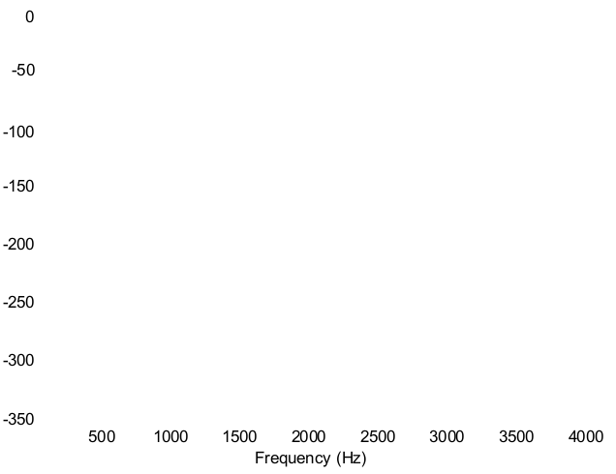****Figure 6.2*** *Bandpass filter spectral response – OMISSIS*

Compression

The audio compander consists of a compressor and a decompressor to reduce the effects of noise on audio quality.

A compressor is used at the transmitting end to reduce the dynamic range of the audio signal by amplifying the small signal and reducing the large signal.

The Syllabic compander is used in the HR_C6000 to change the amplitude of the average envelope of the signal according to the time constant t. The steady-state output of the compressor is the root mean square of the input signal, that is, when the input signal is increased or decreased by 2dB, the output signal is correspondingly increased or decreased by 1dB. Generally, in a voice communication system, the dynamic range can be converted from 60 dB of the input signal to 30 dB of the output signal by audio compression technology. The user can open the compression module by configuring register 0x34[6]=1’b1. It should be noted that the compressor should be used in conjunction with decompression.

*OMISSIS*

***Figure 6.3*** *Compressed Time Domain Response*

At the same time, the user can set the compressor's 0dB compression point by configuring Register 0x2D[3:0].

Aggravation

The HR_C6000 provides an optional weighting module that meets the requirements of the TIA. The weighting module processes the audio signal in the 300Hz to 3000Hz band at +6dB/Oct. The weighting module can be turned on by configuring register 0x34[5]=1'b1.

*OMISSIS*

***Figure 6.4*** *Weighted frequency response curve*

Filter

The HR_C6000 provides two sets of low-pass filters with embedded soft limiters, 2.55KHz and 3KHz low-pass filters, of which 2.55KHz can be used for 12.5KHz channel spacing to provide better ACPR specifications; 3KHz low The pass filter is typically used for channel spacing of 25KHz. Select by configuration register 0x34.

FM modulation

If the transmit RF interface of the HR_C6000 is configured for baseband IQ or IF mode, FM signal modulation of the audio signal is performed using the FM modulator inside the HR_C6000. The modulation offset is adjusted by configuring 0x3E and Mic gain 0x0F, while preventing overmodulation by configuring the soft limit register 0x3F of the transmit low pass filter.

### CTCSS send

The system determines the sub-tone rate (62.5~254.1Hz) according to the set CTCSS sending address code (1~51). The sub-tone signal is generated by querying the sine table. Different frequencies correspond to different addressing step lengths. The accumulated method sequentially outputs sinusoidal data at a sampling clock rate.

***Figure 6.5*** *CTCSS Transmit Block Diagram – OMISSIS*

At the moment the PTT button is released, the audio signal transmission ends, and the subsonic signal phase reversals and continues to remain in the air for approximately 155ms to ensure sufficient voice path closure processing time at the receiving end. Among them, the inversion of the subsonic phase is realized by the above-mentioned sinusoidal table addressing phase jump.

The subsonic signal is weighted by the modulation coefficient (which can be configured by software) and superimposed with the audio signal, and then modulated by FM.

The detailed usage is detailed in Appendix A2.2.1.

### CDCSS send

The transmitter first transmits the original data 12-bit via the golay coding cycle to the 23-bit DCS code, then the DCS code is NRZ(1) mapped, and the two-stage interpolated and filtered data is input to the FM modulator to obtain the modulation phase value and the baseband modulation to form the CDCSS. Baseband signal output.

*****Figure 6.6*** *Transmitter system block diagram*

Detailed usage is detailed in Appendix A2.2.2.

### DTMF sending

The DTMF signal is generated by a combination of four sets of high frequency signals and four sets of low frequency signals. The low frequency signal is 2.5 dB lower than the amplitude of the high frequency signal. The DTMF signal is sent before the start of the audio signal, after the PTT is valid, and under normal circumstances, from the PTT press to the transmission of the DTMF signal, there is an idle state of about 600ms in the middle, in order to allow the receiver to have enough time to enter Detection mode.

Flow Description:

Like CTCSS, DTMF signals are also generated by querying a sine table. The high frequency signal is superimposed with the low frequency signal and weighted by the modulation frequency offset coefficient, which is modulated by FM and output. Each DTMF code corresponds to a signal length of 50ms, followed by an IDLE state of 50ms. The length of the code that DTMF can support is determined by the user.

*OMISSIS*

***Figure 6.7*** *DTMF Transmit Block Diagram*

### 2-tone send

The 2-tone signal has an in-band tone signal and an IDLE gap to form a tone sequence. Take the EIA standard as an example. Each group of tones has a duration of 33ms and an IDLE gap of zero. However, considering compatibility with other standards, software is available for signal length and IDLE gap duration. As shown in the figure below, the switching between the tone signal and the IDLE gap is achieved by the combination of the timing module and the path selection module.

Selcall tone occurs after the PTT is pressed and before the audio signal is transmitted. Selcall tone is weighted by modulation factor and output after FM modulation.

Path selector

Selcall tone tone

generation module

FM modulation

Modulation coefficient

weighting

IDLE

Timing module

***Figure 6.8*** *2-tone Transmit Block Diagram*

The detailed usage is detailed in Appendix A2.2.4.

### 5-tone send

5-tone is sent in the same way as 2-tone, with different register control bits to distinguish. The detailed usage is detailed in Appendix A2.2.5.

## FM reception

When configuration register 0x60=0x00, HR_C6000 is in receive mode. The HR_C6000 filters and receives the received IQ (or intermediate frequency) signal and sends it to the FM processing module. The phase-detected signal is filtered by an audio filter and then processed by Codec after an optional de-emphasis and decompression module.

The above analog channels mainly support the reception of voice and signaling such as analog voice, analog/digital sub-tone (CTCSS and CDCSS), DTMF, 2-tone/5-tone and MSK.

Filter

HR_C6000 provides two sets of low-pass filters in the FM receive processing channel, 2.55KHz and 3KHz low-pass filters, of which 2.55KHz can be used for 12.5KHz channel spacing; 3KHz low-pass filter is usually used for 25KHz channels interval. It can be selected by configuring the 0x34 register.

The HR_C6000 provides an optional de-emphasis module that meets the TIA requirements. The de-emphasis module processes audio signals in the 300Hz to 3000Hz band at -6dB/Oct. The de-emphasis module can be turned on by configuring register 0x34[5]=1'b1.

*OMISSIS*

***Figure 6.9*** *De-emphasis frequency response curve*

Decompression

A decompressor is used at the receiving end to increase the dynamic range of the audio signal by reducing the large signal and amplifying the small signal.

The steady-state output of the decompressor is the square of the input signal, that is, when the input signal is increased or decreased by 1dB, the output signal is correspondingly increased or decreased by 2dB. Generally, in a voice communication system, the dynamic range can be converted from 30 dB of the input signal to 60 dB of the output signal by audio compression technology. The user can open the compression module by configuring register 0x34[6]=1’b1.

*OMISSIS*

***Figure 6.10*** *Decompressing the time domain response*

At the same time, the user can set the compressor's 0dB compression point by configuring Register 0x2D[7:4].

Bandpass filter

The HR_C6000 has an optional bandpass filter built into the FM receiver. The signal bandwidth is 300Hz to 3400Hz. The bandpass filter can be turned on by configuring the register 0x34[7]=1’b1.

### CTCSS reception

The CTCSS air signal generates phase information through the phase detector, and the DC offset of the signal is cancelled by the frequency offset calibration module. After the limiting processing, the high frequency audio portion is filtered by the 4th order IIR 300Hz low pass filter.

The frequency response amplitude detection result is compared with the preset threshold value. When the threshold is greater than the threshold, the voice enable is enabled, and the output interrupt signal is sent to the peripheral to open the speaker and the voice path.

*OMISSIS*

***Figure 6.11*** *CTCSS Receive Block Diagram*

Detailed usage is detailed in Appendix A2.2.1.

### CDCSS reception

The CDCSS modulation consists of an FM demodulation module that uses a non-coherent demodulation scheme. CDCSS signal reception includes key steps such as differential phase discrimination, frequency offset estimation, decision, and golay decoding. The flow of back-end baseband processing is shown in Figure 6.12.

*OMISSIS*

***Figure 6.12*** *Receive Baseband Processing Flowchart*

The CDCSS baseband signal is filtered by a low-pass filter to remove some of the out-of-band noise and reduced to an amplitude value by FM demodulation. Then the next two LPFs further filter out the noise and audio signals and then perform frequency offset compensation. The signal obtained at this time passes 7 times. The extraction of the symbol rate hardly determines the golay decoding to select the best one.

The detailed usage is detailed in Appendix A2.2.2.

### DTMF reception

The demodulation process of DTMF analyzes the air signal frequency distribution and reverse decodes according to the DTMF combination. Calculate the frequency response amplitude of the air signal at 8 groups of frequencies, and select the maximum amplitude in the high frequency part and the maximum amplitude in the low frequency part respectively. A combination of the two can determine the DTMF code.

At the end of each set of DTMF decoding, a system interrupt will be generated, and a flag indicating whether the DTMF detection is complete. After receiving the interrupt, the peripheral saves the DTMF code in a buffer area, and when a certain interrupt comes and the detection end flag information is valid, all the previously stored DTMF codes are combined into one frame output.

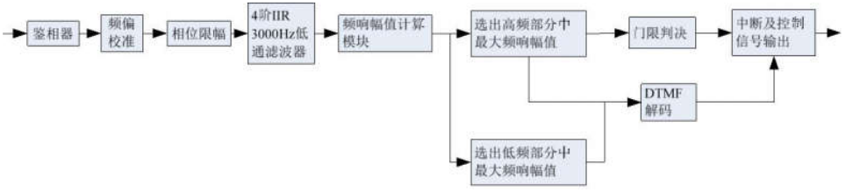

***Figure 6.13*** *DTMF Receive Block Diagram*

The detailed usage is detailed in Appendix A2.2.3.

### 2-tone reception

2-tone's demodulation mechanism is similar to address matching, and the voice path can only be turned on when 2-tone matches the receive address setting. 2-tone contains two sets of tones or a set of long tones, so each time the match is correct, the demodulation coefficient is set to the corresponding value of the next set of received frequency points. In addition, a timeout mechanism is added to the module. If the frequency point cannot be matched for a long time, the previous result is cleared and the matching process is restarted.

*OMISSIS*

***Figure 6.14*** *2-tone Receiver Block Diagram*

The detailed usage is detailed in Appendix A2.2.4.

### 5-tone reception

The 5-tone reception process is the same as 2-tone, and is distinguished by different register control bits. The detailed usage is detailed in Appendix A2.2.5.

# MSK application note

## MSK send

The MSK transmission first frames the information data according to the frame structure, then maps the data into the MSK modulation, and then transfers the modulated data to the 1.5KHz intermediate frequency through the NCO. The MSK and spectrum shifting are performed in one module. A continuous phase signal is generated and finally input to the FM modulation. Thus the modulation process of the entire data is completed.

*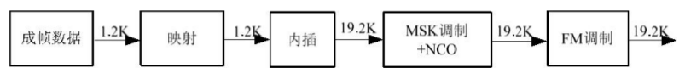****Figure 7.1*** *Transmitter system block diagram*

## MSK receiving

The MSK modulation proposed by MPT1327 contains an FM modulator, so the design of the receiver is opposite to the modulation process, and the FM demodulation module is added, that is, the non-coherent demodulation scheme is adopted. The receiver is divided into front-end data acquisition and back-end baseband signal processing.

The front-end data collection part is similar to the second half of the sending end, and will not be described here. In the back-end signal processing part, key steps such as arrival detection, timing synchronization, and decision are all completed in this part. The flow of MSK baseband processing is shown in Figure 7.2.

*OMISSIS*

***Figure 7.2*** *Receive Baseband Processing Flowchart*

The receiver design uses non-coherent demodulation, using the front-end data acquisition module to obtain two baseband IQ signals, followed by differential phase discrimination, then sent to a low-pass filter to eliminate out-of-band noise, and finally back-end signal processing.

## MCU instructions

### MCU workflow

#### Initialization

MCU initialization, configuration register TrainErrorThreshold is 5, DTBeforeTransAndRec is 160, Channel_Delay is 20, NT is 103.

#### Send control

Control channel transmission

When the MCU needs to send data, when it detects the receiving time slot interrupt, it first writes the ping ping buffer, then configures the sending.

The storage OperationType is 1, the ChannelType is 0, the TranOrRecFlag is 1, MacFrameEn (1 for MAC framing, 0 for PHY framing), 0 for Unsolicited, and 0 for MultiMessageTransFlag. When the MAC receives a ping-pong buffer half-full interrupt, there are two cases:

PHY framing. The data sent each time is 64 bits. If there is still no bit data sent, continue to send 64 bits. Set MACTransFinishFlag to 1 if there is no data to send.

MAC framing. The previous data is 64 bits at a time, and the last time the data is sent may be less than 64 bits. If there is still no bit data sent, continue to send. If it is the last time to send data, set MACTransFinishFlag to 1, and send data and configure RemBitNum as the remaining data bit length.

Traffic channel transmission control

When the MCU needs to send data, it first writes the ping-pong buffer, then the MCU configuration register OperationType is 1, the ChannelType is 1, the TranOrRecFlag is 1, the MacFrameEn (the MAC framing is 1, the PHY framing is 0), and the Unsolicited is 1.

When the MAC receives the ping-pong buffer half-full interrupt, there are two cases:

PHY framing. The data sent each time is 64 bits. If there is still no bit data sent, continue to send 64 bits. Set MACTransFinishFlag to 1 if there is no data to send. If the multi-frame information is sent, the first message is sent, and the 64-bit data is set to the MultiMessageTransFlag register and the next message is sent.

MAC framing. The previous data is 64 bits at a time, and the last time the data is sent may be less than 64 bits. If there is still no bit data sent, continue to send. If it is the last time to send data, set MACTransFinishFlag to 1, and send data and configure RemBitNum to the remaining data bit length.

Data channel transmission control

The data channel transmission control is the same as the control channel transmission, except that the ChannelType is set to 2.

#### Receiving control

Control channel reception

When the MCU needs to receive the receipt, the configuration register OperationType is 1, ChannelType is 0, TranOrRecFlag is 0, AcqEnable is 1, RxInterMask is 0, and CtrlDataInterMask is 0. The MCU receive interrupt handler reads the register values ( RecBitLen , TrainCodewordFlag , and TrainErrorBitNum ) after detecting the receive terminal pulse and reads the corresponding length data based on the register value.

Traffic channel reception

When the MCU needs to receive the receipt, the configuration register OperationType is 1, the ChannelType is 1, the TranOrRecFlag is 0, the AcqEnable is 1, the RxInterMask is 0, and the CtrlDataInterMask is 0. The MCU receive interrupt handler reads the register values ( RecBitLen , TrainCodewordFlag , and TrainErrorBitNum ) after detecting the receive terminal pulse and reads the corresponding length data based on the register value.

Data channel reception

When the MCU needs to receive the receipt, the configuration register OperationType is 1, ChannelType is 2, TranOrRecFlag is 0, AcqEnable is 1, RxInterMask is 0, and CtrlDataInterMask is 1. The MCU receive interrupt handler reads the register values ( RecBitLen , TrainCodewordFlag , and TrainErrorBitNum ) after detecting the receive terminal pulse and reads the corresponding length data based on the register value.

### Reset operation

When recapture is required, the physical layer can be reset to 1 and then 0 by the configuration register SoftRest.

## Parameter configuration

### Basic parameter configuration

1. Capture and synchronization decision threshold
2. The delay between the receive pulse and the transmit start pulse.
3. NT

***Table 7.1*** *Basic Parameter Configuration*

|  |  |  |  |
| --- | --- | --- | --- |
| Address | Name | Default value | Definition |
| 0x12A | TrainErrorThreshold | Bit7-Bit6 | Reserved |
|  |  | Bit5-Bit0 | The training sequence for capture and synchronization determines the threshold. |
| 0x12B | DTBeforeTransAndRec |  | The delay between receiving the pulse and transmitting the initial pulse. The value configured here is based on the 19.2kHz sampling clock. Assuming a configuration value of n, the delay time is n/19.2 milliseconds. |
| 0x12C | NT |  | Delay difference between MAC group frame and air interface transmission start point |
| 0x12D | ChannelDelay |  | The maximum delay (in bits) of the TSC response to the active message on the service channel. |

### MAC Delivered parameter configuration

1. Whether to capture the message (AcqEnable).
2. The message of the channel (control channel, traffic or data channel, Channel Type) of the current channel.
3. The current time slot is a message transmitted or received (TranOrRecFlag).
4. Working mode (working state or idle state, OperationType).
5. The remaining message that sends the bit data length. The framing is divided into a MAC framing and a PHY framing. In the case of a MAC framing, since the total number of bits is not necessarily a multiple of 64 (including the link establishment time, etc.), when the number of transmitted bits is less than 64 bits, You must tell the PHY how many bits remain without being sent (RemBitNum).
6. Software reset message (SoftRest).
7. Multi-message frame transmission message (MultiMessageTransFlag), when transmitting multiple information frames, before the flip bit is inserted at the intersection of the two information, this message is given, given when the PHY group is framed, and the MAC group frame is not given.
8. Receive interrupt mask message (RxInterMask).
9. Control data interrupt mask message (CtrlDataInterMask).
10. MAC transmission end message (MACTransFinishFlag).
11. Active frame information (Unsolicited). Valid when the traffic channel is sent.

***Table 7.2*** *MAC Provisioning Parameters Configuration*

|  |  |  |  |
| --- | --- | --- | --- |
| Address | Name | Default value definition | Description |
| 0xd5 | AcqEnable | Bit7 | 1: PHY performs a capture operation.  0: Does not work.  Note: This message is active for the upper transition, so the PHY reads 0 immediately after AcqEnable is set to 1 by the MAC. |
|  | OperationType |  | 0: indicates an idle state.  1: indicates the working status. |
|  | ChannelType | Bit5- Bit4 | Base station as the type of transmission channel  00: Control channel.  01: Traffic channel.  10: Data channel.  11: Reserved. |
|  | TranOrRecFlag | Bit3 | 0: Receive.  1: Send. |
|  | SoftReset | Bit2 | The base station acts as the reset signal of the transmitting module, and the hand set is used for receiving reset and sending reset.  0: Does not work.  1: Reset. |
|  |  | Bit1- Bit0 | Reserved |
| 0xd6 |  | Bit7- Bit6 | Reserved |
|  | RemBitNum | Bit5- Bit0 | The remaining bits of the MAC are not sent. Range 0-63. |
| 0xd7 | MultiMessageTr  ansFlag | Bit7 | 0: does not work  1: After the current codeword is sent, add the flip bit.  Note: This message is active for the upper transition, so the PHY reads 0 immediately after AcqEnable is set to 1 by the MAC. And only valid for PHY framing. |
|  | RxInterMask | Bit6 | 0: Does not work.  1: Receive interrupt mask. |
|  | CtrlDataInterMa  sk | Bit5 | 0: Does not work.  1: Receive interrupt mask. |
|  | MacFrameEn | Bit4 | 0: PHY framing.  1: MAC framing. |
|  | MACTransFinis  hFlag | Bit3 | 0: Does not work.  1: After the current codeword is taken for the PHY group, the bit data is collected. For the MAC group frame, the current codeword is taken out and the RemBitNum length is taken again to end the bit data. |
|  | Unsolicited |  | 0: Send response message.  1: Proactively send information. |
|  | msk_voice_send  _en |  | 0: Send MSK signaling information.  1: Send FM voice. |
|  |  | Bit0 | Reserved |
| 0xd8 | ChannelType_R  X | Bit1- Bit0 | The base station is used as the receiving channel type, and the hand station is not used.  00: Control channel.  01: Traffic channel.  10: Data channel.  11: Reserved. |
|  | SoftReset_RX | Bit2 | The base station acts as a reset signal for the receiving module, and the hand station does not use  0: Does not work.  1: Reset. |
|  |  | Bit7- Bit3 | Reserved |

### Parameter Configuration for MAC Acquisition

1) Interrupt category message (CtlDataInterpType). The PHY can have multiple interrupts for the MAC. There are two interrupt pins in total, one of which is the receive time slot interrupt (the receive demodulation interrupt is replaced by the receive time slot interrupt, and the current register data is validated by adding a register flag). One is to control the data interrupt (this interrupt includes sending the ping-pong buffer half-full interrupt and the PHY send end interrupt, which are distinguished by the register vector).

2) Receive data length (RecBitLen). The received data length is divided into 128 bits and 64 bits. The received data length at the time of capture is 128 bits. The received data length during synchronization is 64 bits.

3) Synchronization sequence codeword flag (TrainCodewordFlag). This message tells the MAC whether the currently decoded codeword has a synchronization sequence. This message can be ignored when the received data length is 128 bits.

4) Synchronization sequence error bit number (TrainErrorBitNum). This data is valid when the received data length is 128 bits or the sync sequence code word flag is 1.

***Table 7.3*** *MAC Get Parameter Information*

|  |  |  |  |
| --- | --- | --- | --- |
| Address | Name | Default value definition | Description |
| 0x96 | RecBitLen | Bit7- Bit0 | The length of the received data bits. |
| 0x97 |  | Bit7- Bit6 | Reserved |
|  | TrainCodewordFlag |  | 0: Data code word.  1: With sync sequence codeword. |
|  | TrainErrorBitNum | Bit4- Bit0 | Indicates the number of error bits in the training sequence (range 0 - 31). Only valid when TrainCodewordFlag is 1. |

# Register description

***Table 8.1*** *System Parameter Table*

|  |  |  |  |  |  |  |
| --- | --- | --- | --- | --- | --- | --- |
| Type | Address | R/W | Name | Default value | Definition | Description |
| Reset | 0x00 | W | DMRnRst |  | Bit7 | When it is 0, the DMR protocol is reset. It is valid in one system clock, and the HR_C6000 is automatically cancelled internally. The following reset processing is the same. |
|  |  |  | PHYnRst | 0x00 | Bit6 | Reset to 0 when the physical layer |
|  |  |  | CodernRst |  | Bit5 | Reset codec when 0 |
|  |  |  | FmnRst |  | Bit4 | Reset to FM when 0 |
|  |  |  | VoCoderRst |  | Bit3 |  |
|  |  |  | MSKRst |  | Bit2 | Reset to MSK module when 0 |
|  |  |  | IISRst |  | Bit1 | Reset to I2S interface when 0 |
|  |  |  | CodeCRst |  | Bit0 | When 0, the built-in CodeC is reset, valid in 3 system clocks, and HR_C6000 is automatically revoked internally. |
| Hardware Configuration | 0x01 | W/R | RFTransIQMode |  |  | In IQ mode:  0: indicates that the I channel of the transmitter is in the I channel of the DAC, and the Q channel of the transmitter is the Q channel of the DAC.  1 : Indicates that the transmitter I is at the Q output of the DAC, and the Q at the transmitter is at the I output of the DAC.  In the two-point mode: adjust the modulation frequency offset mapping relationship, as described in 4.7.2. |
|  |  |  | RFRecvIQMode |  | Bit6 | 0: indicates that the I path of the receiving end is in the I input of the ADC, and the Q path of the receiving end is input in the Q path of the ADC;  1 : Indicates that the receiving end I is in the Q input of the ADC, and the Q side of the receiving end is in the I input of the ADC. |
|  |  |  | RFTransMode |  | Bit5-Bit4 | 00 means send IF mode, 01 means send IF IQ mode, 10 means transmit baseband IQ mode, 11 is send two-point modulation mode |
|  |  |  | RFRecvMode |  | Bit3-Bit2 | 00 means receive IF mode, 01 means receive IF IQ mode, 10 means receive baseband IQ mode |
|  |  |  |  |  | Bit1 | IQ road balance debugging, 1 means the signal is 0 plus offset value, 0 means normal value |
|  |  |  |  |  | Bit0 | Controls the phase enable of the input clocks of the ADC and DAC modules. When configured as 1, the clock is in the opposite phase to the system clock, otherwise it is the same. |
|  | 0x02 | R/W | TransIsigCenter | 0x00 | Bit7-Bit0 | In IQ mode: send the offset value of I. If RFTransIQMode is 0, the offset is added to the I path of the DAC. Otherwise, it should be added to the Q path of the DAC.  In two-point mode: adjust the output MOD2 way offset, the adjustment range is about ±422mV, and the minimum adjustment step is 3.3mV. |
|  | 0x03 | R/W | RecvIsigCenter | 0x00 | Bit7-Bit0 | Receive the offset value of I. If RFRecvIQMode is 0, the offset is added to the I path of the ADC. Otherwise, it should be added to the Q path of the ADC. |
|  | 0x04 | R/W | TransQsigCenter | 0x00 | Bit7-Bit0 | In IQ mode: send the offset value of the Q channel. If RFTransIQMode is 0, the offset is added to the Q path of the DAC. Otherwise, it should be added to the I path of the DAC.  In two-point mode: adjust the output MOD2 way offset, the adjustment range is about ±422mV, and the minimum adjustment step is 3.3mV. |
|  | 0x05 | R/W | RecvIsigCenter | 0x00 | Bit7-Bit0 | Receive the bias value of the Q path. If RFRecvIQMode is 0, the offset is added to the Q path of the ADC. Otherwise, it should be added to the I path of the ADC. |
|  | 0x06 | R/W | Vocoder | 0x40 | Bit7-Bit6 | 00 Select V_SPI vocoder  01 Select AMBE3000  11 Select AMBE1000 |
|  |  |  | DMRFrom |  | Bit5 | 0 indicates that two vocoders (AMBE3000, AMBE1000) are selected as the source coded output, and 1 is the vocoder coded output accessed through the V_SPI universal interface. |
|  |  |  | VocoderFrom |  | Bit4 | 0 indicates that the voice codec packet is processed by the DMR protocol layer, and the vocoder works normally in the voice transmission state;  1 indicates that the speech code is directly sent to the decoding buffer of the vocoder; at this time, the vocoder works in the self-loop test state. |
|  |  |  | SPIFrom |  | Bit3 | 0 means that the general V_SPI interface reads the voice data from the protocol layer of the DMR chip, and the vocoder works normally in the voice receiving state;  1 indicates that the general V_SPI interface reads the codec packet directly from the vocoder of the DMR chip. At this point the vocoder works on the recording of the voice. |
|  |  |  | CodeCMode |  | Bit2 | 0 means built-in, 1 means external |
|  |  |  | OpenMusic |  | Bit1 | 1 Turned on to play the boot sound or call  Prompt, etc., 0 off |
|  |  |  | LocalVoCoderControl |  | Bit0 | 0 means the system is automatically controlled, 1 means the switch of the MCU control vocoder |
|  | 0x07 | R/W | IFFreq2 | 0x0B | Bit7-Bit0 | The IF frequency word is 8 bits high, and the 24-bit IF frequency word is divided by 2^24 by 9.8304M to get the final IF frequency. |
|  | 0x08 | R/W | IFFreq1 | 0xB8 | Bit7-Bit0 | 8 bits in the IF frequency word |
|  | 0x09 | R/W | IFFreq0 | 0x00 | Bit7-Bit0 | IF frequency word is lower 8 bits |
|  | 0x0A | R/W | Clk_enb | 0x81 | Bit7 | Clock switch control bit. The internal clock is switched from the crystal clock to the output clock control bit of the PLL. A high level indicates that the internal clock directly clocks the crystal. After changing the configuration reg0x0B and reg0x0C, it is necessary to wait for more than 500μs to switch the internal clock from the crystal to the PLL output. |
|  |  |  |  |  | Bit6-Bit1 | Reserved |
|  |  |  |  |  | Bit0 | The CLKOUT pin clock output control of the HR_C6000 is enabled. |
|  | 0x0B | R/W | PLLM | 0x28 | Bit7-Bit0 | PLL M register |
|  | 0x0C | R/W | PLLBP | 0xB3 | Bit7 | 0 means use PLL, 1 means PLL bypass |
|  |  |  | PLL SLEEP |  | Bit6 | Reserved |
|  |  |  |  |  | Bit5-Bit4 | PLL output division number |
|  |  |  |  |  | Bit3-Bit0 | PLL input division number |
|  | 0x0D | R/W | Voice_superframe | 0x02 | Bit7-Bit4 | Reserved |
|  |  |  |  |  | Bit3-Bit0 | The length of the superframe waiting for the voice anomaly detection to exit, the internal actual detection time is (Voice_superframe+1)*360ms |
|  |  | R/W | Reserved |  |  |  |
|  |  |  | FSKErro |  | Bit7-Bit0 | Count the FSKErro or EVM value, which is valid when the time slot is interrupted. |
| System parameter configuration | 0x10 | R/W | ModulatorMode | 0x73 | Bit7 | 0 means DMR, 1 means FM |
|  |  |  | TierMode |  | Bit6 | 0 means TierI, 1 means TierII |
|  |  |  | ContinueMode |  | Bit5 | 0 means Continue, 1 means TimeSlot. In Layer 2 mode, this bit must be set to 0 when receiving CACH information. |
|  |  |  | LayerMode |  | Bit4-Bit3 | 00 indicates the physical layer mode, 01 indicates the second layer mode, and 10 indicates the third layer mode. |
|  |  |  | ISRepeater |  | Bit2 | 0 means non-relay, 1 means relay |
|  |  |  | ISAligned |  | Bit1 | 0 means offset (offset mode in non-relay mode means single-frequency relay), 1 means alignment |
|  |  |  | RepeaterSlot |  | Bit0 | In the three-layer mode: must be configured as 1; in the second-layer mode: 0 means Slot1, 1 means Slot2 |
|  | 0x11 | R/W | LocalChanMode | 0x80 | Bit7 |  |
|  |  |  |  |  | Bit6 |  |
|  |  |  |  |  | Bit5 |  |
|  |  |  |  |  | Bit4 |  |
|  |  |  |  |  | Bit3 |  |
|  |  |  |  |  | Bit2 |  |