KRUSH LABS
OPENWIFI Implementation Review
version 0.0.1
FPGA TEAM
11-14-2025

System overview
The OpenOFDM processing consists of two main components: the transmit path (openofdm_tx) which is implemented as local IP, and the receive path (openofdm_rx) which is integrated as an external submodule from the OpenOFDM project.
The high-level system architecture is as shown in the figure below.
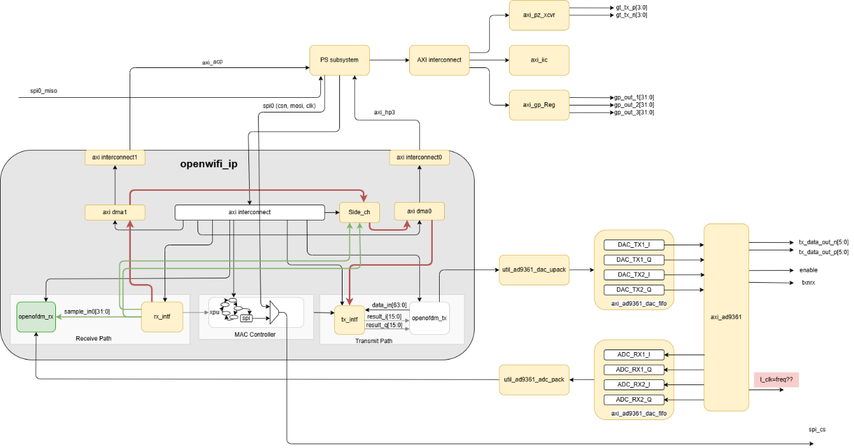
Figure 1: Openwifi system top level architecture
The blocks in orange indicate the potential reuse of blocks in case we choose the MATLAB based I/Q system for PoC henceforth called Arch2.
The main blocks under consideration for this study are:
            - OpenOFDM transmitter: Overview The openofdm_tx IP block implements a complete 802.11 OFDM transmitter including preamble generation, channel coding, modulation, and IFFT processing. The design supports both legacy 802.11a/g rates and 802.11n HT modes.
            - OpenOFDM Receiver: OpenOFDM Rx is an open-source Verilog implementation of an IEEE 802.11 OFDM PHY (physical layer) decoder. This project provides a fully synthesized hardware implementation that can decode packets from 802.11a/g/n wireless networks, along with a Python reference implementation for validation and development purposes.
            - MAC Layer Controller (XPU): The XPU (eXtended Processing Unit) is the central MAC layer controller in the OpenWiFi hardware system. It implements the IEEE 802.11 Medium Access Control (MAC) protocol in hardware, coordinating packet transmission and reception, managing CSMA/CA channel access, handling acknowledgments, and providing timing services. The XPU serves as the bridge between the ARM processing system and the physical layer components (OpenOFDM TX/RX blocks).
            - Tx interface: The TX Interface Module serves as the central transmit processing unit in the OpenWiFi hardware design, handling the complete transmit data path from the ARM processing system to the DAC interface that drives the AD9361 RF transceiver. This module bridges the gap between software-generated packets and RF transmission by managing packet buffering, IQ data processing, DAC interfacing, and transmit control coordination.
            - RX Interface Module (rx_intf): This serves as the central data processing and control hub for the receive path in the OpenWiFi system. It interfaces between the AD9361 RF transceiver's ADC output and the OpenOFDM RX processing blocks, while managing packet streaming to the ARM Processing System via AXI DMA. This module handles ADC data conditioning, IQ sample processing, packet filtering, and system control functions including RSSI monitoring and GPIO status management.

Licensing terms
The openofdm_rx is released under Apache 2.0 license, our current understanding hence is that we are free to use the code as it is or do changes for commercial use without violation of copyright laws. The rest of the Verilog modules have the following licensing requirements.
IP block | License | Comments
Openofdm Rx | Apache License Version 2.0 | Free to use and distribute
Openwifi (other blocks) | AGPL-3.0 license | Need to buy based on value addition
FFT engine | LGPL v3
ADI libs | ADI BSD license | Free to modify and not open source the result
SPDIF | LGPL license only
JESD Core | GPL, commercial  license only | Currently we don’t use it, but is needed for AD9374 device
- Licensing terms

Scope
The rest of the document is intended to provide the critic of the code and notes for improvement and reuse. This document is not for code documentation. A comprehensive document is generated and available at following locations:
- open-sdr/openwifi-hw | DeepWiki
- open-sdr/openofdm | DeepWiki
- OpenOFDM: Synthesizable, Modular Verilog Implementation of 802.11 OFDM Decoder — OpenOFDM 1.0 documentation

OFDM transmitter
This is the simplest of the blocks in the open WIFI system. The design is composed of a processing pipeline of bit scrambler, convolutional encoder, puncturing modulation, pilot and synchronization pattern insertion and IFFT block. The finally the cyclic prefix is inserted to get the data to be transmitted.
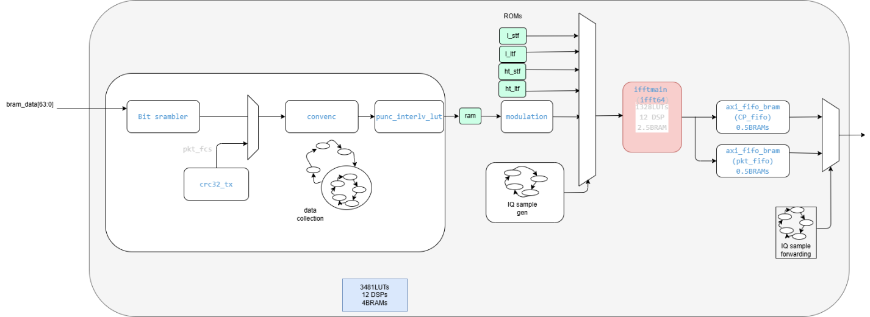
Figure 2: OFDM transmitter
As seen from the table below the synthesis report shows the net complexity of this design. It is clear from the table that the IFFT block is the main resource consuming block.
Name | Slice LUTs | Block RAM Tile | DSPs
bits_enc_fifo (axi_fifo_bram) | 432 | 0.5 | 0
bits_ram (ram_simo) | 618 | 0 | 0
convenc (convenc) | 6 | 0 | 0
CP_fifo (axi_fifo_bram__parameterized0) | 55 | 0.5 | 0
fcs_inst (crc32_tx) | 47 | 0 | 0
ht_ltf_rom (ht_ltf_rom) | 54 | 0 | 0
ht_stf_rom (ht_stf_rom) | 2 | 0 | 0
ifft64 (ifftmain) | 1327 | 2.5 | 12
l_ltf_rom (l_ltf_rom) | 38 | 0 | 0
l_stf_rom (l_stf_rom) | 1 | 0 | 0
modulation (modulation) | 1 | 0 | 0
pkt_fifo (axi_fifo_bram__parameterized1) | 170 | 0.5 | 0
punc_interlv_lut (punc_interlv_lut) | 290 | 0 | 0
dot11_tx (dot11_tx) | 3407 | 4 | 12
- OpenOFDM transmitter synthesis report
IFFT is implemented using another opensource code released on LGPL license. This block is quite like the XFFT engine from Xilinx/AMD used in OFDM receiver. Hence, it is suggested to replace this block with Xilinx block. Care needs to be taken to match the processing delay of this block w.r.t. Xilinx xfft engine. The block when simulated doesn’t initialize properly, leading to ‘X’s in simulation. This is also a red flag and hence the need to replace this block.
The excluding the ifft block, the design is composed of ~10 files out of the 32 design files listed.
Given the simplicity of the code and provided with it is also a good idea to rewrite the code in its entirety as Krush labs Arch1 is expected to diverge from this basic implementation.
Design | Effort | Comment
ifft | 2 weeks | Replace due to presence of X’s in simulation, LGPL license, Uniformity with Xilinx fft block
Entire design [dot11.v] | No timeline | Based on needs

OpenOFDM Receiver
This is the most complex part of the design and may be the main source of instability too. The design is a fork of an opensource openofdm project released on permissive apache 2.0 license. The original fork seems still being updated and maintained [last update being 2years back]. It might be best to have a comparison of the files and see what is updated and still relevant for Krush labs Arch1.
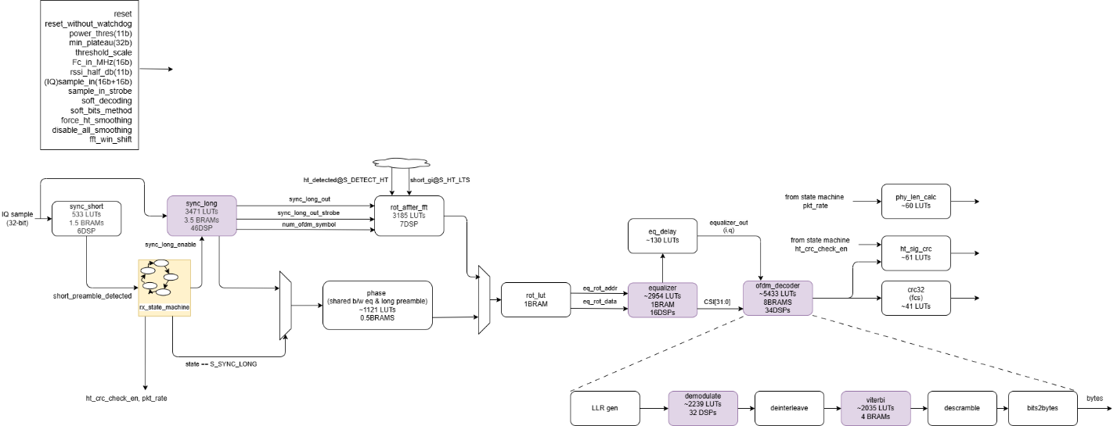
Figure 3: ODFM RX chain architecture
The entire design is spread across 24 files. Out of which the main complexity of the code lies in 5 files that have a length of more than 300 lines of code:
            - Control state machine in dot11.v: It is the main control state machine of the entire OFDM RX chain. See figure It is closely related to the frame format supported and would need a major upgrade legacy + HT mode is discarded and only Greenfield format needed to be supported.
            - Long_sync.v: Includes a state machine control to skip the cyclic prefix and identify that exact start position of FFT calculations for the given frame. It includes the phase correction [rotate.v] and the Xilinx FFT engine.
            - Equalizer.v: would be considered if the equalizer algorithm is upgraded to advanced version.
            - Ofdm_decoder.v: consists of instantiations of descramble, Viterbi, demodulator and LLR calculator. The design also includes a look-up table-based divider that may need further investigation.
            - Demodulate.v: would be needed to modify if we must support higher level modulation schemes. At this point, it is unlikely to have a change.

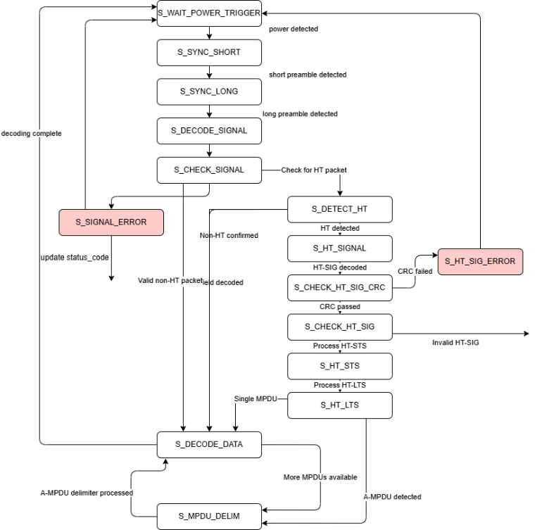
Figure 4: OFDM RX state machine supporting legacy and HT modes

XPU – The MAC Layer Controller
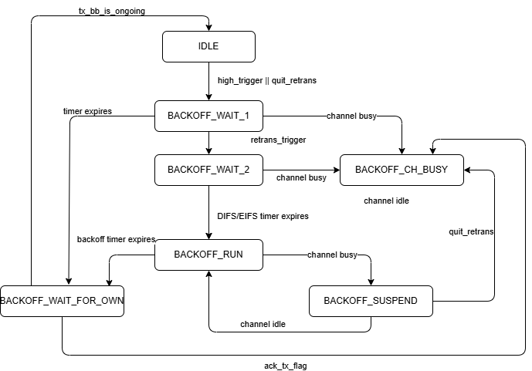
Figure 5: XPU CSMA Back off state machine

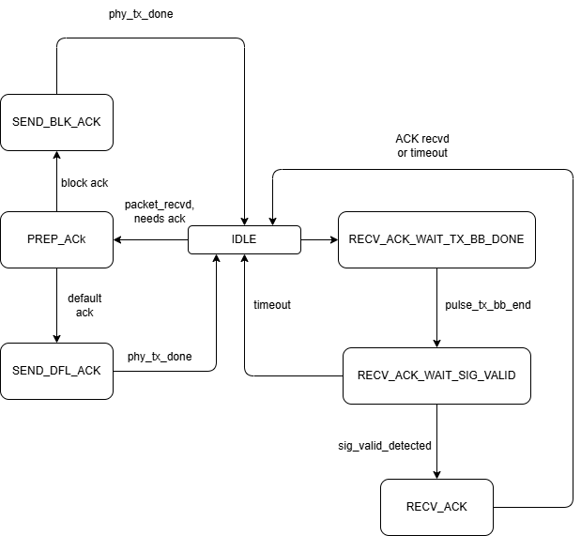
Figure 6: Packet acknowledgement

Tx interface
The TX Interface Module serves as the central transmit processing unit in the OpenWiFi hardware design, handling the complete transmit data path from the ARM processing system to the DAC interface that drives the AD9361 RF transceiver. This module bridges the gap between software-generated packets and RF transmission by managing packet buffering, IQ data processing, DAC interfacing, and transmit control coordination.

Side channel
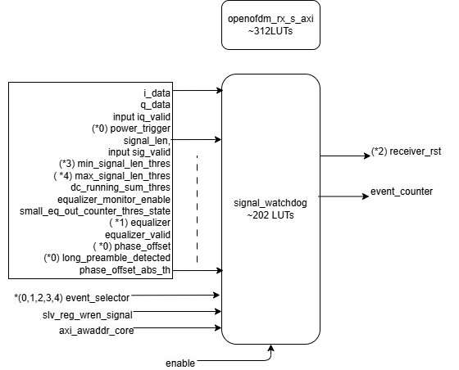
Figure 7: Architecture of side channel

