Linux Device Driver
Linux Kernel
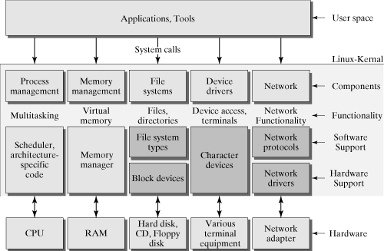
- Linux Devided in Two part UserSpace and KernelSpace
- You Can Communicate UserSpace and Kernel Space via System Call Interface.
- In Kernel Several Concurrent process performe differnet task
- So kernel is big chunk of executing code which handling the requerests.
- Drivers may intregrated to kernel or can build sepratley and plug in run time called loadable kernel module.
- Mainly 3 type of Device Driver Charecter, block, Network
- Charecter Access as Stream of bytes mouse or keyboard
- Block are USB, Flash.
- Network are Ethernet Driever.

Loadable Kernel Module
- Peace of code that loaded at run-time called Module.
- Module defined two function, when module is added to kernel amd when module removed from kernel.
- module_init() and module_exit() special macro function.
- MODULE_LICENSE() macro indicate the license of module.
- Printk() function used to print in kernel space. Or cat var/log/syslog or dmesg.
- Builed module with use of Makefile. Out file will be .ko extension
- ismod cmd to load module in kernel. Insmod allocate the kernel memory to hold module. And copies the module text in memory region. Perform similer function like GNU linker. Link any resolved symbol int the module to the symbol table of linux kernel and call the module initialization function.
- rmmod used to remove the module from kernel space.
- lsmod used to display the current list of module loaded in kernel.
- The __init and __initdata used to tell kernel that function is used only for initialization. After init function memory of the function is free.

UserSpace Vs KernelSpace
Application Runs | Module Runs
Low Level, Many Restrictions | Highest Level, Everything is Allowed

Charecter Driver:
- It can access the data like stream of bytes like file.
- regular file can move back and froth.where as in char is just a data channels, where data can access sequencely.
- Charecter device are access through names in fileSystem called device files.
Major & Minor number
- Major Number indicate driver associated with device. Kernel use major no to invoke the driver.
- Minor number is used by driver to check exectly which device to refer.
- Withing the kernel, the dev_t (defined in <linux/types.h>) is type that hold the device number.
Allocating Major & Minor Number
There are Two ways to allocate Statically and Dynamically.
Statically
- int register_chrdev_region(dev_t first, unsigned int count, char *name);
- if you want to create dev_t structure for major and minor number there is macro MKDEV(int major, int minor);
- to get the major number or minor no from dev_t there is macros
- MAJOR(dev_t dev) and MINOR(dev_t dev)
Dynamically
- int alloc_chrdev_region(dev_t *dev, unsigned int firstminor, unsigned int count, char *name);
How Application Communicate with Device File ?
First Application will open device file which is created by Device driver.
Device Driver we can create in two ways manually and autometically.
Manually : mknod -m 666 /dev/char_device c 246 0
Autimetically :
- include <linux/device.h> and <linux/kdev_t.h>
- create a class. struct class * class_create(struct module *owener, const cahr *name);
- Create device with class. struct device * device_create(struct *class, struct device *parent, dev_t dev, const char * fmt,..)
- you can distroy device using void device_destroy(struct class *class, dev_t devt)
Charecter Driver Registration
- if we want to read, write, open, close, we need to register some structure to driver.
- The kernel using structure of type struct cdev to represent the char devices internally.
- Before any device operation you must register this structure.
- For use of this structure you need to include <linux/cdev.h> where structure and its associated helper functions are defined.
- There are two ways to allocating and initializing one of these stuctures
- Dynamic allocation cdev_alloc() function call, For static cdev_init() function call.
- Once initialized cdev_add() function to register character driver to kernel. int cdev_add(struct cdev *cdev, dev_t num, unsigned int count);
- use cdev_del() function to unregister the character driver from kernel. void cdev_del(struct cdev *dev)
Option 1 cdev_alloc()
struct cdev *my_cdev = cdev_alloc();
my_cdev->ops = &my_fops;
my_cdev->owner = THIS_MODULE;
Option 2 cdev_init()
struct cdev my_cdev;
cdev_init(“my_cdev, &my_fops);
my_cdev.owner = THIS_MODULE;
void cdev_init(struct cdev * cdev, struct file_operations *fops);
Functions used in driver file.
- kmalloc() allocate the memory in kernel space void *kmalloc(size_t size, gfp_t flags);
- kfree() used to free the previously allocated memory void kfree(const void *objp)
- copy_to_user() copy block of data from kernel space to user space.
- copy_form_user() copy block of data from user space to kernel space.

