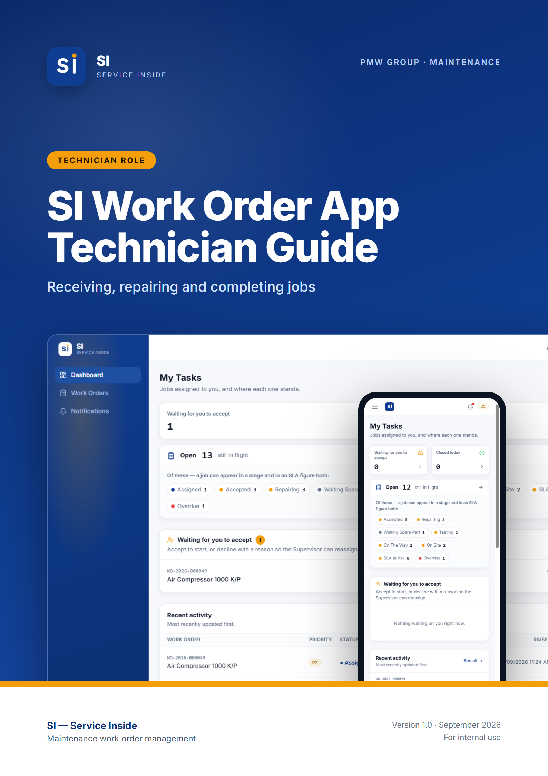

Contents
01 Getting started FOR EVERYONE
What SI does · Roles — who does what · Getting an account · Signing in · Choosing a new password · Finding your way around · Using SI on your phone · Notifications · How a work order moves · Priorities and SLA deadlines · Inside a work order
02 Technician guide ROLE GUIDE
At a glance · Your dashboard — My Tasks · The job workflow · Comments and photos · Keeping an eye on the SLA · Notifications you receive · Common situations
03 Quick reference APPENDIX
Who can do what · Words SI uses · Need help?

Note: How to use this guide. Chapter 1 covers what everybody needs: getting an account, signing in, finding your way around, and how work orders move. Chapter 2 is everything a Technician can do, step by step. Screenshots come from the SI test site with demo data, so names and numbers will differ from what you see. Buttons and labels are shown in bold.

01.
FOR EVERYONE

Getting started
What SI is, how to get an account, how to sign in, and how to find your way around. Read this first, whatever your role.
IN THIS CHAPTER
1.1 What SI does
1.2 Roles — who does what
1.3 Getting an account
1.4 Signing in
1.5 Choosing a new password
1.6 Finding your way around
1.7 Using SI on your phone
1.8 Notifications
1.9 How a work order moves
1.10 Priorities and SLA deadlines
1.11 Inside a work order

1.1 What SI does
SI (Service Inside) is PMW Group's maintenance work order app. When a machine or facility has a fault, somebody raises a work order. An HOD or Administrator assigns it to a technician, the technician carries out the repair, and the app keeps a full record of who did what and when.
It runs in any web browser — on a PC, a tablet or a phone — so there is nothing to install. You can also add it to your phone's home screen so it opens like an app (see Using SI on your phone below).

1.2 Roles — who does what
Every account has one or more roles. Your role decides which screens you see and which buttons you get. This guide covers the three most common roles:
Role | What they do in SI
Requester | Reports faults by raising work orders, adds photos and comments, and follows the repair until it is finished.
Technician | Receives jobs, accepts or declines them, carries out the repair step by step, and marks the work completed.
Administrator | Oversees all work in the plant, assigns technicians, manages user accounts, and maintains the settings (departments, equipment, priorities and SLA targets).

Note: SI also has Supervisor, HOD and Manager roles. HODs assign technicians and sign off closed work orders, and Supervisors and Managers oversee the work. One person can hold more than one role — for example Requester + Technician — and then gets everything both roles allow.

1.3 Getting an account
There is no self sign-up in SI. Accounts are created by your Administrator, so the app always knows who everybody is and what they are allowed to do.
- Contact your Administrator (or the IT / maintenance office) and ask for an SI account.
- Give them your full name, company email address, phone number, your employee ID (if you have one) and your department, and tell them which role you need.
- The Administrator creates the account and gives you a temporary password.
- Sign in with it (see below). The first time you sign in, SI asks you to choose your own password before you can do anything else.

1.4 Signing in
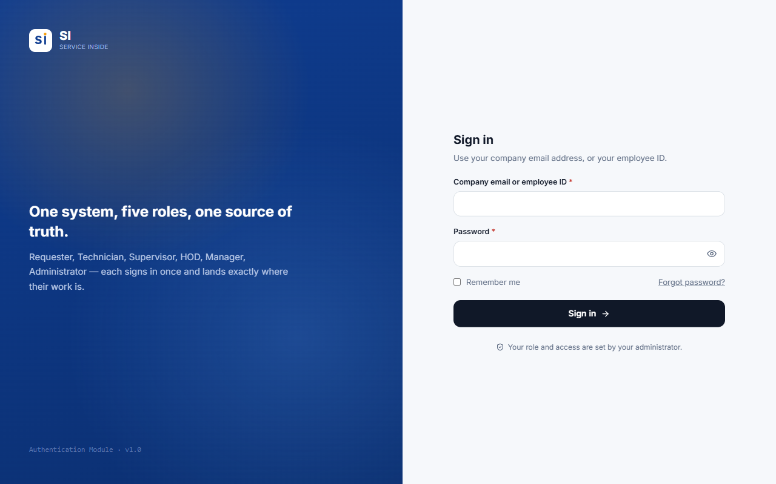
Figure 1.1 — The sign-in screen.
- Open SI in your browser (or tap the SI icon on your home screen).
- In Company email or employee ID, type either your company email address or your employee ID. Both work — capital letters and spaces in an employee ID do not matter.
- Type your Password. Tap the eye icon to show what you typed.
- Tick Remember me on your own phone or PC so you stay signed in. Leave it unticked on a shared computer.
- Press Sign in. SI opens the dashboard for your role.

Tip: If sign-in fails, SI shows the same message whether the email/ID or the password was wrong — this protects your account. Check both, and after a few failed tries wait a moment before trying again.

Important: Forgot your password? Contact your Administrator. They will set a temporary password for you, which you replace the next time you sign in.

1.5 Choosing a new password
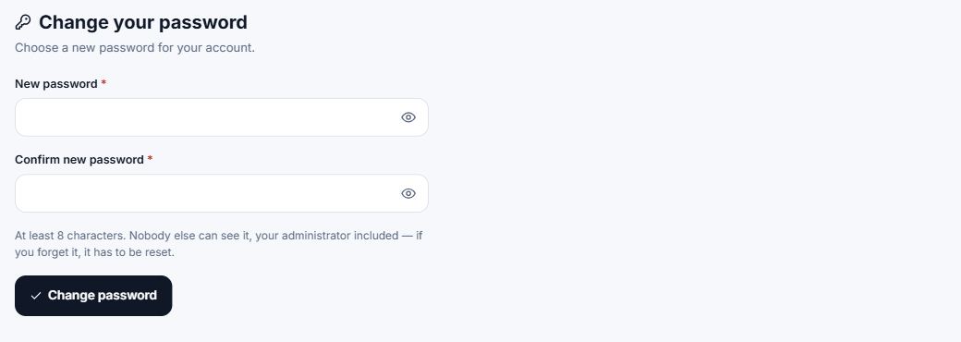
Figure 1.2 — The Change password screen appears on your first sign-in, and after an Administrator resets your password.
- Enter the new password twice. It must be at least 8 characters.
- Nobody else can see your password — not even your Administrator.
- Until you set your own password you cannot reach any other screen. This is on purpose: the temporary password was chosen by somebody else.

1.6 Finding your way around
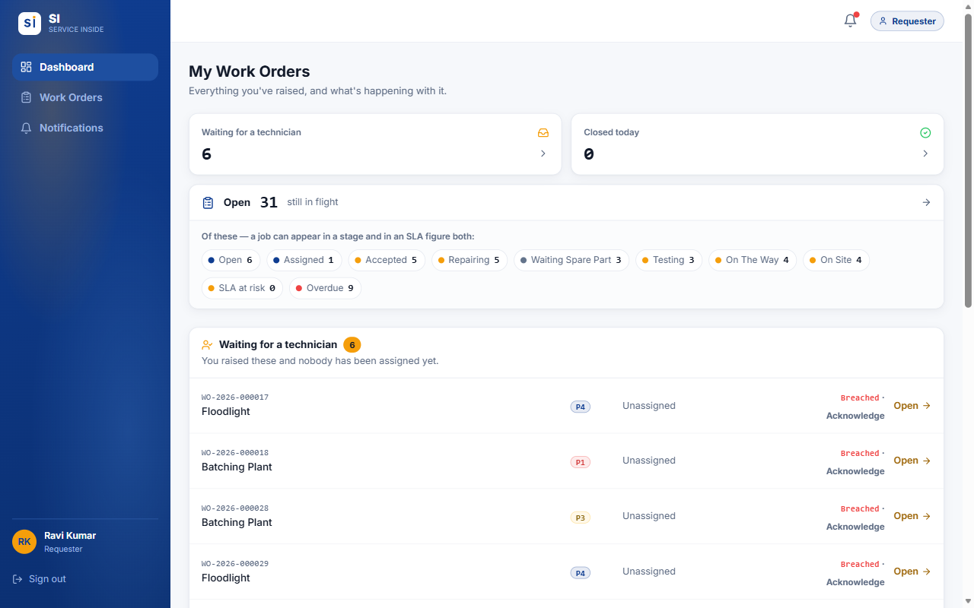
Figure 1.3 — The screen layout (Requester shown). On a PC the menu is on the left.
Part of the screen | What it is for
Dashboard | Your starting page: counts and lists of the work that needs your attention.
Work Orders | The full list of work orders you can see, with search, filters, sorting and Excel export.
Notifications | Everything SI has told you about, grouped by category.
Users / Settings | Administrators only — accounts and system settings.
Bell icon (top right) | Opens your latest notifications. A red dot means something is unread.
Role badge (top right) | Shows the role you are working as. If you hold several roles, use it to switch dashboards.
Your name / Sign out | Bottom of the menu. Always sign out on a shared computer.

1.7 Using SI on your phone
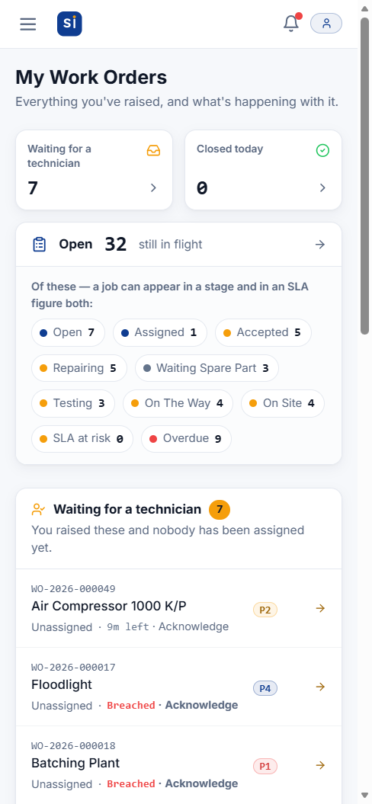  Figure 1.4 — Dashboard on a phone | 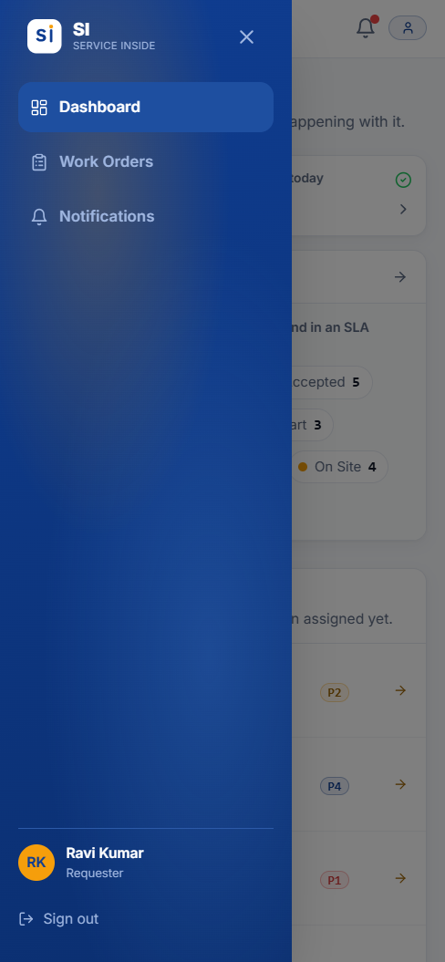  Figure 1.5 — Tap ☰ to open the menu | 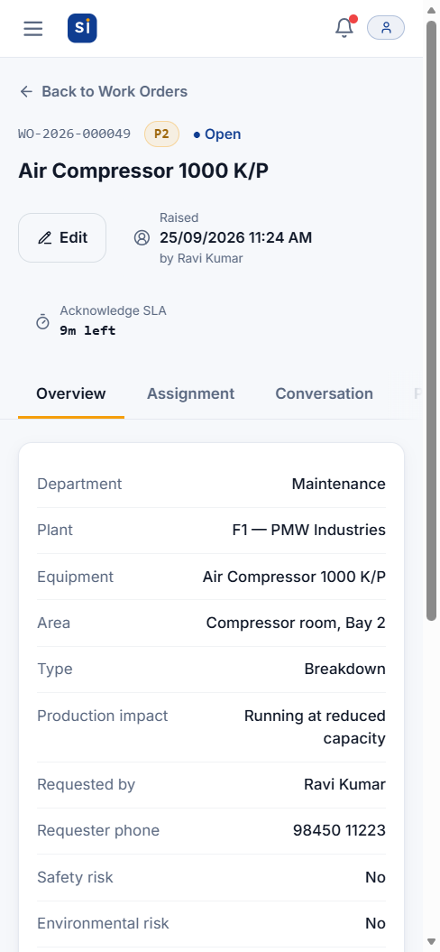  Figure 1.6 — A work order on a phone

SI adapts to small screens. The menu hides behind the ☰ button at the top left, and wide tables turn into cards you can scroll.
- iPhone: open SI in Safari, tap the Share button, then Add to Home Screen. Pop-up alerts on iPhone only work once SI is added this way.
- Android: open SI in Chrome, tap the ⋮ menu, then Install app or Add to Home screen.

1.8 Notifications
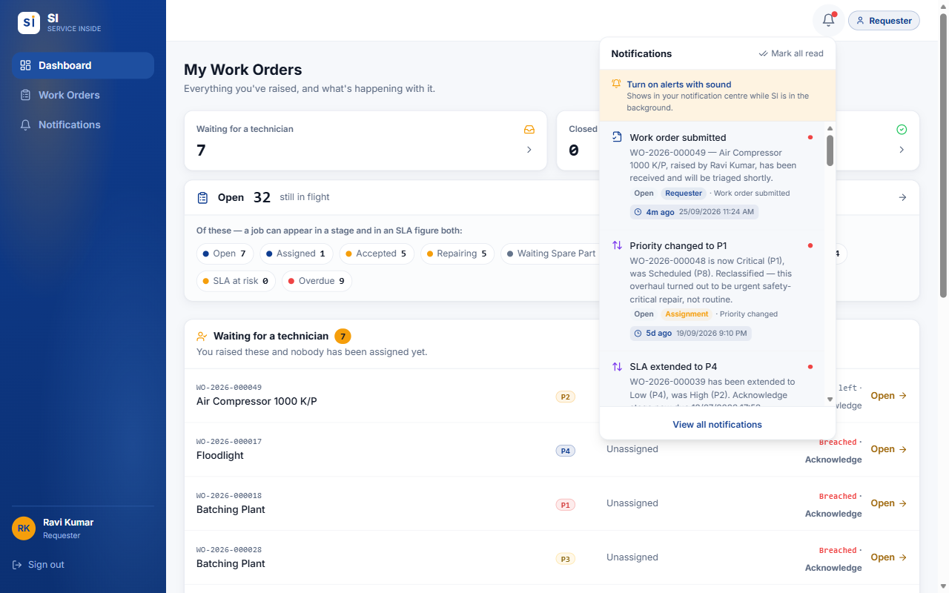
Figure 1.7 — The bell opens your latest notifications without leaving the page.
- SI notifies you when something happens that concerns you — for example a job assigned to you, or your work order completed.
- Each notification shows how long ago it happened and the exact date and time, plus tags for who caused it and which stage the job was at.
- Tap a notification to open that work order. Mark all read clears the red dot.
- On the Notifications page, filter by category and use Clear read to delete notifications you have already read. Unread ones are never deleted.
- To get alerts on your phone or PC while SI is in the background, press Turn on alerts with sound in the bell panel and allow notifications when the browser asks. Alerts only arrive while SI is open somewhere (a tab or the home-screen app) — not after it has been fully closed.

1.9 How a work order moves
Every work order goes through the same stages, in order. No stage can be skipped, and every move is recorded on the Status Timeline with the person's name and the time.
Open | → | Assigned | → | Accepted | → | Repairing | → | Testing | → | Completed | → | Closed

Status | Meaning
Open | Raised and waiting for somebody to assign a technician.
Assigned | A technician has been chosen and must accept or decline. A decline sends it back to Open.
Accepted | The technician has taken the job but not started yet.
Repairing | Work is in progress.
Waiting Spare Part | Paused because a part is needed. Returns to Repairing when the part arrives.
Testing | The fix is being tested. A failed test sends it back to Repairing.
Completed → Closed | The technician marks the repair completed, and SI closes it automatically at the same moment.

1.10 Priorities and SLA deadlines
You never choose a priority — SI works it out from the production impact picked when the work order is raised, and raises it further if a safety or environmental risk is flagged. Each priority has an SLA (service-level agreement): a time limit for each of three stages.
Priority | Production impact | 1. Acknowledge | 2. Response | 3. Resolution
P1 Critical | Full production stoppage | 5 min | 10 min | 3 hrs 45 min
P2 High | Running at reduced capacity | 15 min | 45 min | 7 hrs
P3 Medium | Auxiliary equipment, no line impact | 30 min | 3 hrs 30 min | 20 hrs
P4 Low | No production impact (cosmetic/routine) | 2 hrs | 22 hrs | 4 days
P7 Long-term | Long-term task (planned) | 5 days | 3 days | 7 days
P8 Scheduled | Scheduled work (month-scale) | 5 days | 5 days | 20 days

- Acknowledge — from raising the work order until a technician is assigned.
- Response — from assignment until the technician starts work.
- Resolution — from starting work until the repair is completed.
- Each stage's clock starts when the previous stage finishes. The header of every work order shows the current stage and the time left, for example 14m left, At risk (in the last quarter of its time) or Breached (late).
- These are the current settings. Administrators can change them, so the times shown in the app are always the ones that apply.

1.11 Inside a work order
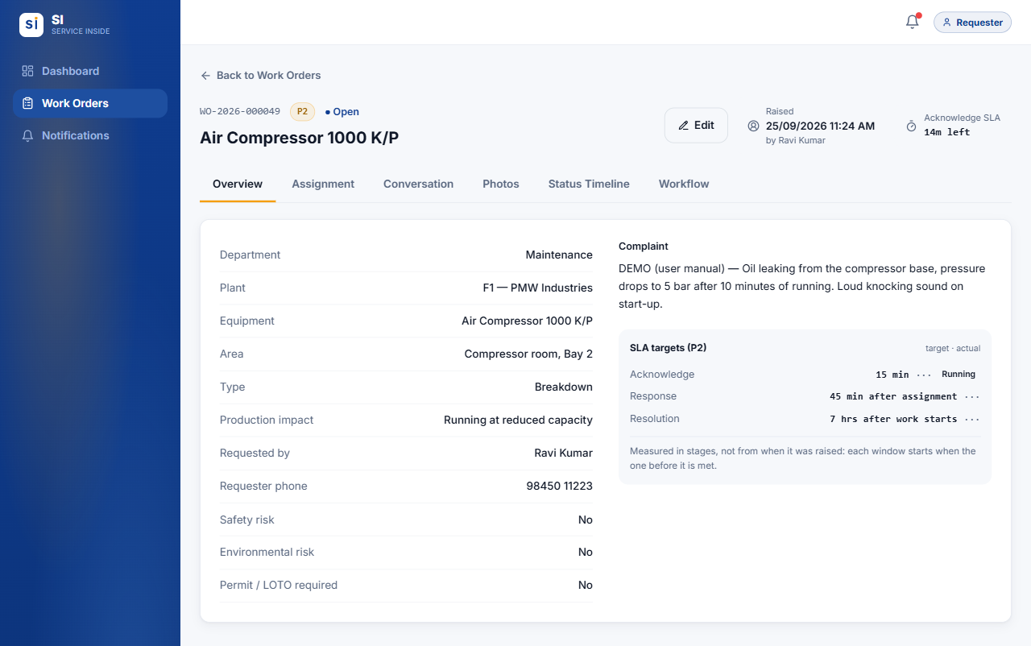
Figure 1.8 — Every work order has the same header and six tabs.
Tab | What you find there
Overview | All the details — department, plant, equipment, complaint, risks — plus the SLA targets and how long each stage actually took.
Assignment | Who the job is assigned to. HODs and Administrators assign and reassign here, until the job is completed. After that the Assign buttons are greyed out.
Conversation | Comments and photos in one chat-style thread. A red number shows how many new messages you have not read.
Photos | Every photo, grouped by the stage it was taken at (before work, during repair, testing...).
Status Timeline | The full history: every move, who made it, when, and any reason given.
Workflow | Tells you whose move it is, and holds the action buttons when it is yours.

Tip: If your session expires while you are typing a work order, SI keeps what you typed and offers to restore it after you sign back in. Photos cannot be kept, so re-attach them.

02.
ROLE GUIDE

Technician guide
You carry out the repairs. This chapter walks through a job from the moment it is assigned to you until it is closed, including every alternative path.
IN THIS CHAPTER
2.1 At a glance
2.2 Your dashboard — My Tasks
2.3 The job workflow
2.4 Comments and photos
2.5 Keeping an eye on the SLA
2.6 Notifications you receive
2.7 Common situations

2.1 At a glance
You can | You cannot
See every job assigned to you, with its SLA clock | See jobs that are not assigned to you, including unassigned ones
Accept a job, or decline it with a reason | Assign or reassign a job — to yourself or to anybody else
Start work, pause for a spare part, resume | Skip a step — the order is fixed
Test the fix, record a failed test, mark it completed | Reopen a job once it is closed
Comment and add before/after photos | Delete a work order, another person's comment, or a photo
Search, filter and export your jobs | Raise a work order (unless you also hold the Requester role)

2.2 Your dashboard — My Tasks
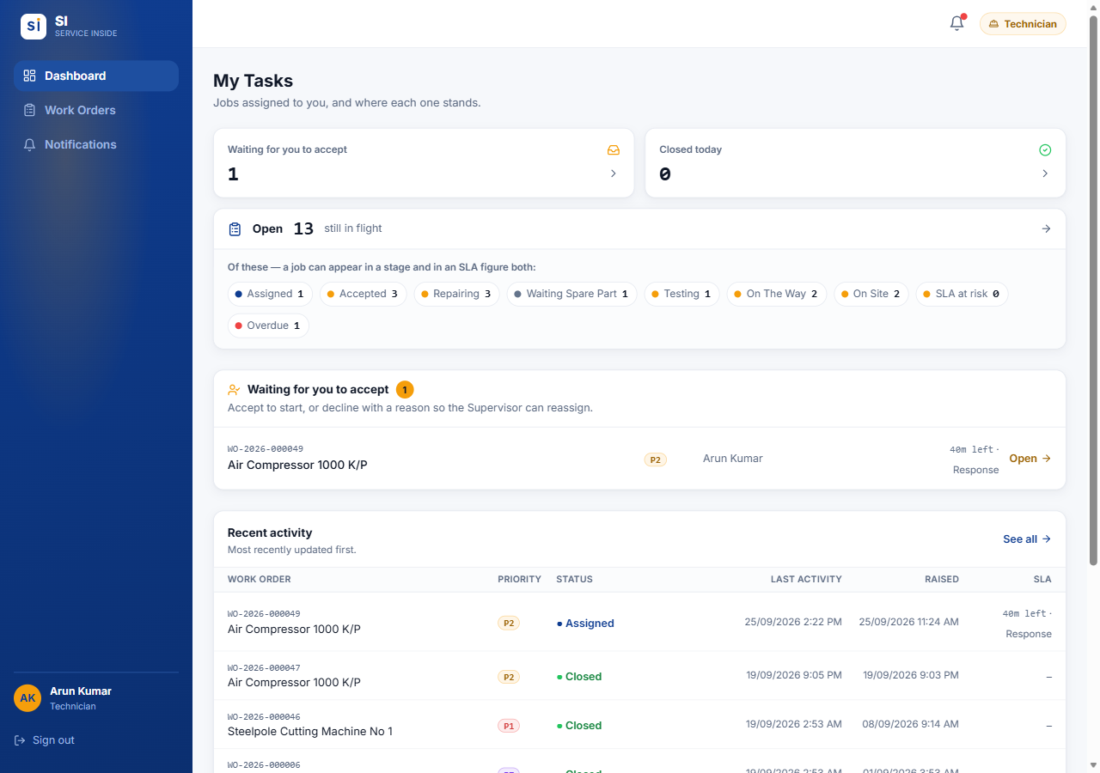
Figure 2.1 — My Tasks — the Technician dashboard.
- Waiting for you to accept — new jobs assigned to you. These need your answer first.
- Closed today — jobs you finished that have been signed off today.
- Open … still in flight — your jobs by stage, plus how many are at risk or overdue on their SLA.
- The list underneath shows each waiting job with its priority and the time left.

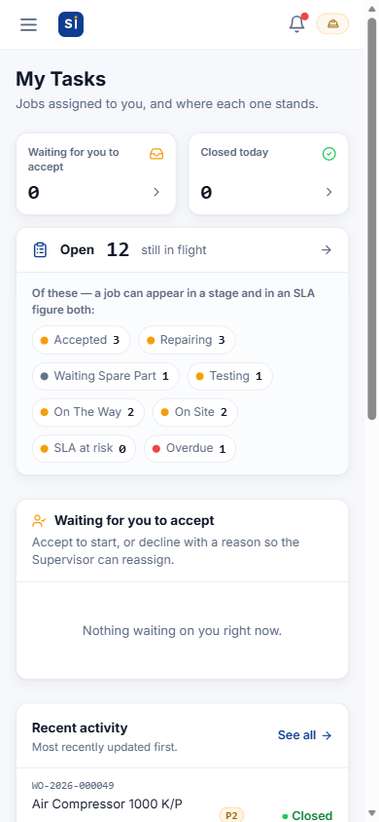
Figure 2.2 — My Tasks on a phone

2.3 The job workflow
Everything you do to a job happens on its Workflow tab. The yellow bar always says "Your move: …" and names the buttons you can press next. Some steps need a short note — the button stays greyed out until you type one.
Assigned | → | Accepted | → | Repairing | → | Testing | → | Completed | → | Closed

Step 1 — Accept or decline
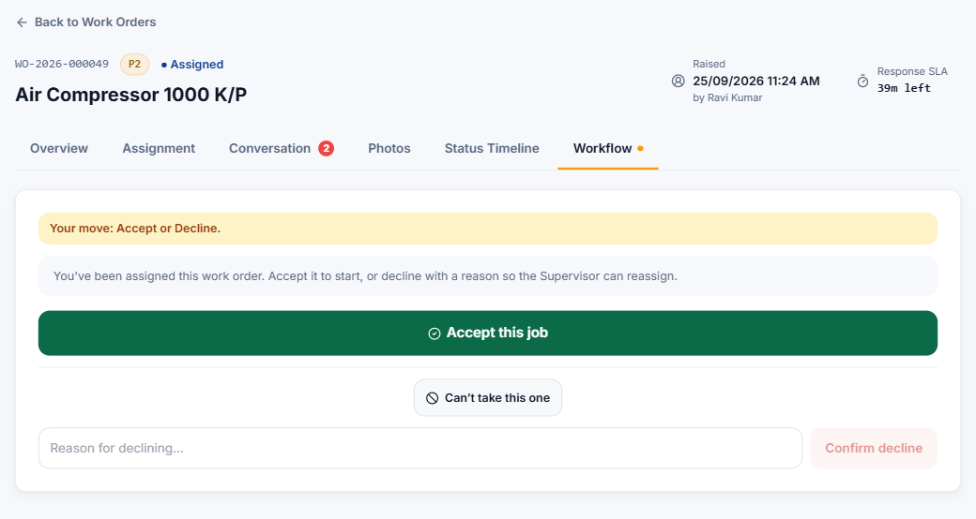
Figure 2.3 — A new assignment: accept it, or decline with a reason.
- You get a notification when a job is assigned to you. Open it, go to Workflow, and read the Overview and Conversation first.
- Accept this job — the job becomes yours and moves to Accepted. The Requester and the people who assign work are told.
- Can't take this one — type a reason (for example "on leave this afternoon") and press Confirm decline. SI shows your reason again before sending. The job goes back to Open to be reassigned, and it disappears from your list.

Step 2 — Start work
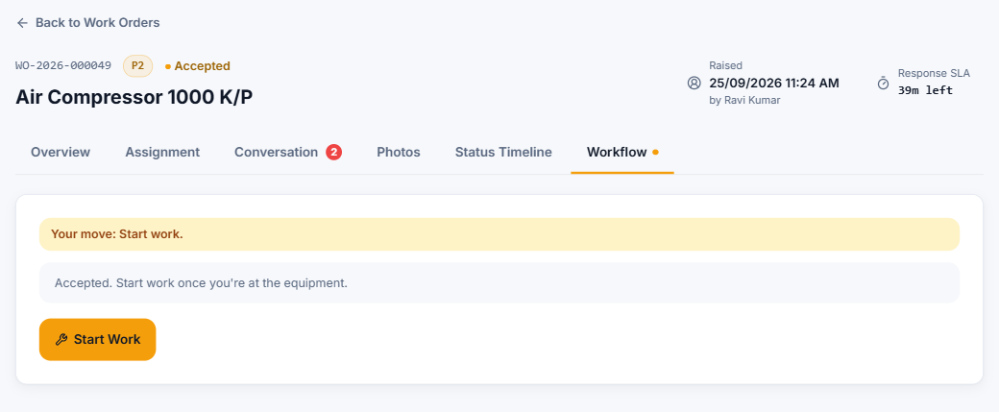
Figure 2.4 — Accepted: press Start Work when you begin the repair.
When you actually begin, press Start Work. The job moves to Repairing and the Resolution clock starts. Press it when you start, not before — the time it takes to repair is measured from this moment.

Step 3 — Repairing (and waiting for a spare part)
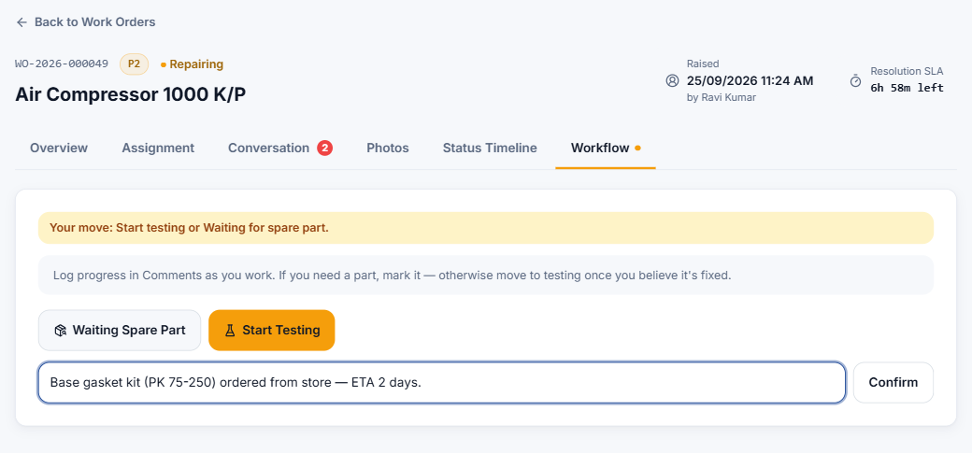
Figure 2.5 — Repairing: go to testing, or pause for a spare part with a reason.
- Post progress in Conversation as you work — findings, part numbers, meter readings, photos.
- If you need a part, press Waiting Spare Part, type which part and why (for example "Base gasket kit ordered from store — ETA 2 days"), then press Confirm. The Requester and the people who assign work are told the job is paused.
- When the part arrives, press Part Received — Resume Repair. The job returns to Repairing.

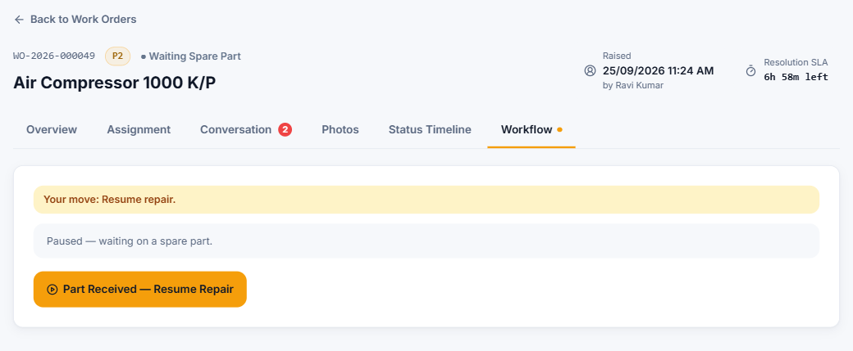
Figure 2.6 — Paused — waiting on a spare part.

Step 4 — Testing
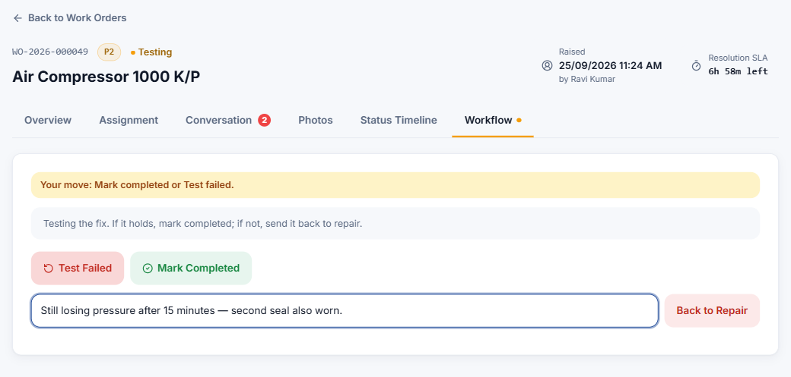
Figure 2.7 — Testing: mark it completed, or record a failed test.
- When you believe it is fixed, press Start Testing.
- If the test fails, press Test Failed, describe what failed, and press Back to Repair. The job returns to Repairing and the reason is recorded on the timeline. Fix it and test again.

Step 5 — Mark completed
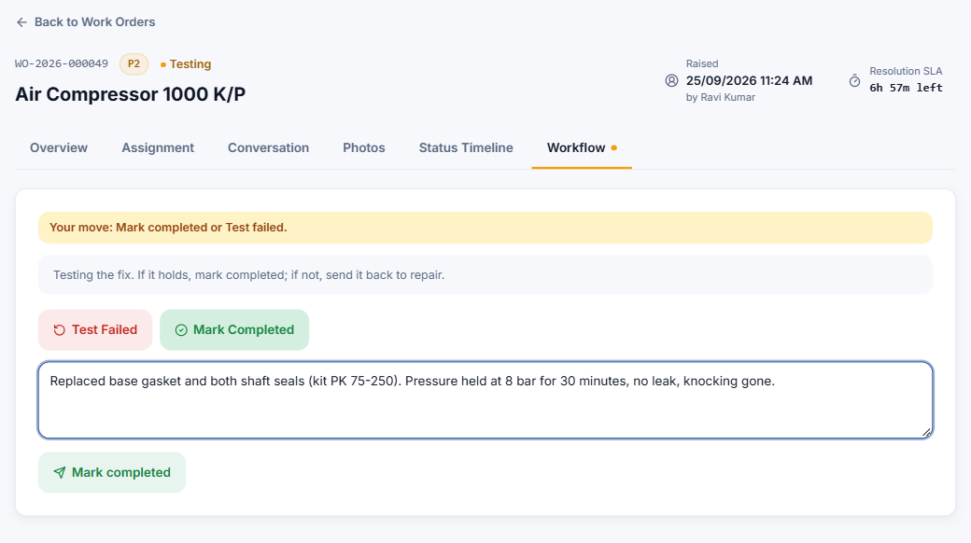
Figure 2.8 — Describe what you did to fix it. The Requester can read this.
- Press Mark Completed.
- In What did you do to fix it? describe the repair — parts replaced, adjustments made, test results. The Requester will read this.
- Press Mark completed to confirm. The job becomes Completed and is closed automatically at the same moment.

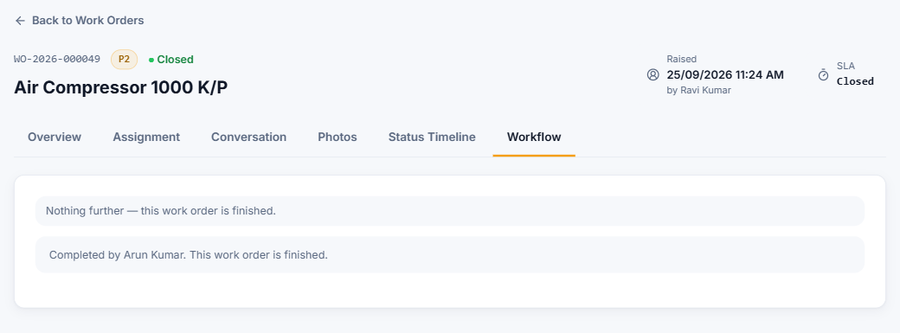
Figure 2.9 — Finished — nothing further to do.
Tip: Before completing, add an "after" photo in Conversation. It is filed under the Testing stage on the Photos tab, next to the "before" photo the Requester took.

2.4 Comments and photos
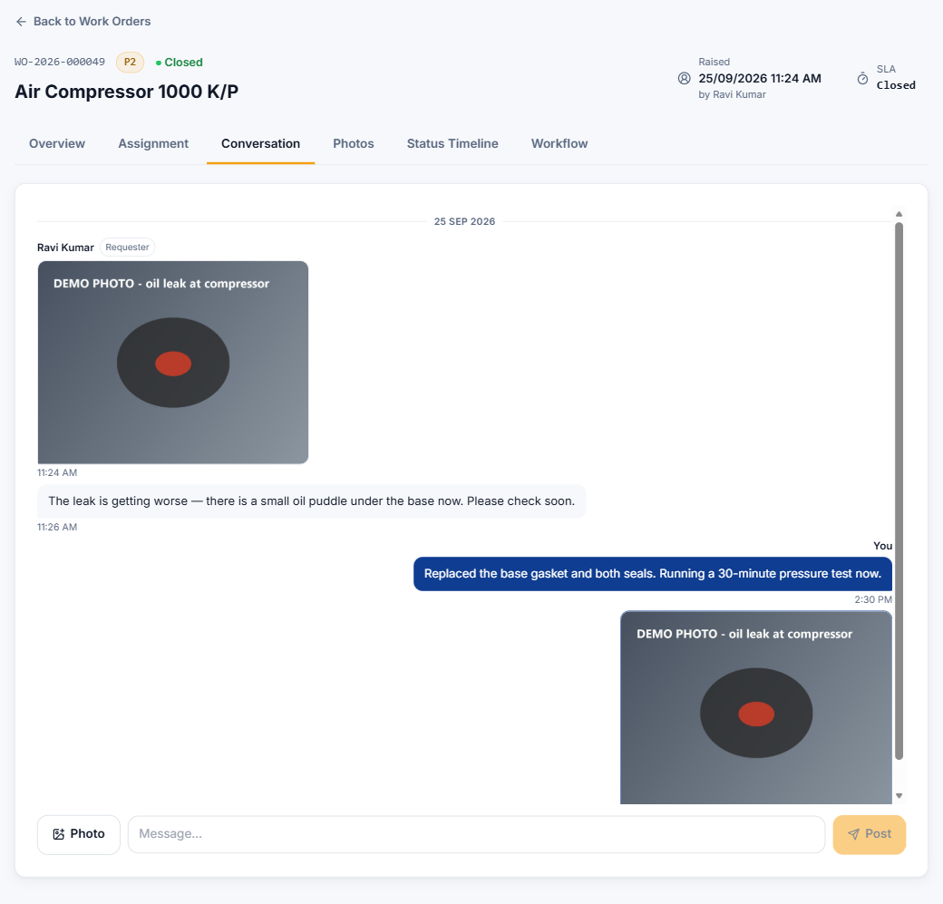
Figure 2.10 — The Conversation thread: your messages on the right in navy.
- Type in Message… and press Post. Press Photo to attach a picture from your camera or gallery.
- Photos are shrunk automatically before upload, so they go up quickly even on mobile data.
- Each photo is filed under the stage the job was at when you took it, so Before work, Repairing and Testing photos stay separate on the Photos tab.
- You can replace a photo you uploaded while the job is live: open it on the Photos tab and press Replace.

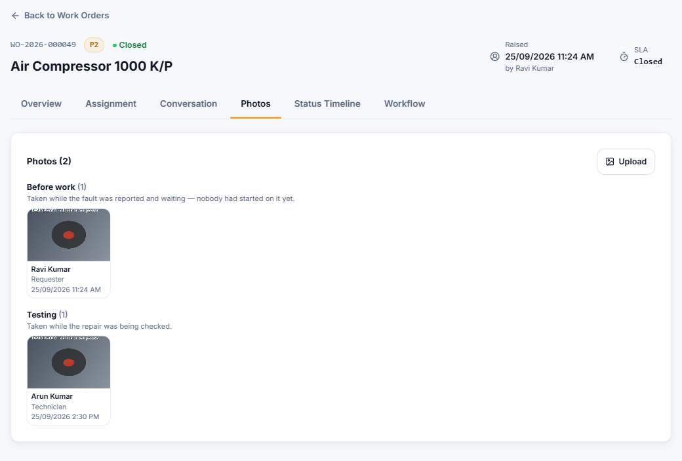
Figure 2.11 — Photos grouped by stage — the Requester's "before" photo and your testing photo.

2.5 Keeping an eye on the SLA
- The top right of every job shows the stage that is running and the time left — Response SLA before you start work, Resolution SLA after.
- SI warns you when a job assigned to you is at risk (in the last quarter of its time) and again if it is breached.
- A late stage stays marked as missed on the record, even if the job is finished afterwards. Only an Administrator can give a job more time (Extend SLA).

2.6 Notifications you receive
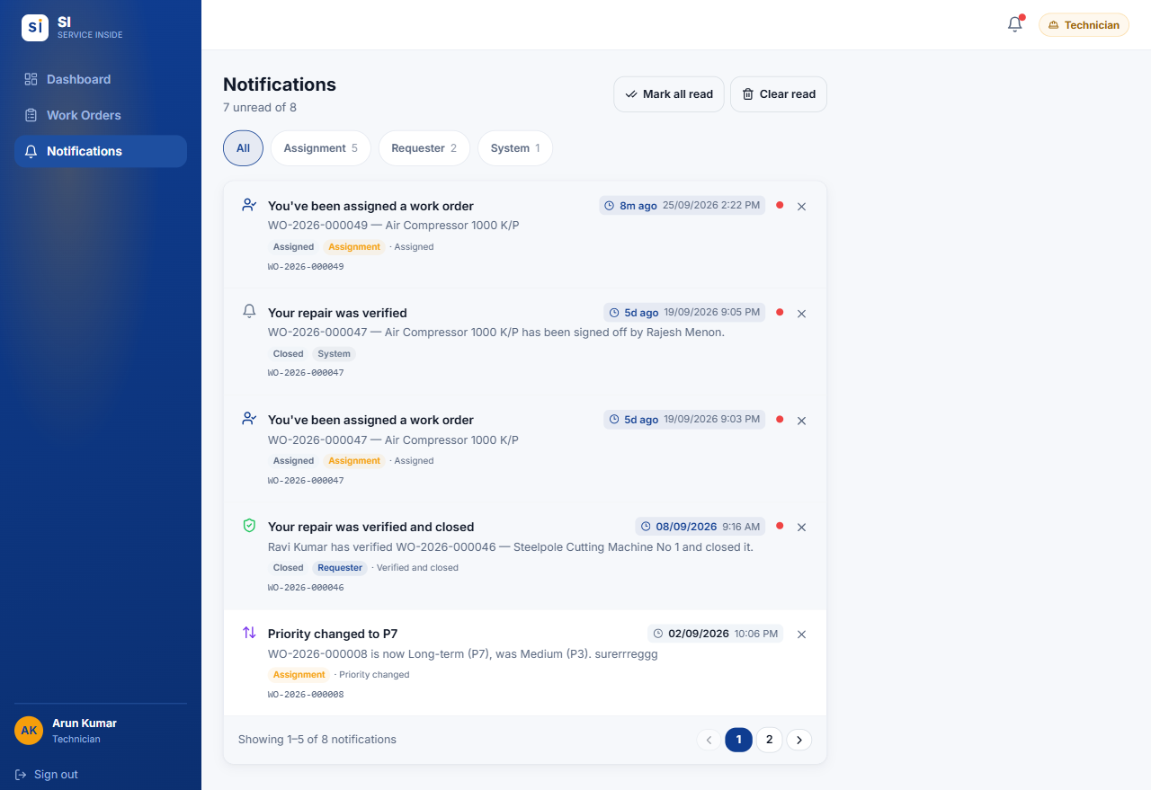
Figure 2.12 — Notifications for a technician.
- A job is assigned to you, or handed over to you from another technician. A handover keeps the job at its current stage — there is nothing to accept, just carry on.
- A job you finished is sent back for rework by a HOD, Manager or Administrator.
- A job of yours is at risk or has breached its SLA.
- An Administrator changed the priority of, or extended, one of your jobs.

2.7 Common situations
Q I accepted by mistake / I can't continue this job.
Tell your HOD in the job's Conversation. Only an HOD or Administrator can reassign it to somebody else.

Q A job I declined has disappeared.
That is expected. It went back to the queue with your reason.

Q The Confirm button is greyed out.
That step needs a note — a decline reason, which spare part, what failed, or what you did. Type it and the button turns on.

Q I don't see a Raise Work Order button.
Technician-only accounts don't raise work orders. Ask your Administrator to add the Requester role if you need to.

Q The job is waiting on a part for a long time.
Leave it in Waiting Spare Part and post updates in Conversation. Press Resume Repair only when the part is actually here.

Q My new role or job isn't showing.
Role changes take up to an hour to take effect. Sign out and back in to see them straight away.

03.
APPENDIX

Quick reference
Who can do what at a glance, and the words SI uses.
IN THIS CHAPTER
3.1 Who can do what
3.2 Words SI uses
3.3 Need help?

3.1 Who can do what
Action | Requester | Technician | Admin
Sign in with email or employee ID | ✓ | ✓ | ✓
Change your own password | ✓ | ✓ | ✓
See work orders you raised | ✓ | — | ✓ all
See work orders assigned to you | — | ✓ | ✓ all
Raise a work order | ✓ | ✗ ¹ | ✓
Raise one on somebody's behalf | ✗ | ✗ | ✓
Edit details while Open | Own | ✗ | ✓
Assign / reassign a technician | ✗ | ✗ | ✓
Accept, decline, start, test, complete | ✗ | Own jobs | —
Pause for a spare part / resume | ✗ | Own jobs | —
Comment and add photos | ✓ | ✓ | ✓
Replace a photo you uploaded | ✓ | ✓ | ✓
Change a priority / extend an SLA | ✗ | ✗ | ✓
Delete a work order | ✗ | ✗ | ✓
Export the list to Excel | ✓ | ✓ | ✓
Manage users | ✗ | ✗ | ✓ ²
Change settings | ✗ | ✗ | ✓ ²

¹ Unless the account also holds the Requester role. ² Some actions are for the app developer only — see the Administrator guide.

3.2 Words SI uses
Term | Meaning
Work order (WO) | A record of one fault or job, numbered like WO-2026-000049.
Requester | The person who reported the fault.
Assign | Choosing which technician does the job.
Handover | Reassigning a job that is already under way. It keeps its stage.
Production impact | How badly the fault affects production. It decides the priority.
Priority (P1–P8) | How urgent a job is. P1 is the most urgent.
SLA | The time allowed for each stage: acknowledge, response and resolution.
At risk / Breached | A stage in its last quarter of time / a stage that ran out of time.
Sign-off | A HOD's check that a closed job was done properly. Only then does it count on the dashboards.
Retire | Take a setting out of use without breaking old records.
App developer | The team that builds and maintains SI. They carry out the actions marked ★.

3.3 Need help?
For account problems — cannot sign in, forgotten password, wrong role — contact your Administrator. For questions about a particular job, comment on the work order so everyone involved can see it.

