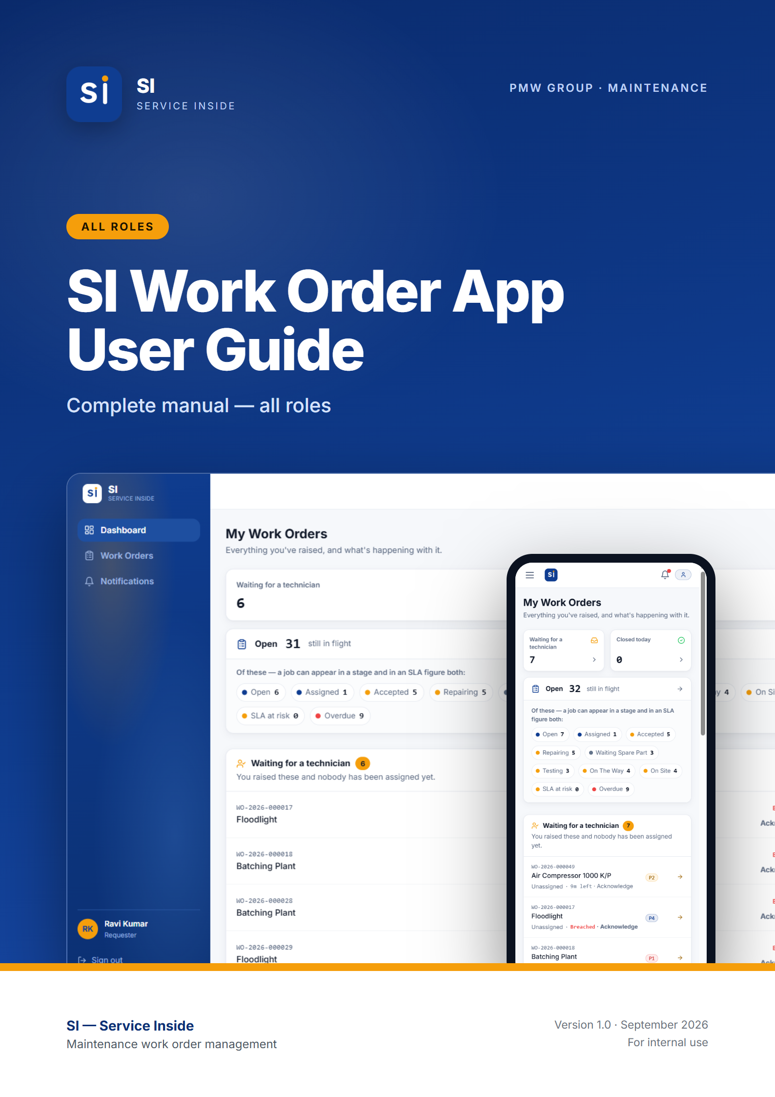

Contents
01 Getting started FOR EVERYONE
What SI does · Roles — who does what · Getting an account · Signing in · Choosing a new password · Finding your way around · Using SI on your phone · Notifications · How a work order moves · Priorities and SLA deadlines · Inside a work order
02 Requester guide ROLE GUIDE
At a glance · Your dashboard · Raising a work order · After you submit · Editing your work order · Comments and photos · Following progress · Finding work orders · Common situations
03 Technician guide ROLE GUIDE
At a glance · Your dashboard — My Tasks · The job workflow · Comments and photos · Keeping an eye on the SLA · Notifications you receive · Common situations
04 Administrator guide ROLE GUIDE
At a glance · The Administrator dashboard · Assigning a technician · Raising a work order for somebody · Changing a priority · Extending an SLA · Deleting a work order · Managing users · Settings · Common situations
05 Quick reference APPENDIX
Who can do what · Words SI uses · Need help?

Note: How to use this guide. Chapter 1 covers what everybody needs: getting an account, signing in, finding your way around, and how work orders move. Chapters 2–4 are one per role — read the one for your role. Screenshots come from the SI test site with demo data, so names and numbers will differ from what you see. Buttons and labels are shown in bold.

01.
FOR EVERYONE

Getting started
What SI is, how to get an account, how to sign in, and how to find your way around. Read this first, whatever your role.
IN THIS CHAPTER
1.1 What SI does
1.2 Roles — who does what
1.3 Getting an account
1.4 Signing in
1.5 Choosing a new password
1.6 Finding your way around
1.7 Using SI on your phone
1.8 Notifications
1.9 How a work order moves
1.10 Priorities and SLA deadlines
1.11 Inside a work order

1.1 What SI does
SI (Service Inside) is PMW Group's maintenance work order app. When a machine or facility has a fault, somebody raises a work order. A Supervisor or Administrator assigns it to a technician, the technician carries out the repair, and the app keeps a full record of who did what and when.
It runs in any web browser — on a PC, a tablet or a phone — so there is nothing to install. You can also add it to your phone's home screen so it opens like an app (see Using SI on your phone below).

1.2 Roles — who does what
Every account has one or more roles. Your role decides which screens you see and which buttons you get. This guide covers the three most common roles:
Role | What they do in SI
Requester | Reports faults by raising work orders, adds photos and comments, and follows the repair until it is finished.
Technician | Receives jobs, accepts or declines them, carries out the repair step by step, and marks the work completed.
Administrator | Oversees all work in the plant, assigns technicians, manages user accounts, and maintains the settings (departments, equipment, priorities and SLA targets).

Note: SI also has Supervisor, HOD and Manager roles. Supervisors assign work, Managers oversee it, and HODs sign off closed work orders. One person can hold more than one role — for example Requester + Technician — and then gets everything both roles allow.

1.3 Getting an account
There is no self sign-up in SI. Accounts are created by your Administrator, so the app always knows who everybody is and what they are allowed to do.
- Contact your Administrator (or the IT / maintenance office) and ask for an SI account.
- Give them your full name, company email address, phone number, your employee ID (if you have one) and your department, and tell them which role you need.
- The Administrator creates the account and gives you a temporary password.
- Sign in with it (see below). The first time you sign in, SI asks you to choose your own password before you can do anything else.

1.4 Signing in
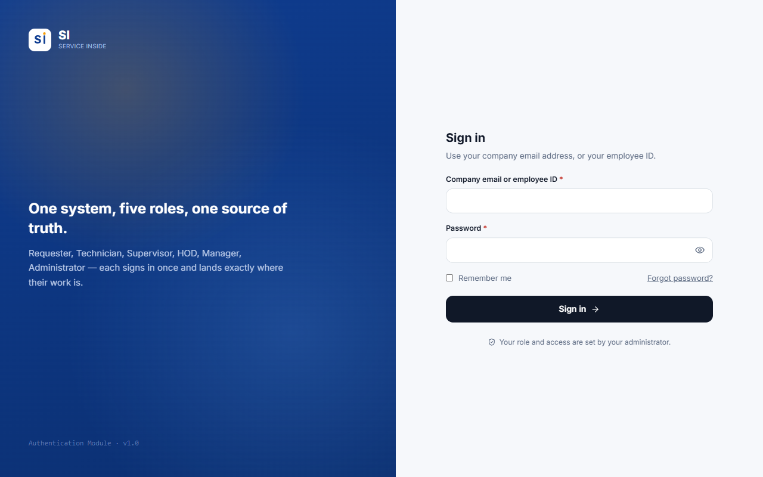
Figure 1.1 — The sign-in screen.
- Open SI in your browser (or tap the SI icon on your home screen).
- In Company email or employee ID, type either your company email address or your employee ID. Both work — capital letters and spaces in an employee ID do not matter.
- Type your Password. Tap the eye icon to show what you typed.
- Tick Remember me on your own phone or PC so you stay signed in. Leave it unticked on a shared computer.
- Press Sign in. SI opens the dashboard for your role.

Tip: If sign-in fails, SI shows the same message whether the email/ID or the password was wrong — this protects your account. Check both, and after a few failed tries wait a moment before trying again.

Important: Forgot your password? Contact your Administrator. They will set a temporary password for you, which you replace the next time you sign in.

1.5 Choosing a new password
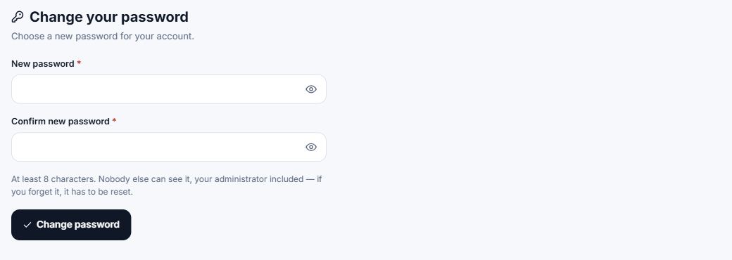
Figure 1.2 — The Change password screen appears on your first sign-in, and after an Administrator resets your password.
- Enter the new password twice. It must be at least 8 characters.
- Nobody else can see your password — not even your Administrator.
- Until you set your own password you cannot reach any other screen. This is on purpose: the temporary password was chosen by somebody else.

1.6 Finding your way around
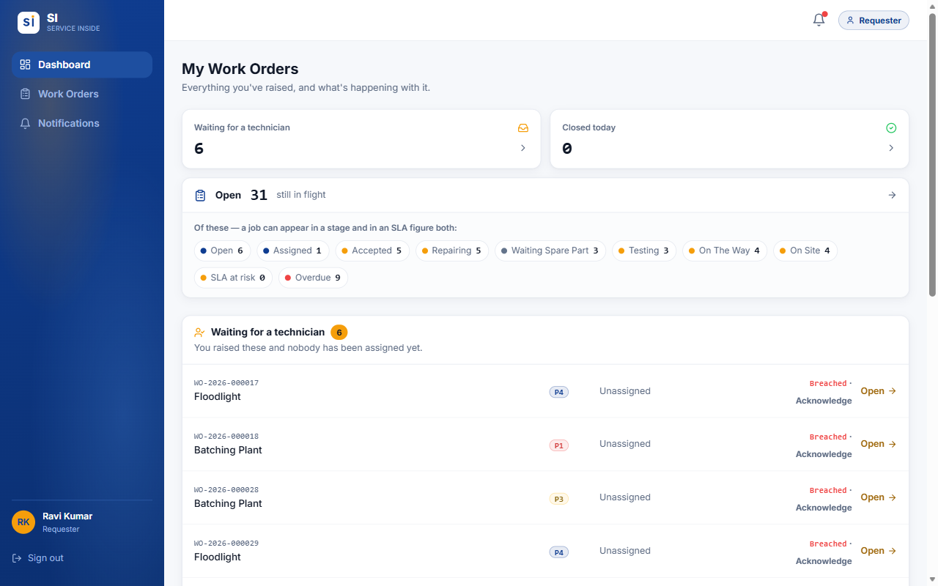
Figure 1.3 — The screen layout (Requester shown). On a PC the menu is on the left.
Part of the screen | What it is for
Dashboard | Your starting page: counts and lists of the work that needs your attention.
Work Orders | The full list of work orders you can see, with search, filters, sorting and Excel export.
Notifications | Everything SI has told you about, grouped by category.
Users / Settings | Administrators only — accounts and system settings.
Bell icon (top right) | Opens your latest notifications. A red dot means something is unread.
Role badge (top right) | Shows the role you are working as. If you hold several roles, use it to switch dashboards.
Your name / Sign out | Bottom of the menu. Always sign out on a shared computer.

1.7 Using SI on your phone
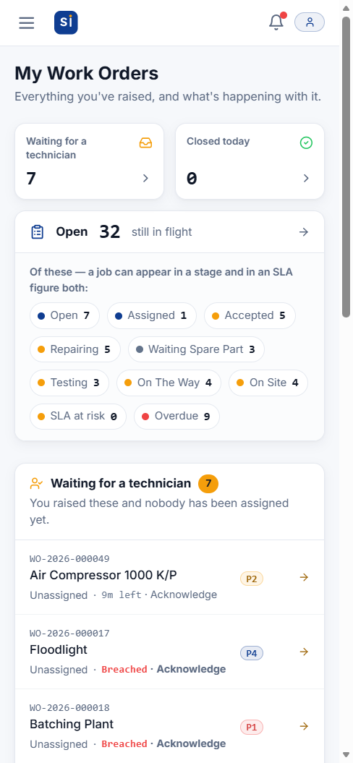  Figure 1.4 — Dashboard on a phone | 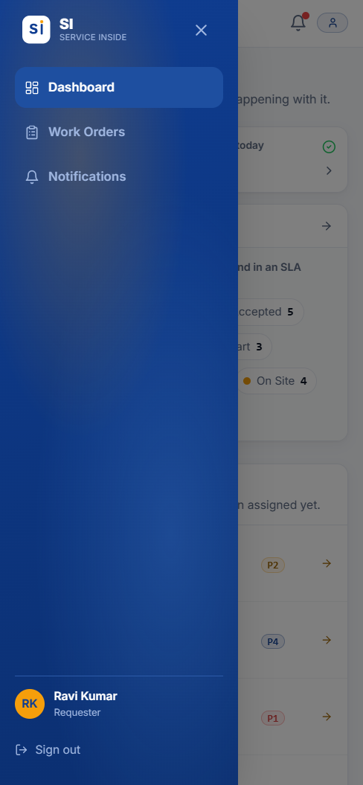  Figure 1.5 — Tap ☰ to open the menu | 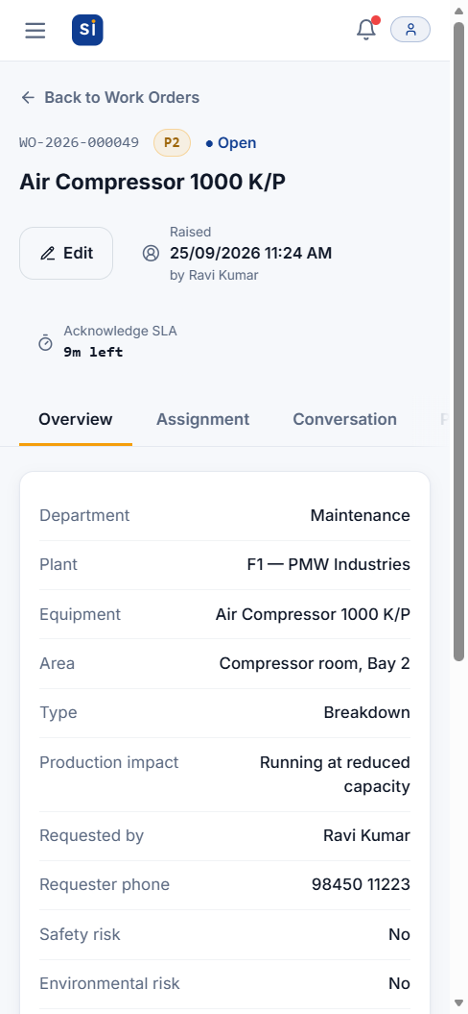  Figure 1.6 — A work order on a phone

SI adapts to small screens. The menu hides behind the ☰ button at the top left, and wide tables turn into cards you can scroll.
- iPhone: open SI in Safari, tap the Share button, then Add to Home Screen. Pop-up alerts on iPhone only work once SI is added this way.
- Android: open SI in Chrome, tap the ⋮ menu, then Install app or Add to Home screen.

1.8 Notifications
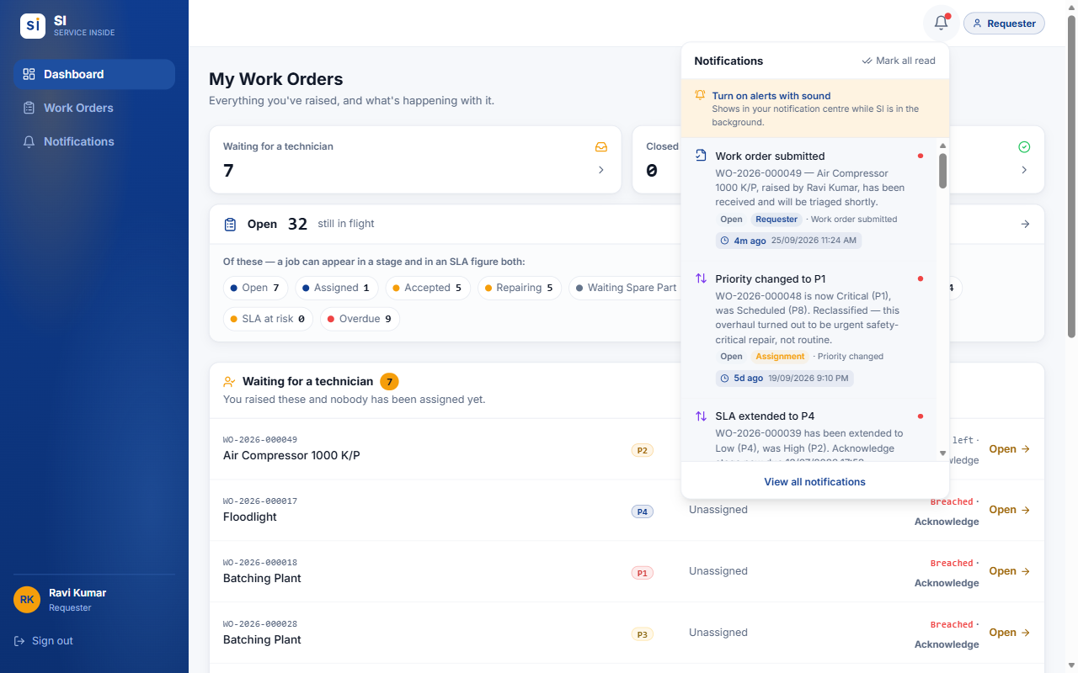
Figure 1.7 — The bell opens your latest notifications without leaving the page.
- SI notifies you when something happens that concerns you — for example a job assigned to you, or your work order completed.
- Each notification shows how long ago it happened and the exact date and time, plus tags for who caused it and which stage the job was at.
- Tap a notification to open that work order. Mark all read clears the red dot.
- On the Notifications page, filter by category and use Clear read to delete notifications you have already read. Unread ones are never deleted.
- To get alerts on your phone or PC while SI is in the background, press Turn on alerts with sound in the bell panel and allow notifications when the browser asks. Alerts only arrive while SI is open somewhere (a tab or the home-screen app) — not after it has been fully closed.

1.9 How a work order moves
Every work order goes through the same stages, in order. No stage can be skipped, and every move is recorded on the Status Timeline with the person's name and the time.
Open | → | Assigned | → | Accepted | → | Repairing | → | Testing | → | Completed | → | Closed

Status | Meaning
Open | Raised and waiting for somebody to assign a technician.
Assigned | A technician has been chosen and must accept or decline. A decline sends it back to Open.
Accepted | The technician has taken the job but not started yet.
Repairing | Work is in progress.
Waiting Spare Part | Paused because a part is needed. Returns to Repairing when the part arrives.
Testing | The fix is being tested. A failed test sends it back to Repairing.
Completed → Closed | The technician marks the repair completed, and SI closes it automatically at the same moment.

1.10 Priorities and SLA deadlines
You never choose a priority — SI works it out from the production impact picked when the work order is raised, and raises it further if a safety or environmental risk is flagged. Each priority has an SLA (service-level agreement): a time limit for each of three stages.
Priority | Production impact | 1. Acknowledge | 2. Response | 3. Resolution
P1 Critical | Full production stoppage | 5 min | 10 min | 3 hrs 45 min
P2 High | Running at reduced capacity | 15 min | 45 min | 7 hrs
P3 Medium | Auxiliary equipment, no line impact | 30 min | 3 hrs 30 min | 20 hrs
P4 Low | No production impact (cosmetic/routine) | 2 hrs | 22 hrs | 4 days
P7 Long-term | Long-term task (planned) | 5 days | 3 days | 7 days
P8 Scheduled | Scheduled work (month-scale) | 5 days | 5 days | 20 days

- Acknowledge — from raising the work order until a technician is assigned.
- Response — from assignment until the technician starts work.
- Resolution — from starting work until the repair is completed.
- Each stage's clock starts when the previous stage finishes. The header of every work order shows the current stage and the time left, for example 14m left, At risk (in the last quarter of its time) or Breached (late).
- These are the current settings. Administrators can change them, so the times shown in the app are always the ones that apply.

1.11 Inside a work order
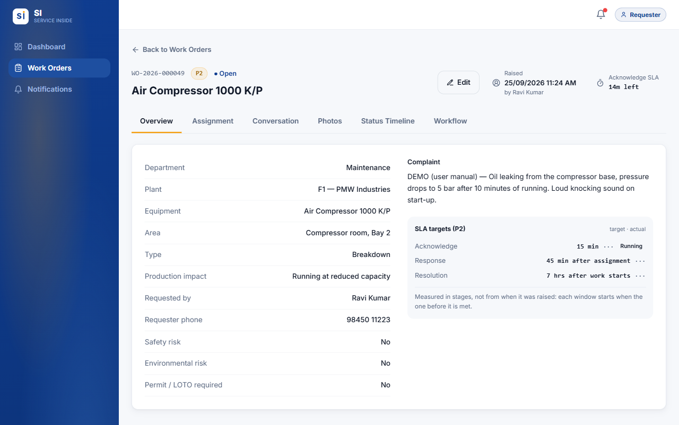
Figure 1.8 — Every work order has the same header and six tabs.
Tab | What you find there
Overview | All the details — department, plant, equipment, complaint, risks — plus the SLA targets and how long each stage actually took.
Assignment | Who the job is assigned to. Supervisors and Administrators assign and reassign here, until the job is completed. After that the Assign buttons are greyed out.
Conversation | Comments and photos in one chat-style thread. A red number shows how many new messages you have not read.
Photos | Every photo, grouped by the stage it was taken at (before work, during repair, testing...).
Status Timeline | The full history: every move, who made it, when, and any reason given.
Workflow | Tells you whose move it is, and holds the action buttons when it is yours.

Tip: If your session expires while you are typing a work order, SI keeps what you typed and offers to restore it after you sign back in. Photos cannot be kept, so re-attach them.

02.
ROLE GUIDE

Requester guide
You report faults and follow them until they are fixed. This chapter covers everything a Requester can do in SI.
IN THIS CHAPTER
2.1 At a glance
2.2 Your dashboard
2.3 Raising a work order
2.4 After you submit
2.5 Editing your work order
2.6 Comments and photos
2.7 Following progress
2.8 Finding work orders
2.9 Common situations

2.1 At a glance
You can | You cannot
Raise a work order, with photos | See work orders raised by other people
Edit your work order while it is still Open | Edit it once a technician is assigned
Comment and add photos on your own work orders | Assign a technician or choose who does the job
Replace a photo you uploaded (while the job is live) | Do the technician's steps (accept, repair, test, complete)
Follow progress on the timeline and get notified | Delete a work order, or anyone else's comment or photo
Search, filter and export your work orders to Excel | Reach the Users or Settings screens

2.2 Your dashboard
Figure 2.1 — My Work Orders — the Requester dashboard.
- Waiting for a technician — work orders you raised that nobody has been assigned to yet.
- Closed today — your work orders finished and signed off today.
- Open … still in flight — everything not yet finished, broken down by stage and by SLA (at risk / overdue). Tap any figure to see the work orders behind it.
- Recent activity — your work orders with the latest changes first. Press See all for the full list.

2.3 Raising a work order
Go to Work Orders and press Raise Work Order. Fields marked * are required.
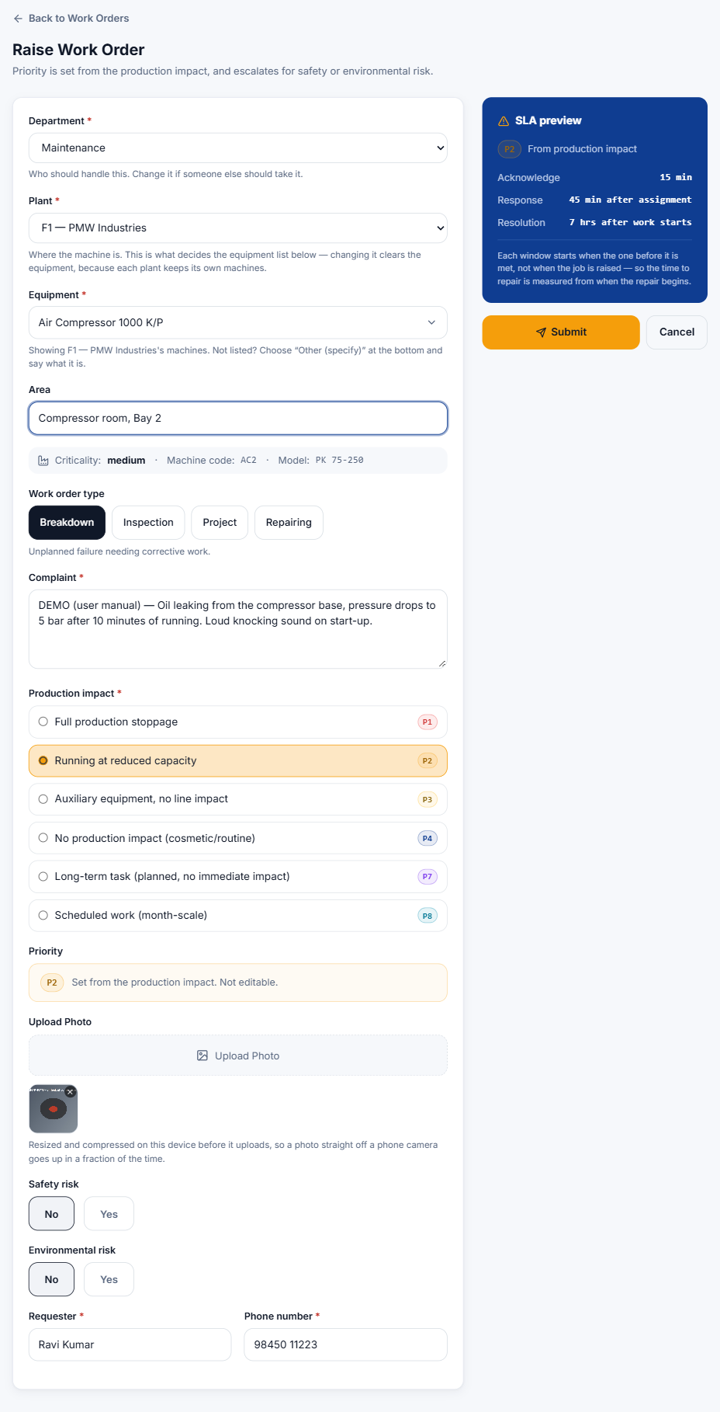
Figure 2.2 — A completed Raise Work Order form, with the SLA preview on the right.
- Department — the department that should handle the job. Pick the right one; it decides who is told about it.
- Plant — where the machine is: F1, F2, F3 or Facility. The equipment list only shows machines at the plant you pick.
- Equipment — click the box and type part of the machine name or machine code, then pick it from the list. The machine's criticality, code and model appear underneath.
- Area (optional) — where exactly: line, bay, floor, room.
- Work order type — Breakdown (unplanned failure), Inspection (routine check), Project (improvement or installation) or Repairing (repair of a known fault).
- Complaint — describe the problem: what happened, symptoms, sounds, error codes, and when it started.
- Production impact — how badly production is affected. This sets the priority, shown in the Priority box underneath.
- Upload Photo — add one or more photos of the fault. They are shrunk automatically before upload, so a phone photo goes up quickly.
- Safety risk / Environmental risk — choose Yes if there is one (see below).
- Requester and Phone number — filled in from your account. Correct them if needed.
- Check the SLA preview on the right, then press Submit.

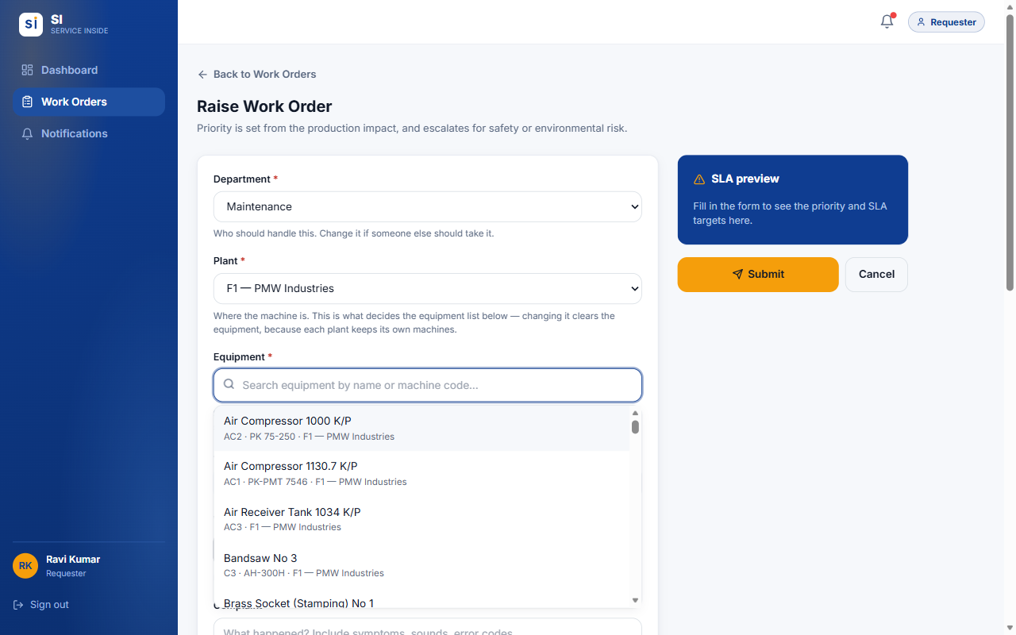
Figure 2.3 — Type to search. Only machines at the chosen plant are listed.

Machine not in the list?
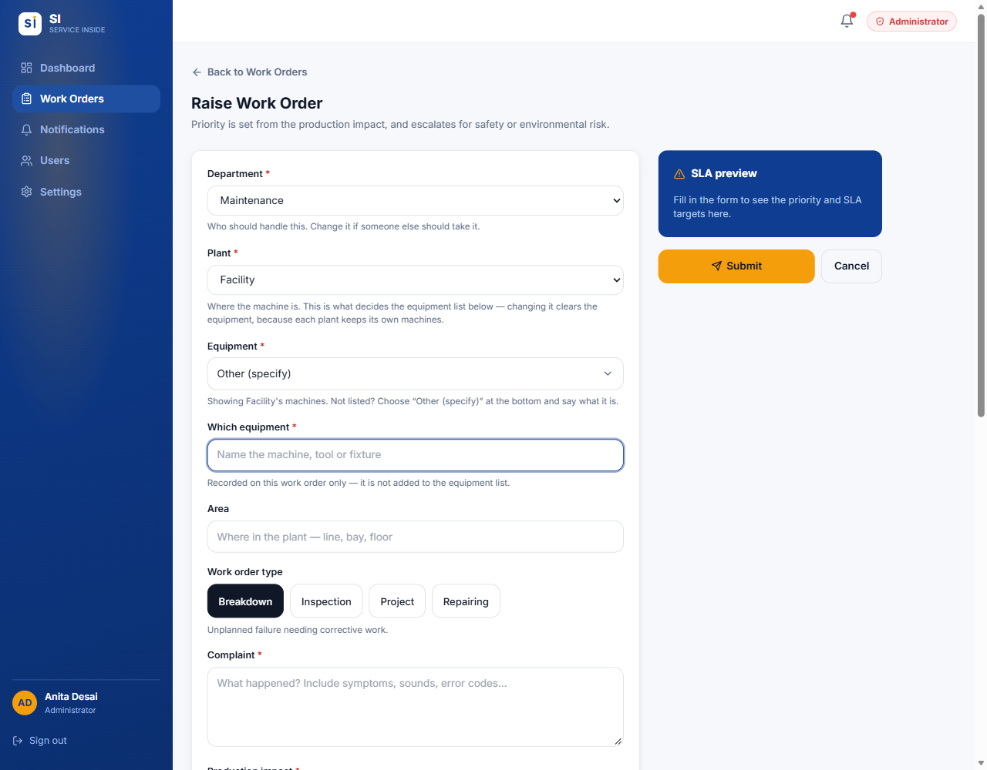
Figure 2.4 — Choose "Other (specify)" at the bottom of the list, then say which equipment it is.
Scroll to the bottom of the equipment list (or type "other") and choose Other (specify). A Which equipment box appears — type the name of the machine. It is recorded on this work order only. Ask your Administrator to add the machine to the list if it will come up again.

Flagging a safety or environmental risk
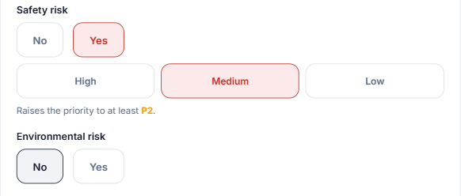
Figure 2.5 — Choosing Yes for Safety risk asks for its severity and can raise the priority.
- Choose Yes under Safety risk, then pick the severity: High (immediate danger to people), Medium (hazardous if left) or Low (minor, controlled).
- A line such as "Raises the priority to at least P2" shows what it does to the priority. A High safety risk always makes the job P1.
- An Environmental risk raises the priority to at least P2.

Important: SI is not an emergency alarm. For immediate danger to people, follow the plant's emergency procedure first — then raise the work order.

2.4 After you submit
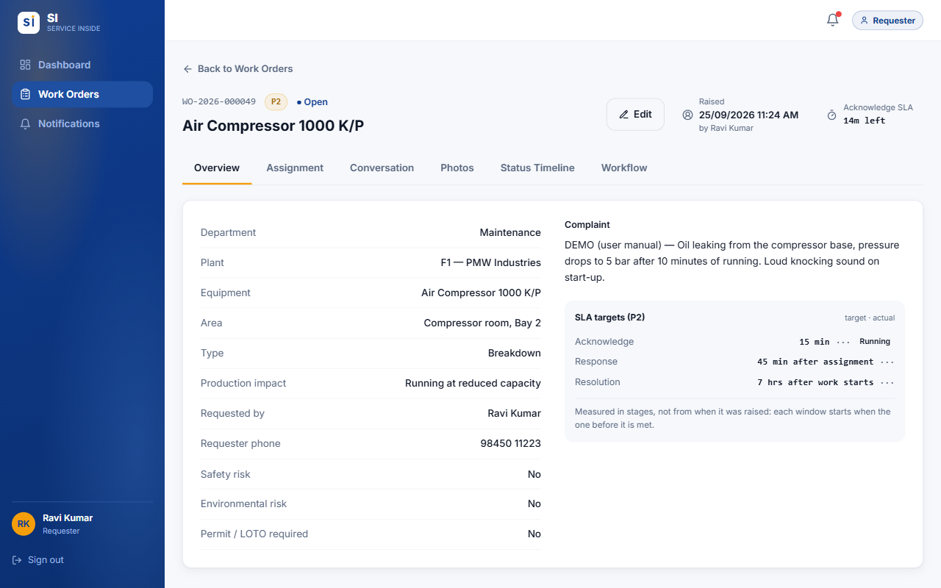
Figure 2.6 — Your new work order opens straight away with its WO number.
- SI gives the work order a number such as WO-2026-000049 — quote it when you talk to maintenance.
- You receive a Work order submitted notification as your receipt.
- Everyone who can assign work (Supervisors, Managers, Administrators) is told about it, and the Acknowledge clock starts.
- The Workflow tab tells you who the job is waiting on.

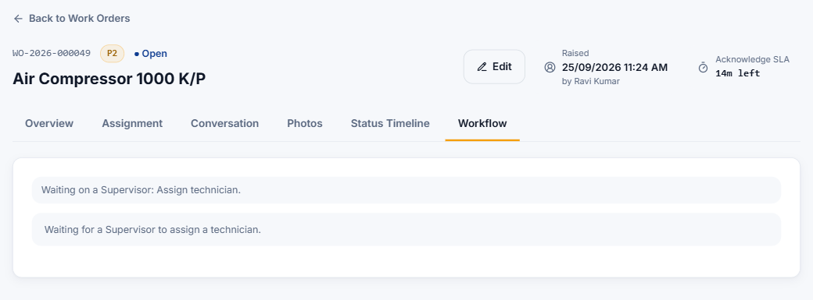
Figure 2.7 — Workflow tab: while it is Open you are waiting for a Supervisor to assign a technician.

2.5 Editing your work order
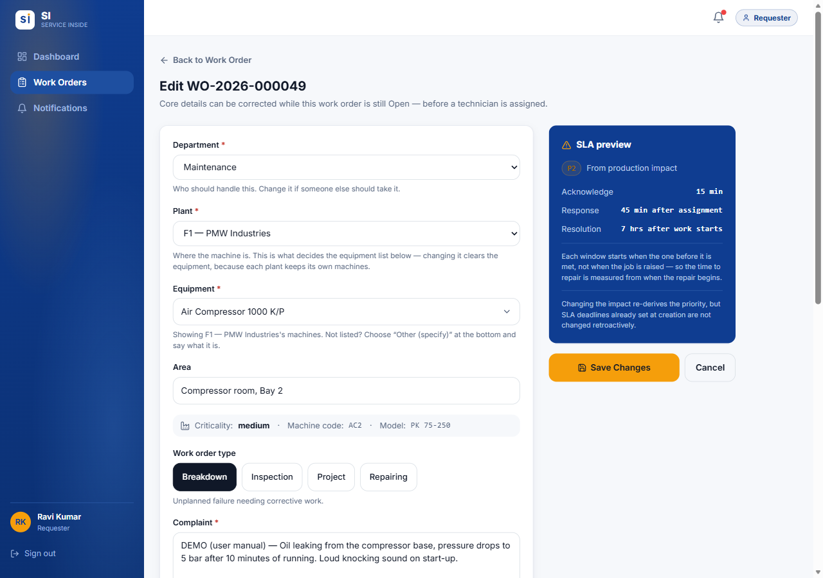
Figure 2.8 — Edit WO — available only while the work order is Open.
- While the status is Open, press Edit at the top of the work order to correct any detail — department, plant, equipment, complaint, impact and so on — then press Save Changes.
- Once a technician is assigned the Edit button disappears. From then on details only change through the workflow, so the record cannot be quietly rewritten. To add information, post a comment instead.

2.6 Comments and photos
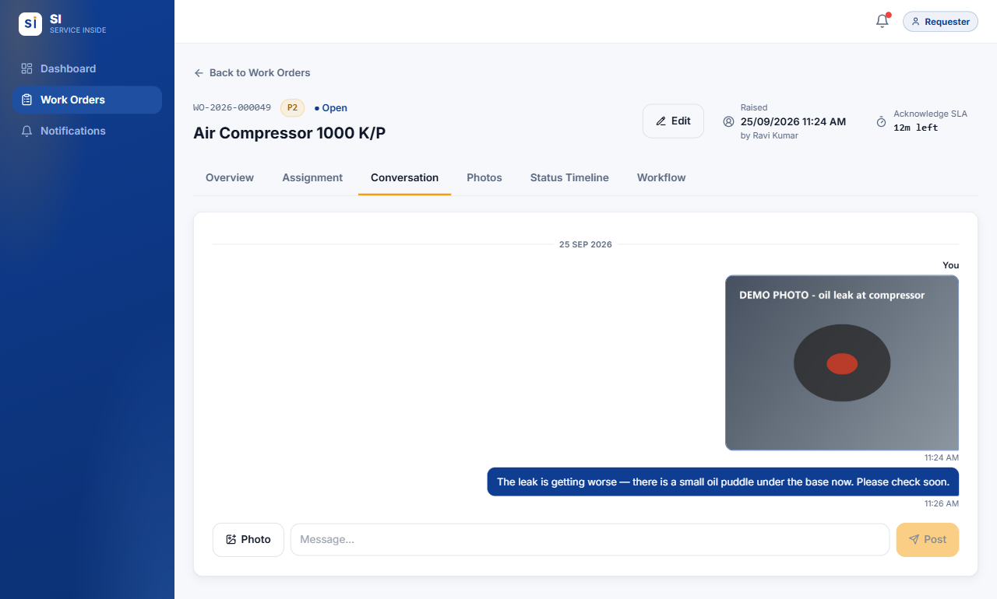
Figure 2.9 — The Conversation tab: your messages on the right, everyone else's on the left.
- Open the work order and go to Conversation.
- Type in the Message… box and press Post.
- To add a picture, press Photo and take or choose one. It appears in the thread and on the Photos tab.

- Use comments to add details the technician needs, answer their questions, or report that things have got worse.
- You can edit or delete your own comments. You cannot delete other people's comments or any photo.
- On the Photos tab, open one of your photos and press Replace to swap it for a better one while the job is still live. A replaced photo is marked as replaced, and the original is kept in the audit record.

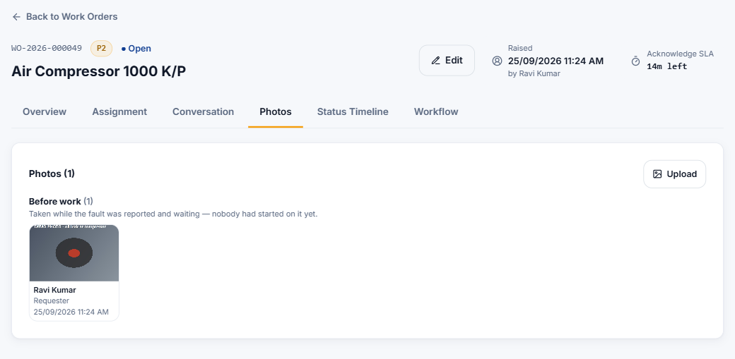
Figure 2.10 — The Photos tab groups photos by the stage they were taken at.

2.7 Following progress
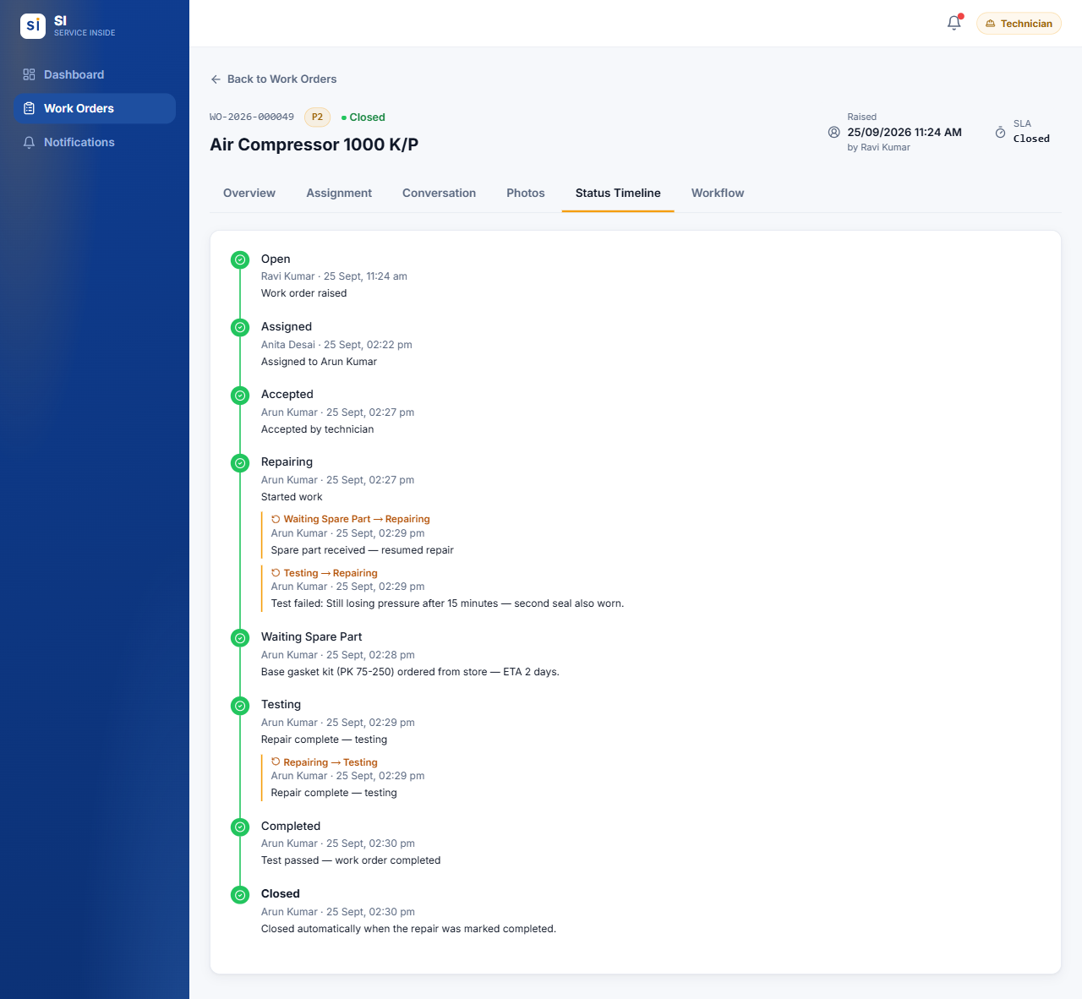
Figure 2.11 — The Status Timeline of a finished work order, including a spare-part wait and a failed test.
- The Status Timeline lists every step with the person and the time. Amber sub-entries show steps that went back — for example a failed test sent back to Repairing, with the reason.
- SI notifies you when your job is accepted, when it is waiting for a spare part (and when work resumes), when it is completed, and if its priority or deadline is changed.
- When the technician marks the job completed it closes automatically. The completion notes on the Overview tab say what was done.

2.8 Finding work orders
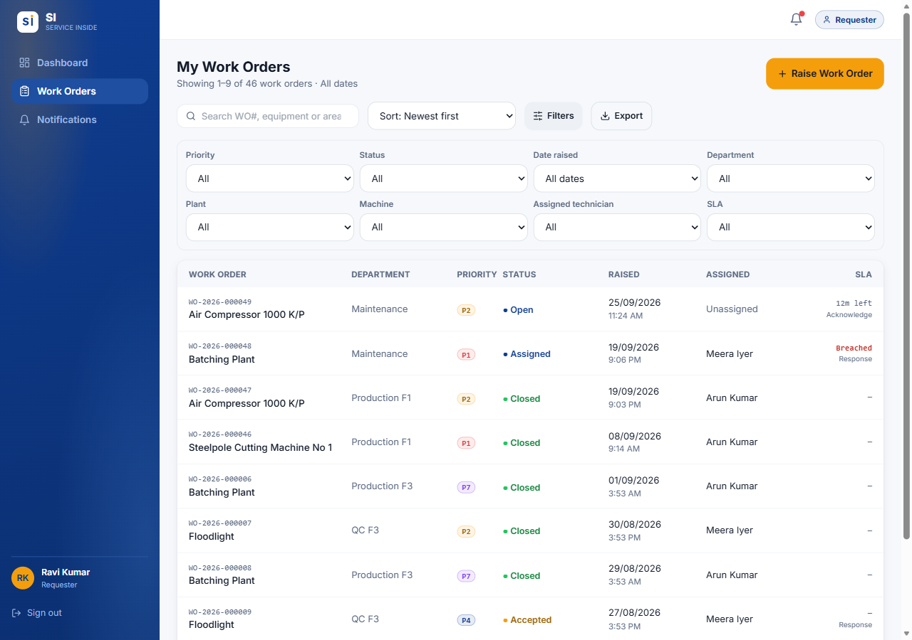
Figure 2.12 — Work Orders list with the Filters panel open.
- Search by WO number, equipment or description.
- Sort by newest, oldest, priority, SLA (soonest due) or WO number.
- Filters — priority, status, date raised (today, this week, this month, a custom range…), department, plant, machine, technician and SLA state.
- Export — downloads the work orders currently listed to an Excel workbook, with their history and comments on separate sheets.
- Tap any row to open that work order.

2.9 Common situations
Q I picked the wrong department or machine.
If the work order is still Open, press Edit and correct it. If a technician is already assigned, post a comment explaining the mistake, or ask a Supervisor.

Q The machine is not in the equipment list.
Check you chose the right Plant first. If it is still missing, choose Other (specify) and type its name.

Q Nobody has picked up my urgent job.
Check the Workflow tab and the SLA in the header. For a true emergency, phone the maintenance team as well.

Q The problem came back after the job was closed.
Contact your HOD or Supervisor. They can send a finished job back to repair, or you can raise a new work order that mentions the old WO number.

Q I raised the same fault twice.
Comment on the duplicate saying which WO number it repeats. Only an Administrator can delete a work order.

Q I can't see a colleague's work order.
Requesters only see work orders they raised. Ask the person who raised it, or a Supervisor.

03.
ROLE GUIDE

Technician guide
You carry out the repairs. This chapter walks through a job from the moment it is assigned to you until it is closed, including every alternative path.
IN THIS CHAPTER
3.1 At a glance
3.2 Your dashboard — My Tasks
3.3 The job workflow
3.4 Comments and photos
3.5 Keeping an eye on the SLA
3.6 Notifications you receive
3.7 Common situations

3.1 At a glance
You can | You cannot
See every job assigned to you, with its SLA clock | See jobs that are not assigned to you, including unassigned ones
Accept a job, or decline it with a reason | Assign or reassign a job — to yourself or to anybody else
Start work, pause for a spare part, resume | Skip a step — the order is fixed
Test the fix, record a failed test, mark it completed | Reopen a job once it is closed
Comment and add before/after photos | Delete a work order, another person's comment, or a photo
Search, filter and export your jobs | Raise a work order (unless you also hold the Requester role)

3.2 Your dashboard — My Tasks
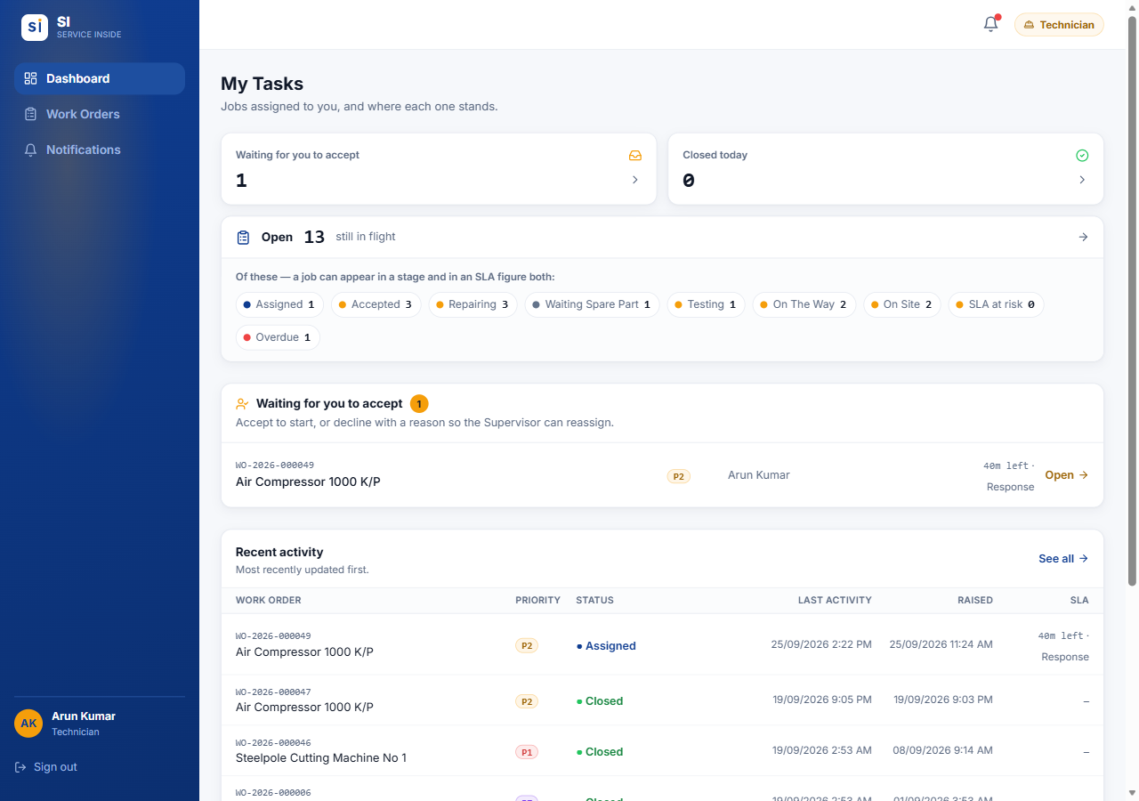
Figure 3.1 — My Tasks — the Technician dashboard.
- Waiting for you to accept — new jobs assigned to you. These need your answer first.
- Closed today — jobs you finished that have been signed off today.
- Open … still in flight — your jobs by stage, plus how many are at risk or overdue on their SLA.
- The list underneath shows each waiting job with its priority and the time left.

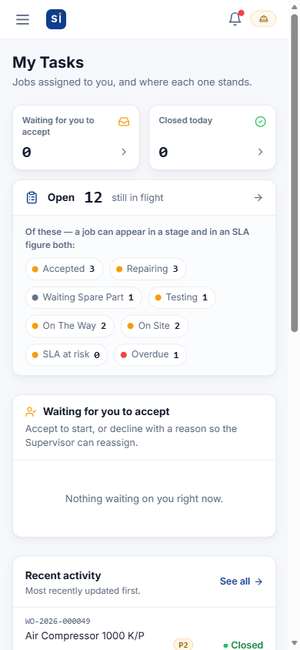
Figure 3.2 — My Tasks on a phone

3.3 The job workflow
Everything you do to a job happens on its Workflow tab. The yellow bar always says "Your move: …" and names the buttons you can press next. Some steps need a short note — the button stays greyed out until you type one.
Assigned | → | Accepted | → | Repairing | → | Testing | → | Completed | → | Closed

Step 1 — Accept or decline
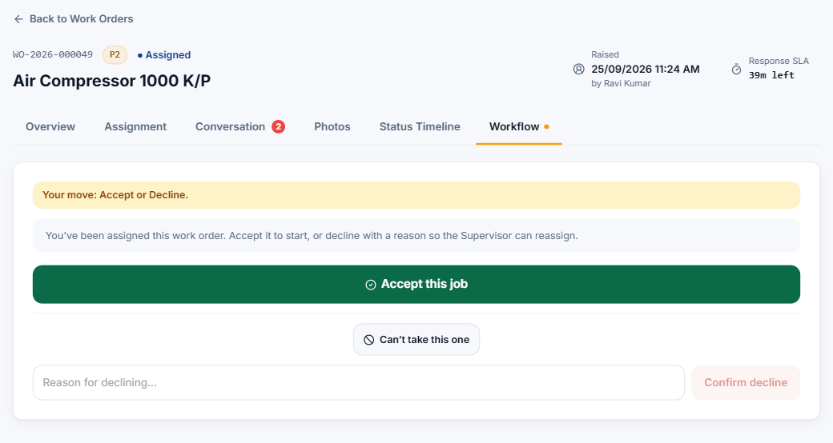
Figure 3.3 — A new assignment: accept it, or decline with a reason.
- You get a notification when a job is assigned to you. Open it, go to Workflow, and read the Overview and Conversation first.
- Accept this job — the job becomes yours and moves to Accepted. The Requester and the people who assign work are told.
- Can't take this one — type a reason (for example "on leave this afternoon") and press Confirm decline. SI shows your reason again before sending. The job goes back to Open for the Supervisor to reassign, and it disappears from your list.

Step 2 — Start work
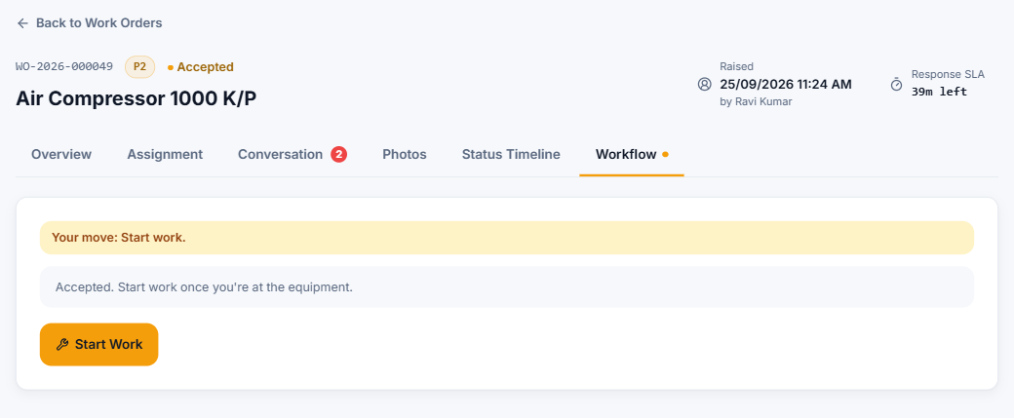
Figure 3.4 — Accepted: press Start Work when you begin the repair.
When you actually begin, press Start Work. The job moves to Repairing and the Resolution clock starts. Press it when you start, not before — the time it takes to repair is measured from this moment.

Step 3 — Repairing (and waiting for a spare part)
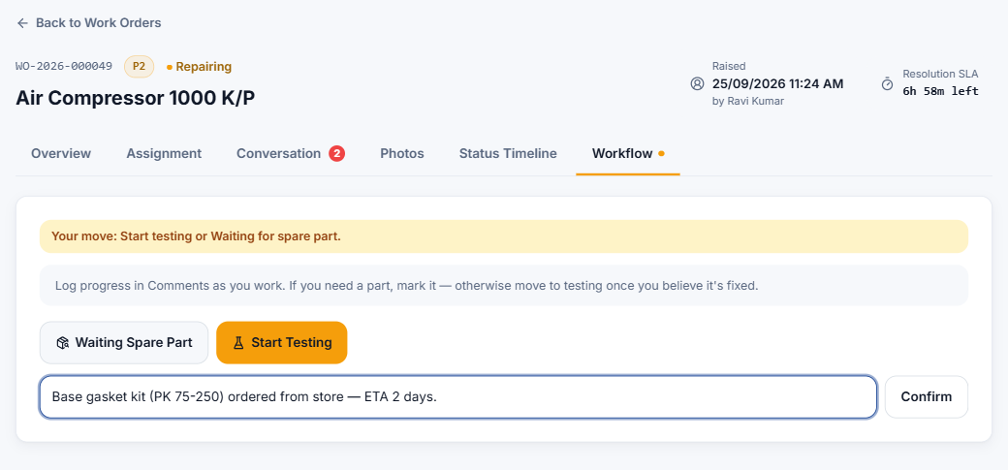
Figure 3.5 — Repairing: go to testing, or pause for a spare part with a reason.
- Post progress in Conversation as you work — findings, part numbers, meter readings, photos.
- If you need a part, press Waiting Spare Part, type which part and why (for example "Base gasket kit ordered from store — ETA 2 days"), then press Confirm. The Requester and the people who assign work are told the job is paused.
- When the part arrives, press Part Received — Resume Repair. The job returns to Repairing.

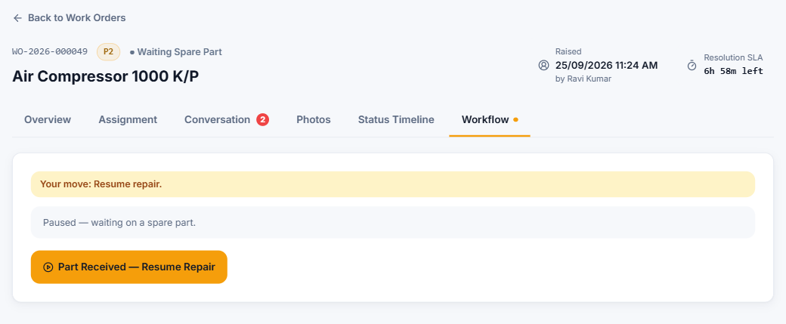
Figure 3.6 — Paused — waiting on a spare part.

Step 4 — Testing
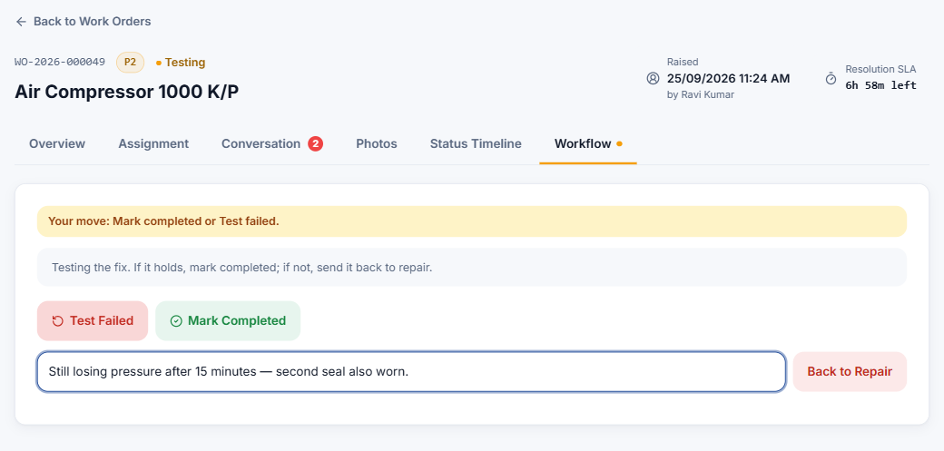
Figure 3.7 — Testing: mark it completed, or record a failed test.
- When you believe it is fixed, press Start Testing.
- If the test fails, press Test Failed, describe what failed, and press Back to Repair. The job returns to Repairing and the reason is recorded on the timeline. Fix it and test again.

Step 5 — Mark completed
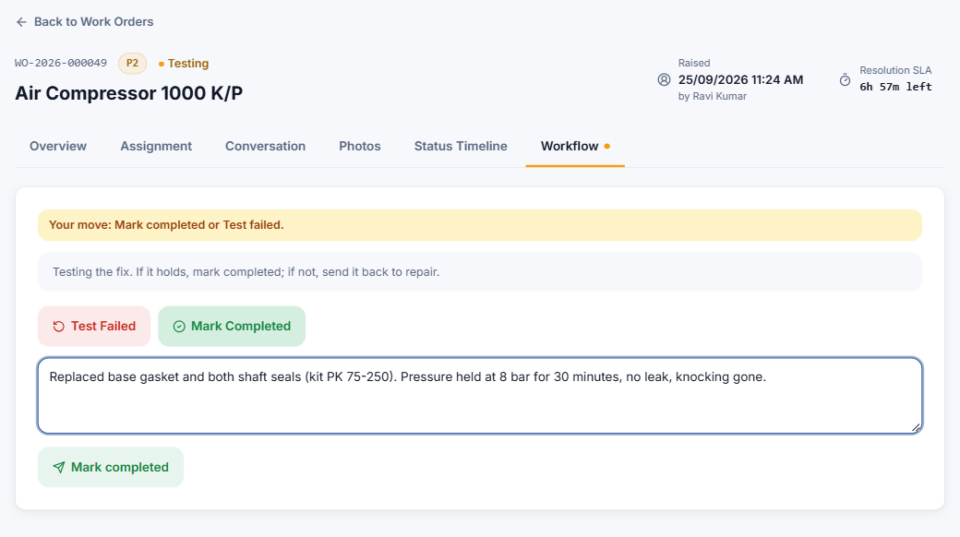
Figure 3.8 — Describe what you did to fix it. The Requester can read this.
- Press Mark Completed.
- In What did you do to fix it? describe the repair — parts replaced, adjustments made, test results. The Requester will read this.
- Press Mark completed to confirm. The job becomes Completed and is closed automatically at the same moment.

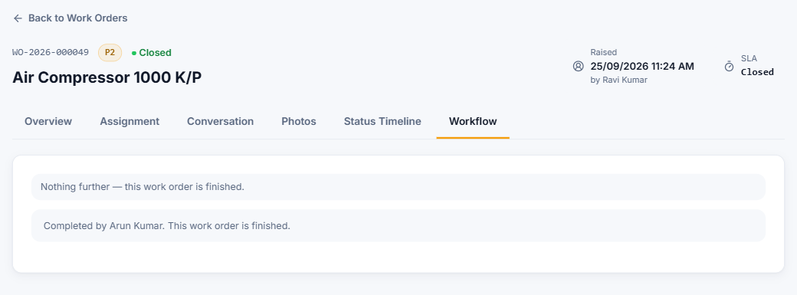
Figure 3.9 — Finished — nothing further to do.
Tip: Before completing, add an "after" photo in Conversation. It is filed under the Testing stage on the Photos tab, next to the "before" photo the Requester took.

3.4 Comments and photos
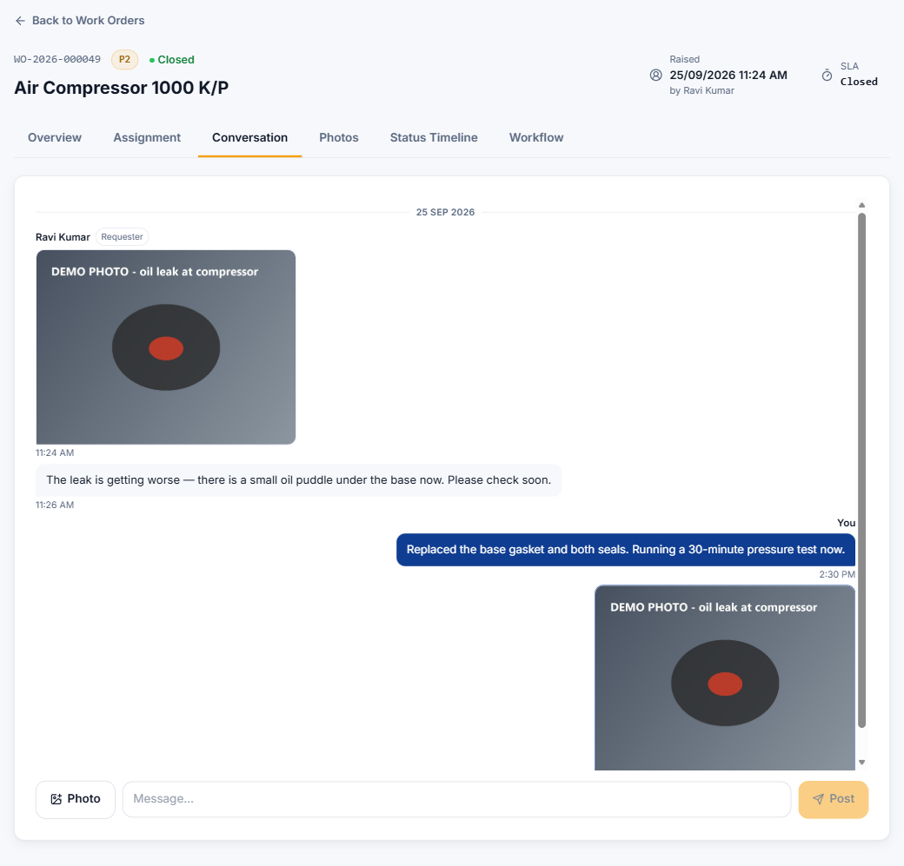
Figure 3.10 — The Conversation thread: your messages on the right in navy.
- Type in Message… and press Post. Press Photo to attach a picture from your camera or gallery.
- Photos are shrunk automatically before upload, so they go up quickly even on mobile data.
- Each photo is filed under the stage the job was at when you took it, so Before work, Repairing and Testing photos stay separate on the Photos tab.
- You can replace a photo you uploaded while the job is live: open it on the Photos tab and press Replace.

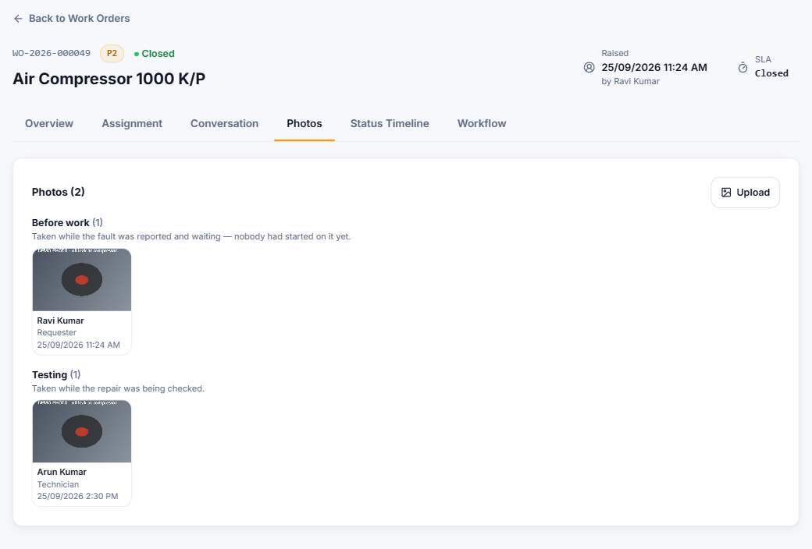
Figure 3.11 — Photos grouped by stage — the Requester's "before" photo and your testing photo.

3.5 Keeping an eye on the SLA
- The top right of every job shows the stage that is running and the time left — Response SLA before you start work, Resolution SLA after.
- SI warns you when a job assigned to you is at risk (in the last quarter of its time) and again if it is breached.
- A late stage stays marked as missed on the record, even if the job is finished afterwards. Only an Administrator can give a job more time (Extend SLA).

3.6 Notifications you receive
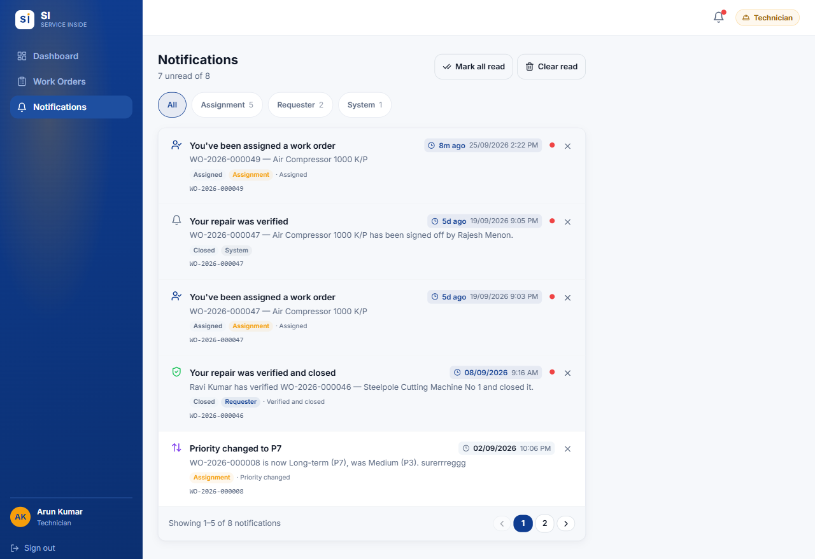
Figure 3.12 — Notifications for a technician.
- A job is assigned to you, or handed over to you from another technician. A handover keeps the job at its current stage — there is nothing to accept, just carry on.
- A job you finished is sent back for rework by a HOD, Manager or Administrator.
- A job of yours is at risk or has breached its SLA.
- An Administrator changed the priority of, or extended, one of your jobs.

3.7 Common situations
Q I accepted by mistake / I can't continue this job.
Tell your Supervisor in the job's Conversation. Only a Supervisor, Manager or Administrator can reassign it to somebody else.

Q A job I declined has disappeared.
That is expected. It went back to the Supervisor's queue with your reason.

Q The Confirm button is greyed out.
That step needs a note — a decline reason, which spare part, what failed, or what you did. Type it and the button turns on.

Q I don't see a Raise Work Order button.
Technician-only accounts don't raise work orders. Ask your Administrator to add the Requester role if you need to.

Q The job is waiting on a part for a long time.
Leave it in Waiting Spare Part and post updates in Conversation. Press Resume Repair only when the part is actually here.

Q My new role or job isn't showing.
Role changes take up to an hour to take effect. Sign out and back in to see them straight away.

04.
ROLE GUIDE

Administrator guide
You oversee all work in the plant, assign technicians, manage accounts and maintain the settings. This chapter covers every Administrator screen.
IN THIS CHAPTER
4.1 At a glance
4.2 The Administrator dashboard
4.3 Assigning a technician
4.4 Raising a work order for somebody
4.5 Changing a priority
4.6 Extending an SLA
4.7 Deleting a work order
4.8 Managing users
4.9 Settings
4.10 Common situations

4.1 At a glance
You can | Rules to know
See and search every work order in every plant | You cannot assign a job to yourself
Raise work orders, including on somebody's behalf | Details can only be edited while a job is Open
Assign and reassign technicians | Priority changes need a written reason
Change a priority, extend an SLA, delete a work order | Deleting a work order cannot be undone
Create accounts, change roles, activate / deactivate | You can only manage accounts ranked below you
Maintain departments, equipment, labels and SLA targets | Some actions are for the Superuser only (marked ★)

Note: ★ Superuser is one specially protected Administrator account held by IT. It exists so there is always somebody who can manage Administrators, because Administrators cannot edit each other. Actions marked ★ in this chapter need the Superuser.

4.2 The Administrator dashboard
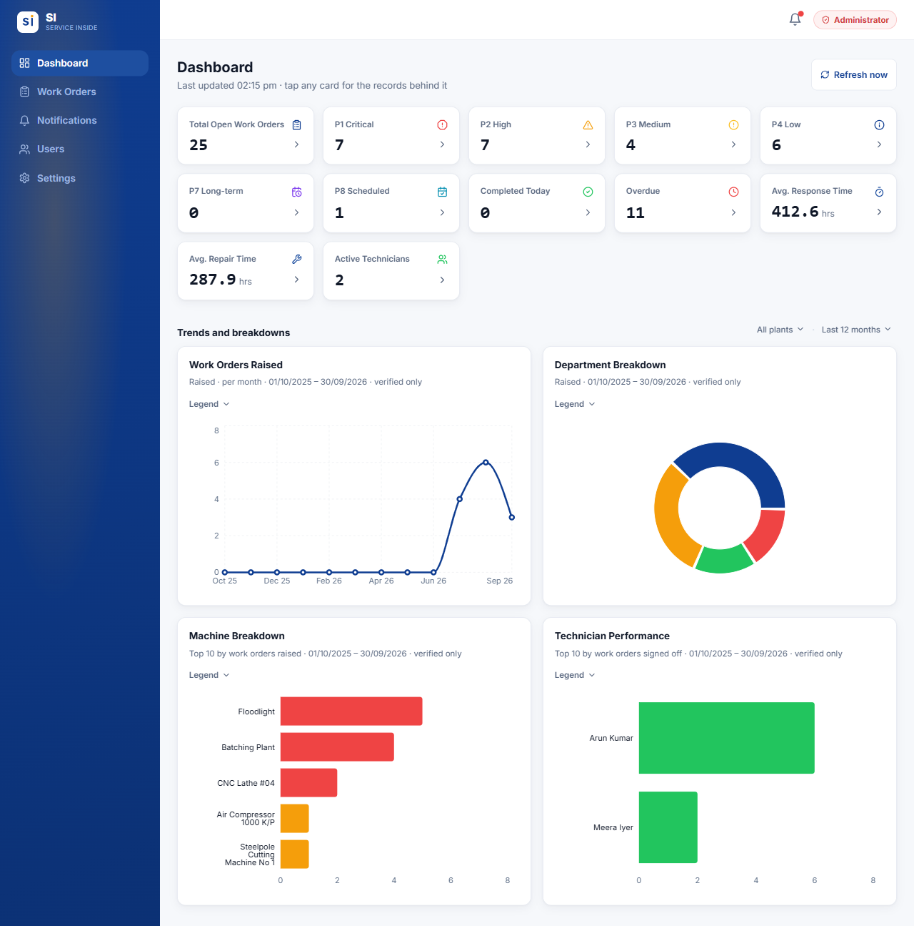
Figure 4.1 — The plant-wide dashboard with its cards and charts.
- Cards — Total open work orders, a count for each priority, Completed today, Overdue, Average response time, Average repair time and Active technicians. Tap any card to see the work orders behind the number.
- Refresh now recalculates the figures (they also refresh by themselves every 15 minutes).
- Trends and breakdowns — work orders raised over time, by department, by machine (top 10), and technician performance. Use the quiet plant · period line above the charts to choose a plant and a period (today, this week, this month, last 12 months or a custom range).
- Figures count work that has been signed off. A job that has closed but not yet been checked by a HOD is not counted yet.

4.3 Assigning a technician
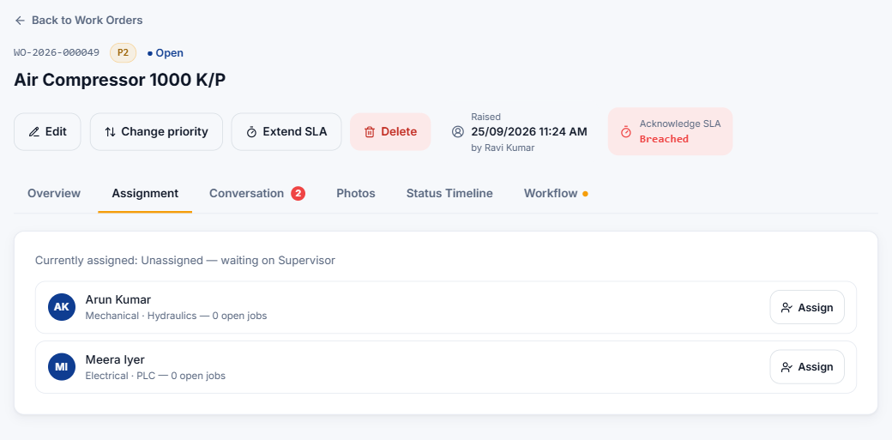
Figure 4.2 — The Assignment tab lists technicians with their skills and how many open jobs they have.
- Open the work order (the dashboard's unassigned list, or Work Orders filtered by status Open).
- Go to the Assignment tab.
- Check each technician's skills and open jobs count, then press Assign next to the right person.
- A confirmation names the technician and explains what happens next. Press Done.

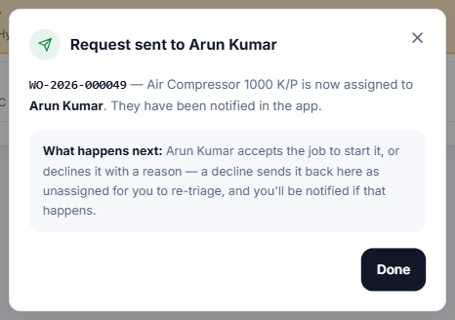
Figure 4.3 — The confirmation after assigning.
- The technician is notified and must accept or decline. If they decline, the job comes back unassigned and you are notified, with their reason.
- Reassign — on the Assignment or Workflow tab, choose a different technician at any stage until the job is completed. Before they accept, the new person must accept. After that it is a handover: the job keeps its stage, and the new technician simply carries on.
- Nobody can assign a job to themselves — not even an Administrator.
- Once a job is completed or closed its technician is fixed, and the Assign buttons are greyed out for everybody — so nobody can hand a finished job to someone by mistake. If it really needs another technician, press Not done properly and Send back for rework first. The job goes back to Repairing, and you can then reassign it.

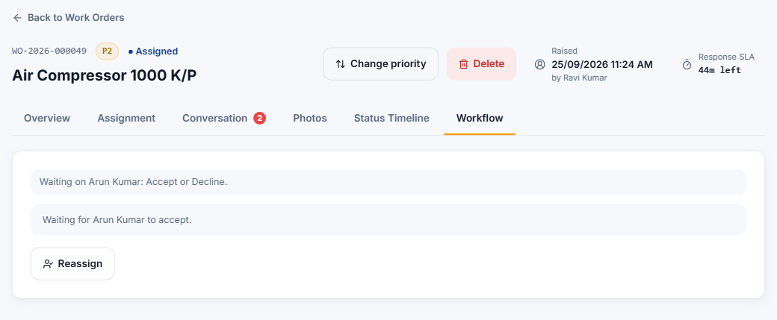
Figure 4.4 — The Workflow tab shows who the job is waiting on, with a Reassign button.

4.4 Raising a work order for somebody
Raise a work order exactly as a Requester does (see the Requester guide). As an Administrator you can change the Requester and Phone number fields to the person who reported the fault — for example after a phone call. That person then gets the "Work order submitted" receipt and can follow the job.

4.5 Changing a priority
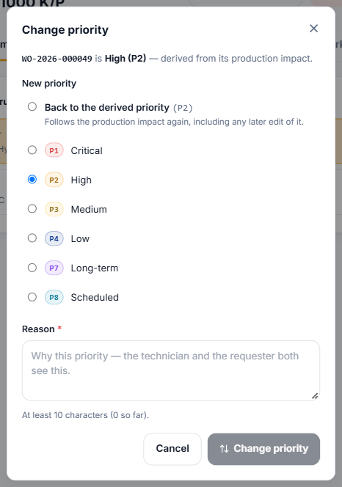
Figure 4.5 — Change priority — a reason of at least 10 characters is required.
- Open the work order and press Change priority at the top.
- Choose the new priority — or Back to the derived priority to let the production impact decide again.
- Type the Reason (at least 10 characters), for example "Reclassified — this overhaul turned out to be urgent".
- Press Change priority.

- Only possible while the job is still live (not once it is closed).
- The SLA deadlines are recalculated from when the job was raised. The technician and the requester are notified, and the change and your reason are recorded on the timeline.
- The assigned technician and the stage do not change.

4.6 Extending an SLA
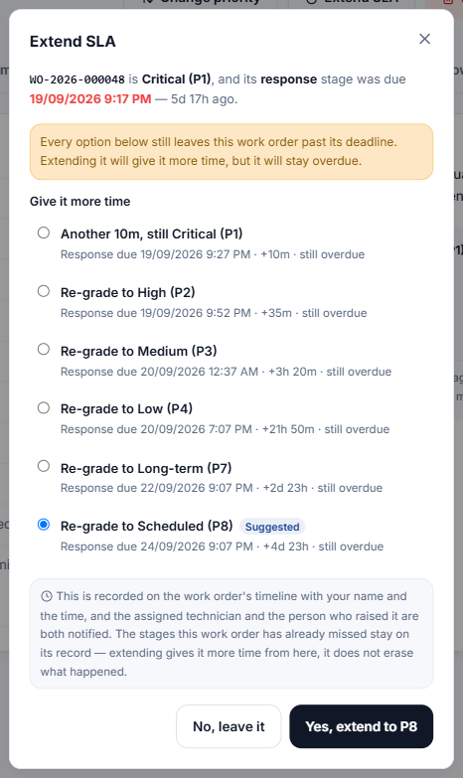
Figure 4.6 — Extend SLA offers more time at the same priority, or a re-grade to a less urgent one.
The Extend SLA button appears when the stage a job is in is at risk or overdue.
- Give it more time — adds another full stage window at the same priority. Use this when the job is correctly graded but genuinely needs longer. You can do it more than once — SI warns you, in red, how many times it has already been extended.
- Re-grade — moves the job to a less urgent priority, which gives the current stage that priority's longer window. Suggested marks the option that best fits.
- Options marked still overdue would still leave the job late.
- Press Yes, extend… to confirm. It is recorded with your name, and the technician and requester are notified. Stages already missed stay recorded as missed — extending gives time from now on, it does not erase history.

4.7 Deleting a work order
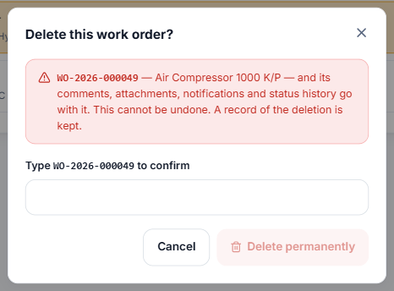
Figure 4.7 — Deleting needs the WO number typed exactly.
Important: Deleting removes the work order together with its comments, photos, notifications and history. It cannot be undone (a record of the deletion is kept). For duplicates or mistakes, deleting is fine — for real work, keep the record.

Press Delete on the work order, type the WO number (for example WO-2026-000049) and press Delete permanently. By default only Administrators can delete. The ★ Superuser can allow other roles in Settings → Permissions.

4.8 Managing users
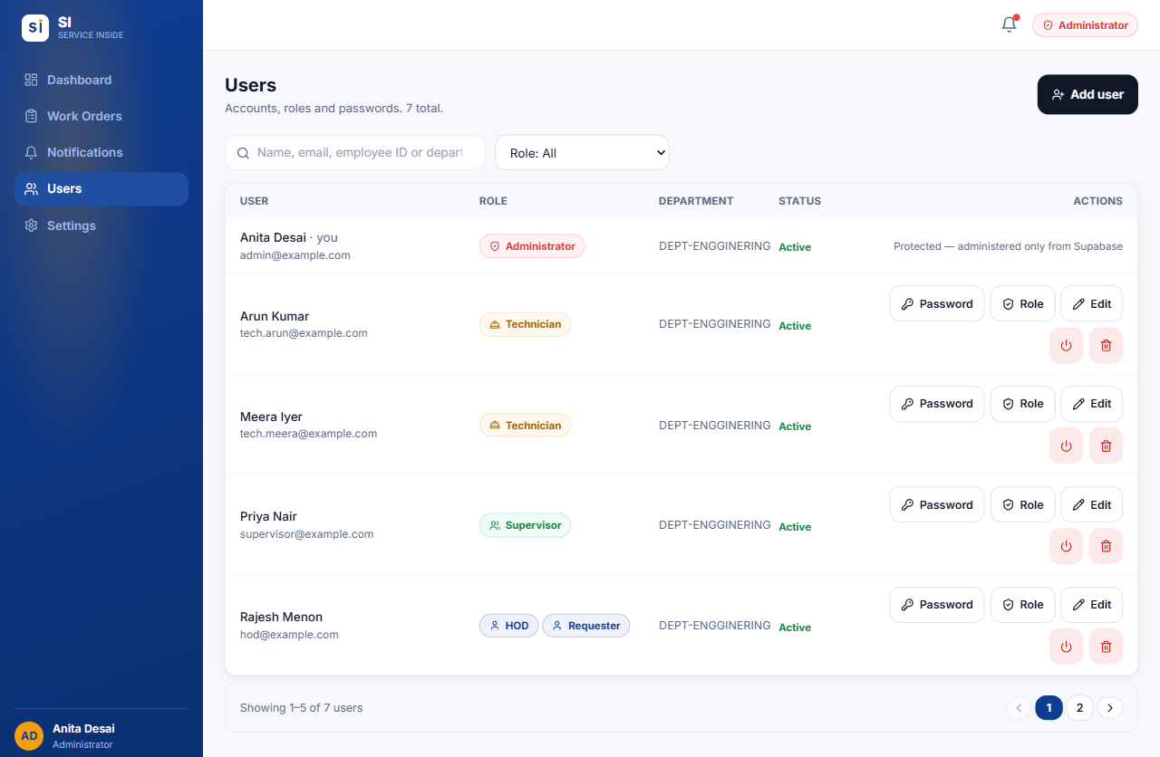
Figure 4.8 — Admin → Users.
Go to Users in the menu. Search by name, email, employee ID or department, and filter by role. Each row shows the person's roles, department and status, with action buttons on the right.
Button | What it does
Add user | Create a new account.
Password ★ | Set a temporary password for somebody (for example when they have forgotten theirs).
Role | Change the person's roles and department.
Edit | Change name, phone and employee ID. Changing somebody else's sign-in email is ★.
Deactivate / Activate (power icon) | Remove or restore the person's access. Their history stays.
Delete (bin icon) ★ | Permanently remove an account that has never been used on a work order.

Note: Who you can manage: you can act on your own account, or on accounts ranked below yours (Requester → Technician → Supervisor → Manager → Administrator → Superuser). Administrators cannot edit other Administrators, and only the Superuser can create one. Protected accounts show "administered only from Supabase" and have no buttons.

Adding a new user
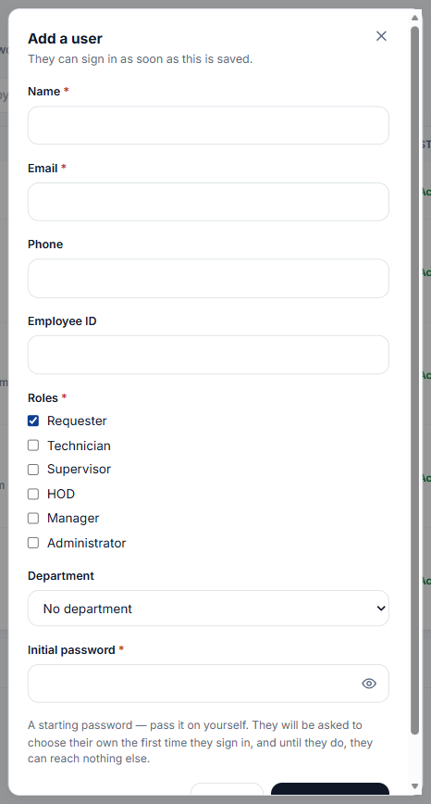
Figure 4.9 — Add a user.
- Press Add user.
- Enter Name and Email (their company email — used to sign in). Add Phone and Employee ID if they have one; the employee ID becomes a second way to sign in.
- Tick one or more Roles, and choose their Department.
- Type an Initial password and press Create user.
- Give the person their email/employee ID and the initial password yourself. SI makes them choose their own password the first time they sign in.

Changing roles
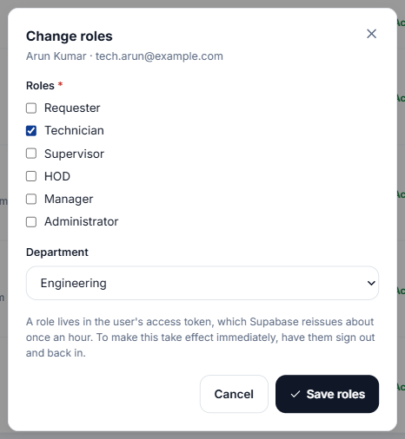
Figure 4.10 — Change roles — tick every role the person should hold.
- Tick every role they need — a person can hold several, and they get everything all of them allow.
- Press Save roles. The change reaches the person the next time their sign-in refreshes — up to an hour. To make it take effect immediately, ask them to sign out and back in.
- You can only give roles that are below your own. Nobody can change their own roles.

Editing a profile
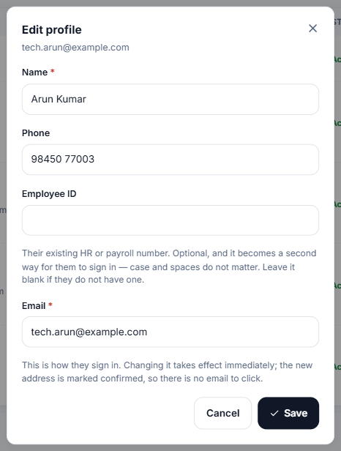
Figure 4.11 — Edit profile.
Correct the name, phone or employee ID and press Save. Changing the sign-in Email takes effect immediately — only the ★ Superuser can do this for other people.

Resetting a password ★
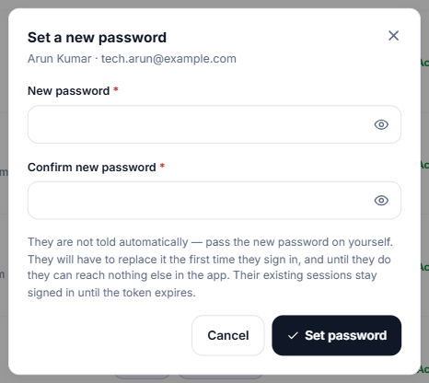
Figure 4.12 — Set a new password.
When somebody has forgotten their password, the Superuser presses Password, types a temporary password twice and presses Set password. Pass it on to the person yourself — SI does not send it. They must replace it the next time they sign in, and can do nothing else until they do.

Deactivating and reactivating
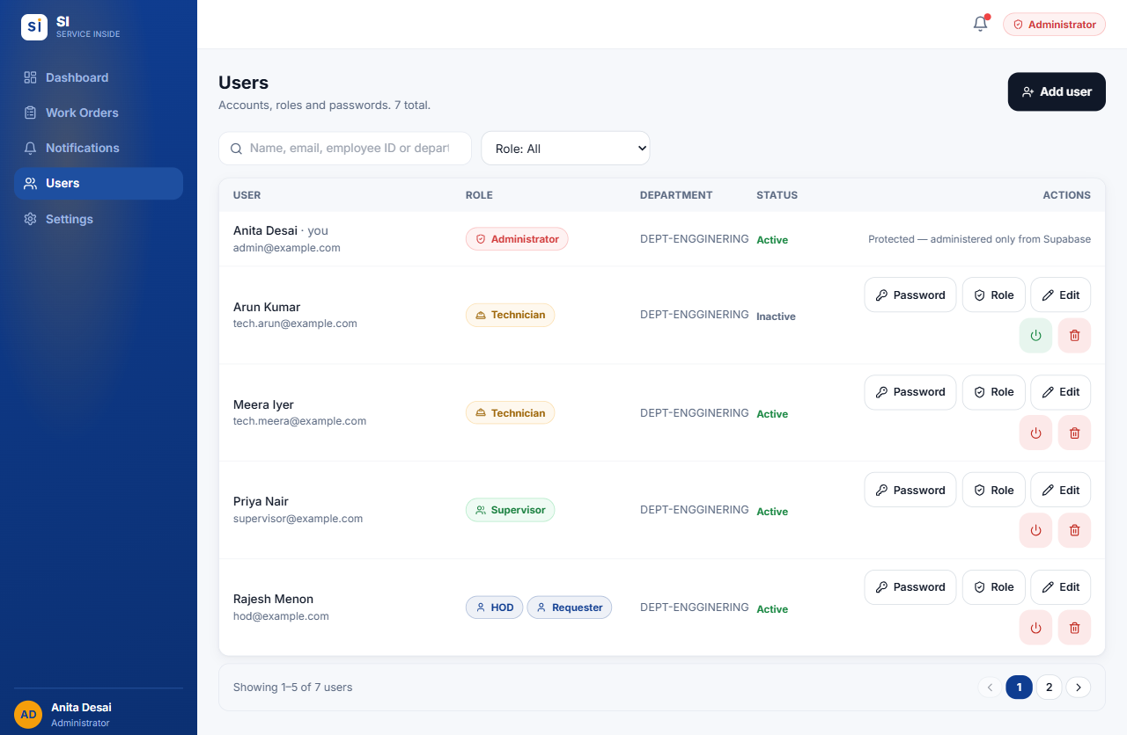
Figure 4.13 — A deactivated account shows Inactive. Press the same button again to reactivate.
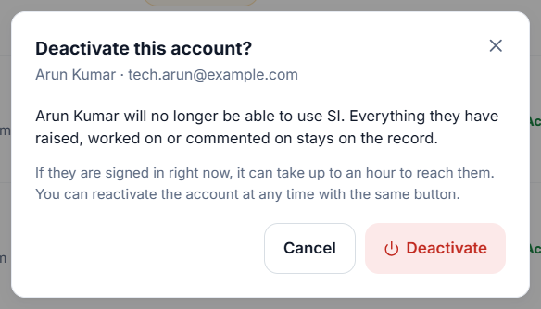
Figure 4.14 — Deactivating asks first, and names the person so you can check it is the right account.
- Find the person in Users and press the red power button on their row.
- SI asks Deactivate this account? and names the person, so you can check it is the right one.
- Press Deactivate to confirm, or Cancel to leave the account as it is.

To reactivate, press the same button (now green) on an Inactive account. This happens straight away, with no confirmation, so a mistaken deactivation is quick to undo.
- Use deactivation when somebody leaves or should no longer have access. Everything they did stays on the record.
- It can take up to an hour to lock out a person who is already signed in.
- Nobody can deactivate their own account.

Deleting an account ★
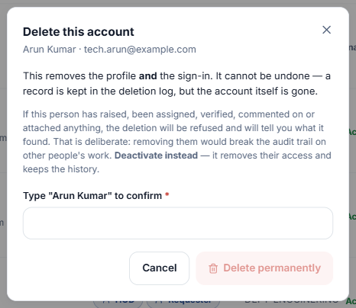
Figure 4.15 — Delete an account — type the person's name to confirm.
Only for accounts that were never used — for example one created by mistake. If the person has raised, worked on, commented on or photographed anything, SI refuses and tells you what it found. Deactivate them instead.

4.9 Settings
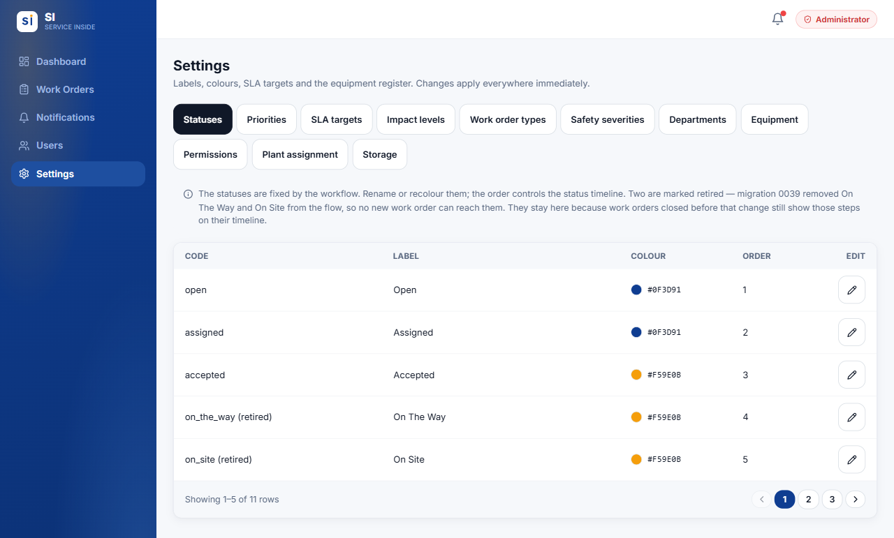
Figure 4.16 — Admin → Settings, with its eleven tabs.
Go to Settings in the menu. Changes apply everywhere in the app straight away. Use the pencil icon on a row to edit it.
Tab | What you can do there
Statuses | Rename and recolour statuses and set their order on the timeline. The statuses themselves are fixed by the workflow.
Priorities | Rename, recolour and describe P1–P8. The colours are used on every badge.
SLA targets | The acknowledge, response and resolution minutes for each priority, plus the labels shown to users. Keep the minutes and the labels matching.
Impact levels | The production-impact choices on the raise form and the priority each one gives.
Work order types | Rename and describe Breakdown, Inspection, Project and Repairing.
Safety severities | The safety severities and the priority each one raises a job to.
Departments | Add, rename and retire departments.
Equipment | Add and edit machines. Plant is required — a machine without one cannot be picked on the raise form. Department and criticality are optional.
Permissions ★ | Which roles may delete work orders.
Plant assignment ★ | Move old work orders raised before plants existed ("Main Plant") to the plant they really happened at.
Storage | How full the database and photo storage are, against the plan limits.

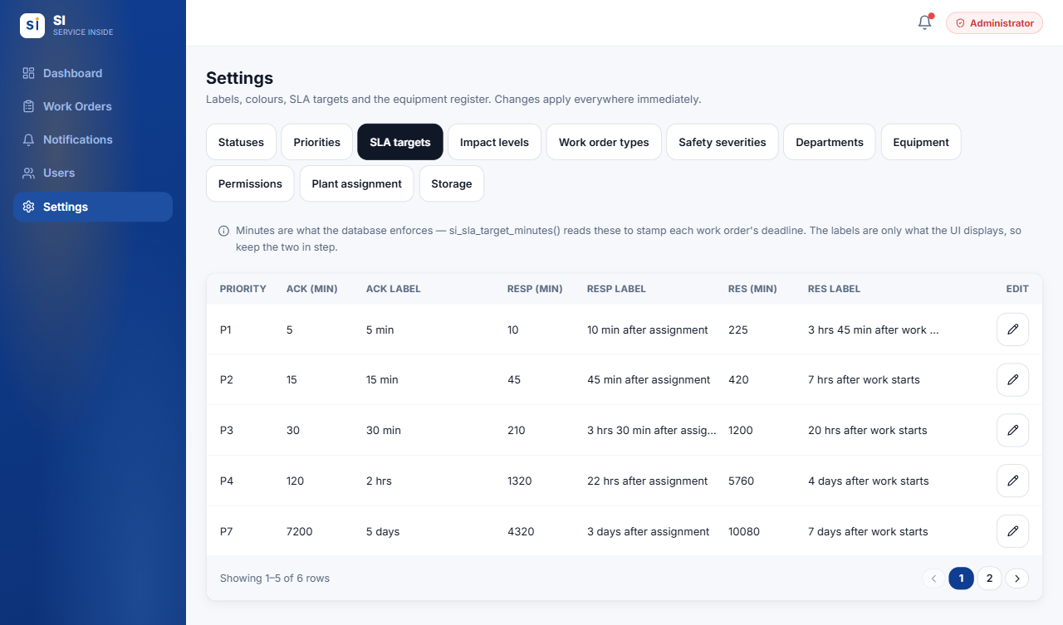  Figure 4.17 — SLA targets | 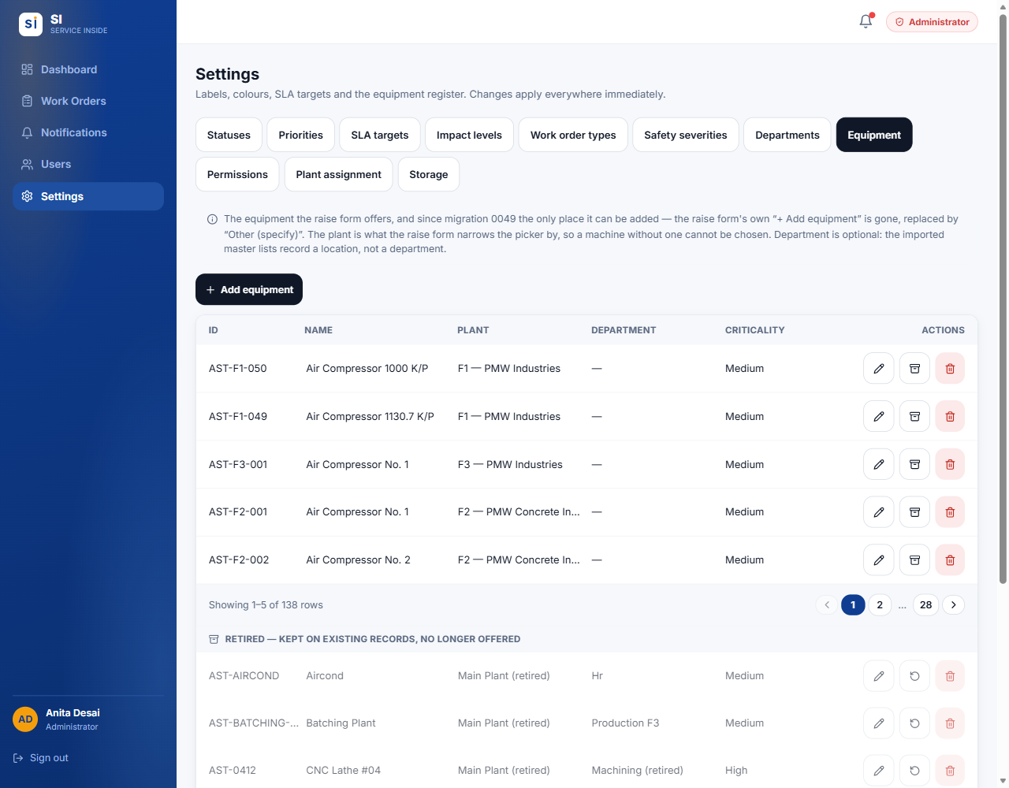  Figure 4.18 — Equipment register

- Retire instead of delete. When a value is no longer used (an old department, a scrapped machine, a priority), retire it: it disappears from the pickers but old work orders keep showing it correctly. Retiring and restoring is ★. A value can only be deleted outright if nothing has ever used it.
- Anyone raising a work order can add a missing department; only Administrators can add equipment. When somebody reports "Other (specify)" machines often, add them in Equipment.

4.10 Common situations
Q A new employee joins.
Users → Add user, with their company email, employee ID, roles and department and an initial password. Give them the details yourself.

Q Somebody forgot their password.
Ask the ★ Superuser to set a temporary password with Password, and pass it on. They choose a new one when they sign in.

Q Somebody leaves the company.
Deactivate their account. Don't delete it — their work history must stay.

Q A role change isn't showing for the person.
It takes up to an hour. Ask them to sign out and back in.

Q A technician declined a job.
You are notified and the job is Open again. Read the reason on the timeline and Assign someone else.

Q A job is stuck because the technician is away.
Reassign it on the Assignment tab. The new technician carries on from the same stage.

Q A job was graded wrongly.
Change priority with a reason. If it just needs more time at the same priority, use Extend SLA → Give it more time.

Q A machine is missing from the raise form.
Settings → Equipment → Add equipment, and set its plant.

Q A duplicate work order was raised.
Check it really is a duplicate, then Delete it (type the WO number to confirm).

Q A closed job wasn't really fixed.
Managers, HODs and Administrators can send a completed or closed job back to Repairing from its Workflow tab.

05.
APPENDIX

Quick reference
Who can do what at a glance, and the words SI uses.
IN THIS CHAPTER
5.1 Who can do what
5.2 Words SI uses
5.3 Need help?

5.1 Who can do what
Action | Requester | Technician | Admin
Sign in with email or employee ID | ✓ | ✓ | ✓
Change your own password | ✓ | ✓ | ✓
See work orders you raised | ✓ | — | ✓ all
See work orders assigned to you | — | ✓ | ✓ all
Raise a work order | ✓ | ✗ ¹ | ✓
Raise one on somebody's behalf | ✗ | ✗ | ✓
Edit details while Open | Own | ✗ | ✓
Assign / reassign a technician | ✗ | ✗ | ✓
Accept, decline, start, test, complete | ✗ | Own jobs | —
Pause for a spare part / resume | ✗ | Own jobs | —
Comment and add photos | ✓ | ✓ | ✓
Replace a photo you uploaded | ✓ | ✓ | ✓
Change a priority / extend an SLA | ✗ | ✗ | ✓
Delete a work order | ✗ | ✗ | ✓
Export the list to Excel | ✓ | ✓ | ✓
Manage users | ✗ | ✗ | ✓ ²
Change settings | ✗ | ✗ | ✓ ²

¹ Unless the account also holds the Requester role. ² Some actions are Superuser-only — see the Administrator guide.

5.2 Words SI uses
Term | Meaning
Work order (WO) | A record of one fault or job, numbered like WO-2026-000049.
Requester | The person who reported the fault.
Assign | Choosing which technician does the job.
Handover | Reassigning a job that is already under way. It keeps its stage.
Production impact | How badly the fault affects production. It decides the priority.
Priority (P1–P8) | How urgent a job is. P1 is the most urgent.
SLA | The time allowed for each stage: acknowledge, response and resolution.
At risk / Breached | A stage in its last quarter of time / a stage that ran out of time.
Sign-off | A HOD's check that a closed job was done properly. Only then does it count on the dashboards.
Retire | Take a setting out of use without breaking old records.
Superuser | The protected master Administrator account, held by IT.

5.3 Need help?
For account problems — cannot sign in, forgotten password, wrong role — contact your Administrator. For questions about a particular job, comment on the work order so everyone involved can see it.

