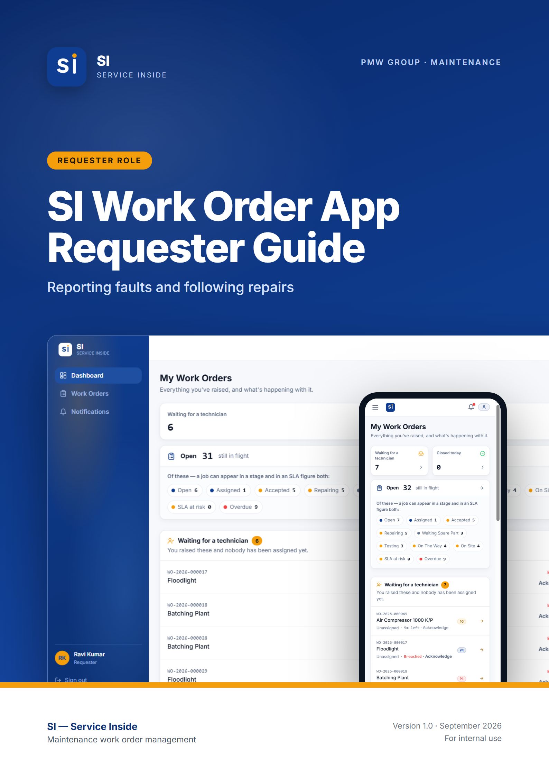

Contents
01 Getting started FOR EVERYONE
What SI does · Roles — who does what · Getting an account · Signing in · Choosing a new password · Finding your way around · Using SI on your phone · Notifications · How a work order moves · Priorities and SLA deadlines · Inside a work order
02 Requester guide ROLE GUIDE
At a glance · Your dashboard · Raising a work order · After you submit · Editing your work order · Comments and photos · Following progress · Finding work orders · Common situations
03 Quick reference APPENDIX
Who can do what · Words SI uses · Need help?

Note: How to use this guide. Chapter 1 covers what everybody needs: getting an account, signing in, finding your way around, and how work orders move. Chapter 2 is everything a Requester can do, step by step. Screenshots come from the SI test site with demo data, so names and numbers will differ from what you see. Buttons and labels are shown in bold.

01.
FOR EVERYONE

Getting started
What SI is, how to get an account, how to sign in, and how to find your way around. Read this first, whatever your role.
IN THIS CHAPTER
1.1 What SI does
1.2 Roles — who does what
1.3 Getting an account
1.4 Signing in
1.5 Choosing a new password
1.6 Finding your way around
1.7 Using SI on your phone
1.8 Notifications
1.9 How a work order moves
1.10 Priorities and SLA deadlines
1.11 Inside a work order

1.1 What SI does
SI (Service Inside) is PMW Group's maintenance work order app. When a machine or facility has a fault, somebody raises a work order. An HOD or Administrator assigns it to a technician, the technician carries out the repair, and the app keeps a full record of who did what and when.
It runs in any web browser — on a PC, a tablet or a phone — so there is nothing to install. You can also add it to your phone's home screen so it opens like an app (see Using SI on your phone below).

1.2 Roles — who does what
Every account has one or more roles. Your role decides which screens you see and which buttons you get. This guide covers the three most common roles:
Role | What they do in SI
Requester | Reports faults by raising work orders, adds photos and comments, and follows the repair until it is finished.
Technician | Receives jobs, accepts or declines them, carries out the repair step by step, and marks the work completed.
Administrator | Oversees all work in the plant, assigns technicians, manages user accounts, and maintains the settings (departments, equipment, priorities and SLA targets).

Note: SI also has Supervisor, HOD and Manager roles. HODs assign technicians and sign off closed work orders, and Supervisors and Managers oversee the work. One person can hold more than one role — for example Requester + Technician — and then gets everything both roles allow.

1.3 Getting an account
There is no self sign-up in SI. Accounts are created by your Administrator, so the app always knows who everybody is and what they are allowed to do.
- Contact your Administrator (or the IT / maintenance office) and ask for an SI account.
- Give them your full name, company email address, phone number, your employee ID (if you have one) and your department, and tell them which role you need.
- The Administrator creates the account and gives you a temporary password.
- Sign in with it (see below). The first time you sign in, SI asks you to choose your own password before you can do anything else.

1.4 Signing in
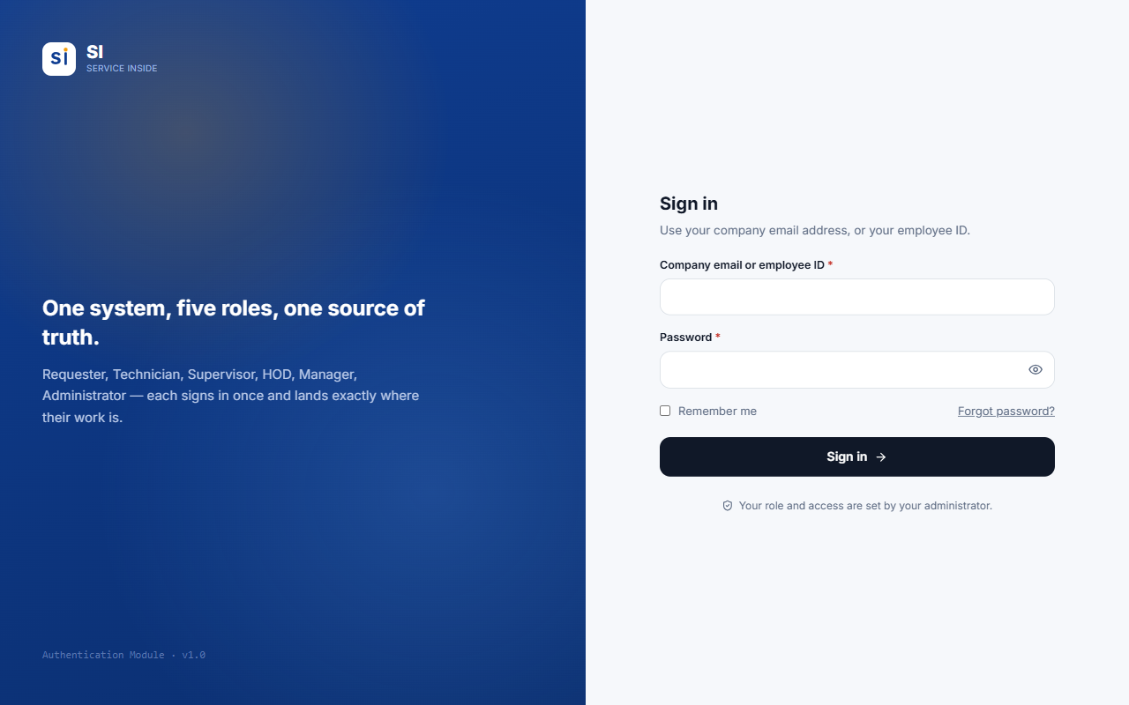
Figure 1.1 — The sign-in screen.
- Open SI in your browser (or tap the SI icon on your home screen).
- In Company email or employee ID, type either your company email address or your employee ID. Both work — capital letters and spaces in an employee ID do not matter.
- Type your Password. Tap the eye icon to show what you typed.
- Tick Remember me on your own phone or PC so you stay signed in. Leave it unticked on a shared computer.
- Press Sign in. SI opens the dashboard for your role.

Tip: If sign-in fails, SI shows the same message whether the email/ID or the password was wrong — this protects your account. Check both, and after a few failed tries wait a moment before trying again.

Important: Forgot your password? Contact your Administrator. They will set a temporary password for you, which you replace the next time you sign in.

1.5 Choosing a new password
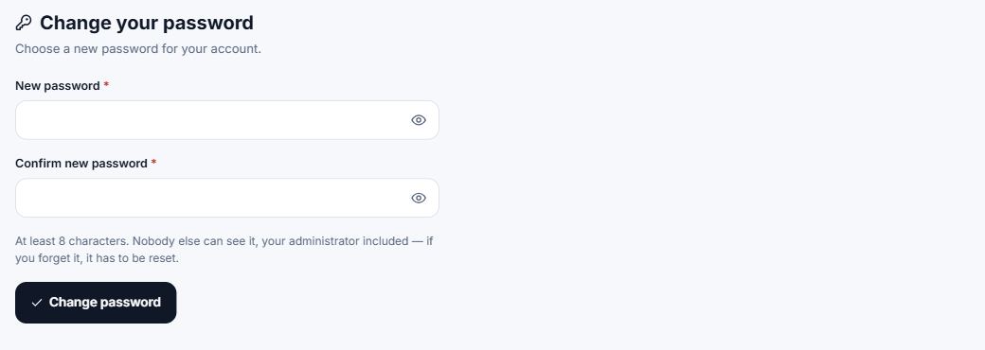
Figure 1.2 — The Change password screen appears on your first sign-in, and after an Administrator resets your password.
- Enter the new password twice. It must be at least 8 characters.
- Nobody else can see your password — not even your Administrator.
- Until you set your own password you cannot reach any other screen. This is on purpose: the temporary password was chosen by somebody else.

1.6 Finding your way around
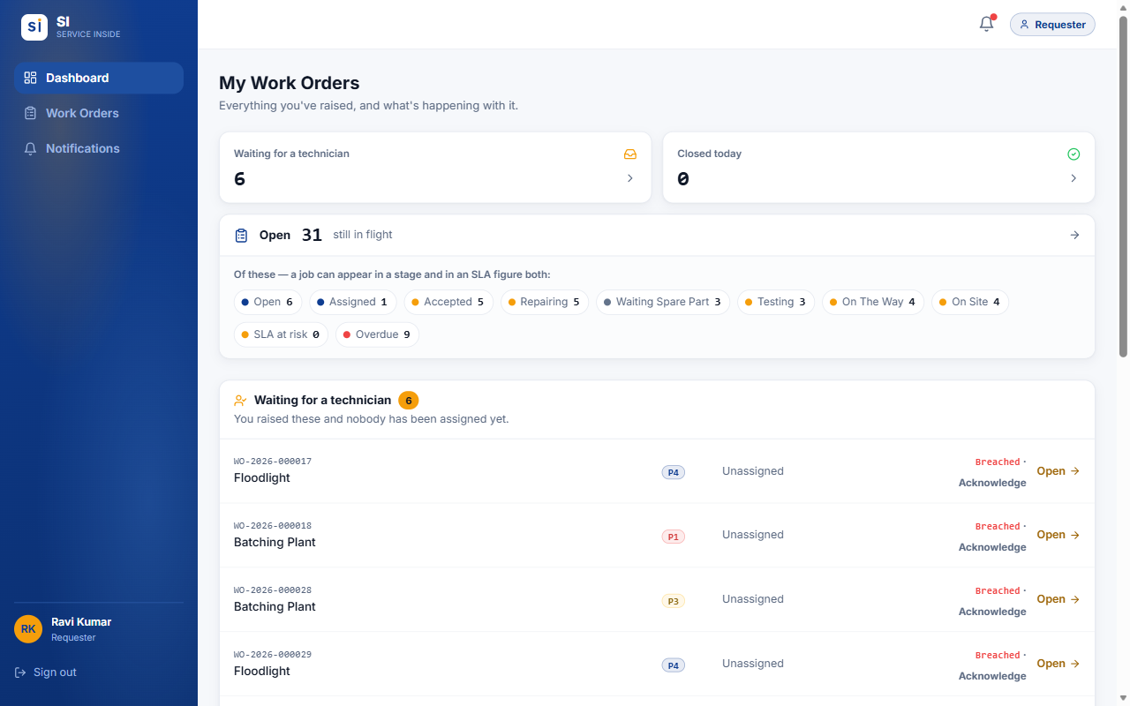
Figure 1.3 — The screen layout (Requester shown). On a PC the menu is on the left.
Part of the screen | What it is for
Dashboard | Your starting page: counts and lists of the work that needs your attention.
Work Orders | The full list of work orders you can see, with search, filters, sorting and Excel export.
Notifications | Everything SI has told you about, grouped by category.
Users / Settings | Administrators only — accounts and system settings.
Bell icon (top right) | Opens your latest notifications. A red dot means something is unread.
Role badge (top right) | Shows the role you are working as. If you hold several roles, use it to switch dashboards.
Your name / Sign out | Bottom of the menu. Always sign out on a shared computer.

1.7 Using SI on your phone
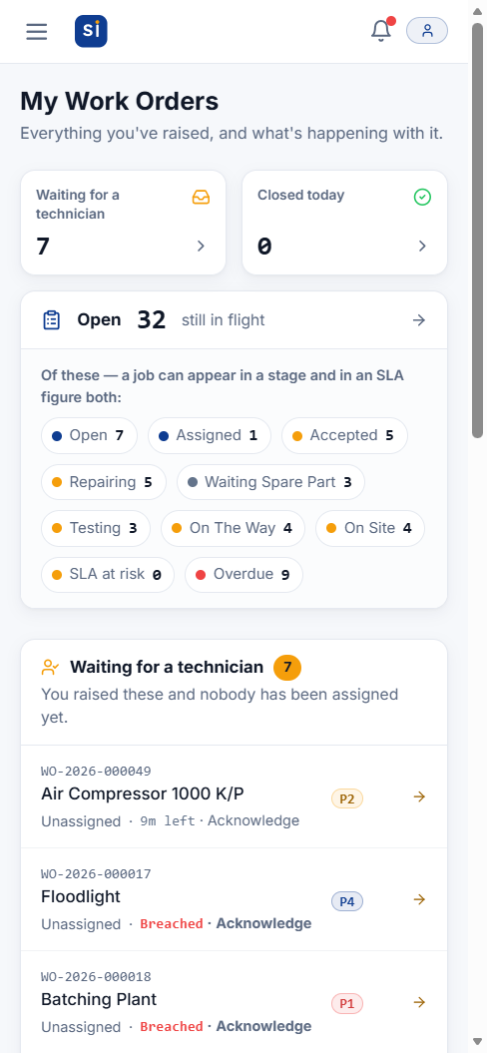  Figure 1.4 — Dashboard on a phone | 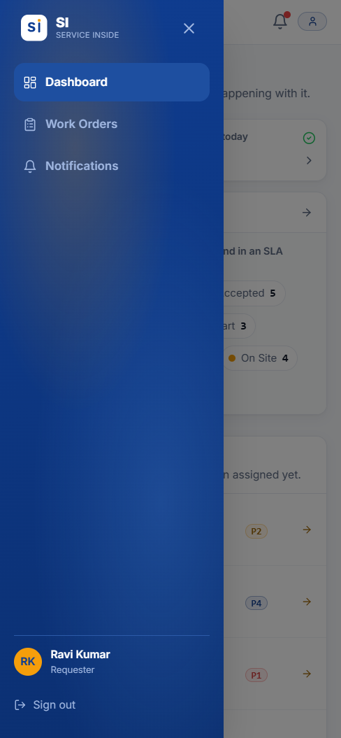  Figure 1.5 — Tap ☰ to open the menu | 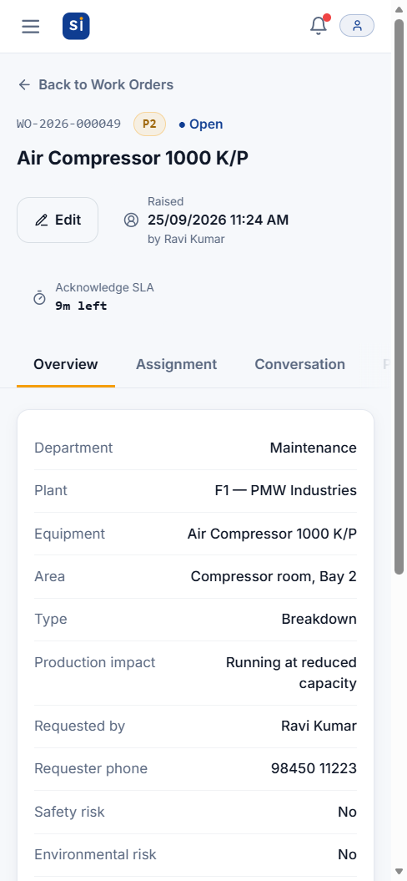  Figure 1.6 — A work order on a phone

SI adapts to small screens. The menu hides behind the ☰ button at the top left, and wide tables turn into cards you can scroll.
- iPhone: open SI in Safari, tap the Share button, then Add to Home Screen. Pop-up alerts on iPhone only work once SI is added this way.
- Android: open SI in Chrome, tap the ⋮ menu, then Install app or Add to Home screen.

1.8 Notifications
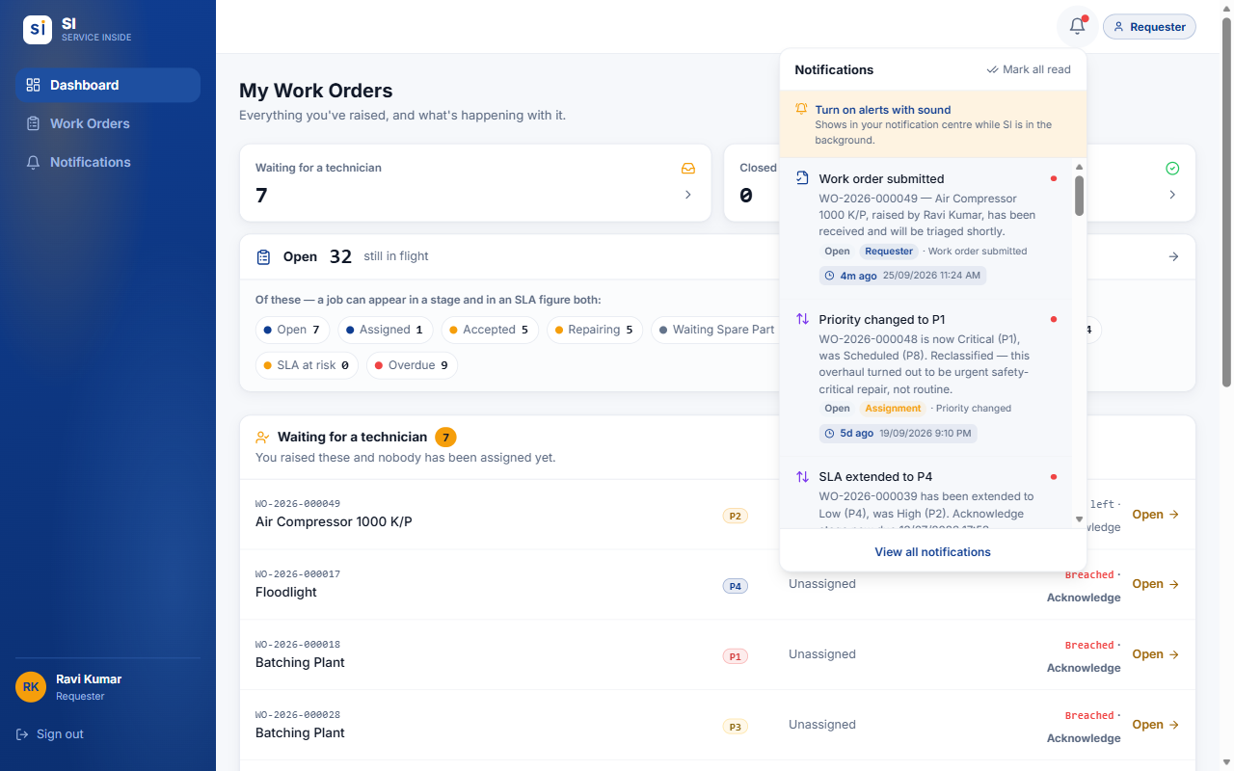
Figure 1.7 — The bell opens your latest notifications without leaving the page.
- SI notifies you when something happens that concerns you — for example a job assigned to you, or your work order completed.
- Each notification shows how long ago it happened and the exact date and time, plus tags for who caused it and which stage the job was at.
- Tap a notification to open that work order. Mark all read clears the red dot.
- On the Notifications page, filter by category and use Clear read to delete notifications you have already read. Unread ones are never deleted.
- To get alerts on your phone or PC while SI is in the background, press Turn on alerts with sound in the bell panel and allow notifications when the browser asks. Alerts only arrive while SI is open somewhere (a tab or the home-screen app) — not after it has been fully closed.

1.9 How a work order moves
Every work order goes through the same stages, in order. No stage can be skipped, and every move is recorded on the Status Timeline with the person's name and the time.
Open | → | Assigned | → | Accepted | → | Repairing | → | Testing | → | Completed | → | Closed

Status | Meaning
Open | Raised and waiting for somebody to assign a technician.
Assigned | A technician has been chosen and must accept or decline. A decline sends it back to Open.
Accepted | The technician has taken the job but not started yet.
Repairing | Work is in progress.
Waiting Spare Part | Paused because a part is needed. Returns to Repairing when the part arrives.
Testing | The fix is being tested. A failed test sends it back to Repairing.
Completed → Closed | The technician marks the repair completed, and SI closes it automatically at the same moment.

1.10 Priorities and SLA deadlines
You never choose a priority — SI works it out from the production impact picked when the work order is raised, and raises it further if a safety or environmental risk is flagged. Each priority has an SLA (service-level agreement): a time limit for each of three stages.
Priority | Production impact | 1. Acknowledge | 2. Response | 3. Resolution
P1 Critical | Full production stoppage | 5 min | 10 min | 3 hrs 45 min
P2 High | Running at reduced capacity | 15 min | 45 min | 7 hrs
P3 Medium | Auxiliary equipment, no line impact | 30 min | 3 hrs 30 min | 20 hrs
P4 Low | No production impact (cosmetic/routine) | 2 hrs | 22 hrs | 4 days
P7 Long-term | Long-term task (planned) | 5 days | 3 days | 7 days
P8 Scheduled | Scheduled work (month-scale) | 5 days | 5 days | 20 days

- Acknowledge — from raising the work order until a technician is assigned.
- Response — from assignment until the technician starts work.
- Resolution — from starting work until the repair is completed.
- Each stage's clock starts when the previous stage finishes. The header of every work order shows the current stage and the time left, for example 14m left, At risk (in the last quarter of its time) or Breached (late).
- These are the current settings. Administrators can change them, so the times shown in the app are always the ones that apply.

1.11 Inside a work order
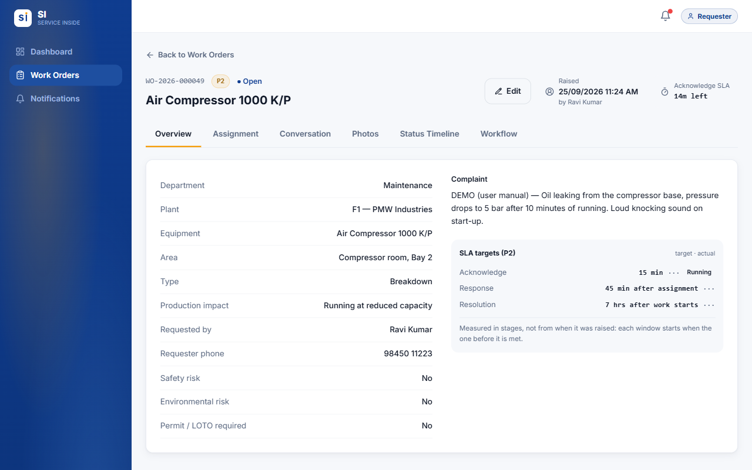
Figure 1.8 — Every work order has the same header and six tabs.
Tab | What you find there
Overview | All the details — department, plant, equipment, complaint, risks — plus the SLA targets and how long each stage actually took.
Assignment | Who the job is assigned to. HODs and Administrators assign and reassign here, until the job is completed. After that the Assign buttons are greyed out.
Conversation | Comments and photos in one chat-style thread. A red number shows how many new messages you have not read.
Photos | Every photo, grouped by the stage it was taken at (before work, during repair, testing...).
Status Timeline | The full history: every move, who made it, when, and any reason given.
Workflow | Tells you whose move it is, and holds the action buttons when it is yours.

Tip: If your session expires while you are typing a work order, SI keeps what you typed and offers to restore it after you sign back in. Photos cannot be kept, so re-attach them.

02.
ROLE GUIDE

Requester guide
You report faults and follow them until they are fixed. This chapter covers everything a Requester can do in SI.
IN THIS CHAPTER
2.1 At a glance
2.2 Your dashboard
2.3 Raising a work order
2.4 After you submit
2.5 Editing your work order
2.6 Comments and photos
2.7 Following progress
2.8 Finding work orders
2.9 Common situations

2.1 At a glance
You can | You cannot
Raise a work order, with photos | See work orders raised by other people
Edit your work order while it is still Open | Edit it once a technician is assigned
Comment and add photos on your own work orders | Assign a technician or choose who does the job
Replace a photo you uploaded (while the job is live) | Do the technician's steps (accept, repair, test, complete)
Follow progress on the timeline and get notified | Delete a work order, or anyone else's comment or photo
Search, filter and export your work orders to Excel | Reach the Users or Settings screens

2.2 Your dashboard
Figure 2.1 — My Work Orders — the Requester dashboard.
- Waiting for a technician — work orders you raised that nobody has been assigned to yet.
- Closed today — your work orders finished and signed off today.
- Open … still in flight — everything not yet finished, broken down by stage and by SLA (at risk / overdue). Tap any figure to see the work orders behind it.
- Recent activity — your work orders with the latest changes first. Press See all for the full list.

2.3 Raising a work order
Go to Work Orders and press Raise Work Order. Fields marked * are required.
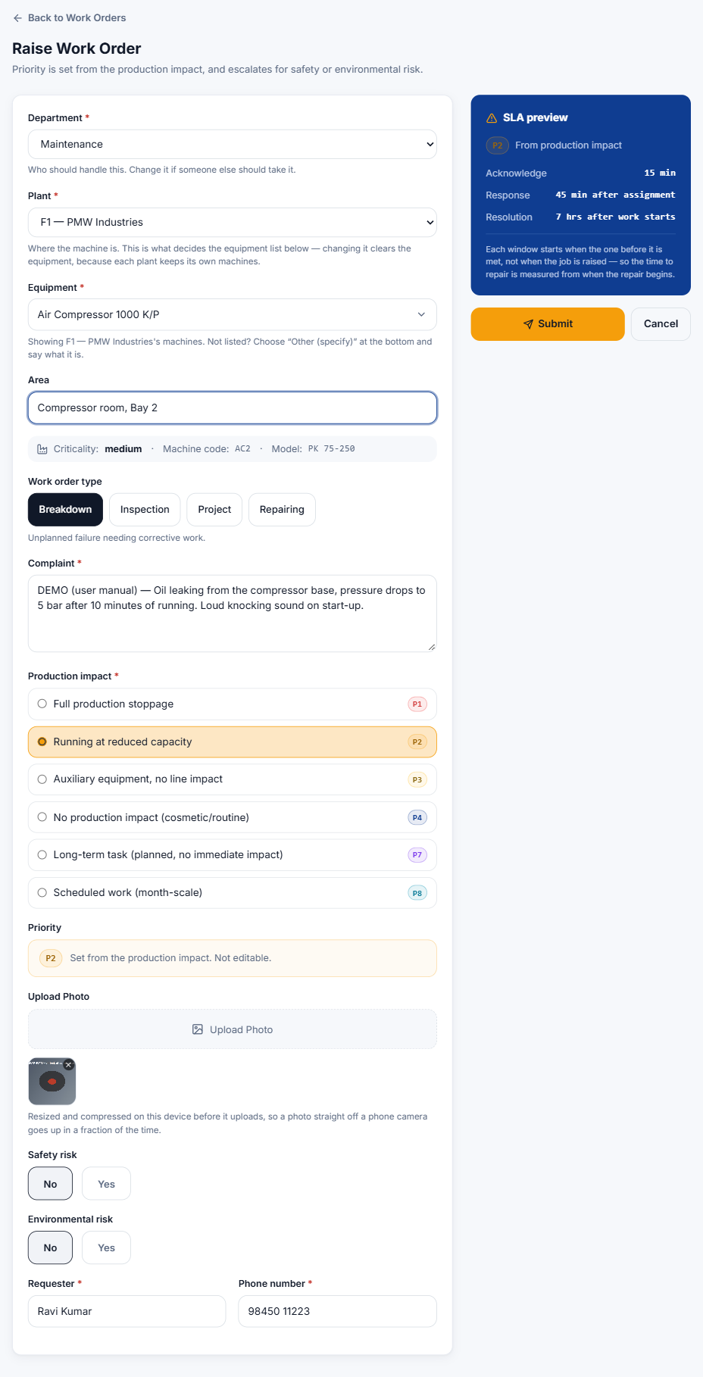
Figure 2.2 — A completed Raise Work Order form, with the SLA preview on the right.
- Department — the department that should handle the job. Pick the right one; it decides who is told about it.
- Plant — where the machine is: F1, F2, F3 or Facility. The equipment list only shows machines at the plant you pick.
- Equipment — click the box and type part of the machine name or machine code, then pick it from the list. The machine's criticality, code and model appear underneath.
- Area (optional) — where exactly: line, bay, floor, room.
- Work order type — Breakdown (unplanned failure), Inspection (routine check), Project (improvement or installation) or Repairing (repair of a known fault).
- Complaint — describe the problem: what happened, symptoms, sounds, error codes, and when it started.
- Production impact — how badly production is affected. This sets the priority, shown in the Priority box underneath.
- Upload Photo — add one or more photos of the fault. They are shrunk automatically before upload, so a phone photo goes up quickly.
- Safety risk / Environmental risk — choose Yes if there is one (see below).
- Requester and Phone number — filled in from your account. Correct them if needed.
- Check the SLA preview on the right, then press Submit.

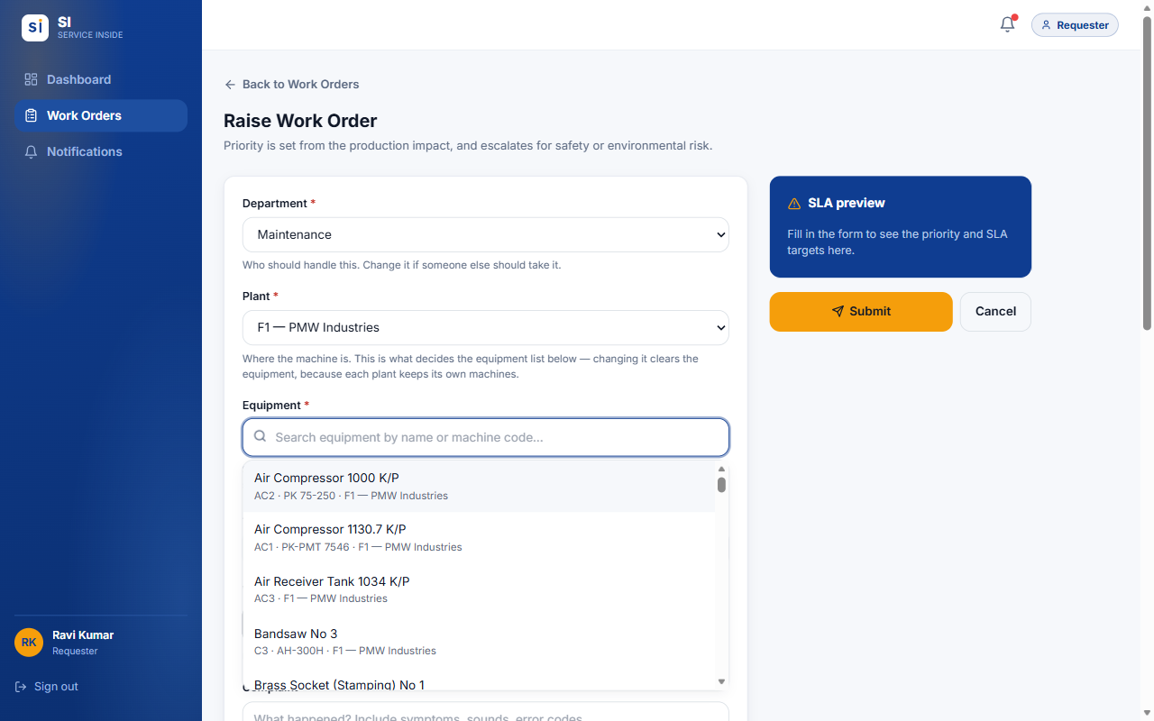
Figure 2.3 — Type to search. Only machines at the chosen plant are listed.

Machine not in the list?
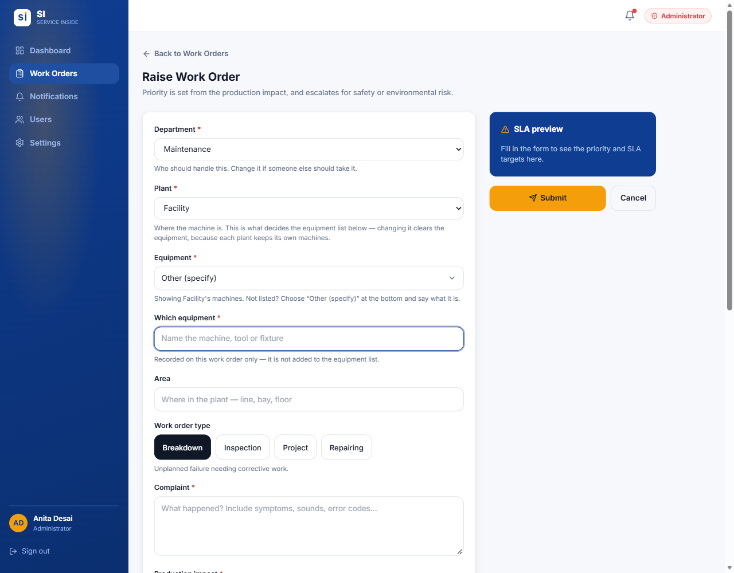
Figure 2.4 — Choose "Other (specify)" at the bottom of the list, then say which equipment it is.
Scroll to the bottom of the equipment list (or type "other") and choose Other (specify). A Which equipment box appears — type the name of the machine. It is recorded on this work order only. Ask your Administrator to add the machine to the list if it will come up again.

Flagging a safety or environmental risk
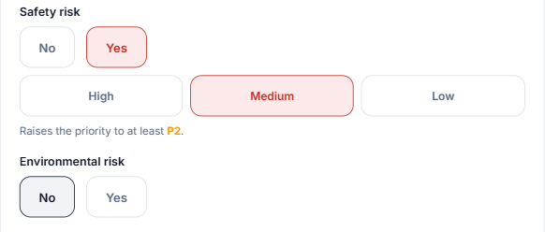
Figure 2.5 — Choosing Yes for Safety risk asks for its severity and can raise the priority.
- Choose Yes under Safety risk, then pick the severity: High (immediate danger to people), Medium (hazardous if left) or Low (minor, controlled).
- A line such as "Raises the priority to at least P2" shows what it does to the priority. A High safety risk always makes the job P1.
- An Environmental risk raises the priority to at least P2.

Important: SI is not an emergency alarm. For immediate danger to people, follow the plant's emergency procedure first — then raise the work order.

2.4 After you submit
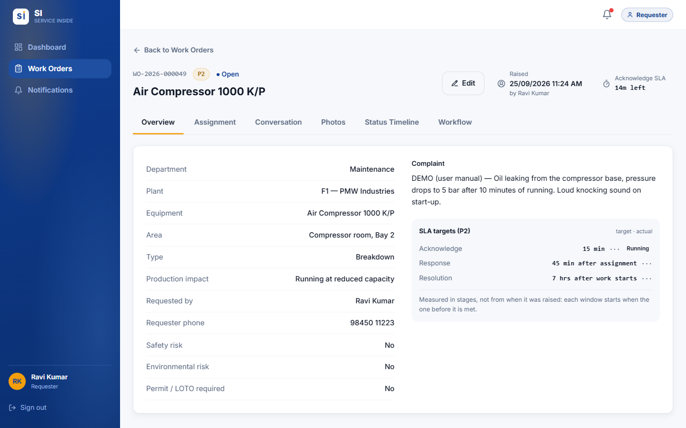
Figure 2.6 — Your new work order opens straight away with its WO number.
- SI gives the work order a number such as WO-2026-000049 — quote it when you talk to maintenance.
- You receive a Work order submitted notification as your receipt.
- Everyone who can assign work (HODs and Administrators) is told about it, and the Acknowledge clock starts.
- The Workflow tab tells you who the job is waiting on.

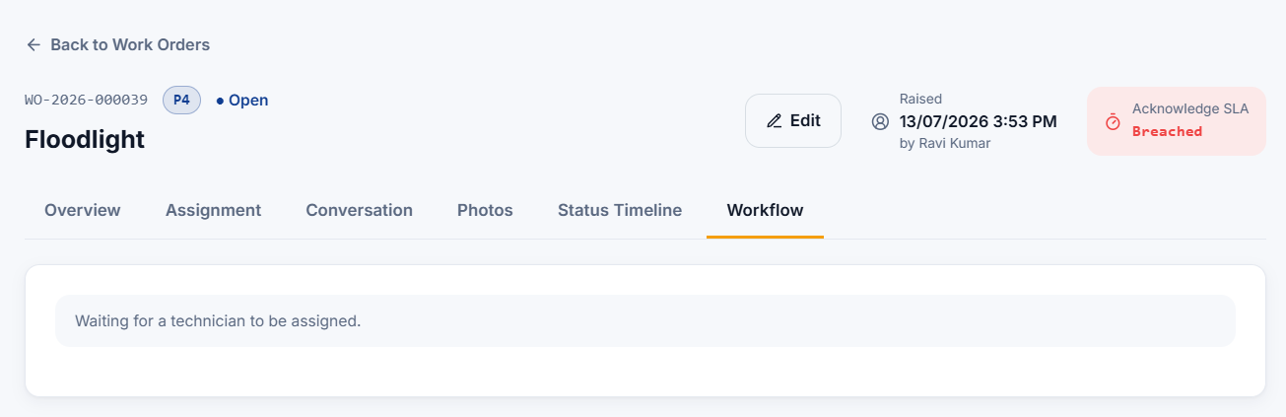
Figure 2.7 — Workflow tab: while it is Open you are waiting for a technician to be assigned.

2.5 Editing your work order
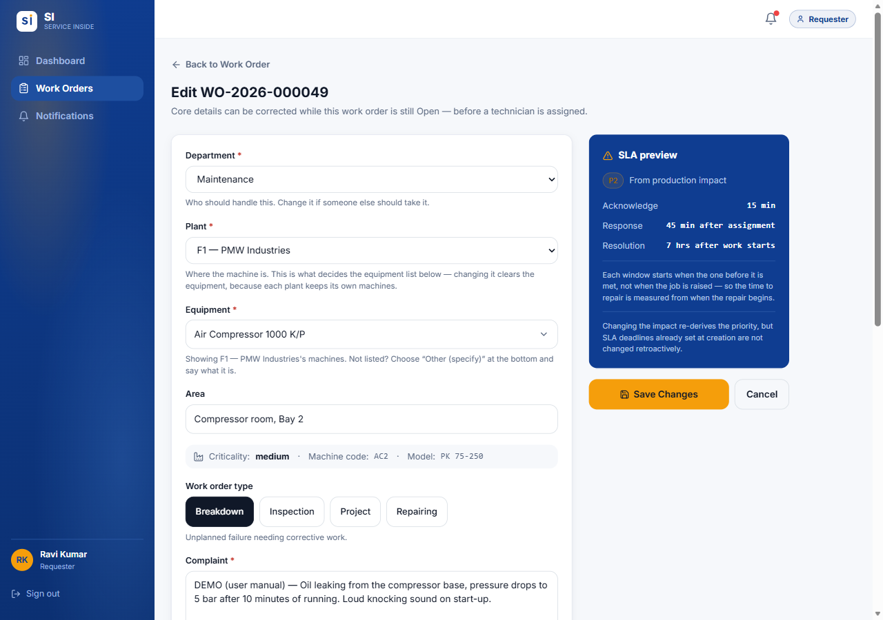
Figure 2.8 — Edit WO — available only while the work order is Open.
- While the status is Open, press Edit at the top of the work order to correct any detail — department, plant, equipment, complaint, impact and so on — then press Save Changes.
- Once a technician is assigned the Edit button disappears. From then on details only change through the workflow, so the record cannot be quietly rewritten. To add information, post a comment instead.

2.6 Comments and photos
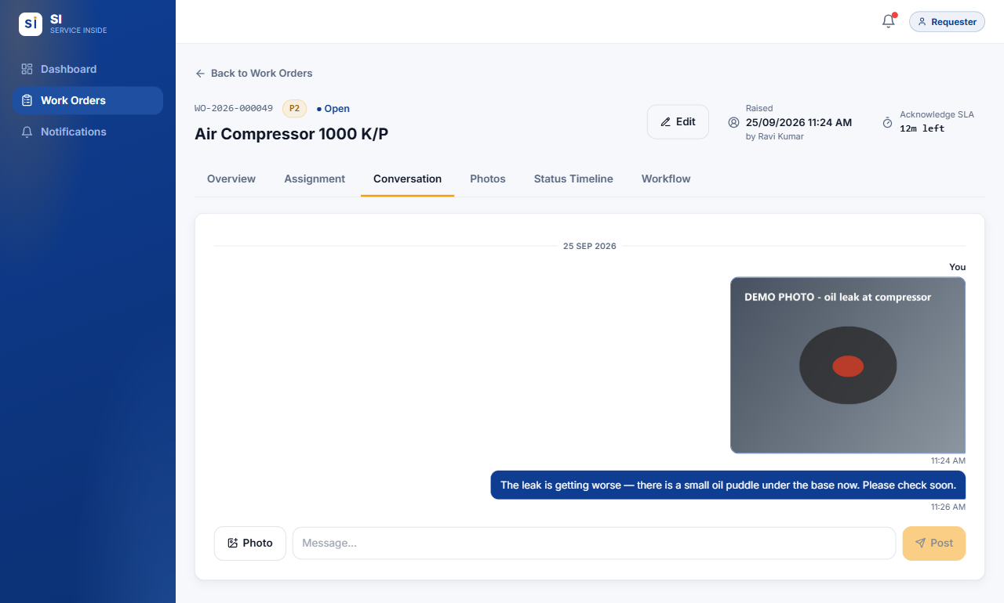
Figure 2.9 — The Conversation tab: your messages on the right, everyone else's on the left.
- Open the work order and go to Conversation.
- Type in the Message… box and press Post.
- To add a picture, press Photo and take or choose one. It appears in the thread and on the Photos tab.

- Use comments to add details the technician needs, answer their questions, or report that things have got worse.
- You can edit or delete your own comments. You cannot delete other people's comments or any photo.
- On the Photos tab, open one of your photos and press Replace to swap it for a better one while the job is still live. A replaced photo is marked as replaced, and the original is kept in the audit record.

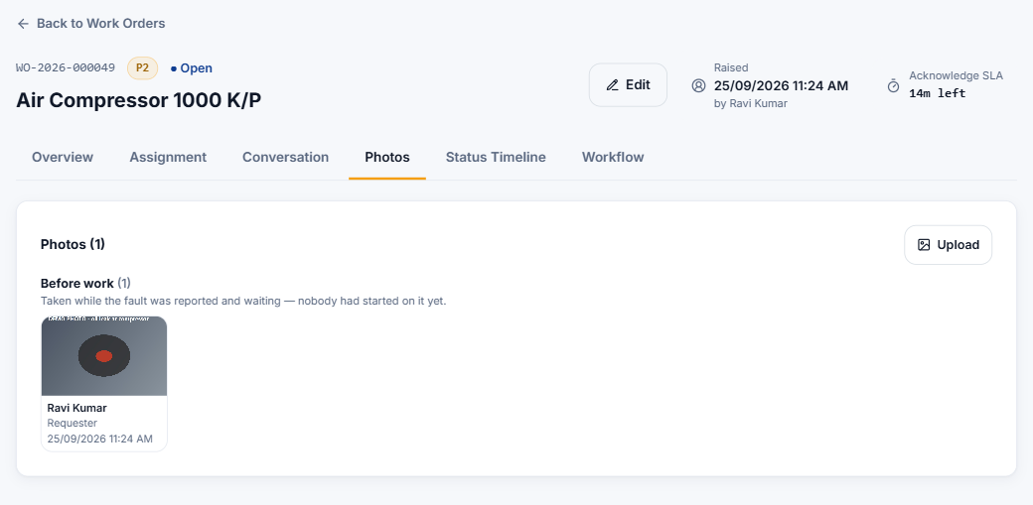
Figure 2.10 — The Photos tab groups photos by the stage they were taken at.

2.7 Following progress
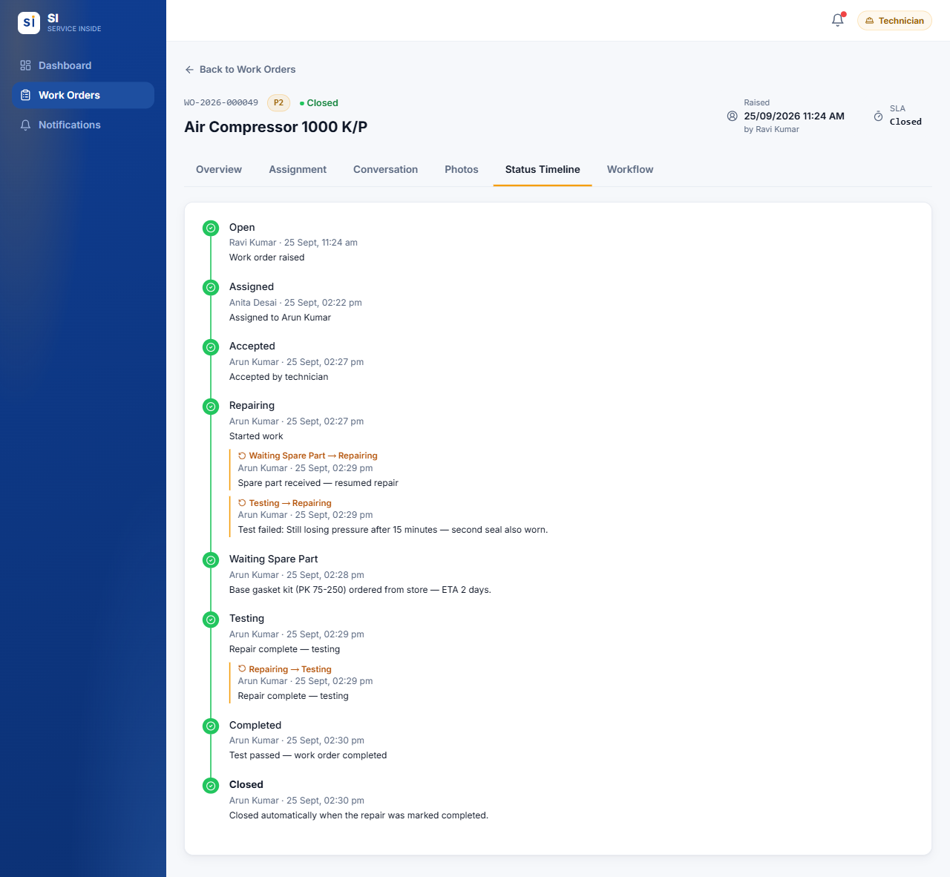
Figure 2.11 — The Status Timeline of a finished work order, including a spare-part wait and a failed test.
- The Status Timeline lists every step with the person and the time. Amber sub-entries show steps that went back — for example a failed test sent back to Repairing, with the reason.
- SI notifies you when your job is accepted, when it is waiting for a spare part (and when work resumes), when it is completed, and if its priority or deadline is changed.
- When the technician marks the job completed it closes automatically. The completion notes on the Overview tab say what was done.

2.8 Finding work orders
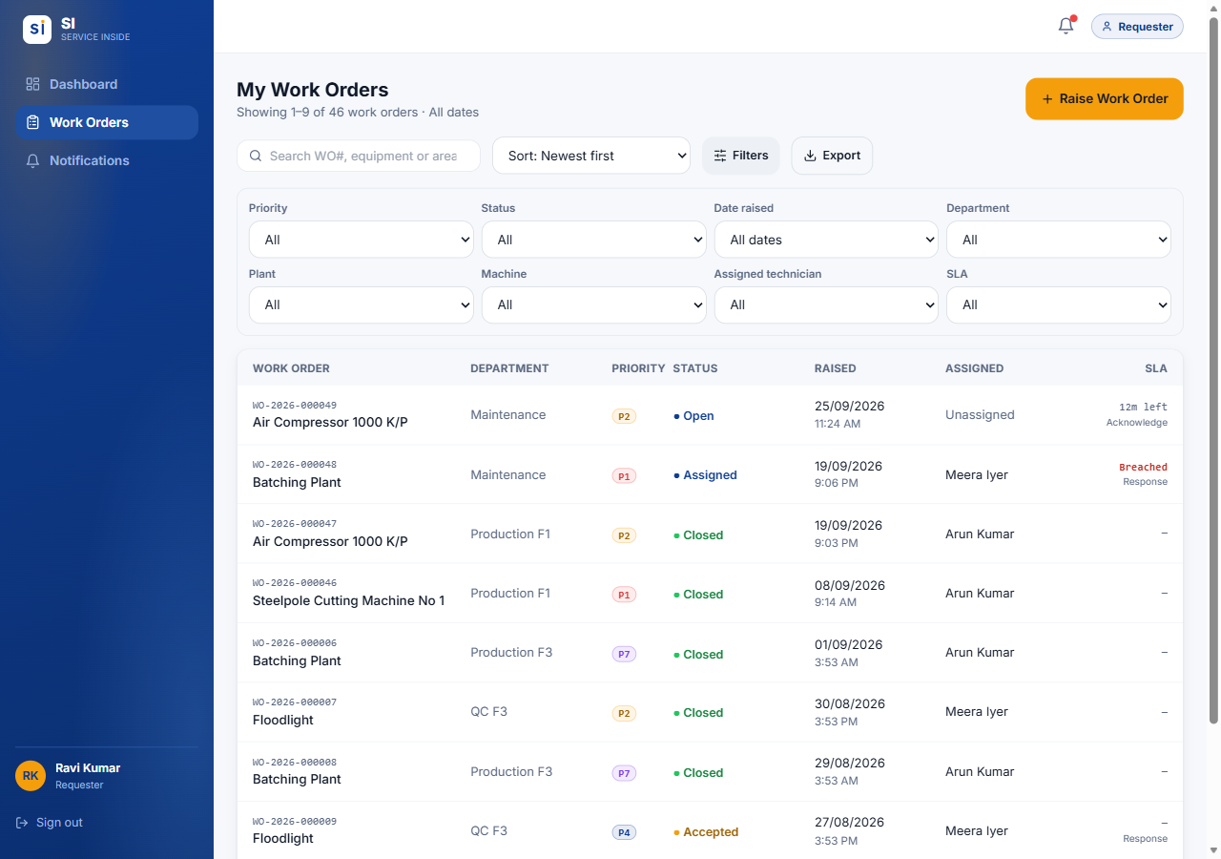
Figure 2.12 — Work Orders list with the Filters panel open.
- Search by WO number, equipment or description.
- Sort by newest, oldest, priority, SLA (soonest due) or WO number.
- Filters — priority, status, date raised (today, this week, this month, a custom range…), department, plant, machine, technician and SLA state.
- Export — downloads the work orders currently listed to an Excel workbook, with their history and comments on separate sheets.
- Tap any row to open that work order.

2.9 Common situations
Q I picked the wrong department or machine.
If the work order is still Open, press Edit and correct it. If a technician is already assigned, post a comment explaining the mistake, or ask your HOD.

Q The machine is not in the equipment list.
Check you chose the right Plant first. If it is still missing, choose Other (specify) and type its name.

Q Nobody has picked up my urgent job.
Check the Workflow tab and the SLA in the header. For a true emergency, phone the maintenance team as well.

Q The problem came back after the job was closed.
Contact your HOD or Supervisor. They can send a finished job back to repair, or you can raise a new work order that mentions the old WO number.

Q I raised the same fault twice.
Comment on the duplicate saying which WO number it repeats. Only an Administrator can delete a work order.

Q I can't see a colleague's work order.
Requesters only see work orders they raised. Ask the person who raised it, or a Supervisor.

03.
APPENDIX

Quick reference
Who can do what at a glance, and the words SI uses.
IN THIS CHAPTER
3.1 Who can do what
3.2 Words SI uses
3.3 Need help?

3.1 Who can do what
Action | Requester | Technician | Admin
Sign in with email or employee ID | ✓ | ✓ | ✓
Change your own password | ✓ | ✓ | ✓
See work orders you raised | ✓ | — | ✓ all
See work orders assigned to you | — | ✓ | ✓ all
Raise a work order | ✓ | ✗ ¹ | ✓
Raise one on somebody's behalf | ✗ | ✗ | ✓
Edit details while Open | Own | ✗ | ✓
Assign / reassign a technician | ✗ | ✗ | ✓
Accept, decline, start, test, complete | ✗ | Own jobs | —
Pause for a spare part / resume | ✗ | Own jobs | —
Comment and add photos | ✓ | ✓ | ✓
Replace a photo you uploaded | ✓ | ✓ | ✓
Change a priority / extend an SLA | ✗ | ✗ | ✓
Delete a work order | ✗ | ✗ | ✓
Export the list to Excel | ✓ | ✓ | ✓
Manage users | ✗ | ✗ | ✓ ²
Change settings | ✗ | ✗ | ✓ ²

¹ Unless the account also holds the Requester role. ² Some actions are for the app developer only — see the Administrator guide.

3.2 Words SI uses
Term | Meaning
Work order (WO) | A record of one fault or job, numbered like WO-2026-000049.
Requester | The person who reported the fault.
Assign | Choosing which technician does the job.
Handover | Reassigning a job that is already under way. It keeps its stage.
Production impact | How badly the fault affects production. It decides the priority.
Priority (P1–P8) | How urgent a job is. P1 is the most urgent.
SLA | The time allowed for each stage: acknowledge, response and resolution.
At risk / Breached / Extended | A stage in its last quarter of time / a stage that ran out of time / a stage an Administrator gave more time, while it is within its new deadline.
Sign-off | A HOD's check that a closed job was done properly. Only then does it count on the dashboards.
Retire | Take a setting out of use without breaking old records.
App developer | The team that builds and maintains SI. They carry out the actions marked ★.

3.3 Need help?
For account problems — cannot sign in, forgotten password, wrong role — contact your Administrator. For questions about a particular job, comment on the work order so everyone involved can see it.

