Vamscore | 📞 +91 9490729484  ✉ info@vamscore.com  🌐 www.vamscore.com

PROJECT REPORT
Your Name : | Yashaswi PM
Your Role : | Frontend Developer
Project Name : | Online Payment Fraud Detection Using ML
Team Members : | Yashaswi PM, Ravi Kumar G, Sinchana K, Shravya K

01 ABOUT THE PROJECT
Developed an Online Payment Fraud Detection single-page web frontend application using Streamlit and Python to deliver a responsive, zero-scroll digital wallet interface (PayGuard AI). The frontend handles user authentication, multi-step Clerk OTP email verification, dynamic frequent payee management, real-time risk score visualization, and step-up UPI PIN authorization in under 50ms latency.
02 SYSTEM DESIGN
The diagram below illustrates the Frontend System Architecture, module boundaries, session state store, Clerk authentication wizard, and FastAPI PyTorch ML backend integration:
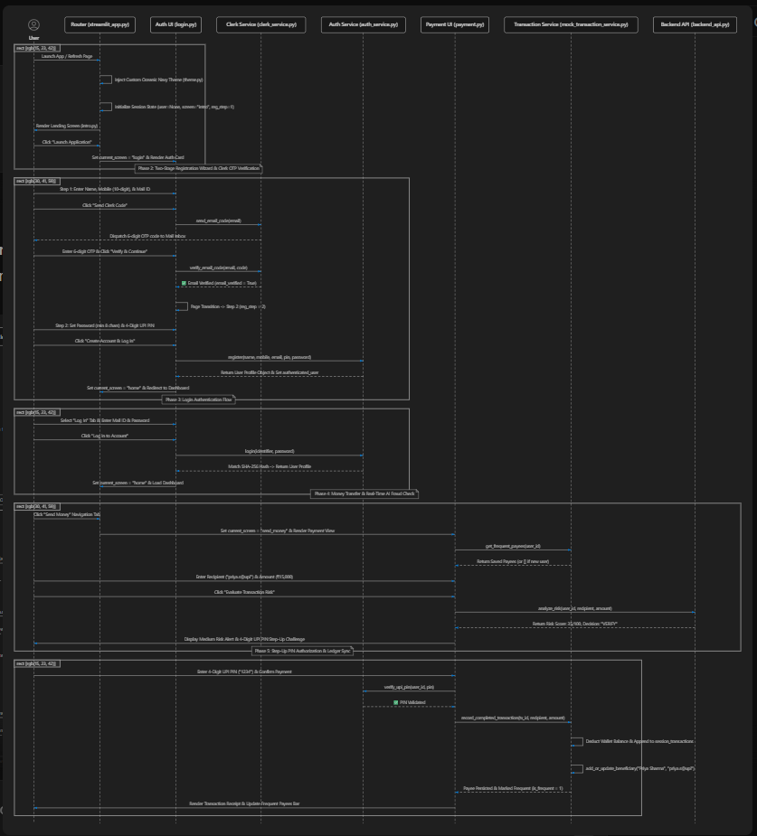
03 TOOLS YOU USED
Technology | Purpose
Python | Main frontend integration and logic programming language
Streamlit | Modern single-page web interface framework for real-time UI rendering
Clerk API / SMTP | Identity verification and 6-digit OTP email code dispatch service
SQLite3 (payguard_bank.db) | Relational database storage for users, payees, transactions, and audit logs
Hashlib (SHA-256) | Cryptographic hashing for user passwords and 4-digit UPI PIN isolation
Requests (HTTP REST) | Async/sync API client connecting frontend UI with FastAPI PyTorch backend
Pandas & Datetime | Ledger transaction filtering, timestamp formatting, and table telemetry
Custom CSS (Oceanic Navy) | Viewport optimization ensuring zero vertical scrolling across screens

04 FRONTEND COMPONENTS
4.1 Streamlit Router & Oceanic Navy Theme Engine
• The main entry point (streamlit_app.py) initializes global session state (st.session_state) and injects responsive CSS styling.
• Provides a top navigation header with wallet balance pills, active user metadata, and instant screen switching without full browser reloads.
4.2 Auth UI & Two-Stage Registration Wizard (Clerk OTP)
• Step 1 (Identity & Clerk Verification): Collects Full Name, 10-digit Mobile Number, and Email ID. Dispatches 6-digit OTP code to email inbox via Clerk API / SMTP.
• Step 2 (Security Credentials Next Page): Dedicated second page screen collects Password (min 8 chars) and 4-Digit UPI PIN. Hashes credentials using SHA-256 and executes UPSERT into SQLite payguard_bank.db.
4.3 Payment UI & Dynamic Frequent Payees
• Dynamic Clean Slate: Newly registered users start with an empty frequent payees list ([]). No mock or hardcoded fake beneficiaries are shown.
• Auto-Save Payee Engine: Upon successful payment completion, the payee is automatically added or marked as frequent (is_frequent = 1) in payguard_bank.db for instant quick-tap transfers on future visits.
4.4 Real-Time AI Fraud Risk Engine & Step-Up PIN Modal
• Intercepts transfers by sending transaction features (user_id, recipient, amount, device, location) to FastAPI backend (/analyze-risk).
• Evaluates PyTorch ResNeXt-GRU model risk score (0-100). Renders real-time risk score badges (ALLOW, VERIFY, REVIEW) and triggers mandatory 4-digit UPI PIN step-up verification for suspicious transactions.
4.5 Ledger Screen & Embedded DB Inspector Module
• Renders searchable transaction ledger tables with status indicators, risk scores, and receipt details.
• Includes an in-app Database Inspector (db_viewer.py) allowing real-time audit of users, beneficiaries, transactions, and security event logs directly from the UI.

05 FRONTEND WORKFLOW
When a user opens the application, Streamlit initializes the session state and renders the responsive landing view. Unauthenticated users navigate the Two-Stage Registration Wizard where Clerk dispatches a 6-digit OTP code to verify their email address. Upon entering their password and 4-digit UPI PIN, account credentials are securely hashed with SHA-256 and stored in SQLite payguard_bank.db. When initiating a payment, the frontend sends transaction telemetry to FastAPI, receiving a PyTorch ML fraud risk score (0-100) and decision (ALLOW, VERIFY, REVIEW). If step-up authorization is required, the user validates their 4-digit UPI PIN before the transaction ledger updates, wallet balance adjusts, and the recipient is automatically saved to the frequent payees bar.
06 CONCLUSION
The frontend system design delivers a robust, responsive, and secure user experience for PayGuard AI. By combining a zero-scroll Streamlit layout, Clerk OTP email authentication, SHA-256 pin isolation, dynamic SQLite payee persistence, and real-time PyTorch ML risk evaluation, the application ensures seamless digital wallet operation with industry-standard fraud prevention capabilities.
WWW.VAMSCORE.COM | INNOVATE | DELIVER | GROW

