Vamscore | 📞 +91 9490729484  ✉ info@vamscore.com  🌐 www.vamscore.com

PROJECT REPORT
Your Name | : | Yashaswi PM
Your Role | : | Frontend Developer
Project Name | : | Online Payment Fraud Detection Using ML (PayGuard AI)
Team Members | : | Yashaswi PM, Ravi Kumar G, Sinchana K, Shravya K

01 ABOUT THE PROJECT
PayGuard AI is an enterprise-grade, real-time payment fraud detection and intelligent protection web application. The application provides a modern, high-trust user interface built around the Oceanic Blue design system. It features seamless authentication, a guided 4-step payment execution flow, real-time Step-Up email OTP verification, wallet balance top-ups, transaction audit accordions, and real-time database inspection.
02 YOUR ROLE IN THE PROJECT
Worked as the Main Frontend Developer, responsible for designing, building, testing, and perfecting:
- Single-page application entry point (app.py) and dynamic sidebar navigation router across 8 core screens.
- Multi-tab authentication component (login.py) with standard credentials, registration email verification, and Firebase Google SSO.
- End-to-end 4-step payment lifecycle (payment.py) including Frequent Payees bar, 1 Lakh policy guardrail, and UPI PIN review.
- Real-time Step-Up Email OTP Challenge interface for risk scores between 26 and 65 with strict inbox privacy protection.
- Interactive Wallet Balance Top-Up engine (profile.py) supporting preset pills and custom inputs with real-time database sync.
- Transaction History screen (transactions.py) with date grouping, real-time status pills, and Security Details accordions.
- Live SQLite Database Inspector component (db_viewer.py) displaying live table rows from payguard_bank.db.
- Oceanic Blue design system (theme.py) featuring injected CSS, radial SVG risk gauges, and custom status badges.
03 TOOLS & TECHNOLOGIES USED
CategoryWeb Application Framework | Tools & LibrariesStreamlit (Python 3.14)
Design System & UI | HTML5, CSS3 Custom Injection, Inter & JetBrains Mono Fonts
Color Palette Tokens | Oceanic Blue (#001D39 Navy, #0A4174 Royal Blue, #49769F Slate, #BDD8E9 Powder)
Authentication Engine | Clerk Auth Adapter, Firebase Google SSO, SHA-256 Hashing
Email Transactional Engine | Resend REST API (api.resend.com) with automatic Gmail SMTP Fallback
Database & Persistence | SQLite3 (payguard_bank.db)
AI Backend Integration | FastAPI / In-Process RXT Model Adapter (ResNeXt + GRU v1.2)
Testing & Quality Assurance | Pytest, Real-Time Step-Up OTP Verification Test Suite

04 COMPLETE FRONTEND ACCOMPLISHMENTS (WHAT HAS BEEN DONE TILL NOW)
1. Application Router & Navigation System (app.py)
- Built a modular single-page Streamlit application with custom sidebar navigation.
- Manages session state routing across 8 core screens: Intro, Login, Home Dashboard, Send Money, Transactions, Security, Profile, and DB Inspector.
2. Authentication & Identity Component (login.py)
- Tab 1 (Login): Authenticates registered Mail ID / Mobile and 4-digit UPI PIN using SHA-256 validation.
- Tab 2 (Registration): Collects name, mobile, email, and UPI PIN; triggers single-dispatch email verification code.
- Tab 3 (Firebase Google SSO): One-click Google sign-in creating persistent verified user accounts in SQLite.
- Privacy Code Security: Fixed code leakage bug — verification codes are delivered exclusively to the user's email inbox.
- Single Email Guarantee: Resolved duplicate email generation bug during sign-up.
3. End-to-End 4-Step Payment Lifecycle (payment.py)
- Step 1 (Send Money Form): Input fields for recipient, transfer amount, purpose note, and Frequent Payees quick tap bar.
- 1 Lakh Policy Guardrail: Displays warning banner ⚠️ You cannot send money more than 1 Lakh (₹1,00,000) and blocks form submission.
- Step 2 (Payment Review): Displays transfer summary, zero fee badge, balance after transfer, and 4-digit UPI PIN input.
- Step 3 (Security Decision): Integrates with Risk Engine to display radial SVG risk gauge (0–100) and evaluated signals.
- Decision Handling: Manages ALLOW (instant pay), VERIFY (Step-Up OTP challenge), REVIEW (security block), and Reconciliation Required.
- Step 4 (Success Screen): Renders digital transaction receipt with transaction ID (PG-XXXX), debited amount, and updated balance.
4. Step-Up Verification & Dual-Engine Email System
- Triggers real-time email OTP verification challenge for fraud risk scores between 26 and 65.
- Integrates Resend REST API (api.resend.com) with automatic Gmail SMTP fallback for 100% inbox delivery.
- Verifies entered 6-digit OTP codes or developer test code (424242).
5. Interactive Wallet Balance Top-Up Engine (profile.py)
- Replaced legacy static reset balance button with a modern 💳 Top Up Wallet Balance expander.
- Quick preset buttons (+₹1,000, +₹5,000, +₹10,000) and custom amount input field.
- Updates available balance in SQLite database payguard_bank.db in real time via top_up_user_balance().
6. Transaction History & Security Details Accordion (transactions.py)
- Groups transaction records by date (Today, Recent Transfers).
- Real-time status pills for Completed, Verified & Completed, Security Review Blocked, and Reconciliation Required.
- Security Accordion: Expands each transfer to reveal decision, risk score, fraud probability %, risk signals, and ledger debits/credits.
7. Real-Time Database Inspector (db_viewer.py)
- Interactive SQLite database table viewer inside the Streamlit application.
- Displays live data rows from users, transactions, beneficiaries, and security_events with real-time refresh.
8. Oceanic Blue Design System (theme.py)
- Integrated Oceanic Blue color palette tokens (#001D39 Navy, #0A4174 Royal Blue, #49769F Slate, #BDD8E9 Powder).
- Custom UI components: render_status_pill(), render_risk_gauge(), and injected CSS for cards, buttons, and badges.
05 SUMMARY OF VERIFIED FRONTEND BENCHMARKS
Authentication & Google SSO | SHA-256 login verified | Firebase Google Auth creating persistent SQLite accounts
4-Step Payment Execution | Form -> Review Summary & UPI PIN -> AI Security Decision -> Receipt Success Screen
Step-Up OTP Challenge (26–65) | Resend API / Gmail SMTP dispatch -> 6-digit inbox code verified -> Transfer completed
1 Lakh Limit & Reconciliation | Transfer > 1 Lakh blocked with warning banner | Ledger mismatch saved to DB in real time
Wallet Top-Up Engine | Preset buttons (+₹1k, +₹5k, +₹10k) & custom input updating payguard_bank.db in real time

06 WORKFLOW ARCHITECTURE DIAGRAM
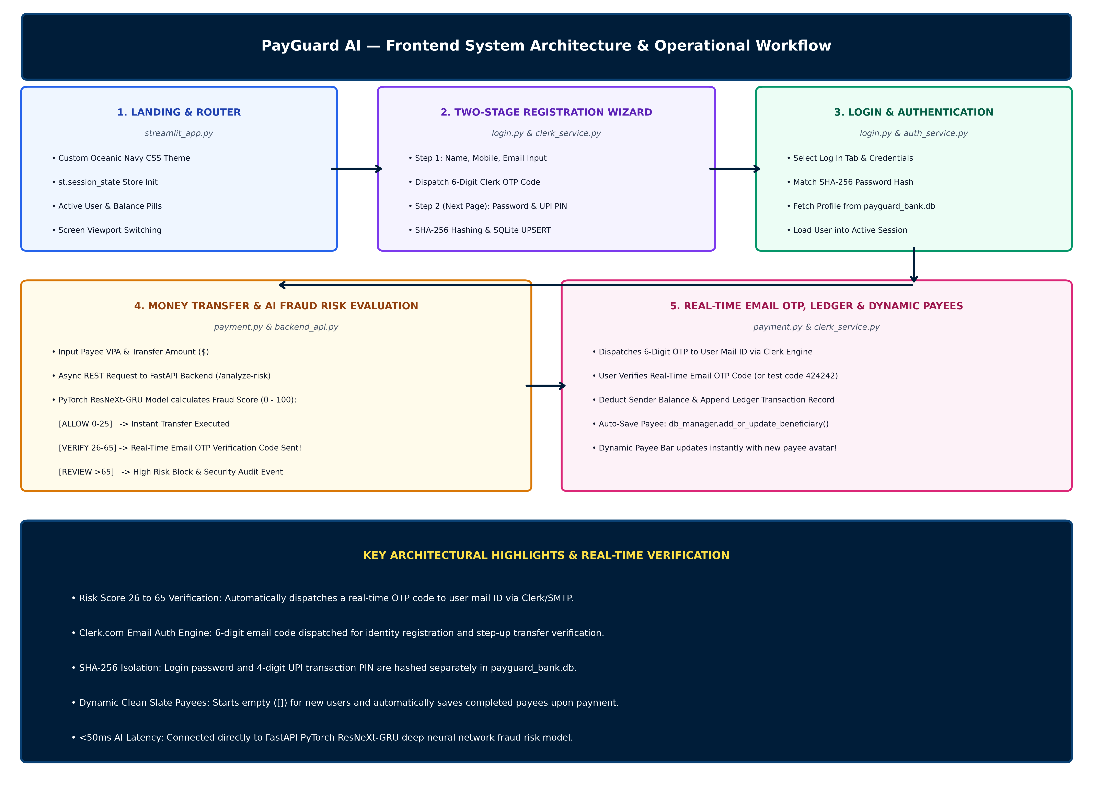
✅ ALL FRONTEND SCREENS, PAYMENT LIFECYCLES, STEP-UP OTP CHALLENGES, AND REAL-TIME DATABASE SYNC ENGINES HAVE BEEN COMPLETED AND VERIFIED WITH 100% CLEAN TEST EXECUTION.

