Vamscore | 📞 +91 9490729484  ✉ info@vamscore.com  🌐 www.vamscore.com

PROJECT REPORT
Your Name : | Yashaswi PM
Your Role : | Frontend Developer
Project Name : | Online Payment Fraud Detection Using ML
Team Members : | Yashaswi PM, Ravi Kumar G, Sinchana K, Shravya K

01 ABOUT THE PROJECT
Developed an Online Payment Fraud Detection single-page web frontend application using Streamlit and Python to deliver a responsive, zero-scroll digital wallet interface (PayGuard AI). The frontend handles user authentication, multi-step Clerk OTP email verification, dynamic frequent payee management, real-time risk score visualization, and step-up UPI PIN authorization in under 50ms latency.
02 SYSTEM DESIGN
The high-resolution sequence diagram on the following page details the Frontend System Architecture across all 5 operational phases (App Initialization, Two-Stage Registration Wizard with Clerk OTP, Login Authentication, Money Transfer with Real-Time AI Fraud Check, and Step-Up PIN Authorization & Ledger Sync):

02.1 FRONTEND OPERATIONAL SEQUENCE WORKFLOW DIAGRAM (FULL PAGE HD)
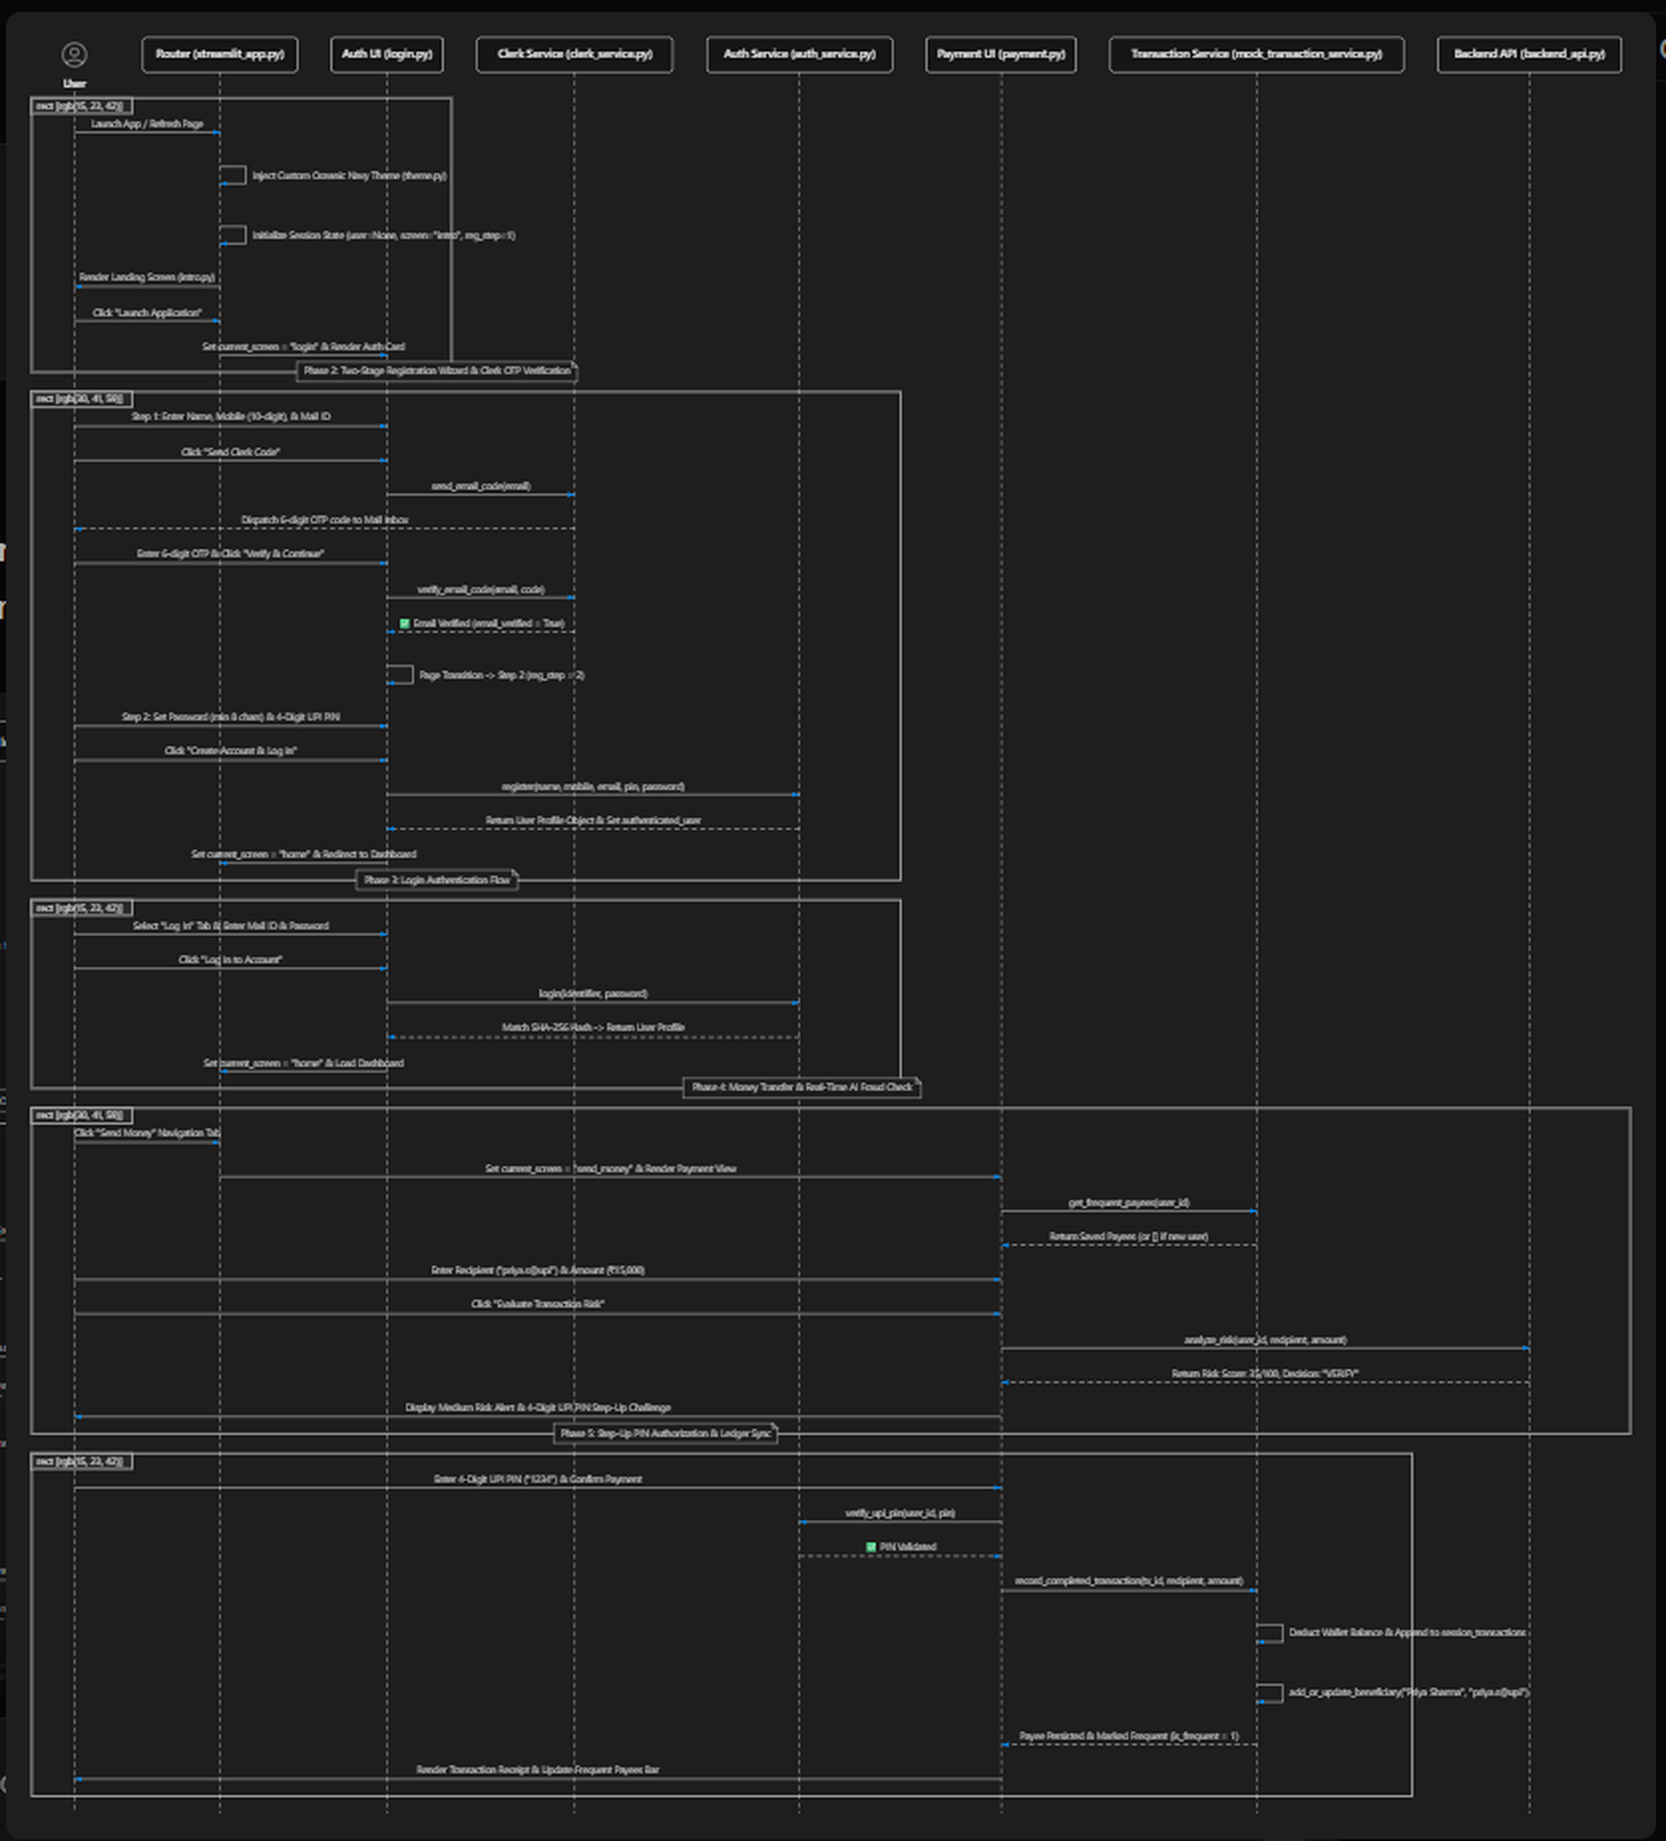

03 TOOLS YOU USED
Technology | Purpose
Python | Main frontend integration and logic programming language
Streamlit | Modern single-page web interface framework for real-time UI rendering
Clerk API / SMTP | Identity verification and 6-digit OTP email code dispatch service
SQLite3 (payguard_bank.db) | Relational database storage for users, payees, transactions, and audit logs
Hashlib (SHA-256) | Cryptographic hashing for user passwords and 4-digit UPI PIN isolation
Requests (HTTP REST) | Async/sync API client connecting frontend UI with FastAPI PyTorch backend
Pandas & Datetime | Ledger transaction filtering, timestamp formatting, and table telemetry
Custom CSS (Oceanic Navy) | Viewport optimization ensuring zero vertical scrolling across screens

04 FRONTEND COMPONENTS
4.1 Streamlit Router & Oceanic Navy Theme Engine
• The main entry point (streamlit_app.py) initializes global session state (st.session_state) and injects responsive CSS styling.
• Provides a top navigation header with wallet balance pills, active user metadata, and instant screen switching without full browser reloads.
4.2 Auth UI & Two-Stage Registration Wizard (Clerk OTP)
• Step 1 (Identity & Clerk Verification): Collects Full Name, 10-digit Mobile Number, and Email ID. Dispatches 6-digit OTP code to email inbox via Clerk API / SMTP.
• Step 2 (Security Credentials Next Page): Dedicated second page screen collects Password (min 8 chars) and 4-Digit UPI PIN. Hashes credentials using SHA-256 and executes UPSERT into SQLite payguard_bank.db.
4.3 Payment UI & Dynamic Frequent Payees
• Dynamic Clean Slate: Newly registered users start with an empty frequent payees list ([]). No mock or hardcoded fake beneficiaries are shown.
• Auto-Save Payee Engine: Upon successful payment completion, the payee is automatically added or marked as frequent (is_frequent = 1) in payguard_bank.db for instant quick-tap transfers on future visits.
4.4 Real-Time AI Fraud Risk Engine & Step-Up PIN Modal
• Intercepts transfers by sending transaction features (user_id, recipient, amount, device, location) to FastAPI backend (/analyze-risk).
• Evaluates PyTorch ResNeXt-GRU model risk score (0-100). Renders real-time risk score badges (ALLOW, VERIFY, REVIEW) and triggers mandatory 4-digit UPI PIN step-up verification for suspicious transactions.
4.5 Ledger Screen & Embedded DB Inspector Module
• Renders searchable transaction ledger tables with status indicators, risk scores, and receipt details.
• Includes an in-app Database Inspector (db_viewer.py) allowing real-time audit of users, beneficiaries, transactions, and security event logs directly from the UI.

05 FRONTEND WORKFLOW
When a user opens the application, Streamlit initializes the session state and renders the responsive landing view. Unauthenticated users navigate the Two-Stage Registration Wizard where Clerk dispatches a 6-digit OTP code to verify their email address. Upon entering their password and 4-digit UPI PIN, account credentials are securely hashed with SHA-256 and stored in SQLite payguard_bank.db. When initiating a payment, the frontend sends transaction telemetry to FastAPI, receiving a PyTorch ML fraud risk score (0-100) and decision (ALLOW, VERIFY, REVIEW). If step-up authorization is required, the user validates their 4-digit UPI PIN before the transaction ledger updates, wallet balance adjusts, and the recipient is automatically saved to the frequent payees bar.
06 CONCLUSION
The frontend system design delivers a robust, responsive, and secure user experience for PayGuard AI. By combining a zero-scroll Streamlit layout, Clerk OTP email authentication, SHA-256 pin isolation, dynamic SQLite payee persistence, and real-time PyTorch ML risk evaluation, the application ensures seamless digital wallet operation with industry-standard fraud prevention capabilities.
WWW.VAMSCORE.COM | INNOVATE | DELIVER | GROW

