(4) Requests
For request generation, the case uses Google cluster-usage traces in February 2011 with utilization data. Each request has requirements shown as amount of requested CPU, memory, and storage. Meanwhile, the case applies the traces to every region, and adjust the time lines according to the region local time, in order to simulating the time lags across the world. The case also scales the request amount according to the region population, i.e. population-density times region-size. For example, the scaled workload for 13 regions along the time are shown in Fig 7 which workload of region WE is from the original Google trace.

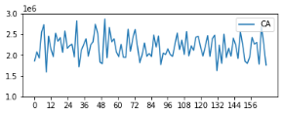 | 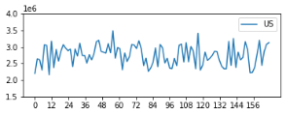 | 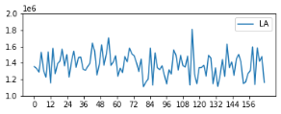 | 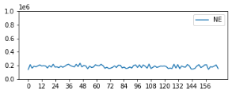

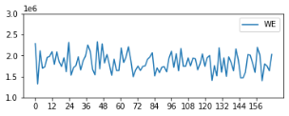 | 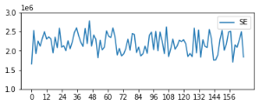 | 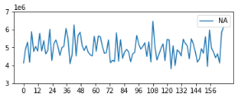 | 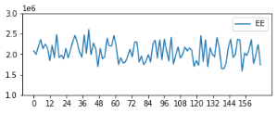 | 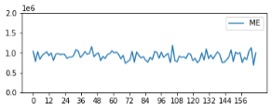
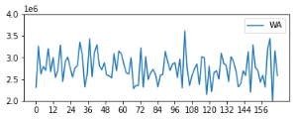 | 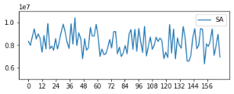 | 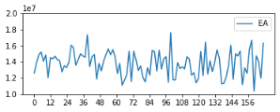 | 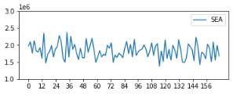

Fig.7 Number of requests in Google trace for each hour of one week

(5) Scheduling algorithms
The simulation case implements six typical request-scheduling approaches, as base-lines of geographical load balancing algorithms. They are explained as the follows:.

Round Robin (RR): The scheduler distributes a request to a data center in turn.

Nearest (NE): The scheduler distributes a request to the data center whose location is the closest to the region where the request is issued.

Min-Time (MT): The scheduler distributes a request to the data center with the most available resources.

Max-Power (MP): The scheduler distributes a request to the data center approaching the full-loaded statues mostly, i.e., the available resources of the datacenter just matched the required resources.

Max-Green (MG): The scheduler distributes a request to the most energy-rich data center among those not reaching their limitations for processing requests.

Min-Cost (MC): The scheduler distributes a request to the data center with the lowest energy prices.

6.2 Evaluation
In this section the simulation results of the case defined in section 6.1 are shown from the aspects of energy generation, energy consumption, renewable energy utilization and energy cost. We simulate the case for a month. We select the 24*7 hours of trace data and show them on the hourly line charts, and one month aggregate data on the time-accumulative bar charts.

(1) Energy generation
The renewable energy (hourly) generated in five datacenters are shown in five sub-figures of Fig.8, respectively. The two lines are in each figures present the solar and wind energy per hour. Notice that the battery does not generate the energy but store the energy, the working status of batteries are related to the therefore the energy data are shown in the scheduling algorithms which are discussed later.

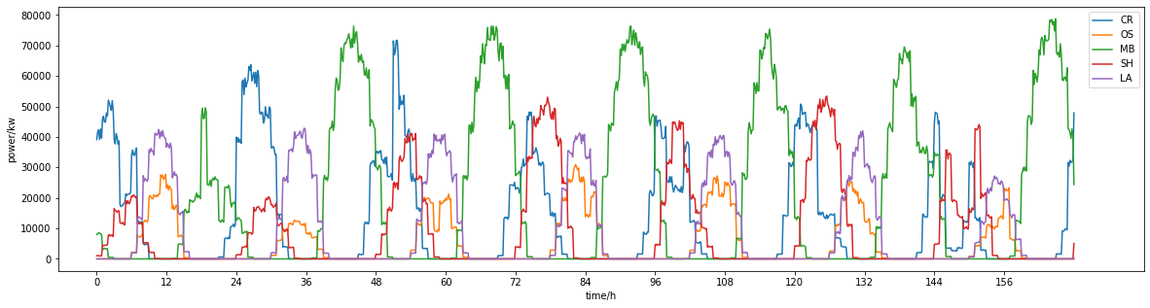
Fig.8 Solar energy generated within five datacenters for each hour of one week
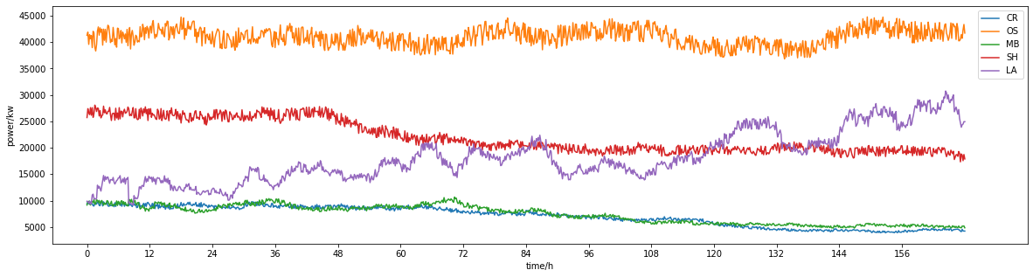
Fig.9 Wind energy generated within five datacenters for each hour of one week
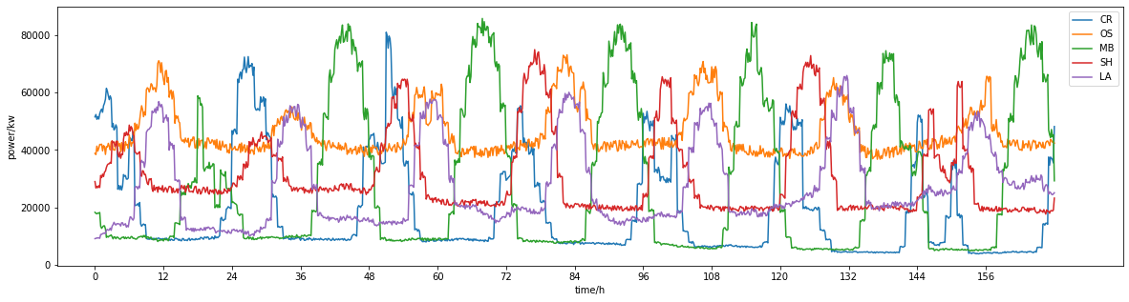
Fig.10 Renewable energy generated within five datacenters for each hour of one week

图八，图九，图十分别展示了一周内五个数据中心每小时的太阳能生成量、风能生成量以及可再生能源的生成总量。其中DC_OS的能源生成规则为按照6.1的公式生成。我们为除DC_OS外的四个数据中心分别配置了不同的MIDC风能和太阳能的能源轨迹数据文件，并且分别根据这四个数据中心的地理位置所在的时区对能源文件进行了偏移。在图八中，由于DC_MB最接近赤道，所以其太阳能生成的峰值最大，DC_SH、DC_MB与DC_LA所处的纬度大致相同，他们的太阳能生成量也相差的不多，只是到达峰值的时间不同，而DC_OS所处的维度最高，其太阳能生成的最少。图九展示了五个数据中心风能的生成量，由于DC_OS、DC_SH与DC_LA地处沿海地区，所以其风能的生成量较多，而DC_CR与DC_MB所处的热带地区风速较小，故其风能生成的较少。因此，从图十中可以看出，这五个数据中心的可再生能源生成总量曲线的形状大致相同，但由于各个数据中心所处的地理位置不同，其最大值、最小值与到达峰值的时间均不相同，这与其太阳能与风能的生成量息息相关。

On one hand, renewable energy of DC_OS is calculation based on theoretical formulas, and the rest four DCREs are based on actual historical renewable energy traces with the time offset consideration. On the other hand, the amount of rest energy is scaled with the corresponding capabilities of the datacenter, i.e., the power of generator is less than but close to the power of corresponding DCRE. Therefore, the curves in Fig. 8-(b, c, e, d) are in similar sharps while a little different from that is Fig 8-a. However, tends of these curves are representative and proves that CloudSimPer successfully simulates the renewable energy generator.

(2) Energy consumption

The energy consumption (hourly) of each data centers under six scheduling algorithms are shown in six sub-figures of Fig. 9, respectively.
RR
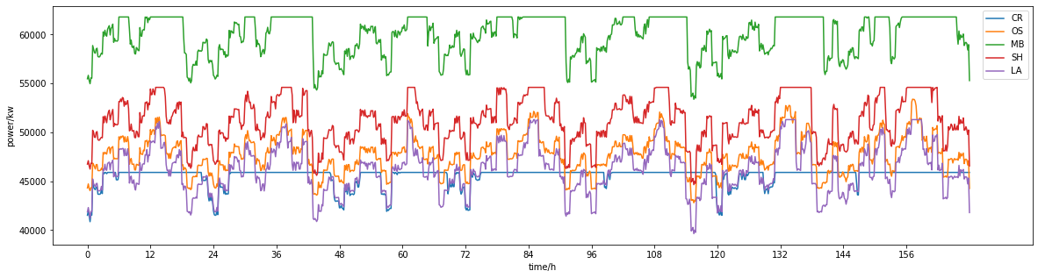
NE
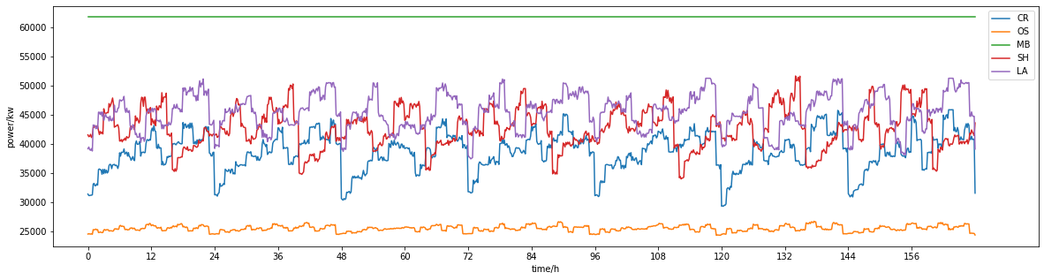
MT
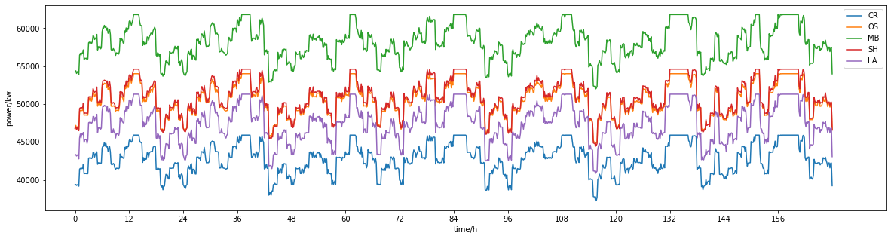
MP
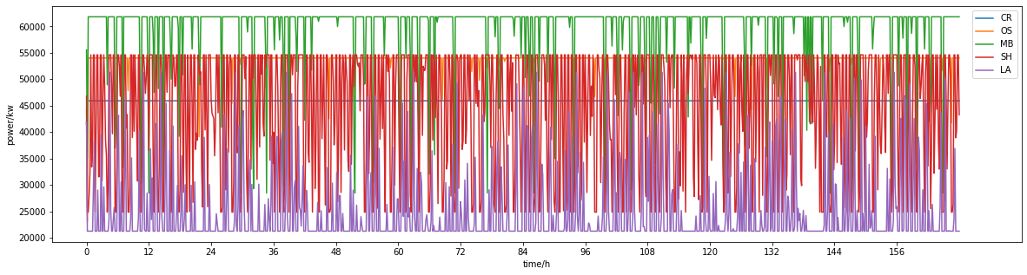
MG
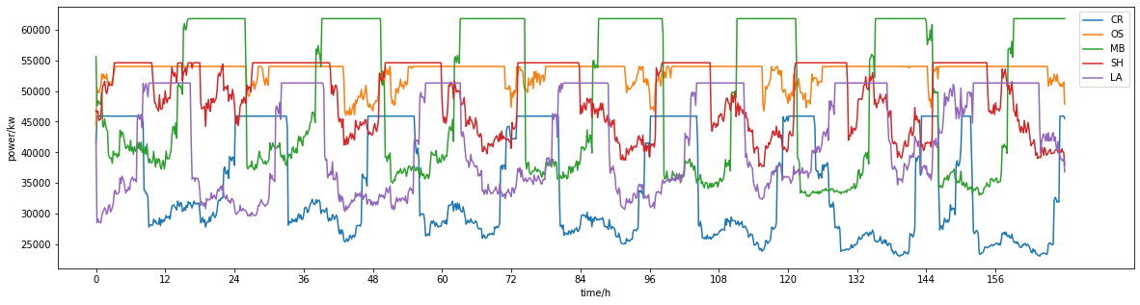
MC
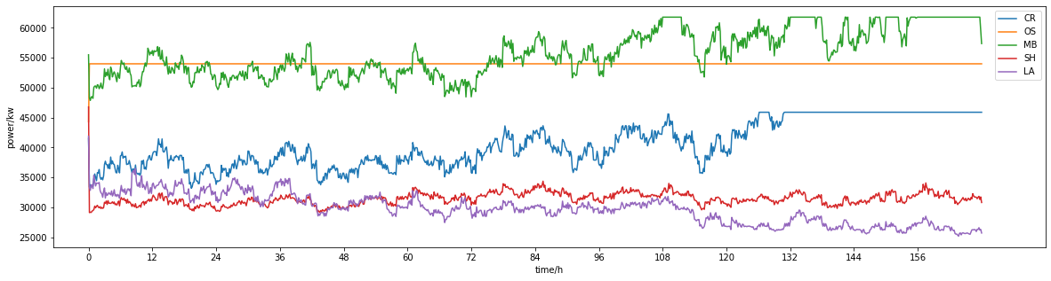
Fig.9 Energy consumption (hourly) of five data centers under six scheduling algorithms

图九展示了一周内六种调度算法下五个数据中心的能源消耗情况。数据中心的能源消耗主要与数据中心执行的请求数量、主机的功率决定。对于五个数据中心，其空闲功率与满载功率由于其配置的不同也不相同，因此，图九中不同数据中心的能耗曲线的最值不同。各个数据中心的空闲与满载功率如下表所示。

 | MB | SH | OS | LA | CR
Idle | 28440 | 24840 | 22980 | 21240 | 19740
Full_load | 61800 | 54600 | 54000 | 51300 | 45900

在图九中，对于RR调度算法，每个数据中心得到相同数量的请求，在这种调度算法下，执行能力强的数据中心的能耗曲线与分到的任务曲线的形状类似，如DC_OS、DC_LA；而执行能力弱的数据中心的能耗曲线则会在任务数量多时达到峰值，此时该数据中心满载，如DC_CR、DC_MB、DC_SH。NE调度算法的能耗曲线与RR类似，只是DC_MB由于地处请求多的区域而得到了最多的请求，所以其能耗曲线一直为满载的能耗值，相反，DC_OS得到了最少的请求数量，所以其数据中心的能耗很低，而其他三个数据中心的能耗曲线则与数据中心获得的请求数量曲线类似。MT调度算法按照数据中心的执行能力将请求分发到各个数据中心，所以每个数据中心得到了与其执行能力匹配的请求数量。在大部分时间内，所有数据中心的能耗曲线类似于请求曲线，只有在请求数量太多时，能耗曲线为满载的能耗值，并且，五个数据中心会同时达到其各自的峰值。MP调度算法会将请求优先向一个数据中心发送，直到其达到其最大处理能力，再发送给下一个数据中心。由于每个单位时间生成的任务数量的不同，DC_CR总会优先拿到任务，所以其总是保持满载状态，能耗曲线为直线，DC_OS次之，其能耗曲线也接近满载的能耗直线，只是在很少的时间，即总任务量少的时间达不到满载的能耗曲线，接着是DC_MB，其达不到满载的功率曲线的时间较DC_OS多一些，DC_SH的能耗曲线在空闲功率的能耗值与满载功率的能耗值之间变化的更为激烈，而DC_LA的能耗曲线大多数时间为空闲功率的能耗值，其他时间，即总任务数量多时不为空闲功率的能耗值。MG调度算法将请求分发到可再生能源多的数据中心，即数据中心的可再生能源越多，其拿到的请求数量就越多，所以数据中心的能耗曲线类似于能源生成的曲线，由于时区的影响，能源生成曲线在不同的时间达到峰值，所以能耗曲线也在不同的时间达到峰值，在此种调度算法下，当数据中心的能力过剩时，其能耗曲线类似于能源生成曲线，而当数据中心的能源过剩时，数据中心满载，能耗曲线达到满载的能耗值。MC调度算法优先将请求发送到能源价格较低的数据中心，在上一节中配置中，DC_OS的可再生能源的价格最低，所以其得到了最多的请求数量，能耗曲线为满载时的能耗值。而其他四个数据中心在大多数时间得到了低于其执行能力的请求数量，所以其能耗曲线类似于得到的任务曲线。

To compare the effects of six algorithms on energy consumption, we treat five datacenter as a wholes system and measures the average energy consumption (hourly) per requests over one month, and 24*30 results are summarized for one algorithm, shown as a box-plot in the Figure 10
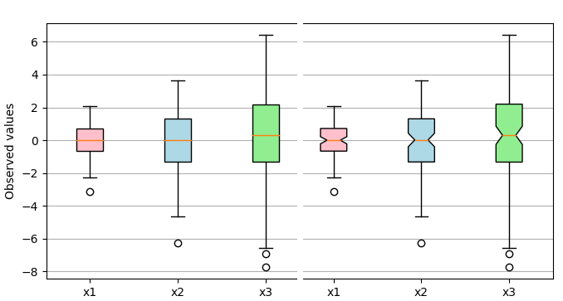
Fig.10 Statistics on energy consumption per request (hourly) of all data centers under six scheduling algorithms
Theoretically, the capabilities of data centers are designed to satisfy the average amount of requests per time, thus no matter when and where the requests is scheduled, the total number of executed requests are same, and the energy a request consumed is almost the same, to this end, the energy consumption under each scheduling algorithm should be basically same. However, as shown in Figure 9, these energy consumption has obviously difference. The reasons of such difference are : 1) execute time.... 2) server power model and idle power…. Nevertheless, these difference are not huge, but the both renewable energy and the battery utilization is definitely various under these algorithm. We analyze these differences in next section.

(3) Renewable Energy Utilization
One of the optimization goals about DCRE studies is improving the renewable energy utilization. As discussed in Fig.9, the utilizations under different scheduling algorithms are different despite the energy consumptions are similar. The six sub-figures in Fig. 10 show the box plots for hourly utilizations of each data center under the six algorithms, respectively.
RR Nearest Max_Power
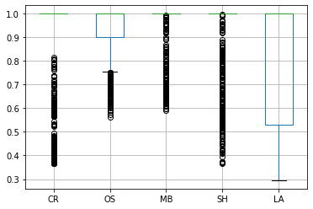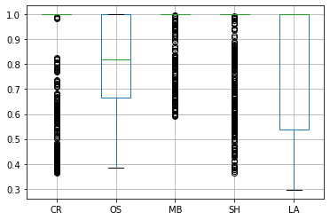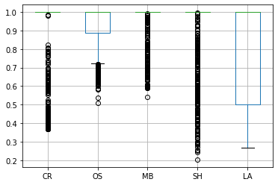
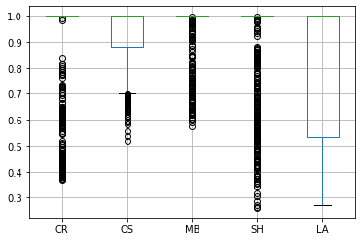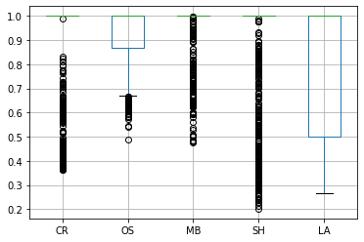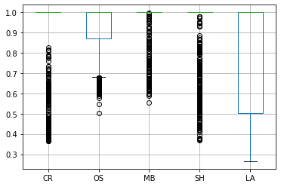
Min_Time Max_Green Min_Cost
Fig.10 Renewable energy utilization of five datacenters under six scheduling algorithms
图十展示了六种调度算法下各个数据中心的可再生能源利用率情况，由于可再生能源的生成随时间的变化而变化，所以在可再生能源生成量小，像夜晚的时间，由于任务量之多，所以可再生能源的使用率总为1，只有在中午，太阳能充足的情况下，可再生能源的生成量大于使用量，此时，数据中心的电池充电，对应着棕色能源使用曲线中凹陷为0的部分。因此可再生能源的使用率呈现图十中的情况。
总体来看，Max_Green调度算法由于将任务偏向发送于剩余可再生能源较多的数据中心，所以其相对于其他调度算法五个数据中心之间的可再生能源的使用率相对平均，下四分位数均在0.5以上，并且异常值较少。而其他几种调度算法，RR算法能力弱的数据中心的使用率基本均为1，而能力强的数据中心则随着任务的数量而分散。Nearest调度算法收到请求多的数据中心的使用率均为1，收到请求少的数据中心使用率也低。Max_Power调度算法由于将任务更多的分向执行功率大的数据中心，所以DC_OS和DC_MB的使用率一直很高，而其他三个数据中心使用率不高。Min_Time调度算法由于其各个数据中心收到的任务数量曲线呈震荡态势，所以其可再生能源的是使用率的差别也较大，最高为1，最低达到了0.2左右。Min_Cost调度算法与能源价格息息相关，所以可再生能源价格低的数据中心接受到的请求多，其可再生能源的使用率也高，而能源价格低的数据中心反之。
To support the above analyze, the average hourly consumption of renewable energy for each data center under the six algorithms are shown in six sub-figures of Fig 11, respectively. In this case, the prices of solar and wind energy are set to be same, so that CloudSimPer does not distinguish them, and there are two lines, one for brown energy and another for renewable energy, in each sub-figure of Fig 11. If the prices of them are not same, the expensive one is used first when solar energy and wind energy exist at the same time.
下图展示了六种调度算法下五个数据中心的棕色能源消耗情况，由于CloudSimPer仿真的能源使用的优先级为：优先使用可再生能源，电池的能源次之，最后使用棕色能源，并且剩余的可再生能源会储存在电池中，所以棕色能源的消耗不会太多。由于五个数据中心的可再生能源的生成有一定的规律，所以其棕色能源的使用量也在一定程度上呈现周期的变化。

RR
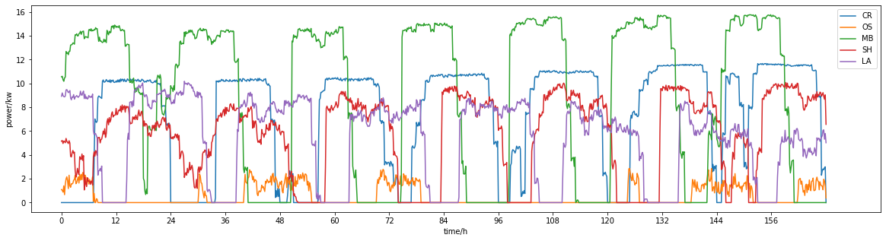
NE
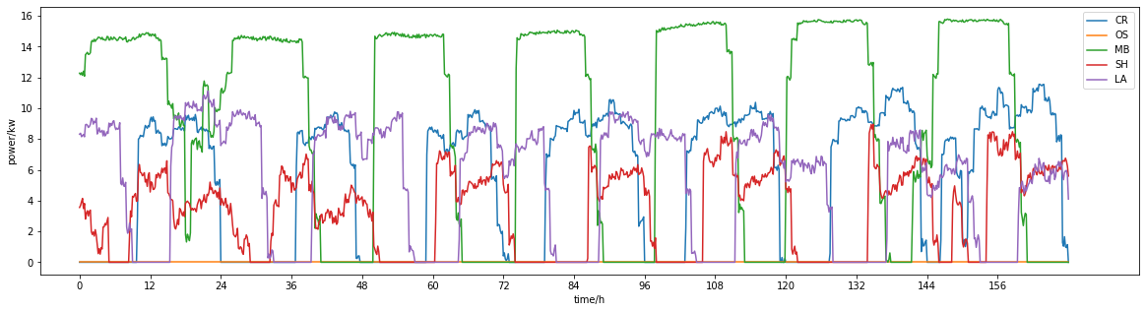
MT
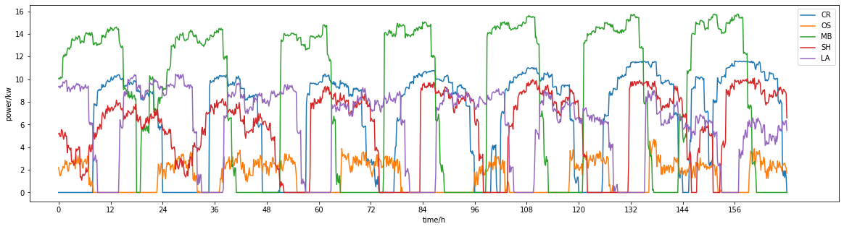
MP
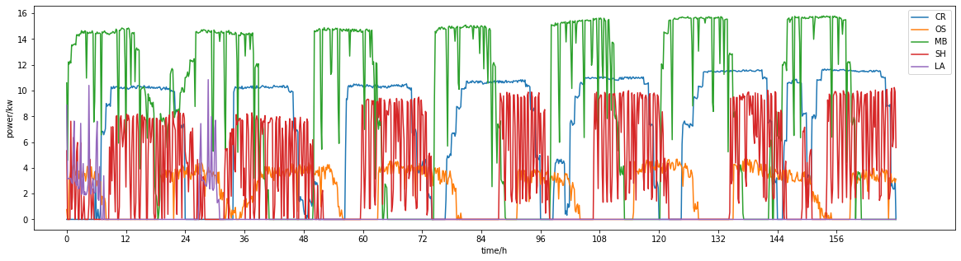
MG
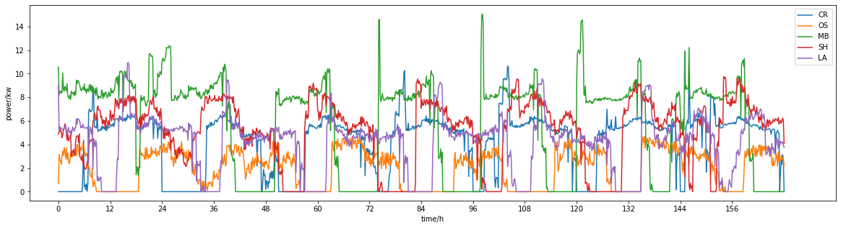
MC
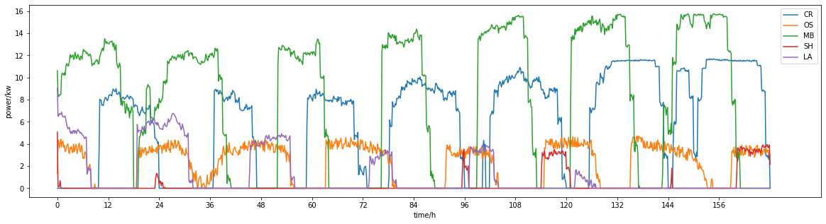
Fig.11 Brown and renewable energy consumption (hourly) of all data centers under six scheduling algorithms
Analyzing….
In the simulation, battery is works only as a short time buffer of renewable energy. Considering the lifecycle of the batteries. The priority of using battery energy is higher than brown energy, but lower that the renewable energy. Energy supplement from the batteries is counted as renewable energy consumption because batteries are only charged by the sufficient renewable energy. Beside these strategies, there is not optimization for batteries, or based on batteries. The five sub-figures in Fig. 12 shows the stored energy of batteries (hourly) under each algorithms for five data centers, respectively.
图12展示了六种调度算法下每个调度时间各个数据中心电池的充放电情况，坐标轴以上代表充电，坐标轴以下代表放电。本次实验中为了模拟各种算法下电池的能量变化情况，特意将电池的容量设计为足够大，以此来确定在不同的实验条件下，该如何设计数据中心的电池容量。根据本次实验数据，不同的调度算法下，各个数据中心储存的最大的能量为1000000.02KW，这为数据中心电池的设定提供了一定的规范。

RR
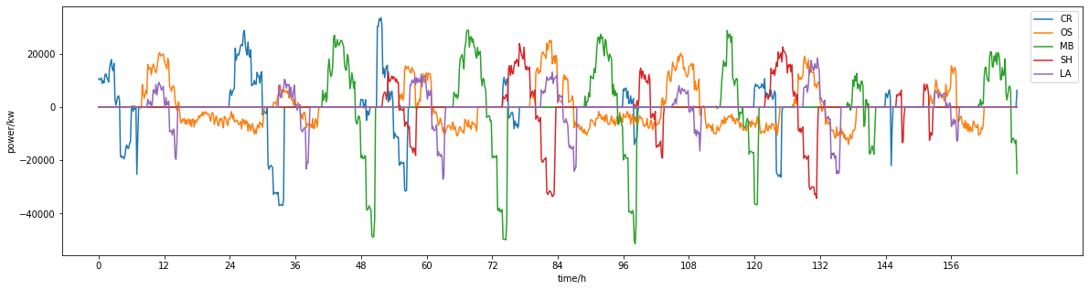
NE
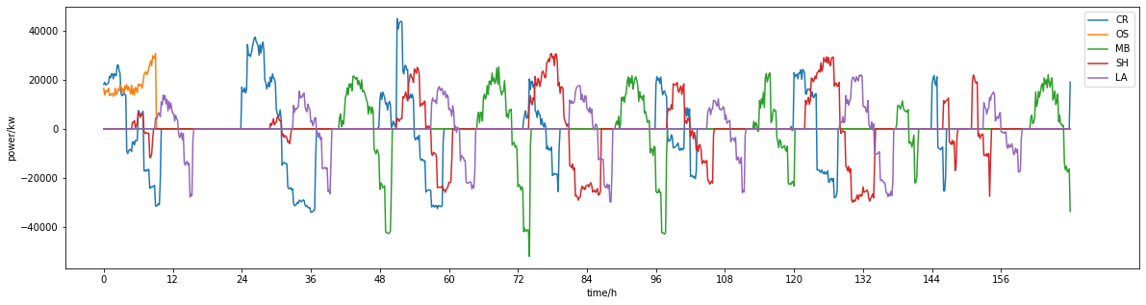
MT
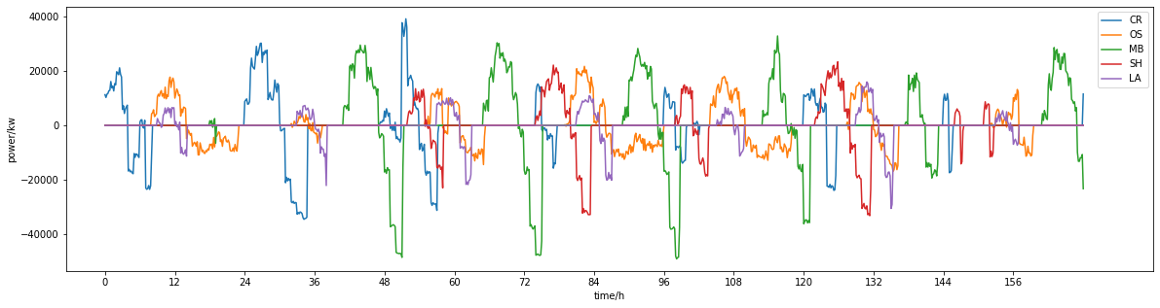
MP
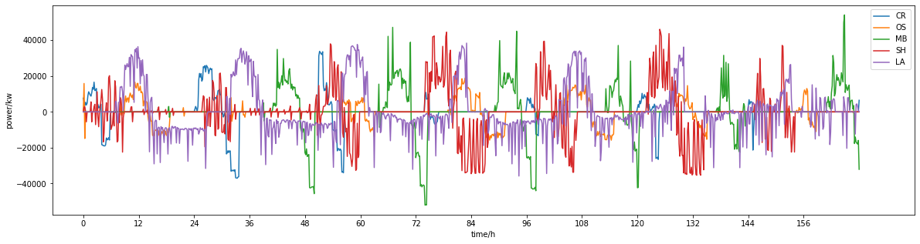
MG
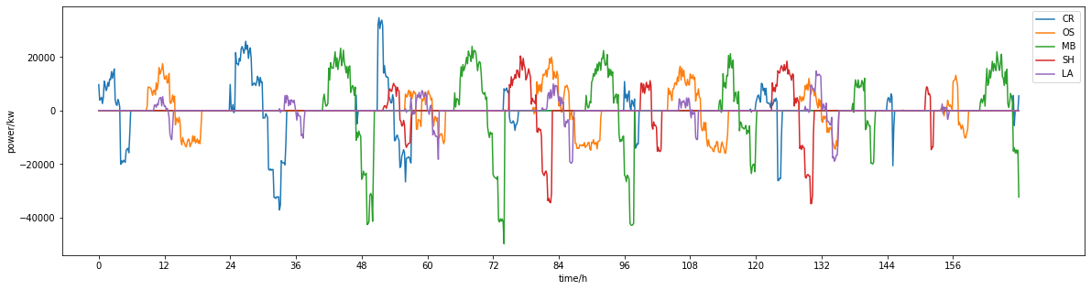
MC
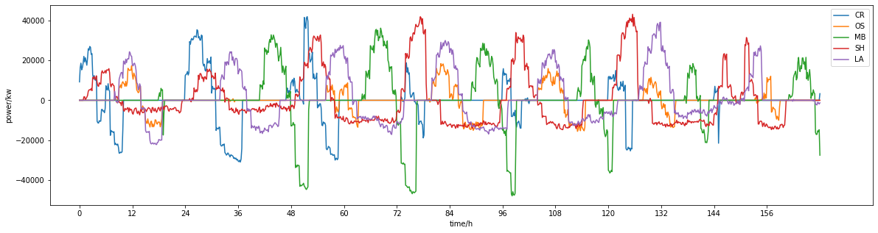
Fig.12 Emery stored in batteries of five data centers under six scheduling algorithms
Analyzing….

(4) Energy Cost
Comparing with energy consumption, the energy cost vary from algorithm to algorithm because the data center are with location-variant and time-variant energy price.
The energy cost (hourly) of each data centers under six scheduling algorithms are shown in six sub-figures of Figure 13, respectively, among which the cost of batteries is not counted in.
（我们认为生成能源就是花钱的，所以各个调度下能源的花费是一样的。。只有上面展示的数据中心的棕色能源花费不一样）
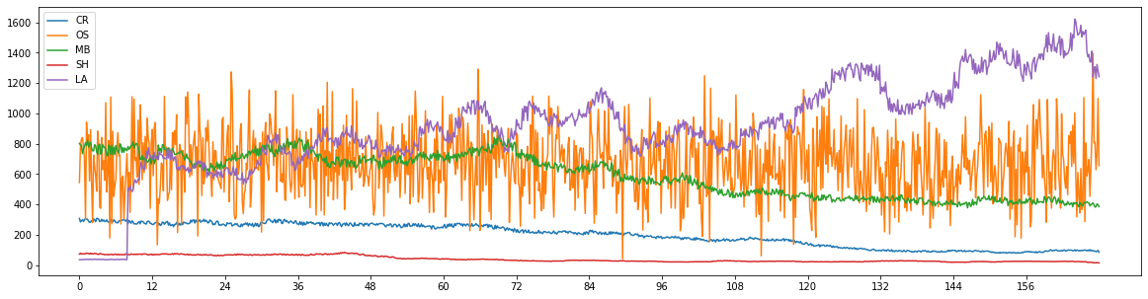
Fig.13 Energy cost (hourly) of five data centers under six scheduling algorithms
Analyzing….
To compare the effects of six algorithms on energy cost, we treat five datacenter as a wholes system and measures the average energy cost (hourly) per requests over one month, and 24*30 results are summarized for one algorithm, shown as a box-plot in the Figure 14
Fig.14 Statistics on energy cost per request (hourly) of all data centers under six scheduling algorithms
Theoretically, the energy cost per request should be similar for the RR, NE, MP and MT because no factor related to the energy price is considered in the algorithm. Beside, the MG has less cost because it consumes more renewable energy with is cheaper than brown energy, and MC has the lest cost because it distributes a request to the data center with the lowest energy prices. However, Fig. 14 shows that ….. The reasons of such situation are : 1) execute time.... 2) server power model and idle power….

(5) Discussion
Analyzing….

