EX NO: 1 – CREATION OF CLOUD ORGANIZATION WITH ROLE-BASED ACCESS CONTROL USING GOOGLE CLOUD PLATFORM
DATE:

AIM:
To create a Cloud Organization in Google Cloud Platform (GCP) with Role-Based Access Control (RBAC).
PROCEDURE:
Google Cloud Platform (GCP) provides a flexible and secure environment for managing cloud resources with fine-grained access control using Identity and Access Management (IAM). In this experiment, a cloud organization structure was implemented by assigning roles to different users, thereby enabling Role-Based Access Control. Initially, the Google Cloud Console was accessed using valid credentials, and the required project was selected from the project dashboard. A project in GCP acts as a logical container for resources, and it is essential for organizing services and permissions.
After selecting the project, the IAM & Admin section was opened to manage access control. The IAM interface displays all users (members) associated with the project along with their assigned roles. To demonstrate RBAC, a new user was added by clicking on the “Grant Access” option. The email ID of another user (friend’s account) was entered, and a predefined role known as the “Browser” role was assigned. This role allows the user to view project structure and resource metadata without granting permission to modify or create resources, thereby ensuring security and controlled access.
Once the role was assigned, the configuration was saved, and the system updated the permissions accordingly. To verify the implementation, the second user logged into the Google Cloud Console using their own credentials. The user was able to view the project and navigate through resources but was restricted from performing any modifications such as creating or deleting instances. This confirmed that the role-based restrictions were functioning correctly.
Screenshots were captured from both the administrator account (showing role assignment) and the user account (showing restricted access) to provide visual evidence of the RBAC implementation. This experiment demonstrates how cloud organizations can securely manage multiple users by assigning appropriate roles based on responsibilities, thereby ensuring both accessibility and security in cloud environments.

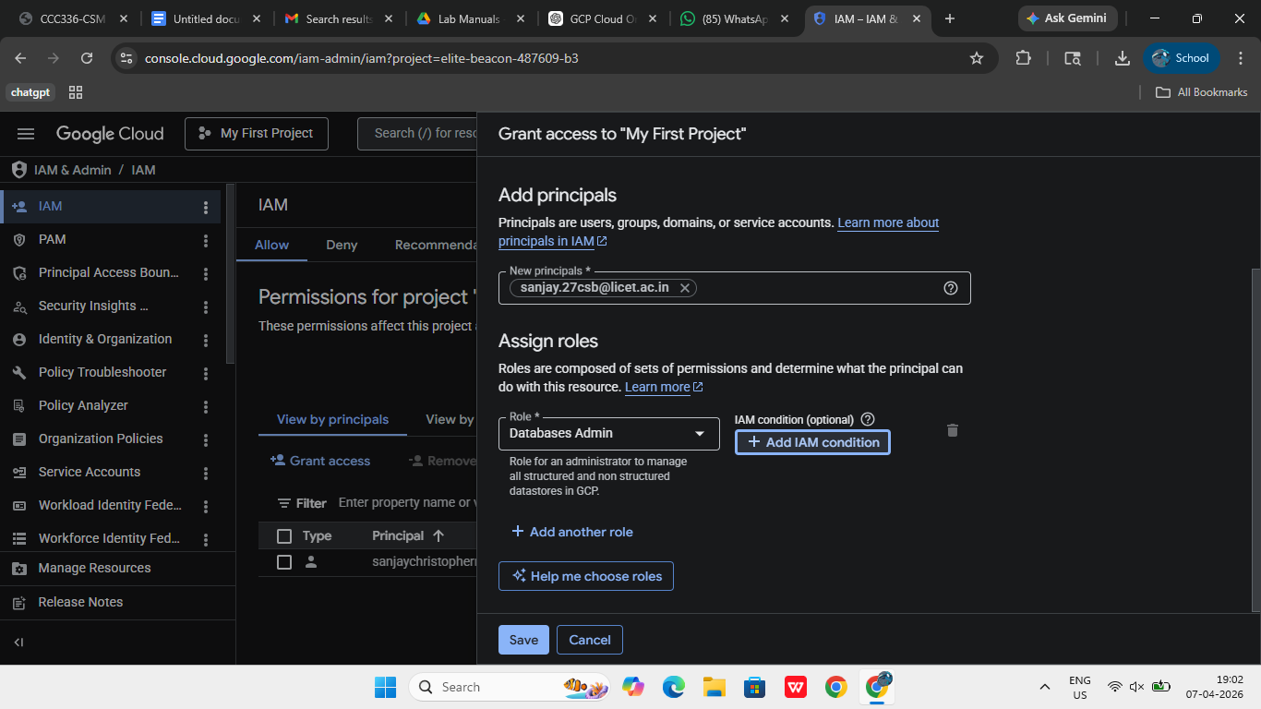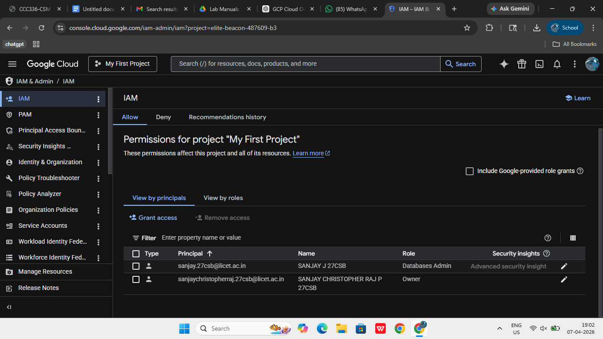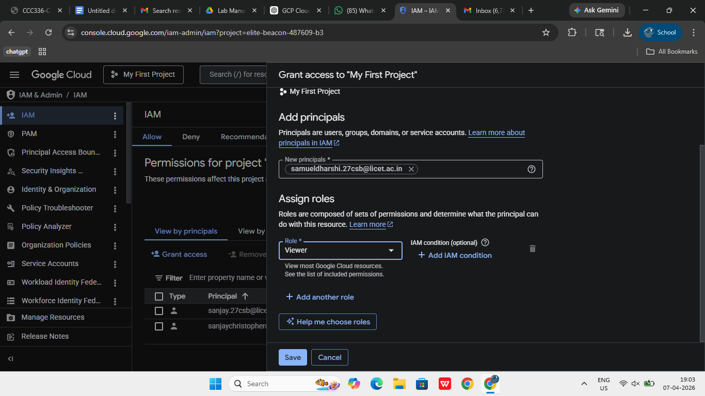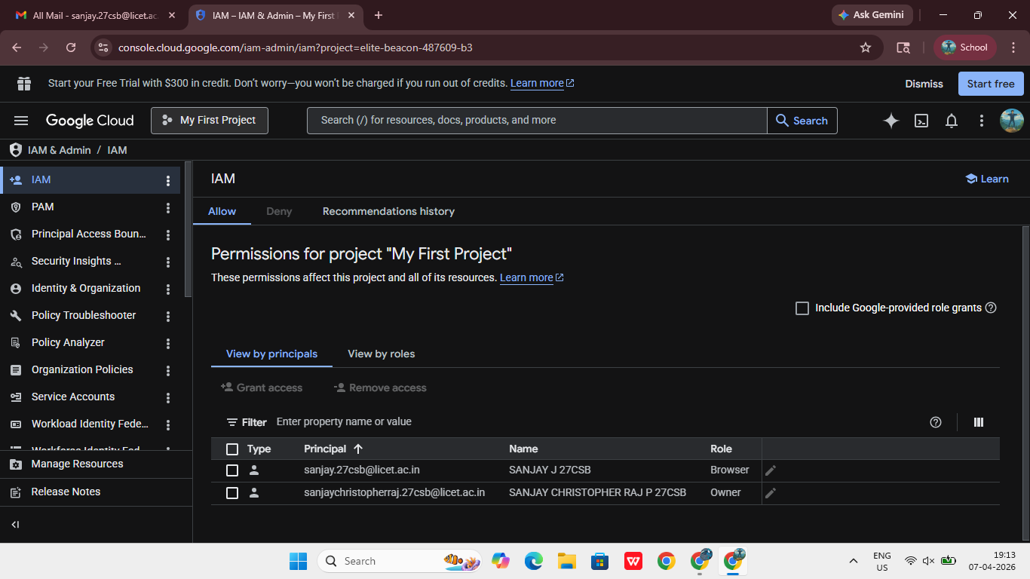
RESULT:
Thus, a Cloud Organization with Role-Based Access Control (RBAC) was successfully implemented and verified using Google Cloud Platform.

EX NO: 2 – CREATION OF COST MODEL FOR A WEB APPLICATION AND COST-BENEFIT ANALYSIS USING MICROSOFT AZURE
DATE:

AIM:
To create a cost model for a web application using Microsoft Azure services and perform cost-benefit analysis.
PROCEDURE:
Microsoft Azure provides comprehensive tools for cost management, enabling users to estimate, monitor, and control cloud expenditure effectively. In this experiment, a cost model for a web application was created by analyzing resource usage and setting budget constraints. Initially, the Azure Portal was accessed using a valid student account. The portal provides a centralized interface to manage all cloud services and billing-related activities.
A resource group containing the web application resources was selected to group related services logically. Resource groups help in organizing resources such as web applications, storage accounts, and databases, making it easier to monitor their combined cost. After selecting the resource group, the Cost Management + Billing section was opened. This section provides detailed insights into usage patterns, pricing, and cost distribution across various services.
Within this section, the Cost Analysis tool was used to visualize the cost incurred by different resources. Filters were applied to focus on the selected resource group, and graphical representations such as charts and tables were used to understand cost trends. This helped in identifying which services contribute most to the total cost.
To implement cost control, a budget was created by navigating to the Budgets section. A new budget was defined by specifying parameters such as budget name, total cost limit, and time duration (monthly). Threshold values were configured to trigger alerts when the spending reached certain percentages of the allocated budget. For example, alerts were set at 50% and 80% of the total budget. Email notifications were configured to inform the user when these thresholds were exceeded.
The cost-benefit analysis was then performed by comparing the estimated cost with the advantages offered by cloud computing. Benefits such as scalability, flexibility, high availability, and pay-as-you-use pricing were considered. At the same time, potential cost-related challenges such as over-provisioning and unnecessary resource usage were analyzed. Screenshots of cost analysis dashboards, budget creation, and alert configuration were captured to document the process.
This experiment demonstrates how Azure enables effective cost modeling and financial management, ensuring that cloud resources are used efficiently while staying within budget constraints.

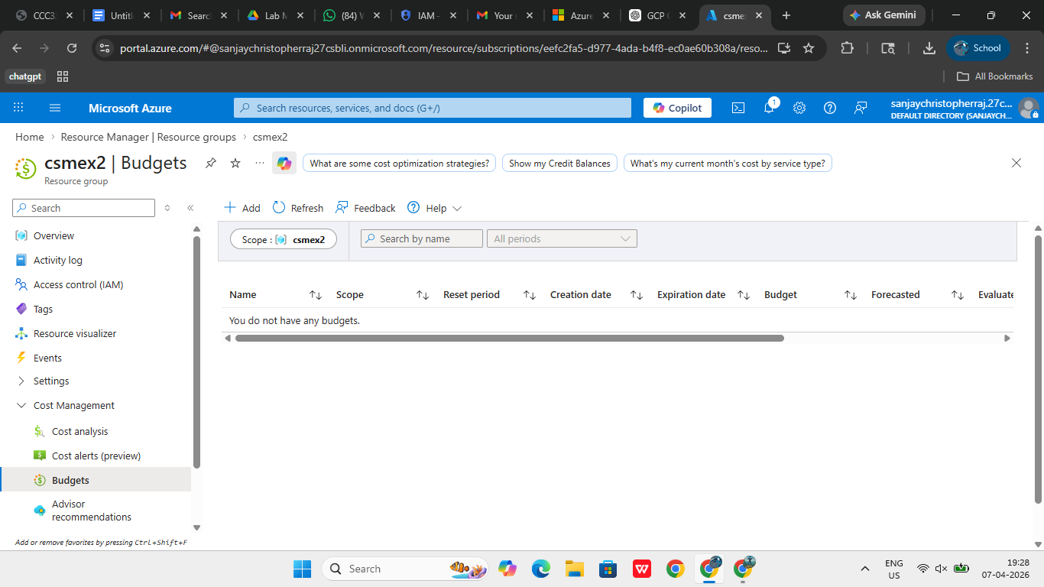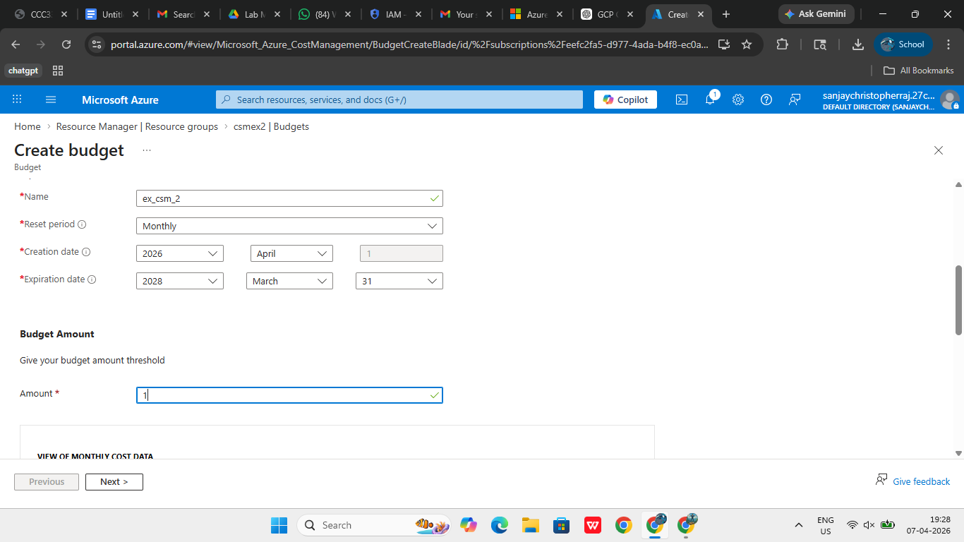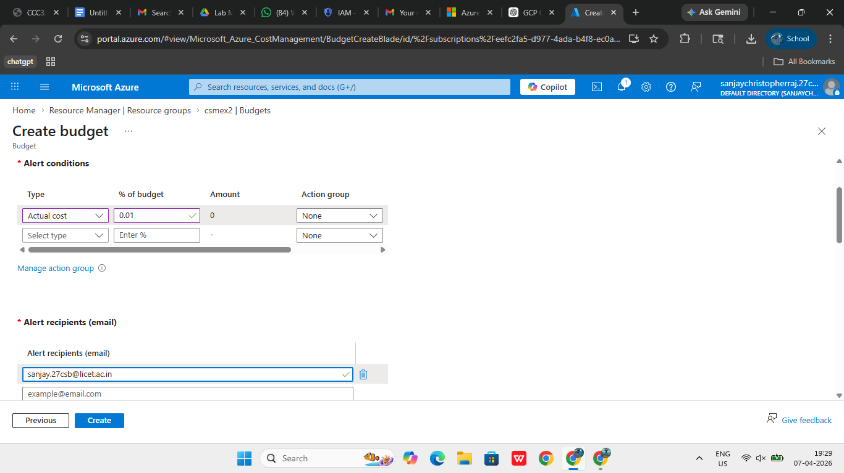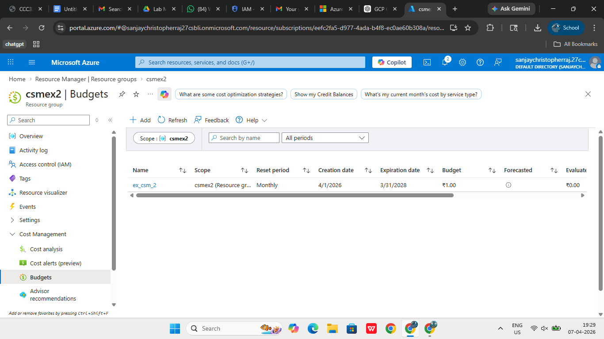

RESULT:
Thus, a cost model for a web application was successfully created and cost-benefit analysis was performed using Microsoft Azure.
EX NO: 3 – CREATION OF ALERTS FOR USAGE OF CLOUD RESOURCES USING MICROSOFT AZURE
DATE:

AIM:
To create alerts for monitoring the usage of cloud resources.
PROCEDURE:
Monitoring and alerting are essential features in cloud computing that help users track resource performance and respond to potential issues in real time. Microsoft Azure provides a powerful alerting mechanism through Azure Monitor, which enables users to define conditions and receive notifications when specific thresholds are met. In this experiment, alerts were created to monitor the usage of a virtual machine resource.
The Azure Portal was accessed, and the virtual machine created earlier was selected. Within the virtual machine dashboard, the Monitoring section was opened, and the Alerts option was selected. This section allows users to create and manage alert rules based on various performance metrics such as CPU utilization, memory usage, and disk activity.
A new alert rule was created by selecting the “Create Alert Rule” option. The scope of the alert was defined by selecting the virtual machine resource. Next, a condition was configured by choosing a metric such as CPU percentage. A threshold value was specified so that the alert would trigger when the CPU usage exceeded a certain limit. This helps in identifying performance issues before they impact the application.
To ensure proper notification, an Action Group was created. Action Groups define how alerts are communicated to users. In this case, an email notification was configured, and the friend’s email ID was added as a recipient. This ensures that whenever the alert condition is met, the notification is sent to the specified user.
Additional details such as alert name, severity level, and description were provided to clearly identify the purpose of the alert. The configuration was reviewed, and the alert rule was created. Once activated, the alert continuously monitors the resource and triggers notifications when the defined conditions are met.
Screenshots were captured showing the alert rule configuration, condition settings, and action group setup. This experiment highlights the importance of proactive monitoring and demonstrates how Azure alerts can be used to maintain system performance and reliability.
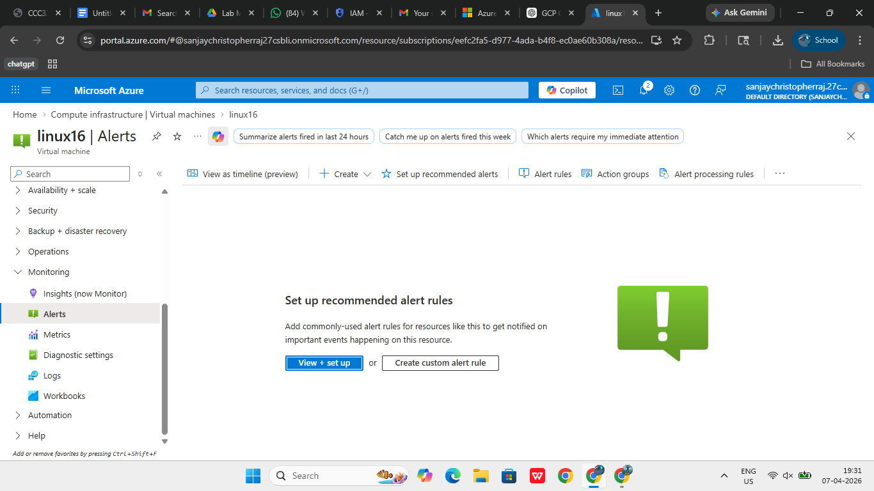

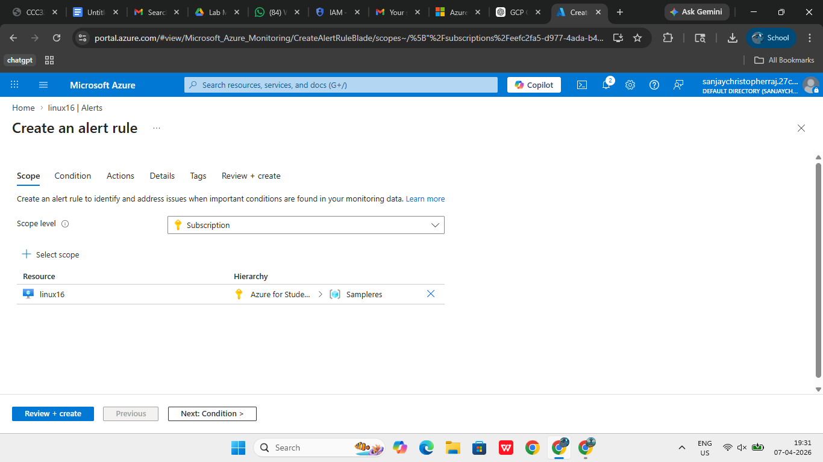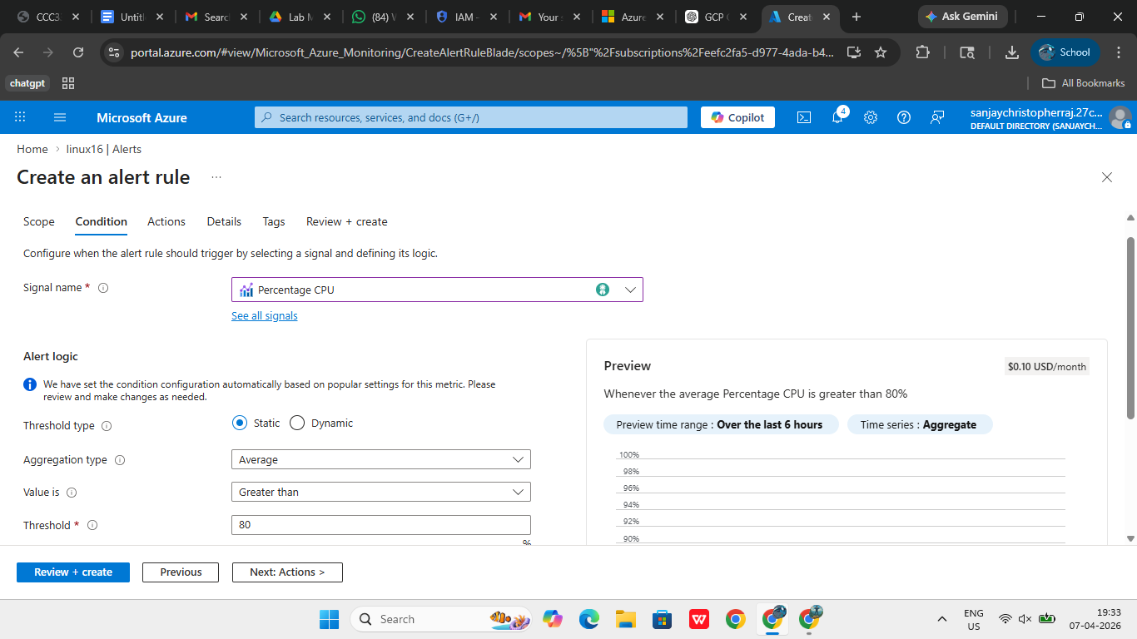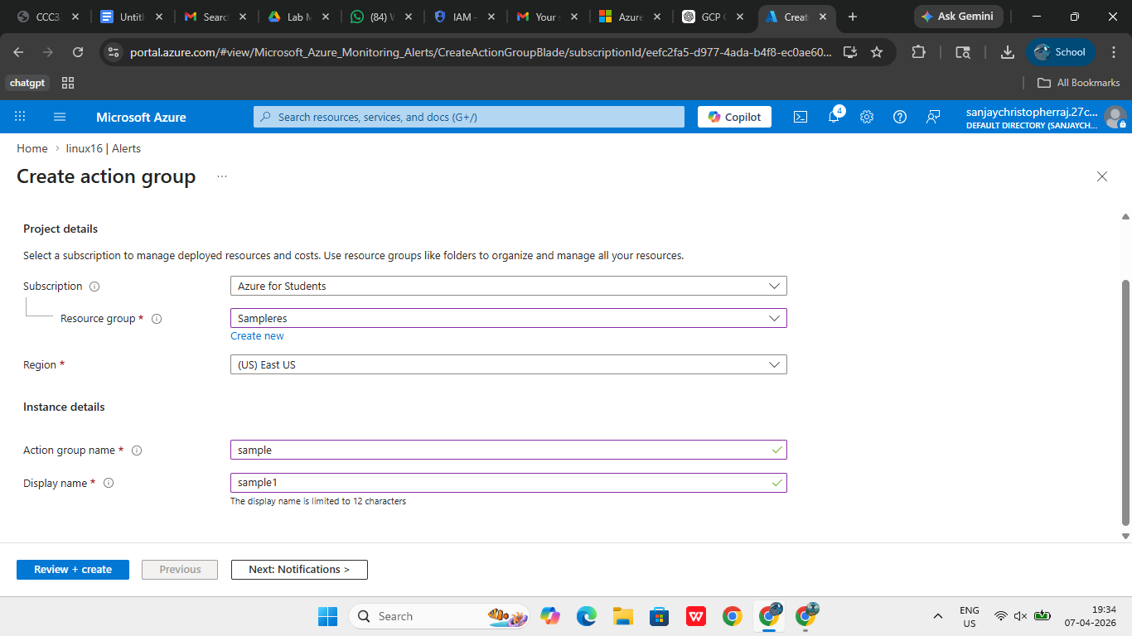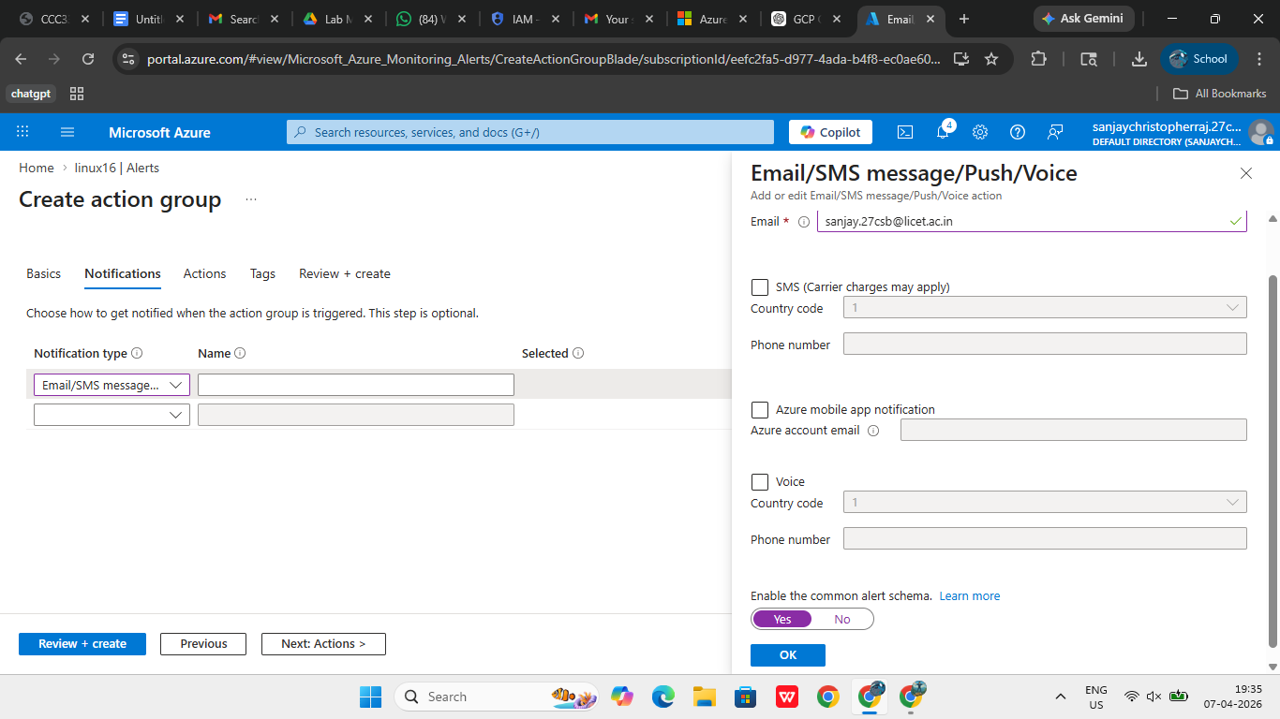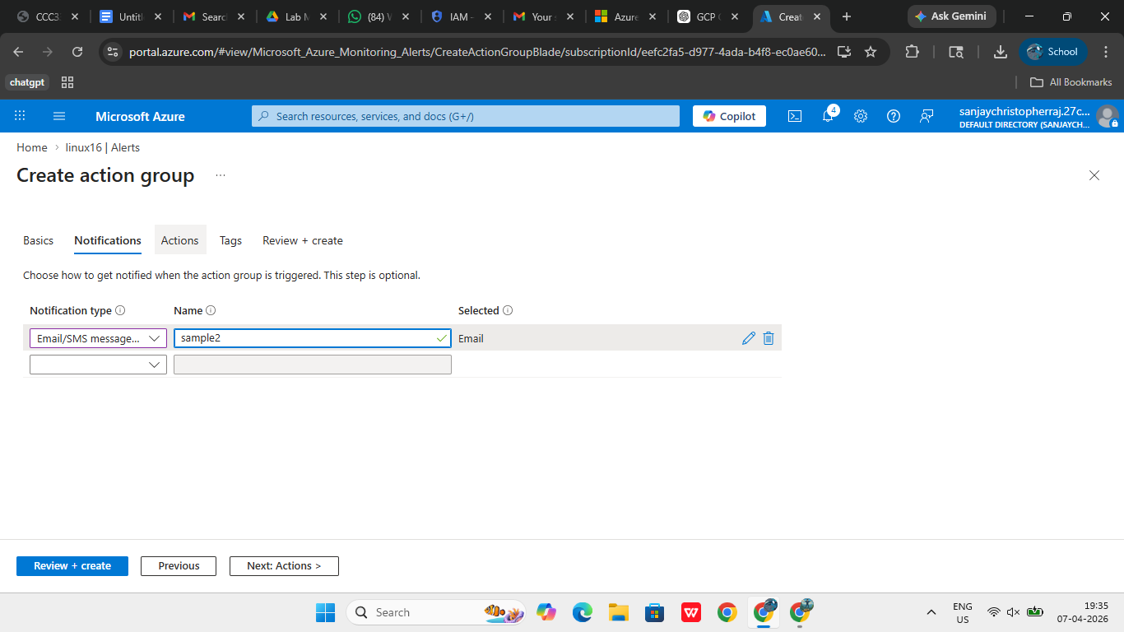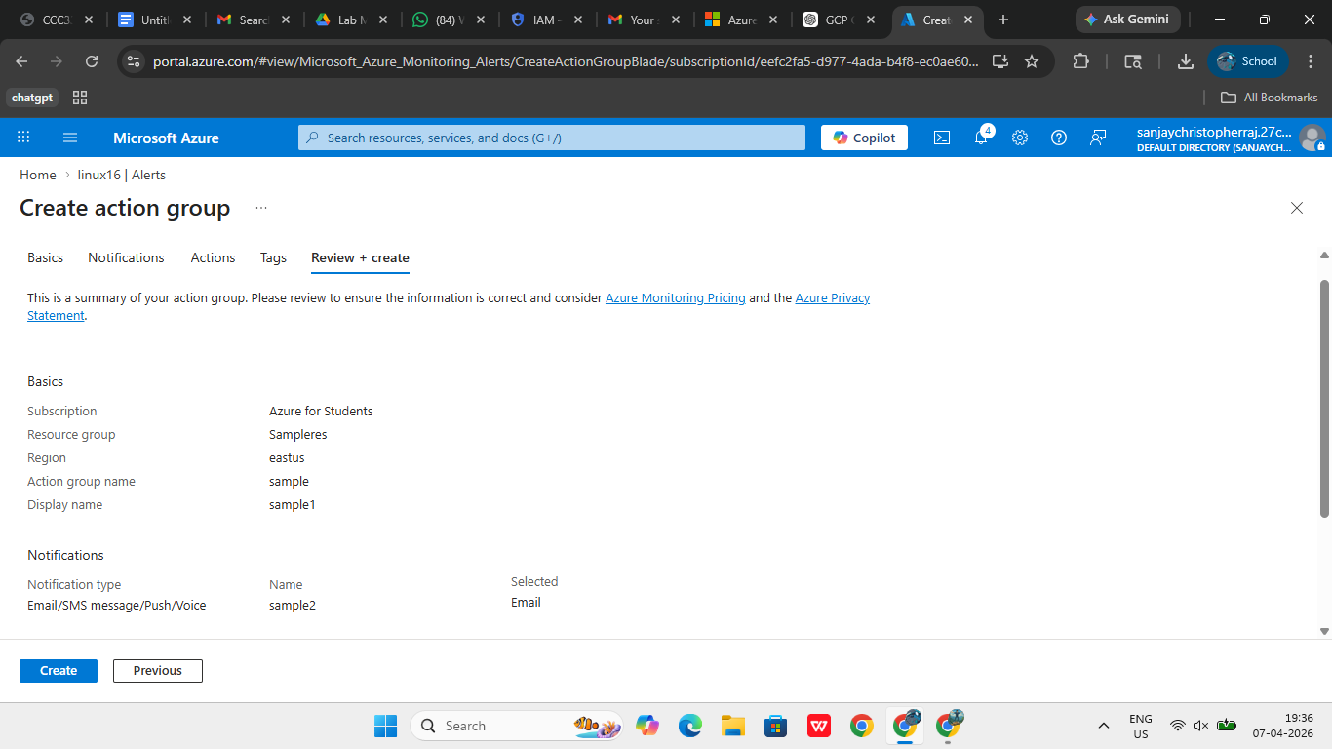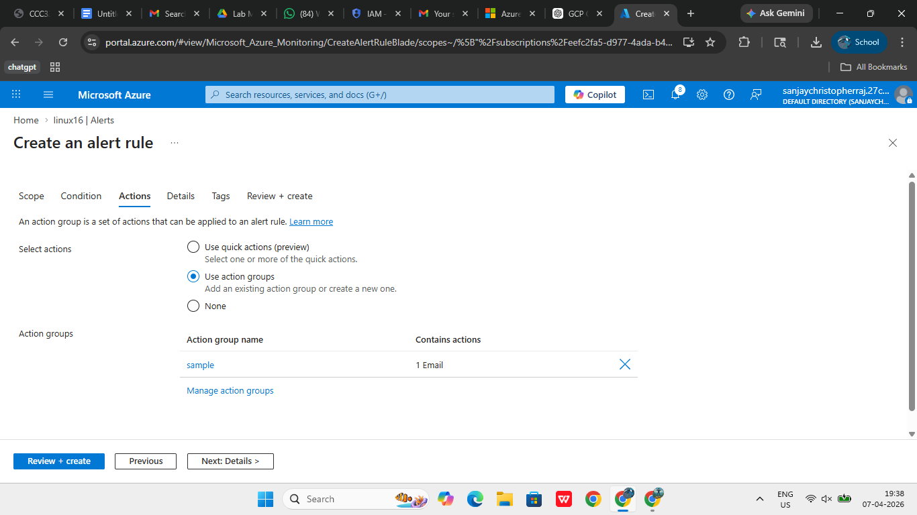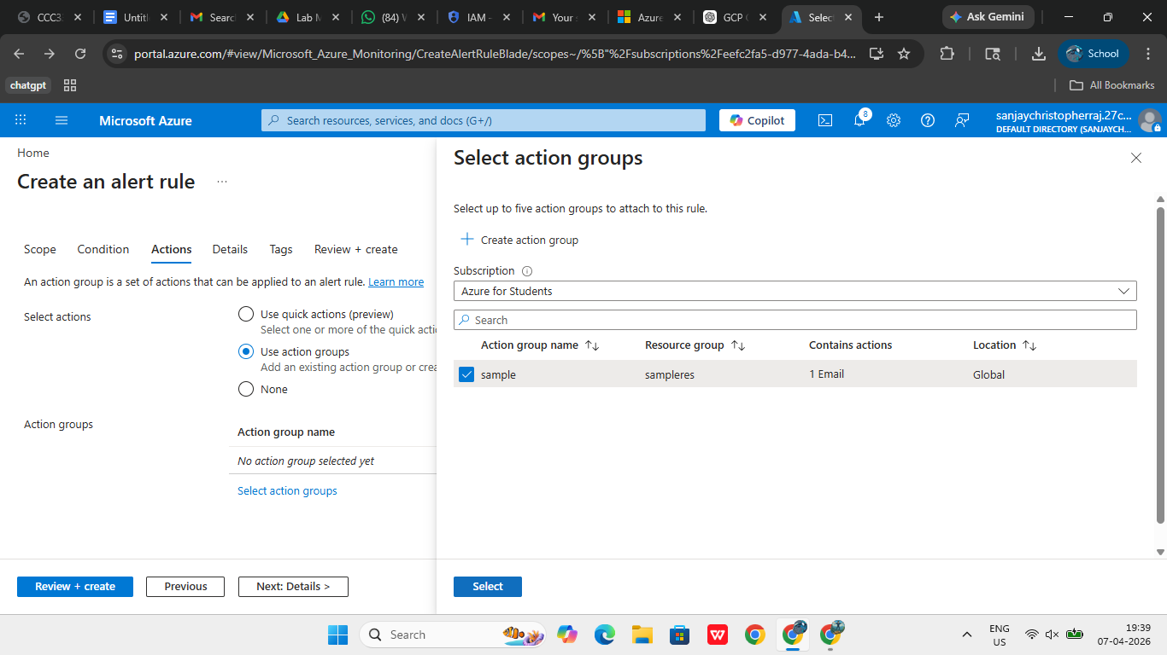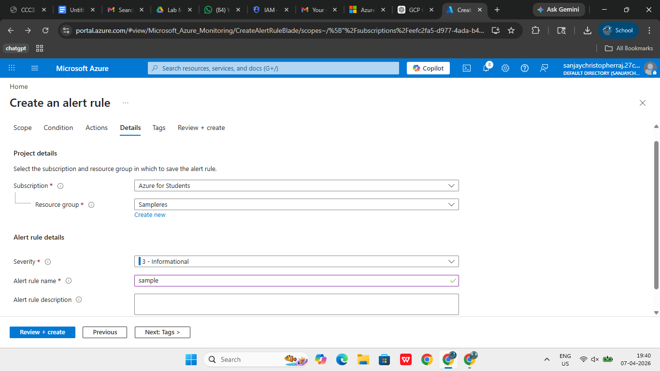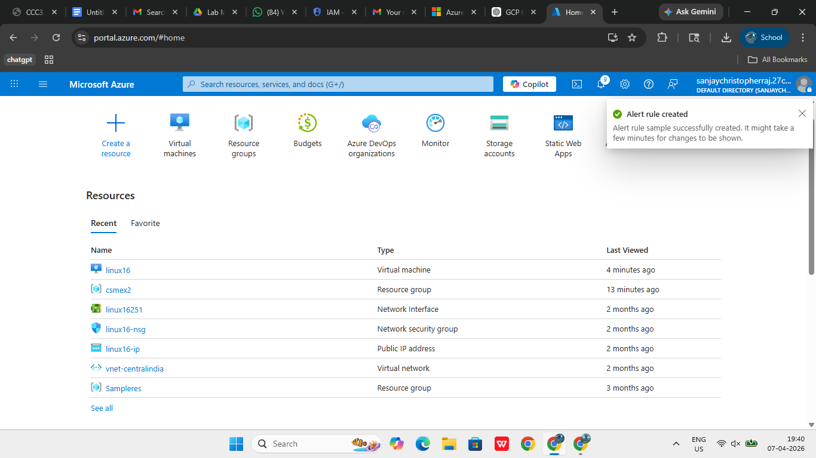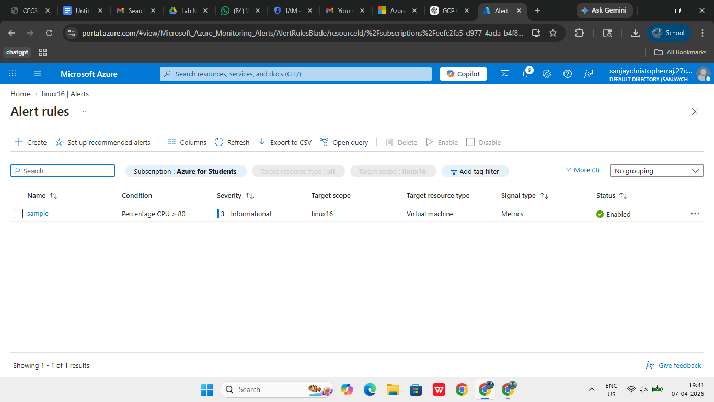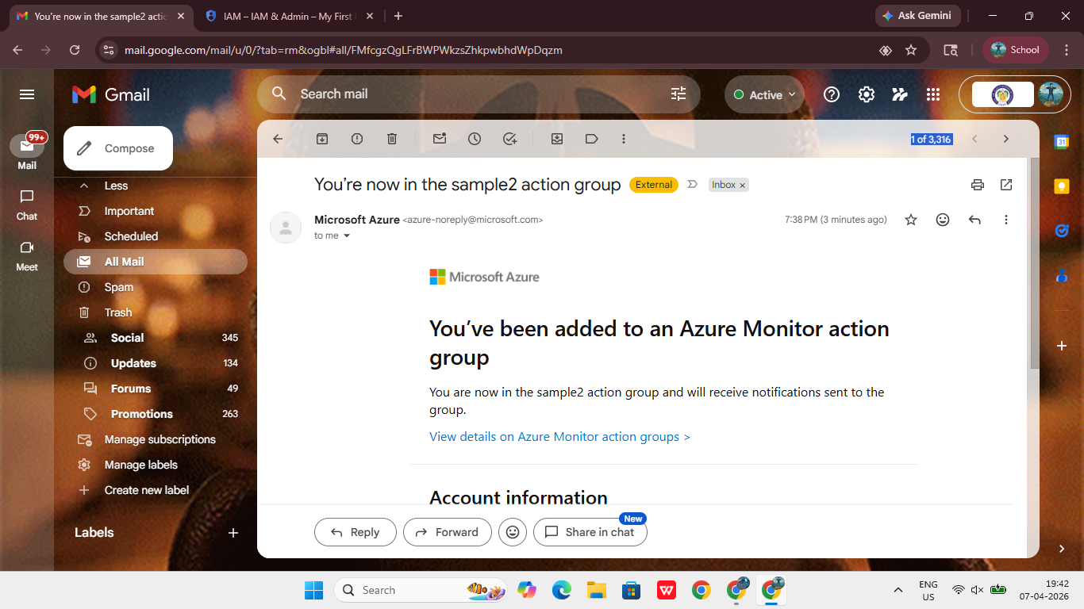

RESULT:
Thus, alerts for monitoring cloud resource usage were successfully created and configured using Microsoft Azure.
EX NO: 4 – CREATION OF BILLING ALERTS FOR CLOUD ORGANIZATION USING MICROSOFT AZURE
DATE:

AIM:
To create billing alerts for the cloud organization to monitor and control expenditure.
PROCEDURE:
Billing alerts are crucial for managing cloud expenses and preventing unexpected charges. Microsoft Azure provides budget-based alerting features that allow users to track spending and receive notifications when predefined limits are reached. In this experiment, billing alerts were configured using Azure Cost Management tools.
The Azure Portal was accessed, and the Cost Management + Billing section was opened. This section provides detailed insights into subscription-level and resource-level spending. To create billing alerts, the Budgets option was selected. Budgets allow users to define a cost threshold for a specific scope such as a subscription or resource group.
A new budget was created by clicking on the “Add” option. The scope was selected, and budget details such as name, amount, and time period were entered. The time period was set to monthly to track recurring expenses. Threshold values were then defined to trigger alerts when the spending exceeded certain percentages of the budget.
Multiple alert levels were configured to provide early warnings and critical notifications. For example, an alert at 50% indicates moderate usage, while an alert at 80% indicates that the budget limit is nearing. Email addresses were added to receive notifications when these thresholds were crossed. This ensures that users are informed in advance and can take corrective actions such as stopping unused resources.
After reviewing the configuration, the budget and alert settings were created successfully. The alerts remain active and continuously monitor spending against the defined budget. Screenshots of the budget creation process and alert configuration were captured for documentation.
This experiment demonstrates how billing alerts help in effective financial management by providing timely notifications and enabling users to control cloud expenses efficiently.



RESULT:
Thus, billing alerts for the cloud organization were successfully created using Microsoft Azure to monitor and control cloud expenditure.
EX NO: 5 – COMPARISON OF CLOUD COST FOR A SIMPLE WEB APPLICATION ACROSS AWS, AZURE AND GCP
DATE:

AIM:
To compare cloud cost for a simple web application across AWS, Azure and GCP and suggest the best platform.
PROCEDURE:
Cloud computing platforms such as Amazon Web Services, Microsoft Azure, and Google Cloud Platform provide similar services for hosting web applications, including compute, storage, and networking. However, their pricing models and cost optimization strategies differ, making cost comparison an important step before deployment.
In this experiment, a simple web application architecture consisting of a virtual machine (compute), storage service, and database was considered. The cost estimation was based on a small configuration typically used for student-level or basic production applications, such as 2 vCPU, 8 GB RAM, and standard storage. Each cloud provider follows a pay-as-you-go pricing model, where users are charged based on actual usage of resources such as compute hours, storage capacity, and data transfer. (Technik GO)
For Amazon Web Services (AWS), services such as EC2 (compute), S3 (storage), and RDS (database) were considered. AWS provides flexible pricing with multiple instance types and discount options such as Reserved Instances and Savings Plans. However, the pricing structure is complex and requires careful monitoring to avoid unnecessary costs.
For Microsoft Azure, services such as Virtual Machines, Blob Storage, and Azure SQL Database were analyzed. Azure provides a similar pricing model but offers advantages such as hybrid benefits and better integration with Microsoft products. Azure pricing is considered moderate and easier to manage compared to AWS in many cases.
For Google Cloud Platform (GCP), services such as Compute Engine, Cloud Storage, and Cloud SQL were considered. GCP provides competitive pricing and offers automatic Sustained Use Discounts, which reduce cost when resources are used continuously without requiring long-term commitment. (CloudInsight)
The cost comparison was carried out by estimating the monthly expenses for similar configurations across all three platforms. It was observed that the cost difference among providers is generally within 10–15% for similar workloads, but discounts and usage patterns significantly affect the final cost. (CostSignals)
Further, cost-benefit analysis was performed by considering factors such as scalability, flexibility, ease of use, and pricing transparency. AWS provides maximum flexibility and global reach, Azure offers enterprise-friendly integration, and GCP provides cost advantages and simpler pricing mechanisms.

Parameter | AWS | Azure | GCP
Compute (2 vCPU, 8GB RAM) | ~$69/month | ~$70/month | ~$52/month
Storage (100GB) | Moderate (S3) | Slightly cheaper | Cheapest
Pricing Model | Pay-as-you-go | Pay-as-you-go | Pay-as-you-go
Discounts | Reserved Instances | Reserved + Hybrid | Sustained Use Discount
Cost Complexity | High | Medium | Low
Overall Cost | Medium-High | Medium | Low

ANALYSIS:
From the comparison, it is observed that GCP generally provides lower pricing for basic workloads, especially due to automatic discounts. Azure offers balanced pricing with better integration features, while AWS provides flexibility but can be costlier if not managed properly. The choice of platform depends on the application requirements, workload type, and budget constraints.

RESULT:
Thus, the cost comparison of a simple web application across AWS, Azure, and GCP was successfully performed, and it is concluded that Google Cloud Platform is the most cost-effective option for small-scale applications, while Azure and AWS provide additional enterprise features and flexibility.

