**DSCI 5360**

**DATA VISUALIZATION FOR ANALYTICS**

**PROJECT REPORT**

**on**

**SUICIDE RATES**

**1985-2016**

**By**

**Prathima Nuthalapati**

**11410397**

**1.INTRODUCTION:**

***1.1 DATA SOURCE:***

The Dataset used for this project was taken from Kaggle. All the data are stored in a comma separated file with “.csv” as its extension. The dataset gives overview of suicide rates across the globe from 1985-2016. It contains 27820 rows and 10 columns. In this analysis, i provide information on suicide rates using the variables: Country, Year, Sex, Age, Suicides_no, Population, Suicides/100k pop, GDP_for_year, GDP_per_capita, HDI for year and Generation.

*Link*: <https://www.kaggle.com/russellyates88/suicide-rates-overview-1985-to-2016>

This dataset contains the following Columns:

* Country **:** Indicates Country name. Country of record data
* Year **:** Indicates Year of record data.
* Sex  **:** Indicates sex (Male or Female).
* Age **:** Represents the Suicide age range. Ages divided in to six categories.

[‘5-14 years’, ’15-24 years’ , ‘25-34 years’, ‘35-54 years’, ‘55-74 years’, ‘75+ years’]

* Suicides_no **:** Number of suicides
* Population **:** Population of the sex, in the age range, country and year.
* GDP_for_year **:** GDP of the country in the year
* GDP_per_capita **:** Ratio between the country’s GDP and its population
* Suicides/100k pop **:** Number of suicide deaths per 100k individuals in a population
* HDI_for_Year **:** Human Development Index, an index that measures life

Expectancy, income and education.

* Generation **:** Based on age grouping average, it has 6 different categories

[‘Generation Z’, ‘ Generation X’, ‘Boomers’, ‘Silent’, ‘Millenials’, ‘ G.I. Generation’]

In addition to this dataset, I have also used the following dataset to elaborate my analysis on leading cause/methods of suicides- Firearms Suicide( 1990-2017) and Pesticide poisoning(2014) from Data.org.

<https://ourworldindata.org/suicide#suicide-is-a-leading-cause-of-death-especially-in-young-people>

The Firearm suicide dataset contains the following Columns:

* Country **:** Indicates Country name. Country of record data
* Year **:** Indicates Year of record data.
* Deaths **:** Self harm by Firearm( Deaths per 100k)

The Pesticide Poisoning suicide dataset contains the following Columns:

* Country **:** Indicates Country name. Country of record data
* Year **:** Indicates Year of record data (2014).
* Share of deaths from pesticide poisoning (%) : Number of Deaths(%)

***1.2 HYPOTHESIS:***

* Who tend to commit suicide more(Generation)?
* Does GDP_per_Capita have any influence on suicide rates?
* Visualize the trend of any one major leading suicide method globally ?
* Which year has the highest suicide deaths by pesticide poisoning?
* Over the years has the number of suicide rates increased or decreased? Which Year has highest rate?
* Global Impact-Suicide rate(Deaths per 100k)
* Which gender has highest suicide rate?
* Country with High Suicides and Low suicides before 2010.
* Number of suicides in Russian Federation for 35-54 age group?

***1.3 TOOLS USED:***

* Tableau 2019.4 version

***1.4 OUTLINE:***

Suicide is one of the major leading causes of deaths. Close to 800,000 people die due to suicide every year, which is one person every 40 seconds. Effective and evidence-based interventions can be implemented at population and individual levels to prevent suicide and suicide attempts. In this project I would like to visualize suicide rates globally over a period of time. Because this helps in understanding on how to bring new laws to reduce the suicide rates and furtherly to enhance already existed laws used in preventing suicide rates.

**2. ANALYSIS:**

The Visualization methods I used for my analysis are:

* Choropleth Mapping
* Pie chart
* Stacked column Bar chart
* Tree Map
* Line Chart
* Bubble Chart
* Box Plot
* Area Chart
* Bar Chart

***2.1 STORY ANALYSIS:***

* Which gender has highest number of suicides

The Pie chart describes the number of suicides globally for both men and women. Globally, suicide deaths in men are more than twice as high as women. For instance, 2000 has the highest number of suicides in men with 200,578 which is more than thrice of that of women 55,254. The difference in suicide no. for males and females can be explored by hovering to the filter(year). Selecting particular year will show us the suicide no. for both men and women. In this visualization I have used dimension ‘sex’ and measures ‘suicides no’

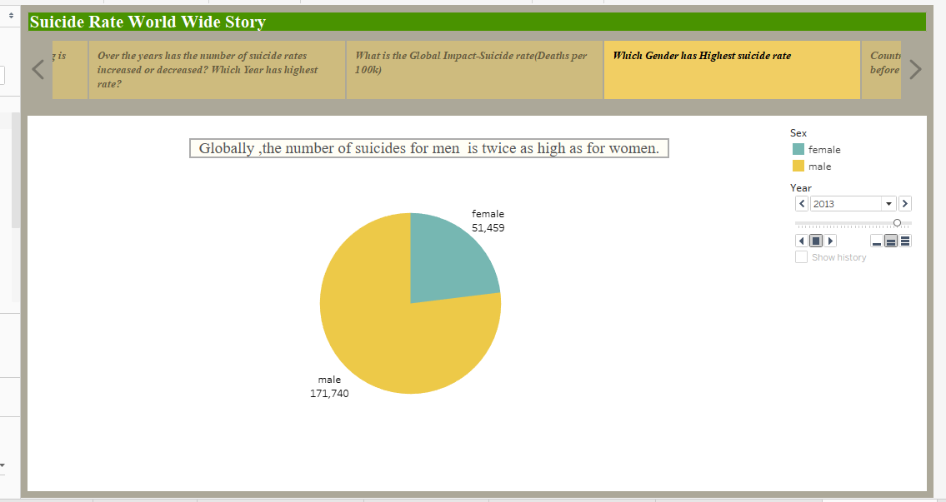

* Over the years has the number of suicide rates increased or decreased? Which Year has highest rate?

The Line chart describes the suicide rates(Deaths per 100k) over a period of time. From this I can say that the suicide rates have been decreased. There was an increasing trend in suicide rates from1992 to 1996 however this went on decreasing for next period of time .In 1995 we have highest rate with 3090 per 100k.I have used dimensions ‘year’ and measures ‘suicides rate(deaths per 100,000).

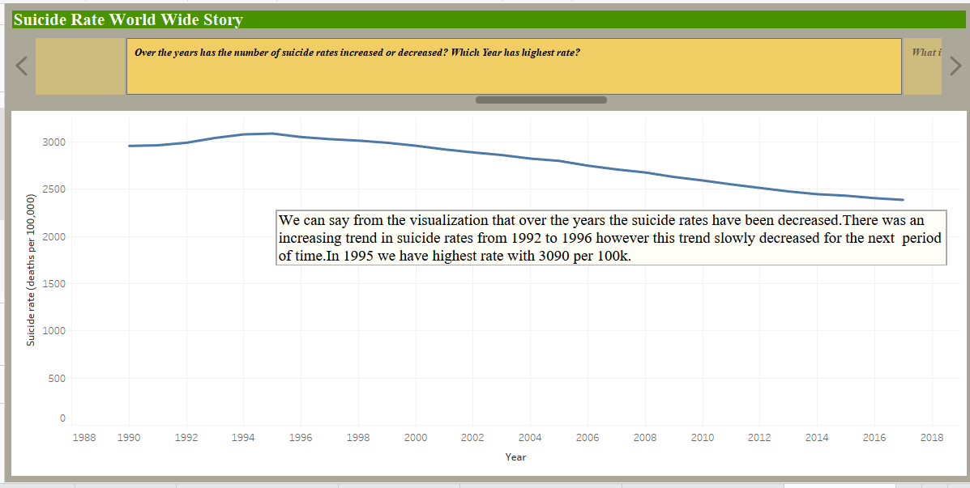

* Who tend to commit suicide more(Generation)?

The Pie chart describes the suicide rate (deaths per 100k) with respect to generation. From this , I can say that high number of suicides are observed in the generation ‘Silent’ that is people with age group of 35-54(adults) from 1990 followed by ‘Bloomers’ that is with age group 25-34(Teenagers).In 1995, the highest rate was for G.I. Generation(75+) which later on decreased rapidly. From this we can say that adults and teenagers tend to commit suicide more. I used dimensions ‘Generation’ and measures ‘suicides/100k’.Also used pages(year) to visualize for different years about the changes in suicide rate in generation.

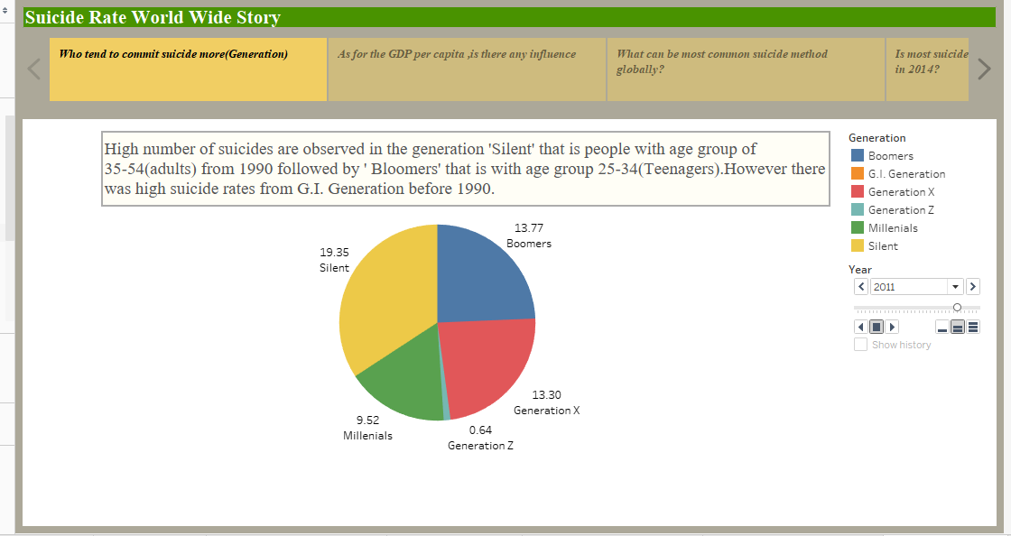

* Does GDP_per_Capita have any influence on suicides?

The Area chart describes the changes in the number of suicides with respect to GDP_per_capita. I can say that overall as the gdp_per_capita increases there is decrease in number of suicides. However at a point nearly from 25k suicides tend to increase and has a sharp fall later. I believe that furthermore investigation is needed to know how these both variables are correlated by considering other factors.

I used measures ‘GDP_per_capita’ and ‘suicides no’. Hovering to filter gives changes in rate for different years.

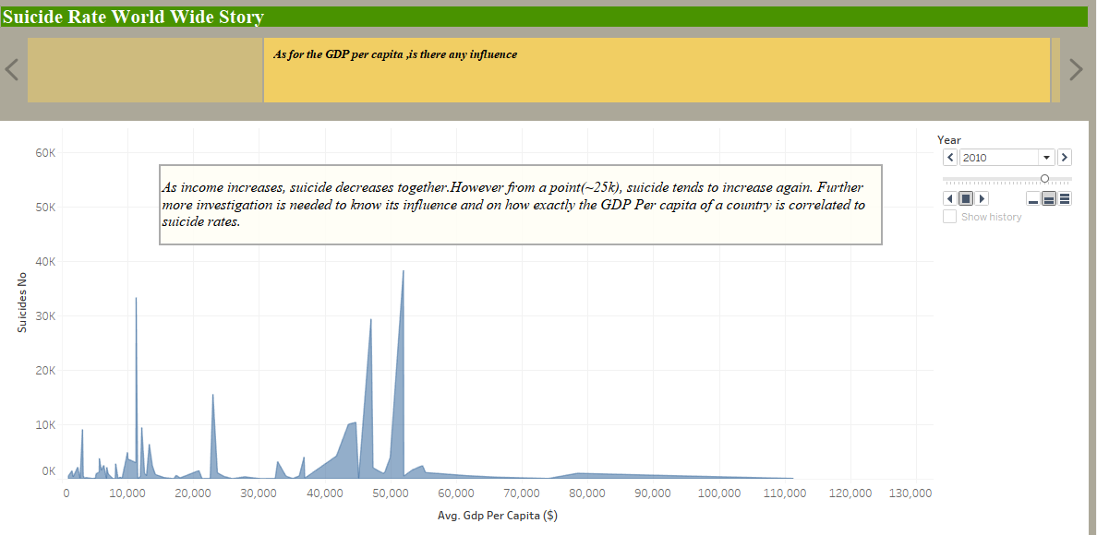

* Visualize the trend of any one major leading suicide method globally ?

The Bubble chart describes the Firearm suicide rates(Deaths per 100k).This is one of the most common suicide method globally. Overall, Greenland has highest firearm suicide rate followed by United states having second highest rate. Highest rate was in 1991 with 28 deaths per 100k in Greenland which later on decreased slowly to 14 deaths per 100k in 2017.

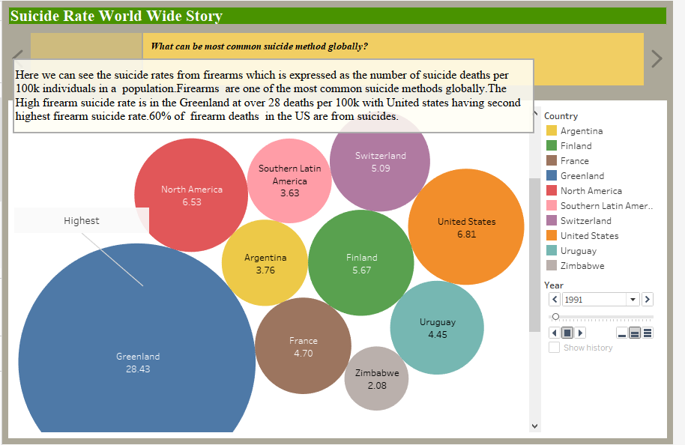

* Which year has the highest suicide deaths by pesticide poisoning?

One of the most common methods of suicide is deliberate poisoning from pesticides. The box plot describes the suicide deaths from pesticide poisoning in 2014.30% of suicides globally were the result of pesticide poisoning most in low to middle income countries in 1990s and 2000s.13.7% around one in seven suicides in the world were the result self-poisoning from pesticides in 2014.This was approximately 110,000 deaths. It was higher across western pacific and less common across Europe.

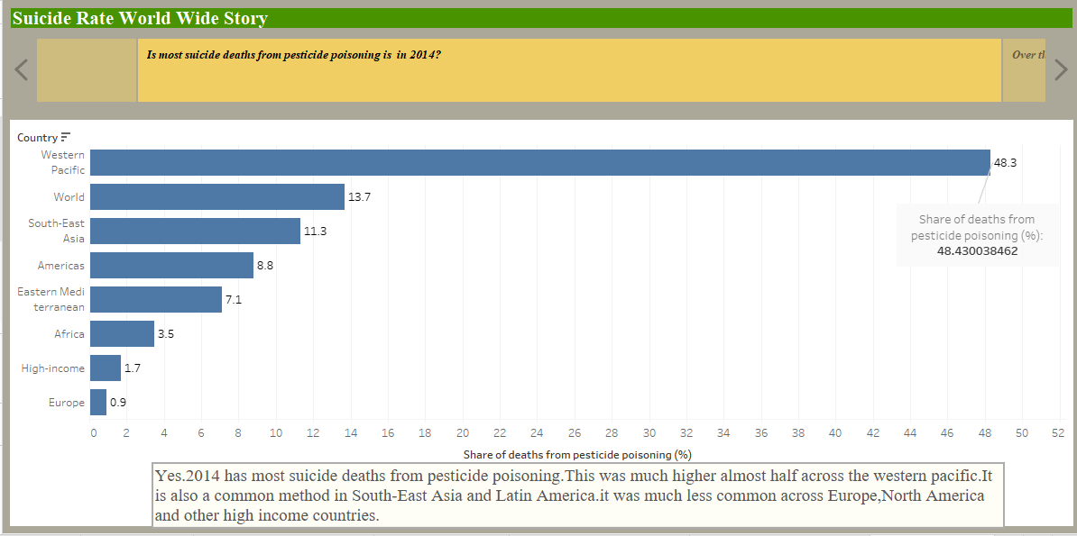

* Country with High Suicides and Low suicides before 2010.

The tree map describes the High and Low number of suicides over a period of time. Russian Federation has high number of Suicides from decades followed by United States until 2009.However this trend was reversed after 2009.Albania being the lowest with zero percent suicide rate over a period of time.

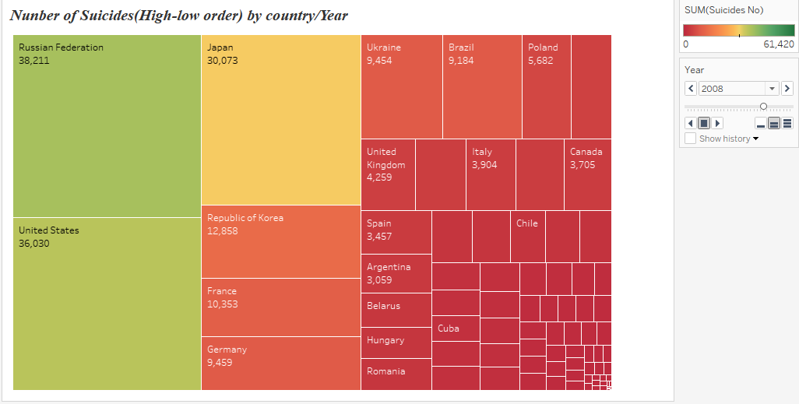

* Number of suicides in Russian Federation for 35-54 age group?

The Stacked column bar chart gives the number of suicides in top 10 countries for different age groups. For Russian federation the high number of suicides was in adults (35-54) with 479,140 deaths.

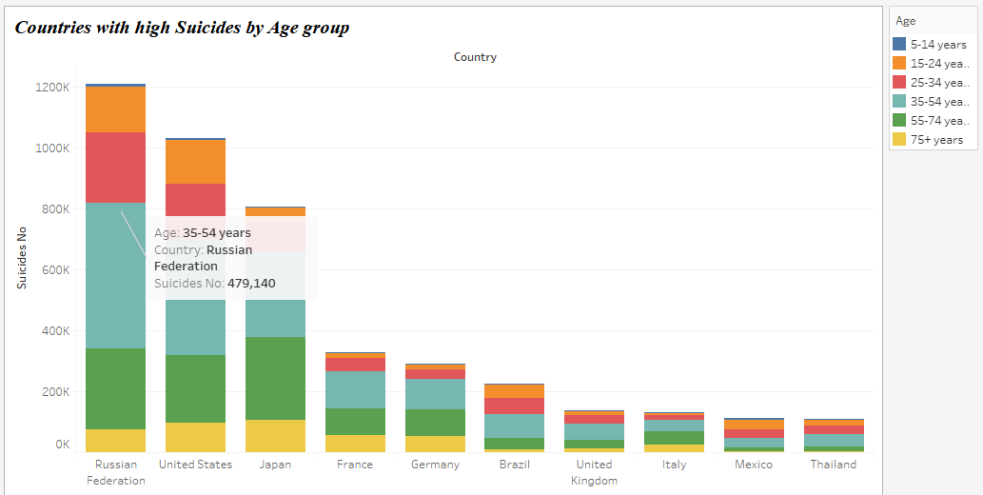

* Global Impact-Suicide rate(Deaths per 100k)

The choropleth map describes the suicide rates globally. Nearly 800,000 people die from suicide every year. This is one of the leading causes of death in young generation and adults. Highest suicide rate was over 51 per 100,000 for Greenland in 2016 which is 78 per 100,000 in 2000 and followed by Russia with 25 per 100,000 in 2016.This shows that though the rate was decreased over a period of time, but still the suicide deaths are happening which reminds us about the actions need to take by the government bodies to completely make suicide rate zero percent globally.

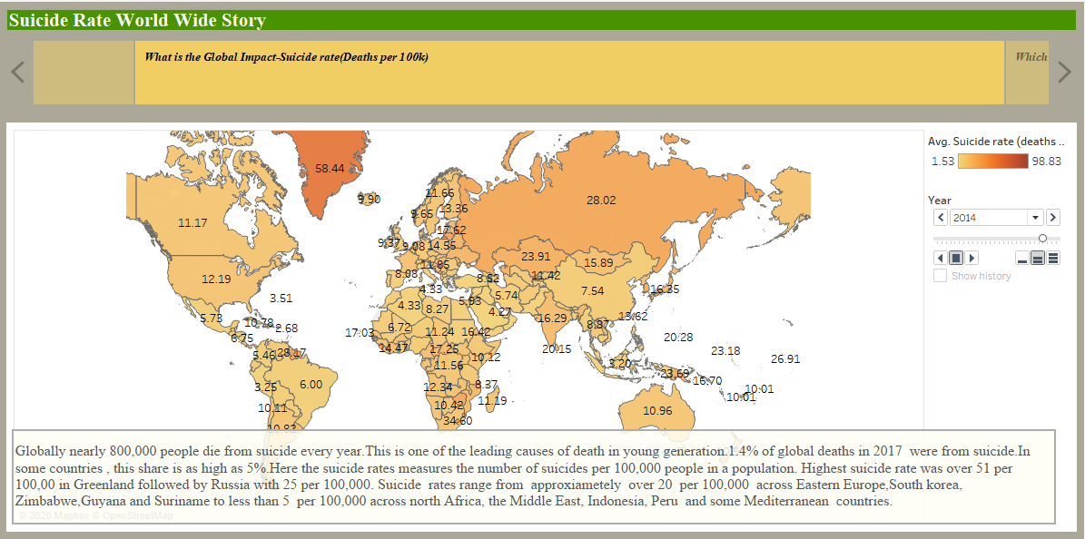

**3. BUSINESS IMPLICATIONS:**

From the analysis, I see that in 1990s the number of suicides increased greatly. Moreover, the amount seems to have grown in an expected and slightly declining way in recent years, perhaps due to the most diverse suicide prevention campaigns. This gives hope that conducting campaigns at places that have high suicide rates will drastically reduce this amount to zero percent in the future globally. Also I observed that adults and teenagers especially men are committing more suicides which can be of various factors. For instance, this can be because of depression caused by economic recessions, health, sexual abuse, social isolation, personal life and other mood disorders. Over the years the suicide rates in men are much higher than in women. These insights can be taken by the government in bringing more laws in terms of health care and helping low-household income group people with more schemes to run their day to day life and by conducting awareness programs .In this way, suicide rates can be reduced globally in the future. More causes of suicides are by firearms and pesticide poisoning. This can be furtherly reduced in future by implementing strict laws on usage of guns and drugs by completely banning them.

These visualizations give an idea to focus on countries that has the highest suicide rate not only for the respective government but also for the individual on how to contribute to their nation. For a nation to grow , the change should come from an individual first. This analysis on suicide rates will help the government authorities to inform to the public about the suicide rates with the help of media and bringing in awareness among the individuals about their responsibility. This helps the protection system like police to tighten the security in those areas that has high suicide rates. Also educational institutions should educate students in school age , so the change can be seen in future generations.

**4. CONCLUSION:**

From the analysis I can conclude that though the suicide rates have been decreased year by year but still it accounts for nearly 800,000 deaths per year globally. The suicide rates for men are much higher than women and it is clear that this suicide rate was more in the age group 35-54 in men and followed by Teenagers. Earlier this rate was more in G.I.Generation (75+) in 1990s which was later drastically reduced. Number of suicides reduced drastically from 1990 by 2016 as the average GDP_per_capita increases. This shows the economic impact of country has on suicide rates. Looking at the annual suicide deaths from firearms across the world tells that Greenland has the highest firearm suicide rate and 60% of firearms deaths in US are from suicides. This warns us that the respective government bodies should strive forward in reducing the suicide rates by implementing laws and bringing awareness. 30% of suicides globally were the result of pesticide poisoning most in low to middle income countries. This was much higher across western pacific with 48% of suicide rate by pesticide poisoning in 2014. Knowing the differences in risk among the age groups is important for suicide prevention, because teenagers and adults have the highest rate of suicide attempts.