**Screen display:**

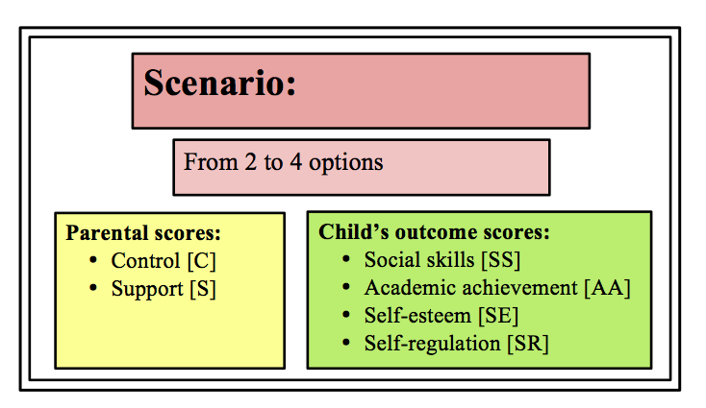

**Scenario and scores:**

Changes in score can be in any combination

Scores are arbitrarily set so the players will be able to see the changes after each decision made, and the scores will be displayed as status bars to avoid this confusion

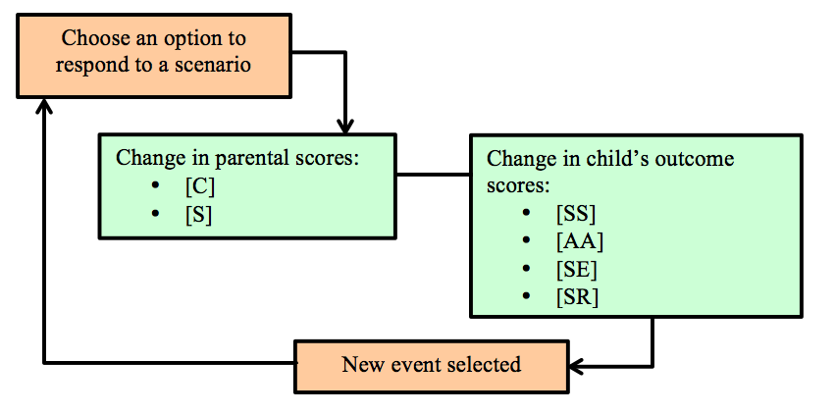

**Stages:**

|  |  |  |
| --- | --- | --- |
|  | **Stage 1:** Childhood | **Stage 2:**  Adolescence |
| Child’s outcome scores: | * Social skills * Academic achievement * Self-esteem * Self-regulation | * Social skills * Academic achievement * Self-esteem * Self-regulation |
| Starting scores | All 0 | All scores are carried forward from stage 1 |

**Scenario set:** 4 starting events to get the child’s outcome scores + 16 childhood IF events + 16 adolescence IF events.

Player plays 8 IF events out of the 16-event set

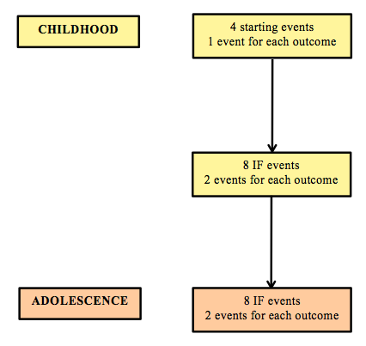

There is also the child’s reaction after the player choses an action.

* Authoritarian style: the child: [“follows the order”, “upsets”]
* Authoritative style: the child: [“says I love you”, “becomes more cheerful”, “says thanks”]
* Permissive style: the child: [“says thanks”, “does as they please”]
* Neglectful: the child: [“shut themselves in their room”]

C – control S – support

Av – Authoritative An – Authoritarian

P – Permissive N – Neglectful

STAGE 1: CHILDHOOD

Starting Events

*Starting Event 1:* Your child wants more snack

[An] – No, they already have their portion for the day +C +SR

[Av] – Give them some healthy options to choose from +C +SR

[P] – Give them anything they want –C –SR

[N] – Leave them be –C –SR

*Starting Event 2:* Your child grabs a toy from a friend

[An] – Order them to return the toy immediately +C +SS

[Av] – Tell them that their friend is playing with it at the moment, and they can take turn playing +C +SS

[P] – Your child should be able to play with it when they want to –C –SS

[N] – Not intervene –C –SS

*Starting Event 3:* Your child is having difficulty with reading and spelling

[An] – Tell them how disappointed you are and get them to practice more –S +AA

[Av] – Get a slightly easier book series to read to encourage them, and then the one at their level +S +AA

[P] – Assure them that they are doing great +S –AA

[N] – They will learn sooner or later –S –AA

*Starting Event 4:* You and your child are going to the park

[An] – Dress them how you want them to look, even if your child wants to wear something else –S –SE

[Av, P] – Let them decide what they want to wear +S + SE

[N] – On a 2nd thought, they can go to the park themselves –S –SE

IF events

* *IF events for SS:*

*IF low SS:*

*SS event 1:* Your child doesn’t know how to join in the group at the park

[An] – Order them to ask the group to join in –S +SS

[Av] – Acknowledge that you understand how difficult it is, but encourage them to go and talk to the other children +S +SS

[P] – Assure your child that they are the best, so the others will invite them eventually +S –SS

[N] – What’s big deal? They will make friends eventually –S –SS

*SS event 2:* Your child has not made any friends at school

[An] – Not a big problem. They can focus more on study –S –SS

[Av] – Talk to them to come up with how to make friends with their classmates +S +SS

[P] – Reassure them they are doing fine +S –SS

[N] – It’s just children’s thing. No need to intervene –S –SS

*IF high SS:*

*SS event 3:* Your child led the a group of other children and graffitied a wall in the school

[An, Av] – Reprimand them +C –SS

[P, N] – Laugh it off–C –SS

*SS event 4:* Your child wants to invite friends for a sleepover

[An] – No, that’s against the house rules –S +C –SS

[Av] – Tell them you are happy for have their friends stay over, but set a light out time so they do disturb the neighbour +S +C +SS

[P] – Of course they can and prepare everything so you can indulge them with +S –C +SS

[N] – No, too troublesome! –S –C –SS

* *IF events for SR:*

*IF low SR:*

*SR event 1:* Your child is throwing a tantrum

[Av] – Find out why and talk it out +C +S +SR

[An] – Tell them to shut up and if they don’t punish them +C –S –SR

[P] – Do or buy anything they want to keep –C +S –SR

[N] – Ignore –C –S –SR

*SR event 2:* Your child makes a fuss in a store and tries to get you to buy the toy they want

[An] – Reprimand them and go to the till +C +SR

[Av] – Tell them that if they behave themselves then they can get it next time +C +SR

[P] – Give them anything they want –C –SR

[N] – Ignore their fuss and take them out of the store –C –SR

*IF high SR:*

*SR event 3:* Your child is playing a board game with other children. They manage to focus on the game while the others are singing to distract them

[An] – Their concentration is as expected +C +SR

[Av] – Tell your child later that they did a great job +C +SR

[P] – Tell the other children off –C –SR

[N] – Ignore –C –SR

*SR event 4:* Your child put away all their toys before meal without being told to do so

[An] – doTell them they have to do this everytime +C +SR

[Av] – Praise them and encourage them to continue to do so +C +SR

[P] – Tell them how amazing they were but you would not mind if they do not tidy up –C –SR

[N] – So? –C –SR

* *IF events for AA:*

*IF low AA:*

*AA event 1:* Your child’s progress is behind the class

[An] – Scold them and try to get them to learn more to catch up with the class –S +C –AA

[Av] – Encourage the child to study and assist them when needed +S +C +AA

[P] – Ask the teacher to slow down +S –C –AA

[N] – They will catch up eventually and schools not important anyway –S –C –AA

*AA event 2:* Your child doesn’t want to go to school

[An] – Take them to school by force +C –AA

[Av] – Ask them why to help them and then encourage them to go +C +AA

[P] – There is no harm in letting them skipping once in a while –C –AA

[N] – It’s fine –C –AA

*IF high AA:*

*AA event 3:* Your child’s work got the highest score in the class

[An] – That is what I expect –S –AA

[Av] – Praise them and encourage them to try their best next time as well +S +AA

[P] – Give them anything they request as their reward +S +AA

[N] – Oh, okay –S –AA

*AA event 4:* Your child won a race

[An] – That is what I expect –S –AA

[Av] – Praise them and encourage them to try their best next time as well +S +AA

[P] – Give them anything they request as their reward +S +AA

[N] – Oh, okay –S –AA

* *IF events for SE:*

*IF low SE:*

*SE event 1:* Your child does not want to join any of the after school sports teams

[An] – Just pick the one you like for them to join –S –SE

[Av] – Encourage them to try a few to see if they find anything fun +S +SE

[P] – They don’t have to do that if they do not want to –S –SE

[N] – No big deal –S –SE

*SE event 2:* Your child said “I’m too stupid to do this assignment”

[An] – Tell them they need to study more –S –SE

[Av] – Tell them not to say that but ask what they don’t understand instead +S +SE

[P] – Assure them that they are the smartest, and the assignment maybe too difficult +S –SE

[N] – They probably are … –S –SE

*IF high SE:*

*SE event 3:* Your child did not make the official football team but continued to practice to get in the next selection match

[An] – Tell them they will get better result the harder they try –S –SE

[Av] – Let them know you are proud of their effort and perseverance +S +SE

[P] – Tell them they play amazingly +S –SE

[N] – Well, whatever –S –SE

*SE event 4:* Your child tries to solve a hard homework question on their own. When they can’t figure out, they ask for your help

[An] – Help and tell them off for not trying hard enough –S –SE

[Av, P] – Acknowledge their effort, help and encourage them to continue +S +SE

[N] – Tell them not to bother you –S –SE

STAGE 2: ADOLESCENCE

* *IF events for SS:*

*IF low SS:*

*SS event 1:* Your child has argued with a friend at school and sulking around in their room

[An] – Tell them you don’t like seeing them looking like that and ask them to study –S –SS

[Av] – Ask them for the reason, and see what to do next to make up with the friend +S +SS

[P] – Your child is right, and buy them whatever to lift up their mood +S –SS

[N] – Leave them alone and go out –S –SS

*SS event 2:* You found out your child got made fun off at school

[An] – Order them to ask to join in with other classmates –S –SS

[Av] – Encourage them to initiate conversation with some classmates +S +SS

[P] – Argue with the teacher for letting this occur and tell them to make other students friendlier to your child +S –SS

[N] – Leave them be –S –SS

*IF high SS:*

*SS event 3:* Your child wants to go out with some friends till late at night

[An] – No –S –SS

[Av] – Find out who the friends are, where they go and find a compromised curfew time +S +SS

[P] – Of course they can +S +SS

[N] – They can take care of themselves –S +SS

*SS event 4:* Your child was voted as class leader

[An] – You expect them to do a proper job –S +SS

[Av, P] – Tell them you are proud +S +SS

[N] – They can take care of themselves –S +SS

* *IF events for SR:*

*IF low SR:*

*SR event 1:* The teacher informed you that your child is bullying other classmates

[An] – Ground them and tell them to not do that again +C +SR

[Av] – Discuss with them about their bullying +C +SR

[P] – The teacher is probably over-reacting –C –SR

[N] – Not bother –C –SR

*SR event 2:* The teacher informed you that your child hit another child

[An] – Ground them for using violence +C +SR

[Av] – Try to find out why and discuss alternative solutions +C +SR

[P] – The other child must have done something. Your child is not violent –C –SR

[N] – Why bother, it’s just a phase –C –SR

*IF high SR:*

*SR event 3:* Your child decided not to go out in order to prepare for an exam

[An] – You wouldn’t let them go anyway –S +SR

[Av, P] – Praise them for their choice +S +SR

[N] – Do not care and go out –S –SR

*SR event 4:* Your child told you that they did not cheat during a test although their classmates did

[An] – Scold them for the average result –S –SR

[Av, P] – Praise them for not doing what the others did +S +SR

[N] – Do not care –S –SR

* *IF events for AA:*

*IF low AA:*

*AA event 1:* Your child comes back with a bad test score

[An] – Punish and enforce their study time till they achieve better result +C +AA

[Av] – Find out why they did badly –C +AA

[P/ N] – Not a big deal anyway –C –AA

*AA event 2:* Your child skipped school

[An] – Ground them and make sure they go into the school in the morning +C –S +SR

[Av] – Find out why and make sure to go to school the next day +C +S +SR

[P] – Just a teenage thing –C +S –SR

[N] – Why bother –C –S –SR

*IF high AA:*

*AA event 3:* Your child brings back a good test result

[An] – Demand them continue the performance or even better result –S –AA

[Av/ P] – Praise them +S +AA

[N] – Don’t care –S –AA

*AA event 4:* Your child won a competition

[Av/ P] – Praise them +S +AA

[An] – That’s expected –S –AA

[N] – Don’t care –S –AA

* *IF events for SE:*

*IF low SE:*

*SE event 1:* You find out your child is being bullied

[An] – Scold your child for not standing up for themselves –S –SE

[Av] – Console them and try to work with the school to see if thing improves +S +SE

[P] – Get the school to punish the other children, and change school if necessary +S –SE

[N] – Don’t care –S –SE

*SE event 2:* You find out your child engaged in self-harm

[An] – Scold them for doing something so stupid –S –SE

[Av/ P] – Talk to them and get a counsellor/ psychotherapist to help +S +SE

[N] – The school can help with that –S –SE

*IF high SE:*

*SE event 3:* You found out that your child stand up for a classmate being bullied

[An] – You are proud, but there is no need to let your child know that –S –SE

[Av/ P] – Let them know you are proud of them for standing up for their friends +S +SE

[N] – Oh, ok –S –SE

*SE event 4:* Your child’s best friend got into the sport team but your child didn’t make it. Although they was feeling upset, they were still happy for their friend and congratulated them

[An] – Tell them you are disappointed that they did not make the team–S –SE

[Av/ P] – Praise them for how they reacted +S +SE

[N] – Such a trivial matter –S –SE

**Desired outcome for each parenting styles:**

|  |  |  |  |  |
| --- | --- | --- | --- | --- |
|  | Authoritative | Authoritarian | Permissive | Neglectful |
| Academic achievement | High | Average | Low | Low |
| Social skill | High | Average | Low | Low |
| Self esteem | High | Average | Low | Low |
| Self regulation | High | Average | Low | Low |