1. Download the meta and the review dataset from link : http://jmcauley.ucsd.edu/data/amazon/links.html

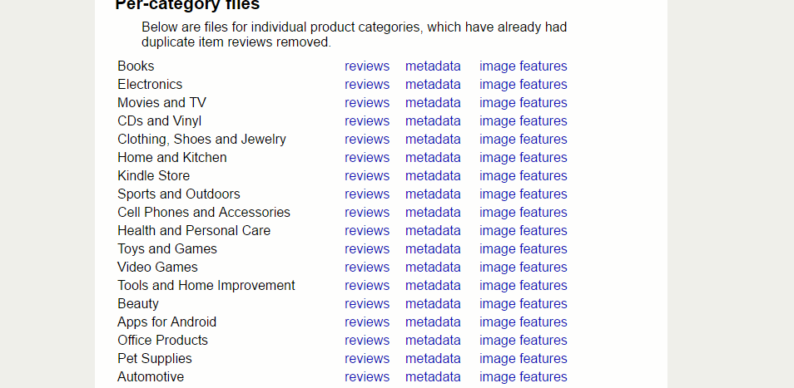

1. Extract the data outside using Winrar.
2. With extracted data open in EMeditor. You can download the Emeditor using this link : <https://www.google.com/url?sa=t&rct=j&q=&esrc=s&source=web&cd=2&cad=rja&uact=8&ved=0ahUKEwjj4Mn3jtXLAhXTySYKHZJQCmgQjBAIJTAB&url=https%3A%2F%2Fwww.emeditor.com%2Fdownload%2F&usg=AFQjCNEbmyg9xhGLdkBf2RDZBn8dfxxZwA>
3. Split the document as given below :

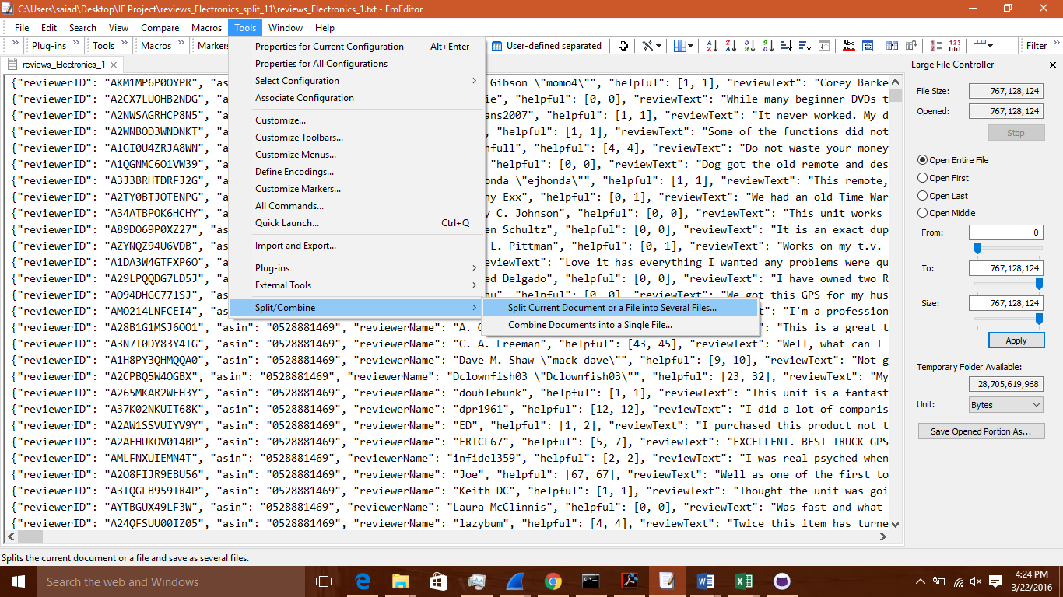

Split it into 10000 lines per document.

1. Now do text analysis for each document using I-python