ItemCatalog Application

**Home Screen:** homepage displays all current categories with the latest added items.

<http://localhost:5000/>

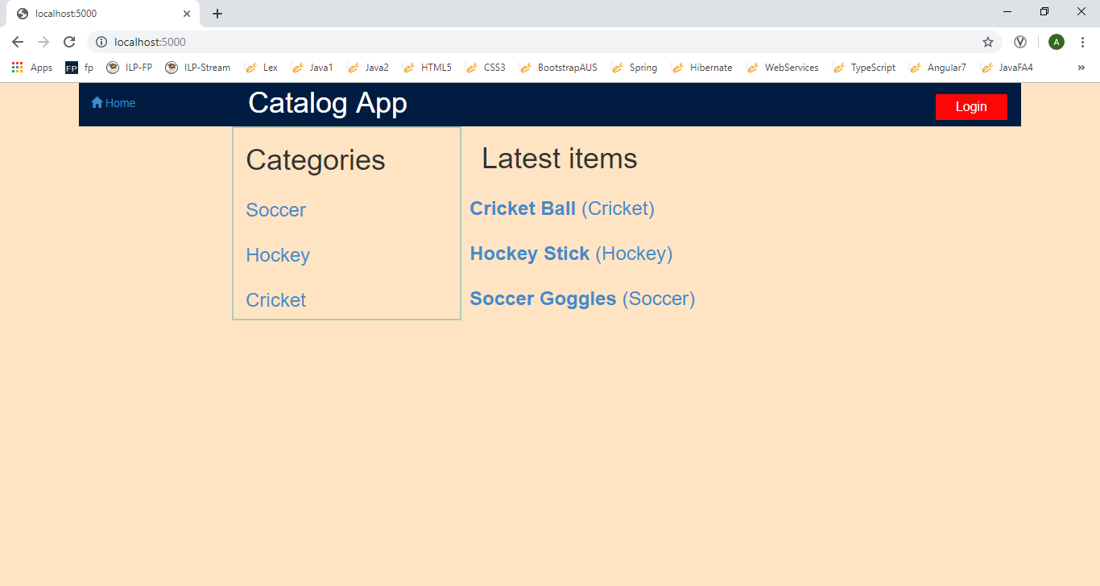

Selecting a specific category shows you all the items available for that category.<http://localhost:5000/catalog/Soccer/items>

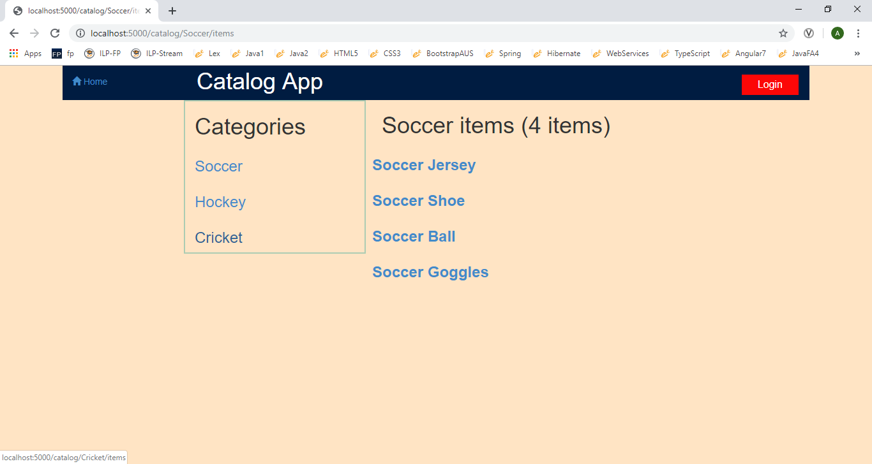

Selecting a specific item shows you specific information about that item.<http://localhost:5000/catalog/Soccer/Soccer%20Jersey>

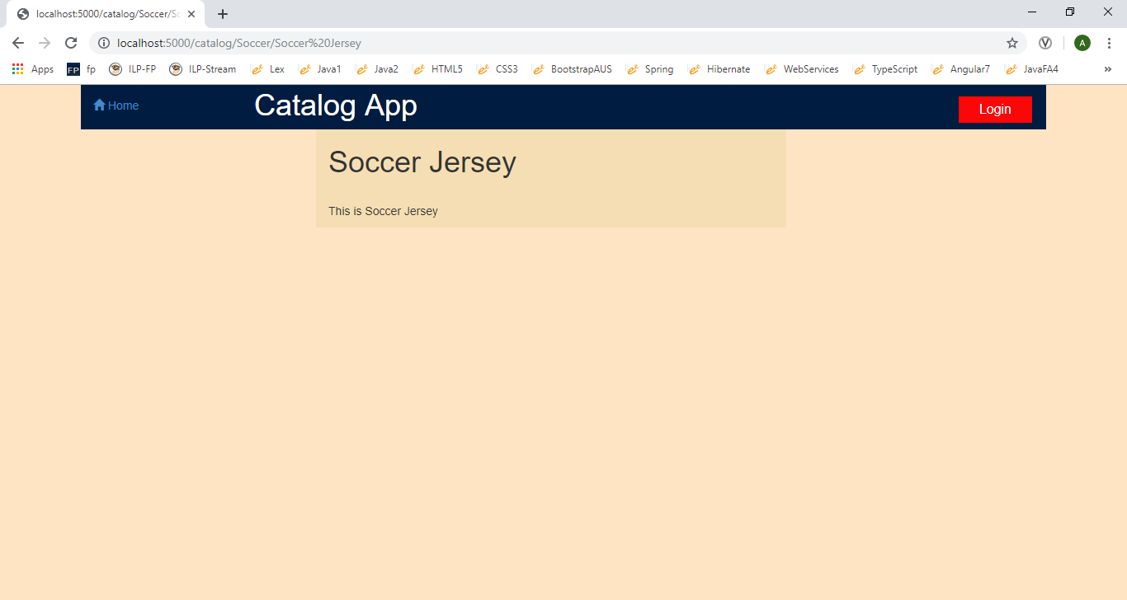

User can login using Facebook or Google Credentials by clicking on Login Button.<http://localhost:5000/login>

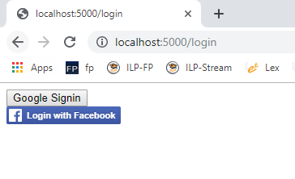

After logging in, a user has the ability to add, update, or delete item information. Users will be able to modify only those items that they themselves have created.

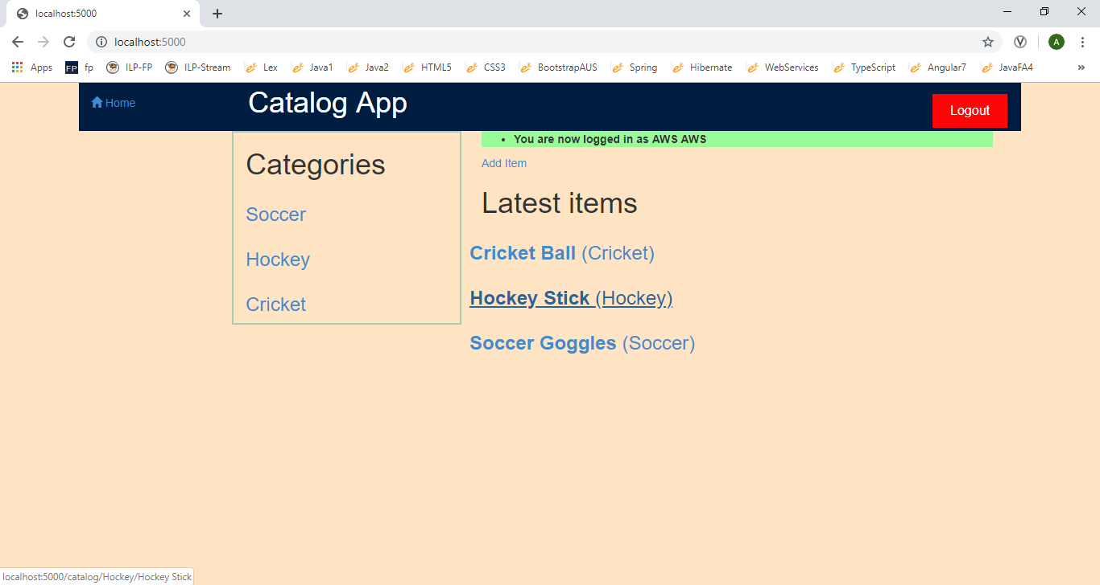

Adding a new Item - <http://localhost:5000/catalog/newItem> (logged in)

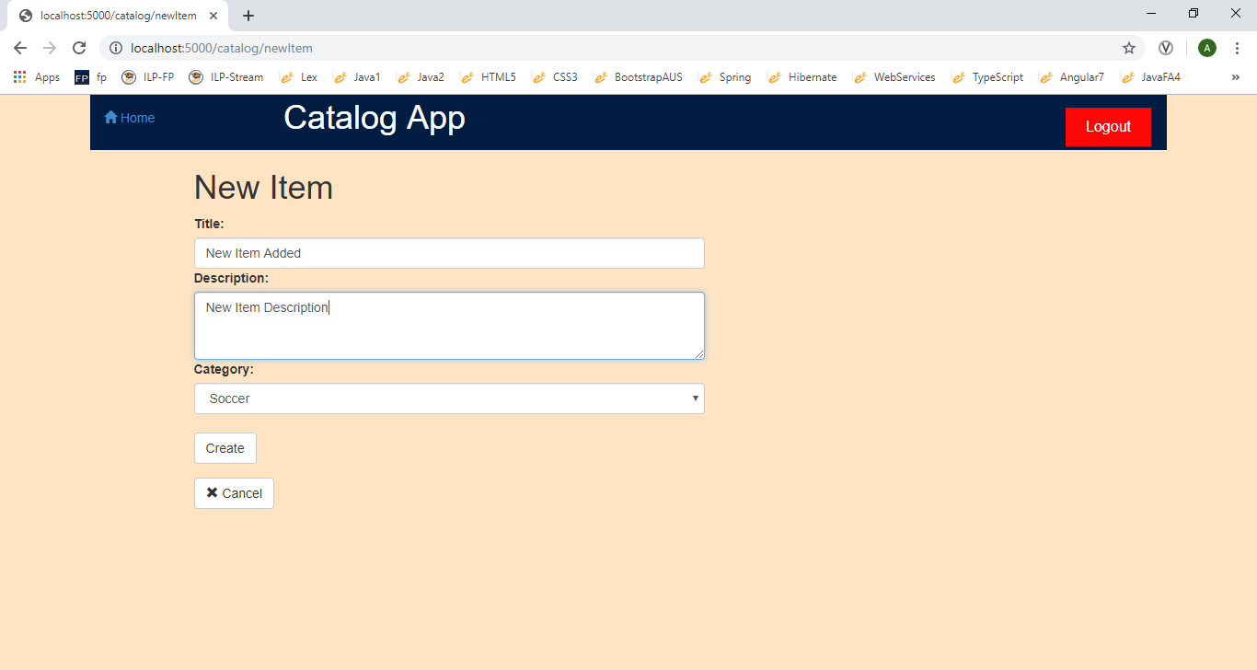

User can edit or delete item that they themselves have created

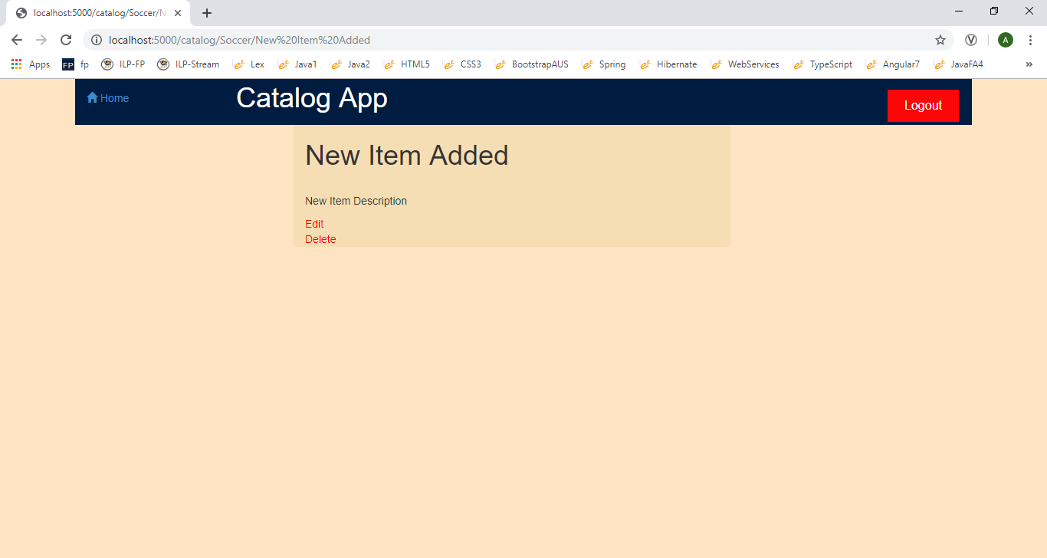

Editing the item (<http://localhost:5000/catalog/Soccer/edit?item_id=10> - Logged in)

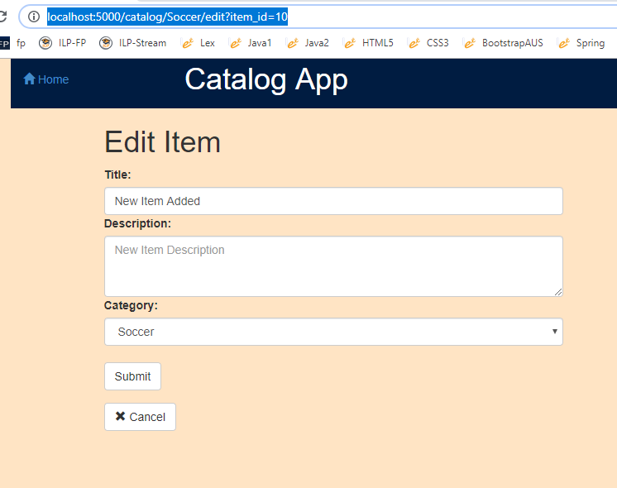

Delete confirmation for item deltion (<http://localhost:5000/catalog/Soccer/delete?item_id=10>)

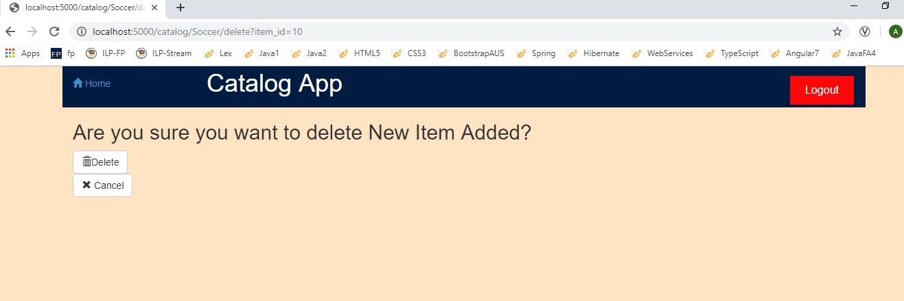

API (Gives JSON output of all Categories and Items) <http://localhost:5000/catalog/JSON>

