Evidence Based Physical Therapy, 2e

**Chapter 2: Asking a Clinical Question and Searching for Research Evidence**

# INTRODUCTION

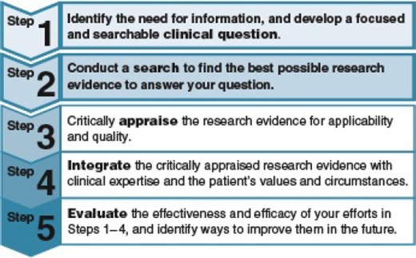

**QUESTIONS TO CONSIDER**

1. Why is it important to construct a searchable clinical question?
2. Give an example of a background question and a foreground question.
3. Describe the difference between a database and a search engine.
4. Name a search engine that anyone can access for free on the Internet. What are this tool’s strengths and weaknesses for helping therapists find research evidence?
5. Name three important techniques for narrowing a search in the PubMed search engine. Do the same for expanding a search.
6. Where could you locate a repository of full­text research articles mandated by the U.S. Congress?

**CHAPTER­AT­A­GLANCE**

*This chapter will help you understand the following:*

Searchable clinical questions Searching for research evidence

Accessing the full text of research articles

This chapter develops your knowledge and skills in the first two steps of evidence based practice (EBP):

 Step 1: Identify a need for information, and develop a focused and searchable **clinical question.**

 Step 2: Conduct a **search** to find the best possible research evidence to answer your question.

These steps take you through the process of obtaining research evidence. Most therapists find that research evidence is the most difficult type of evidence to obtain. This chapter helps you learn to obtain it quickly and efficiently.

# HOW DO I KNOW IF I NEED INFORMATION?

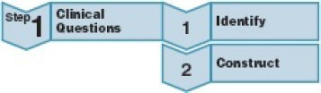

Step 1 can be divided into two parts—*identifying* a need for information and then *constructing* a focused, searchable clinical question. How do you identify a need for information? During your physical therapy education, you are flooded with information about how to care for patients. As an evidence based therapist and lifelong learner, you will constantly add to your knowledge. Every patient is different, and many present in ways that push you to find new information to optimize their care. Also, scientific evidence rapidly changes. There are now over 3,500 new clinical trials published every year related to physical therapy ([Fig. 2.1](http://fadavispt.mhmedical.com/#eviphyther_ch2fg1)). You cannot know the answer to every clinical question that arises. The key is to identify important knowledge gaps and know how to fill them with the best available evidence.

**FIGURE 2.1**

Number of physical therapy­related clinical trials published each year from 2000 to 2014.

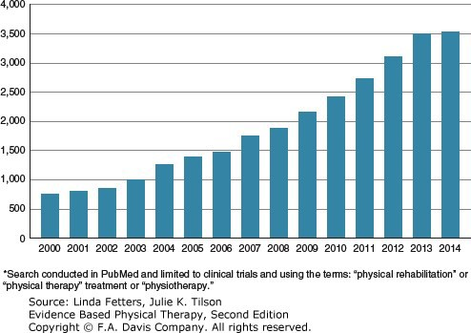

Identification of your information needs may occur before you see a patient and throughout a patient’s course of care. The American Physical Therapy Association[1](http://fadavispt.mhmedical.com/#eviphyther_ch2rf1) defines *patient management* as having six components ([Fig. 2.2](http://fadavispt.mhmedical.com/#eviphyther_ch2fg2)):

1. Examination
2. Evaluation
3. Diagnosis
4. Prognosis
5. Intervention
6. Outcomes measurement

**FIGURE 2.2**

Elements of patient/client management. From: American Physical Therapy Association. *Guide to Physical Therapist Practice.* 2nd ed. Alexandria, VA: American Physical Therapy Association; 2001; with permission.

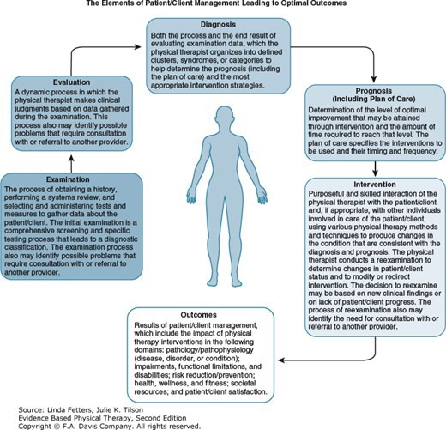

We describe the use of EBP for each of these components throughout this book. This chapter addresses clinical questions related to diagnosis, prognosis, and intervention. The information that the evidence based therapist needs during day­to­day patient care often falls into these three categories. Consider a patient who presents to you with neck pain. You will need to decide which tests are best to determine the cause of the pain, what interventions are most likely to help relieve that problem, and the type of outcome the patient can expect as a result of your care.



Tufts University Hirsh Health Sciences Library

Access Provided by:

**EVIDENCE IN PRACTICE June Wilson**

Consider June Wilson from [Chapter 1](http://fadavispt.mhmedical.com/content.aspx?legacysectionid=eviphyther_ch1) and review her patient information summary.

### Patient Information Summary

Name: Wilson, June Age: 17

**Current Condition:** Ms. Wilson is a 17­year­old female who presents to physical therapy with worsening neck pain over the past 2 weeks.

**Past Medical History:** Previous episodes of similar neck pain with high­intensity swim training.

**Medications:** Ibuprofen 400 mg 3x/day for 1 week

**Disability/Social History:** Ms. Wilson is a high school student and member of her school’s swim team. She swims 10,000+ yards 5 days per week. She has excelled in the current competition season and is scheduled to compete in the state high school championships (100­yard freestyle, 100­ yard individual medley) in 3 days. She has had progressively worsening neck pain that is exacerbated by swimming and prolonged sitting. Her sleep is slightly disturbed. Ms. Wilson lives with her parents, who are present at the examination and supportive of her swimming activities.

#### *Functional Status*

**Sitting Tolerance:** 30 minutes before onset of pain—affects comfort in classroom and doing homework.

**Sleep:** Difficulty falling asleep due to pain, “difficult to find a comfortable position.”

**Self­care:** Slow in the a.m. due to “morning stiffness” but otherwise unlimited.

**Swimming:** Able to complete full 10,000­yard workouts but with pain. Pain is worst with freestyle and butterfly strokes. Swim speed has been only mildly affected by the injury (<5%).

#### *Impairments*

**ROM:** Limited cervical ROM for right rotation (45°), side bend right (15°), and extension (30°)—all with pain. Shoulders—full, pain­free range bilaterally.

**Strength:** Bilateral shoulders 5/5 strength for all major muscle groups. Isometric testing of neck musculature reproduces pain for extension and right side bend. No overt cervical muscle weakness.

**Pain:** Neck pain average 4/10; radiates into her right arm to the elbow, interrupts her sleep (<1 hour/night), and increases to 7/10 during swim practice. Better with ice, ibuprofen.

Information regarding patient June Wilson. Format from: Quinn, L, Gordon, J. *Functional Outcomes Documentation for Rehabilitation.* Maryland Heights, MO: Saunders; 2003.

From this information, you might have questions about several areas of patient care: What special tests should be done to determine the cause of her pain? (Diagnosis) What treatments will be most effective for reducing her pain quickly? (Intervention) How likely is her neck pain to recur? (Prognosis)

These are examples of background questions on page 15. **Background questions** ask about general information and are not specific to an individual

Downloaded 2024­3­12 11:15 A Your IP is 130.64.11.161

Chapter 2: Asking a Clinical Question and Searching for Research Evidence,

©2024 F.A. Davis Company. All Rights Reserved. [Terms of Use](http://fadavispt.mhmedical.com/ss/terms.aspx) • [Privacy Policy](http://fadavispt.mhmedical.com/privacy) • [Notice](http://fadavispt.mhmedical.com/ss/notice.aspx) • [Accessibility](http://fadavispt.mhmedical.com/about/accessibility.html)

**Page 4 / 31**

patient. When you are less familiar with a particular condition, you ask more background questions. As your knowledge about a condition increases, the frequency of your background questions diminishes, and your need increases for foreground clinical questions.

Answers to background questions are usually best found in a general resource (e.g., textbook, reliable Web page) rather than in a specific research study. In contrast, **foreground questions** are specific to a particular patient, condition, and clinical outcome of interest. Foreground questions are typically answered using a research study or evidence based clinical practice guideline. Electronic databases house thousands and sometimes millions of articles and guidelines. To conduct an efficient and effective search, you must first develop a focused, searchable clinical question.

## Searchable Clinical Questions

**Searchable clinical questions** are foreground questions about a patient that are structured to help you find the best available research evidence as efficiently as possible. Many hours of frustration can be avoided by following a formula to focus your search. Focused, searchable clinical questions contain three elements:

1. *Patient characteristics:* Include the most important patient characteristics that relate to a patient’s health condition.
2. *Patient management* (e.g., intervention, diagnosis, prognosis): Define the component of interest for patient management. Study designs differ for questions about interventions, diagnostic tests, and prognosis. By specifying the component of patient management, you focus your question on a particular type of research study.
3. *Outcome of interest:* Determine your patient’s goals, and identify an appropriate measurable outcome for your patient. This is often difficult for new learners.

### PICO (Patient, Intervention, Comparison, Outcome)

**PICO** is an acronym that comprises the key components of a searchable clinical question about interventions. The letters stand for the following:  Patient (or population) and clinical characteristics

 Intervention

 Comparison (referring to an alternative intervention)  Outcome

It is common to have PICO questions without a *C* (comparison). [Searchable Clinical Question Example 2.1](http://fadavispt.mhmedical.com/#eviphyther_ch2_ubx1-4) illustrates two intervention PICO questions about June Wilson.

|  |  |  |
| --- | --- | --- |
| **PICO** | **Question Element** | **Question** |
| P | Patient characteristics | For a 17­year­old female swimmer with neck pain … |
| I | Patient management | is manual therapy or therapeutic exercise more effective … |
| C | … |  |
| O | Outcome of interest | for improving function and sport performance? |
| →  Searchable Clinical Question | (A) For a 17­year­old female swimmer with neck pain, is manual therapy or therapeutic exercise more effective for improving function and sport performance? | |
| P | Patient characteristics | For a 17­year­old female swimmer with neck pain … |
| I | Patient management | are manual therapy techniques effective … |
| O | Outcome of interest | for short­term pain reduction? |
| →  Searchable Clinical Question | (B) For a 17­year­old female swimmer with neck pain, are manual therapy techniques effective for short­term pain reduction? | |

The outcome(s) component *O* of clinical questions refers to the particular outcome of interest to the patient and/or clinician. When considering the outcome, the **International Classification of Function, Disability and Health (ICF)** model ([Fig. 2.3](http://fadavispt.mhmedical.com/#eviphyther_ch2fg3)) may help you to frame and focus your question.[2](http://fadavispt.mhmedical.com/#eviphyther_ch2rf2)

**Searchable Clinical Question Example 2.1: Intervention**

**FIGURE 2.3**

Different types of outcome measures organized by categories established in the International Classification of Function, Disability and Health model. Modified from: World Health Organization. *International Classification of Functioning, Disability and Health: ICF*. Geneva, Switzerland: World Health Organization; 2001; with permission of the World Health Organization.

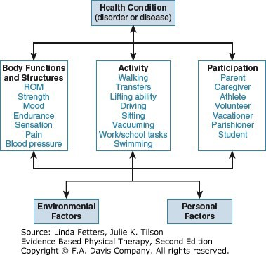

The World Health Organization encourages health professionals to use a common language to communicate issues of health and wellness. ICF terms include body functions and structures, activity, and participation. **Body functions and structures** describe individual system functions such as muscle strength, joint range of motion, and emotional mood. Problems at the level of body functions and structures are referred to as impairments. **Activity** describes actions such as walking, climbing stairs, or getting out of bed. Problems with activity are referred to as activity limitations.

**Participation** includes work, school, and community involvement. Problems at the level of participation are called participation restrictions.

The outcomes component of a searchable clinical question specifies whether the therapist is looking for research information about results for body structures and functions (e.g., pain, strength), activity (e.g., prolonged sitting, swimming), and/or participation level (e.g., attend high school, participate on a sports team).

Questions about diagnosis and prognosis do not conform as easily to the PICO framework but can be formulated into three general parts. Diagnostic [questions can include the diagnostic test characteristics (Question A) or the possible results for a particular patient (Question B) (Searchable Clinical Question Example 2.2).](http://fadavispt.mhmedical.com/#eviphyther_ch2_ubx1-5)

|  |  |  |
| --- | --- | --- |
| **PICO** | **Question Element** | **Question** |
| P | Patient characteristics | For a 17­year­old female with radiating neck pain … |
| I C | Patient management: **Diagnosis (test characteristics)** | how sensitive and specific is the Spurling test for |
| O | Outcome of interest | detecting cervical nerve root impingement? |
| →  Searchable Clinical Question | (A) For a 17­year­old female with radiating neck pain, how sensitive and specific is the Spurling test for detecting cervical nerve root impingement? | |
| P | Patient characteristics | For an athlete with neck pain and a positive Spurling test … |
| I | Patient management: **Diagnosis (test result)** | what is the likelihood that … |
| O | Outcome of interest | the person has cervical nerve root impingement? |
| →  Searchable Clinical Question | (B) For an athlete with neck pain and a positive Spurling test, what is the likelihood that the person has cervical nerve root impingement? | |

Questions may address a patient population rather than a specific patient. [Searchable Clinical Question Example 2.3](http://fadavispt.mhmedical.com/#eviphyther_ch2_ubx1-6) on the following page illustrates searchable clinical questions about prognosis for a patient population (Question A) and for an individual patient (Question B).

**Searchable Clinical Question Example 2.2: Questions About Diagnosis**

|  |  |  |
| --- | --- | --- |
| **PICO** | **Question Element** | **Question** |
| P | Patient characteristics | For a competitive swimmer with recurrent neck pain |
| I C | Patient management: **Prognosis** | what is the likelihood that the athlete will develop … |
| O | Outcome of interest | chronic neck pain? |
| →  Searchable Clinical Question | (A) For a competitive swimmer with recurrent neck pain, what is the likelihood that the athlete will develop chronic neck pain? | |
| P | Population characteristics | Among competitive high school swimmers … |
| I | Patient management: **Prognosis** | what risk factors are associated with the onset of … |
| O | Outcome of interest | cervical disk herniation? |
| →  Searchable Clinical Question | (B) Among competitive high school swimmers, what risk factors are associated with the onset of cervical disk herniation? | |

# RESEARCH YOUR CLINICAL QUESTION

**Searchable Clinical Question: Example 2.3: Questions About Prognosis**

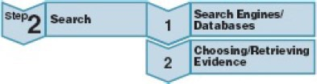

The second step in EBP involves searching for the best available research evidence to answer your clinical question. Most often, you will accomplish this by searching a database. In the context of EBP, a **database** is a compilation of research evidence resources, primarily lists of peer­reviewed journal articles, designed to organize the large amount of research published every year. Before choosing the best database to search, you will need to decide which type of research evidence you want to find.

**SELF­TEST 2.1 Practice Using the ICF Model**

You are working with a 65­year­old truck driver, Ed Dean, who has developed low back pain associated with prolonged periods of sitting. When not working, Mr. Dean enjoys working on antique tractors and doing odd jobs around the house. He is married and has eight grandchildren.

List five outcome measures at the levels of body functions and structures, activity, and participation that pertain to Mr. Dean.

Use the outcome measures you have listed under the three ICF categories to complete the following foreground questions:

For a 55­year­old truck driver with low back pain, is physical therapy care or chiropractic care more effective for

?

For a 55­year­old male with low back pain, are stabilization exercises or strength­training exercises more effective for

?

For a 55­year­old male with low back pain, is bedrest or a walking program more likely to improve ?

|  |  |  |
| --- | --- | --- |
| **Body Structure and Function** | **Activity** | **Participation** |
| Example: Lumbar spine range of motion | Example: Prolonged sitting | Example: Occupation–truck driver |
| 1. | 1. | 1. |
|  |  |  |
| 2. | 2. | 2. |
|  |  |  |
| 3. | 3. | 3. |

**SELF­TEST 2.2 Writing Clinical Questions**

Let’s consider another patient, Jose Lopez. Mr. Lopez is a 52­year­old grandfather. He works on a peach farm and has had increasing knee pain for the past 4 months. He is not aware of a specific mechanism of injury. His pain has become so severe that he is unable to pick peaches or carry his 2­ year­old grandson.

**Patient Information Summary**

Name: Lopez, Jose Age: 52

**Current Condition:** Mr. Lopez presents to physical therapy with worsening right knee pain over the past 4 months.

**Past Medical History:** Hypertension

**Medications:** Diuril (Chlorothiazide)

**Disability/Social History:** Mr. Lopez works as a crop manager and peach picker at a peach farm. He is on his feet 6 to 8 hours per day, often



Tufts University Hirsh Health Sciences Library

Access Provided by:

climbing on and off ladders and tractors. He lives with his wife, daughter, and son­in­law and their two children (2 and 5 years). He has had progressively worsening right knee pain that is exacerbated by prolonged standing.

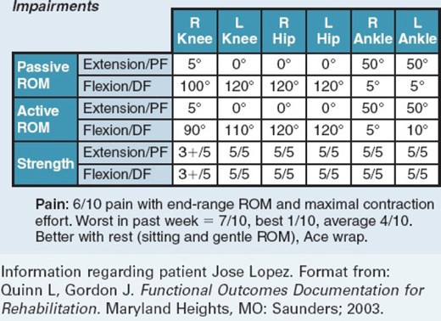

#### *Functional Status*

**Standing Tolerance:** 3 hours before onset of pain—affects work and home activities requiring standing.

**Sleep:** Generally uninterrupted by knee pain.

**Self­care:** Unlimited.

**Climbing Ladders:** Knee feels unstable, as if it might give out. This limits Mr. Lopez’s efficiency and confidence working on the farm.

**Tractor Driving:** Knee becomes painful/stiff after long hours of driving tractor due to constant use of foot pedals.

After reviewing his patient information summary, reflect on the information provided.

1. Write your questions about his care.
2. Determine if each question is a background or a foreground question.
3. Determine the component of patient management for each question (diagnosis, intervention, or prognosis).
4. For the questions that you believe are foreground questions, underline the three key components: patient characteristics, patient management (diagnosis, intervention, or prognosis), and outcome. If the question does not have all of those parts, try rewriting.

Information regarding patient Jose Lopez. Format from: Quinn L, Gordon J. *Functional Outcomes Documentation for Rehabilitation.* Maryland Heights, MO: Saunders; 2003.

## Summarized Evidence

Physical therapists and patients are best served by rapid access to preappraised, user­friendly summaries of research evidence that guide clinical decision­making and care. Response to this need has resulted in increased availability of preappraised summaries of research evidence. [Figure 2.4](http://fadavispt.mhmedical.com/#eviphyther_ch2fg4) illustrates several types of summarized evidence.

**FIGURE 2.4**

Downloaded 2024­3­12 11:15 A Your IP is 130.64.11.161

Chapter 2: Asking a Clinical Question and Searching for Research Evidence,

©2024 F.A. Davis Company. All Rights Reserved. [Terms of Use](http://fadavispt.mhmedical.com/ss/terms.aspx) • [Privacy Policy](http://fadavispt.mhmedical.com/privacy) • [Notice](http://fadavispt.mhmedical.com/ss/notice.aspx) • [Accessibility](http://fadavispt.mhmedical.com/about/accessibility.html)

**Page 11 / 31**

Efficiency of resources for research evidence.

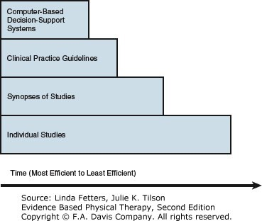

Computer­based decision­support systems are generally thought of as systems that integrate with electronic health records. Essentially, as the clinician (or patient) enters pertinent health information into the system, computer algorithms identify preappraised, synthesized evidence specific to that patient.[3](http://fadavispt.mhmedical.com/#eviphyther_ch2rf3) For example, for a person hospitalized after back surgery, the system might integrate guidelines on fall prevention with information from multiple providers to assess the person’s risk for falls and suggest evidence based interventions to reduce the patient’s fall risk. In this case, the physical therapist may receive evidence based recommendations almost instantly, without even having to leave the documentation system. It is worth noting, however, that for this type of system to work, the therapist needs to recognize, trust, and act upon the recommendations. Computer­based decision­support systems are emerging but need development and technical innovation to become the primary source of research evidence in practice.

An applicable, recent, and rigorously developed clinical practice guideline is the next most efficient source of research evidence. **Clinical practice guidelines (CPGs)** are systematically developed statements that make recommendations for practice based on the best available evidence. You can avoid personally reading and synthesizing evidence from multiple individual studies yourself if you use a CPG that

 Relates to your clinical question.  Was published in the last 5 years.

 Scores well on specific criteria (see [Chapter 8](http://fadavispt.mhmedical.com/content.aspx?legacysectionid=eviphyther_ch8)).

CPGs also provide a venue for experts to fill in research gaps with consensus opinion and may include information regarding patients’ opinion of different care options. You should always search for CPGs on a topic in order to know the professional recommendations. Synopses of studies can take many other forms. Generally, other types of synopses are not as rigorously developed as CPGs.

Finally, individual studies, although the most common source of research evidence, are the least time efficient. Clinical decision­making should be based on a body of evidence, not a single study. Thus, the clinician needs to access more than one study before a fully informed decision can be made. **Systematic reviews** are studies that synthesize information from multiple primary studies. They help to address this problem and are discussed in the next section and in [Chapter 7](http://fadavispt.mhmedical.com/content.aspx?legacysectionid=eviphyther_ch7) of this book. Ultimately, summarized evidence for physical therapists is becoming more available. Physical therapists are encouraged to search for summarized evidence first, and if they find a summary of high quality, they should consider it as a primary resource for answering searchable clinical questions.

## Searching for Individual Studies

The evidence pyramid ([Fig. 2.5](http://fadavispt.mhmedical.com/#eviphyther_ch2fg5)) illustrates a hierarchy that can serve as an *initial* filter for identifying high­quality individual studies. Study designs at the top of the pyramid are least likely to produce biased results. **Bias** occurs when a study’s results are affected by unknown or unacknowledged errors resulting from the study’s design, analysis, or protocols. Your ability to recognize different study types and the possible bias they introduce improves as you proceed through the chapters of this book.

**FIGURE 2.5**

Consider the evidence pyramid when searching in databases for research evidence. Adapted from: Evidence­based practice (EBP) resources. Upstate Medical University website. <http://upstate.libguides.com/ebp/pyramid>; 2011.

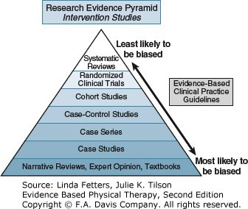

When searching for studies of *interventions*, first search for a clinical practice guideline, then systematic reviews, then **randomized controlled trials**, and then proceed down the pyramid. Randomized controlled trials are often not an appropriate design for studies of diagnosis or prognosis (see [Chapters 5](http://fadavispt.mhmedical.com/content.aspx?legacysectionid=eviphyther_ch5) and [6](http://fadavispt.mhmedical.com/content.aspx?legacysectionid=eviphyther_ch6)). For those categories, first search for systematic reviews, and then search for cohort studies. Subsequent chapters support your increased ability to identify these different study designs.

## Using Search Engines to Find Research Evidence

A **search engine** is the user interface that allows specific articles to be identified in a database. Sometimes several search engines can be used to search the same database. For example, Medline,[4](http://fadavispt.mhmedical.com/#eviphyther_ch2rf4) one of the most comprehensive databases of medical research articles, can be searched using numerous search engines (e.g., PubMed,[5](http://fadavispt.mhmedical.com/#eviphyther_ch2rf5) **Ovid** Medline, and **ProQuest).** One search engine may also allow you to search numerous databases. For example, the Turning Research Into Practice (TRIP)[6](http://fadavispt.mhmedical.com/#eviphyther_ch2rf6) search engine searches over 21 databases simultaneously. This chapter focuses on freely available and effective search engines and databases. [Figure 2.6](http://fadavispt.mhmedical.com/#eviphyther_ch2fg6) illustrates search engines and important databases for evidence based physical therapists.

**FIGURE 2.6**

The relationships between common databases and search engines that are either freely available or available to members of the American Physical Therapy Association (*).

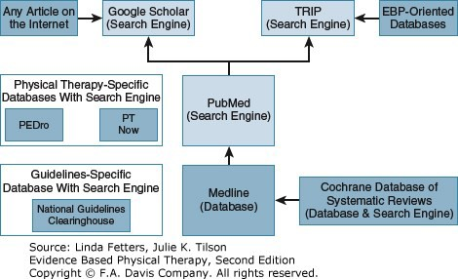

### National Guidelines Clearinghouse

The **National Guidelines Clearinghouse**[**7**](http://fadavispt.mhmedical.com/#eviphyther_ch2rf7)([guidelines.gov](http://guidelines.gov/)) is a database of clinical practice guidelines (CPGs) developed by the Agency for Healthcare Research and Quality (AHRQ). The clearinghouse allows authors of CPGs to post their guidelines for public reference. The site has its own search engine that is best searched using broad terms (e.g., multiple sclerosis and physical therapy). This database contains numerous CPGs that are not indexed in MEDLINE.

### Physiotherapy Evidence Database (PEDro)

The **Physiotherapy Evidence Database (PEDro)**[8](http://fadavispt.mhmedical.com/#eviphyther_ch2rf8) ([pedro.org.au](http://pedro.org.au.ezproxy.library.tufts.edu/)) is a freely available database and search engine. You can locate abstracts of physical therapy–specific literature. The database includes only intervention­related literature and includes CPGs, systematic reviews, and other clinical studies. PEDro developers have created a well­documented rating system for determining the quality of clinical trials called the PEDro scale.[9](http://fadavispt.mhmedical.com/#eviphyther_ch2rf9),[10](http://fadavispt.mhmedical.com/#eviphyther_ch2rf10) The scale ranges from 0 to 10; studies rated as 10/10 are considered to have the least risk for bias.

### PT Now

PT Now[11](http://fadavispt.mhmedical.com/#eviphyther_ch2rf11) ([ptnow.org](http://ptnow.org/)) is a physical therapy–specific database developed by the American Physical Therapy Association (APTA). The database contains clinical summaries (a type of evidence summary), CPGs, systematic reviews, and other resources. This database is only available to APTA members.

### The Cochrane Library of Systematic Reviews

The **Cochrane Library of Systematic Reviews**[12](http://fadavispt.mhmedical.com/#eviphyther_ch2rf12) ([https://www­cochrane­org.ezproxy.library.tufts.edu/](https://www-cochrane-org.ezproxy.library.tufts.edu/)) is a database of systematic reviews conducted by Cochrane­approved reviewers. All Cochrane Systematic Reviews are conducted using the same methods, which are considered the gold standard. Cochrane Systematic Reviews are indexed in PubMed; using a supplemental search engine is not necessary to find these articles. A separate Cochrane search engine, however, is available.

### MEDLINE

**MEDLINE**[**14**](http://fadavispt.mhmedical.com/#eviphyther_ch2rf14)is the U.S. National Library of Medicine bibliographic database of journal articles published in life sciences and biomedicine. It indexes over 5,600 journals published from around the world and across numerous medical and related disciplines. The journals indexed in MEDLINE are reviewed for quality by the U.S. National Library of Medicine. MEDLINE includes over 23 million research articles.

### PubMed

**PubMed**[4](http://fadavispt.mhmedical.com/#eviphyther_ch2rf4) ([pubmed.gov](http://pubmed.gov/)) is a freely available search engine developed by the U.S. National Library of Medicine and National Center for Biotechnology Information. MEDLINE is the primary database accessed by the PubMed search engine.

### Google Scholar

**Google Scholar** ([google.com/scholar](http://google.com/scholar)) is a search engine developed by the company Google. The search engine is designed to search the Internet for journal articles. The Google Scholar search engine also links to the full text of articles (both free and paid). Google Scholar does not share its search strategy publicly; however, it appears to search all entries included in PubMed and the National Guidelines Clearinghouse, among a vast number of other Internet sources. The search engine provides limited tools for refining your search with precision.

### Turning Research Into Practice (TRIP)

**Turning Research Into Practice** (**TRIP;** [tripdatabase.com](http://tripdatabase.com/))[5](http://fadavispt.mhmedical.com/#eviphyther_ch2rf5) is a search engine designed to assist medical practitioners in searching numerous databases to find the best available evidence. TRIP searches PubMed/MEDLINE, the National Guidelines Clearinghouse, and more than 20 other pre­ screened databases and databases focused on EBP.

## Searching in PubMed

This chapter highlights the PubMed search engine ([Fig. 2.7](http://fadavispt.mhmedical.com/#eviphyther_ch2fg7)). PubMed is the most comprehensive and powerful freely available search engine for

finding research evidence in health care. Learning the skills to use PubMed efficiently is important for becoming an evidence based practitioner. Most powerful search engines have tools similar to those of PubMed but use a different user interface. The choice to use one search engine over another is a matter of purpose and personal preference. You should identify a primary search engine that is user­friendly and efficient for initial searches.

Additional backup search engines can be used when necessary. The outcome of the search is more important than the tool used. Beyond this text, practice and working with a therapist or librarian skilled in medical literature searches can help you develop your skills. Screenshots are included in this book to guide your learning. Although the look of the interface shown in these screenshots will change over time, the general concepts of how to use the various online services will remain relatively constant.

**FIGURE 2.7**

Screenshot from the PubMed homepage. The **main search box** can be used to enter terms to search. The **Advanced Search** link provides access to [tools for refined searching. **My NCBI** allows the user to customize and save information in a personal account linked to PubMed (see Digging Deeper 2.1 and](http://fadavispt.mhmedical.com/#eviphyther_ch2_ubx1-10) [Chapter 11](http://fadavispt.mhmedical.com/content.aspx?legacysectionid=eviphyther_ch11)[). The **MeSH Database** is a helpful resource for identifying appropriate search terms. **Special search tools** are available for](http://fadavispt.mhmedical.com/#eviphyther_ch2_ubx1-10) specific types of searches; several of these are addressed in [Digging Deeper 2.1](http://fadavispt.mhmedical.com/#eviphyther_ch2_ubx1-10), “Additional Tools for Searching in PubMed.” **Frequently asked questions (FAQs) pages and tutorials** about PubMed are helpful for new users.

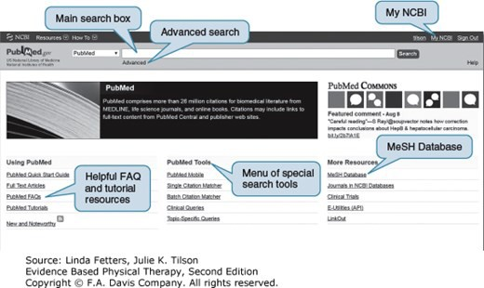

Students familiar with Web browsers have experience using search engines for general Web searches. Research article databases, however, do not function exactly like all­purpose Internet search engines. Developing refined, efficient search skills takes practice. To use research article databases, you need to learn the most appropriate terms to enter, how to combine terms, how to limit search results, and how to filter by different categories, such as author, year, journal, or keyword.

The following is a searchable clinical question about the patient June Wilson to illustrate several key skills for searching in PubMed:

**Searchable Clinical Question**

For a 17­year­old swimmer with neck pain, is a combination of manual therapy and exercise effective for reducing pain and improving function?

### Identify Your Search Terms

The first step in searching PubMed is to identify your search terms. When you enter a term into the PubMed search box, PubMed searches for articles using that term in the title or abstract. **Keywords** are important words from your searchable clinical question and/or synonyms of those words.

Ideally, an article that has your keywords in the title and abstract will be relevant to your searchable clinical question.

Each article entered into the MEDLINE database (that PubMed searches) is also assigned a list of Medical Subject Headings (MeSH). **MeSH terms** are designed to provide a common and consistent language across published articles. Within PubMed, you can enter keywords from your question into a MeSH Database to determine the best MeSH term for that topic. However, therapists often discover that MeSH terms are somewhat limited in appropriately describing therapy topics of interest. In this case it is best to use keywords rather than MeSH terms.



Tufts University Hirsh Health Sciences Library

Access Provided by:

[Table 2.1](http://fadavispt.mhmedical.com/#eviphyther_ch2tb1) illustrates an example of how to identify useful search terms from our searchable clinical question.

TABLE 2.1

**Selecting Search Terms**

|  |  |  |  |
| --- | --- | --- | --- |
|  | **Searchable Clinical Question:** | |  |
| “For a 17­year­old female swimmer with neck pain, is a combination of manual therapy and exercise effective for reducing pain and improving function?” | |
| **TERMS** | **EXPLANATION** |
| Start with terms from the question:  17­year­old Female Swimmer Neck pain  Manual therapy Exercise  Pain Function | Choose the terms or keywords that best describe the information that you are seeking. In this case, we chose all of the nouns in the sentence except *combination. Combination* was not chosen because we expect that the concept of combining the two interventions will be captured by putting both interventions in the search box. It should be noted, however, that this will also result in studies that compare manual therapy and exercise therapy. The terms *reducing* and *improving* were not chosen. We expected that the studies that we would be looking for would inherently address improvement in our outcomes of interest. |
| Next, reorder terms from most to least important:  Neck pain *(most important)* Manual therapy Exercise  Pain Function 17­year­old Swimmer Female *(least important)* | After selecting the terms that you feel are most important, reorder the terms from most to least important. Determining which terms are important requires practice and a willingness to take a guess. We have placed the terms that we feel best describe an article that tells us how to treat our patient at the top of the list. For example, an article about people with neck pain has a better chance of being related to our question than an article about females. The order is only a guess. Any term can ultimately be prioritized in a search. |
| Refine your terms using the MeSH Database:  Neck pain (same) Musculoskeletal manipulations Exercise therapy Recovery of function Adolescent  (identified | When you are new to searching in a particular topic area, it is helpful to check your keyword list against the Medline MeSH headings. In this case, we anticipated that the term *17­year­old* would need to be modified. Most papers would not be so specific to list “17­year­old” in the title or abstract. We used the MeSH search to identify the more appropriate term *adolescent.* Additional terms were also modified or added based on our MeSH Database search. We found that some keyword terms were the same as the MeSH term. |

Downloaded 2024­3­12 11:15 A Your IP is 130.64.11.161

Chapter 2: Asking a Clinical Question and Searching for Research Evidence,

©2024 F.A. Davis Company. All Rights Reserved. [Terms of Use](http://fadavispt.mhmedical.com/ss/terms.aspx) • [Privacy Policy](http://fadavispt.mhmedical.com/privacy) • [Notice](http://fadavispt.mhmedical.com/ss/notice.aspx) • [Accessibility](http://fadavispt.mhmedical.com/about/accessibility.html)

**Page 16 / 31**

|  |  |  |  |
| --- | --- | --- | --- |
|  | through term “teenager”) Swimming Female |  |  |
| Finally, order all terms from most to least important:   1. Neck pain 2. Musculoskeletal manipulations 3. Manual therapy 4. Exercise therapy 5. Recovery of function 6. Adolescent 7. Swimming 8. Female | The final list provided is our best guess of the order of importance. |

After you have identified your most important terms, enter each of the top­four terms individually into PubMed’s Advanced Search. This allows you to see the number of articles associated with each term. This step is illustrated in [Figure 2.8](http://fadavispt.mhmedical.com/#eviphyther_ch2fg8) with Searches #1 through #4 under Search History.

**FIGURE 2.8**

Example of an Advanced Search in PubMed.

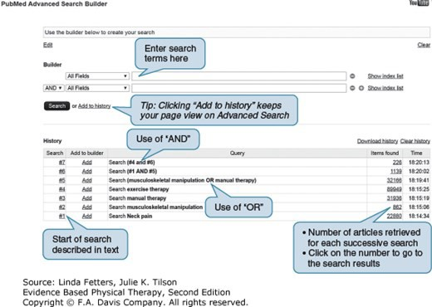

### Combining Terms

The next step is to combine terms using the Boolean operator OR. The term *manual therapy* (Search #3) and the MeSH term *musculoskeletal manipulation* (Search #2) address the same topic. Therefore, they should be combined using the operator OR. Using OR retrieves a list of all articles that have *either* the term *musculoskeletal manipulation* or the term *manual therapy.* This can be done using the terms themselves (*manual therapy OR musculoskeletal manipulation*) or using the search number to the left of each term (*#3 OR #4*).

The operator AND is used when you want only articles that contain both (or more than two) terms. In this search, the terms *neck pain* and *manual therapy OR musculoskeletal manipulation* were combined using AND (see [Fig. 2.8](http://fadavispt.mhmedical.com/#eviphyther_ch2fg8), Search #6.). Using this strategy, a list was retrieved of the articles that contained *both* terms. It is easiest to use the search numbers (see [Figure 2.8](http://fadavispt.mhmedical.com/#eviphyther_ch2fg8), Search Box). Notice that PubMed requires that you use the number sign (#) when identifying search numbers. Finally, combine the results from Search #6 with the term *exercise therapy*. [Figure 2.9](http://fadavispt.mhmedical.com/#eviphyther_ch2fg9) illustrates how the search strategy in [Figure 2.8](http://fadavispt.mhmedical.com/#eviphyther_ch2fg8) narrowed the search to relevant articles. Column A illustrates the number of articles retrieved when each separate term is used in the search (*exercise therapy, manual therapy, musculoskeletal manipulation*, and *neck pain*). The number of articles retrieved is approximated by the size of the circle. Column B illustrates the number of articles retrieved when two terms, *manual therapy* and *musculoskeletal manipulation*, are combined using OR; PubMed retrieves all articles containing *either* of these terms. Hence, the number of articles is greater than that from either term retrieved separately. Column C illustrates the number of articles retrieved when terms (or combinations of terms) are combined using AND; PubMed retrieves only the articles that contain *all* of the terms included in the AND statement. Hence, the number of articles is steadily reduced. With all terms combined, 226 articles remain.

**FIGURE 2.9**

Column A illustrates the number of articles retrieved when each separate term is used in the search. Column B illustrates the number of articles retrieved when two terms, *manual therapy* and *musculoskeletal manipulation*, are combined using OR. Column C illustrates the number of articles retrieved when terms are combined using AND. Langevin P, Desmeules F, Lamothe M, Robitaille S, Roy JS. Comparison of 2 manual therapy and exercise protocols for cervical radiculopathy: a randomized clinical trial evaluating short­term effects. *J Orthop Sports Phys Ther.* 2015;45(1):4­17.[3](http://fadavispt.mhmedical.com/#eviphyther_ch2rf3)

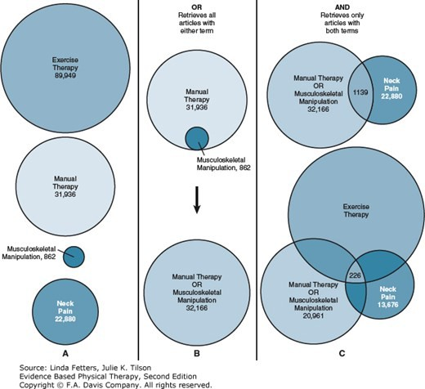

### Filtering Your Search

Finally, PubMed provides options for filtering your search results. An efficient way to search for best evidence is to start by searching for clinical practice guidelines. If necessary (as is frequently the case), proceed down the levels of the pyramid. In our example, the initial *filters* we used restricted the results to recent (the past 5 years) clinical practice guidelines in English.

This search produced one result, and it was not applicable based on the title. Therefore, we added the Systematic Review filter, which produced 17 results ([Fig. 2.10](http://fadavispt.mhmedical.com/#eviphyther_ch2fg10)). A few systematic reviews look helpful, although they address exercise and/or musculoskeletal manipulation for persons with *chronic* neck pain. Then we turned *off* the Practice Guideline and Systematic Review filters and *selected* and turned *on* Randomized Controlled Trial. We chose an article by Langevin et al[13](http://fadavispt.mhmedical.com/#eviphyther_ch2rf13) ([Fig. 2.11](http://fadavispt.mhmedical.com/#eviphyther_ch2fg11)) to appraise for applicability and quality:

**FIGURE 2.10**

Screenshot of PubMed search results page with filters used to search for clinical practice guidelines and systematic reviews published in the past 5 years in English. Other resources are highlighted: the “Customize” link under each type of filter can be used to access more options for filtering; searchers with access to resources through a library should not use the “free full text” limit because it will not show articles accessible through their library; filters can be preset using your My NCBI account; and the “Send to” option provides a number of useful tools for articles of interest in the search results.

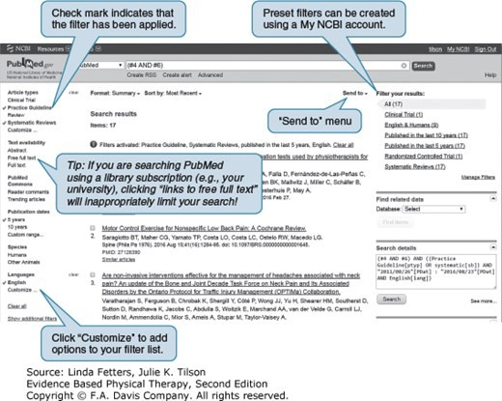

**FIGURE 2.11**

Screenshot of the PubMed abstract page.

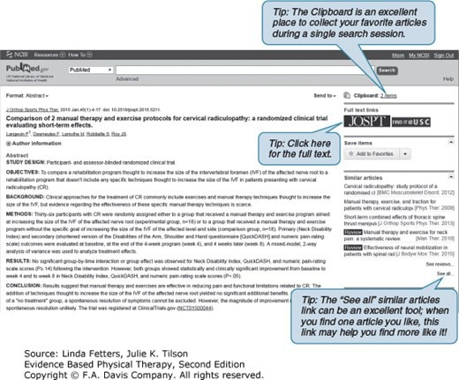

See [Chapters 3](http://fadavispt.mhmedical.com/content.aspx?legacysectionid=eviphyther_ch3) and [4](http://fadavispt.mhmedical.com/content.aspx?legacysectionid=eviphyther_ch4) for appraisal skills for randomized controlled trials.

### Search History

The final search strategy used to find the best available research evidence to answer our question is illustrated in [Figure 2.12](http://fadavispt.mhmedical.com/#eviphyther_ch2fg12). This example is one of many strategies for searching in PubMed. Additional suggestions are provided in [Digging Deeper 2.1](http://fadavispt.mhmedical.com/#eviphyther_ch2_ubx1-10). For self­study, consult the PubMed tutorial page and tutorial pages from other individual online databases and search engines.

**FIGURE 2.12**

Final search history in PubMed for the following clinical question: “For a 17­year­old swimmer with neck pain, is a combination of manual therapy and exercise effective for reducing pain and improving function?”

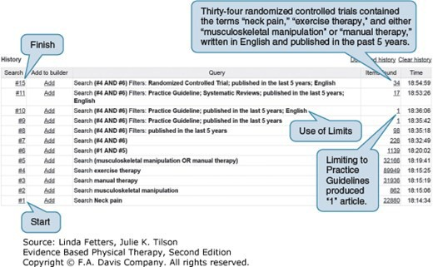

**Digging Deeper 2.1 Additional tools for searching in PubMed**



The PubMed search engine has numerous tools designed to make searching easier. This section highlights Clinical Queries, My NCBI, the “Send to” menu, and the Similar Articles link.

**Clinical Queries**

The Clinical Queries tool is a good place to start searching if you have a good idea of what terms to use. The page has two components that therapists find useful. First, the Search by Clinical Study Category allows the searcher to enter terms and then select the type of clinical question of interest (etiology, diagnosis, therapy, prognosis, and clinical prediction guides). The search can be broad (capturing as many articles as possible) or narrow (capturing a more specific selection of articles). PubMed uses your terms with preestablished search criteria to retrieve articles. The second Clinical Queries tool is the Find Systematic Reviews tool. This tool uses the terms that you enter in order to find articles indexed as systematic reviews.

**My NCBI**

The My NCBI tool (see [Fig. 2.7](http://fadavispt.mhmedical.com/#eviphyther_ch2fg7)) supports the development of your private library within PubMed. With a freely available personal account, you can create alerts for new articles from your favorite searches, preset filters you use commonly, and permanently save lists of articles that can be shared. The Create Alert tool initiates an automatic e­mail of new results for a particular search you have conducted. For example, if you decide to create an alert for a search about interventions for June Wilson, you could request an e­mail when new articles are published that fit that search. That search is automatically performed, and the results are sent to you on a schedule that you select. More details about My NCBI are provided in [Chapter 11](http://fadavispt.mhmedical.com/content.aspx?legacysectionid=eviphyther_ch11).

**“Send to” menu**

The “Send to” menu on the search results page (see [Fig. 2.10](http://fadavispt.mhmedical.com/#eviphyther_ch2fg10)) provides a number of useful options. Articles selected from the results page can be

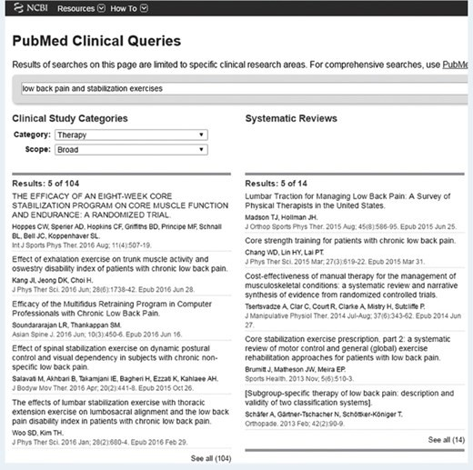

sent to the clipboard for short­term storage, My NCBI collections for long­term storage, reference management software for organizing and citing articles (see [Chapter 12](http://fadavispt.mhmedical.com/content.aspx?legacysectionid=eviphyther_ch12)), and e­mail.

**Similar Articles link**

The “See all” Similar Articles link (see [Fig. 2.11](http://fadavispt.mhmedical.com/#eviphyther_ch2fg11)) is helpful when you locate an applicable article and want to retrieve other similar articles. The top­ five similar articles are listed in the right­hand column of a given article abstract page. Click “See all” to retrieve a longer list of similar articles and the “See reviews” link to retrieve a list of related systematic and narrative reviews.

### Special Considerations for Background Questions

Background questions ask about fundamental, factual information that is often not easily found in recently published journal articles. [Box 2.1](http://fadavispt.mhmedical.com/#eviphyther_ch2_bx1-1) contains examples of helpful websites for accessing credible background information. These types of resources can also be helpful for patients and clients who want to learn about their condition.

**BOX 2.1 Accessing Credible Background Information Online**

**Credible General Medical Information**

MedlinePlus[14](http://fadavispt.mhmedical.com/#eviphyther_ch2rf14) ([medlineplus.gov](http://medlineplus.gov/))

National Institute of Neurologic Disorders and Stroke[15](http://fadavispt.mhmedical.com/#eviphyther_ch2rf15) ([ninds.nih.gov](http://ninds.nih.gov.ezproxy.library.tufts.edu/))

National Institute of Arthritis and Musculoskeletal and Skin Diseases ([niams.nih.gov/](http://niams.nih.gov.ezproxy.library.tufts.edu/)) Mayo Clinic ([mayoclinic.com](http://mayoclinic.com/))

**Condition­Specific Government and Advocacy Societies**

Arthritis Foundation ([arthritis.org](http://arthritis.org.ezproxy.library.tufts.edu/))

American Diabetes Association ([diabetes.org](http://diabetes.org/)) Multiple Sclerosis Society[16](http://fadavispt.mhmedical.com/#eviphyther_ch2rf16) ([nationalmssociety.org](http://nationalmssociety.org/)) National Stroke Association[17](http://fadavispt.mhmedical.com/#eviphyther_ch2rf17) ([stroke.org](http://stroke.org/))

***Narrative Reviews in Scientific Journals and Book Chapters***

To learn about rehabilitation for persons with cancer:

Gilchrist LS, Galantino ML, Wampler M, Marchese VG, Morris GS, Ness KK. A framework for assessment in oncology rehabilitation. *Phys Ther.* 2009;89:286­306.

To learn about multidisciplinary care for persons with amyotrophic lateral sclerosis:

Mayadev AS, Weiss MD, Jane Distad B, Krivickas LS, Carter GT. The amyotrophic lateral sclerosis center: a model of multidisciplinary management. *Phys Med Rehabil Clin N Am.* 2008;19:619–631, xi.

## Choosing and Retrieving Evidence

Choosing the article that is likely to be the *best* available research evidence is not an easy task. Before we discuss retrieving the full text of research articles, we address a common misperception that often leads to frustration for new searchers.

### Let Close Be Good Enough

One of the most challenging tasks for new searchers is to know when they have found the best available evidence. It is important to recognize the emphasis on *best* rather than *perfect.* Because each of your patients is unique, it is improbable that you will find a research article that exactly addresses your clinical question with research participants who are a perfect match for your patient.

For example, review the abstracts from the articles that we found to address the question for June Wilson. None of the articles is specifically about 17­ year­olds, or swimmers, or women. In subsequent chapters you will learn how to decide if an article is similar enough to your patient to make it useful. During the search process, look for the closest match you can find, and then move on to Step 3.

### Finding Full Text

Once you determine which articles appear most relevant to your question, the next step is to obtain a full­text copy of the article. Students in physical therapy programs are likely to have access to a wide range of full­text articles through their university library. However, access to full­text articles while

working in the clinic is important to making the EBP process manageable. The challenge for the evidence based therapist is to ensure continued access to online texts after graduation.

The availability of open­access medical journals contributes to successful EBP. In the open­access model, authors pay a fee to the publisher to make their articles freely available to the public. Unfortunately, in addition to many high­quality open­access journals, sham journals have also been created, taking advantage of unsuspecting authors and making the consumer’s job of identifying quality evidence more difficult. Many legitimate online, open­ access publishers exist; two of the largest are BioMed Central and PLOS One.

In 2007, the U.S. Congress passed a law to ensure research papers presenting findings from research conducted with U.S. taxpayer dollars are available to the public. These are available within 1 year of publication through PubMed Central (effective April 2008; [pubmedcentral.gov](http://pubmedcentral.gov.ezproxy.library.tufts.edu/); [Fig. 2.13](http://fadavispt.mhmedical.com/#eviphyther_ch2fg13)).

Unfortunately, many articles are still not available without a fee, a limitation for therapists not associated with a medical library that subscribes to many journals. Information about how to access PubMed Central and other online text resources is provided in [Box 2.2](http://fadavispt.mhmedical.com/#eviphyther_ch2_bx1-2).

**FIGURE 2.13**

Links to full text for an article in PubMed that has several resources for full text, including free full text through PubMed Central.

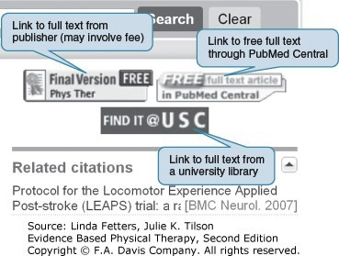

**BOX 2.2 Helpful Sources for Obtaining Free Full­Text Articles**

|  |  |
| --- | --- |
| **Online Resource** | **Comments** |
| PubMed Central [www.pubmedcentral.nih.gov](http://www.pubmedcentral.nih.gov.ezproxy.library.tufts.edu/) | All NIH­funded studies published after April 2008 are available but may have up to a 12­month release delay. PubMed searches link to full text available through BioMed Central. |
| Article search [ptnow.org](http://ptnow.org/) | Available to American Physical Therapy Association members. Provides access to full text of Cochrane Library journals in the ProQuest Nursing and Allied Health database. |
| Free Medical Journals [http://highwire.stanford.edu.ezproxy.library.tufts.edu](http://highwire.stanford.edu.ezproxy.library.tufts.edu/) | Lists free journal titles by specialty. Free access may be limited to articles greater than 1 year old. |
| HighWire Press www.highwire. [stanford.edu](http://fadavispt.mhmedical.com/stanford.edu) | Maintained by Stanford University. Claims to have the largest library of free full­text articles anywhere. |
| Public Library of Science [www.plos.org](http://www.plos.org.ezproxy.library.tufts.edu/) | Online scientific journals built around a core principle of unrestricted access to research articles. |
| Google Scholar | A search by the search engine Google specific to research articles. Results will often provide a link to any freely available full text. |



Tufts University Hirsh Health Sciences Library

Access Provided by:

**SELF­TEST 2.3 Putting It All Together**

Now that you have had the opportunity to follow along on our search for information to inform our question about June Wilson, it is time for you to practice searching. Refer to the patient information for Jose Lopez in Self­Test 2.1 to guide you through a PubMed Search.

**Searchable Clinical Question**

For a 52­year­old male with knee osteoarthritis, what types of exercise are most effective for reducing pain and improving standing tolerance? Step­by­step search:

1. List important terms from the question.
2. Reorder those terms from most to least important (remember that this is your best guess; you can always reorder them again).
3. Use the MeSH Database within PubMed to search for MeSH terms that might be more effective for searching.
4. Add any other synonyms that you think are important descriptors of the question.
5. Enter each of your top­four or top­five terms separately in PubMed. Use the “History” tab to see how many articles are associated with each term.
6. Combine similar terms with the operator OR.
7. Combine the two most important concepts with the operator AND.
8. Keep combining until you narrow to less than 300 and greater than 0 articles.

If you get to less than 15 to 20 articles, click on that result to look at the articles that you found.

1. As needed, filter your search to get to your goal of 15 to 20 articles. Remember that study type, language, and time since publication are good filters to use.
2. Scan your articles’ titles and abstracts—how do they look?

Are there any clinical practice guidelines? Are there any systematic reviews?

Are there any randomized clinical trials?

1. Pick the three articles that are the highest evidence level and are close to the topic of exercise for persons with knee osteoarthritis.
2. Do your best to find a printable (.pdf file) copy of each article.

A final bit of advice: think of searching as learning to ride a bike. It probably isn’t as easy as it looks. However, just like riding a bike, with practice you become good at it. Don’t get discouraged—you will get it, we promise!

# SUMMARY

In Step 1 of the EBP process, we identify a need for information and develop a clinical question. Clinical questions can be divided into two types: background and foreground. Background questions seek general information and are more commonly asked when a topic or diagnosis is unfamiliar. Foreground questions are specific to an individual patient or group of patients. Searchable foreground clinical questions have three important parts: patient characteristics, patient management type (etiology, diagnosis, intervention, or prognosis), and outcome measures of interest. Outcome measures can address three different levels of the ICF model: body functions and structures, activity, and participation. A well­designed and focused searchable clinical question improves the efficiency of Step 2.

Downloaded 2024­3­12 11:15 A Your IP is 130.64.11.161

Chapter 2: Asking a Clinical Question and Searching for Research Evidence,

©2024 F.A. Davis Company. All Rights Reserved. [Terms of Use](http://fadavispt.mhmedical.com/ss/terms.aspx) • [Privacy Policy](http://fadavispt.mhmedical.com/privacy) • [Notice](http://fadavispt.mhmedical.com/ss/notice.aspx) • [Accessibility](http://fadavispt.mhmedical.com/about/accessibility.html)

**Page 25 / 31**

Tufts University Hirsh Health Sciences Library

Access Provided by:

Step 2, searching for research evidence, is conducted using online databases. Search engines are the user interfaces that allow us to efficiently search a database for the best available research evidence to inform a clinical question. PubMed is a freely available search engine that accesses MEDLINE, a comprehensive database of biomedical research evidence. Learning to use a search engine takes practice. Determining the best terms to use and how to narrow and broaden a search with Boolean operators such as OR and AND are examples of those skills. With practice, you can become an efficient user of your favorite search engines. Finally, accessing full­text articles is important for moving to Step 3, appraising research evidence. It is important to be familiar with the resources that you have available as a student and clinician to access free or low­cost full­text articles.

Downloaded 2024­3­12 11:15 A Your IP is 130.64.11.161

Chapter 2: Asking a Clinical Question and Searching for Research Evidence,

©2024 F.A. Davis Company. All Rights Reserved. [Terms of Use](http://fadavispt.mhmedical.com/ss/terms.aspx) • [Privacy Policy](http://fadavispt.mhmedical.com/privacy) • [Notice](http://fadavispt.mhmedical.com/ss/notice.aspx) • [Accessibility](http://fadavispt.mhmedical.com/about/accessibility.html)

**Page 26 / 31**



Tufts University Hirsh Health Sciences Library

Access Provided by:

**REVIEW QUESTIONS**

1. Think of a person with a medical condition. The person might be a physical therapy patient you have encountered or a friend or family member. What questions do you have about that person’s medical condition? Can you think of a question for each of the four areas of clinical questions: etiology, diagnosis, intervention, and prognosis?
2. Choose one of the questions that you identified for question 1. Formulate that question into both a background (general) and foreground (patient­specific) question. Check to make sure that the foreground question contains all three important components. Background question:

Foreground question:

1. Search PubMed for the best available research evidence to inform the following question. Follow a step­by­step approach to make the search more manageable.

*For a 62­year­old grandmother 2 months post­stroke, is body­weight­supported treadmill training an effective modality for improving gait speed and balance?*

**Step 1.** First write out all of the search terms that you think might be helpful for this question. Don’t forget to think of synonyms (e.g., stroke and cerebrovascular accident).

Use the MeSH terms database in PubMed to check your terms list against the terms used to index articles in the MEDLINE database.

Prioritize your terms from most to least important.

On the “Advanced” page in PubMed, enter your first four to six terms individually. How many articles came up for each term? Combine any synonym terms with OR to find all of the articles that contain *either* term.

Now, one at a time, use AND to look for articles that contain two important terms (or concepts combined with OR).

Combine terms to find between 5 and 20 articles, and scan the article titles and abstracts to assess the quality of the results. Use the filters to limit articles to the past 5 years and English language.

Use the filters tab to search for different types of articles.

**Step 2.** How many applicable clinical practice guidelines did you find?

**Step 3.** How many applicable systematic reviews did you find?

**Step 4.** How many applicable randomized controlled trials did you find? Next, review the abstracts of the best articles and the best single article.

**Step 5.** Review the first 10 “Similar Articles” in PubMed—can you identify anything better?

**Step 6.** Describe at least one method you can use to access the full text of the article you chose and print it out.

**Step 7.** Practice using the “Send to” menu to send your article to the clipboard or a My NCBI collection.

Use the “Clinical Queries” PubMed tool as an alternate search method for your question. Compare the articles you found with the first search to the “Clinical Queries” results. Are the articles similar? Which search method worked best?

# REFERENCES

1. American Physical Therapy Association. *Guide to Physical Therapist Practice.* 2nd ed. Alexandria, VA: American Physical Therapy Association; 2001.

Downloaded 2024­3­12 11:15 A Your IP is 130.64.11.161

Chapter 2: Asking a Clinical Question and Searching for Research Evidence,

©2024 F.A. Davis Company. All Rights Reserved. [Terms of Use](http://fadavispt.mhmedical.com/ss/terms.aspx) • [Privacy Policy](http://fadavispt.mhmedical.com/privacy) • [Notice](http://fadavispt.mhmedical.com/ss/notice.aspx) • [Accessibility](http://fadavispt.mhmedical.com/about/accessibility.html)

**Page 27 / 31**

1. World Health Organization. *International Classification of Functioning, Disability and Health: ICF.* Geneva, Switzerland: World Health Organization; 2001.
2. DiCenso A, Bayley L, Haynes RB. ACP Journal Club. Editorial: Accessing preappraised evidence: fine­tuning the 5S model into a 6S model. *Ann Intern Med.* 2009;151(6):JC3–2, JC3–3. [[PubMed: 19755349]](http://www-ncbi-nlm-nih-gov.ezproxy.library.tufts.edu/pubmed/19755349)
3. Fact Sheet MEDLINE®. NIH website. [https://www­nlm­nih­gov.ezproxy.library.tufts.edu/pubs/factsheets/medline.html](https://www-nlm-nih-gov.ezproxy.library.tufts.edu/pubs/factsheets/medline.html); 2016.
4. [PubMed database. Bethesda, MD: National Center for Biotechnology Information, U.S. National Library of Medicine; 2016. http://www­ncbi­nlm­nih­ gov.ezproxy.library.tufts.edu/sites/entrez/.](http://www-ncbi-nlm-nih-gov.ezproxy.library.tufts.edu/sites/entrez/)
5. Turning Research Into Practice (TRIP) database. Newport, UK: Trips Database Ltd.; 2016. [http://www.tripdatabase.com](http://www.tripdatabase.com/).
6. National Guideline Clearinghouse. Rockville, MD: Agency for Healthcare Research and Quality; 2016. [http://www.guidelines.gov](http://www.guidelines.gov/).
7. Physiotherapy Evidence Database: PEDro. New South Wales, Australia: University of Sydney; 2016. <http://www.pedro.fhs.usyd.edu.au/>.
8. Criteria for inclusion on PEDro: PEDro scale. PEDro website. <http://www.pedro.fhs.usyd.edu.au/scale_item.html>; 2016.
9. Maher CG, Sherrington C, Herbert RD, Moseley AM, Elkins M. Reliability of the PEDro scale for rating quality of randomized controlled trials. *Phys Ther.* 2003;83:713–721. [[PubMed: 12882612]](http://www-ncbi-nlm-nih-gov.ezproxy.library.tufts.edu/pubmed/12882612)
10. PT Now database. Alexandria, VA: American Physical Therapy Association; 2016. [http://www.ptnow.org](http://www.ptnow.org/).
11. Cochrane Collaboration. Cochrane Reviews. [https://www­cochrane­org.ezproxy.library.tufts.edu/](https://www-cochrane-org.ezproxy.library.tufts.edu/); 2016.
12. Langevin P, Desmeules F, Lamothe M, Robitaille S, Roy JS. Comparison of 2 manual therapy and exercise protocols for cervical radiculopathy: a randomized clinical trial evaluating short­term effects. *J Orthop Sports Phys Ther.* 2015;45(1):4–17. [[PubMed: 25420010]](http://www-ncbi-nlm-nih-gov.ezproxy.library.tufts.edu/pubmed/25420010)
13. MedlinePlus database. Bethesda, MA: U.S. National Library of Medicine; 2016. [http://www.medlineplus.gov](http://www.medlineplus.gov/).
14. National Institute of Neurological Disorders and Stroke website. [http://www.ninds.nih.gov.ezproxy.library.tufts.edu](http://www.ninds.nih.gov.ezproxy.library.tufts.edu/); 2016.
15. National Multiple Sclerosis Society website. [http://www.nationalmssociety.org](http://www.nationalmssociety.org/); 2016.
16. National Stroke Association website. [http://www.stroke.org](http://www.stroke.org/); 2016.

# ANSWERS TO SELF­TEST

## SELF­TEST 2.1

|  |  |  |
| --- | --- | --- |
| **Body Functions and Structures** | **Activity** | **Participation** |
| Example: Lumbar | Example: | Example: |
| spine range of motion | Prolonged sitting | Occupation–truck driver |
| 1. Lumbar range of motion | 1. Sitting tolerance | 1. Truck driver |
| 2. Average pain on 0–10 scale | 2. Standing tolerance | 2. Tractor mechanic |
| 3. Trunk muscle strength | 3. Lifting capacity | 3. Spouse |

 For a 55­year­old truck driver with low back pain, is physical therapy care or chiropractic care more effective for improving trunk strength?

 For a 55­year­old male with low back pain, are stabilization exercises or strength training exercises more effective for improving sitting tolerance?  For a 55­year­old male with low back pain, is bedrest or a walking program more likely to improve likelihood to return to work as a truck driver?

## SELF­TEST 2.2

Student questions will vary; two sample questions are as follows, with the question type and component of patient management noted in parentheses: What types of knee problems cause pain with prolonged standing? (Background question, diagnosis)

For a 52­year­old male with knee osteoarthritis, is water or land exercise more effective for improving standing and walking tolerance? (Foreground question, intervention, three question parts are underlined)

## SELF­TEST 2.3

Answers to question 1 include the following: osteoarthritis, exercise, pain, and standing tolerance. The answers to questions 2–12 are dynamic, and the results depend on your search. Answers will change from day to day and sometimes hour to hour.

# PRACTICE ACTIVITIES

## PubMed Search

The purpose of this assignment is to develop your skills using PubMed to find the *best* possible article to answer a searchable clinical question. PubMed is a freely available *search engine* used to search the Medline *database.* The Medline database is managed by the U.S. National Library of Medicine. Although PubMed is free ([pubmed.gov](http://pubmed.gov/)), you should *always* access PubMed through your institution’s library. This will allow you to link directly to the full text of articles paid for by the library.

Prior to starting the lab, you should establish and access your My NCBI account on PubMed. (If you do not already have a My NCBI account, create one now. See [Figure 2.7](http://fadavispt.mhmedical.com/#eviphyther_ch2fg7) and Digging Deeper 12.1 to assist you in setting up an account.)

## Introduction

*For a 45­year­old female with chronic neck pain, what exercises are most appropriate for reducing pain and improving function, including return to golf?*

## Step 1: List Potential Keywords

 Potential keywords are extracted from the searchable clinical question.

 You are trying to guess what terms are associated with the best articles to answer your question.

PubMed will search the title, abstract, text, and assigned MeSH in all articles in the database. When your question is about treatment, you will usually need to include a diagnosis/impairment/problem term (e.g., *neck pain*) and treatment method term (e.g., *exercise*). An outcome term (e.g., *function*) often helps to narrow your search. A topic­area term (e.g., *recreation/sports/golf*) will also help to narrow your search.

**Potential Keywords**

Female

Neck, neck pain Chronic Exercise

Pain Function

Rehabilitation Golf

## Step 2: Reorder Terms by Importance

Knowing what terms are most important takes practice through trial and error. (Note: There are countless paths to the same article—the exact order that you pick to enter terms is not what is important; finding the best article is what matters.)

**Reorder the terms by importance:**

Neck pain Exercise Chronic Pain Function

Rehabilitation Golf

Female

## Step 3: Enter Your Terms One at a Time

Use “Advanced Search” at PubMed@USC. Enter new term and click “add to history.”

 See how many citations are associated with each term. Click “Items found” to see the articles.

Looking at the results may give you new ideas for better terms.

## Step 4: Combine Terms Using OR, AND, or NOT

 First, you are going to use OR to link together two or three synonyms or like terms for a single concept (e.g., *function OR recovery of function OR rehabilitation*). This will increase the number of results you get. An easy way to remember this concept is “OR is MORE.”

 Neck pain OR chronic neck pain  Exercise OR physical activity

 Function OR recovery of function OR rehabilitation

 Next, we will combine our concepts using AND. AND narrows your search results because it is telling the database to only return articles that talk about each of the concepts (e.g., neck pain AND exercise).

 Parentheses placement matters, so let the database use AND to link your concepts together.  Use the # symbol to combine search items in “Advanced Search.”

## Step 5: Use Filters as Needed

 The goal is to get down to less than 20 potential articles to scan a reasonable number for the best­sounding titles, journals, and abstracts.  If you are searching a topic with lots of studies (like neck pain), it is best to limit your search using filters.

 When you are searching more obscure topics, filters may not be required.  If you aren’t finding many articles, the “See related” link can be very useful.

## Step 6: Save the Article Links and Your Search Strategy

You can save articles *temporarily* on the clipboard.

You can save articles *permanently* using My NCBI Collections.

You can also save your search, then run it in the future to see if any new articles have been published. You can have My NCBI e­mail you with updates on a saved search.