NEXUS-ARTIFACT-APPLICATION

**First create on EC2 Instance**

--------------------------------------------

Server name = nexus-artifact-applicaton

OS = Ubuntu

Instance_type = t2.medium

Key pair = nexus

Lanch instance

**Connect to server**

-------------------------------------

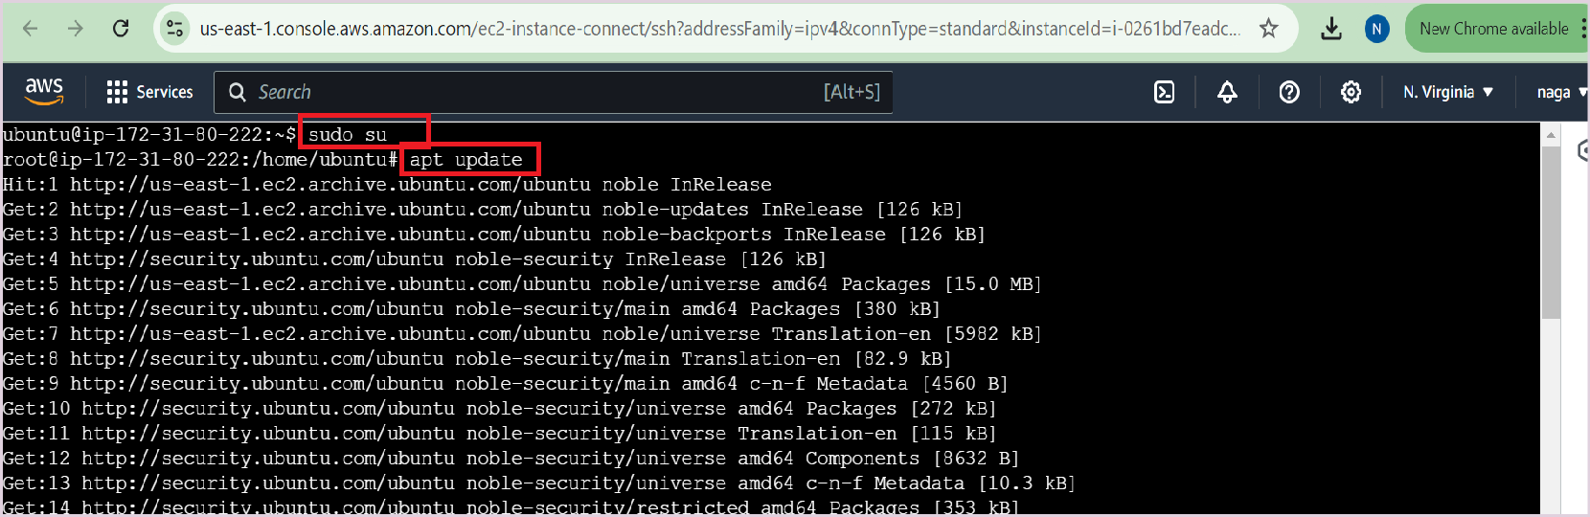

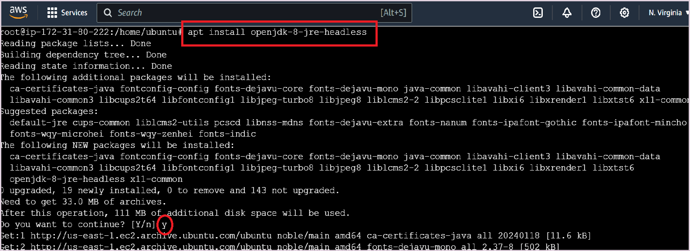

<https://github.com/BecomeDevops/Nexus/blob/main/NexusDowloadSteps>

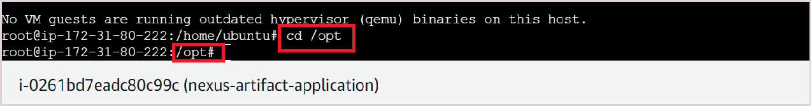

wget <https://download.sonatype.com/nexus/3/nexus-3.63.0-01-unix.tar.gz>

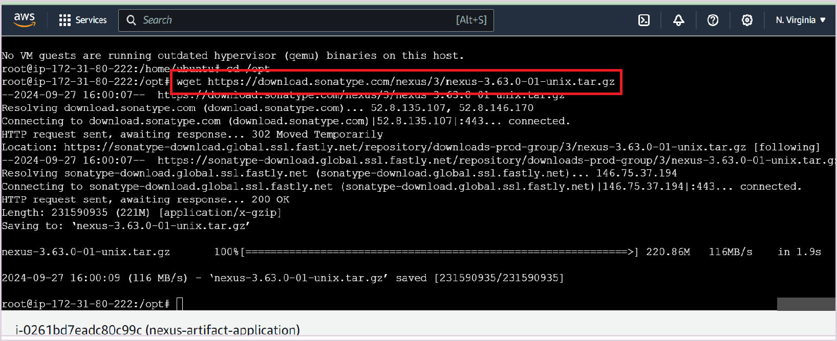

tar -zxvf nexus-3.63.0-01-unix.tar.gz

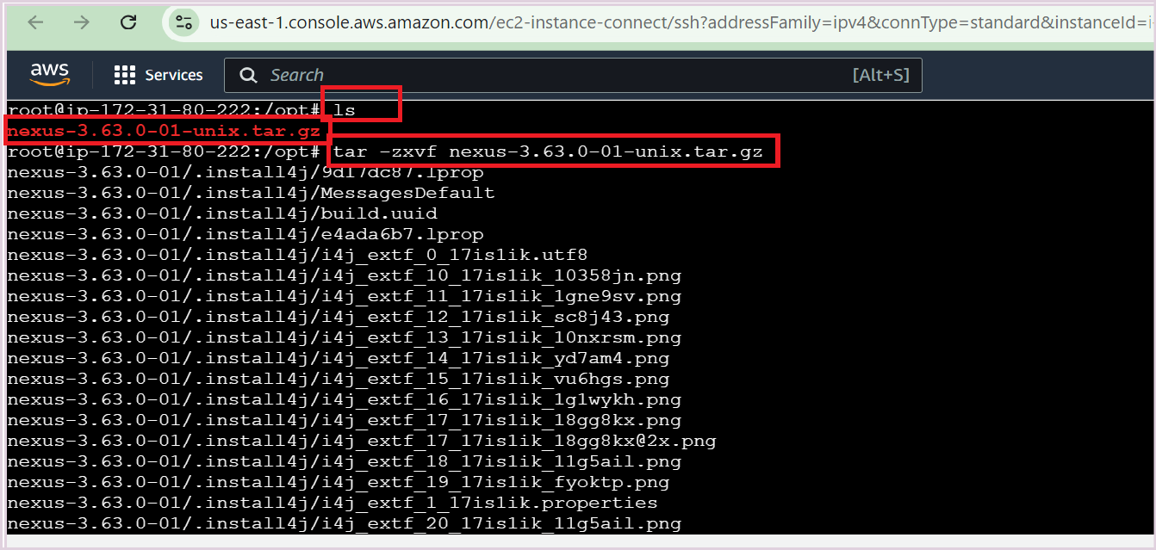

mv /opt/nexus-3.63.0-01 /opt/nexus

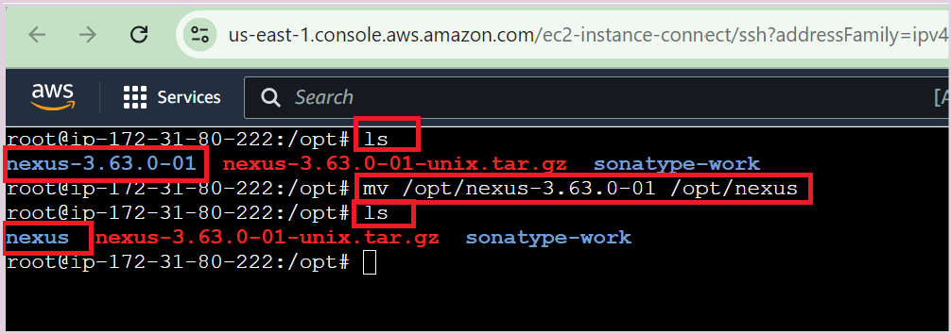

sudo adduser nexus

**add no password for nexus by opening below visudo file**

---------------------------------------------------------

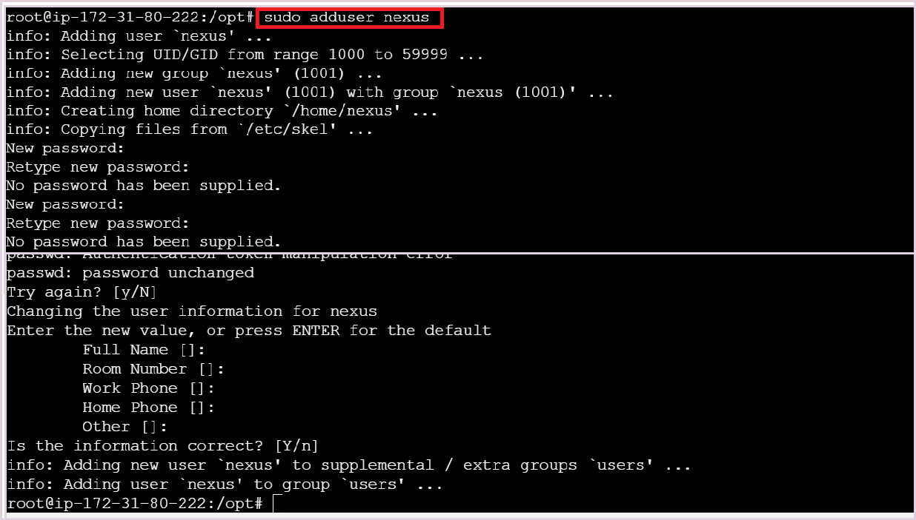

sudo visudo

nexus ALL=(ALL) NOPASSWD: ALL

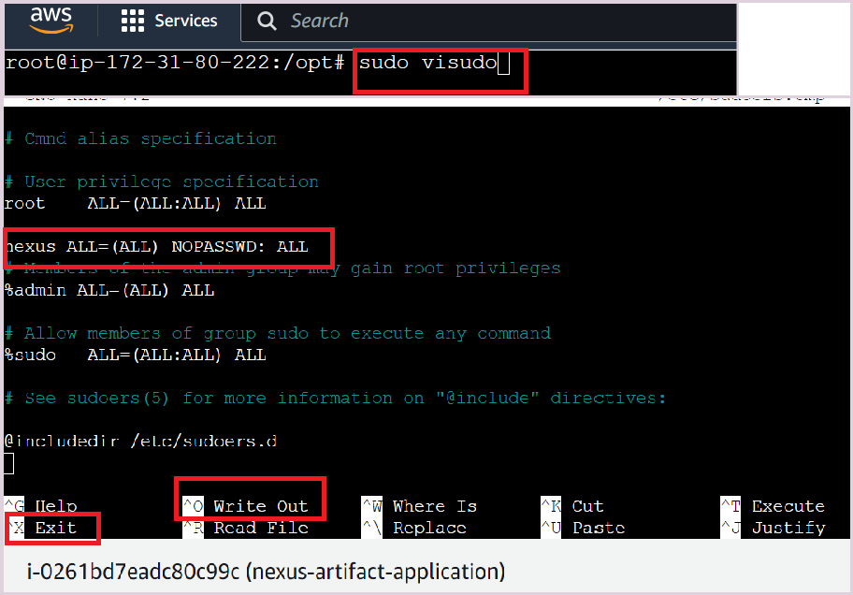

**EXIT**

**--------------**

Ctrl+o

Click Enter button ctrl+x

sudo chown -R nexus:nexus /opt/nexus

sudo chown -R nexus:nexus /opt/sonatype-work

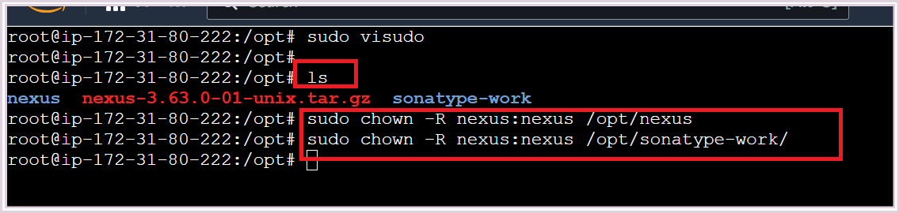

To run nexus as service at boot time, open /opt/nexus/bin/nexus.rc file, uncomment it and add nexus user as shown below

sudo nano /opt/nexus/bin/nexus.rc

run_as_user="nexus"

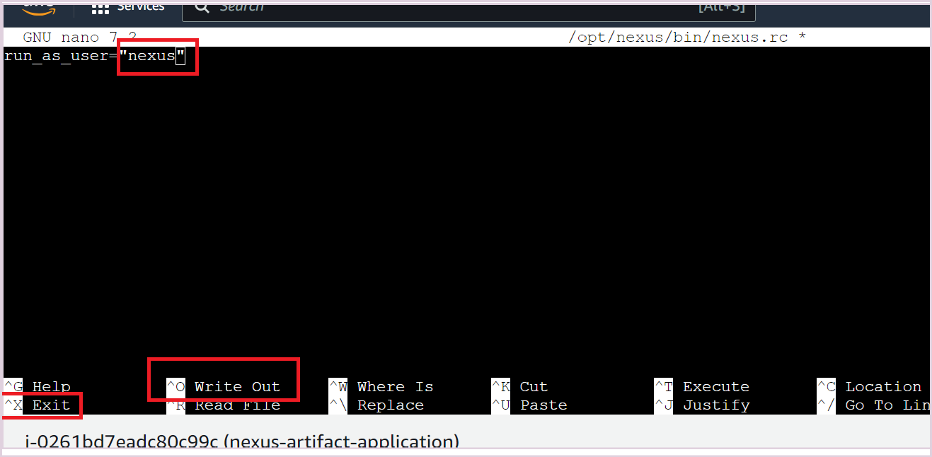

**To run nexus as service using System**

sudo nano /etc/systemd/system/nexus.service

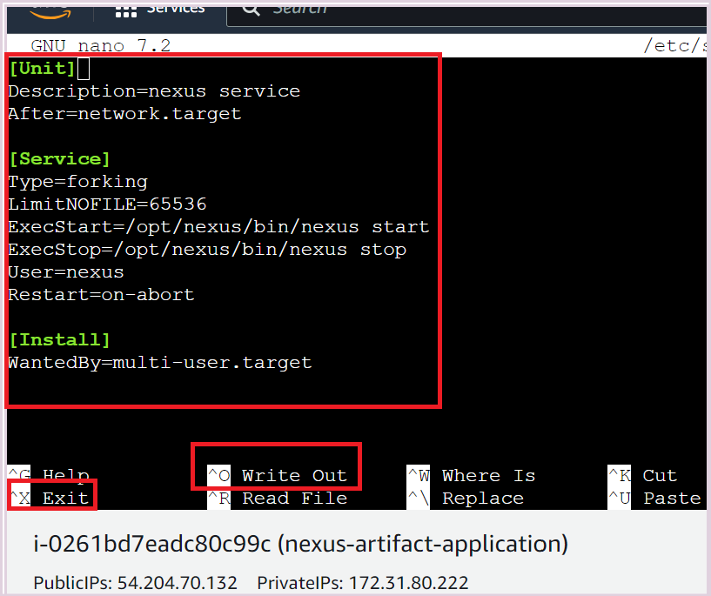

[Unit]

Description=nexus service

After=network.target

[Service]

Type=forking

LimitNOFILE=65536

ExecStart=/opt/nexus/bin/nexus start

ExecStop=/opt/nexus/bin/nexus stop

User=nexus

Restart=on-abort

[Install]

WantedBy=multi-user.target

**To start nexus service using systemctl**

sudo systemctl start nexus

**To enable nexus service at system startupsudo systemctl enable nexus**

**To check nexus service status**

sudo systemctl status nexus

**To stop Nexus service**

sudo systemctl stop nexus

**if the nexus service is not started, you can the nexus logs using below command**

tail -f /opt/sonatype-work/nexus3/log/nexus.log

We have covered How to Install Nexus Repository on Ubuntu 20.04 LTS.

Access Nexus Repository Web Interface

To access Nexus repository web interface , open your favorite browser

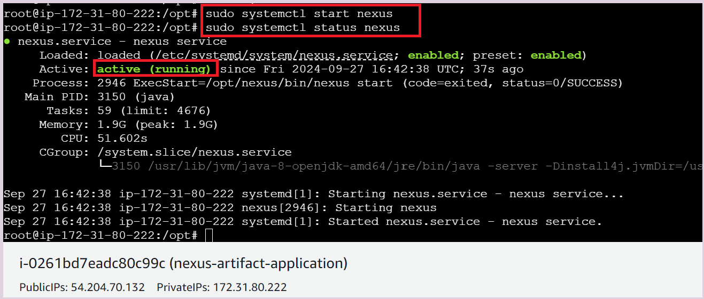

**open the firewall port(port on security group) 8081**

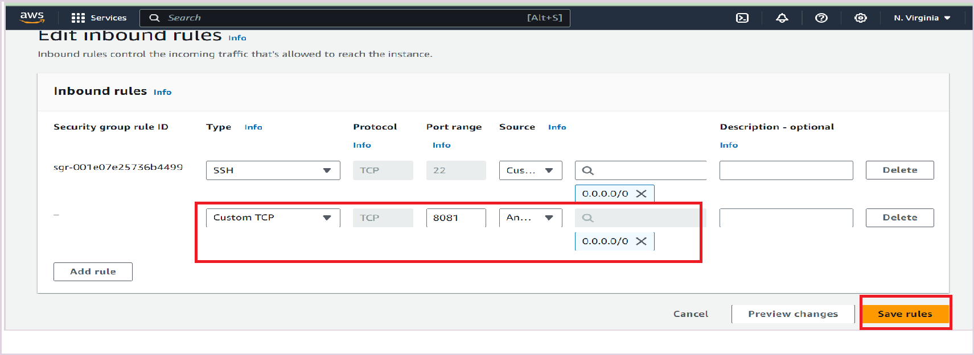

Public IPv4 address

54.204.70.132 | [open address](https://54.204.70.132/)

**Search chrome**

54.204.70.132:8081

