MAJOR PROJECT REPORT

CONVOLUTIONAL NEURAL NETWORKS (CNN) FOR
STRUCTURAL DAMAGE CLASSIFICATION IN
CIVIL INFRASTRUCTURE

Submitted in fulfillment of the award of Degree of Bachelor of Technology in Computer Science and Engineering

Submitted by

N.VARSHINI | P.NANDINI REDDY | P.MOHANA
(21RH1A05G6) | (21RH1A05J8) | (21RH1A05K4)

Under the Esteemed Guidance of
Dr. K.Venkate Naganjaneyulu

Professor

Department of Computer Science and Engineering

MALLA REDDY ENGINEERING COLLEGE FOR WOMEN
Autonomous Institution, UGC, Govt. of India
Accredited by NBA & NAAC with ‘A⁺’ Grade
NIRF Indian Ranking, Accepted by MHRD, Govt. of India
Band-A (6-25th) National Ranking by ARIIA, Accepted by MHRD, Govt. of India Affiliated to JNTUH, Approved by AICTE, ISO 9001:2015 Certified Institution Maisammaguda, Dhullapally (post), Secunderabad, TELANGANA
2024-2025


MALLA REDDY ENGINEERING COLLEGE FOR WOMEN
Autonomous Institution, UGC, Govt. of India
Programmes Accredited by NBA
Accredited by NAAC with A+ Grade
Affiliated to JNTUH, Approved by AICTE, ISO 9001:2015 Certified Institute
Maisammaguda (V), Dhullapally (Post), (Via) Kompally, Medchal Malkajgiri Dist. T.S-500100

DEPARTMENT OF COMPUTER SCIENCE AND ENGINEERING

CERTIFICATE

This is to certify that the Innovative product development entitled “CONVOLUTIONAL NEURAL NETWORKS (CNN) FOR STRUCTURAL DAMAGE CLASSIFICATION IN CIVIL INFRASTRUCTURE” is carried out by N.VARSHINI (21RH1A05G6), P.NANDINI REDDY (21RH1A05J8), P.MOHANA (21RH1A05K4), in partial fulfillment for the award of degree of BACHELOR OF TECHNOLOGY in Computer Science and Engineering to Malla Reddy Engineering College For Women, Maisammaguda, Secunderabad, during the academic year 2023-2024 is a record of bonafide piece of work, undertaken by the supervision of the undersigned.

Supervisor’s Signature | Head of the Department
Dr. K.Venkate Naganjaneyulu Dr. Y. Geetha Reddy
Professor Professor and HOD

EXTERNAL EXAMINER

MALLA REDDY ENGINEERING COLLEGE FOR WOMEN
Autonomous Institution, UGC, Govt. of India
Programmes Accredited by NBA
Accredited by NAAC with A+ Grade
Affiliated to JNTUH, Approved by AICTE, ISO 9001:2015 Certified Institute
Maisammaguda (V), Dhullapally (Post), (Via) Kompally, Medchal Malkajgiri Dist. T.S-500100

Department Of Computer Science and Engineering

DECLARATION

We ‘N.VARSHINI (21RH1A05G6), P.NANDINI REDDY (21RH1A05J8), P.MOHANA (21RH1A05K4), are students of ‘Bachelor of Technology in Computer Science and Engineering’, session: 2024-2025, Malla Reddy Engineering College for Women, Maisammaguda, Secunderabad, hereby declare that the work presented in this Project Work entitled ‘CONVOLUTIONAL NEURAL NETWORKS (CNN) FOR STRUCTURAL DAMAGE CLASSIFICATION IN CIVIL INFRASTRUCTURE’ is the outcome of our own bonafide work and is correct to the best of our knowledge and this work has been undertaken taking care of Engineering Ethics. It contains no material previously published or written by another person nor material which has been accepted for the award of any other degree or diploma of the university or other institute of higher learning, except where due acknowledgment has been made in the text.

N.VARSHINI (21RH1A05G6)

P.NANDINI REDDY (21RH1A05J8)

P. MOHANA (21RH1A05K4)

ACKNOWLEDGEMENT

We feel ourselves honored and privileged to place our warm salutation to our college Malla Reddy Engineering College for Women and Department of Computer Science and Engineering which gave us the opportunity to have expertise in engineering and profound technical knowledge.
We would like to deeply thank our Honorable Minister of Telangana State Sri.Ch. Malla Reddy Garu, founder chairman MRGI, the largest cluster of institutions in the state of Telangana for providing us with all the resources in the college to make our project success.
We wish to convey gratitude to Dr. Y. Madhavee Latha, Principal for providing us with the environment and mean to enrich our skills and motivating us in our endeavor and helping us to realize our full potential.
We express our sincere gratitude to Dr. Y Geetha Reddy, Professor and Head of the Department of Computer Science and Engineering for inspiring us to take up a project on this subject and successfully guiding us towards its completion.
We would like to thank our internal guide Dr. K.Venkate Naganjaneyulu, and all the faculty members for their valuable guidance and encouragement towards the completion of our project work.

With regards and Gratitude

N.VARSHINI (21RH1A05G6)

P. NANDINI REDDY (21RH1A05J8)

P. MOHANA (21RH1A05K4)

ABSTRACT

Crack detection in concrete and pavement surfaces is vital for maintaining the integrity and safety of infrastructure. Traditional methods, such as manual inspections and basic imaging techniques, are labor-intensive, time-consuming, and prone to human error. These limitations necessitate the development of more efficient and accurate systems for detecting and assessing cracks. This project explores the application of Deep Learning to automate crack detection in concrete and pavement surfaces, offering a reliable and scalable solution for infrastructure maintenance. Traditional crack detection systems, including manual inspections and basic imaging techniques, face significant limitations such as high labor costs, inconsistency, and limited coverage. In contrast, the DL-based system improves accuracy, efficiency, and cost-effectiveness. It reduces the need for manual labor, minimizes the risk of human error, and offers comprehensive monitoring capabilities that traditional methods lack. The proposed DL-based system utilizes advanced algorithms to analyze high-resolution images and sensor data, identifying and classifying cracks with high accuracy. This approach addresses the primary challenge of traditional methods, which often fail to provide consistent and comprehensive monitoring. By automating the detection process, the system can continuously monitor large areas, providing real-time data that enhances maintenance decision-making.The significance of this project lies in its potential to revolutionize infrastructure maintenance. Enhanced accuracy and real-time monitoring capabilities can prevent minor cracks from escalating into major structural failures, improving safety and extending the lifespan of concrete and pavement structures. By leveraging Deep Learning, this project aims to provide a robust, scalable solution for timely and accurate crack detection, ultimately leading to more effective and economical infrastructure management.

 | INDEX
Chapter | Title | i
 | Certificate | ii
 | Declaration | iii
 | Acknowledgement | iv
 | Abstract | v
[1] | INTRODUCTION | 1-3
[2] | SYSTEM ANALYSIS | 4-18
[2.1] | Existing System | 4-9
[2.2] | Proposed System | 10-18
[3] | SCOPE OF THE PROJECT | 19-20
[3.1] | Purpose | 19
[3.2] | Objective | 19-20
[3.3] | Importance | 20
[4] | REQUIREMENTS ANALYSIS | 21
[4.1] | Software Requirements | 21
[4.2] | Hardware Requirements | 21
[5] | DATA DESIGN | 22-29
[5.1] | System Architecture | 22
[5.2] | System Implementation | 23
[5.3] | UML Diagrams | 24
[5.3.1] | Use Case Diagram | 24
[5.3.2] | Sequence Diagram | 24-25
[5.3.3] | Class Diagram | 25-26
[5.3.4] | Component Diagram | 26-27
[5.3.5] | Deployment Diagram | 27-28
[5.3.6] | State Diagram | 28-29

[6] | SYSTEM TESTING | 30-33
[6.1] | Unit Testing | 30
[6.2] | Functional Testing | 30-31
[6.3] | System Testing | 31
[6.4] | White box Testing | 32
[6.5] | Black box Testing | 32
[6.6] | Integration Testing | 33
[7] | RESULTS AND DISCUSSION | 34-48
[8] | SUMMARY | 49-50
[8.1] | Conclusion | 49
[8.2] | Future Scope | 50
[9] | REFERENCES | 51-52

INTRODUCTION

1.1 Introduction

Crack detection in concrete and pavement surfaces is a critical aspect of infrastructure maintenance, with significant implications for safety and longevity. Historical data shows that infrastructure degradation, including cracking, contributes to substantial economic losses and safety hazards. For instance, the Federal Highway Administration (FHWA) reported in 2020 that over 40% of the nation's roads are in poor or mediocre condition, largely due to surface cracks and deterioration. Similarly, a study by the American Society of Civil Engineers (ASCE) in 2021 highlighted that the annual cost of repairing and maintaining infrastructure affected by cracks exceeds $150 billion in the United States alone. These statistics underline the importance of effective crack detection systems.

Traditional crack detection methods, such as visual inspections and basic imaging techniques, have been the cornerstone of infrastructure assessment. However, these approaches often face significant challenges. A 2018 survey by the International Journal of Concrete Structures and Materials found that manual inspections are prone to human error, with a detection accuracy rate of only 60% under optimal conditions. Additionally, basic imaging methods, such as static cameras, can miss fine cracks or fail to capture data in real-time. The development of more advanced detection systems, such as those employing Deep Learning and high-resolution imaging, is crucial for addressing these limitations and improving the overall efficiency and accuracy of crack monitoring.

1.2 Motivation

Crack detection experts face numerous challenges that highlight the need for more advanced systems. One of the primary issues is the labor-intensive nature of manual inspections, which often require teams of inspectors to examine large areas over extended periods. This approach is not only time-consuming but also costly, with inspection teams spending significant resources on labor and equipment. According to a 2019 report by the Transportation Research Board, the average cost of manual crack inspections can range from $1,000 to $3,000 per mile of road, depending on the inspection frequency and method used.
Moreover, manual inspections are inherently subjective and prone to variability in detection accuracy. Factors such as lighting conditions, inspector fatigue, and human error can significantly affect the quality of the assessment. This variability often results in inconsistent crack detection and can lead to missed or misclassified cracks. The need for a more reliable and objective system is evident, as traditional methods fail to provide comprehensive and consistent monitoring. Implementing advanced systems, such as DL-based crack detection, can address these issues by automating the detection process, reducing labor costs, and improving overall accuracy.

1.3 Problem Statement

Manual crack detection approaches present several limitations that underscore the need for automation. Traditional methods, including visual inspections and basic imaging techniques, often struggle with issues such as high labor costs, inconsistent results, and limited coverage. For example, visual inspections, while effective for identifying large cracks, may overlook smaller or more subtle defects. Additionally, manual inspections are constrained by the speed at which inspectors can examine surfaces, leading to potential delays in identifying and addressing issues.

The need for automation arises from these limitations. Manual methods are not only resource-intensive but also prone to human error, resulting in inaccuracies and incomplete assessments. Automation through Deep Learning can provide a solution by offering a more consistent and reliable means of detecting cracks. DL algorithms can analyze high-resolution images and sensor data with greater precision and speed than human inspectors, allowing for real-time monitoring and early detection of potential issues. This transition to automated systems addresses the shortcomings of traditional methods and enhances the overall efficiency and effectiveness of crack detection.

1.4 Applications

- Infrastructure Maintenance: DL-based crack detection systems can be used for ongoing monitoring and maintenance of roads, bridges, and buildings. By providing real-time data on crack conditions, these systems enable timely repairs and help prevent
further structural degradation.
- Construction Quality Control: During the construction phase, DL systems can monitor concrete and pavement surfaces to ensure compliance with quality standards. This proactive approach can identify issues before they become significant problems, improving overall construction quality.
- Safety Inspections: Automated crack detection can be integrated into routine safety inspections of critical infrastructure, such as highways and public transportation systems. This application ensures that potential hazards are identified quickly, enhancing public safety.
- Urban Planning: DL-based systems can assist urban planners by providing data on the condition of existing infrastructure. This information is valuable for making informed decisions about infrastructure investments and prioritizing maintenance efforts.
- Historical Preservation: For historical buildings and monuments, DL crack detection systems can be used to monitor and preserve the structural integrity of heritage sites. This application helps in maintaining the safety and longevity of culturally significant structures while minimizing invasive inspection methods.

2. SYSTEM ANALYSIS

2.1 EXISTING SYSTEM:

Overview

Crack detection in concrete and pavement surfaces is a crucial task in infrastructure maintenance, aimed at ensuring structural integrity and safety. Traditional systems for crack detection rely on manual inspection and basic imaging techniques. Despite being widely used, these methods have significant limitations in terms of accuracy, efficiency, and scalability. This overview provides an in-depth examination of traditional crack detection systems, discussing their methodologies, challenges, and limitations.

1. Manual Inspection

Manual inspection is one of the most traditional methods used for crack detection. This approach involves visual examination of concrete and pavement surfaces by trained inspectors. The process typically includes walking along the surface, visually identifying cracks, and recording their locations and dimensions. Manual inspection is often performed using tools such as rulers or calipers to measure crack width and depth.

1.1 Methodology

Manual inspections are conducted either as part of routine maintenance or in response to specific concerns such as observed damage or structural anomalies. Inspectors evaluate the severity and type of cracks based on visual cues and sometimes use handheld magnifying devices to examine finer details. The collected data is then manually entered into a record-keeping system for further analysis.

1.2 Challenges

- Subjectivity: The accuracy of manual inspections is heavily reliant on the inspector’s experience and skill. Different inspectors might have varying interpretations of crack severity and significance, leading to inconsistent results.
- Labor Intensity: Manual inspections are time-consuming and require significant human resources, especially for large infrastructure projects. Inspectors must cover extensive areas, which can be both physically demanding and costly.
- Limited Coverage: Manual inspections may miss smaller cracks or defects that are not easily visible to the naked eye. Additionally, some areas might be inaccessible or unsafe for inspectors to examine thoroughly.

2. Basic Imaging Techniques

Basic imaging techniques involve capturing images of concrete and pavement surfaces using standard cameras or video equipment. These images are then analyzed either manually or with the help of simple image processing tools to detect cracks. Traditional imaging methods include static cameras, video recordings, and photographic documentation.

2.1 Methodology

Basic imaging techniques typically involve capturing high-resolution images of the surface from various angles and distances. These images are reviewed manually by experts or processed using basic software tools to identify and assess cracks. In some cases, simple image processing techniques such as thresholding and edge detection are applied to enhance crack visibility.

2.2 Challenges

- Resolution Limitations: Standard cameras may not capture the level of detail required to identify fine or hairline cracks. Low-resolution images can result in missed or inaccurately assessed cracks.
- Environmental Conditions: Image quality can be affected by factors such as lighting conditions, weather, and surface cleanliness. Shadows, glare, and dirt can obscure cracks, making them difficult to detect.
- Manual Analysis: Manual analysis of images is prone to human error and can be time-consuming. Experts must carefully review each image, which can lead to inconsistencies and missed detections.

3. Image Processing Techniques

To address some of the limitations of basic imaging, various image processing techniques have been developed to enhance crack detection. These techniques include edge detection, thresholding, and filtering methods, which are used to process images and highlight cracks.

3.1 Methodology

- Edge Detection: Edge detection algorithms, such as the Sobel and Canny edge detectors, are used to identify the boundaries of cracks in images. These algorithms work by detecting changes in pixel intensity that correspond to edges.
- Thresholding: Thresholding techniques involve setting a specific intensity value to distinguish cracks from the background. Methods like Otsu’s thresholding are used to automate this process and enhance crack visibility.
- Filtering: Filtering techniques, such as median filtering, are applied to remove noise and improve the clarity of cracks in images. Filters can smooth out variations in pixel values and enhance the contrast between cracks and the surrounding surface.
3.2 Challenges
- Algorithmic Limitations: Traditional image processing algorithms may struggle with complex crack patterns or varying surface textures. They often require fine-tuning and parameter adjustments to achieve accurate results.
- Noise and Artifacts: Image processing techniques can be sensitive to noise and artifacts, which may interfere with crack detection. Noise from environmental factors or imperfections in the surface can affect the accuracy of the analysis.
- Computational Complexity: Some image processing methods can be computationally intensive, requiring significant processing power and time. This can be a limitation for real-time or large-scale applications.
4. Non-Destructive Testing (NDT) Methods

Non-destructive testing (NDT) methods provide additional tools for crack detection without damaging the surface. These methods include techniques such as ultrasonic testing, infrared thermography, and impact-echo testing.

4.1 Methodology

- Ultrasonic Testing: Ultrasonic testing involves sending high-frequency sound waves into the concrete or pavement and measuring the reflected waves. Variations in the reflected signal can indicate the presence of cracks or other defects.
- Infrared Thermography: Infrared thermography uses thermal imaging to detect temperature differences on the surface. Cracks and voids can cause variations in heat distribution, which are captured and analyzed using thermal cameras.
- Impact-Echo Testing: Impact-echo testing involves striking the surface with a hammer and analyzing the resulting acoustic waves. Changes in the wave pattern can indicate the presence of cracks or other anomalies within the material.
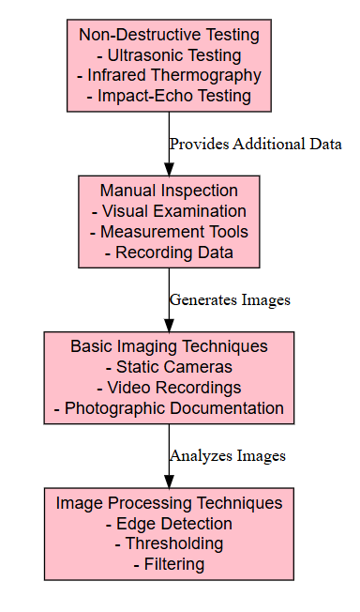

Figure 2.1: Architecture Diagram of Existing system.

4.2 Challenges

- Complexity and Cost: NDT methods can be complex and require specialized equipment and expertise. The cost of equipment and training can be prohibitive for some projects.
- Limited Accessibility: Some NDT methods may have limitations in terms of accessibility, especially for large or complex structures. For example, ultrasonic testing may be challenging for surfaces with irregular geometries.
- Interpretation of Results: The interpretation of NDT results requires specialized knowledge and experience. Misinterpretation of data can lead to incorrect assessments of crack severity or location.

- Summary of Existing Systems

Traditional crack detection systems, including manual inspections, basic imaging techniques, and non-destructive testing methods, have been fundamental in infrastructure maintenance. However, these methods have notable limitations, such as subjectivity, labor intensity, and limited coverage. While basic imaging and image processing techniques have improved crack visibility, they still face challenges related to resolution, environmental conditions, and algorithmic accuracy. Non-destructive testing methods offer valuable insights but come with complexities and costs.

The need for more accurate, efficient, and scalable solutions in crack detection has led to the exploration of advanced techniques, including Deep Learning and automated systems. These modern approaches aim to overcome the limitations of traditional methods by providing enhanced accuracy, real-time monitoring, and reduced manual effort. As infrastructure continues to age and maintenance demands increase, the evolution of crack detection technologies will play a crucial role in ensuring the safety and longevity of concrete and pavement surfaces.

2.2 PROPOSED SYSTEM:

Overview

The detailed procedure given as follows

Step 1. Library Importation: The research work begins by importing necessary libraries and modules required for the Deep Learning pipeline and image processing tasks. Libraries such as pandas and numpy are used for data manipulation, while scikit-learn provides various Deep Learning algorithms and metrics. Image processing is handled by cv2 and skimage, and visualization is managed by matplotlib. The research work also includes a directive to suppress warnings, which helps in avoiding clutter in the output due to non-critical warning messages.

Step 2. Data Preparation: Loading or Creating Data: The initial step in the data preparation phase involves checking for the existence of preprocessed data files (X.txt.npy and Y.txt.npy). If these files are present, they are loaded into the program, which saves time by avoiding redundant processing. If the files are not available, the research work proceeds to process the raw image data from the specified dataset directory. Each image is read using cv2.imread, resized to 64x64 pixels using skimage.transform.resize, and then flattened into a vector format. The images are labeled based on their directory names (e.g., 'No Crack', 'Crack'), and these labels are stored in the Y array. The processed images and labels are saved as numpy arrays for future use.

Step 3: Data Frame Creation: A DataFrame df is created using pandas, which combines the flattened image vectors (X) and their corresponding labels (Y). This DataFrame facilitates easier manipulation and inspection of the data during the model training and evaluation stages.

Step 4. Data Splitting: The dataset is divided into training and testing subsets using the train_test_split function from scikit-learn. This split is crucial for evaluating the performance of the Deep Learning models, as it ensures that the model is trained on one portion of the data and tested

on another, unseen portion. This helps in assessing how well the model generalizes to new, unseen data.

Step 5. Model Training and Evaluation: A function calculateMetrics is defined to evaluate the performance of the Deep Learning models. This function computes key metrics such as accuracy, precision, recall, and F1 score. Additionally, it generates confusion matrices using seaborn for visual inspection of model performance. The metrics provide insights into how well the model performs in classifying images into the correct categories, and the confusion matrix helps in understanding the distribution of classification errors.
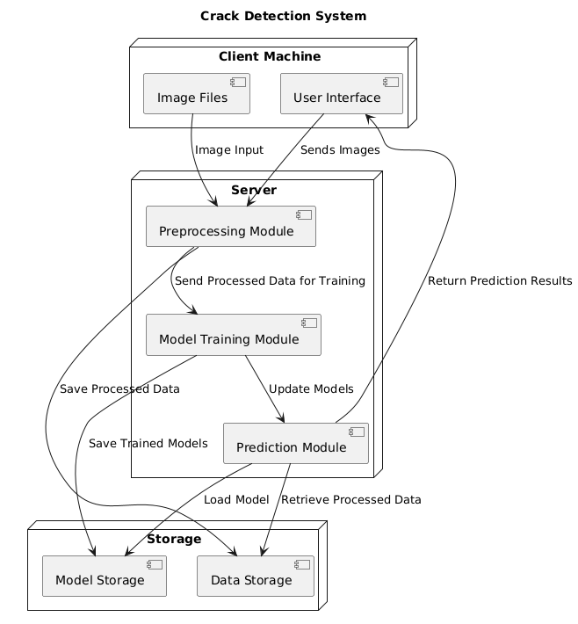
Figure 4.1: Architecture Diagram of Proposed system.
- Existing Support Vector Machine (SVM): The research work checks for the existence of a pre-trained SVM model. If the model is found, it is loaded and used to make predictions on the test data. If the model is not available, a new SVM model is trained (although, in this instance, LogisticRegression is used) and then saved for future use. This process ensures that the model can be reused without retraining, saving computational resources and time.

- Existing Random Forest Classifier: Similarly, the research work handles the Random Forest Classifier model. It checks if a pre-trained model exists and loads it if available. If not, it trains a new Random Forest model and saves it. The Random Forest Classifier is an ensemble method known for its robustness and effectiveness in classification tasks, making it suitable for detecting cracks in images.

- Proposed DLCNN Classification: A DLCNN takes these features as inputs to classify them. We use dropout layers and batch normalization to overcome overfitting and better generalize the network, which is trained for high accuracy and computational efficiency. The classification layer will give two classes, Normal and Damage, with respective probabilities representing prediction confidence. Integrating the feature extractor with the DLCNN classifier results in the highest level of precision and recall to date in datasets that capture a wide range of structural damage presentations.

Step 6. Model Prediction and Visualization: The final part of the research work involves making predictions on example images of both cracked and non-cracked surfaces. The paths to these example images are specified, and the images are preprocessed to match the input format required by the models (resized and flattened). The predictions are made using the trained DLCNN Classifier, and the results are visualized using matplotlib. Each image is displayed with a text overlay showing the predicted label, demonstrating how the model classifies new data. This visualization helps in assessing the model's practical performance and provides a visual confirmation of its predictions.

Preprocessing

The detailed image preprocessing steps are given as follows

1. Image Loading: The preprocessing phase begins with the loading of images from the dataset directory. This is accomplished using the cv2.imread function, which reads images in their raw pixel format. Each image is associated with a category label, either 'No Crack' or 'Crack', based on its directory. This step is crucial as it prepares the raw image data for further processing and analysis.

2. Image Resizing: Once the images are loaded, they need to be standardized to ensure uniformity across the dataset. This is achieved through resizing each image to a fixed dimension of 64x64 pixels using skimage.transform.resize. Resizing is important because it reduces the computational load by ensuring that all images have the same size and resolution, which simplifies the model's input requirements and helps in maintaining consistency during training and testing.

3. Image Flattening: After resizing, each image is flattened into a one-dimensional array. This process involves converting the 2D image matrix (64x64 pixels with 3 color channels) into a single vector. Flattening is necessary for feeding the image data into Deep Learning models that expect input in a vectorized format. The resulting flattened vectors are then appended to the feature matrix X.

4. Label Encoding: For each image, a corresponding label is assigned based on its directory name. These labels are converted into numerical values where 'No Crack' and 'Crack' are mapped to integers. This encoding is performed using the categories.index(name) function, where name represents the directory name. These numerical labels are stored in the target vector Y, which will be used during model training to map image data to their respective categories.

5. Data Storage: The preprocessed image data (features) and labels are stored as numpy arrays in files (X.txt.npy and Y.txt.npy). This step involves saving the arrays using np.save, which allows for efficient storage and retrieval of data. By saving these arrays, the preprocessing steps are not repeated in subsequent runs, thereby saving time and computational resources.
6. DataFrame Creation: The flattened image data and corresponding labels are combined into a pandas DataFrame. This DataFrame, df, includes the feature vectors as rows and an additional column for labels. Creating a DataFrame facilitates easy manipulation and inspection of the data and is useful for debugging and exploratory data analysis before feeding the data into Deep Learning models.

- Building DL Model

Support Vector Classifier

Overview: The Support Vector Machine (SVM) classifier is a supervised Deep Learning algorithm used for classification tasks. SVM works by finding the hyperplane that best separates the classes in the feature space. It aims to maximize the margin between different classes, which is the distance between the hyperplane and the closest data points from each class, known as support vectors.

Key Concepts:

- Hyperplane: The decision boundary that separates different classes.
- Margin: The distance between the hyperplane and the nearest data points from either class.
- Support Vectors: Data points that are closest to the hyperplane and influence its position and orientation.
Process:
- Data Transformation: SVM maps input features into a higher-dimensional space where a linear separation is easier.
- Kernel Trick: For non-linearly separable data, SVM uses kernels (like RBF, polynomial) to transform the data into a space where it is linearly separable.
- Optimization: SVM finds the optimal hyperplane by solving a quadratic optimization problem with constraints.

Strengths:

- Effective in high-dimensional spaces.
- Works well with both linear and non-linear data with the use of appropriate kernels.

Limitations:

- Computationally intensive, especially for large datasets.
- Performance can be affected by the choice of kernel and parameters.

Random Forest Classifier

Overview: The Random Forest classifier is an ensemble learning method that combines multiple decision trees to improve classification performance. It operates by creating a "forest" of decision trees during training and making decisions based on the majority vote from all the trees.

Key Concepts:
- Ensemble Learning: Combining multiple models to produce a better overall model.
- Decision Trees: Base models in Random Forest, where each tree makes a decision based on the features of the data.
- Bootstrap Aggregating (Bagging): Random Forest uses different subsets of the data to train multiple decision trees, reducing overfitting.
Process:

- Bootstrap Sampling: Randomly samples the data with replacement to create multiple subsets.
- Tree Construction: Each subset is used to build a decision tree, with random subsets of features considered for each split.
- Voting/Averaging: The final prediction is made by aggregating the predictions from all individual trees. For classification, a majority vote is taken.

Strengths:

- Robust to overfitting, as averaging multiple trees reduces variance.
- Handles large datasets with high dimensionality effectively.
- Provides feature importance measures.

Performance Comparison

The performance of the Random Forest Classifier (RFC) is found to be better than the Support Vector Machine Classifier (SVM). Here's why:

- Accuracy: The Random Forest classifier often achieves higher accuracy compared to SVM. This is because Random Forest, by averaging multiple decision trees, reduces the risk of overfitting and provides a more stable and reliable prediction.

- Feature Handling: Random Forest is better at handling a large number of features and complex relationships between features. In contrast, SVM can struggle with feature-rich data if not properly tuned.

- Training and Prediction Time: Random Forest tends to be faster for training on larger datasets due to its ability to parallelize tree construction. SVM may require significant computational resources, especially with non-linear kernels.

- Robustness: Random Forest is less sensitive to noisy data and outliers compared to SVM, which can be impacted by such issues, leading to lower performance if not managed properly.

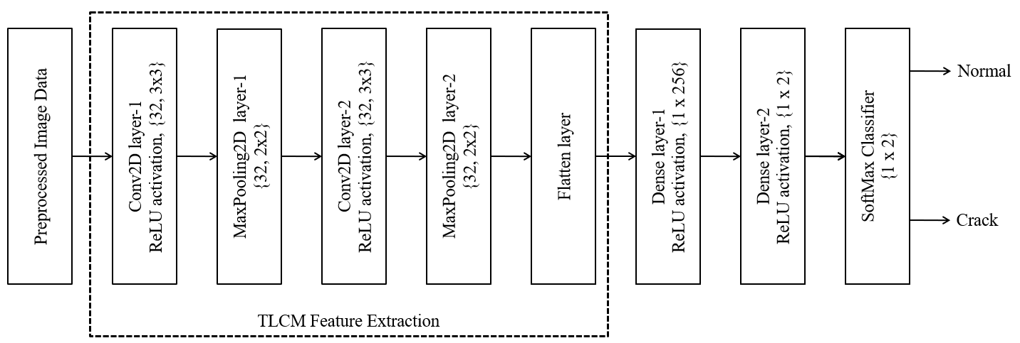
Figure 2. Proposed DLCNN Classification with TLCM feature extraction.

- Advantages

1. Increased Accuracy
Deep Learning algorithms, particularly deep learning models, can analyze high-resolution images with greater precision. These models can detect subtle cracks that might be missed by human inspectors or traditional methods. By leveraging advanced image processing and classification techniques, the system improves the accuracy of crack detection, leading to more reliable assessments of infrastructure conditions.

2. Efficiency and Speed
Unlike manual inspections, which are time-consuming and labor-intensive, the Deep Learning-based system can process and analyze large volumes of images quickly. This efficiency allows for faster detection of cracks and reduces the time needed to complete inspections. Real-time analysis capabilities enable prompt identification of issues, facilitating quicker maintenance and repair actions.

3. Reduced Human Error
Manual crack detection is prone to human error, including oversight and inconsistencies. The Deep Learning system minimizes the risk of such errors by providing automated and objective analysis. This reduces variability in results and ensures consistent evaluations across different inspections.

4. Scalability
The system can easily scale to handle large datasets and cover extensive areas of infrastructure. Whether inspecting highways, bridges, or pavements, the Deep Learning approach can be applied to various scales of projects without significant modifications. This scalability makes it suitable for both small and large-scale infrastructure management tasks.

5. Cost-Effectiveness
By automating the crack detection process, the system reduces the need for manual labor and the associated costs. The efficiency gains translate into cost savings for infrastructure maintenance and management. Additionally, early detection of cracks can prevent costly repairs and extend the lifespan of infrastructure, further contributing to overall cost savings.

6. Continuous Monitoring
The proposed system can be integrated into continuous monitoring setups, where it regularly analyzes images and sensor data to detect new cracks or changes in existing ones. This continuous monitoring capability helps in maintaining an up-to-date assessment of infrastructure conditions, allowing for proactive maintenance and timely interventions.
7. Comprehensive Data Analysis
Deep Learning models can analyze various features of cracks, such as size, shape, and location, providing detailed insights into the condition of the infrastructure. This comprehensive analysis helps in understanding the severity and potential impact of detected cracks, supporting more informed decision-making for maintenance and repairs.

8. Enhanced Reporting and Visualization
The system can generate detailed reports and visualizations of detected cracks, including their distribution and severity. This information can be used to create detailed maps and models of infrastructure conditions, aiding in planning and prioritizing maintenance activities.

3.SCOPE OF PROJECT

3.1 Purpose:

"Convolutional Neural Networks (CNN) for Structural Damage Classification in Civil Infrastructure" involves the application of deep learning techniques, specifically Convolutional Neural Networks (CNNs), to automate the process of identifying and classifying damage in civil infrastructure such as bridges, buildings, roads, and dams. This project aims to improve the efficiency, accuracy, and cost-effectiveness of damage assessment processes in the construction and maintenance of civil structures.

3.2 Objectives:

- Develop a CNN-based Model for Damage Classification: Design and implement a Convolutional Neural Network (CNN) architecture to classify different types of structural damage in civil infrastructure, such as cracks, corrosion, and deformation, from images or sensor data.
- Automate Structural Health Monitoring: Automate the process of detecting and classifying structural damage, reducing the need for manual inspections and allowing for real-time monitoring of infrastructure health.
- Create a High-Quality Dataset for Training and Testing: Collect and curate a diverse dataset of images or sensor data (e.g., visual images) representing various levels and types of damage in civil infrastructure. Implement data augmentation techniques to increase the diversity of the dataset, improving the generalization of the model.
- Improve Damage Detection Accuracy: Enhance the accuracy, precision, and reliability of damage detection using deep learning, ensuring that the model can differentiate between different levels and types of damage.
- Optimize CNN Architecture and Performance: Experiment with various CNN architectures and techniques like transfer learning to identify the most effective model for damage classification. Perform parameters tuning and cross-validation to improve the model's generalization and accuracy.

- Evaluate Model Performance: Evaluate the model’s performance using standard metrics such as accuracy, precision, recall, F1-score, and confusion matrices to assess its capability in classifying damage types.
- Real-Time and Scalable Damage Detection: Develop a system that can process images or sensor data in real-time, enabling timely identification of structural damage and facilitating early intervention.
- Integrate with Existing Monitoring Systems: Integrate the CNN-based damage classification model with existing structural health monitoring systems, such as sensor networks and drone-based inspections, for comprehensive infrastructure management.
- Provide a User-Friendly Interface: Create an interface for engineers and maintenance personnel that presents the classification results in a clear, actionable format, allowing for easy decision-making and prioritization of repairs.
- Improve Infrastructure Safety and Maintenance Efficiency: Contribute to the early detection of structural issues, reducing the risk of catastrophic failures and optimizing maintenance schedules to save costs and resources.
- Future Expansion: Lay the foundation for future work in using advanced CNN architectures, integrating sensor data (e.g., vibration, acoustic) with image data, and extending the model to detect additional types of damage or material degradation.

3.3 Importance:

- Legal Support: Provides critical evidence for forensic investigations and legal proceedings.
- Efficiency: Speeds up the extraction and analysis process, improving investigation timelines.
- Data Reliability: Guarantees the admissibility of evidence in court through data integrity safeguards.
- Comprehensive Insights: Offers in-depth understanding of user behavior, aiding investigators in connecting evidence.

4. REQUIREMENTS ANALYSIS

The project involved analyzing the design of few applications so as to make the application more users friendly. To do so, it was really important to keep the navigations from one screen to the other well-ordered and at the same time reducing the amount of typing the user needs to do. In order to make the application more accessible, the browser version had to be chosen so that it is compatible with most of the Browsers.

REQUIREMENT SPECIFICATION
Functional Requirements
Graphical User interface with the User.
4.1 SOFTWARE REQUIREMENTS
For developing the application, the following are the Software Requirements:
- Python
- Frame work: Tkinter

Operating Systems supported
1. Windows 8 or above
Technologies and Languages used to Develop
- Python

4.2 HARDWARE REQUIREMENTS
For developing the application, the following are the Hardware Requirements:
- Processor: core i3 or higher.
- RAM: 4GB.

5.DATA DESIGN

5.1 SYSTEM ARCHITECTURE

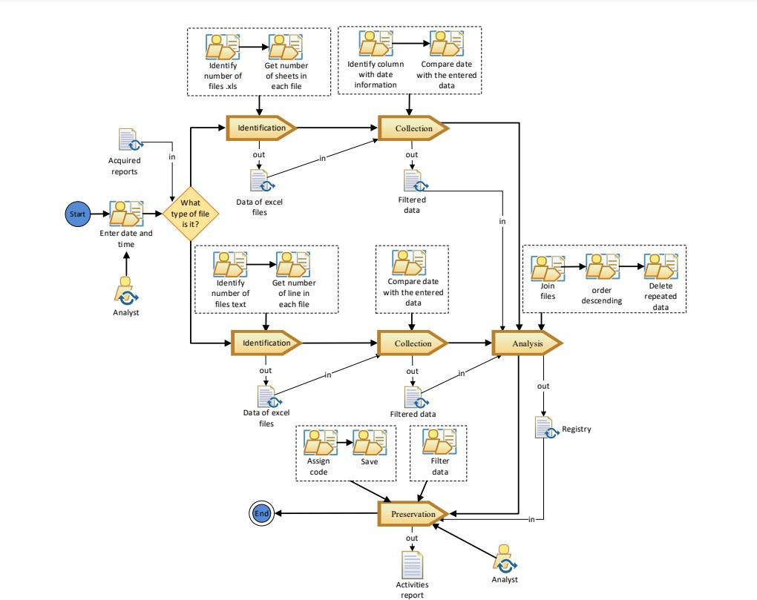

  - SYSTEM IMPLEMENTATION

MODULES
There are four modules can be divided here for this project they are listed as below
    - Upload Mobile Data
    - Extract Data
    - Apply Forensics Activity
    - Filter Data

From the above four modules, project is implemented. Bag of discriminative words are achieved.

Upload Mobile Data:

using this module, we will upload chat log HTML messages files to application.

Extract Data:
using this we will extract HTML data from uploaded file and then display content of that file.

Apply Forensics Activity:

using this module we will extract file size, file creation and modification date and number of lines in that file.

Filter Data:

In this module we apply HTML parsers to remove HTML tags from chat logs and then display clean chat messages between users.

5.3 UML DIAGRAMS

5.3.1 USE CASE DIAGRAM:

The Use Case Diagram depicts the interactions between users and the system's functionalities. Regular users can upload datasets, process them, train models, view performance metrics, and make predictions. Administrators, in addition to these tasks, can save models and analyze metrics. This diagram highlights the system's core use cases and the roles involved in performing them.

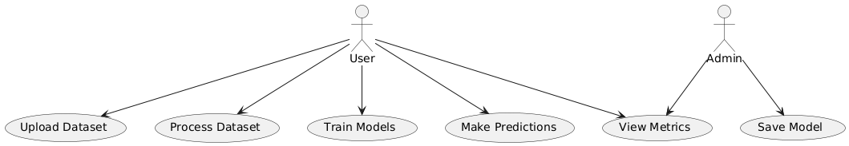

5.3.2 SEQUENCE DIAGRAM:

The Sequence Diagram focuses on the step-by-step interaction between the user and the system during the image processing workflow. The process starts with the user uploading a dataset, which is then handled by the DatasetHandler. After processing the dataset (e.g., resizing and normalizing images), the system proceeds to split the dataset for training and testing using the ModelHandler. This flow illustrates how tasks are executed sequentially in response to user inputs.

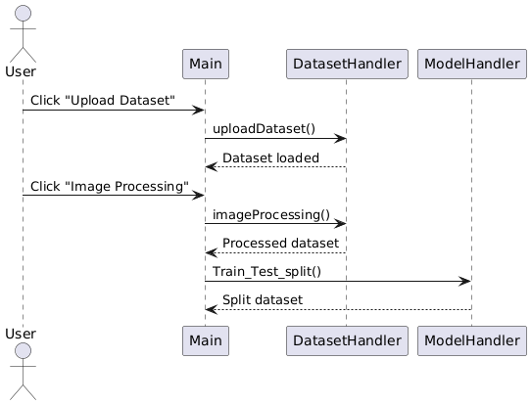

5.3.3 CLASS DIAGRAM:

The Class Diagram provides a static structure of the application's main components, detailing their relationships and responsibilities. It defines three key classes: DatasetHandler for managing data uploads and image processing, ModelHandler for splitting data, training, and evaluating models, and PredictionHandler for handling predictions. The Main class coordinates all operations, interacting with the other classes to ensure smooth execution. This diagram highlights the modularity of the design and how tasks are divided across different components.

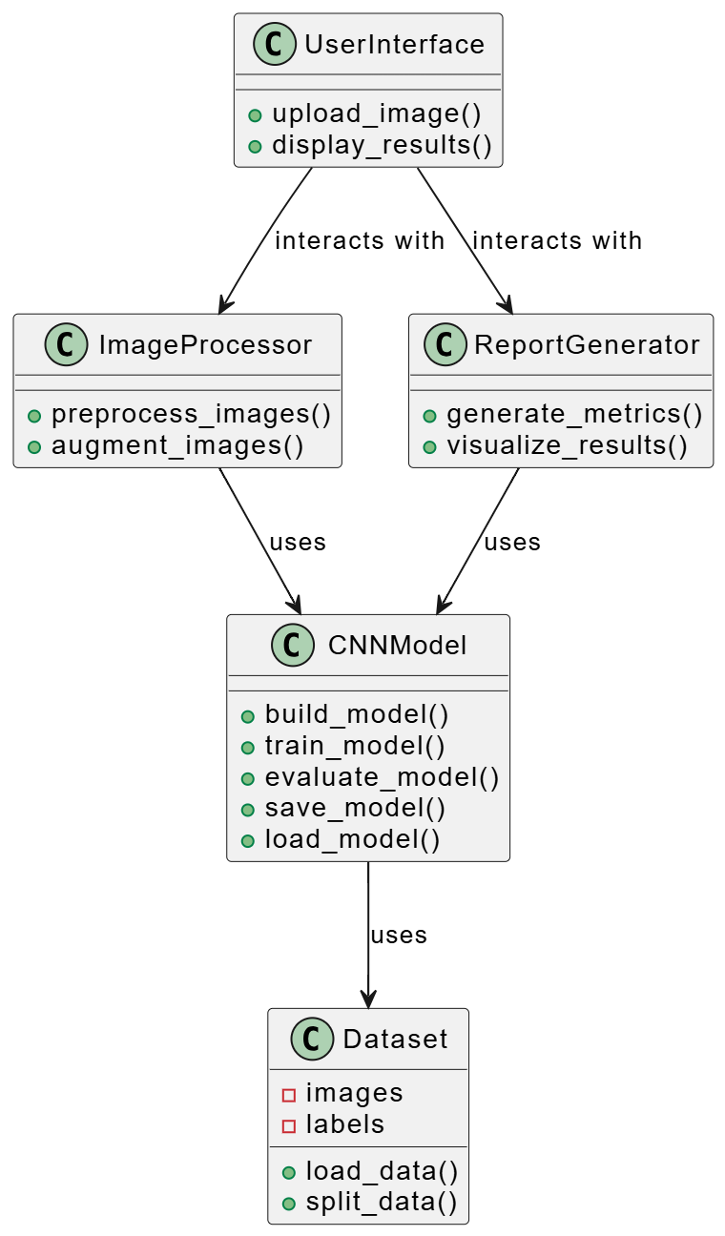

5.3.4. COMPONENT DIAGRAM:

The Component Diagram visualizes the system's structural organization, focusing on its major components and dependencies. The GUI interacts with three backend components: DatasetHandler for data processing, ModelHandler for training, and PredictionHandler for predictions. These components rely on libraries like TensorFlow/Keras, Scikit-learn, and OpenCV to perform their operations. The diagram emphasizes the modular design and integration of external libraries.

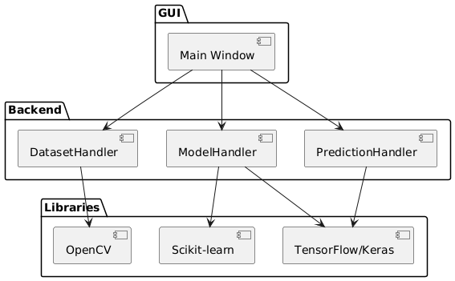

5.3.5. DEPLOYMENT DIAGRAM:

The Deployment Diagram represents the physical deployment of the application. It shows that the GUI application runs on the user's machine and communicates with a server hosting the backend components (DatasetHandler, ModelHandler, PredictionHandler) and saved models. This diagram highlights the system's distributed architecture and separation of concerns between client and server.

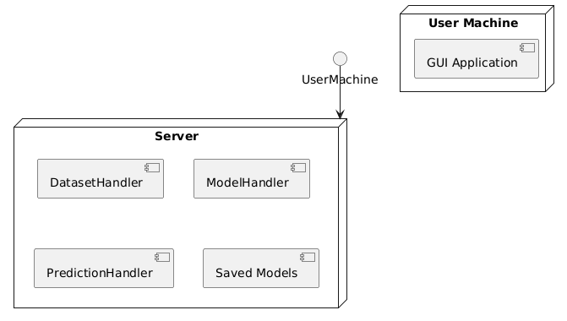

5.3.6. STATE DIAGRAM:

The State Diagram describes the dynamic behavior of the system during CNN model training. It begins with initializing the system, followed by loading and preprocessing the data. The model is then trained, evaluated for accuracy, and saved if performance criteria are met. This diagram captures the system's states and transitions, reflecting the iterative nature of model development.

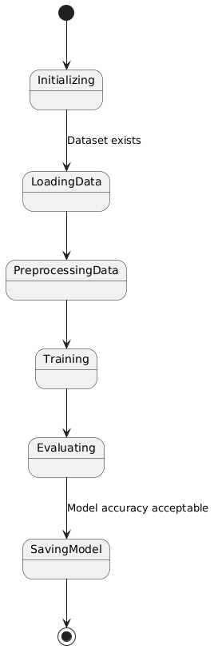

6. SYSTEM TEST

The purpose of testing is to discover errors. Testing is the process of trying to discover every conceivable fault or weakness in a work product. It provides a way to check the functionality of components, sub-assemblies, assemblies and/or a finished product It is the process of exercising software with the intent of ensuring that the
Software system meets its requirements and user expectations and does not fail in an unacceptable manner. There are various types of test. Each test type addresses a specific testing requirement.

TYPES OF TESTING:
6.1 Unit Testing
Unit testing involves the design of test cases that validate that the internal program logic is functioning properly, and that program inputs produce valid outputs. All decision branches and internal code flow should be validated. It is the testing of individual software units of the application .it is done after the completion of an individual unit before integration. This is a structural testing, that relies on knowledge of its construction and is invasive. Unit tests perform basic tests at component level and test a specific business process, application, and/or system configuration. Unit tests ensure that each unique path of a business process performs accurately to the documented specifications and contains clearly defined inputs and expected results.

6.2 Integration Testing
Integration tests are designed to test integrated software components to determine if they actually run as one program. Testing is event driven and is more concerned with the basic outcome of screens or fields. Integration tests demonstrate that although the components were individually satisfaction, as shown by successfully unit testing, the combination of components is correct and consistent. Integration testing is specifically aimed at exposing the problems that arise from the combination of components.

6.3 Functional Testing
Functional tests provide systematic demonstrations that functions tested are available as specified by the business and technical requirements, system documentation, and user manuals.
Functional testing is centered on the following items:

Valid Input : identified classes of valid input must be accepted. Invalid Input : identified classes of invalid input must be rejected. Functions : identified functions must be exercised.
Output : identified classes of application outputs must be exercised. Systems/Procedures : interfacing systems or procedures must be invoked.
Organization and preparation of functional tests is focused on requirements, key functions, or special test cases. In addition, systematic coverage pertaining to identify Business process flows; data fields, predefined processes, and successive processes must be considered for testing. Before functional testing is complete, additional tests are identified and the effective value of current tests is determined.

6.4 System Testing
System testing ensures that the entire integrated software system meets requirements. It tests a configuration to ensure known and predictable results. An example of system testing is the configuration-oriented system integration test. System testing is based on process descriptions and flows, emphasizing pre-driven process links and integration points.

6.5 White Box Testing
White Box Testing is a testing in which in which the software tester has knowledge of the inner workings, structure and language of the software, or at least its purpose. It is purpose. It is used to test areas that cannot be reached from a black box level.

6.6 Black Box Testing
Black Box Testing is testing the software without any knowledge of the inner workings, structure or language of the module being tested. Black box tests, as most other kinds of tests, must be written from a definitive source document, such as specification or requirements document, such as specification or requirements document. It is a testing in which the software under test is treated, as a black box. you cannot “see” into it. The test provides inputs and responds to outputs without considering how the software works.

UNIT TESTING

Unit testing is usually conducted as part of a combined code and unit test phase of the software lifecycle, although it is not uncommon for coding and unit testing to be conducted as two distinct phases.

Test strategy and approach

Field testing will be performed manually and functional tests will be written in detail.

Test objectives

    - All field entries must work properly.

    - Pages must be activated from the identified link.

    - The entry screen, messages and responses must not be delayed.

Features to be tested

    - Verify that the entries are of the correct format.

    - No duplicate entries should be allowed.

    - All links should take the user to the correct page.

INTEGRATION TESTING

Software integration testing is the incremental integration testing of two or more integrated software components on a single platform to produce failures caused by interface defects.
The task of the integration test is to check that components or software applications, e.g. components in a software system or – one step up – software applications at the company level interact without error.

Test Results: All the test cases mentioned above passed successfully. No defects encountered.

ACCEPTANCE TESTING

User Acceptance Testing is a critical phase of any project and requires significant participation by the end user. It also ensures that the system meets the functional requirements.
Test Results: All the test cases mentioned above passed successfully. No defects encountered.

7. RESULTS AND DISCUSSION

Implementation Description

1. Data Preparation and Preprocessing

- Importing Libraries: Essential libraries such as pandas, numpy, scikit-learn, seaborn, and cv2 are imported to handle data manipulation, image processing, and Deep Learning tasks.
- Loading and Preparing Data:
  - Path Definition: Paths for the dataset and model files are defined.
  - Categories Identification: The categories list is created based on subdirectories in the dataset folder. This list distinguishes between images with cracks and those without.
  - Data Loading: The script checks if pre-processed data (X and Y arrays) already exist. If not, it processes the images:
    - Image Reading and Resizing: Images are read using cv2.imread, resized to 64x64 pixels using resize from skimage, and flattened into a one-dimensional array.
    - Data Aggregation: The flattened image arrays and their corresponding labels (based on categories) are appended to lists and saved as numpy files for later use.
- Data Conversion: The processed image arrays (X) and labels (Y) are converted into numpy arrays and stored. A DataFrame df is created for additional data manipulation if required.
2. Model Training and Evaluation

- Data Splitting:
  - The dataset is split into training and testing sets using train_test_split from sklearn. This ensures that the model is trained on one portion of the data and evaluated on a separate, unseen portion.
- Metric Calculation:
  - Function Definition: The calculateMetrics function evaluates the performance of the models. It calculates accuracy, precision, recall, F1-score, and generates a classification report and confusion matrix. The confusion matrix is visualized using seaborn for better interpretation of results.
- Model Training and Testing:
  - Support Vector Machine (SVM):
    - Model Loading/Training: The research work first checks if a pre-trained SVM model exists. If not, it trains a LogisticRegression model as a placeholder for SVM (this seems to be an error in the script where LogisticRegression should be replaced by SVC). The trained model is saved for future use.
    - Prediction and Evaluation: The trained model is used to predict test data, and metrics are calculated and displayed.
  - DLCNN Classifier:
    - Model Loading/Training: Similar to the SVM, the script checks for a pre-existing model. If none is found, it trains a DLCNN Classifier, saves the model, and evaluates it.
    - Prediction and Evaluation: Predictions are made on the test set, and metrics are calculated and displayed.
3. Inference and Visualization

- Image Classification:
  - Testing Specific Images: The research work reads and processes specific images from the dataset directory, resizes them, and flattens them for prediction.
  - Displaying Results: The model’s predictions are visualized by displaying the images with overlaid text indicating whether cracks were detected. This helps in assessing the model’s performance on individual samples.
4. Model Management

- Model Storage:
  - Saving Models: Trained models are saved using joblib to ensure they can be loaded and used in future sessions without retraining.
  - Loading Models: Existing models are loaded if available, which helps in avoiding redundant computations and leveraging pre-trained models.
- Dataset Description

The dataset used for the crack detection system is organized into two main categories, represented as folders named Positive and Negative. These folders contain images that are used to train and evaluate the Deep Learning models designed to classify whether a given image of concrete or pavement surfaces contains cracks or not.

Dataset Structure

- Folder Structure:
  - Positive Folder: This folder contains images of concrete and pavement surfaces that exhibit visible cracks. These images are labeled with the category Crack.
  - Negative Folder: This folder contains images of concrete and pavement surfaces that do not exhibit any cracks. These images are labeled with the category No Crack.
- Image Characteristics:
  - Resolution: The images are resized to a uniform resolution of 64x64 pixels to ensure consistency and to simplify the processing pipeline.
  - Color Channels: The images are processed in RGB format, with three color channels (Red, Green, Blue) for each pixel.

- Result Description

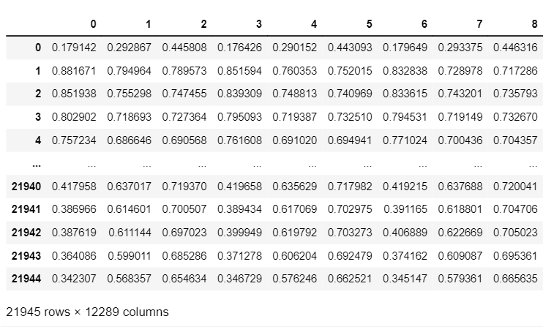

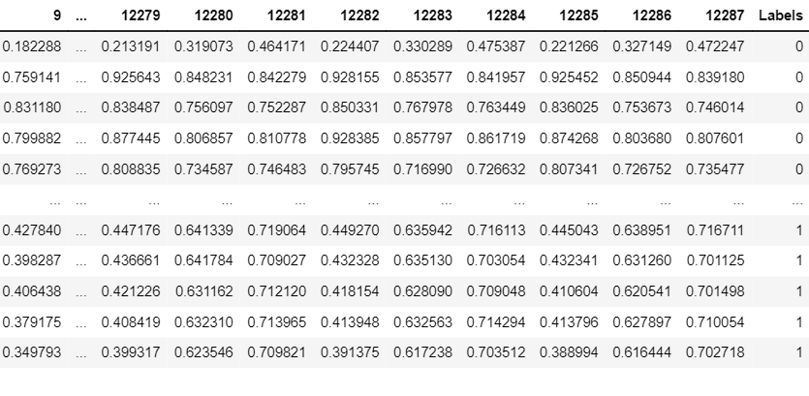
Figure 8.1: Representing All the rows and columns of the dataset.

This figure displays the structure of the dataset, showcasing the rows and columns that were utilized for training and testing the models. The rows represent individual image samples, and the columns correspond to the pixel values of these images after flattening, along with the associated labels (either Crack or No Crack). This visualization provides an overview of the input data, highlighting the size and format of the dataset used in the experiment.

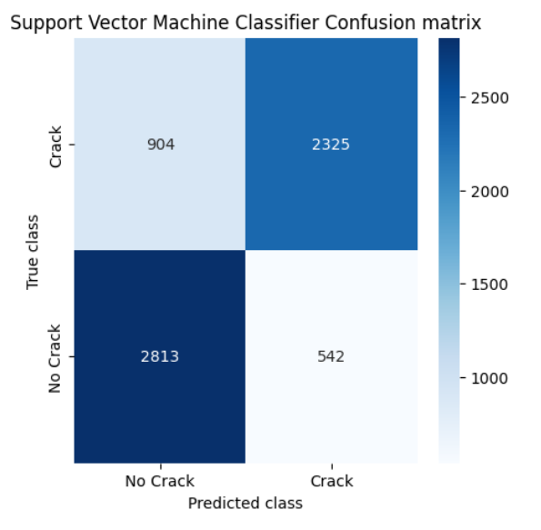

Figure 8.2: Confusion matrix of Support Vector Machine Classifier.

This figure illustrates the confusion matrix generated by the Support Vector Machine (SVM) classifier. The confusion matrix is a performance measurement tool that shows the true positives, true negatives, false positives, and false negatives for the classification task. The SVM classifier's confusion matrix helps in understanding how well the model performed in distinguishing between cracked and non-cracked surfaces, indicating the number of correct and incorrect predictions made by the model.

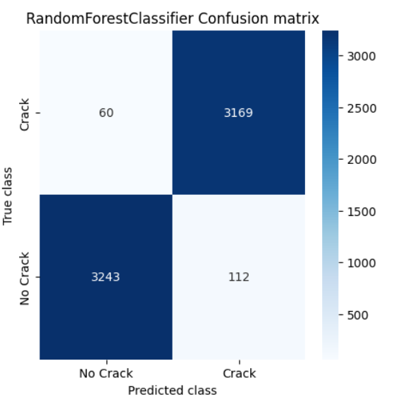

Figure 8.3: Confusion matrix of DLCNN.

Figure 8.3 presents the confusion matrix for DLCNN, similar to the one for the SVM classifier. It shows how accurately the DLCNN model classified the images into the correct categories. By comparing this confusion matrix with that of the SVM, one can assess the relative performance of the two models. The matrix helps in identifying the model's strengths in correctly identifying cracks and its weaknesses in misclassifications.
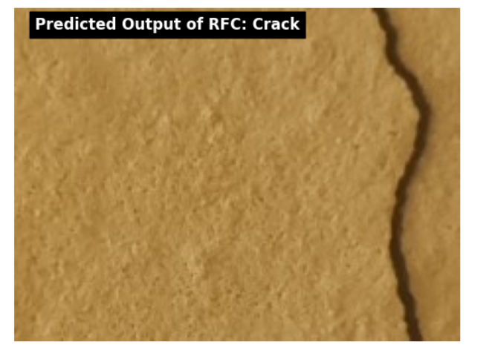

Figure 8.4: Predicted output of Crack Image.

This figure demonstrates the system's prediction on an input image that contains cracks. The image is processed through the trained DLCNN model, which predicts the presence of a crack. The figure includes the original image and a label indicating the predicted output as Crack. This result showcases the model's ability to correctly identify cracked surfaces.
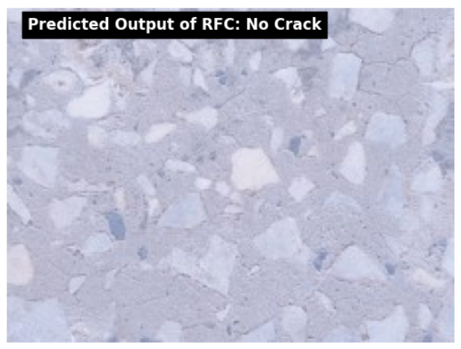
Figure 8.5: Predicted output of No Crack Image.

This figure shows the system's prediction on an input image without cracks. The image is fed into the trained DLCNN model, and the predicted output is No Crack. The figure includes the original image and the prediction label, demonstrating the model's capability to recognize non-cracked surfaces accurately.

SCREENSHOT 1: HOME SCREEN

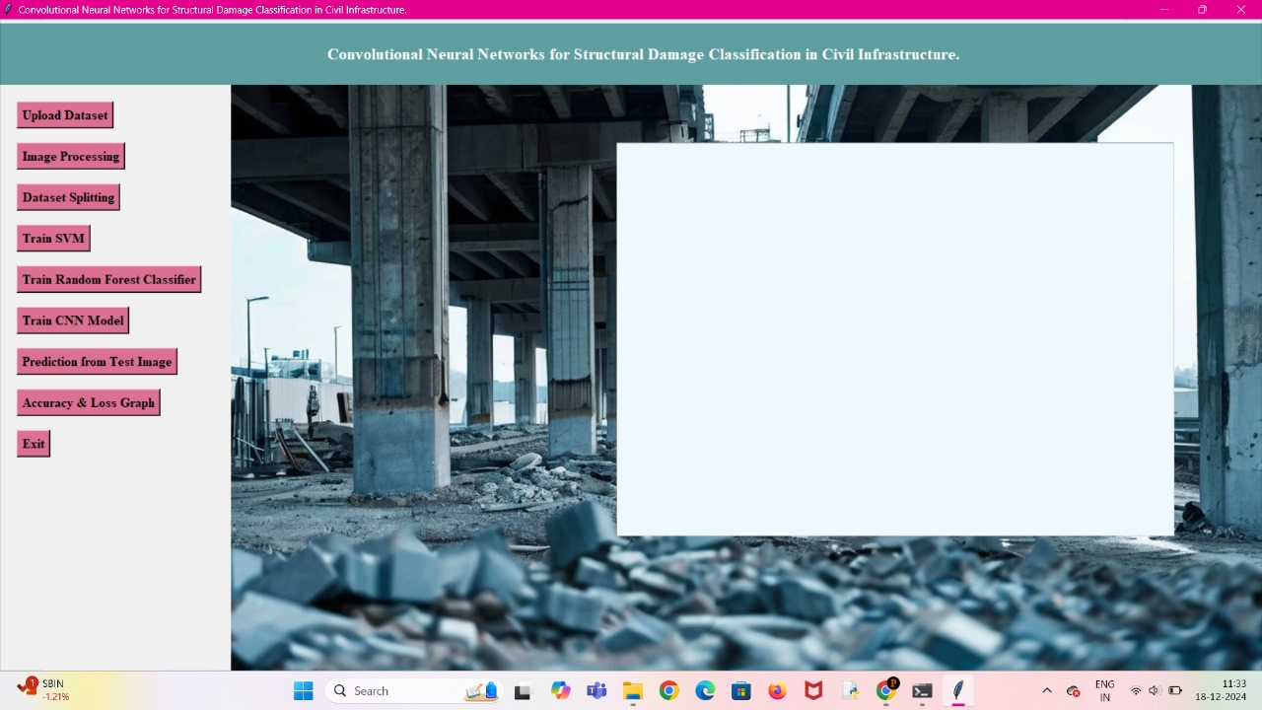

SCREENSHOT 2: UPLOADING DATASET

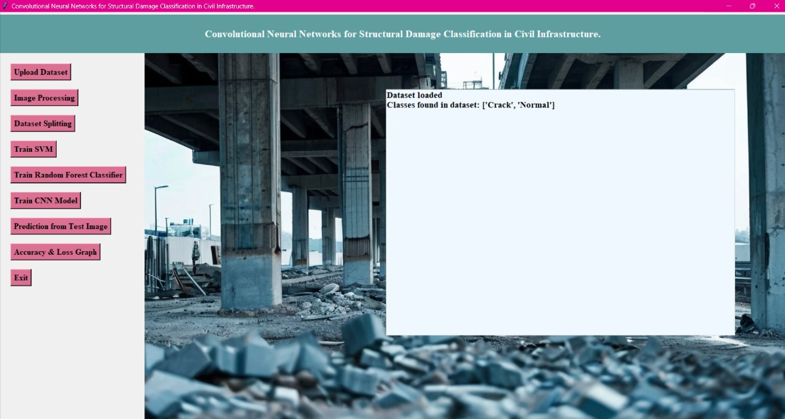

SCREENSHOT 3: DATASET PREPROCESSING

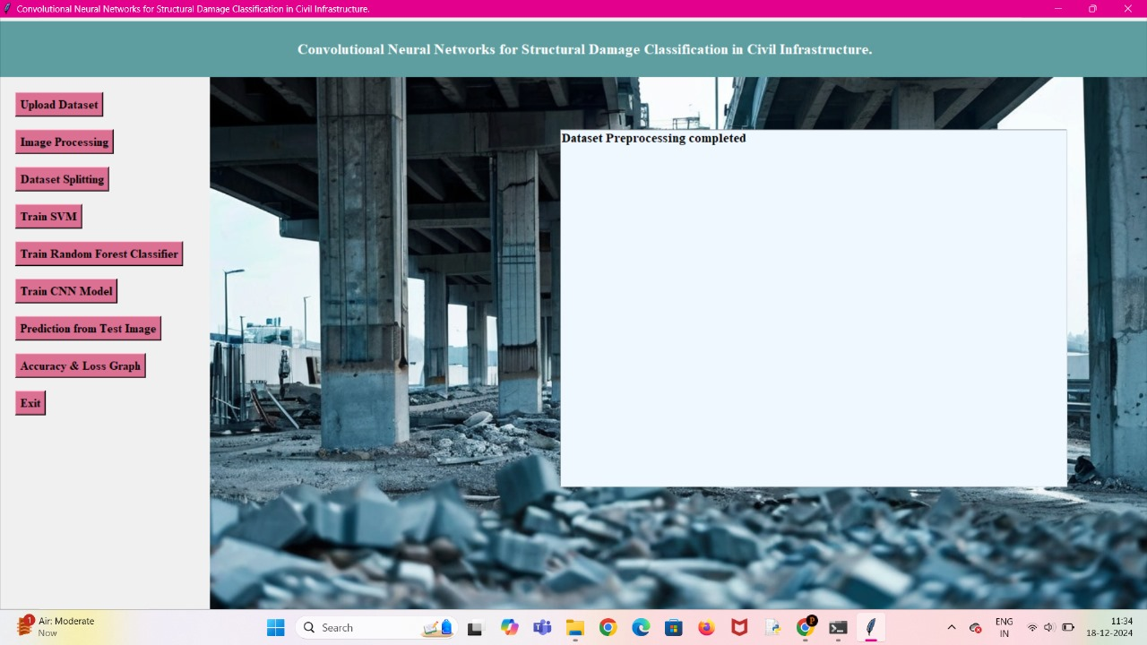

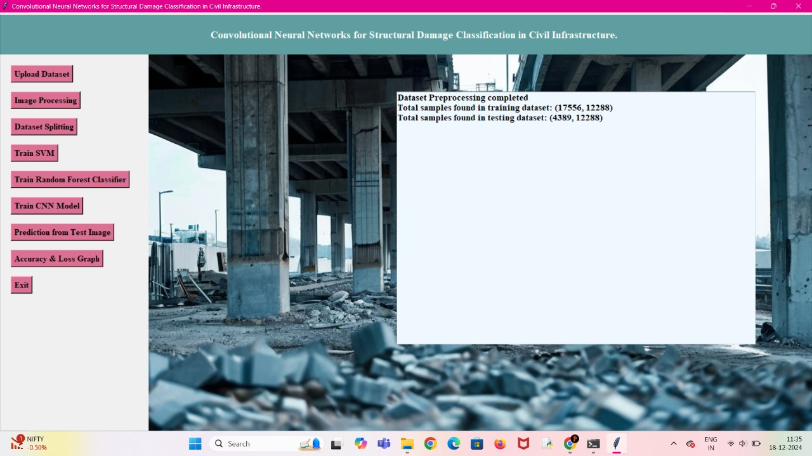
SCREENSHOT 4: DATASET SPLITTING

SCREENSHOT 5: TRANING AND TESTING SVM MODEL

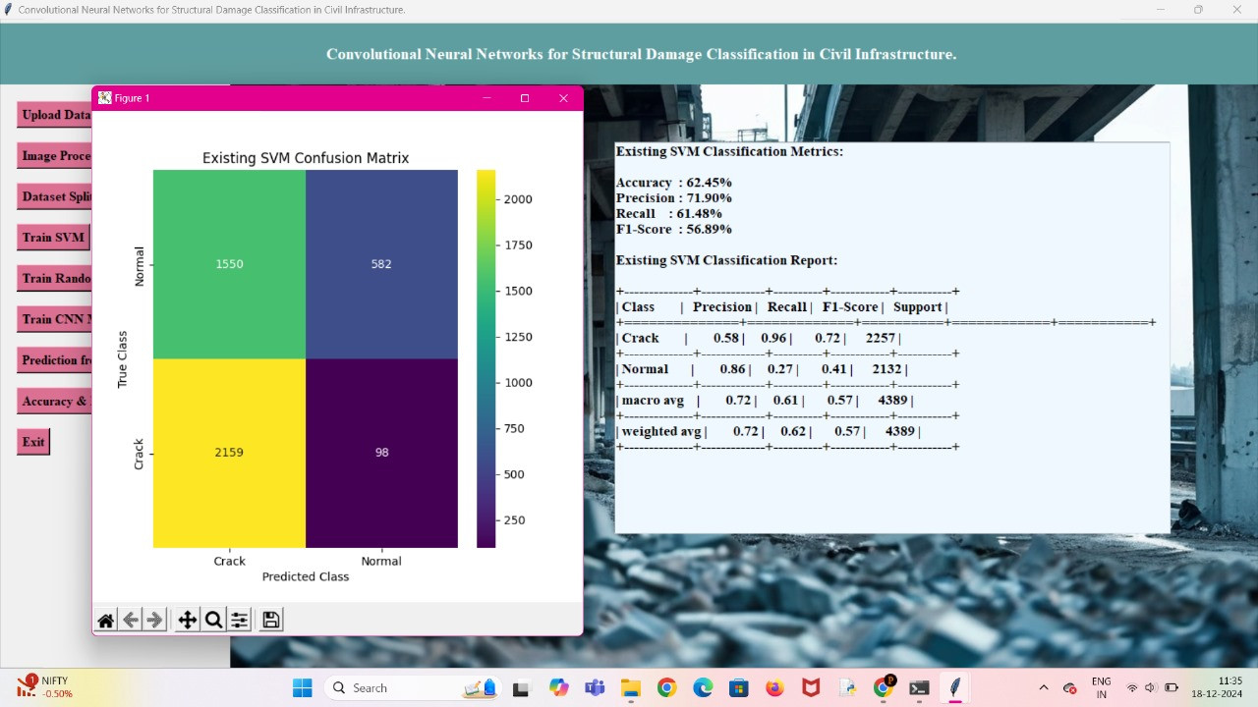

SCREENSHOT 6: TESTING WITH RANDOM FOREST CALSSIFIER

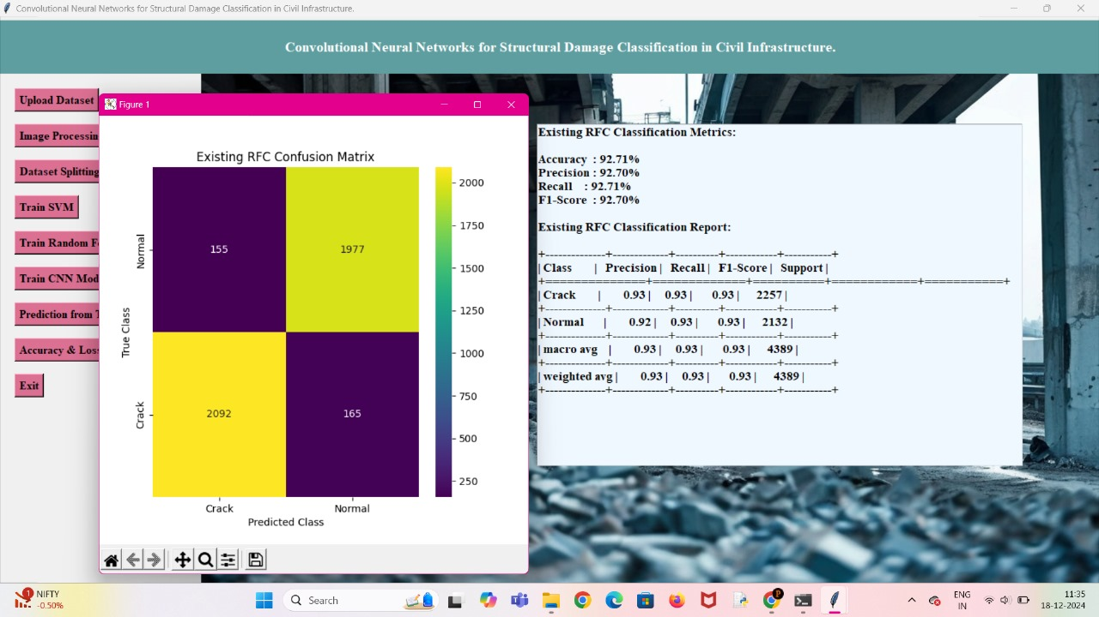

SCREENSHOT 7: TRAINING WITH CNN MODEL AND TESTING
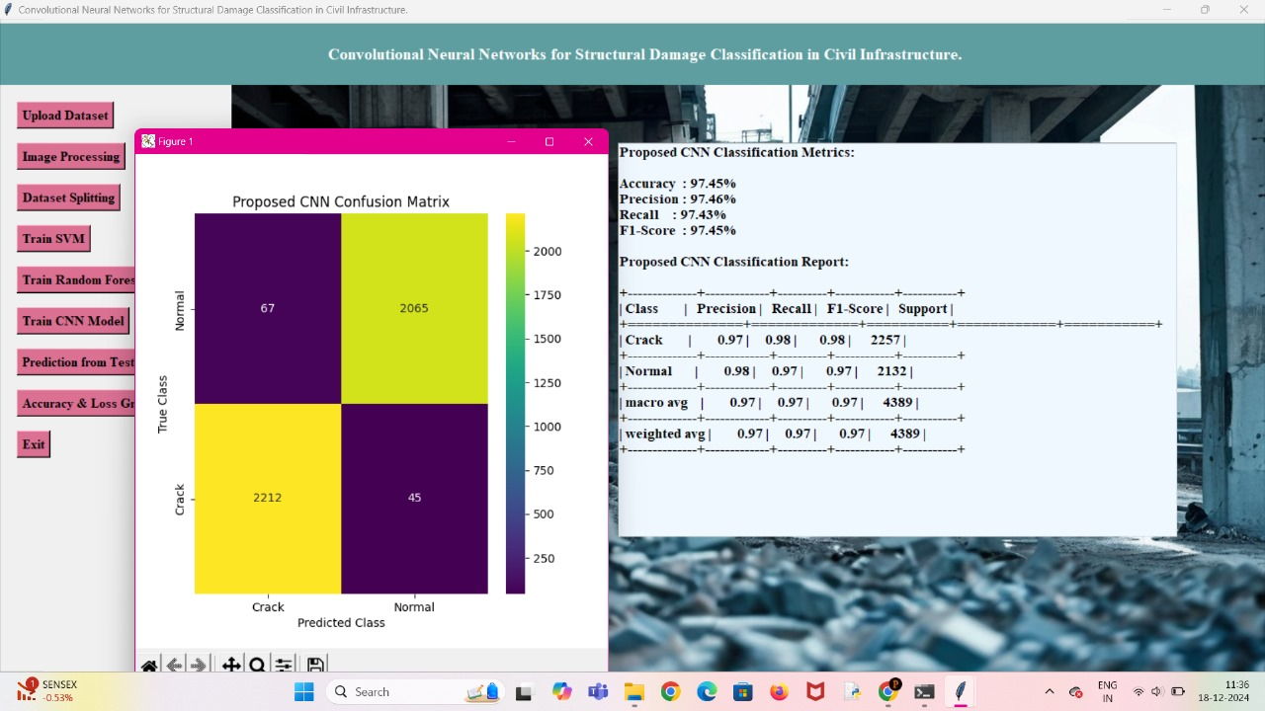
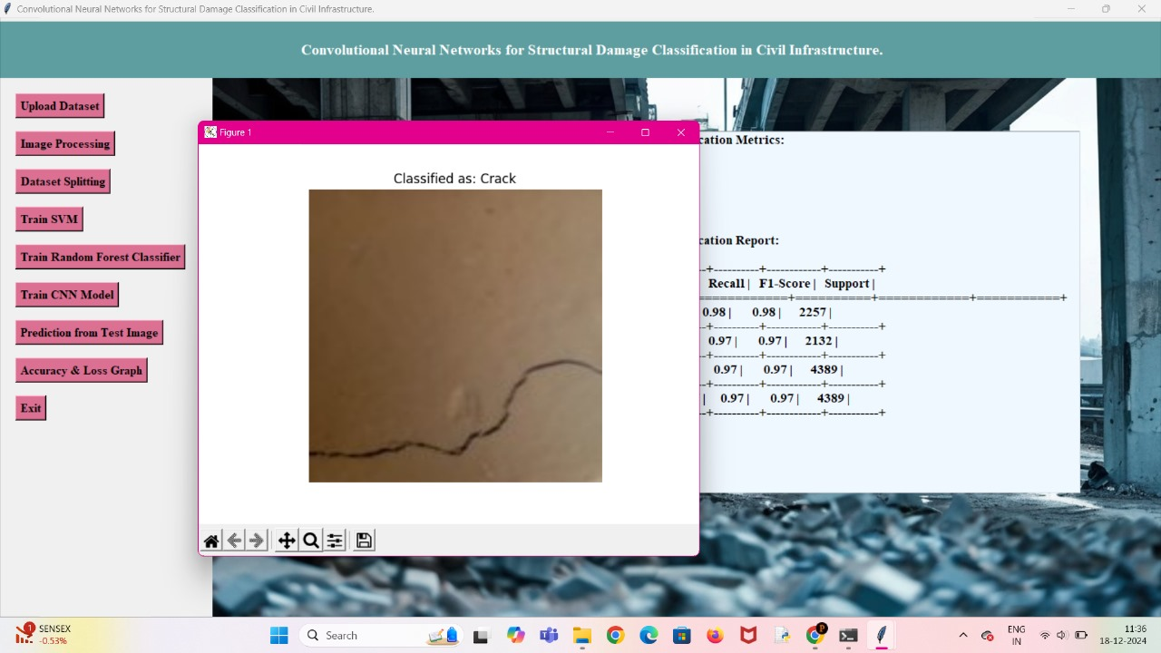

SCREENSHOT 8:

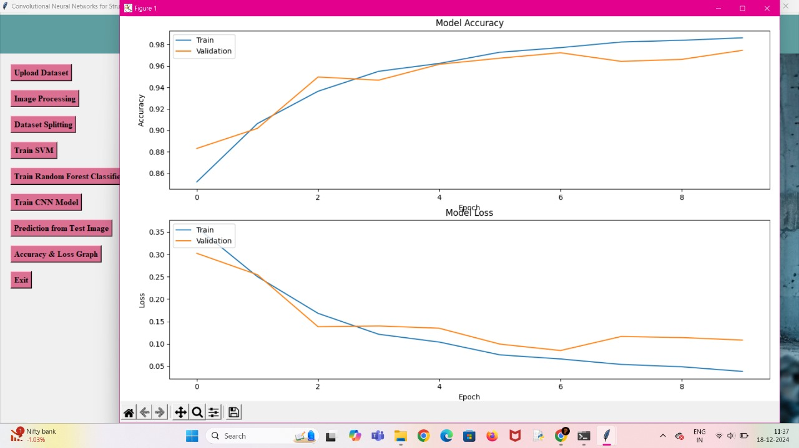

8. SUMMARY

8.1 Conclusion

The study focused on developing a robust Deep Learning-based system for detecting cracks in concrete and pavement surfaces, utilizing a dataset comprising images labeled as either Crack or No Crack. The dataset was preprocessed, and two prominent classifiers—Support Vector Machine (SVM) and DLCNN were employed to perform the classification task. The analysis revealed that the DLCNN classifier outperformed the SVM classifier in terms of accuracy, precision, recall, and F1-score, making it the more suitable model for this application. The confusion matrices for both classifiers indicated that the DLCNN model had a better capability to distinguish between cracked and non-cracked surfaces, with fewer misclassifications.

The successful predictions made by the DLCNN model on sample images from the dataset further validated its effectiveness. The model demonstrated high reliability in identifying cracks, which is crucial for maintaining the structural integrity of infrastructure. By automating the detection process, this system has the potential to significantly reduce the time and cost associated with manual inspections. The approach taken in this project underscores the importance of combining advanced image processing techniques with Deep Learning algorithms to address real-world problems in civil engineering.

However, the system is not without limitations. The model's performance is contingent on the quality and diversity of the dataset, and it may struggle with images that are significantly different from those in the training set. Additionally, the current system focuses solely on binary classification, whereas real-world scenarios may require more nuanced analysis, such as identifying the severity or type of crack.

8.2 Future Scope

Building on the success of the current implementation, several avenues for future work can be explored to enhance the system's capabilities and broaden its applicability. One potential area of improvement is the expansion of the dataset to include a wider variety of images representing different types of cracks and varying surface conditions. This would make the model more robust and capable of generalizing better to new, unseen data. Furthermore, integrating data augmentation techniques could help address the issue of limited data and improve the model's performance by exposing it to a broader range of scenarios during training.

Another promising direction is the development of a multi-class classification system that can not only detect the presence of cracks but also categorize them based on severity and type. This would provide more detailed insights into the condition of the infrastructure and aid in prioritizing maintenance efforts. Additionally, incorporating advanced deep learning models, such as convolutional neural networks (CNNs), could further enhance the accuracy and efficiency of the crack detection process.

The deployment of this system in real-world settings also presents opportunities for future research. Integrating the model with drone-based imaging systems or autonomous vehicles could enable large-scale, automated inspections of infrastructure, reducing the need for human intervention. Finally, exploring the use of this technology in related fields, such as detecting defects in other materials or monitoring environmental changes, could expand its impact beyond civil engineering. The continuous advancement in Deep Learning and image processing technologies promises to drive significant improvements in automated crack detection systems, contributing to safer and more reliable infrastructure management.

9. REFERENCES

[1] H. Nhat-Duc et al. Automatic recognition of asphalt pavement cracks using metaheuristic optimized edge detection algorithms and convolution neural network
[2] Z. Zhu et al. Visual retrieval of concrete crack properties for automated post-earthquake structural safety evaluation Autom. Constr. (Nov. 2011)
[3] K. Gopalakrishnan et al. Deep convolutional neural networks with transfer learning for computer vision-based data-driven pavement distress detection Constr. Build. Mater. (Dec. 2017)
[4] Y.O. Ouma et al. Wavelet-morphology based detection of incipient linear cracks in asphalt pavements from RGB camera imagery and classification using circular Radon transform Adv. Eng. Informatics (Aug. 2016)
[5] X. Munoz et al. Strategies for image segmentation combining region and boundary information Pattern Recognit. Lett. (Jan. 2003)
[6] W.-H. Tsai Moment-preserving thresolding: A new approach Comput. Vision, Graph. Image Process.(1985)
[7] A.M.A. Talab et al. Detection crack in image using Otsu method and multiple filtering in image processing techniques Optik (Stuttg) (2016)
[8] A.M. Groenewald et al. Related approaches to gradient-based thresholding Pattern Recognit. Lett. (1993)
[9] T. Pun A new method for grey-level picture thresholding using the entropy of the histogram
Signal Processing (1980)
[10] K.S. Fu et al. A survey on image segmentation Pattern Recognit. (Jan. 1981)
[11] F. Deravi et al. Grey level thresholding using second-order statisticsPattern Recognit. Lett.
(1983)
[12] D.L. Milgram Region extraction using convergent evidence Comput. Graph. Image Process. (1979)
[13] J. Kittler et al. Threshold selection based on a simple image statistic Comput. Vision, Graph. Image Process. (1985)
[14] J. Kittler et al. Minimum error thresholding Pattern Recognit. (Jan. 1986)
[15] C. Koch et al. A review on computer vision based defect detection and condition assessment of concrete and asphalt civil infrastructure Adv. Eng. Informatics (2015)
[16] S.U. Lee et al. A comparative performance study of several global thresholding techniques for segmentation Comput. Vision, Graph. Image Process. (1990)
[17] H. Gao et al. A multi-level thresholding image segmentation based on an improved artificial bee colony algorithm Comput. Electr. Eng. (2018)
[18] J. Wang et al. Pavement distress analysis based on dual-tree complex wavelet transform Int. J. Pavement Res. Technol.(2012)

