CMSC 204

Huffman Lab

Praharsh Nanduri

1. Create a Huffman Tree and generate the codes for each character of the following input:

create a huffman tree

For consistency:

1. If same frequency – put in priority queue alphabetically; put space before other characters of the same frequency
2. Add subtrees to end of group with same priority
3. Lower number has higher priority (goes to front)

space – 3

c – 1

r - 2

e-4

a-3

t-2

h-1

u-1

f-2

m-1

n-1

Now encode “create a huffman tree”

0100000111101001111100101100010111001101110101101010111100001000111111

1. Based on the following Huffman tree and binary sequence, what is the text

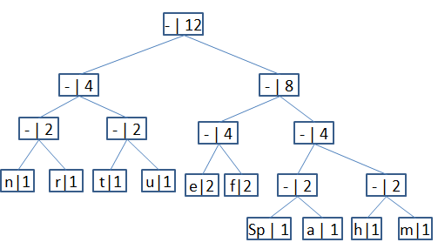

n-000

r-001

t-010

u-011

e-100

f-101

space-1100

a-1101

h-1110

m-1111

1110 011 101 101 1111 1101 000 1100 010 001 100 100

h u f f m a n space t r e e

text : “huffman tree”