**Architecture**

This project is built based on Java MVC framework. MVC framework is used to separate the data access layer, business logic code and the graphical user interface (for our case the GUI is just the console output) that has to be defined and designed to let the user interact with the application. Therefore the application consists from three parts,

1. Model - this part of the framework is to store and retrieve all data for the application. It consists from three Java classes (Stock.java, Trade.java). These classes handles (setters and getters) the data for the Stock and Trade values
2. View - this is the graphical user interface of the application. That would contain controls to let the user interact with the application in order to be able to retrieve the data from model.
3. Controller - the actual back-end code constitutes the controller of the framework (SimpleStockController.java). A controller controls the data coming from the users, or going to the user from a model.

This sets up a condition of validation, because the stream of data (coming from or going to the user) is always validated on the controller. That is why it makes the data more consistent by removing any chance of invalid data entry or unauthorized data deletion from the application's data source.

These are a few of the good points of the MVC framework for developing the software applications. In visual representation, the MVC framework works in the way below

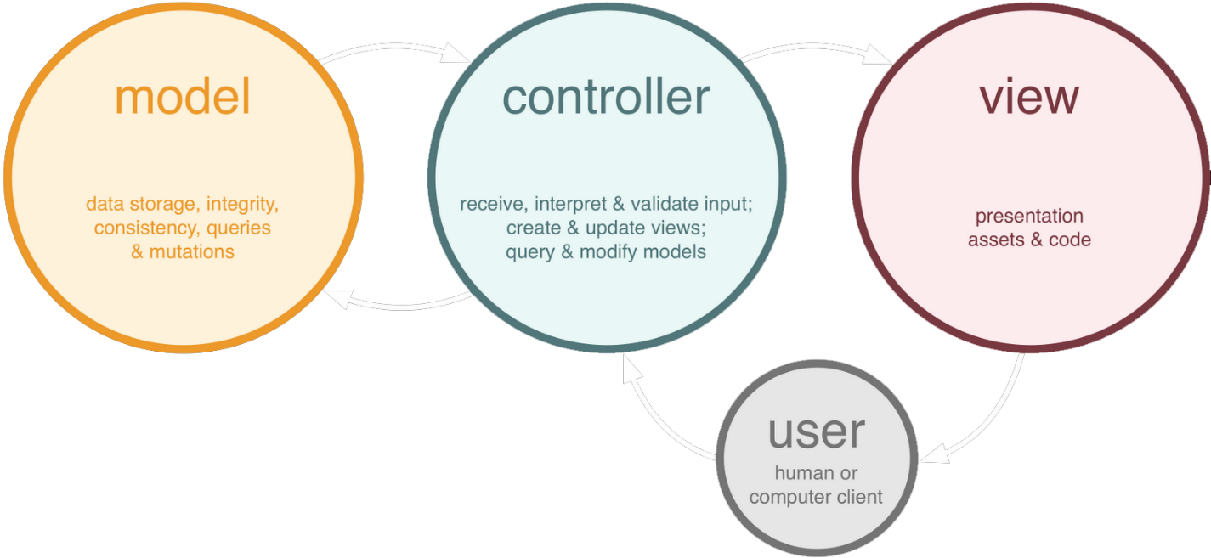

**Building**

Also the data for the application are provided via xml files. Two xml files were created:

* stocks.xml: contains the initial parameters for the stock values: stock symbols, last Dividend, fixed Dividend and the Par Value that are project specifics
* trades.xml: contains some initial parameters for the trade values. These parameters are configurable, therefore the user can modify only these values without modifying any source code.

In order the application to be successfully compiled open source libraries were used. Therefore in the build path of the application the following jars should be included: commons-math3-3.5.jar, hamcrest-all-1.3.jar, hamcrest-library-1.3.jar, org.apache.commons.collections.jar, log4j-1.2.17.jar and junit-4.12.jar.

**Testing**

The data for the application are loaded from trades.xml and stocks.xml files and for testing purposes 5 JUnit has been created that tests the whole application.