Setting up AutoUI:

1. Copy *AutoUI.zip* to your local system (e.g. E drive)
2. Extract all the files to *E:/AutoUI*
3. Open *autoui.config* file located in *E:/AutoUI* and provide the parameters as per your configuration

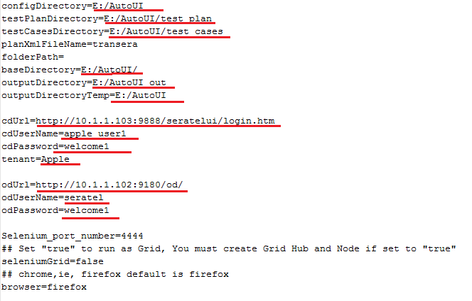

1. To execute multiple test suite go to *E:/AutoUI/test_plan* directory and edit *transera.xml* and uncomment only those test suites you want to execute

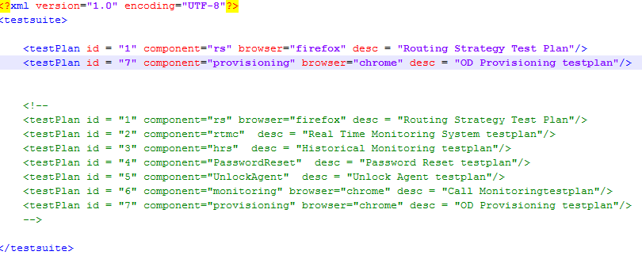

1. Execute test suites in different browser, in *transera.xml* for the specific test plan provide *browser*, if browser attribute is not provided then by default it will execute in firefox



All the above steps 1 to 5 are same for executing test in standalone system or in multiple systems.

**To execute on standalone system follow step 6 and 7**

1. To execute in standalone system, open *autoui.config* file and set *seleniumGrid=false*

**

1. To start execution click on the bat file *run_autoui.bat* located in *E:/AutoUI* , it will start executing the test cases on your local system

**To execute on multiple system follow step 8 and 12**

1. Open *autoui.config* file and set *seleniumGrid=true*



1. Go to *E:\AutoUI\SeleniumGrid* and click on *SeleniumGridHub.bat* file and start it, it will configure your desktop as Selenium Grid HUB
2. In all the bat files wherever following IP address is present change it to your desktop IP



1. After changing the IP in the bat files, copy the folder *SeleniumGrid* to C drive of all the systems wherever you want to configure node, now clicking on the specific bat files will configure that system as NODE in the selenium grid.
2. To start execution click on the bat file *run_autoui.bat* located in *E:/AutoUI* , it will start executing the test cases on the NODE systems depending upon the NODE specification

**Execution Reports**

1. Once execution is completed reports can be located as per the *outputDirectory* location set in autoui.config file



1. Reports are generated in html format, for each test suite it will generate report with file name *<TESTSUITENAME>.html* and *Summary.html* which contains report for all test suite.