Ruby:

Ruby is an "interpreted" programming language which means it can’t run on your processor directly, it has to be fed into a middleman called the "virtual machine" or VM.
A Ruby program can’t run on it’s own, you need to load the VM. There are two ways to execute Ruby with the VM: through IRB and through the command line.
- Execute from the command line: ruby my_program.rb

Numbers:
abs: takes the absolute value of the number:
puts ((2-5).abs) → 3

rand: puts rand-→ you'll get a float greater than or equal to 0.0 and less than 1.0. puts rand
puts(rand(100)) → it will give you an integer greater than or equal to 0 and less than 100. so to get 100 → rand(101).
pust(rand(1)) → always return 0.

The Math Object:
puts(Math::PI)
puts(Math::E)
puts(Math.cos(Math::PI/3))
puts(Math.tan(Math::PI/4))
puts(Math.log(Math::E**2))
puts((1 + Math.sqrt(5))/2)

string:
- Substrings
Often with strings we want to pull out just a part of the whole – this is called a substring.
greeting = "Hello Everyone!"
greeting[0..4] → Hello
greeting[6..-1] → Everyone!
Greeting[6..-2] → Everyone

greeting.length → 15
sentence = "This is my sample sentence.”
sentence.split → ["This", "is", "my", "sample", "sentence."]
sentence = "This is my sample sentence."
numbers = "one,two,three,four,five"
numbers.split(",") → ["one", "two", "three", "four", "five"]

.sub and .gsub
These two methods can be used to replace parts of a string. They’re like using "Find & Replace" in a word processor. .sub, short for substitute, replaces just a single occurance. .gsub, short for global substitute, replaces all occurances (like "Replace All").
For both .sub and .gsub you’ll need to specify two arguments: first the substring you’re wanting to replace and second the string you want to replace it with.

String Concatenation
name = "Frank"
puts "Good morning, #{name}!" (interpolation)
or
puts "Good morning, " + name + "!"
letters = 'aAbBcCdDeE'
puts letters.upcase → AABBCCDDEE
puts letters.downcase → aabbccddee
puts letters.swapcase → AaBbCcDdEe
puts letters.capitalize → Aabbccddee
puts ' a'.capitalize → A
puts letters → 'aAbBcCdDeE' → dont change the original string/letters remains unchanged

var1 = 'stop'
puts var1.reverse → pots
puts var1 –> stop

the method center: adds spaces to the beginning and end of the string to make it centered:
puts('And scared her poor shoe dog away.'.center(lineWidth))
And scared her poor shoe dog away.

Symbols:
Symbols are difficult to explain, they’re halfway between a string and a number. You can recognize a symbol because it starts with a colon then one or more letters, like :flag or :best_friend. think of a symbol as a "named integer". It doesn’t matter what actual value the symbol references. All we care about is that any reference to that value within the VM will give back the same value. Symbols are thus defined in a global symbol table and their value cannot change.
For Loop: For loops are common, but they’re not very readable. Because Ruby’s integers are objects they have methods. One of those is the times method to repeat an instruction a set number of times.
5.times do
puts "Hello, World!"
end

Blocks:
The block starts with the keyword do and ends with the keyword end. The do/end style is always acceptable.

Bracket Blocks - When a block contains just a single instruction, though, we’ll often use the alternate markers { and } to begin and end the block.

"this is a sentence".gsub("e"){
puts "Found an E!"
} → Found an E!
Found an E!
Found an E!
"this is a sntnc"

Block Parameters
5.times do |i|
puts "#{i}: Hello, World!"
end

Arrays:
meals = ["Breakfast", "Lunch", "Dinner"]
meals << "Dessert" → ["Breakfast", "Lunch", "Dinner", "Dessert"]
meals[2] → Dinner
meals.last → Desert

Common Array Methods
The sort method will return a new array where the elements are sorted. If the elements are strings they’ll come back in alphabetacal order. If they’re numbers they’ll come back in ascending value order:
one = ["this", "is", "an", "array"]
one.sort
one

each allows us to do something (whatever we want) to each object the array points:
languages = ['English', 'German', 'Ruby']

languages.each do |lang|
puts 'I love ' + lang + '!'
puts 'Don\'t you?'
end
push adds an object to the end of your array, and pop removes the last object from the array (and tell you what it was).

Hashes:A hash is a collection of data where each element of data is addressed by a name. The key is used as the address and the value is the data at that address. In the produce hash we have keys including "apples" and "oranges" and values including 12 and 3. When creating a hash the key and value are linked by the => symbol which is called a rocket. So hashes start with a curly bracket {, have zero or more entries made up of a key, a rocket, and a value separated by commas, then end with a closing curly bracket }.
Example:
colorHash['strings'] = 'red'
colorHash['numbers'] = 'green'
colorHash['keywords'] = 'blue'

colorHash.each do |codeType, color|
puts codeType + ': ' + color
end
strings: red
numbers: green
keywords: blue

Conditionals
Conditional statements evaluate to true or false. The most common conditional operators are == (equal), > (greater than), >= (greater than or equal to), < (less than), and <= (less than or equal to).
Some objects also have methods which return a true or false, so they’re used in conditional statements. For example every object has the method .nil? which is true only when the object is nil. Arrays have a method named .include? which returns true if the array includes the specified element. The convention in Ruby is that a method which returns true or false should have a name ending in a ?.

Nil & Nothingness:
nil is Ruby’s idea of nothingness. It’s usually encountered when you ask for something that doesn’t exist. When looking at arrays, for instance, we created a list with five elements then asked Ruby to give us the sixth element of that list. There is no sixth element, so Ruby gave us nil. It isn’t that there’s a blank in that sixth spot (""), it’s not a number 0, it’s nothingness – nil.

Mixing it up:
var1 = 2
var2 = '5'

puts var1 + var2
Part of the problem is that your computer doesn't know if you were trying to get 7 (2 + 5), or if you wanted to get 25 ('2' + '5').
Before we can add these together, we need some way of getting the string version of var1, or to get the integer version of var2.
To get the string version of an object, we simply write .to_s after it:
var1 = 2
var2 = '5'

puts var1.to_s + var2 → 25
Similarly, to_i gives the integer version of an objec:
var1 = 2
var2 = '5'

puts var1 + var2.to_i → 7

to_f gives the float version: puts '15'.to_f → 15.0

- Well, here's the big secret behind our friend, puts: Before puts tries to write out an object, it uses to_s to get the string version of that object. In fact, the s in puts stands for string; puts really means put string.
gets: gets will only retrieve strings. And whence does it get them?
From you! Well, from your keyboard, anyway. Since your keyboard only makes strings, that works out beautifully. What actually happens is that gets just sits there, reading what you type until you press Enter.
Example:
puts 'Hello there, and what\'s your name?'
name = gets
puts 'Your name is ' + name + '? What a lovely name!'
puts 'Pleased to meet you, ' + name + '. :)'
the output-→
Hello there, and what's your name?
Chris
Your name is Chris
? What a lovely name!
Pleased to meet you, Chris
. :)

Hmmm... it looks like when I typed in the letters C, h, r, i, s, and then pressed Enter, gets got all of the letters in my name and the Enter! Fortunately, there's a method just for this sort of thing: chomp. It takes off any Enters hanging out at the end of your string. Let's try that program again, but with chomp to help us this time:
puts 'Hello there, and what\'s your name?'
name = gets.chomp
puts 'Your name is ' + name + '? What a lovely name!'
puts 'Pleased to meet you, ' + name + '. :)'

the output-→
Hello there, and what's your name?
Chris
Your name is Chris? What a lovely name!
Pleased to meet you, Chris. :)
**now it’s ignore the Enter.
- The important thing to take away from all of this is that every method is being done by some object, even if it doesn't have a dot in front of it.

Blocks and Procs:
It's the ability to take a block of code (code in between do and end), wrap it up in an object (called a proc), store it in a variable or pass it to a method, and run the code in the block whenever you feel like .
toast = Proc.new do
puts 'Cheers!'
end

toast.call → Cheers!
Ok, so we see what blocks and procs are, and how to use them, but what's the point? Why not just use methods? Well, it's because there are some things you just can't do with methods. In particular, you can't pass methods into other methods (but you can pass procs into methods), and methods can't return other methods (but they can return procs). This is simply because procs are objects; methods aren't.

Methods Which Take Procs:
def doSelfImportantly someProc
puts 'Everybody just HOLD ON! I have something to do...'
someProc.call
puts 'Ok everyone, I\'m done. Go on with what you were doing.'
end

sayHello = Proc.new do
puts 'hello'
end

sayGoodbye = Proc.new do
puts 'goodbye'
end

doSelfImportantly sayHello
doSelfImportantly sayGoodbye

Methods Which Return Procs:
One of the other cool things you can do with procs is to create them in methods and return them. This allows all sorts of crazy programming power, but the fact is that I almost never do this in practice, nor can I remember seeing anyone else do this in their code.

Model View Controller architecture
it’s the rails architecture employ.
- Model- is for the objects.
- View – is the presentation layer- what the user sees and interact with. A view's purpose is to display this information in a human readable format.
- Controller – process and respond to events-such as user actions and its going to invoke changes to the Model and the View based on that.
- A controller's purpose is to receive specific requests for the application. Routing decides which controller receives which requests. Often, there is more than one route to each controller, and different routes can be served by different actions. Each action's purpose is to collect information to provide it to a view.

The diagram for it:
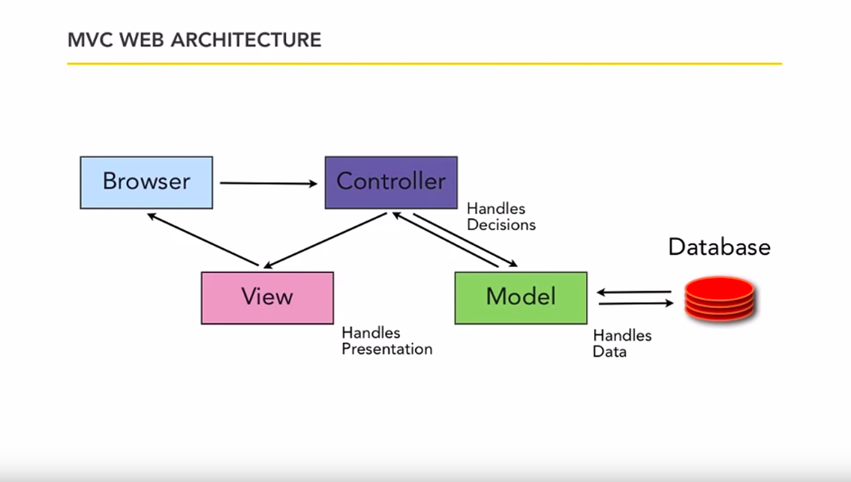
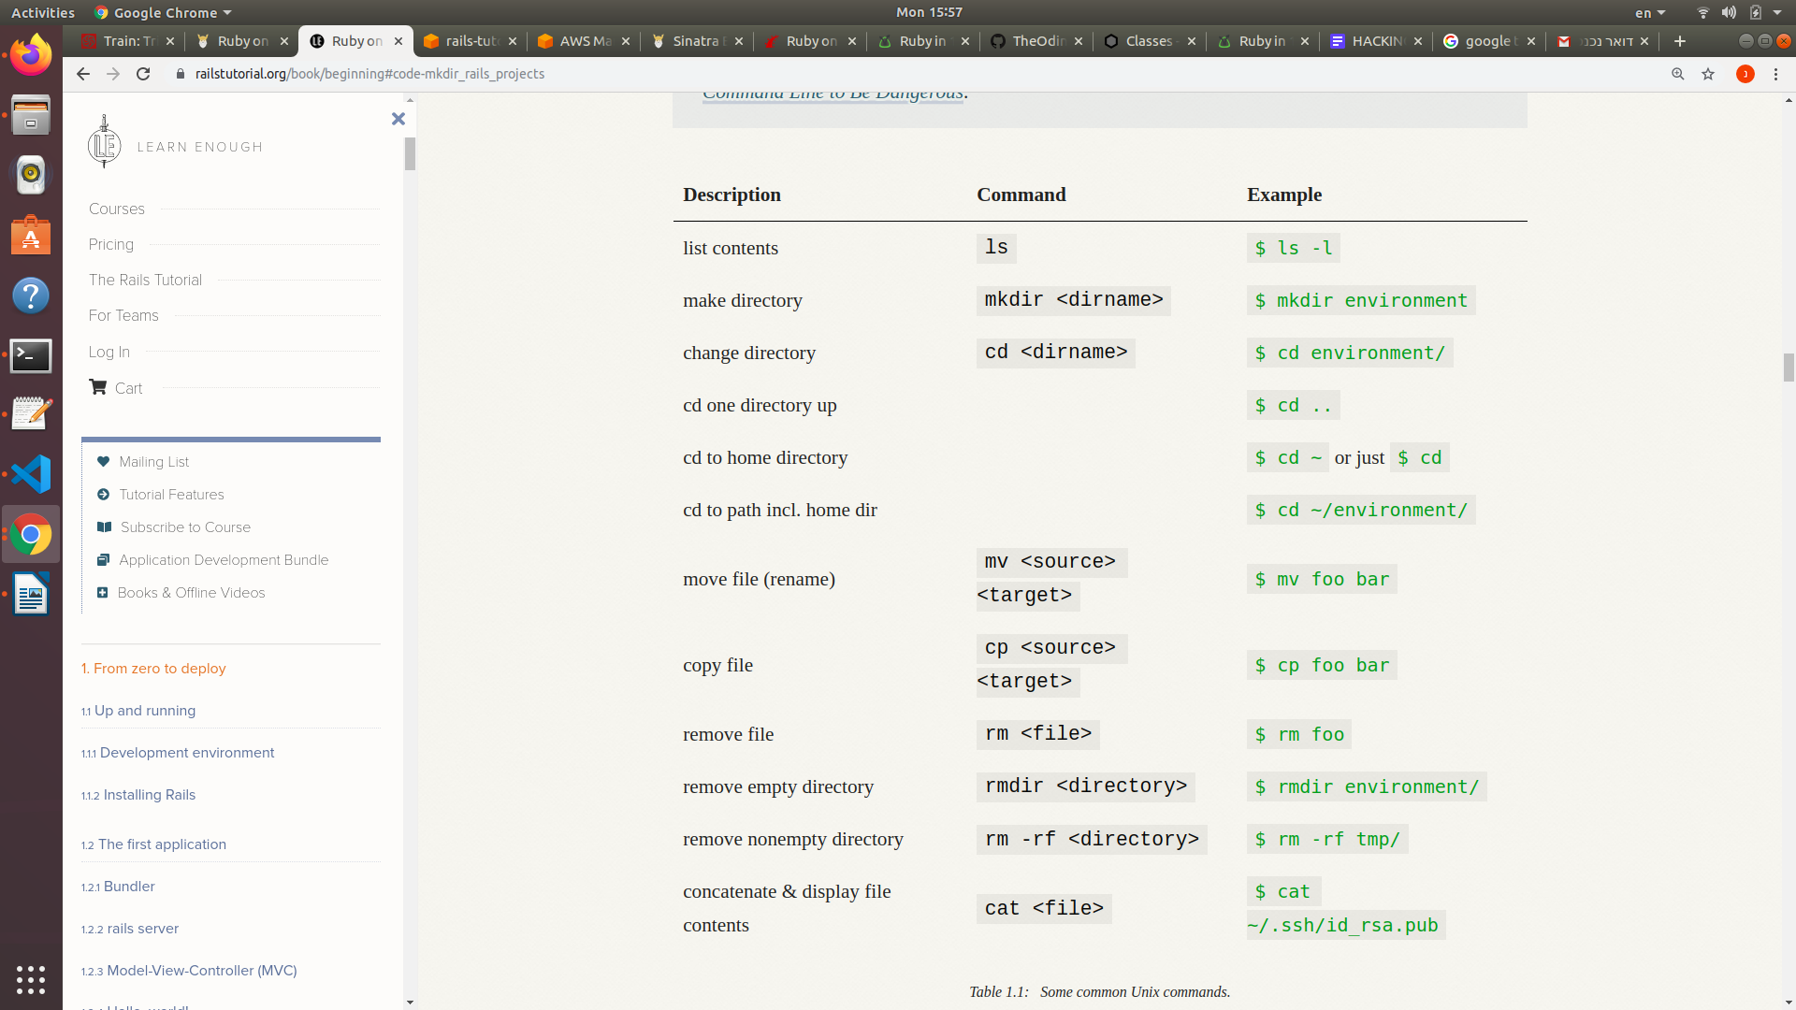
Unix command line:
Ruby on Rails:
- to create a new apllication with rails :
rails <the version- for example: _6.0.1_> new <the name of the project- for example : hello_app>
after create the application – the rails create for us a lots of folders and files. It look like this:
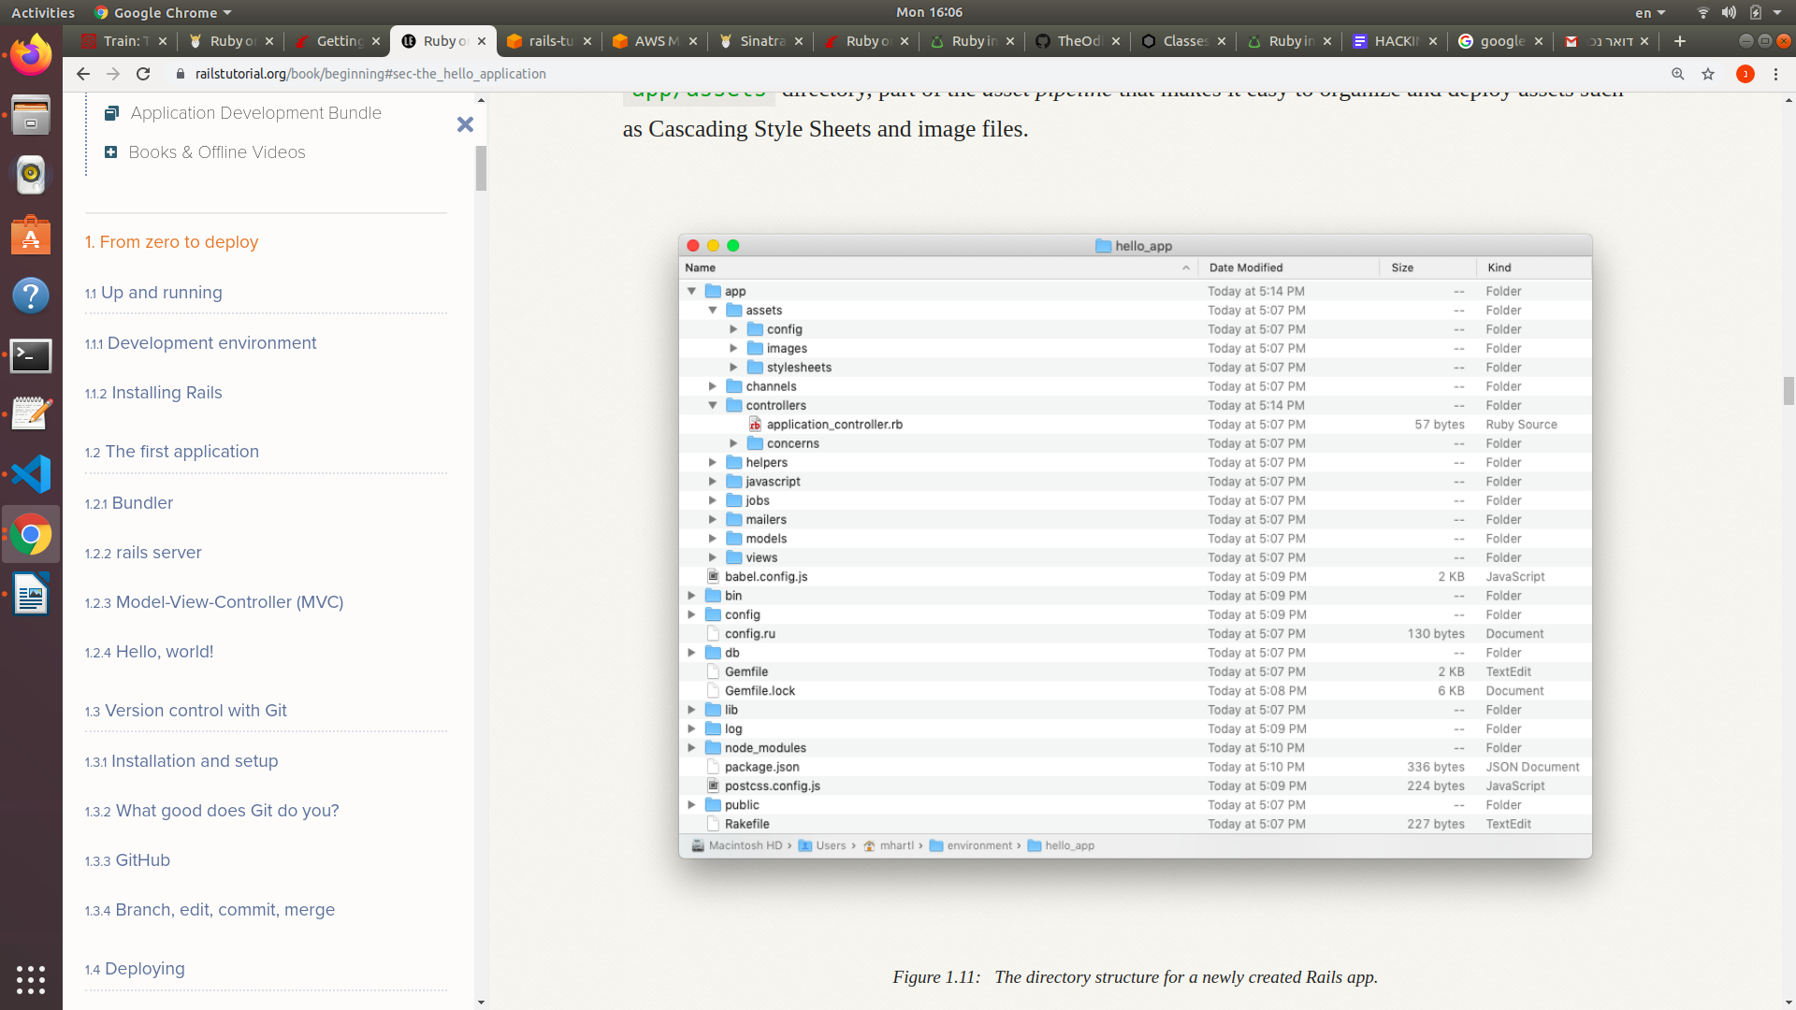
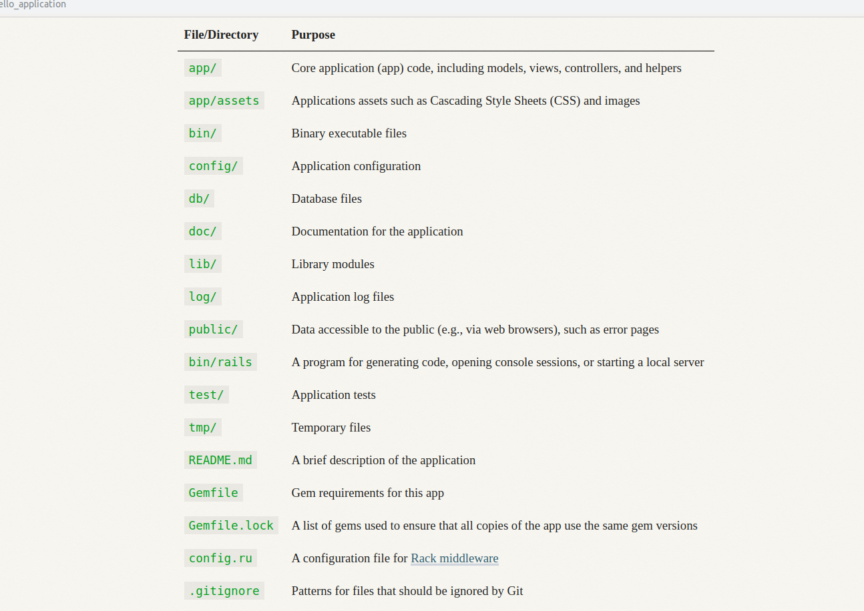

app - This is where 98% of your effort will go. It contains subfolders which will hold most of the code you write including Models, Controllers, Views, Helpers, JavaScript, etc.
- bin - This is where your app’s executables are stored: bundle, rails, rake, and spring.
- config - Control the environment settings for your application. It also includes the initializers subfolder which holds items to be run on startup.
- db - Will eventually have a migrations subfolder where your migrations, used to structure the database, will be stored. When using SQLite3, as is the Rails default, the database file will also be stored in this folder.
- lib - This folder is to store code you control that is reusable outside the project.
- log - Log files, one for each environment (development, test, production)
- public - Static files can be stored and accessed from here, but all the interesting things (JavaScript, Images, CSS) have been moved up to app since Rails 3.1
- test - If your project is using the default Test::Unit testing library, the tests will live here
- tmp - Temporary cached files
- vendor - Infrequently used, this folder is to store code you do not control. With Bundler and Rubygems, we generally don’t need anything in here during development.

- rails server:
Before running rails server, it’s necessary on some systems (including the cloud IDE) to allow connections to the local web server. To enable this, you should navigate to the file config/environments/development.rb and paste in:
# Allow connections to local server.
config.hosts.clear

To get Rails saying "Hello", you need to create at minimum a controller and a view.
To create a new controller, you will need to run the "controller" generator and tell it you want a controller called "Welcome" with an action called "index", just like this:
$ rails generate controller Welcome index
Rails will create several files and a route for you.
Controller should look like that- need to have all this method:
class ArticlesController < ApplicationController

def index
...
end

def show
...
end

def new
...
end

def edit
...
end

def create
...
end

def update
...
end

def destroy
...
end

private
...
end

-first we need to generate model, update the config/route.rb
rake db:migrate
then we need to generate a controller for that model.

Always worked with the ‘MVC’ Model – when we create a model we need to check is migrate (in the db folder) and check the routes.rb (in the config folder). Then we need to create a controller for this model, and create a view for each of the controller methods.

ERB is a templating language that allows us to mix Ruby into our HTML. There are only a few things to know about ERB:
- An ERB clause starts with <% or <%= and ends with %>
- If the clause started with <%, the result of the ruby code will be hidden
- If the clause started with <%=, the result of the ruby code will be output in place of the clause

close minimize deactivat
ddd

f

