MVC Architecture:
MVC framework is an architectural/design pattern that separates an application into three main logical components Model, View, and Controller. MVC separates the business logic and presentation layer from each other. It was traditionally used for desktop graphical user interfaces (GUIs). MVC architecture has become popular for designing web applications as well as mobile apps.
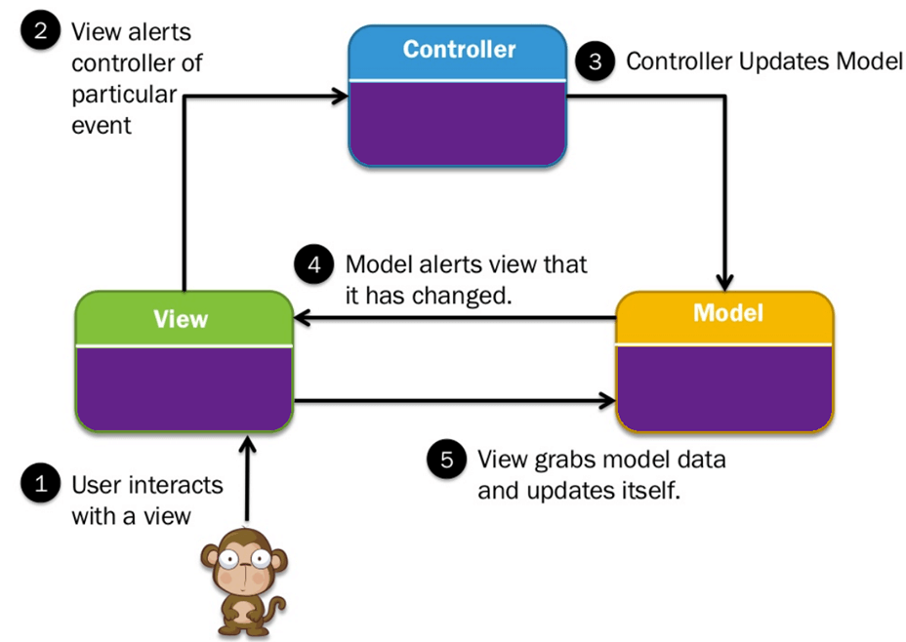

MVC in Swift:
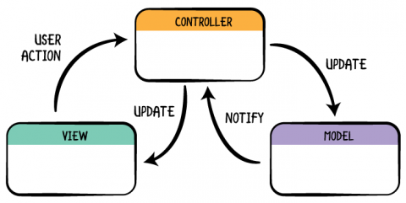

Model: Where data, and logic that manipulates the data is stored. It represents data that is being transferred between controller components or any other related business logic. For example, a Controller object will retrieve the customer info from the database. It manipulates data and sends back to the database or uses it to render the same data.Perhaps model objects, or networking code is stored here.
View: Present information to the user. Views are created by the data collected from the model data. A view requests the model to give information so that it presents the output presentation to the user. Views are UIViews and their subclasses. Can be said as the UI components that have to be controlled by the controller.
Controller: Sits between the view and the model, tying them together. The controller interprets the mouse and keyboard inputs from the user, informing model and the view to change as appropriate.

MVC architecture is triangular: the view sends updates to the controller, the controller updates the model, and the view gets updated directly from the model. In Swift, the model notifies controller and controller updates the view. View doesn’t get updates directly from the model.

