1. 2Sum problem.
Given an array of values and a sum, return the number of pairs available in that array that add to that sum, in linear time.
input array: [1, 2, 3, 4, 5]
input sum: 5
output: 2
reasoning: [1, 4] and [2, 3] are the only pairs with the sum 5

CODE:
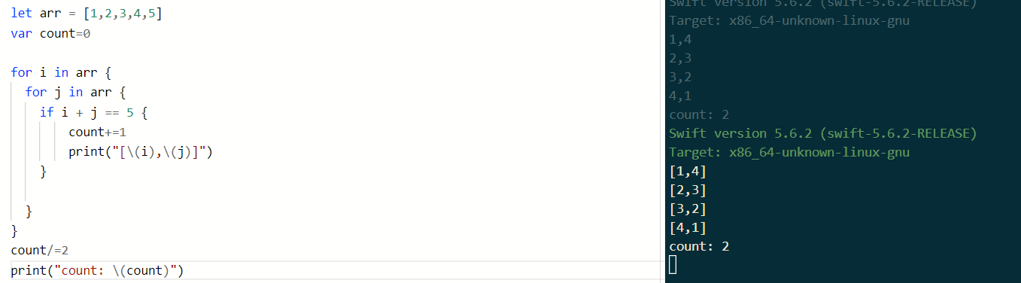

2. Example
x -> 2x
Input Array:
[1, 5, 2]
Output Dictionary:
[1 : 2,
5 : 10,
2 : 4]

CODE:
I got without closures and trying dictionary in closures
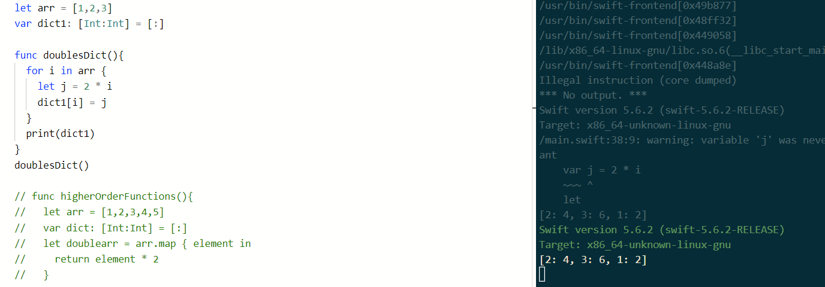
- What is the difference between var and let?
‘Var’ is used to declare mutables whereas ‘let’ is used for constants.

- What is an optional?
Optional is a constant or a variable that can hold a value or no value. Reurns ‘nil’ for variable when not declared.
Eg: let constantOpt: Int? =
var mutableOpt: String?

- What is and optional chaining vs optional binding?
Optional binding is used to check whether an optional variable or constant has a non-nil value, and if so, assign that value to a temporary, non-optional variable. It stores the value that you’re binding in a variable.
Optional chaining allows us to call properties, methods, and subscripts on an optional that might be nil. If any of the chained values return nil, the return value will be nil. It does not store the value on the left into a variable.

- What are the different ways to unwrap an optional? How do they work? Are they safe?
- Conditional/Optional Binding
- Guard let
- Nil-Coalescing
- Force Unwrapping
Other than Force Unwrapping, all are safe. In Force unwrapping, if we are not sure that variable is not nil, which results in error.

- What is a Closure?
Closure is a special type of function without the function name and closures can be assigned to a variable.
Eg: let greetUser = { (name: String) in
print(“Hey, \(name).” }
greetUser(“Closure”)

- What is the difference between a class and a struct?
- Classes are reference types while Structs are value types.
- Classes need to have Initializer whereas Structs doesn’t.
- Inheritance is possible only with Classes.

- What is the syntax '??' do?
Nil-Coalescing operator unwraps the optional if it has a value, or provide a default if the optional is empty.
Eg: var a: Int? = nil
let something = a ?? 0

- What is a tuple?
Tuples are group of values that are immutable and can store any data types.

- What is Any vs AnyObject?
Any can represent an instance of any type at all, including function types. AnyObject can represent an instance of any class type.
Eg: func anyVsAnyObject() {
let arr: [Any] = [1, 2, true, "t", "askdasd", 5.7, MyStruct(str: "sadasd", bool: false)]
print(arr)

let arr2: [AnyObject] = [NSObject(), MyClass(str: "asdas", bool: false)]
}
anyVsAnyObject()

- What is a protocol?
Protocol defines a blueprint of methods or properties that can be adopted by classes.

