**TATA Motors**

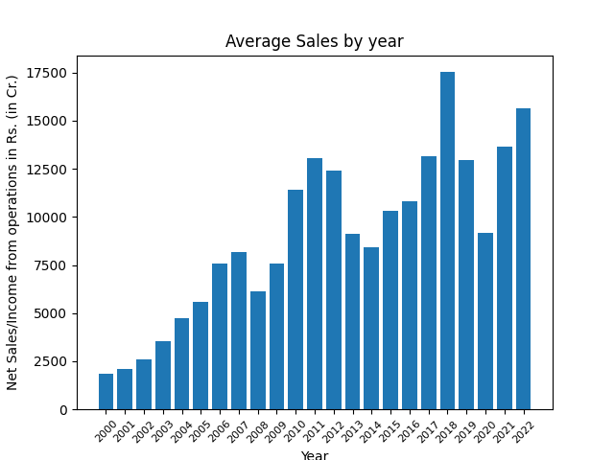

March 2023 -

Net Sales/Income from operations : Rs. (in Cr.) 2418.4221680403402

Expenditure for Consumption of Raw Materials : Rs. (in Cr.) 1234.4542178851734

June 2023 -

Net Sales/Income from operations : Rs. (in Cr.) 2524.663505044107

Expenditure for Consumption of Raw Materials : Rs. (in Cr.) 1301.097233936871

September 2023 -

Net Sales/Income from operations : Rs. (in Cr.) 2479.242777257255

Expenditure for Consumption of Raw Materials : Rs. (in Cr.) 1296.9196046040267

December 2023 -

Net Sales/Income from operations : Rs. (in Cr.) 2490.657492747592

Expenditure for Consumption of Raw Materials : Rs. (in Cr.) 1277.41765000929

March 2024 -

Net Sales/Income from operations : Rs. (in Cr.) 2492.1564402874305

Expenditure for Consumption of Raw Materials : Rs. (in Cr.) 1293.8272821283392

June 2024 -

Net Sales/Income from operations : Rs. (in Cr.) 2488.2987529397315

Expenditure for Consumption of Raw Materials : Rs. (in Cr.) 1287.8639662050891

September 2024 -

Net Sales/Income from operations : Rs. (in Cr.) 2491.023645798346

Expenditure for Consumption of Raw Materials : Rs. (in Cr.) 1286.8538963527367

December 2024 -

Net Sales/Income from operations : Rs. (in Cr.) 2489.7518820158784

Expenditure for Consumption of Raw Materials : Rs. (in Cr.) 1289.662382639325

March 2025 -

Net Sales/Income from operations : Rs. (in Cr.) 2490.1297735012668

Expenditure for Consumption of Raw Materials : Rs. (in Cr.) 1287.8484935664821

June 2025 -

Net Sales/Income from operations : Rs. (in Cr.) 2490.1252911938955

Expenditure for Consumption of Raw Materials : Rs. (in Cr.) 1288.285198064144

September 2025 -

Net Sales/Income from operations : Rs. (in Cr.) 2490.0407026283956

Expenditure for Consumption of Raw Materials : Rs. (in Cr.) 1288.5678009827336

December 2025 -

Net Sales/Income from operations : Rs. (in Cr.) 2490.1091657782426

Expenditure for Consumption of Raw Materials : Rs. (in Cr.) 1288.2018101034519