Src1: Zellis /HR Src2 : Civica(Property,Finan)

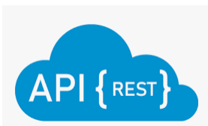   

Truncate Load/Incremental



Landing Area   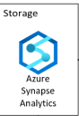

SqlPool/ServerPool (Structured/Unstructured flexibility)

MetaData based Triggers

Spark Frames.