ServiceCond_ID:

lll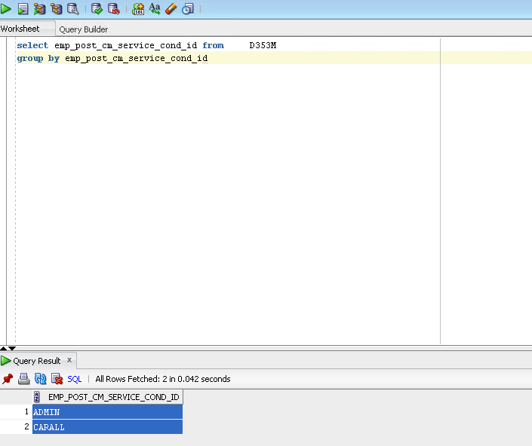

Service Cond ID - Start Date ? examples required

Occupany:

LEFT OUTER JOIN DBO.RAW_D800M OCCUPANCY_TYPE ON (EMPLOYEE_POST.OCC_TYPE = OCCUPANCY_TYPE.NARRATIVE_CODE AND OCCUPANCY_TYPE.NARRATIVE_CATEGORY = 'OCCTYP')

No duplicates:

SELECT EMPLOYEE_POST_REFERENCE,EMPLOYEE_PERSON_REFERENCE,COUNT(EMPLOYEE_POST_OCCUPANCY_TYPE)

FROM dbo.REC_RESOURCELINK_ACTIVE_DIRECTORY_ALL_POSTS

WHERE EMPLOYEE_POST_END_DATE>getdate()

GROUP BY EMPLOYEE_POST_REFERENCE, EMPLOYEE_PERSON_REFERENCE

HAVING COUNT(EMPLOYEE_POST_OCCUPANCY_TYPE)>1

EX:

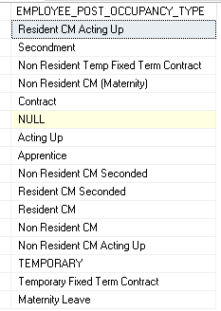

FTE_Hours

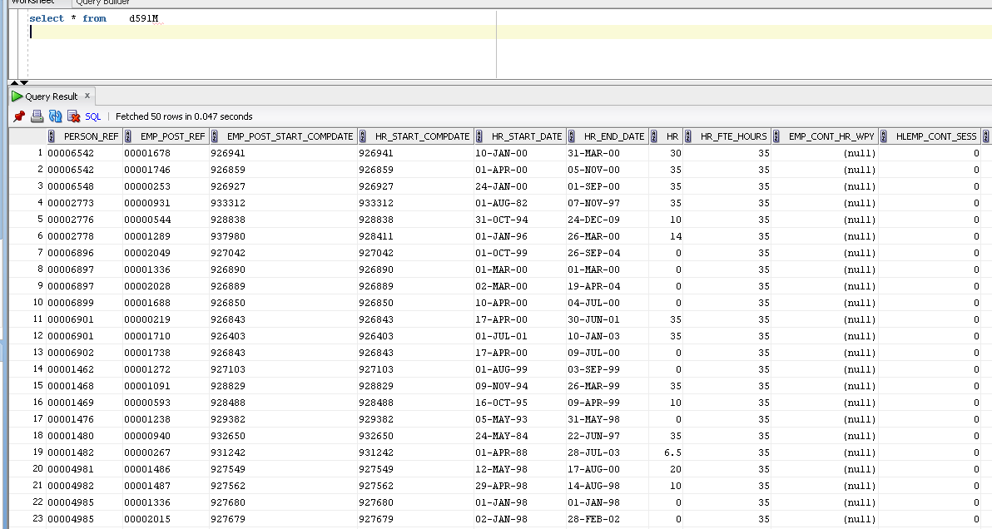

Duplicates:

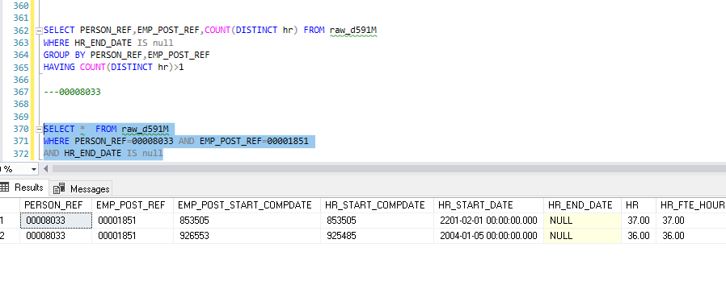

Position Status:D539M

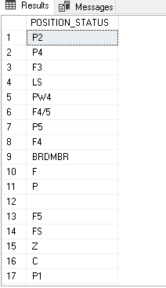

Multiple values ex:

SELECT

*

---PERSON_REF,ref,COUNT(POSITION_STATUS)

FROM dbo.RAW_D539M

WHERE

PERSON_REF='00007121' AND

POSN_STAT_END_DATE IS null

GROUP BY PERSON_REF,REF

HAVING COUNT(*)>1

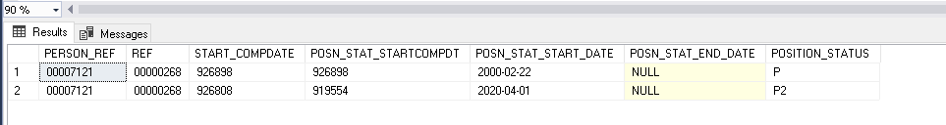

Location:

No Duplicates

SELECT EMPLOYEE_POST_REFERENCE,EMPLOYEE_PERSON_REFERENCE,COUNT(LOCATION_NUMBER)

FROM dbo.REC_RESOURCELINK_ACTIVE_DIRECTORY_ALL_POSTS

WHERE EMPLOYEE_POST_END_DATE>getdate()

GROUP BY EMPLOYEE_POST_REFERENCE, EMPLOYEE_PERSON_REFERENCE

HAVING COUNT(DISTINCT LOCATION_NUMBER)>1

---00001067,00002062

SELECT *

FROM dbo.REC_RESOURCELINK_ACTIVE_DIRECTORY_ALL_POSTS

WHERE EMPLOYEE_POST_END_DATE>getdate()

AND EMPLOYEE_PERSON_REFERENCE=00007121

AND EMPLOYEE_POST_REFERENCE=00000268