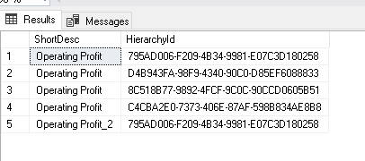

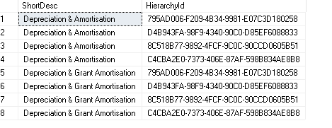

('D4B943FA-98F9-4340-90C0-D85EF6088833','C4CBA2E0-7373-406E-87AF-598B834AE8B8','8C518B77-9892-4FCF-9C0C-90CCD0605B51','795AD006-F209-4B34-9981-E07C3D180258')