Question | 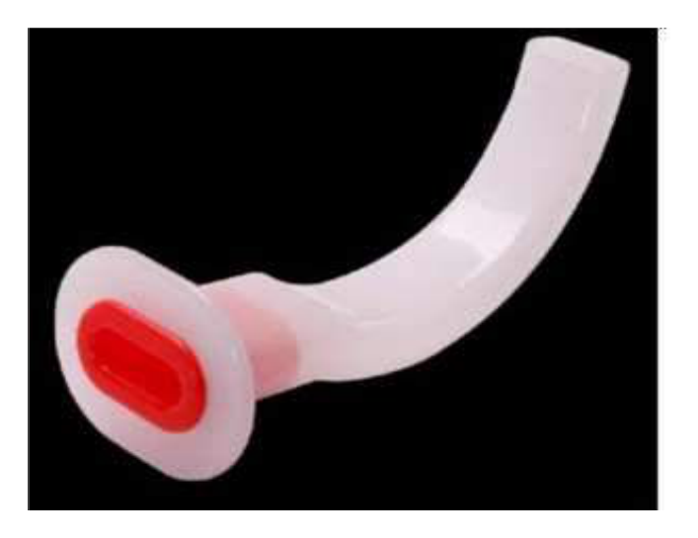  Identify the image:
Type | multiple_choice
Option | ET tube
Option | Orotracheal airway
Option | William airway
Option | Guedel airway
Answer | 4
Solution | Rationale: Guedel airway (oropharyngeal airway) is a rigid curved plastic device inserted into the mouth to maintain an open airway by preventing the tongue from obstructing the oropharynx. It is used in unconscious patients. Key Clues: Rigid curved shape, inserted orally, prevents tongue fall-back Why Not Others: A-ET tube goes into trachea not mouth; B-Orotracheal is not a standard term; C-Williams airway has a different shape with lateral channels Exam Trap: Confusing Guedel with Williams airway - Guedel is classic curved; Williams has central and lateral channels PNC Pearl: Guedel airway: Remember G-Goes in mouth, curved like a J-shape. Color-coded by size (size 0 for neonates to size 5 for large adults).
Positive Marks | 1
Negative Marks | 0.33

Question | 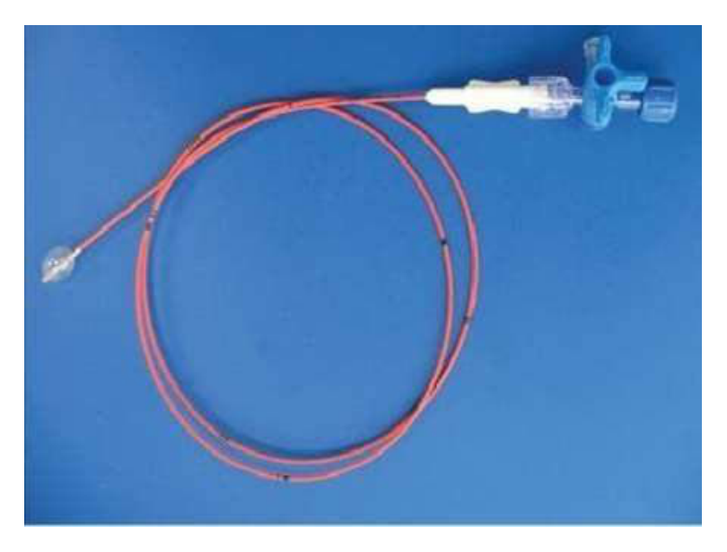  This phototogrph used in?
Type | multiple_choice
Option | To drain the urine
Option | To remove secretion
Option | To treat embolism
Option | To Stomach irrigation
Answer | 2
Solution | Rationale: This photograph shows a suction catheter/Yankauer catheter used to remove secretions from the oropharynx and trachea. Suctioning maintains airway patency by clearing mucus, blood, and debris. Key Clues: Catheter tip visible, connected to suction apparatus, used in airway clearance Why Not Others: B-Drain urine is done with urinary catheter; C-Embolism treated with anticoagulation; D-Stomach irrigation uses NG tube Exam Trap: Confusing suction catheter with other tubes - the rigid Yankauer tip is distinctive PNC Pearl: Yankauer catheter: Large-bore, rigid, used for oropharyngeal suctioning. Always use negative pressure 80-120 mmHg. Suction for max 10 seconds per pass.
Positive Marks | 1
Negative Marks | 0.33

Question | 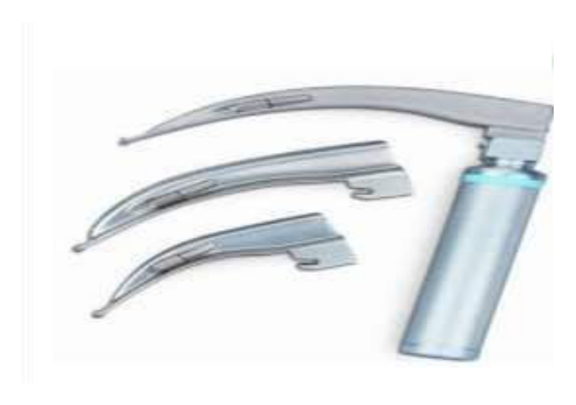  Identify the image?
Type | multiple_choice
Option | Fetoscope
Option | Otoscope
Option | Laryngoscope
Option | Fibroscope
Answer | 3
Solution | Rationale: Laryngoscope is used to visualize the larynx for endotracheal intubation. It consists of a handle with a light source and interchangeable blades (Macintosh for adults, Miller for pediatrics). Key Clues: Handle with blade, light source at tip, used for intubation Why Not Others: A-Fetoscope is for fetal heart auscultation; C-Otoscope is for ear examination; D-Fibroscope is flexible Exam Trap: Confusing rigid laryngoscope with flexible fibroscope - laryngoscope is rigid with straight/curved blade PNC Pearl: Laryngoscope blades: Macintosh (curved, size 3-4 for adults) - inserted into vallecula. Miller (straight, size 1-2) - lifts epiglottis directly. Always check light before intubation.
Positive Marks | 1
Negative Marks | 0.33

Question | 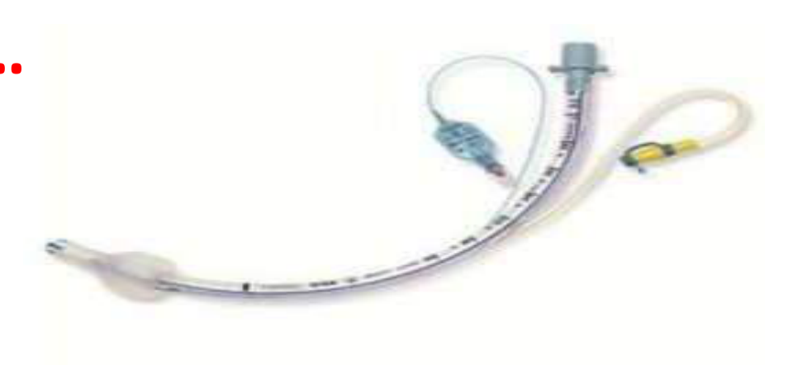  Identify the image:
Type | multiple_choice
Option | ET tube
Option | CASS tube
Option | TT tube
Option | Canther tube
Answer | 3
Solution | Rationale: Tracheostomy tube (TT tube) is a curved tube inserted through the tracheostomy stoma into the trachea for long-term airway management. It has an outer cannula, inner cannula, and obturator. Key Clues: Inserted through neck into trachea, has flange, inner cannula removable Why Not Others: A-ET tube is inserted through mouth; C-CASS tube is not a standard term; D-Canthor tube is not standard Exam Trap: Confusing TT tube with ET tube - TT goes through neck stoma, ET goes through mouth PNC Pearl: Tracheostomy tube sizes: Neonate 3.0-3.5mm, Child 4.0-5.0mm, Adult 6.0-8.0mm. Always have spare inner cannula and obturator available.
Positive Marks | 1
Negative Marks | 0.33

Question | 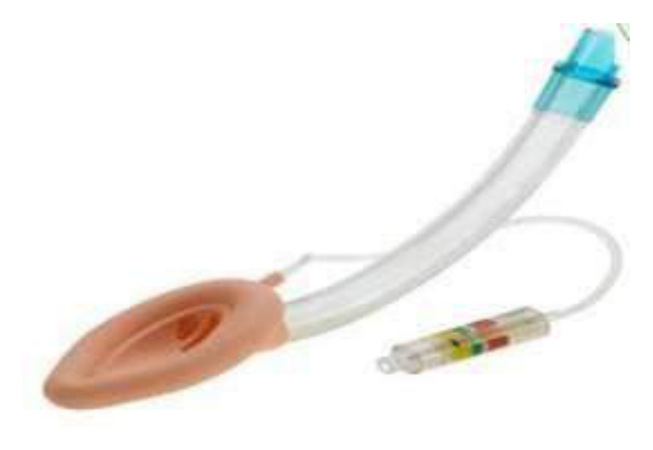  Identify the image:
Type | multiple_choice
Option | LMA
Option | ET tube
Option | TT tube
Option | NRB
Answer | 1
Solution | Rationale: LMA (Laryngeal Mask Airway) is a supraglottic airway device that sits above the larynx. It has an inflatable cuff that seals around the laryngeal inlet, providing a clear airway without tracheal intubation. Key Clues: Mask-like shape with inflatable cuff, sits above glottis Why Not Others: A-ET tube goes into trachea; B-TT tube goes through neck; D-NRB is a face mask Exam Trap: LMA vs ET tube - LMA is supraglottic (above vocal cords), ET is infraglottic (below vocal cords) PNC Pearl: LMA sizes: 1 (neonate <5kg) to 5 (large adult >100kg). Contraindicated in: full stomach, obesity, pregnancy, pulmonary aspiration risk. Cuff pressure 40-60 cmH·O.
Positive Marks | 1
Negative Marks | 0.33

Question | 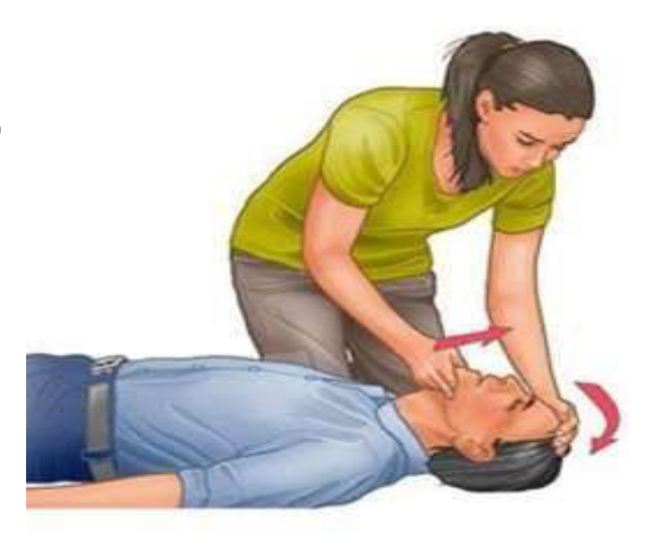  Identify the image?
Type | multiple_choice
Option | Check response
Option | Jaw thrust manuever
Option | Head tilt chin lift manuever
Option | Heimlich manuever
Answer | 3
Solution | Rationale: Head tilt chin lift maneuver opens the airway by tilting the head back and lifting the chin forward. This displaces the tongue forward, relieving airway obstruction in unconscious patients. Key Clues: Hands on forehead and chin, head extended, chin lifted Why Not Others: A-Check response is tapping shoulders; B-Jaw thrust uses hands on mandible angles; C-Heimlich is abdominal thrusts Exam Trap: Head tilt chin lift vs jaw thrust - jaw thrust is preferred in cervical spine injury PNC Pearl: Head tilt chin lift: First step in BLS/ABC. Contraindicated if C-spine injury suspected - use jaw thrust instead. Two-finger technique for chin lift.
Positive Marks | 1
Negative Marks | 0.33

Question | 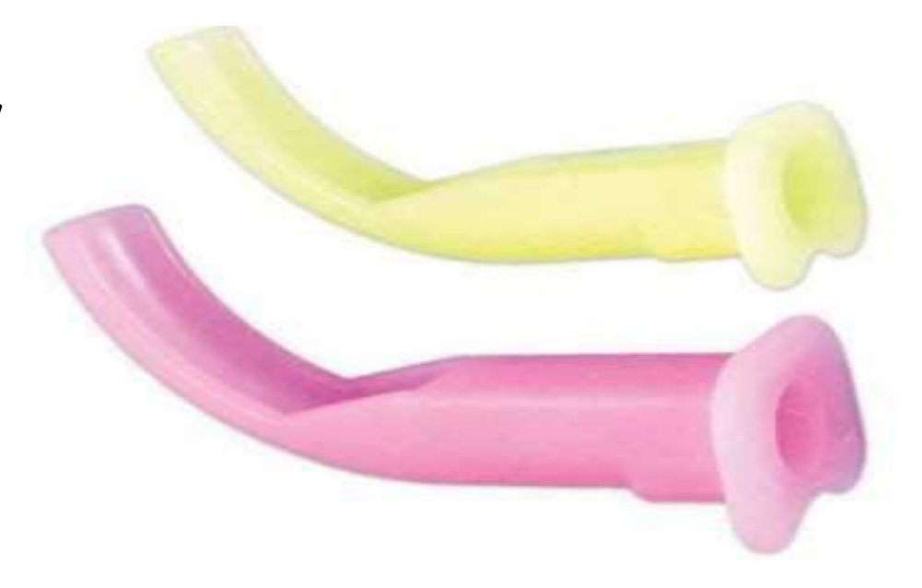  Identify the image:
Type | multiple_choice
Option | Williams Airway
Option | NPA Airway
Option | Guedel airway
Option | Berman airway
Answer | 2
Solution | Rationale: NPA (Nasopharyngeal Airway): A soft, flexible tube inserted through the nose into the nasopharynx. Used to maintain airway in conscious/semi-conscious patients or when oral airway cannot be used. Key Clues: Inserted through nose, flexible, for semi-conscious patients Why Not Others: A-Williams has lateral channels;B-Guedel is oropharyngeal;D-Berman has different shape Exam Trap: NPA vs Guedel - NPA goes through nose (better tolerated), Guedel goes through mouth PNC Pearl: NPA: Size = diameter of patient's little finger. Lubricate before insertion. Insert with bevel toward septum. Contraindicated in: basilar skull fracture, suspected CSF leak, nasal fracture.
Positive Marks | 1
Negative Marks | 0.33

Question | 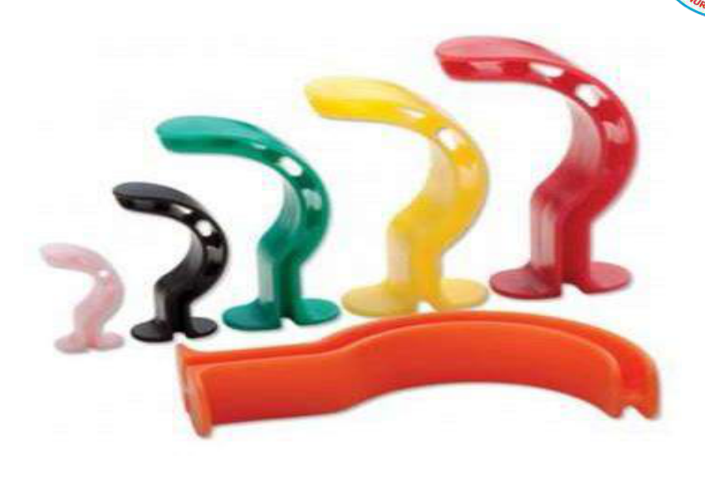  Identify the image:
Type | multiple_choice
Option | NPA Airway
Option | Williams Airway
Option | Guedel airway
Option | Berman airway
Answer | 1
Solution | Rationale: NPA (Nasopharyngeal Airway): A soft, flexible tube with a beveled tip and flange at the nostril end. Inserted through the naris to the nasopharynx to maintain airway patency. Key Clues: Beveled tip, flange, nasally inserted Why Not Others: A-Williams is rigid oral;B-Guedel is curved oral;D-Berman has channels Exam Trap: NPA sizes: 6.0-8.0mm (adult). Smallest finger width guide. PNC Pearl: NPA advantages over oral: Better tolerated in conscious patients, no dental trauma risk, preferred injaw injuries. Always use water-based lubricant. Insert bevel toward septum.
Positive Marks | 1
Negative Marks | 0.33

Question | 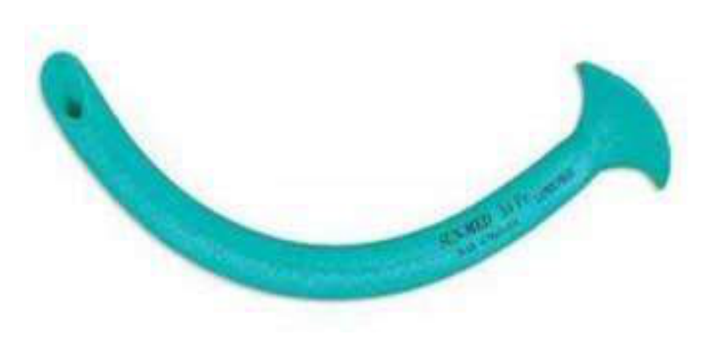  Identify the image:
Type | multiple_choice
Option | Guedel airway
Option | Williams Airway
Option | NPA Airway
Option | Berman airway
Answer | 2
Solution | Rationale: Williams Airway: An oropharyngeal airway with a central channel and two lateral channels. The central channel allows suctioning while the airway is in place, and the lateral channels allow some ventilation. Key Clues: Central + lateral channels, allows suctioning in place Why Not Others: B-Guedel is simple curved;C-NPA is nasal;D-Berman has different channel arrangement Exam Trap: Williams vs Guedel - Williams has central channel for suction, Guedel is solid curved PNC Pearl: Williams airway: Useful when frequent suctioning needed. Can pass suction catheter through central channel. Available in sizes for adults and children.
Positive Marks | 1
Negative Marks | 0.33

Question | 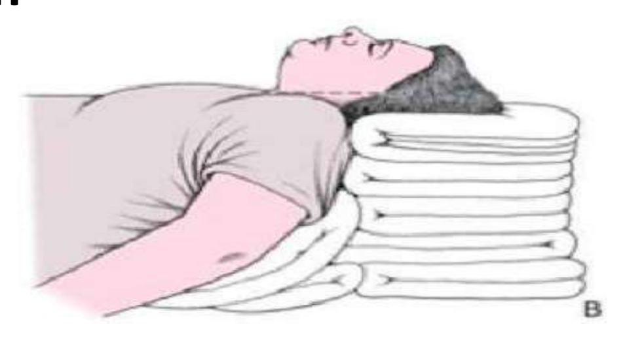  Identify the Position?
Type | multiple_choice
Option | Rose position
Option | Ramped position
Option | Durant position
Option | Sniffing position
Answer | 4
Solution | Rationale: Sniffing Position: Head extended at atlanto-occipital joint, neck flexed at cervical spine. Creates alignment of oral, pharyngeal, and laryngeal axes. Optimal position for endotracheal intubation. Key Clues: Head extended, neck flexed, for intubation alignment Why Not Others: A-Rose is for prone;C-Ramped elevates entire body;D-Durant is left lateral for air embolism Exam Trap: Sniffing vs ramped - sniffing is head/neck only, ramped elevates entire body to ear- sternal notch level PNC Pearl: Sniffing position: Ear-to-sternal notch alignment. Use pillow under head (10-15cm). Essential for laryngoscopy and intubation. Modified sniffing for obese patients.
Positive Marks | 1
Negative Marks | 0.33

Question | 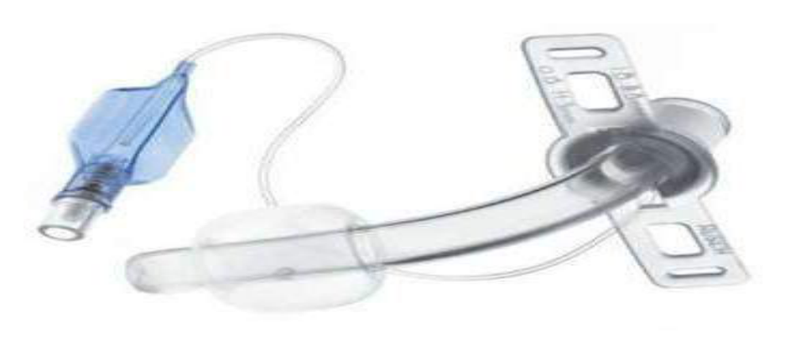  Identify the image:
Type | multiple_choice
Option | ET tube
Option | CT tube
Option | BTT tube
Option | TT tube
Answer | 4
Solution | Rationale: Tracheostomy Tube: A curved tube inserted directly into the trachea through a surgical stoma in the neck. Used for long-term mechanical ventilation and airway management. Key Clues: Inserted through neck into trachea Why Not Others: A-ET tube goes through mouth;C-CT tube is not standard;D-BTT tube is not standard Exam Trap: Tracheostomy vs ET tube - tracheostomy is through neck (long-term), ET is through mouth (short-term) PNC Pearl: Tracheostomy: Indications: prolonged ventilation (>14 days), upper airway obstruction, airway protection. Sizes: 6.0-8.0mm (adult). Always have emergency tracheostomy set at bedside.
Positive Marks | 1
Negative Marks | 0.33

Question | 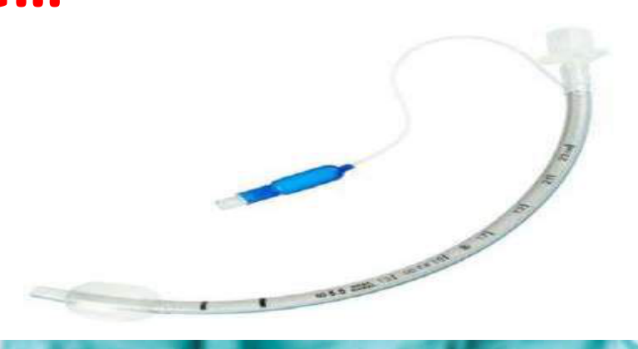  Identify the image:
Type | multiple_choice
Option | TT tube
Option | ET tube
Option | CT tube
Option | BTT tube
Answer | 1
Solution | Rationale: Tracheostomy Tube (TT Tube): Features include outer cannula, inner cannula (removable for cleaning), obturator (for insertion), and inflatable cuff for mechanical ventilation. Key Clues: Outer + inner cannula, obturator, cuff Why Not Others: A-ET is endotracheal;C-CT is not standard;D-BTT is not standard Exam Trap: TT inner cannula: Remove and clean q4-8h or as needed. Never remove outer cannula. PNC Pearl: Tracheostomy care: Clean stoma site daily, inner cannula q4-8h, change ties when soiled, humidify oxygen, suction PRN. Emergency: Have spare tube and obturator at bedside.
Positive Marks | 1
Negative Marks | 0.33

