Question | 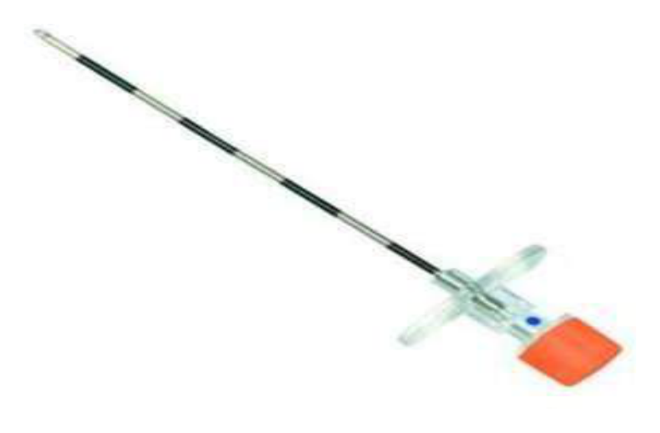  Identify the image:
Type | multiple_choice
Option | LP needle
Option | Epidural needle
Option | BMP needle
Option | Menghini gun
Answer | 2
Solution | Rationale: Epidural Needle: A thick, hollow needle with a stylet, used to access the epidural space for anesthesia or catheter placement. Has a loss-of-resistance technique for identification. Key Clues: Thick hollow needle, stylet, loss-of-resistance Why Not Others: A-LP is for subarachnoid space;B-BMP is for bone marrow;D-Menghini is for biopsy Exam Trap: Epidural vs spinal needle - epidural is larger (Tuohy 16-18G), spinal is smaller (25-27G) PNC Pearl: Epidural needle (Tuohy): 16-18G with curve at tip. Loss-of-resistance technique with saline or air. Test dose before loading. Complications: dural puncture, epidural hematoma, nerve damage.
Positive Marks | 1
Negative Marks | 0.33

Question | 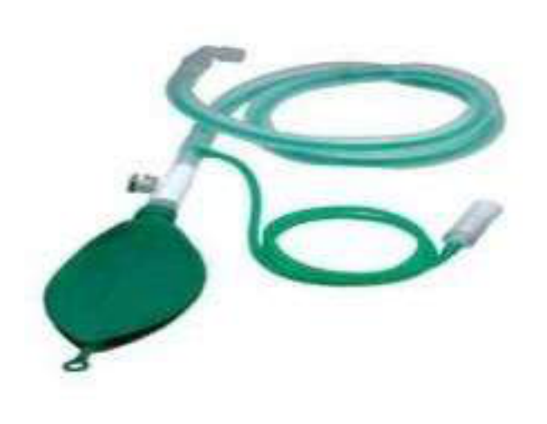  Identify the image:
Type | multiple_choice
Option | Venti circuit
Option | Bain circuit
Option | NIBP
Option | Ambu bag
Answer | 2
Solution | Rationale: Bain Circuit: A modified Mapleson system used for anesthesia delivery. It is a coaxial circuit with an inner fresh gas tube inside an outer breathing tube. Efficient for controlled ventilation. Key Clues: Coaxial design, inner fresh gas tube, for anesthesia Why Not Others: B-VMPI circuit is not standard; C-NIBP is blood pressure; D-Ambu bag is manual ventilation Exam Trap: Bain vs Jackson-Rees - Bain is modified Mapleson D, Jackson-Rees is modified Mapleson F PNC Pearl: Bain circuit: Always set fresh gas flow at >70 ml/kg/min to prevent rebreathing. Check for disconnection - can cause hypercapnia rapidly. Light weight, easy to use.
Positive Marks | 1
Negative Marks | 0.33

Question | 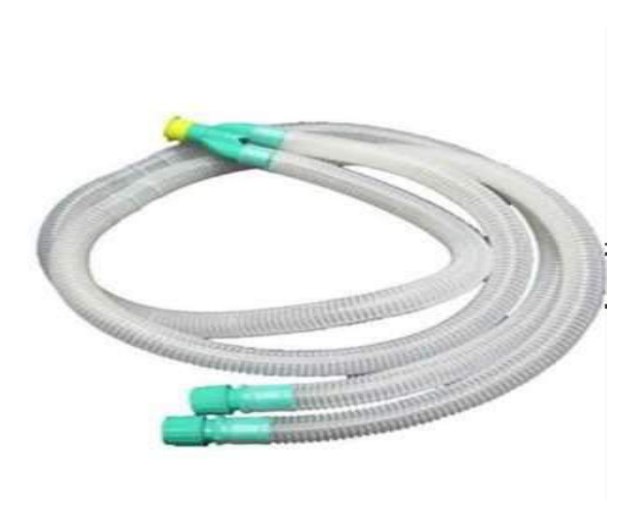  Identify the image:
Type | multiple_choice
Option | Bain circuit
Option | NIBP
Option | Ambu bag
Option | Venti circuit
Answer | 4
Solution | Rationale: Circle Circuit (Venti Circuit): A semi-closed breathing system used in anesthesia machines. Features unidirectional valves, CO· absorber, and reservoir bag. Allows rebreathing of gases after CO· removal. Key Clues: Unidirectional valves, CO· absorber, reservoir bag Why Not Others: A-Bain is coaxial; C-NIBP is blood pressure;D-Ambu bag is manual Exam Trap: Circle vs Bain - circle has CO· absorber and unidirectional valves, Bain is coaxial PNC Pearl: Circle circuit: Most common anesthesia circuit. CO· absorber (soda lime) removes CO·. Check unidirectional valves function. Fresh gas flow 1-2 L/min (low flow anesthesia).
Positive Marks | 1
Negative Marks | 0.33

Question | 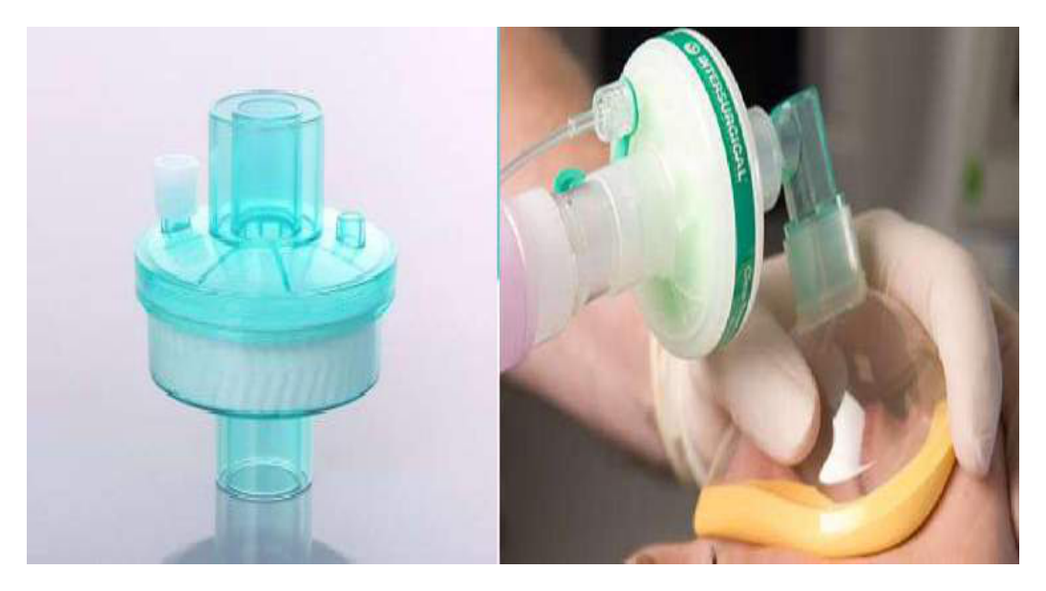  Identify the image:
Type | multiple_choice
Option | HEFA filter
Option | NRB filter
Option | PNRB filter
Option | HME filter
Answer | 4
Solution | Rationale: HME Filter (Heat and Moisture Exchanger): A device placed between the ET tube and ventilator circuit that conserves heat and moisture from exhaled gases. Also called artificial nose. Key Clues: Conserves heat/moisture, artificial nose Why Not Others: A-HEFA is not standard;C-NRB is non-rebreather mask;D-PNRB is partial non-rebreather Exam Trap: HME vs heated humidifier - HME is passive (no heat source), heated humidifier is active PNC Pearl: HME: Passive humidification. Not suitable for: thick secretions, high minute ventilation, pediatric patients. Change q24-48h or when soiled. Contraindicated with nebulized medications.
Positive Marks | 1
Negative Marks | 0.33

Question | 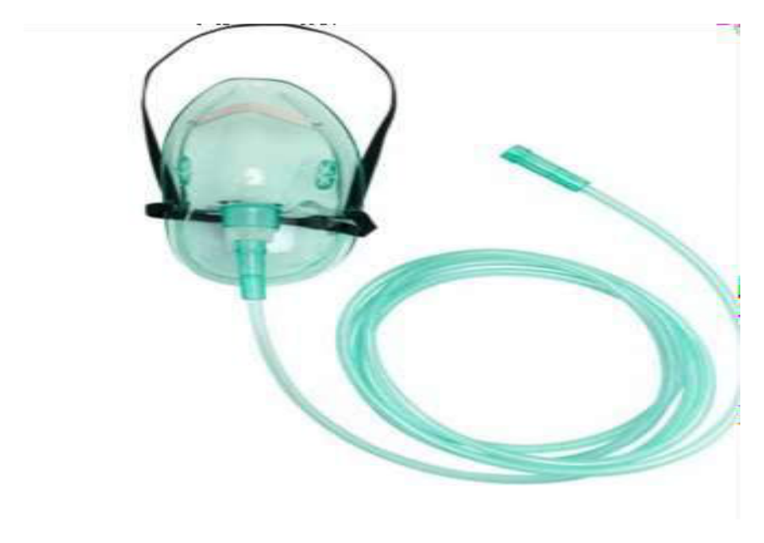  Identify the image:
Type | multiple_choice
Option | NRB mask
Option | Face mask
Option | PNRB mask
Option | Venturi mask
Answer | 3
Solution | Rationale: PNRB (Partial Non-Rebreather) Mask: An oxygen mask with a reservoir bag that allows partial rebreathing of expired gases. Delivers 40-60% FiO· at 10-15 L/min oxygen flow. Key Clues: Reservoir bag attached, partial rebreathing, 40-60% FiO· Why Not Others: A-NRB is full non-rebreather (no valve); C-Face mask delivers 35-50%; D-Venturi provides precise FiO· Exam Trap: PNRB vs NRB - PNRB has a small opening allowing some rebreathing, NRB has one-way valve PNC Pearl: PNRB: Always ensure reservoir bag is 1/3 to 1/2 full during inhalation. O· flow 10-15 L/min. FiO· 40-60%. Monitor patient comfort and O· saturation.
Positive Marks | 1
Negative Marks | 0.33

Question | 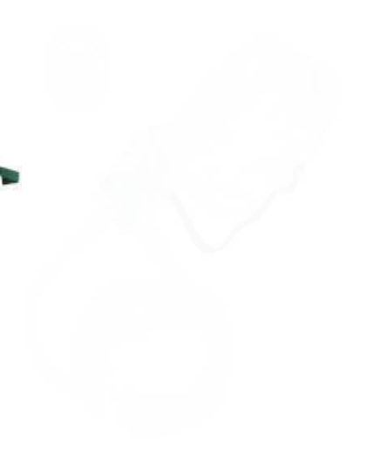  Identify the image:
Type | multiple_choice
Option | NRB mask
Option | Nabulizer mask
Option | Venturi mask
Option | Face mask
Answer | 3
Solution | Rationale: Venturi Mask: An oxygen delivery device that provides precise, controlled FiO· (24-60%) using the Venturi principle. Color-coded adapters indicate different oxygen concentrations. Key Clues: Color-coded adapters, precise FiO· delivery, air-entrainment Why Not Others: A-NRB delivers high FiO·;B-Nebulizer delivers medication;C-Face mask delivers 35-50% Exam Trap: Venturi vs simple face mask - Venturi provides exact FiO·, face mask is variable PNC Pearl: Venturi mask colors: Blue=24%, White=28%, Orange=31%, Yellow=35%, Red=40%, Green=60%. Ideal for COPD patients needing controlled O·. Uses Bernoulli principle.
Positive Marks | 1
Negative Marks | 0.33

Question | 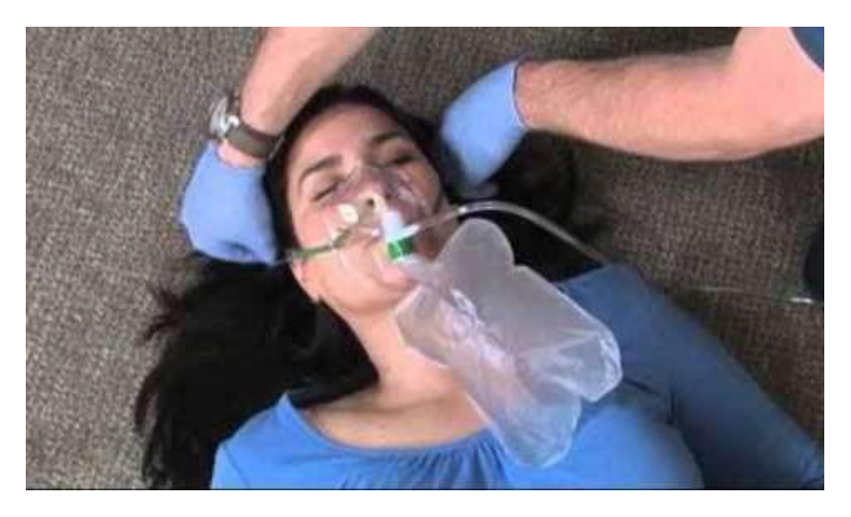  Identify the image:
Type | multiple_choice
Option | Face mask
Option | NRB mask
Option | PNRB mask
Option | Venturi mask
Answer | 1
Solution | Rationale: Face Mask (Simple Face Mask): A basic oxygen delivery device that covers nose and mouth. Delivers 35-50% FiO· at 5-8 L/min. Used for moderate oxygen supplementation. Key Clues: Covers nose and mouth, simple design, 35-50% FiO· Why Not Others: A-NRB delivers higher FiO·;B-PNRB has reservoir;D-Venturi provides precise FiO· Exam Trap: Simple face mask vs nasal cannula - face mask delivers higher FiO· but is less comfortable PNC Pearl: Simple face mask: O· flow 5-8 L/min. FiO· 35-50%. Remove for eating/drinking. Check for skin breakdown on face. Ensure proper fit.
Positive Marks | 1
Negative Marks | 0.33

Question | 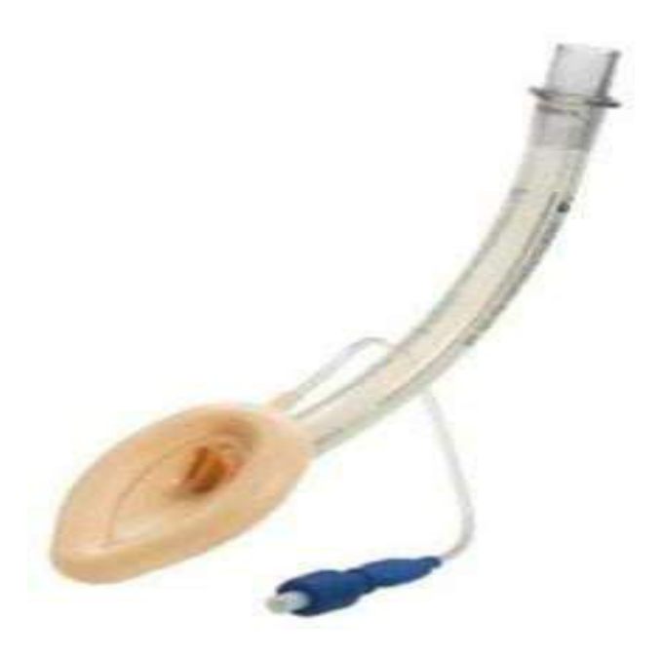  Identify the item in this image?
Type | multiple_choice
Option | AMBU bag
Option | Endotracheal tube
Option | Flexo-metallic tube
Option | Laryngeal mask airway
Answer | 4
Solution | Rationale: Laryngeal Mask Airway (LMA): A supraglottic airway device consisting of a mask connected to a tube. The inflatable mask sits over the laryngeal inlet, providing ventilation without tracheal intubation. Key Clues: Mask over laryngeal inlet, supraglottic Why Not Others: A-AMBU bag is manual ventilation;B-ET tube goes into trachea;D-Flexo-metallic tube is for specific procedures Exam Trap: LMA vs ET tube - LMA sits above vocal cords (supraglottic), ET goes through vocal cords PNC Pearl: LMA: Sizes 1-5 based on weight. Insert with cuff deflated, inflate after placement. Cuff pressure 40-60 cmH·O. Contraindicated in full stomach, pregnancy, obesity. Cuff pressure monitoring essential.
Positive Marks | 1
Negative Marks | 0.33

Question | 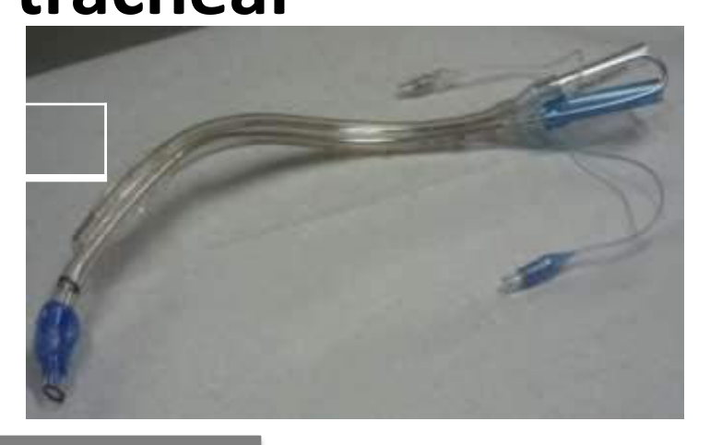  Identify the image:
Type | multiple_choice
Option | Double lumen endo tracheal
Option | ET tube
Option | Lobectomy tube
Option | Pneumenctomy tube
Answer | 1
Solution | Rationale: Double Lumen Endotracheal Tube: A specialized ET tube with two separate lumens allowing independent ventilation of each lung. Used in thoracic surgery for one-lung ventilation. Key Clues: Two lumens, for one-lung ventilation in thoracic surgery Why Not Others: A-Standard ET tube has one lumen;B-Lobectomy is lung removal;C-Pneumonectomy is total lung removal Exam Trap: Double lumen vs standard ET - double lumen allows selective lung ventilation PNC Pearl: Double lumen ET tube: Right-sided (Robertshaw) most common. Used for: thoracoscopic surgery, lobectomy, pneumonectomy. Cuff pressure monitoring essential. Verify position with auscultation and fiber optics.
Positive Marks | 1
Negative Marks | 0.33

Question | 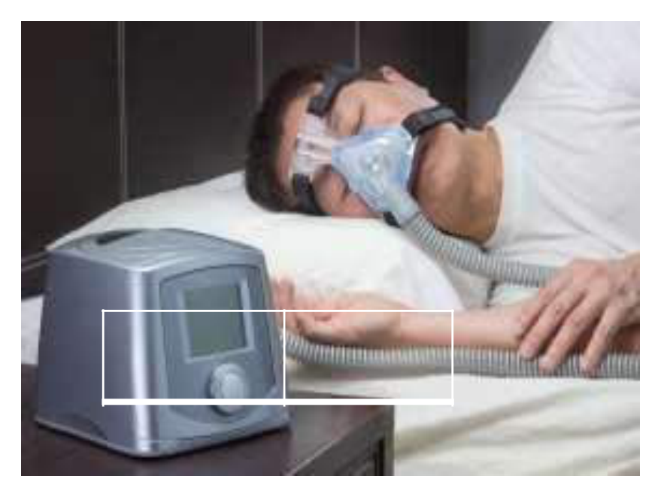  Identify the image:
Type | multiple_choice
Option | SIMV
Option | BIPAP
Option | CMV
Option | PEEP
Answer | 2
Solution | Rationale: BIPAP (Bilevel Positive Airway Pressure): A non-invasive ventilation device that provides two levels of pressure: IPAP (inspiratory) for breath delivery and EPAP (expiratory) for alveolar recruitment. Key Clues: Two pressure levels, non-invasive ventilation Why Not Others: B-SIMV is invasive ventilator mode;C-CMV is continuous mandatory ventilation;D-PEEP is positive end-expiratory pressure Exam Trap: BIPAP vs CPAP - BIPAP has two pressures (IPAP + EPAP), CPAP has one constant pressure PNC Pearl: BIPAP: IPAP 8-20 cmH·O, EPAP 4-12 cmH·O. Used for: COPD exacerbation, acute respiratory failure, obesity hypoventilation. Monitor: mask fit, skin breakdown, gastric distension.
Positive Marks | 1
Negative Marks | 0.33

Question | 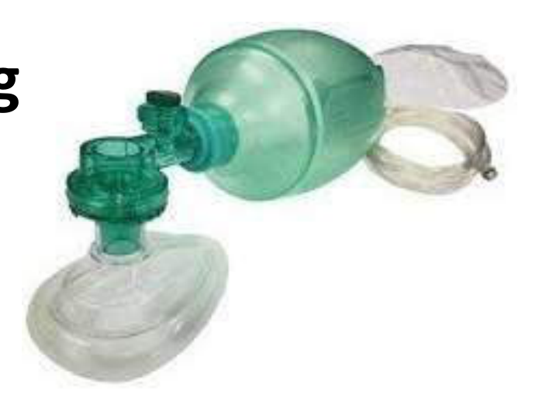  Identify the image:
Type | multiple_choice
Option | Ambu bag with rebreathing
Option | Ambu bag
Option | Ambu bag with reservoir bag
Option | Artificial manual breathing
Answer | 3
Solution | Rationale: AMBU Bag with Reservoir: A self-inflating ventilation bag with an attached reservoir bag and non-rebreathing valve. The reservoir allows higher FiO· (up to 100%) when connected to high-flow oxygen. Key Clues: Self-inflating bag + reservoir bag, for high FiO· Why Not Others: B-Rebreathing is incorrect concept;C-AMBU bag without reservoir gives lower FiO·;D-Artificial manual breathing is the full form Exam Trap: AMBU with reservoir vs without - with reservoir achieves FiO· up to 100%, without only 40-60% PNC Pearl: AMBU bag with reservoir: O· flow 10-15 L/min into reservoir. Non-rebreathing valve ensures patient gets fresh O· only. Always check valve function. Adult 1600ml, pediatric 500ml.
Positive Marks | 1
Negative Marks | 0.33

Question | 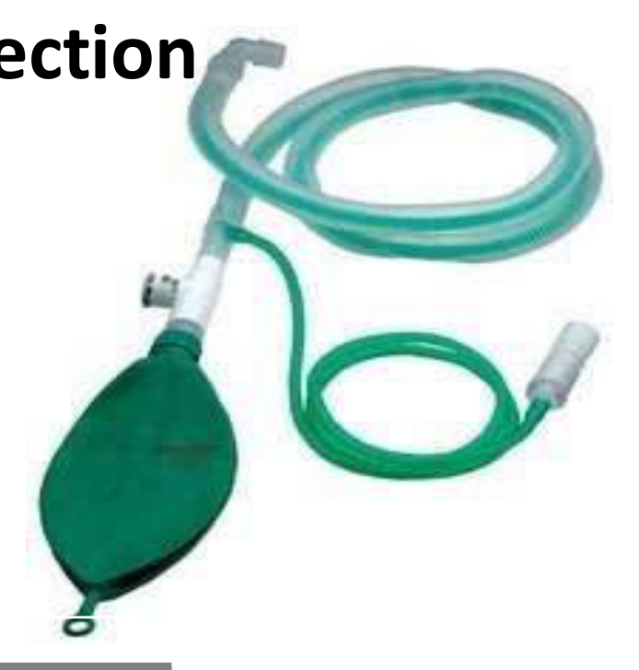  Identify the image:
Type | multiple_choice
Option | Bain circuit
Option | Mepalson catheter
Option | Ambu bag with L connection
Option | Respiratory circuit
Answer | 1
Solution | Rationale: Bain Circuit: A modified Mapleson D coaxial breathing system used in anesthesia. The fresh gas tube runs inside the expiratory tube. Lightweight and convenient for head and neck surgery. Key Clues: Coaxial design, Mapleson D modified, for anesthesia Why Not Others: A-Mepalson is not standard;C-AMBU with L is not standard;D-Respiratory circuit is generic Exam Trap: Bain circuit: Set fresh gas flow ·70 ml/kg/min to prevent rebreathing. Check for disconnection (can cause CO· retention rapidly). Lightweight advantage. PNC Pearl: Bain circuit: Set fresh gas flow ·70 ml/kg/min to prevent rebreathing. Check for disconnection (can cause CO· retention rapidly). Lightweight advantage.
Positive Marks | 1
Negative Marks | 0.33

