Question | 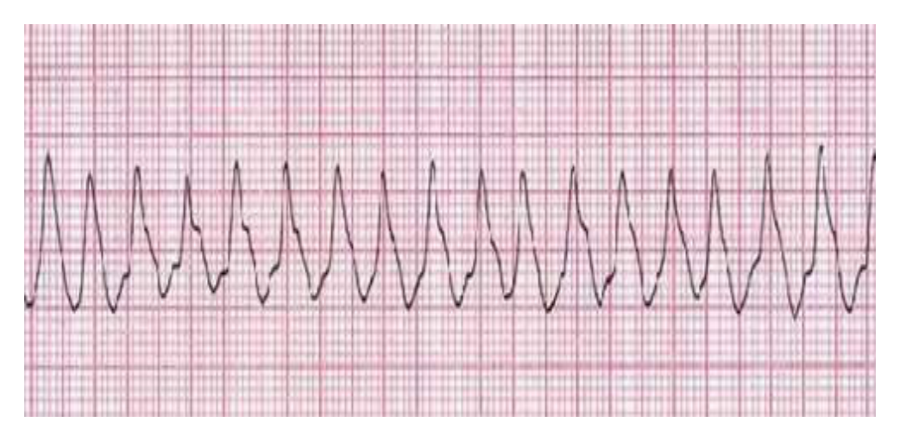  Identify the image:
Type | multiple_choice
Option | PVT
Option | VF
Option | VT
Option | AF
Answer | 3
Solution | Rationale: Ventricular Tachycardia (VT): Wide QRS complex (>120ms), rate 100-250 bpm, regular rhythm. The QRS complexes are bizarre and uniform. This is a life-threatening arrhythmia. Key Clues: Wide QRS, regular, fast rate, uniform complexes Why Not Others: B-PVT is polymorphic VT (Torsades); C-VF has no organized complexes; D-AF has irregularly irregular rhythm Exam Trap: VT vs SVT with aberrancy - VT has AV dissociation, fusion beats, capture beats PNC Pearl: VT: If pulseless · immediate defibrillation (biphasic 120-200J). If pulse present · Amiodarone 150mg IV over 10 min. Always consider reversible causes (5H, 5T).
Positive Marks | 1
Negative Marks | 0.33

Question | 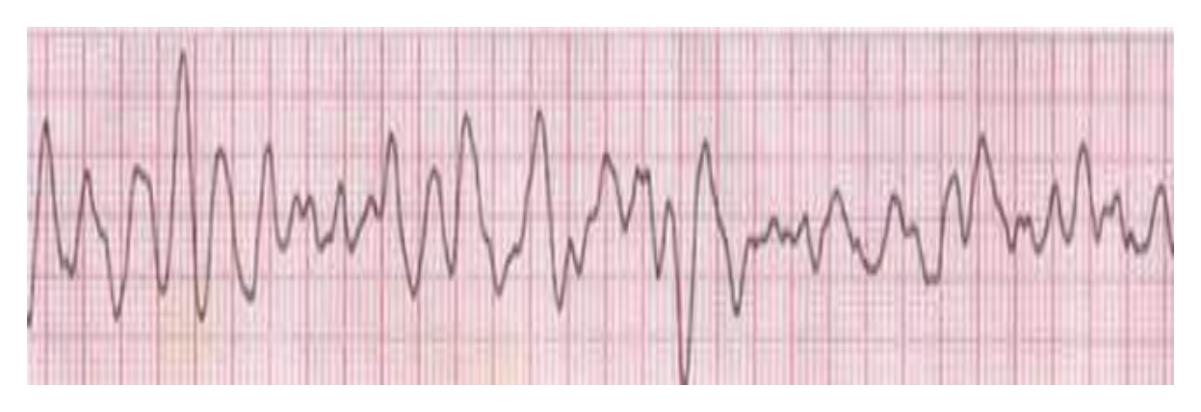  Identify the image:
Type | multiple_choice
Option | VT
Option | VF
Option | AF
Option | PVT
Answer | 4
Solution | Rationale: Polymorphic VT (PVT/Torsades de Pointes): Wide QRS complexes that twist around the baseline with varying amplitude. Often associated with prolonged QT interval. Key Clues: QRS complexes vary in amplitude, twisting pattern, irregular Why Not Others: A-VT is uniform wide QRS; C-VF has no organized complexes; D-AF has narrow QRS irregular Exam Trap: PVT vs VT - PVT has varying QRS morphology (polymorphic), VT is usually uniform PNC Pearl: Torsades de Pointes: Treatment = Magnesium sulfate 2g IV. Avoid class Ia/III antiarrhythmics. Temporary pacing if bradycardia. Isoproterenol may help.
Positive Marks | 1
Negative Marks | 0.33

Question | 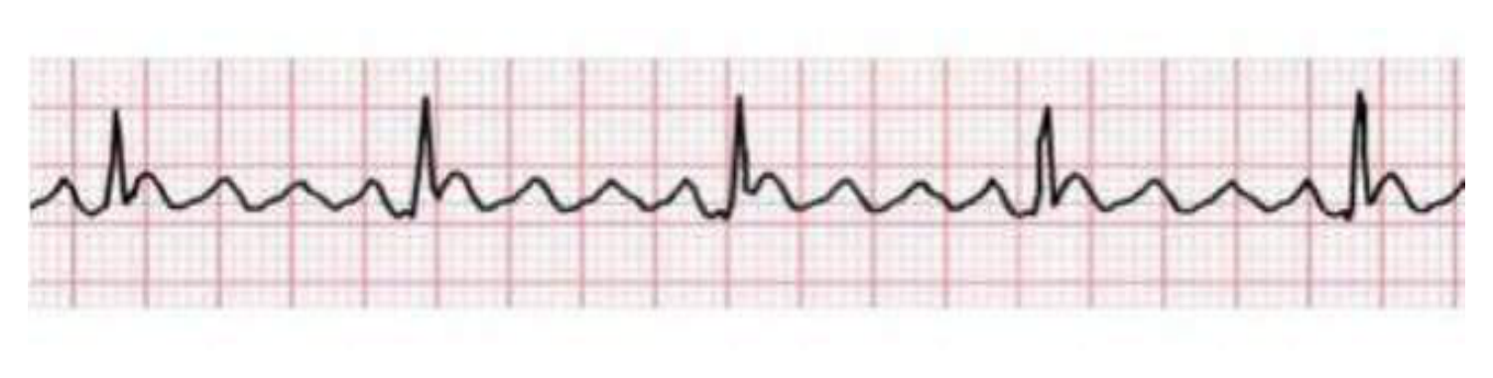  Identify the image?
Type | multiple_choice
Option | Atrial flutter
Option | Ventricular fibrillation
Option | Atrial fibrillation
Option | Ventricular tachycardia
Answer | 2
Solution | Rationale: Ventricular Fibrillation (VF): No identifiable P waves, QRS, or T waves. Instead, chaotic, irregular waveforms of varying amplitude. No effective cardiac output - medical emergency. Key Clues: Chaotic undulating baseline, no organized complexes, no pulse Why Not Others: A-Atrial flutter has saw-tooth pattern; B-AF has irregularly irregular narrow QRS; C-VT has wide QRS regular Exam Trap: VF vs asystole - VF shows chaotic activity, asystole is flat line PNC Pearl: VF: Immediate CPR + defibrillation. Biphasic 120-200J, Monophasic 360J. Epinephrine 1mg IV q3-5min. Amiodarone 300mg IV after 3rd shock. Reversible causes: 4H4T.
Positive Marks | 1
Negative Marks | 0.33

Question | 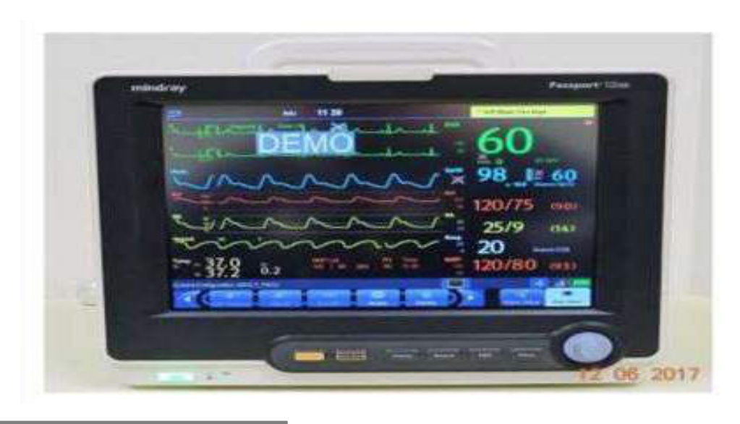  Identify the image:
Type | multiple_choice
Option | ECG machine
Option | Cardiac monitor
Option | Defibrillator
Option | Ecography
Answer | 3
Solution | Rationale: Defibrillator: An electrical device that delivers controlled electric shocks to the heart to restore normal rhythm. Used in cardiac arrest (VF/pulseless VT). Available as manual, AED, or implantable. Key Clues: Electric shock delivery, paddle/pad placement, emergency device Why Not Others: A-ECG machine records rhythm; B-Cardiac monitor displays rhythm; D-Ecography is ultrasound Exam Trap: Defibrillator vs pacemaker - defibrillator terminates arrhythmia, pacemaker treats bradycardia PNC Pearl: Defibrillator: Biphasic 120-200J (preferred), Monophasic 360J. Anterior-lateral pad placement. Ensure no one is touching patient during shock. Always resume CPR immediately after shock.
Positive Marks | 1
Negative Marks | 0.33

Question | 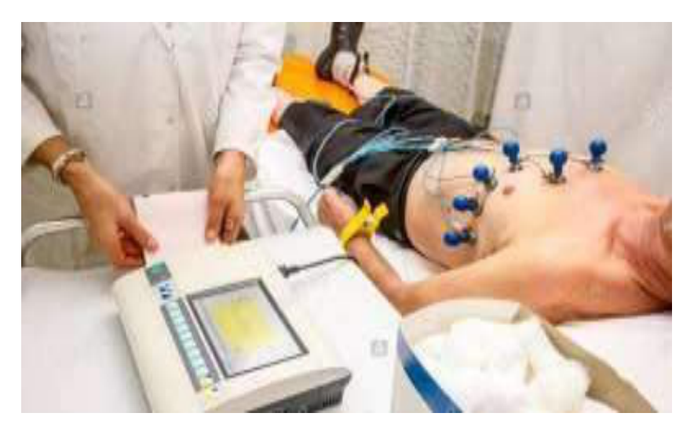  Identify the image:
Type | multiple_choice
Option | Defibrillator
Option | ECG machine
Option | Cardiac monitor
Option | Echography
Answer | 1
Solution | Rationale: Defibrillator: Device used to deliver electrical countershock to terminate life- threatening arrhythmias (VF, pulseless VT). Synchronized mode for cardioversion, unsynchronized for defibrillation. Key Clues: Emergency cardiac device, delivers electrical shock Why Not Others: A-ECG records; B-Cardiac monitor displays; D-Echography is ultrasound Exam Trap: Defibrillator types: Manual (hospital), AED (community), ICD (implantable) PNC Pearl: Defibrillation: Start CPR immediately. Shock as soon as defibrillator available. Post-shock: resume CPR 2 min before next rhythm check. Epinephrine after 3rd shock.
Positive Marks | 1
Negative Marks | 0.33

Question | 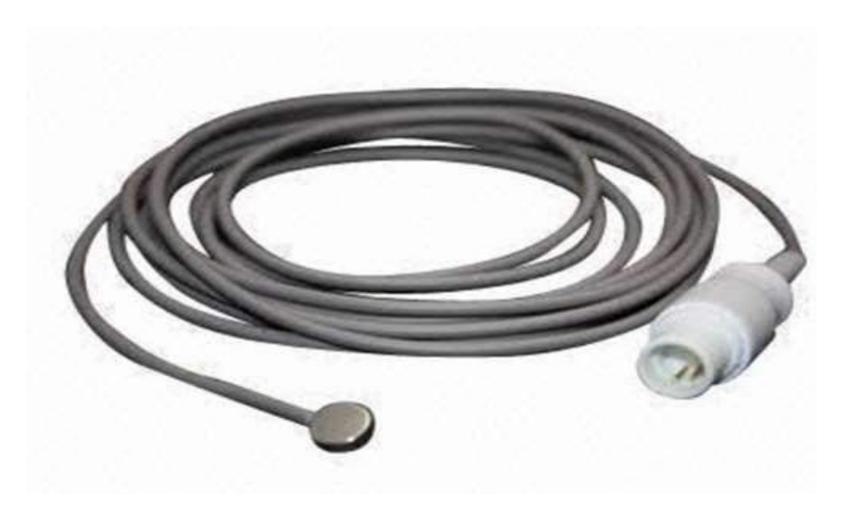  Identify the given image:
Type | multiple_choice
Option | ECG sensor
Option | Temperature probe
Option | SPO2 sensor
Option | Hearing device
Answer | 3
Solution | Rationale: SPO· Sensor (Pulse Oximeter Probe): A non-invasive device that measures oxygen saturation of hemoglobin using light absorption. Clip-on or adhesive sensor placed on finger, earlobe, or toe. Key Clues: Finger/ear clip, measures SpO·, non-invasive Why Not Others: A-ECG sensor measures electrical activity;B-Temperature probe measures temp;D-Hearing device is for audiology Exam Trap: SPO· vs ABG - SPO· is non-invasive (SpO·), ABG is invasive (PaO·) PNC Pearl: Pulse oximeter: Normal SpO· 95-100%. Accuracy affected by: nail polish, poor perfusion, hypothermia, carbon monoxide, methemoglobin. Probe placement: finger (index/middle), earlobe, forehead.
Positive Marks | 1
Negative Marks | 0.33

Question | 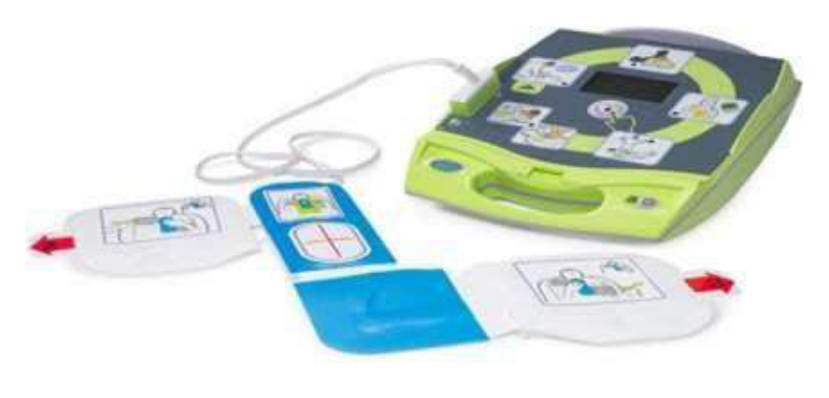  Identify the image.:
Type | multiple_choice
Option | Manual defibrillator
Option | Pulse dose
Option | AED
Option | Holter monitor
Answer | 1
Solution | Rationale: Manual Defibrillator: An operator-controlled device that delivers electrical shocks to terminate life-threatening arrhythmias. The operator must interpret the rhythm and decide when to shock. Key Clues: Operator-controlled, rhythm interpretation required Why Not Others: A-Pulse dose is pacing;B-AED is automated;D-Holter is continuous ECG recording Exam Trap: Manual vs AED - manual requires operator interpretation, AED automates analysis PNC Pearl: Manual defibrillator: Operator decides rhythm analysis and energy level. Biphasic 120-200J. Synchronized mode for cardioversion. Always ensure patient not on wet surface.
Positive Marks | 1
Negative Marks | 0.33

Question | 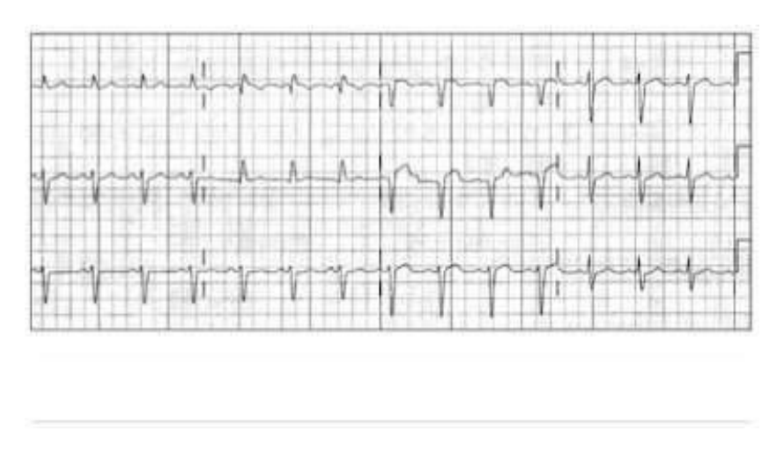  Identify the abnormal ECG finding?
Type | multiple_choice
Option | 1st degree heart block
Option | -
Option | Sinus bradycardia
Option | S-T segment elevation
Answer | 4
Solution | Rationale: S-T Segment Elevation indicates acute myocardial injury/infarction. ST elevation of ·1mm in two contiguous leads represents acute STEMI requiring immediate intervention (PCI or thrombolysis). Key Clues: ST segment elevated above baseline, convex or concave upward Why Not Others: A-1st degree has prolonged PR >0.20s; B-Not applicable; D-Sinus bradycardia has rate <60 Exam Trap: ST elevation vs early repolarization - STEMI has reciprocal changes and clinical symptoms PNC Pearl: STEMI: Door-to-balloon <90 min (PCI) or door-to-needle <30 min (thrombolysis). Aspirin 325mg, Heparin, Beta-blocker (if no contraindication). Look for reciprocal changes.
Positive Marks | 1
Negative Marks | 0.33

Question | 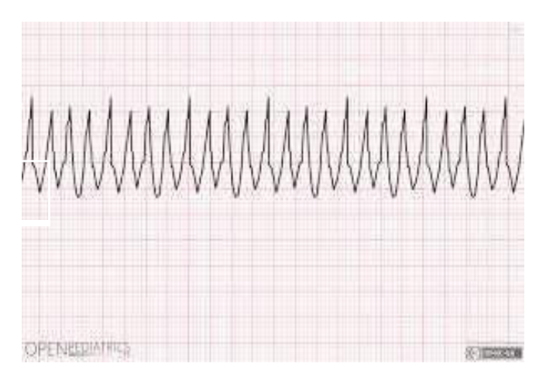  Identify the image:
Type | multiple_choice
Option | Atrial fibrillation
Option | Ventricular fibrillation
Option | Sinus tachycardia
Option | Venous tachycardia
Answer | 2
Solution | Rationale: Ventricular Fibrillation: Totally disorganized electrical activity with no effective cardiac output. The ECG shows chaotic, irregular oscillations with no identifiable complexes. Key Clues: No P waves, no QRS, no T waves, chaotic baseline Why Not Others: A-AF has irregularly irregular narrow QRS; C-Sinus tachycardia has normal P-QRS-T; D-Venous tachycardia is not standard term Exam Trap: VF vs VT - VT has some organization, VF is completely disorganized PNC Pearl: VF survival decreases 7-10% per minute without defibrillation. Chain of survival: Early access, Early CPR, Early defibrillation, Early ACLS.
Positive Marks | 1
Negative Marks | 0.33

Question | 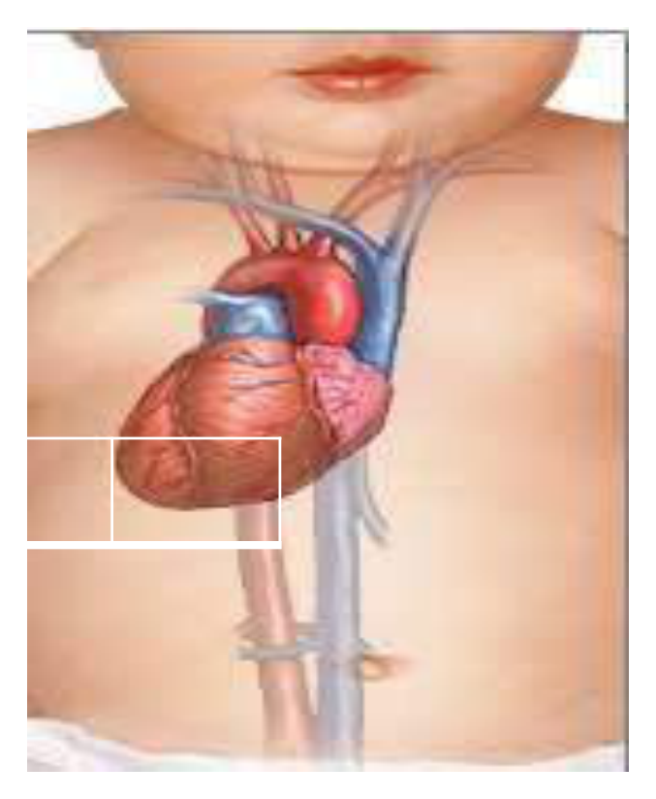  Identify the image:
Type | multiple_choice
Option | Dextrocardia
Option | Levocardia
Option | Mesocardia
Option | Situs inversus
Answer | 1
Solution | Rationale: Dextrocardia: The heart is positioned on the right side of the chest. Lead I shows inverted P, QRS, and T waves. aVR shows upright P wave. Chest leads show reversed R-wave progression. Key Clues: Inverted complexes in lead I, upright P in aVR, apex to right Why Not Others: B-Levocardia is normal left-sided heart; C-Mesocardia is midline; D-Situs inversus includes all organs reversed Exam Trap: Dextrocardia vs lead reversal - dextrocardia shows consistent pattern across all leads PNC Pearl: Dextrocardia: Lead I inverted, aVR upright. CXR shows apex to right. Situs inversus totalis = dextrocardia + all viscera reversed. Kartagener syndrome = situs inversus + bronchiectasis + sinusitis.
Positive Marks | 1
Negative Marks | 0.33

Question | 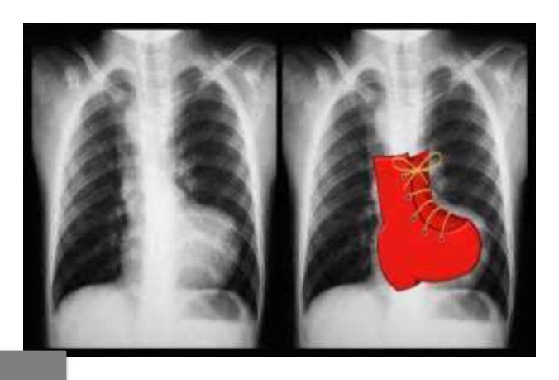  Identify the image:
Type | multiple_choice
Option | Right ventricular hypertrophy
Option | Right heart failure
Option | Left ventricular hypertrophy
Option | Tetralogy of fallot
Answer | 3
Solution | Rationale: Left Ventricular Hypertrophy (LVH): Increased voltage of QRS complexes in left precordial leads (V5, V6 > 2.5mV). May show ST-T changes (strain pattern) in lateral leads. Axis may shift left. Key Clues: Tall R waves in V5-V6, deep S in V1-V2, strain pattern Why Not Others: A-RVH shows tall R in V1; C-Heart failure is clinical diagnosis; D-ToF shows right axis deviation and RVH Exam Trap: LVH criteria: S-wave in V1 + R-wave in V5/V6 > 35mm (Sokolow-Lyon) PNC Pearl: LVH most common cause: Chronic hypertension. Other causes: Aortic stenosis, HCM. Remember: LVH voltage criteria differ by age and sex.
Positive Marks | 1
Negative Marks | 0.33

Question | 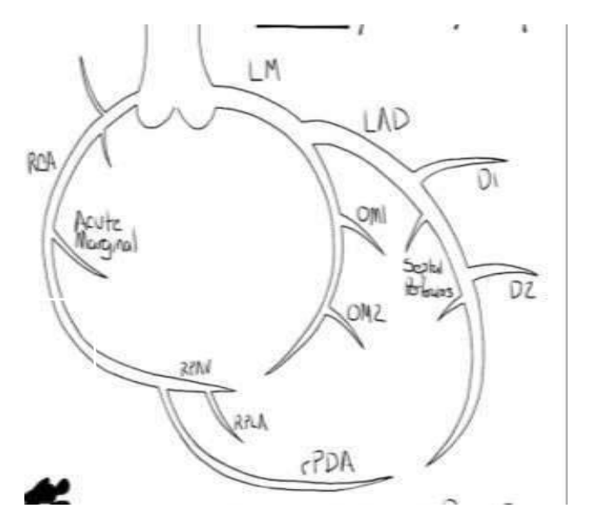  Identify the image:
Type | multiple_choice
Option | Carotid artery
Option | Coronary artery
Option | Femoral artery
Option | Circle of Willis
Answer | 4
Solution | Rationale: Circle of Willis: An arterial anastomosis at the base of the brain formed by the internal carotid and vertebral arteries. Provides collateral circulation to protect against ischemia. Key Clues: Arterial ring at brain base, collateral circulation Why Not Others: A-Carotid is a single artery;B-Coronary supplies heart;D-Femoral is in thigh Exam Trap: Circle of Willis: Forms hexagonal ring. Components: AComm, ACom, PCOM, basilar bifurcation. Protects brain from single vessel occlusion. PNC Pearl: Circle of Willis: Forms hexagonal ring. Components: AComm, ACom, PCOM, basilar bifurcation. Protects brain from single vessel occlusion.
Positive Marks | 1
Negative Marks | 0.33

Question | 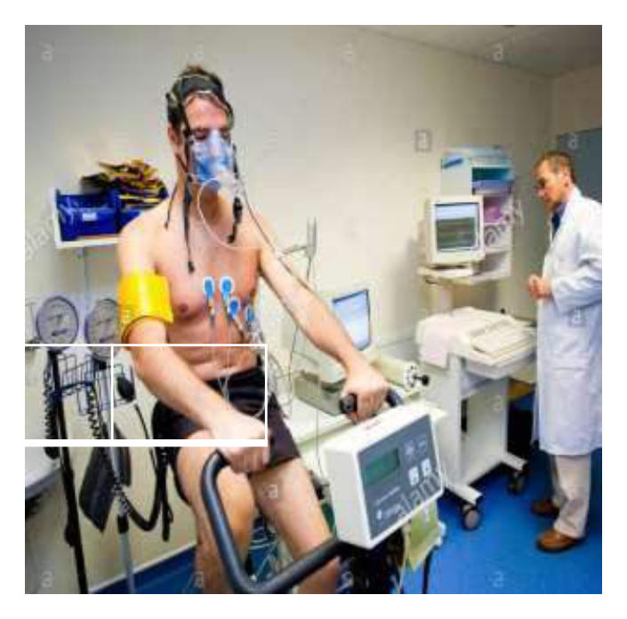  Identify the image:
Type | multiple_choice
Option | Non stress test
Option | Cardiac stress test
Option | Plethysmography
Option | Oxygenator
Answer | 2
Solution | Rationale: Cardiac Stress Test: Exercise or pharmacological test to evaluate cardiac function under stress. Patient exercises on treadmill while ECG is monitored. Detects exercise-induced ischemia and arrhythmias. Key Clues: ECG during exercise, treadmill, detects ischemia Why Not Others: B-NST is non-stress test (OBG);C-Plethysmography measures volume changes;D-Oxygenator is for heart-lung machine Exam Trap: Stress test vs angiography - stress test is non-invasive screening, angiography is invasive definitive PNC Pearl: Stress test: Contraindications: acute MI (48h), unstable angina, severe AS, uncontrolled HF. Target HR = 85% max predicted. Positive = ST depression ·1mm. Sensitivity 68%, specificity 77%.
Positive Marks | 1
Negative Marks | 0.33

Question | 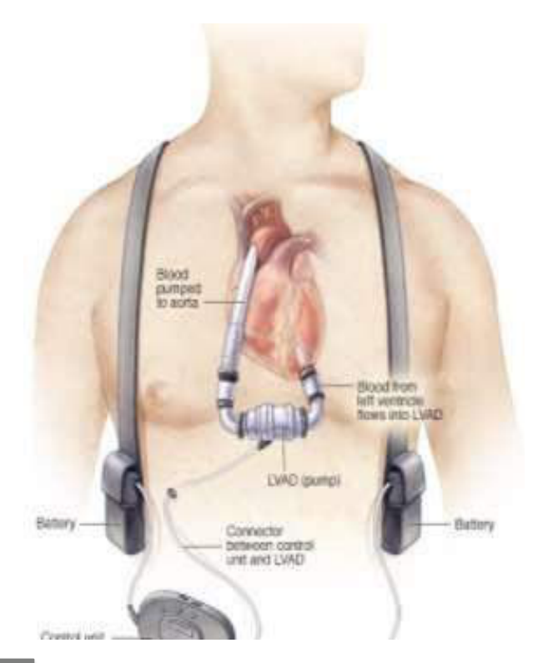  Identify the image:
Type | multiple_choice
Option | Pacemaker
Option | Ventricular assistive device
Option | Atrial assistive device
Option | Automated external
Answer | 1
Solution | Rationale: Pacemaker: An electronic device that generates electrical impulses to regulate heart rate and rhythm. Used for symptomatic bradycardia, heart block, and sick sinus syndrome. Key Clues: Generates electrical impulses, regulates heart rate Why Not Others: A-VAD assists ventricular pumping;B-AAD is not standard;D-AED is for defibrillation Exam Trap: Pacemaker vs ICD - pacemaker treats bradycardia, ICD treats tachyarrhythmias PNC Pearl: Pacemaker: Single chamber (atrial or ventricular), Dual chamber (DDD), Biventricular (CRT). MR-conditional pacemakers now available. Precautions: avoid magnets, strong electromagnetic fields.
Positive Marks | 1
Negative Marks | 0.33

Question | 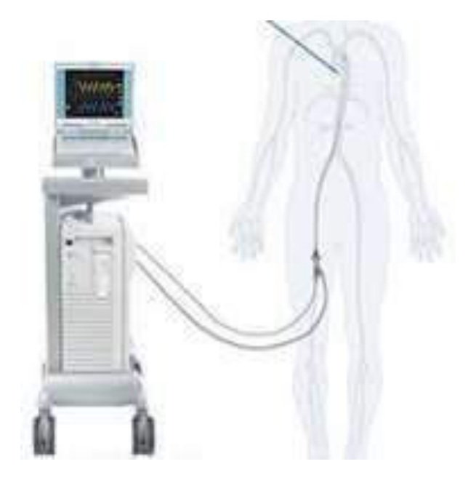  Identify the image:
Type | multiple_choice
Option | PEEP
Option | IABP
Option | CPAP
Option | BIPAP
Answer | 2
Solution | Rationale: IABP (Intra-Aortic Balloon Pump): A mechanical circulatory support device with a balloon catheter in the descending aorta. Inflates during diastole (coronary perfusion) and deflates during systole (afterload reduction). Key Clues: Balloon in aorta, inflates diastole/deflates systole, circulatory support Why Not Others: B-PEEP is positive end-expiratory pressure;C-CPAP is continuous positive airway;D-BIPAP is bilevel positive airway Exam Trap: IABP vs VAD - IABP is counterpulsation, VAD is direct mechanical pumping PNC Pearl: IABP: Augments coronary perfusion (diastolic inflation) and reduces afterload (systolic deflation). Ratio 1:1 or 1:2. Contraindicated in aortic regurgitation. Complications: limb ischemia, aortic rupture.
Positive Marks | 1
Negative Marks | 0.33

