Question | 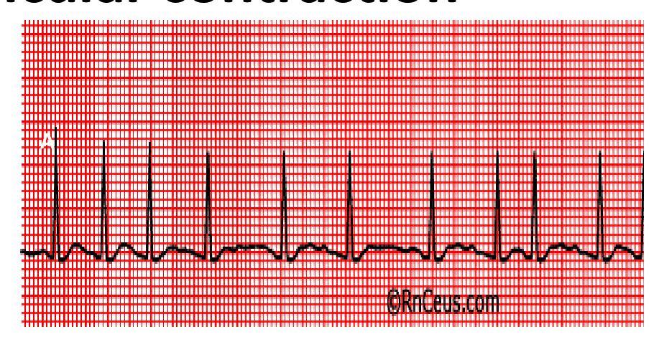  Identify the image:
Type | multiple_choice
Option | Atrial fibrillation
Option | Ventricular fibrillation
Option | Atrial flutter
Option | Premature ventricular contraction
Answer | 2
Solution | Rationale: Ventricular Fibrillation: Complete disorganized electrical activity of the ventricles. No effective contraction occurs. ECG shows chaotic, irregular waveforms of varying amplitude. Key Clues: Completely disorganized ventricular activity, no pulse Why Not Others: A-AF has fibrillatory baseline with irregular narrow QRS; C-Atrial flutter has saw- tooth pattern; D-PVC is single premature beat Exam Trap: VF is a shockable rhythm - must defibrillate immediately PNC Pearl: VF is always a shockable rhythm. Remember: Shockable = VF/VT, Non-shockable = Asystole/PEA.
Positive Marks | 1
Negative Marks | 0.33

Question | 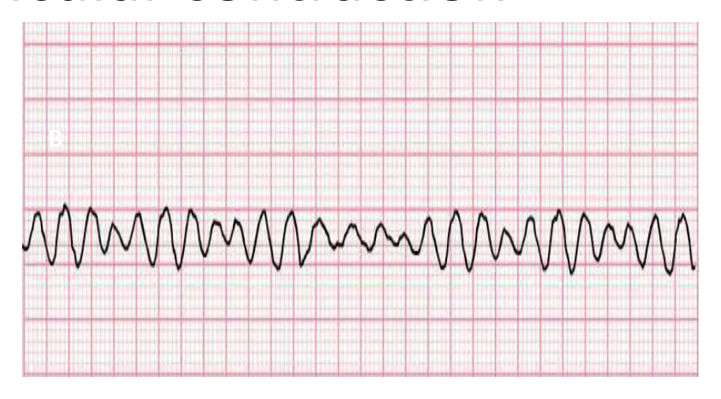  Identify the image:
Type | multiple_choice
Option | Sinus tachycardia
Option | Ventricular fibrillation
Option | Premature ventricular contraction
Option | Sinus ventricular tachycardia
Answer | 4
Solution | Rationale: Sinus Ventricular Tachycardia (Sinus Tachycardia): Regular rhythm, rate >100 bpm, normal P waves before each QRS, normal QRS morphology. P wave axis and morphology are normal. Key Clues: Rate >100, normal P-QRS-T, regular, narrow QRS Why Not Others: A-Sinus tachycardia is correct but C specifies "ventricular" which may indicate rate; B-VF is chaotic; D-PVC is premature Exam Trap: Sinus tachycardia vs SVT - sinus tach has gradual onset/offset, SVT is abrupt PNC Pearl: Sinus tachycardia: Always search for cause (fever, pain, anxiety, hypovolemia, sepsis, anemia, thyrotoxicosis). Treat underlying cause, not the rate.
Positive Marks | 1
Negative Marks | 0.33

Question | 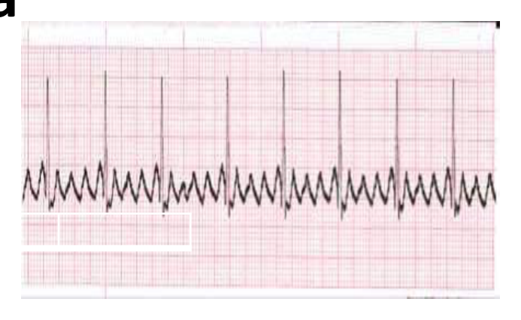  Identify the image:
Type | multiple_choice
Option | Atrial flutter
Option | Atrial fibrillation
Option | Sinus rhythm
Option | Ventricular tachycardia
Answer | 1
Solution | Rationale: Atrial Flutter: Regular "saw-tooth" flutter waves (F waves) at rate ~300 bpm, with variable AV block giving ventricular rate of ~150 bpm. QRS complexes are narrow. Key Clues: Saw-tooth baseline, regular rhythm, rate ~150 bpm if 2:1 block Why Not Others: A-AF is irregularly irregular; B-Sinus rhythm has normal P waves; D-VT has wide QRS Exam Trap: Atrial flutter vs AF - flutter has organized saw-tooth pattern, AF has chaotic fibrillatory waves PNC Pearl: Atrial flutter: Classic rate with 2:1 block = 150 bpm (always think flutter at 150!). Vagal maneuver or adenosine can unmask flutter waves by increasing AV block.
Positive Marks | 1
Negative Marks | 0.33

Question | 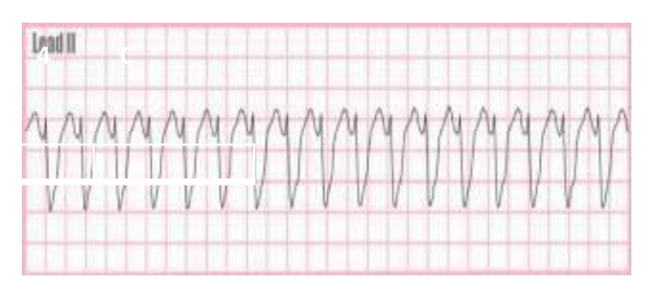  Identify the image:
Type | multiple_choice
Option | Sinus bradycardia
Option | Ventricular fibrillation
Option | Sinus tachycardia
Option | Ventricular tachycardia
Answer | 2
Solution | Rationale: Ventricular Fibrillation: No organized cardiac activity. Chaotic, irregular baseline oscillations. No pulse, no blood pressure. Immediate defibrillation required. Key Clues: No organized complexes, chaotic baseline, pulseless Why Not Others: A-Sinus bradycardia has normal P-QRS-T with rate <60; B-Sinus tachycardia has rate >100; D-VT has wide QRS regular Exam Trap: VF always looks chaotic - never confuse with organized rhythms PNC Pearl: VF has zero survival without immediate defibrillation. Chain of survival is critical.
Positive Marks | 1
Negative Marks | 0.33

Question | 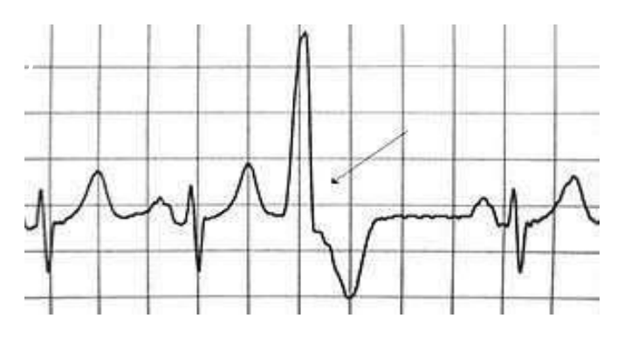  Identify the image:
Type | multiple_choice
Option | AV junctional rhythm
Option | Accelerate junctinal rhythm
Option | Normal sinus rhythm
Option | Premature ventricular contraction
Answer | 3
Solution | Rationale: Normal Sinus Rhythm: Regular rhythm, rate 60-100 bpm, P wave present before each QRS, P-R interval 0.12-0.20 sec, QRS <0.12 sec. Normal P wave axis (upright in leads II, III, aVF). Key Clues: Rate 60-100, regular P-QRS-T, normal intervals Why Not Others: B-AV junctional has absent or retrograde P waves; C-Accelerated junctional is 60-100 from junction; D-PVC is premature wide QRS Exam Trap: Normal sinus vs junctional - sinus has upright P in II, junctional has absent/inverted P PNC Pearl: Normal sinus rhythm: Rate 60-100, regular, 1 P wave per QRS, P-R 0.12-0.20s, QRS <0.12s. This is the gold standard rhythm.
Positive Marks | 1
Negative Marks | 0.33

Question | 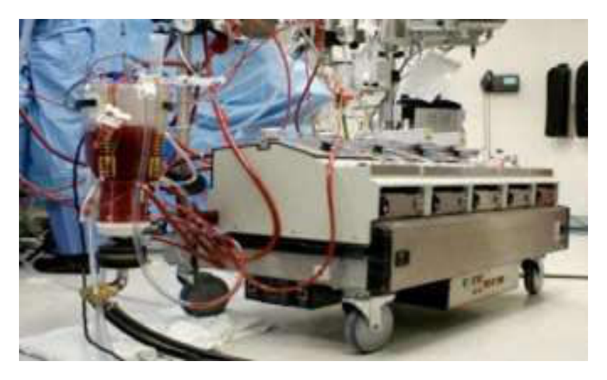  Identify the image:
Type | multiple_choice
Option | Plasmapheresis machine
Option | Heart lung machine
Option | Dialysis machine
Option | Apheresis machine
Answer | 2
Solution | Rationale: Heart-Lung Machine: A cardiopulmonary bypass device that temporarily takes over the function of the heart and lungs during cardiac surgery. Oxygenates blood and pumps it through the body. Key Clues: Cardiopulmonary bypass, takes over heart/lung function Why Not Others: A-Plasma pheresis removes plasma;C-Dialysis filters blood;D-Apheresis removes specific components Exam Trap: Heart-lung machine vs dialysis - heart-lung machine oxygenates AND pumps blood, dialysis only filters PNC Pearl: Heart-lung machine: Used in CABG, valve replacement, cardiac transplant. Primed with crystalloid. Anticoagulated with heparin. Reversed with protamine. Monitor: temperature, ACT, blood gases.
Positive Marks | 1
Negative Marks | 0.33

Question | 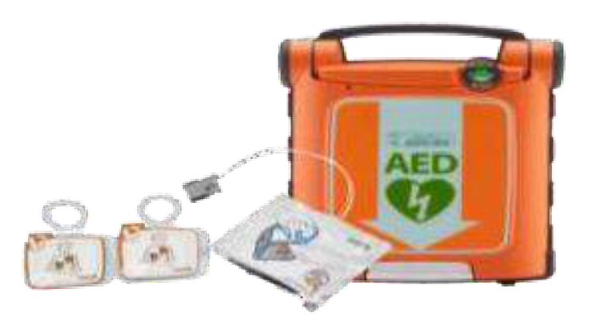  Identify the image:
Type | multiple_choice
Option | Automated external defibrillator
Option | Advanced external defibrillator
Option | Assisted external defibrillator
Option | Appropriate external defibrillator
Answer | 1
Solution | Rationale: Automated External Defibrillator (AED): A portable, automated device that analyzes heart rhythm and delivers shock if needed. Designed for use by anyone, with voice prompts guiding the operator. Key Clues: Automated rhythm analysis, voice prompts, public access Why Not Others: A-Advanced;B-Assisted;D-Appropriate are not correct terminology Exam Trap: AED: Automatic = no operator discretion needed. Semi-automatic = operator confirms shock. PNC Pearl: AED: Attach pads · device analyzes · voice prompt. If shock advised · ensure clear · press shock. If no shock · resume CPR. Check for water/metal/pacemaker on chest.
Positive Marks | 1
Negative Marks | 0.33

Question | 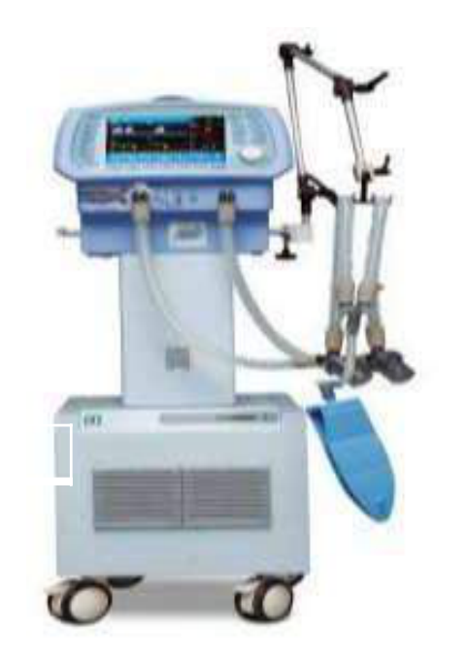  Identify the image:
Type | multiple_choice
Option | Ventilator
Option | Boyle·s machine
Option | Anaesthesia machine
Option | Dialysis machine
Answer | 3
Solution | Rationale: Anaesthesia Machine: A complex device that delivers precise concentrations of anesthetic gases, oxygen, and air to patients during surgery. Includes vaporizers, ventilator, monitoring systems. Key Clues: Delivers anesthetic gases, includes vaporizers Why Not Others: A-Ventilator only provides ventilation;C-Boyle machine is a specific type;D-Dialysis filters blood Exam Trap: Anaesthesia machine vs ventilator - anaesthesia machine includes gas delivery, ventilator, and monitoring PNC Pearl: Anaesthesia machine: Pre-use check (daily). Check: O· supply, N·O supply, vaporizers, ventilator, scavenging, monitors. Common gases: Sevoflurane, Desflurane, Isoflurane.
Positive Marks | 1
Negative Marks | 0.33

Question | 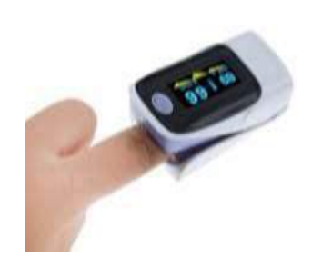  Identify the image:
Type | multiple_choice
Option | Spirometery
Option | PFT machine
Option | Blood sugar manitor
Option | Pulse oximetry
Answer | 4
Solution | Rationale: Pulse Oximetry: A non-invasive method of monitoring oxygen saturation (SpO·) using light absorption through a probe attached to the patient's finger, earlobe, or toe. Key Clues: Light absorption, finger probe, SpO· measurement Why Not Others: A-Spirometry measures lung volumes;B-PFT is comprehensive lung testing;D-Blood sugar monitor measures glucose Exam Trap: Pulse oximetry vs ABG - pulse oximetry is continuous, non-invasive; ABG is intermittent, invasive PNC Pearl: Pulse oximetry: Normal 95-100%. Red light (660nm) and infrared (940nm). Oxyhemoglobin absorbs more infrared, deoxyhemoglobin absorbs more red. Probe must have good perfusion.
Positive Marks | 1
Negative Marks | 0.33

Question | 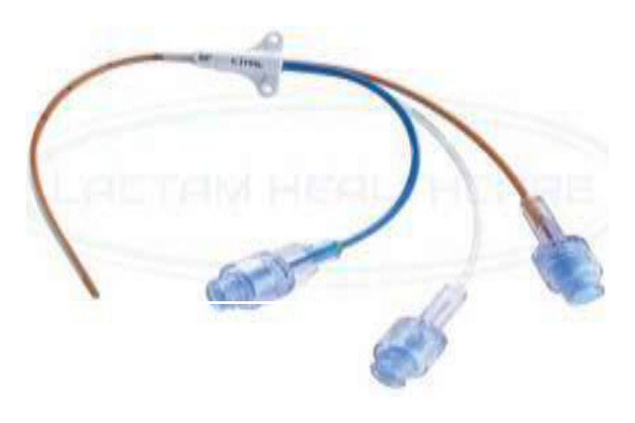  Identify the image:
Type | multiple_choice
Option | Cardiac catheter
Option | Pig tail catheter
Option | Central arterial catheter
Option | Central venous catheter
Answer | 1
Solution | Rationale: Cardiac Catheter: A thin, flexible tube inserted into the heart for diagnostic and therapeutic purposes. Used for coronary angiography, angioplasty, and hemodynamic monitoring. Key Clues: Thin, flexible, inserted into heart chambers/vessels Why Not Others: A-Pigtail catheter is a specific shape; C-Central arterial catheter is for arterial monitoring; D-Central venous catheter is for venous access Exam Trap: Cardiac cath vs coronary stent - catheter is the tube, stent is the implant PNC Pearl: Cardiac catheterization: Femoral or radial approach. Monitor for bleeding, hematoma, pseudoaneurysm. NPO before procedure. Check renal function (contrast nephropathy risk).
Positive Marks | 1
Negative Marks | 0.33

Question | 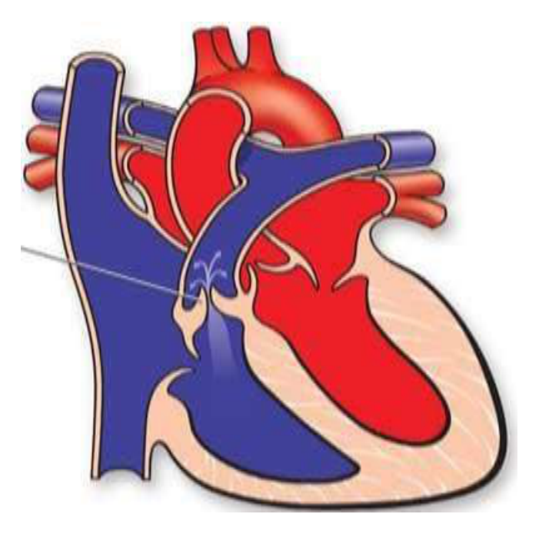  Identify the image:
Type | multiple_choice
Option | Mitral regurgitation
Option | Right ventricular hypertrophy
Option | Pulmonic valve stenosis
Option | Aortic valve stenosis
Answer | 4
Solution | Rationale: Aortic Valve Stenosis: Characteristic systolic crescendo-decrescendo (diamond-shaped) murmur heard best at the right upper sternal border, radiating to the carotid arteries. ECG shows LVH. Key Clues: Systolic murmur at right upper sternal border, radiates to carotids, LVH on ECG Why Not Others: A-Mitral regurgitation is pansystolic at apex; B-RVH is right-sided; C-Pulmonic stenosis murmur at left upper sternal border Exam Trap: AS vs MS - AS is systolic, MS is diastolic. Both can cause LVH over time PNC Pearl: Aortic stenosis: Classic triad = angina, syncope, heart failure. Peak incidence in elderly (calcific). Murmur quality: Crescendo-decrescendo. Severe AS: Valve area <1.0 cm², gradient >40 mmHg.
Positive Marks | 1
Negative Marks | 0.33

Question | 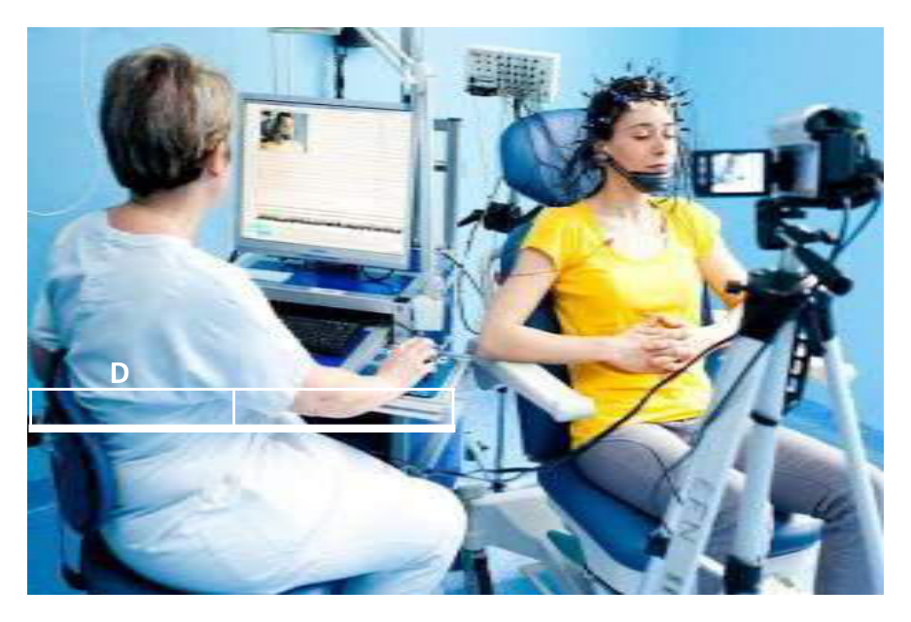  Identify the image:
Type | multiple_choice
Option | ECG
Option | EMG
Option | EKG
Option | EEG
Answer | 2
Solution | Rationale: EMG (Electromyography): A diagnostic procedure that records electrical activity of muscles using needle electrodes. Used to evaluate neuromuscular disorders, nerve injuries, and muscle diseases. Key Clues: Records muscle electrical activity, needle electrodes Why Not Others: A-ECG records heart;B-EKG is same as ECG;D-EEG records brain Exam Trap: EMG vs EEG - EMG records muscle activity, EEG records brain activity PNC Pearl: EMG: Needle electrode inserted into muscle. Records at rest and during contraction. Shows: fibrillation potentials, fasciculations, motor unit action potentials. Used for: neuropathy, myopathy, NMJ disorders.
Positive Marks | 1
Negative Marks | 0.33

Question | 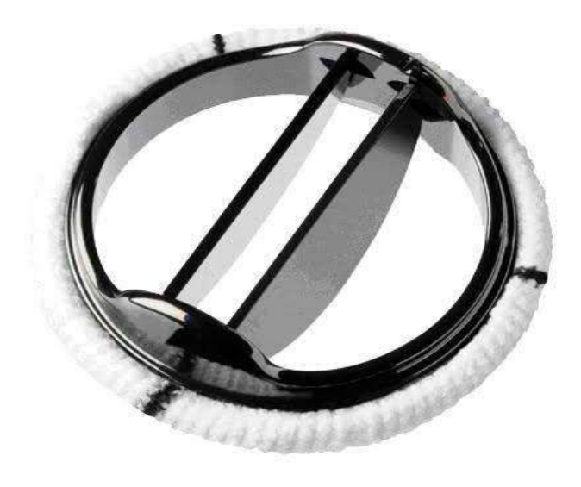  Identify the Type of Prosthetic:
Type | multiple_choice
Option | Ball and cage mechanical
Option | Bi-leaflet mechanical
Option | Tri-leaflet mechanical
Option | Tilting disc mechanical
Answer | 1
Solution | Rationale: Ball and Cage Mechanical Valve: A prosthetic heart valve consisting of a ball (silicone) inside a cage (metal struts). The ball moves forward during systole to allow blood flow and backward to seal the valve. Key Clues: Ball inside cage, opens/closes with blood flow Why Not Others: A-Bi-leaflet has two discs;B-Tri-leaflet has three leaflets;D-Tilting disc has one disc Exam Trap: Ball and cage vs other mechanical valves - oldest design, most thrombogenic PNC Pearl: Ball and cage valve: Most thrombogenic mechanical valve.·· anticoagulation (warfarin) required. INR target 2.5-3.5. Regular follow-up with echocardiography.
Positive Marks | 1
Negative Marks | 0.33

Question | 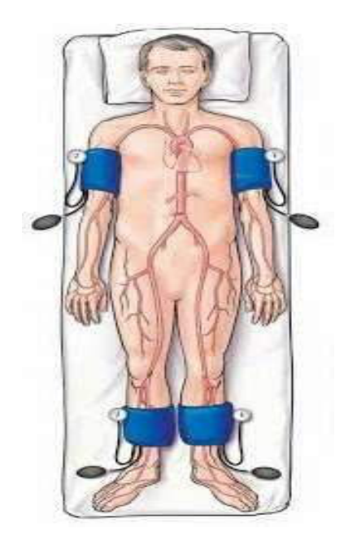  Normal value of Index (Arrows):
Type | multiple_choice
Option | -
Option | 1.8
Option | 1.0
Option | 1.4
Answer | 3
Solution | Rationale: Normal value shown for the index (likely PTT/aPTT ratio or INR): Normal INR is 1.0. Values >1.0 indicate anticoagulation or coagulopathy. Key Clues: Normal value 1.0 for INR/ratio Why Not Others: A is unspecified;C-1.8 is elevated;D-1.4 is mildly elevated Exam Trap: INR monitoring: Normal 1.0. Warfarin target 2-3 (or 2.5-3.5 for mechanical valves). Report if >5 or <1.5. PNC Pearl: INR/Coagulation: Always check before procedures. Hold warfarin 5 days before surgery. Reverse with vitamin K or FFP/PCC if bleeding.
Positive Marks | 1
Negative Marks | 0.33

