Question | 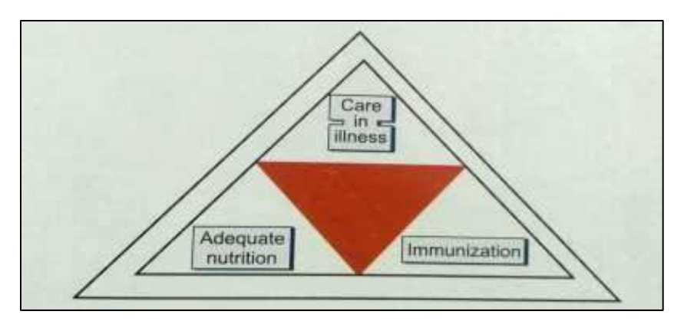  Identify the image:
Type | multiple_choice
Option | Under five clinic
Option | Triangle for caring of traumatic
Option | Baks triangle
Option | Epidemiology triangle
Answer | 4
Solution | Rationale: Epidemiology Triangle: A model used in epidemiology showing the interaction between Agent, Host, and Environment. Used to understand disease transmission and develop prevention strategies. Key Clues: Agent-Host-Environment interaction model Why Not Others: A-Under 5 clinic is service delivery;C-Triangle for caring is nursing;D-Bakst triangle is for surgery Exam Trap: Epidemiological triad: Agent (pathogen), Host (susceptible person), Environment (conditions) PNC Pearl: Epidemiology triangle: Disrupt any side to prevent disease. Agent = bacteria/virus. Host = immune status, age, genetics. Environment = sanitation, climate, housing. Control = elimination, immunization, sanitation.
Positive Marks | 1
Negative Marks | 0.33

Question | 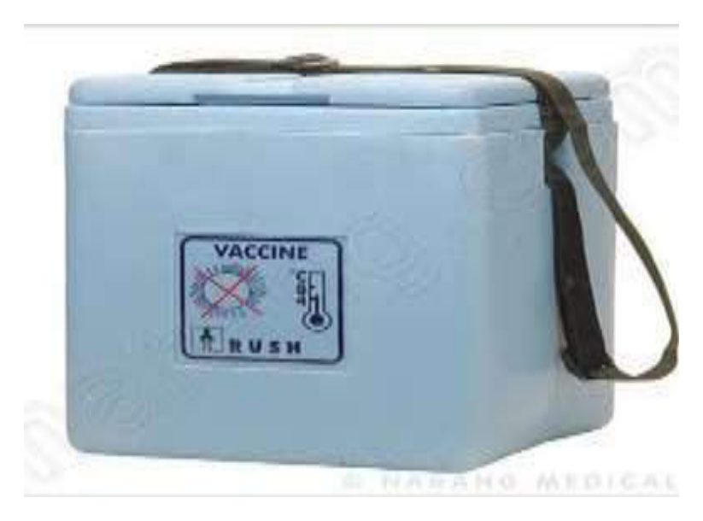  Identify the image:
Type | multiple_choice
Option | Vaccine carrier
Option | Blood carrier
Option | Ice packs
Option | Cold box
Answer | 1
Solution | Rationale: Vaccine Carrier: An insulated container used to transport vaccines from cold store to outreach sites. Maintains 2-8C temperature using ice packs. Used in immunization programs for community outreach. Key Clues: Insulated container, ice packs, for vaccine transport Why Not Others: A-Blood carrier is for blood products;B-Ice packs are components;D-Cold box is for larger storage Exam Trap: Vaccine carrier vs cold box - carrier is smaller (portable), cold box is larger (storage) PNC Pearl: Vaccine carrier: Keep in shade. Open lid minimally. Check temperature twice daily. Ice packs should be conditioned (not frozen solid). Capacity varies (typically 1.5-6 liters).
Positive Marks | 1
Negative Marks | 0.33

Question | 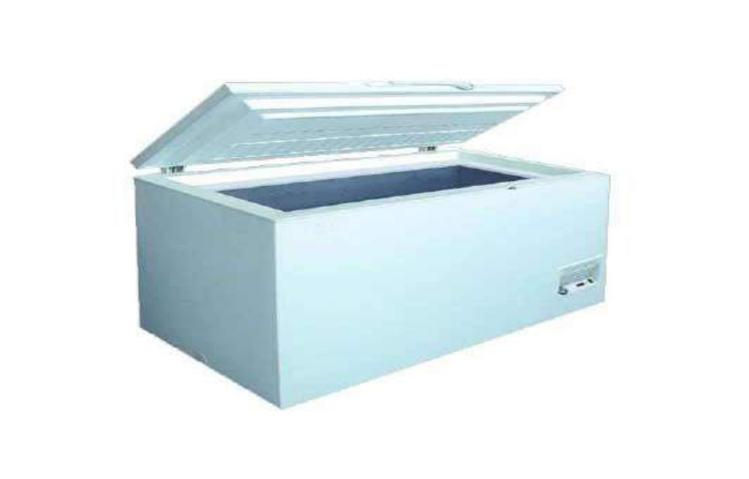  Identify the given box?
Type | multiple_choice
Option | Ice lined refrigerator
Option | Vaccine cold box
Option | Cold room
Option | Freezer room
Answer | 1
Solution | Rationale: Ice Lined Refrigerator: A specialized refrigerator used in vaccine cold chain. Vaccines are stored between ice packs (not in contact). Maintains 2-8C temperature. Used in health facilities for vaccine storage. Key Clues: Refrigerator with ice packs, maintains 2-8C Why Not Others: B-Cold box is portable;C-Cold room is large facility;D-Freezer room is below 0 degC Exam Trap: Ice lined refrigerator vs cold box - ILR is stationary (facility), cold box is portable (outreach) PNC Pearl: Ice lined refrigerator: Capacity 100-500 liters. Place water bottles between ice packs. Do not place vaccines directly on ice packs. Check temperature twice daily. Record min/max temperature.
Positive Marks | 1
Negative Marks | 0.33

Question | 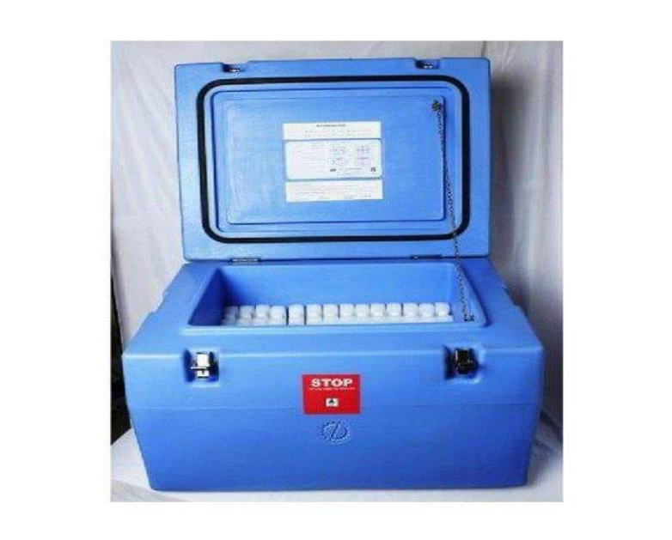  Identify the given box?
Type | multiple_choice
Option | Ice lined refrigerator
Option | Vaccine cold box
Option | Cold room
Option | Freezer room
Answer | 2
Solution | Rationale: Vaccine Cold Box: An insulated container used for storing and transporting vaccines. Maintains 2-8C using conditioned ice packs. Used in outreach and mobile immunization sessions. Key Clues: Insulated portable container, ice packs Why Not Others: A-ILR is stationary;C-Cold room is large;D-Freezer room is below 0 degC Exam Trap: Cold box vs vaccine carrier - cold box is larger (capacity up to 60 liters), carrier is smaller PNC Pearl: Cold box: Size determines capacity. Open lid as infrequently as possible. Place ice packs on top and sides (cold air sinks). Check temperature at least twice daily.
Positive Marks | 1
Negative Marks | 0.33

Question | 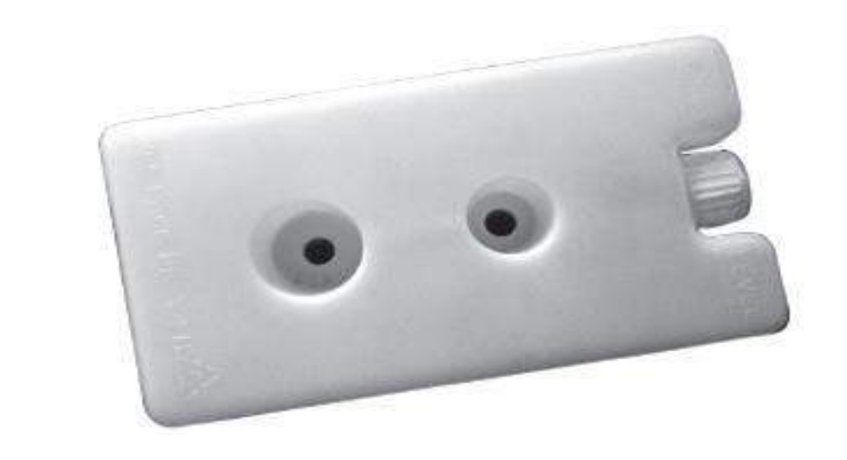  How many vaccine can be put on ice:
Type | multiple_choice
Option | 1
Option | 2
Option | 3
Option | 4
Answer | 3
Solution | Rationale: Vaccine storage: Up to 3 vaccine vials can be placed between each ice pack in a cold box or ice-lined refrigerator to maintain proper temperature distribution. Key Clues: 3 vials between ice packs Why Not Others: A-1 is too few;B-2 is insufficient;D-4 is too many (blocks air circulation) Exam Trap: 3 vials between ice packs - ensures adequate air circulation for temperature uniformity PNC Pearl: Cold chain rule: Place 3 vials between ice packs. Leave space between vials for air circulation. Do not stack vials directly on ice packs (freezing risk).
Positive Marks | 1
Negative Marks | 0.33

