Question |   Identify the image:
Type | multiple_choice
Option | Peritoneal dialysis
Option | Blood tranfusion
Option | Blood Donation
Option | Hemodialysis
Answer | 4
Solution | Rationale: Hemodialysis: A renal replacement therapy that uses an extracorporeal circuit to filter blood through a dialyzer (artificial kidney). Blood flows through the dialyzer where waste and excess fluid are removed. Key Clues: Extracorporeal circuit, dialyzer, blood flowing through machine Why Not Others: A-Peritoneal dialysis uses peritoneal membrane;C-Blood transfusion adds blood;D-Blood donation is collection Exam Trap: Hemodialysis vs peritoneal dialysis - HD uses dialyzer machine, PD uses peritoneal membrane PNC Pearl: Hemodialysis: Typically 3x/week, 3-4 hours. Blood flow 200-400 ml/min. Dialysate flow 500 ml/min. AV fistula preferred access. Monitor for hypotension, cramps, bleeding.
Positive Marks | 1
Negative Marks | 0.33

Question | 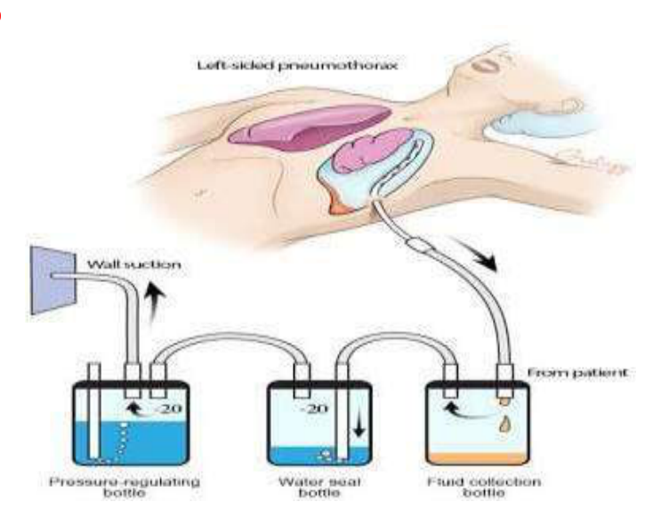  Identify the image:
Type | multiple_choice
Option | ICD set
Option | Suction set
Option | Dialysis
Option | Paracentesis
Answer | 1
Solution | Rationale: ICD Set (Intercoastal Drainage System): A chest drainage system used to drain air, blood, or fluid from the pleural space. Includes chest tube, collection chamber, water seal, and suction control. Key Clues: Chest tube, three-chamber system, pleural drainage Why Not Others: A-Suction set is for wound;B-Dialysis filters blood;C-Paracentesis drains abdomen Exam Trap: ICD vs chest tube - ICD is the complete drainage system, chest tube is the tube itself PNC Pearl: ICD nursing: Keep below chest level. Never clamp without order. Monitor bubbling. Measure output. Suction at -10 to -20 cmH·O. Water seal at 2cm H·O. Ambulate when stable.
Positive Marks | 1
Negative Marks | 0.33

Question | 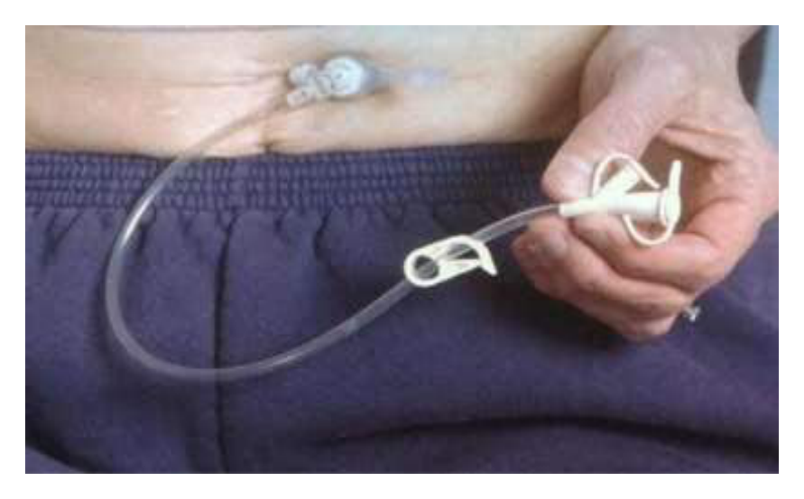  Identify the image:
Type | multiple_choice
Option | Ileostomy
Option | PEG tube
Option | SPC catheter
Option | Chest tube
Answer | 2
Solution | Rationale: PEG Tube (Percutaneous Endoscopic Gastrostomy): A feeding tube inserted through the abdominal wall into the stomach using endoscopic guidance. Used for long-term enteral nutrition when oral feeding is not possible. Key Clues: Inserted through abdominal wall into stomach, endoscopic placement Why Not Others: B-Ileostomy is for small bowel;C-SPC is suprapubic catheter;D-Chest tube is for pleural space Exam Trap: PEG vs NG tube - PEG is for long-term, NG tube is for short-term feeding PNC Pearl: PEG tube: Indications: dysphagia, head/neck cancer, neurological conditions. Care: Flush before and after feeds, check tube position, monitor site for infection. Complications: dislodgement, infection, tube blockage.
Positive Marks | 1
Negative Marks | 0.33

Question | 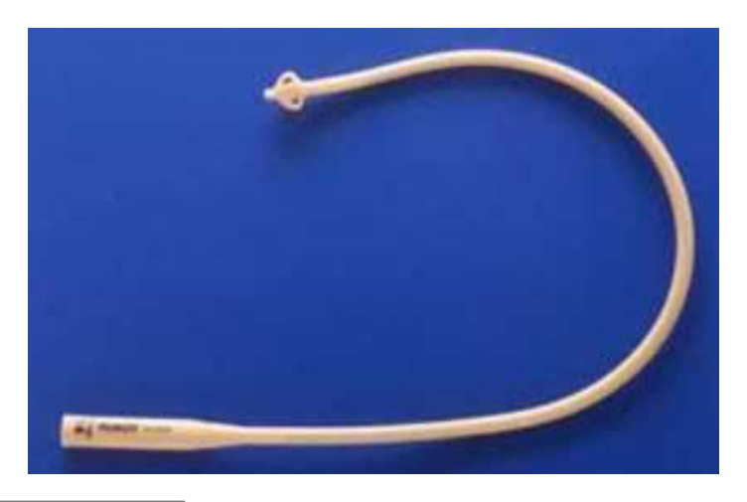  Identify the image:
Type | multiple_choice
Option | Simple rubber catheter
Option | Mashroom catheter
Option | Malecot catheter
Option | Foleys catheter
Answer | 3
Solution | Rationale: Malecot Catheter: A self-retaining catheter with wing-like projections at the tip that expand inside the bladder. Used for suprapubic catheterization. No balloon needed - retention by wing shape. Key Clues: Wing-shaped tip, self-retaining, for suprapubic use Why Not Others: A-Simple rubber catheter has no retention;B-Mushroom is for drainage;D-Foley has balloon Exam Trap: Malecot vs Foley - Malecot uses wings for retention, Foley uses balloon PNC Pearl: Malecot catheter: Inserted suprapubically. Wings expand inside bladder. Used for: urinary retention when urethral catheterization fails, suprapubic cystostomy. Monitor for blockage.
Positive Marks | 1
Negative Marks | 0.33

Question | 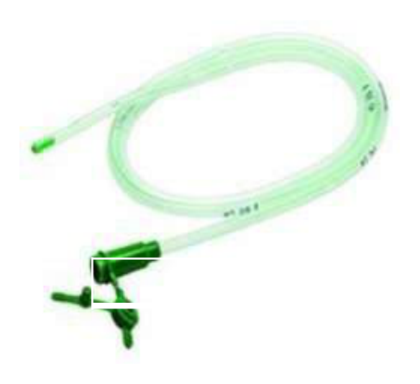  Identify the image:
Type | multiple_choice
Option | Nephrostomy tube
Option | Ryles tube
Option | Suction catheter
Option | Urethral catheter
Answer | 1
Solution | Rationale: Nephrostomy Tube: Same as Q150 - percutaneous catheter into kidney pelvis for urinary diversion when ureteral obstruction prevents normal urine flow. Key Clues: Kidney pelvis drainage, for ureteral obstruction Why Not Others: A-Ryles is for stomach;B-Suction is for airway;D-Urethral catheter goes through urethra Exam Trap: Nephrostomy tube management: Keep system closed. Monitor urine output. Check for hematuria (normal first 24-48h). PNC Pearl: Nephrostomy tube management: Keep system closed. Monitor urine output. Check for hematuria (normal first 24-48h).
Positive Marks | 1
Negative Marks | 0.33

Question | 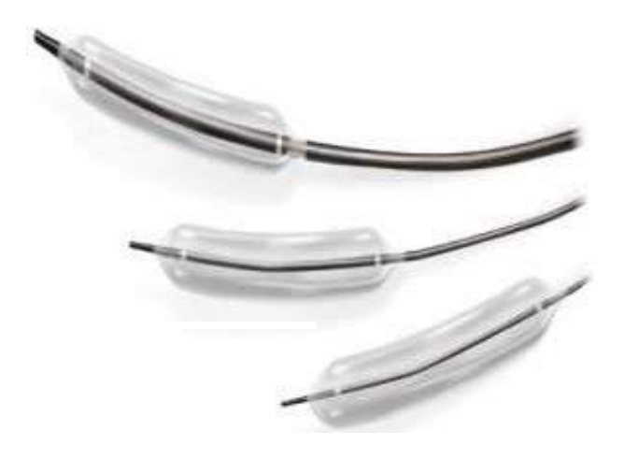  Identify the image:
Type | multiple_choice
Option | Urethral dialation catheter
Option | Esophageal dilation catheter
Option | Male urethral catheter
Option | PTCA balloon dialation catheter
Answer | 4
Solution | Rationale: PTCA Balloon Dilation Catheter: A catheter with an inflatable balloon at the tip used in percutaneous transluminal coronary angioplasty. Inflated at the site of coronary artery stenosis to widen the lumen. Key Clues: Balloon-tip catheter, for coronary angioplasty Why Not Others: B-Urethral is for urinary;C-Esophageal is for esophagus;D-Male urethral is different Exam Trap: PTCA catheter vs coronary stent - PTCA dilates, stent maintains patency PNC Pearl: PTCA: Via femoral or radial artery. Balloon inflation 10-20 atm. Duration 30-60 seconds. Stent placement often follows. Post-procedure: monitor vascular access, anticoagulation.
Positive Marks | 1
Negative Marks | 0.33

Question | 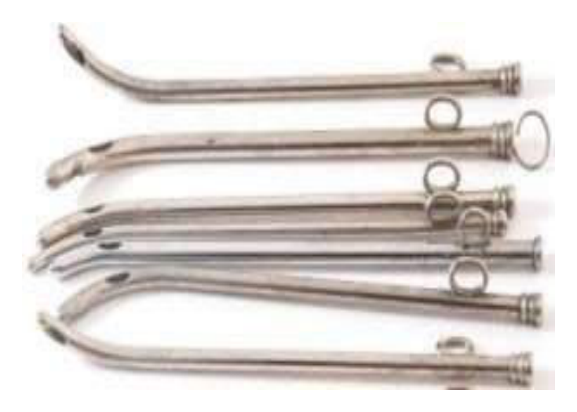  Identify the image:
Type | multiple_choice
Option | Metal irrigation catheter
Option | Female metal catheter
Option | Male metal catheter
Option | Metal suction catheter
Answer | 2
Solution | Rationale: Female Metal Catheter: A rigid, curved metal catheter used for urinary catheterization in female patients. The curve follows the anatomy of the female urethra. Key Clues: Rigid, curved, for female catheterization Why Not Others: A-Metal irrigation catheter is for irrigation;C-Male metal catheter is longer/straighter;D-Metal suction is for airway Exam Trap: Female vs male catheter: Female is shorter (4-5cm), male is longer (20-25cm) PNC Pearl: Female catheterization: Short urethra (4-5cm). Insert until urine flows. Advance 1-2cm more. Use aseptic technique. Female catheter has characteristic curve.
Positive Marks | 1
Negative Marks | 0.33

Question | 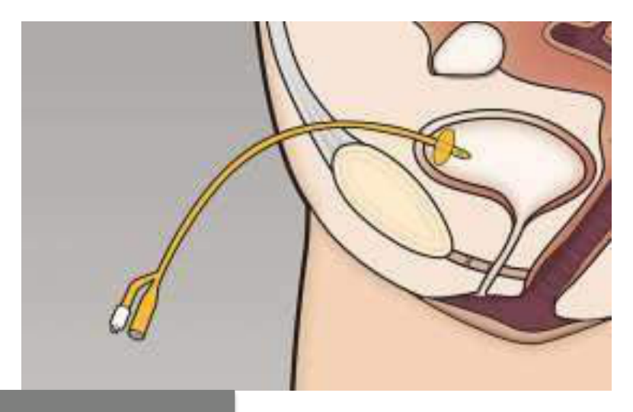  Identify the image:
Type | multiple_choice
Option | Foleys catheter
Option | Urethral catheter
Option | Malecot catheter
Option | Supra pubic catheter
Answer | 3
Solution | Rationale: Malecot Catheter: A self-retaining catheter with expandable wings (Malecot wings) at the tip. No balloon required - the wings provide retention. Used for suprapubic drainage. Key Clues: Expandable wings, self-retaining, for suprapubic use Why Not Others: A-Foley has balloon retention;C-Urethral catheter goes through urethra;D-Suprapubic catheter is a type Exam Trap: Malecot vs Foley - Malecot uses wings (suprapubic), Foley uses balloon (urethral) PNC Pearl: Malecot: Insert with stylet to keep wings compressed. Once in bladder, stylet removed and wings expand. Used when urethral catheterization fails.
Positive Marks | 1
Negative Marks | 0.33

Question | 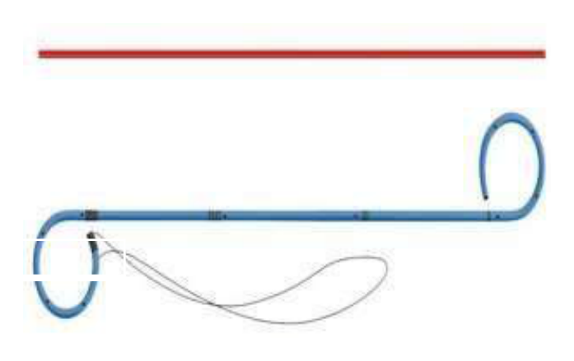  Identify the image:
Type | multiple_choice
Option | DJ stent
Option | Pigtail catheter
Option | Multi loop stent
Option | Coronary stent
Answer | 1
Solution | Rationale: DJ Stent (Double J Stent): A ureteral stent with curled ends (J-shape) at both the renal and bladder ends. Used to maintain ureteral patency after stone surgery, strictures, or obstruction. Key Clues: Double J-shaped ends, ureteral stent Why Not Others: A-Pigtail catheter has one curled end;C-Multi loop is different;D-Coronary stent is in heart Exam Trap: DJ stent vs pigtail - DJ has J-curls at BOTH ends, pigtail has curl at ONE end PNC Pearl: DJ stent: Remove cystoscopically after 4-6 weeks. Monitor for: frequency, urgency, flank pain, hematuria. Stent syndrome: bladder irritation, frequency. Encourage fluids.
Positive Marks | 1
Negative Marks | 0.33

Question | 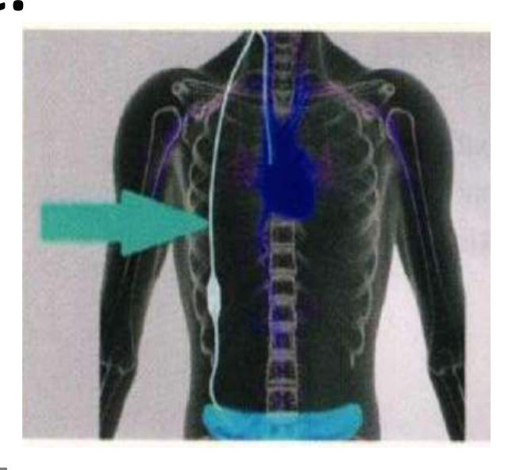  Shunt as represented by an arrow:
Type | multiple_choice
Option | Dialysis.
Option | Raised Intracranial pressure.
Option | Headache.
Option | Ascites.
Answer | 2
Solution | Rationale: VP Shunt shown is used to treat raised intracranial pressure (hydrocephalus) by draining excess CSF from the ventricles to the peritoneal cavity. Key Clues: VP shunt for hydrocephalus Why Not Others: A-Dialysis is for kidney failure;C-Headache is a symptom;D-Ascites is fluid in abdomen Exam Trap: VP shunt: Treats hydrocephalus by draining CSF. Monitor: ICP signs, shunt function, infection. PNC Pearl: VP shunt: Treats hydrocephalus by draining CSF. Monitor: ICP signs, shunt function, infection.
Positive Marks | 1
Negative Marks | 0.33

