Question | 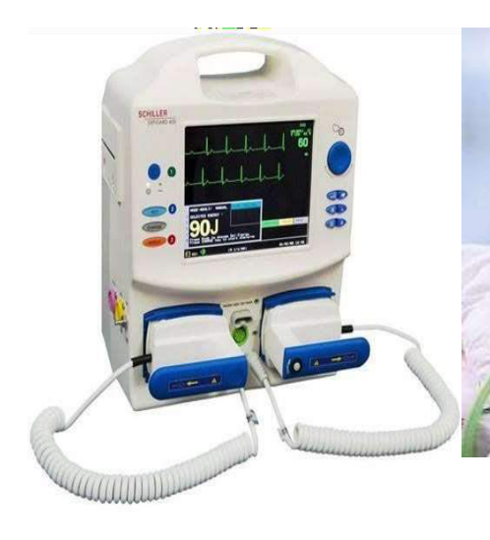  Identify the image:
Type | multiple_choice
Option | Manual defab
Option | Cardiac monitor
Option | AED
Option | ECG monitor
Answer | 3
Solution | Rationale: AED (Automated External Defibrillator): A portable device that automatically analyzes heart rhythm and delivers a shock if needed. Designed for use by laypersons and healthcare providers in cardiac arrest. Key Clues: Portable, automated rhythm analysis, shock delivery Why Not Others: A-Manual defab requires operator decision;C-Cardiac monitor displays only;D-ECG monitor records only Exam Trap: AED vs manual defibrillator - AED automates rhythm analysis, manual requires operator interpretation PNC Pearl: AED: Turn on · Attach pads · Analyze · Shock if advised. Resume CPR 2 min after shock. Check for water/metal. Ensure no one touching patient. Follow voice prompts.
Positive Marks | 1
Negative Marks | 0.33

Question | 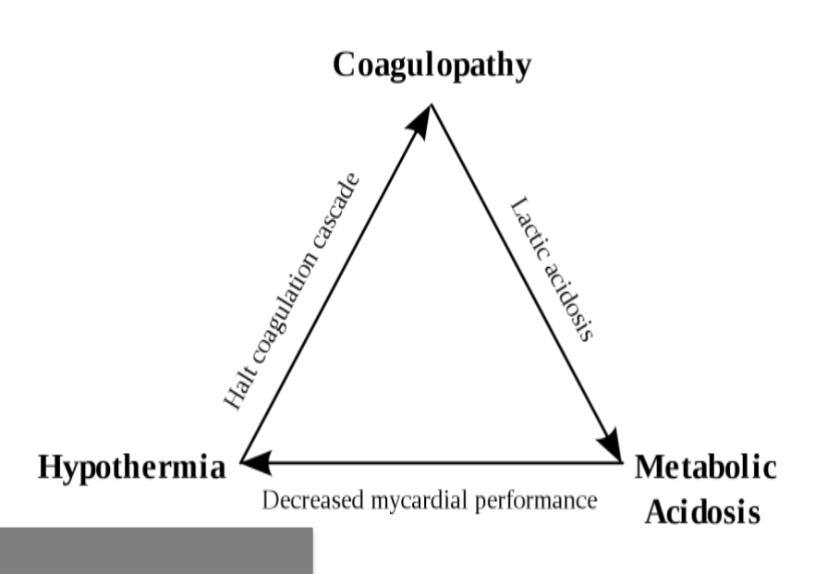  following death triangle used for:
Type | multiple_choice
Option | Trauma patient
Option | Burn patient
Option | MI patient
Option | Amputation
Answer | 2
Solution | Rationale: Death Triangle (Burn Triangle): Used for burn patient assessment and management. Represents the three components of burn resuscitation: fluid resuscitation, airway management, and wound care. Key Clues: Burn assessment/resuscitation triangle Why Not Others: A-Trauma uses ABCDE approach;B-MI uses MONA;C-Amputation uses tourniquet/preservation Exam Trap: Burn triangle: Airway, Fluid, Wound - three pillars of burn resuscitation PNC Pearl: Burns: Parkland formula = 4ml × body weight (kg) × %TBSA. First half in first 8 hours, second half in next 16 hours. Monitor: urine output (0.5-1 ml/kg/hr for adults), vital signs.
Positive Marks | 1
Negative Marks | 0.33

Question | 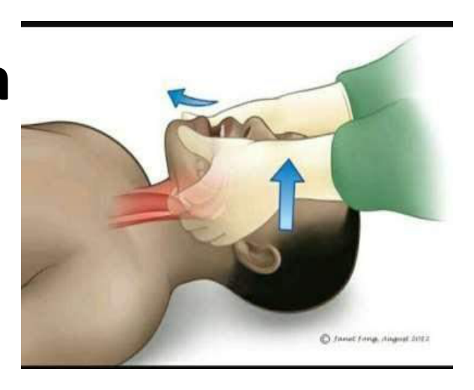  What is the name of this:
Type | multiple_choice
Option | Head tilt and chin lift
Option | Heimlich maneuver
Option | Carotid pulse examination
Option | Jaw thrust maneuver
Answer | 4
Solution | Rationale: Jaw Thrust Maneuver: An airway opening technique where the rescuer places fingers behind the angles of the mandible and lifts forward while stabilizing the head. Preferred in suspected cervical spine injury. Key Clues: Fingers behind mandible angles, lifts forward, for C-spine injury Why Not Others: A-Head tilt chin lift extends neck;C-Heimlich is abdominal thrusts;D-Carotid pulse is assessment Exam Trap: Jaw thrust vs head tilt chin lift - jaw thrust is safer for C-spine injury PNC Pearl: Jaw thrust: Place fingers behind angle of mandible. Push jaw forward. Stabilize head. Open mouth slightly. Does not extend neck. Preferred in trauma. Combine with C-spine immobilization.
Positive Marks | 1
Negative Marks | 0.33

Question | 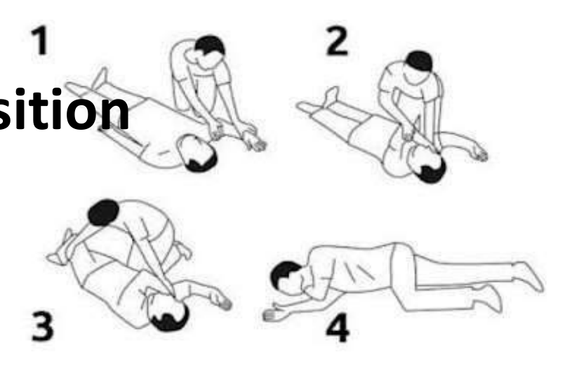  Which position is demonstrating:
Type | multiple_choice
Option | Sims lateral position
Option | Recovery position
Option | Dorsal recumbent position
Option | Knee chest position
Answer | 2
Solution | Rationale: Recovery Position (Lateral Position): Patient placed on their side with the dependent arm forward and upper leg flexed. Maintains airway patency, allows drainage of secretions, and prevents aspiration in unconscious but breathing patients. Key Clues: Lateral position, airway maintained, for unconscious breathing patients Why Not Others: B-Sims is similar but more tilted;C-Dorsal recumbent is supine with knees flexed;D-Knee chest is for gynecological exam Exam Trap: Recovery position vs lateral - recovery position is specifically for unconscious breathing patients PNC Pearl: Recovery position: Roll toward you. Bottom arm forward. Top knee flexed. Head tilted back to maintain airway. Monitor breathing. Never leave patient unattended.
Positive Marks | 1
Negative Marks | 0.33

Question | 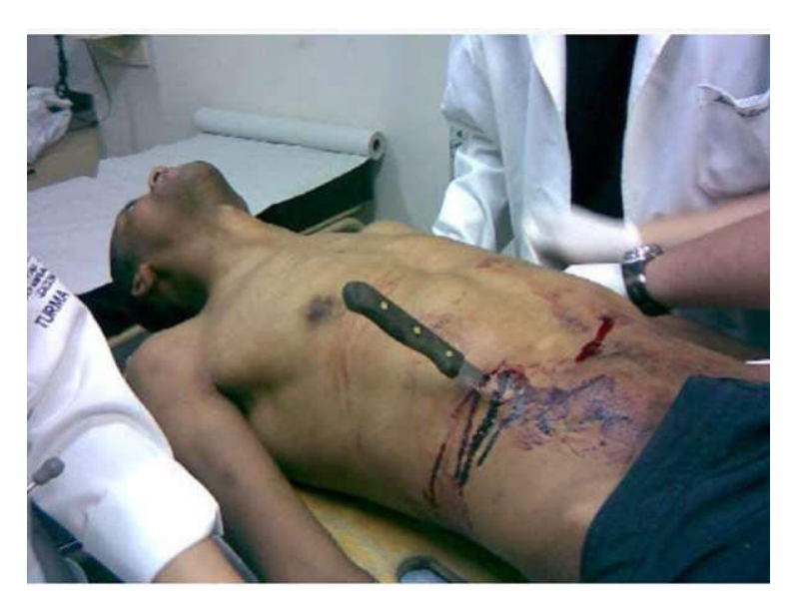  Most common organ injured in:
Type | multiple_choice
Option | Spleen
Option | Liver
Option | Pancreas
Option | Gall bladder
Answer | 1
Solution | Rationale: Spleen is the most commonly injured organ in blunt abdominal trauma due to its position in the left upper quadrant and relatively fixed position. Key Clues: Most commonly injured in blunt trauma Why Not Others: A-Liver is second most common;C-Pancreas is retroperitoneal;D-Gallbladder is protected Exam Trap: Spleen vs liver in trauma - spleen is #1 in blunt trauma, liver is #2 PNC Pearl: Splenic injury: Grade I-V. Conservative management for stable patients (bed rest, monitoring, transfusion). Emergency splenectomy for hemodynamic instability. Vaccination post-splenectomy.
Positive Marks | 1
Negative Marks | 0.33

Question | 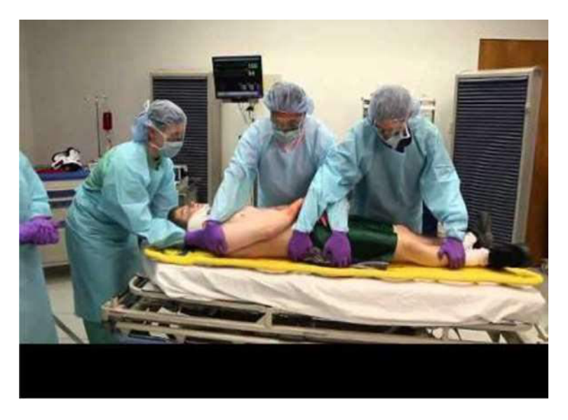  Maneuver used in Trauma:
Type | multiple_choice
Option | Log rolling
Option | Vertical lift
Option | Translational lift
Option | Patient lift
Answer | 1
Solution | Rationale: Log Rolling: A trauma maneuver where the patient is rolled as a unit while maintaining spinal alignment. Used to examine the back and apply spinal board in trauma patients. Key Clues: Patient rolled as unit, maintains C-spine alignment Why Not Others: A-Vertical lift raises patient;B-Translational is sliding;D-Patient lift is different Exam Trap: Log rolling vs other maneuvers - log rolling specifically maintains spinal alignment during turning PNC Pearl: Log rolling technique: One person controls head/neck (C-spine immobilization). Others roll body simultaneously. Used to: apply spinal board, assess back injuries, apply cervical collar.
Positive Marks | 1
Negative Marks | 0.33

Question | 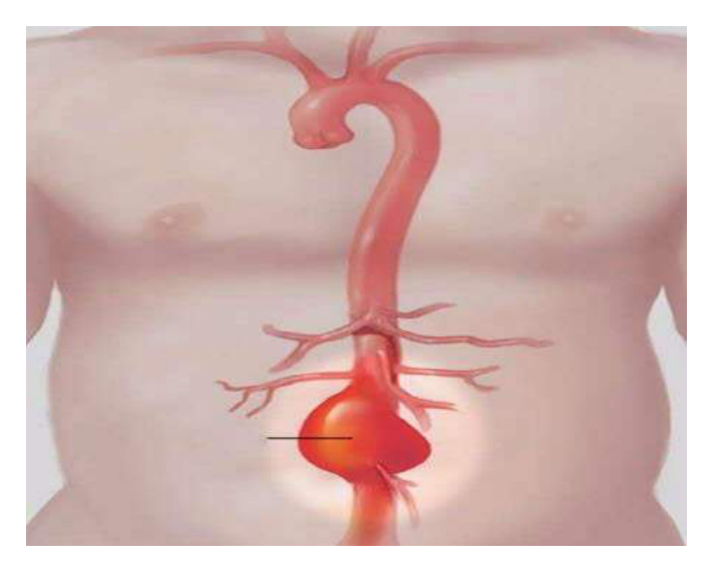  Investigation of choice for measurement:
Type | multiple_choice
Option | Plain abdominal X-ray.
Option | USG
Option | CT scan.
Option | MRI
Answer | 3
Solution | Rationale: CT Scan is the investigation of choice for measuring intra-abdominal injuries, organ damage, and fluid collections in trauma patients. Provides detailed cross-sectional images. Key Clues: CT scan for trauma assessment Why Not Others: A-X-ray is limited;B-USG is for initial screening;D-MRI is too slow for trauma Exam Trap: CT scan vs USG in trauma - CT is definitive (more detailed), USG (FAST) is initial screening PNC Pearl: Trauma imaging: FAST USG (initial screening for free fluid), CT abdomen/pelvis with contrast (definitive for organ injury), CXR (pneumothorax, hemothorax).
Positive Marks | 1
Negative Marks | 0.33

