Question | 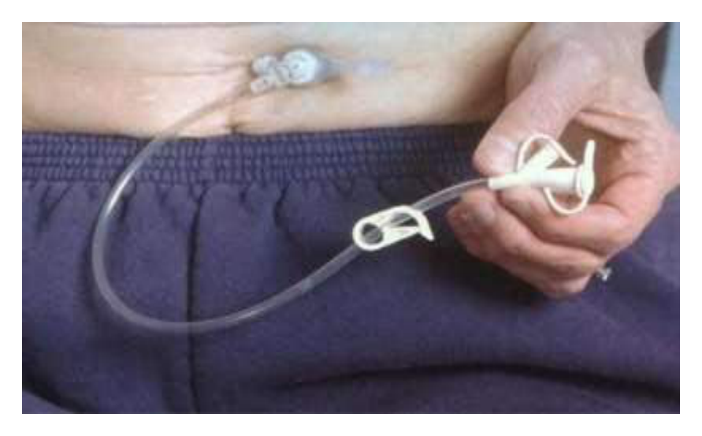  Identify the image:
Type | multiple_choice
Option | PEG tube
Option | Ileostomy
Option | SPC catheter
Option | Chest tube
Answer | 1
Solution | Rationale: PEG Tube (Percutaneous Endoscopic Gastrostomy): A feeding tube inserted through the abdominal wall into the stomach using endoscopic guidance. Used for long-term enteral nutrition when oral feeding is not possible. Key Clues: Inserted through abdominal wall into stomach, endoscopic placement Why Not Others: B-Ileostomy is for small bowel;C-SPC is suprapubic catheter;D-Chest tube is for pleural space Exam Trap: PEG vs NG tube - PEG is for long-term, NG tube is for short-term feeding PNC Pearl: PEG tube: Indications: dysphagia, head/neck cancer, neurological conditions. Care: Flush before and after feeds, check tube position, monitor site for infection. Complications: dislodgement, infection, tube blockage.
Positive Marks | 1
Negative Marks | 0.33

Question | 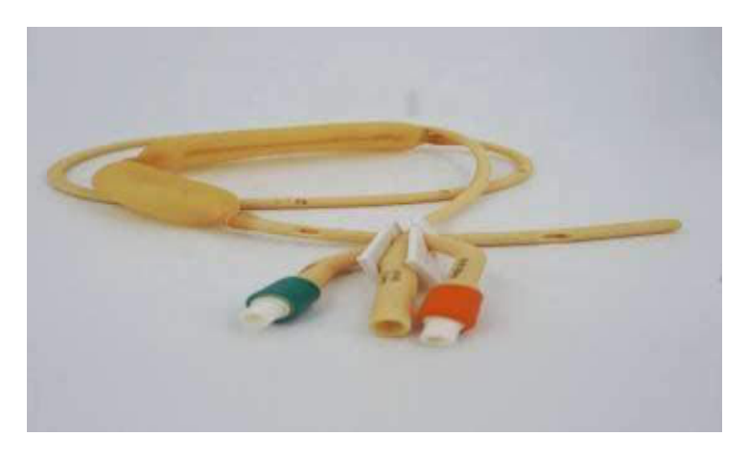  Identify the image:
Type | multiple_choice
Option | SB tube
Option | Levin tube
Option | Ryles tube
Option | Minnesota tube
Answer | 3
Solution | Rationale: Ryles Tube (Nasogastric Tube): A flexible tube inserted through the nose into the stomach for gastric decompression, feeding, or medication administration. Has radio- opaque line for position verification. Key Clues: Inserted nasally into stomach, radio-opaque line, multiple ports Why Not Others: B-SB tube is for small bowel;C-Levin tube is single lumen;D-Minnesota tube is for esophageal varices Exam Trap: Ryles vs Levin - Ryles has radio-opaque line and multiple ports, Levin is simpler PNC Pearl: Ryles tube: Verify position with pH testing (gastric pH <5.5) and CXR. Never irrigate with air. Record length at nostril. Aspirate before feeding. Complications: aspiration, nasal pressure injury, tube misplacement.
Positive Marks | 1
Negative Marks | 0.33

Question | 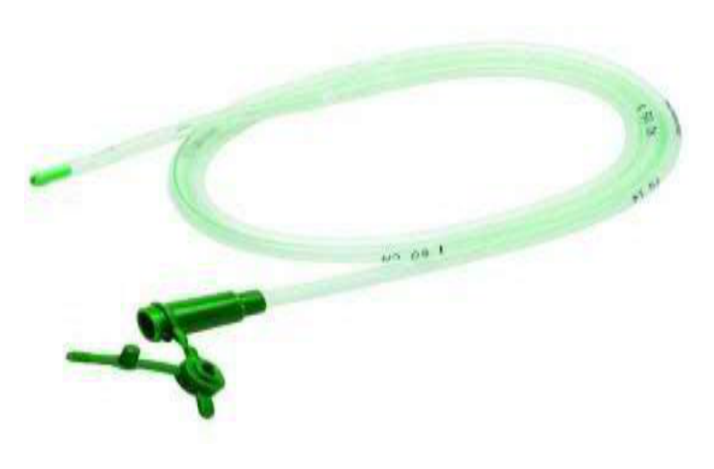  Identify the image:
Type | multiple_choice
Option | 12F NG tube
Option | 16F NG tube
Option | 14F NG tube
Option | 18F NG tube
Answer | 2
Solution | Rationale: 16F NG Tube: A nasogastric tube of size 16 French (outer diameter ~5.3mm). This is the standard adult size used for gastric decompression, feeding, and medication administration. Key Clues: 16 French, standard adult size Why Not Others: A-12F is pediatric;B-14F is small adult;D-18F is large adult Exam Trap: NG tube French sizes: 8-10F (neonate), 12-14F (child), 16F (adult standard), 18F (large/decompression) PNC Pearl: NG tube sizes: 16F is most common adult size. Measure from nose to earlobe to xiphoid (NEX). Verify position with pH <5.5 and CXR before use.
Positive Marks | 1
Negative Marks | 0.33

Question | 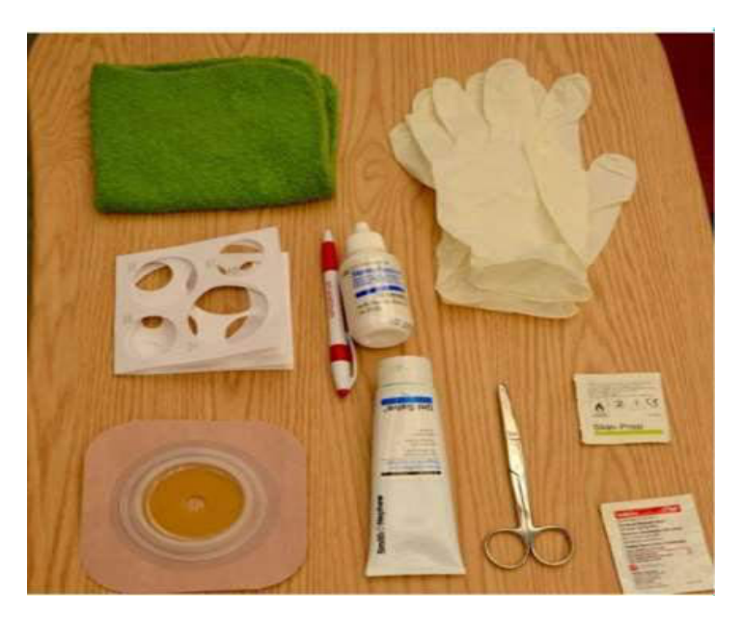  Identify the supplies:
Type | multiple_choice
Option | CVP set
Option | ICD set
Option | Tracheostomy set
Option | Colostomy set
Answer | 3
Solution | Rationale: Tracheostomy Set: A collection of supplies for tracheostomy care including: inner cannulas, obturator, ties, cleaning supplies, suction equipment, and emergency tracheostomy tube. Key Clues: Collection of tracheostomy care supplies Why Not Others: A-CVP set is for central line;B-ICD is for chest;C-Colostomy set is for stoma Exam Trap: Tracheostomy set should be at bedside at all times for emergency tube change PNC Pearl: Tracheostomy set contents: Spare inner cannula, obturator, emergency tracheostomy tube, suction catheter, scissors, clean ties, normal saline, gauze pads.
Positive Marks | 1
Negative Marks | 0.33

Question | 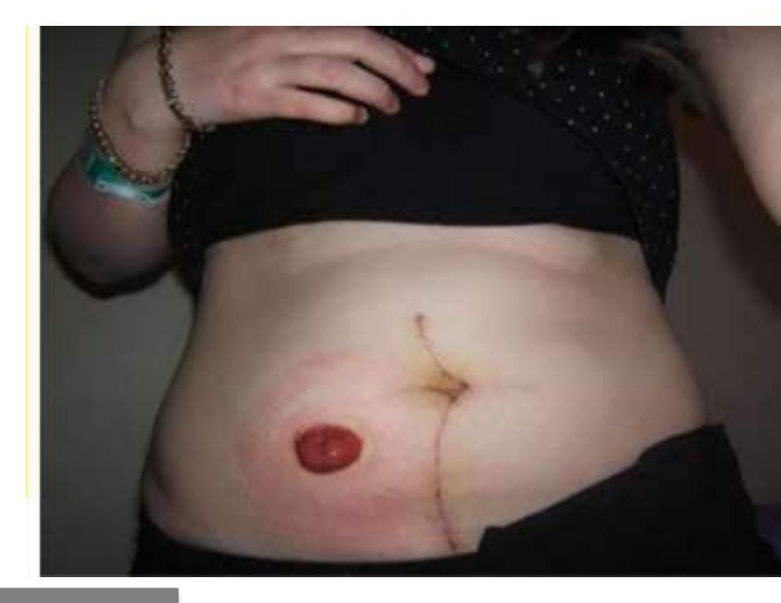  Identify the image:
Type | multiple_choice
Option | Transverse colostomy
Option | Ascending Colostomy
Option | Urostomy
Option | Ileostomy
Answer | 3
Solution | Rationale: Urostomy: A surgical opening (stoma) created to divert urine from the kidneys to an external collection bag when the bladder is removed or non-functional. Usually placed in the right lower abdomen. Key Clues: Stoma for urine diversion, right lower abdomen Why Not Others: A-Colostomy is for stool;C-Ascending colostomy is bowel;D-Ileostomy is small bowel Exam Trap: Urostomy vs colostomy - urostomy drains urine, colostomy drains stool PNC Pearl: Urostomy: Stoma is pink/red, moist. Urine bag always below stoma. Monitor: stoma color, output, skin integrity. Irrigate per protocol. Avoid irritation from urine.
Positive Marks | 1
Negative Marks | 0.33

Question |   Identify the image:
Type | multiple_choice
Option | Jejunostomy tube
Option | Nephrostomoy tube
Option | Ileostomy tube
Option | PFG machine
Answer | 1
Solution | Rationale: Nephrostomy Tube: A catheter inserted through the skin directly into the kidney pelvis to drain urine when the ureter is blocked. Used for urinary obstruction, kidney stones, or ureteral injury. Key Clues: Inserted percutaneously into kidney, for urine drainage Why Not Others: A-Ryles tube is nasogastric;B-Ileostomy is for small bowel;D-PEG is for feeding Exam Trap: Nephrostomy vs ureteral stent - nephrostomy goes through skin into kidney, ureteral stent goes through ureter internally PNC Pearl: Nephrostomy: Care includes: bag below kidney level, monitor output/color, secure tube, prevent accidental removal. Complications: infection, bleeding, tube dislodgement. Irrigate gently if blocked.
Positive Marks | 1
Negative Marks | 0.33

Question | 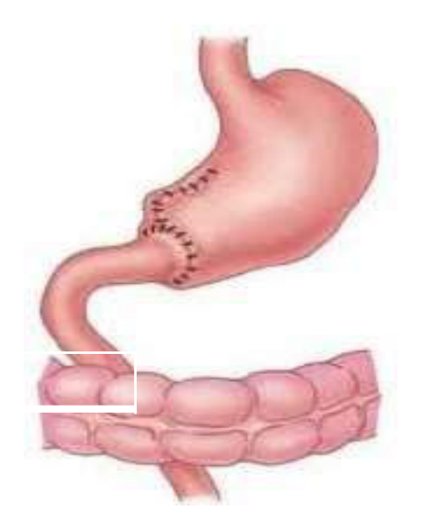  Identify the image:
Type | multiple_choice
Option | Duodenctomy
Option | Gastrectomy
Option | Bariatic surgery
Option | Billroth I
Answer | 4
Solution | Rationale: Billroth I (Gastroduodenostomy): Partial gastrectomy where the remaining stomach is connected directly to the duodenum. Used for gastric ulcer and early gastric cancer. Maintains more physiological GI continuity. Key Clues: Stomach connected to duodenum, partial gastrectomy Why Not Others: B-Duodenctomy is removal of duodenum;C-Gastrectomy is total;D-Bariatric is weight loss surgery Exam Trap: Billroth I vs II - Billroth I connects to duodenum, Billroth II connects to jejunum PNC Pearl: Billroth I: Used for distal gastric cancers and ulcers. Complications: dumping syndrome, bile reflux, nutritional deficiencies. Post-op: small frequent meals, avoid high sugar, elevate head after eating.
Positive Marks | 1
Negative Marks | 0.33

Question | 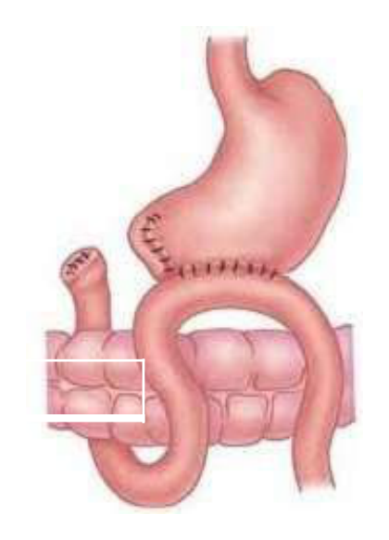  Identify the image:
Type | multiple_choice
Option | Billroth I
Option | Billroth II
Option | Duodenctomy
Option | Gastrectomy
Answer | 2
Solution | Rationale: Billroth II (Gastrojejunostomy): Partial gastrectomy where the remaining stomach is connected to a loop of jejunum, with a blind duodenal stump. Used for gastric cancer and complicated ulcers. Key Clues: Stomach connected to jejunum, duodenal stump Why Not Others: A-Billroth I connects to duodenum;B-Duodenectomy removes duodenum;C-Gastrectomy is total Exam Trap: Billroth II vs I - Billroth II connects to jejunum with roux-en-Y or loop PNC Pearl: Billroth II: Higher risk of dumping syndrome, blind loop syndrome, and nutritional deficiencies than Billroth I. Monitor for anemia (B12, iron malabsorption).
Positive Marks | 1
Negative Marks | 0.33

Question | 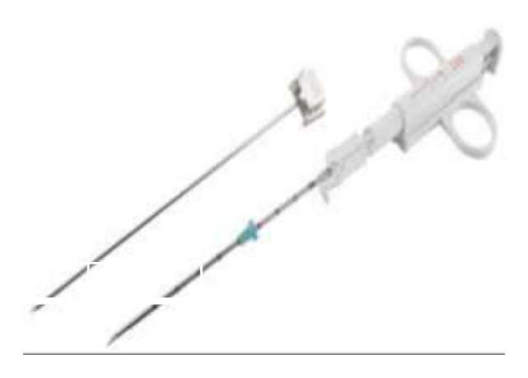  Identify the image:
Type | multiple_choice
Option | Vim Silverman needle
Option | Menghini biopsy needle
Option | True cut needle
Option | Punch biopsy needle
Answer | 1
Solution | Rationale: Vim-Silverman Needle: A cutting-type liver biopsy needle with a split cutting edge. Used for percutaneous liver biopsy to obtain tissue samples for histological examination. Key Clues: Split cutting edge, for liver biopsy Why Not Others: A-Menghini is aspiration type;C-True cut is for solid tissue;D-Punch is for skin biopsy Exam Trap: Vim-Silverman vs Menghini - Vim-Silverman is cutting type, Menghini is aspiration type PNC Pearl: Vim-Silverman needle: Patient in supine or left lateral. Breath-hold during insertion. Post-procedure: right lateral position, monitor vitals, watch for bleeding/peritonitis for 24 hours.
Positive Marks | 1
Negative Marks | 0.33

Question | 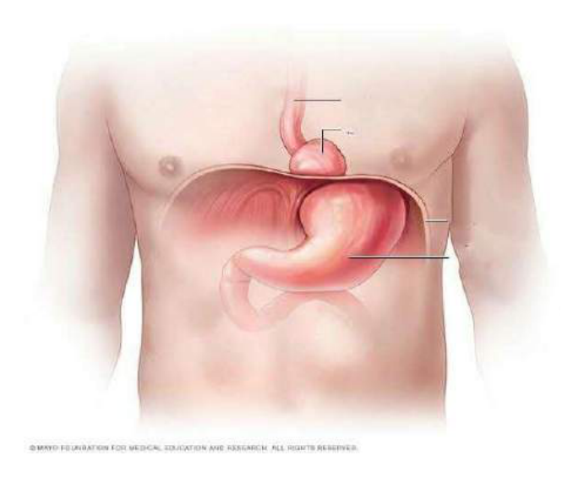  The Common complication of the:
Type | multiple_choice
Option | Aspiration
Option | Esophagitis
Option | Volvulus
Option | Esophageal
Answer | 1
Solution | Rationale: Aspiration is a common complication of procedures involving the airway or GI tract. Aspiration of gastric contents can cause chemical pneumonitis (Mendelson syndrome) and respiratory failure. Key Clues: Aspiration of gastric contents, respiratory complication Why Not Others: A-Esophagitis is inflammation;C-Volvulus is bowel twist;D-Esophageal is incomplete term Exam Trap: Aspiration prevention: NPO 6-8 hours, head elevation 30-45 deg, cuffed ET tube, rapid sequence intubation PNC Pearl: Aspiration pneumonitis: Caused by gastric acid in lungs. Prevention: NPO, elevation, RSI with cricoid pressure (Sellick maneuver). Treatment: supportive, antibiotics if secondary infection.
Positive Marks | 1
Negative Marks | 0.33

Question | 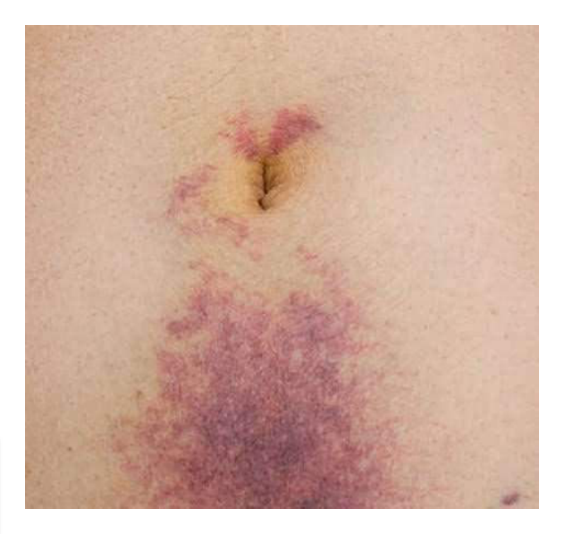  Patient with Acute Abdomen Pain:
Type | multiple_choice
Option | Acute hemorrhagic pancreatitis
Option | Acute cholecystitis
Option | Ureteric stone
Option | Acute hepatic
Answer | 1
Solution | Rationale: Acute Hemorrhagic Pancreatitis: Severe inflammation of the pancreas with bleeding. Shows Cullen sign (periumbilical ecchymosis), Turner sign (flank ecchymosis), and severe abdominal pain. Key Clues: Cullen sign, Turner sign, severe epigastric pain Why Not Others: A-Cholecystitis is RUQ pain;C-Ureteric stone is colicky pain;D-Hepatic is liver- related Exam Trap: Acute pancreatitis signs: Cullen (umbilicus), Turner (flank), Grey-Turner (flank), Fox (groin) PNC Pearl: Pancreatitis: Caused by gallstones and alcohol. Diagnosed: amylase/lipase >3x normal. Treatment: NPO, IV fluids, pain management, nutrition support.
Positive Marks | 1
Negative Marks | 0.33

Question | 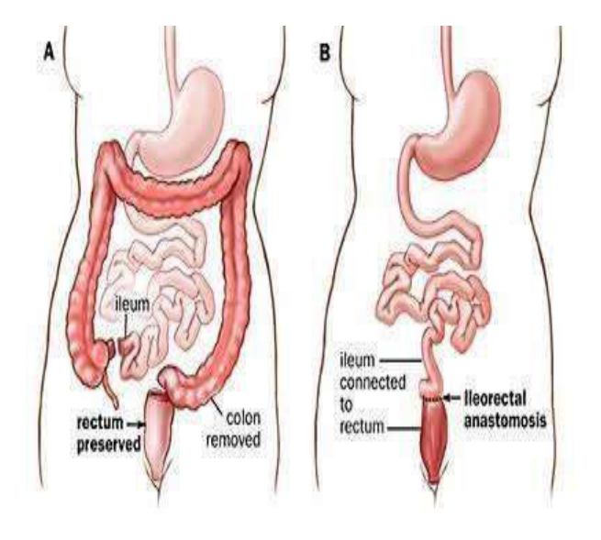  Identify the procedure as:
Type | multiple_choice
Option | Partial Colectomy.
Option | Complete Colectomy.
Option | None of the above
Option | Total Colectomy.
Answer | 4
Solution | Rationale: Total Colectomy: Complete removal of the large intestine (colon) from cecum to rectum. Results in permanent ileostomy or ileal pouch-anal anastomosis (J-pouch). Key Clues: Complete colon removal Why Not Others: B-Partial is segment removal;C-Complete is same as total;D-None is incorrect Exam Trap: Total vs partial colectomy - total removes entire colon, partial removes segment PNC Pearl: Total colectomy: Indications: ulcerative colitis, familial polyposis, colon cancer. Post-op: ileostomy care, nutritional support, monitor for dehydration/electrolyte imbalance.
Positive Marks | 1
Negative Marks | 0.33

Question | 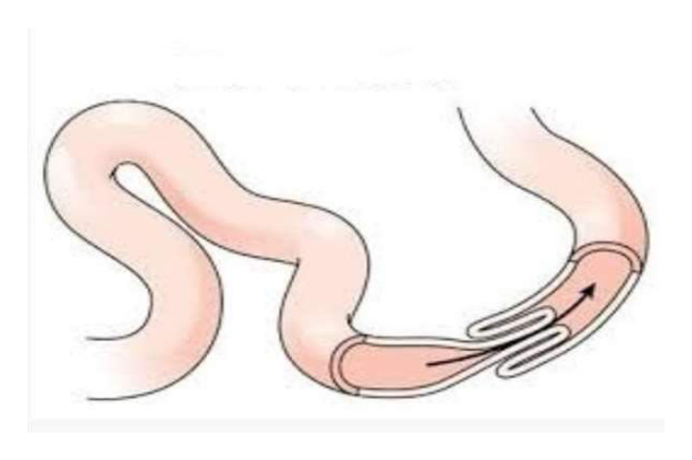  The traditional and most reliable way to:
Type | multiple_choice
Option | Radiography.
Option | Contrast enema.
Option | Ultrasonography.
Option | All of the above.
Answer | 2
Solution | Rationale: Contrast Enema: A radiological investigation where contrast material (barium or water-soluble) is introduced into the rectum to visualize the large bowel. Used to diagnose obstruction, volvulus, and other colonic pathology. Key Clues: Contrast in rectum, for colonic imaging Why Not Others: A-Radiography is plain X-ray;B-Ultrasonography uses sound waves;D-All of above includes non-specific options Exam Trap: Contrast enema vs CT colonography - contrast enema is fluoroscopic, CT is cross- sectional PNC Pearl: Contrast enema: Water-soluble preferred (safety if perforation). Barium for non- perforation cases. Patient: NPO, bowel preparation. Monitor: perforation signs, contrast reaction.
Positive Marks | 1
Negative Marks | 0.33

Question | 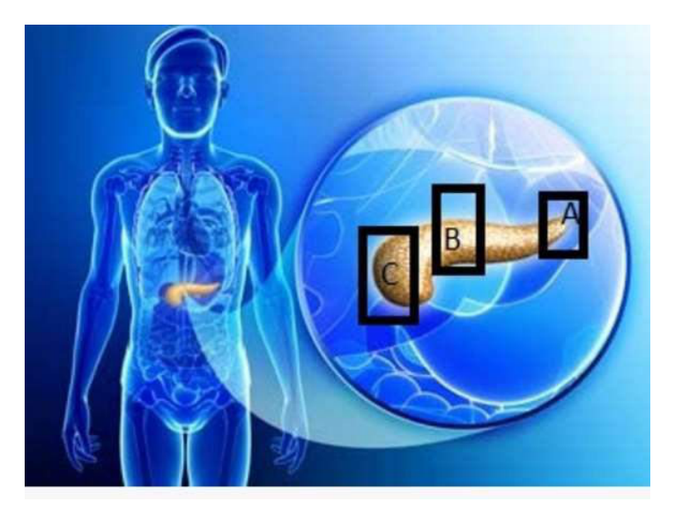  Most common site of carcinoma of:
Type | multiple_choice
Option | Neck
Option | Body
Option | Head
Option | Tail
Answer | 3
Solution | Rationale: Carcinoma of the Pancreas: Most common site is the head of the pancreas (60-70%). Presents with painless jaundice, weight loss, andCourttorial sign (palpable gallbladder). Key Clues: Head of pancreas is most common site Why Not Others: B-Neck,C-Body,D-Tail are less common Exam Trap: Pancreatic cancer: Head = painless jaundice. Body/Tail = late diagnosis. CA 19-9 marker. Whipple procedure for resectable. PNC Pearl: Pancreatic cancer: Head = painless jaundice. Body/Tail = late diagnosis. CA 19-9 marker. Whipple procedure for resectable.
Positive Marks | 1
Negative Marks | 0.33

Question | 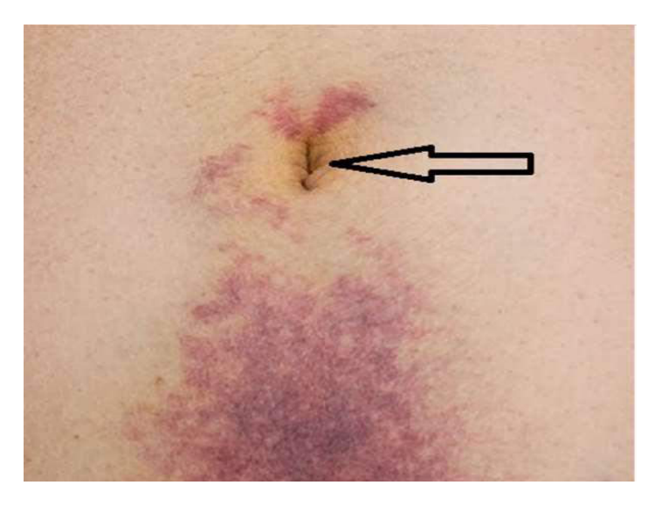  Sign (around Umbilicus) shown in:
Type | multiple_choice
Option | Acute pancreatitis
Option | Blunt abdominal trauma
Option | Ectopic pregnancy
Option | All of the above
Answer | 4
Solution | Rationale: Clinical signs around umbilicus in acute conditions: Cullen sign (periumbilical ecchymosis) seen in acute pancreatitis, blunt abdominal trauma, and ectopic pregnancy. Key Clues: Periumbilical ecchymosis Why Not Others: A-Acute pancreatitis;B-Blunt trauma;C-Ectopic pregnancy Exam Trap: All listed conditions can cause periumbilical ecchymosis - D (all of above) is correct PNC Pearl: Cullen sign: Periumbilical ecchymosis. Caused by retroperitoneal hemorrhage tracking to umbilicus. Seen in: acute pancreatitis, ruptured AAA, ectopic pregnancy, DIC.
Positive Marks | 1
Negative Marks | 0.33

Question | 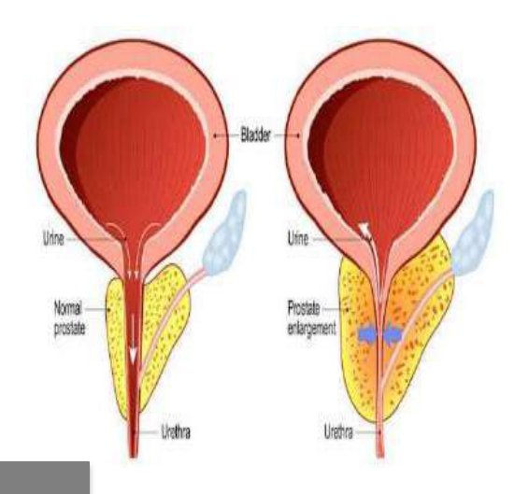  Most important marker for:
Type | multiple_choice
Option | PLAP.
Option | PSA.
Option | NSE.
Option | PAP.
Answer | 2
Solution | Rationale: PSA (Prostate Specific Antigen): The most important tumor marker for prostate cancer screening and monitoring. Elevated levels suggest prostatic pathology. Key Clues: PSA for prostate cancer Why Not Others: A-PLAP is for germ cell tumors;B-NSE is for small cell lung cancer;D-PAP is less specific Exam Trap: PSA: Normal <4 ng/mL. Elevated in: BPH, prostatitis, prostate cancer. Free/total PSA ratio helps differentiate. PNC Pearl: PSA: Normal <4 ng/mL. Elevated in: BPH, prostatitis, prostate cancer. Free/total PSA ratio helps differentiate.
Positive Marks | 1
Negative Marks | 0.33

Question | 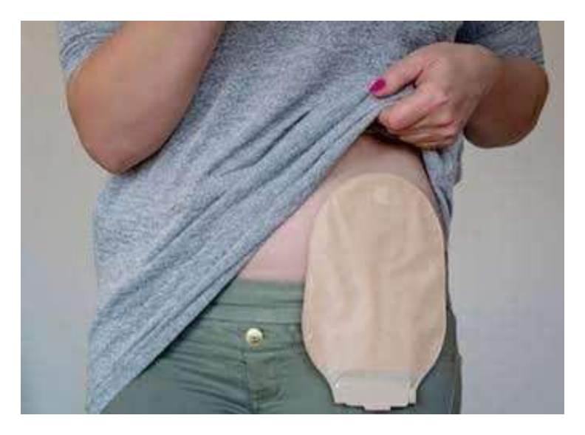  Identify the bag marked by an arrow:
Type | multiple_choice
Option | Colostomy bag.
Option | Kocher's bag.
Option | Rectal bag.
Option | Lane's bag.
Answer | 4
Solution | Rationale: Lane's Bag: A type of colostomy bag used for collecting fecal output from a colostomy. Named after the surgeon who designed it. Key Clues: Colostomy collection bag Why Not Others: A-Colostomy bag is generic;C-Kocher bag is not standard;D-Rectal bag is for rectal use Exam Trap: Lane's bag is a specific design of colostomy appliance for waste collection PNC Pearl: Colostomy bags: One-piece or two-piece systems. Measure stoma for proper fit. Empty when 1/3 to 1/2 full. Change appliance per schedule.
Positive Marks | 1
Negative Marks | 0.33

