Question | 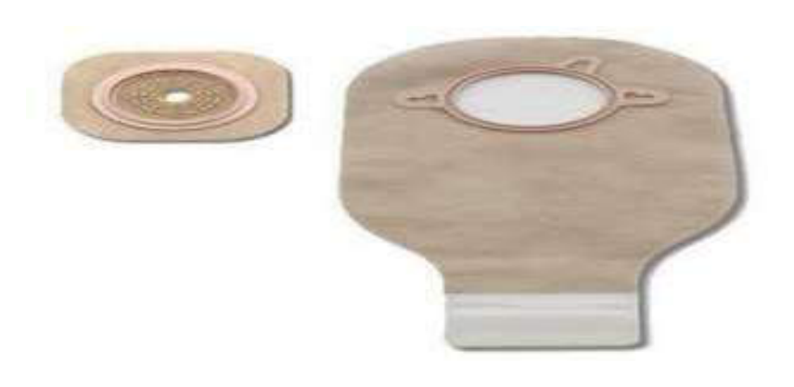  Identify the image:
Type | multiple_choice
Option | Colostomy bag
Option | Uro bag
Option | AMBU bag
Option | Waste bag
Answer | 3
Solution | Rationale: AMBU bag (Artificial Manual Breathing Unit) is a self-inflating bag used for positive pressure ventilation. It provides temporary ventilation during cardiac arrest, anesthesia, or respiratory failure. Key Clues: Self-inflating bag with mask and reservoir, squeeze to ventilate Why Not Others: A-Colostomy bag is for stoma drainage; B-Uro bag is for urine collection; D-Waste bag is for disposal Exam Trap: Students often confuse AMBU bag with ventilator - AMBU is manual, ventilator is mechanical PNC Pearl: AMBU = Ambu (brand name that became generic). Always check valve function before use. Adult bag ~1600ml, pediatric ~500ml.
Positive Marks | 1
Negative Marks | 0.33

Question | 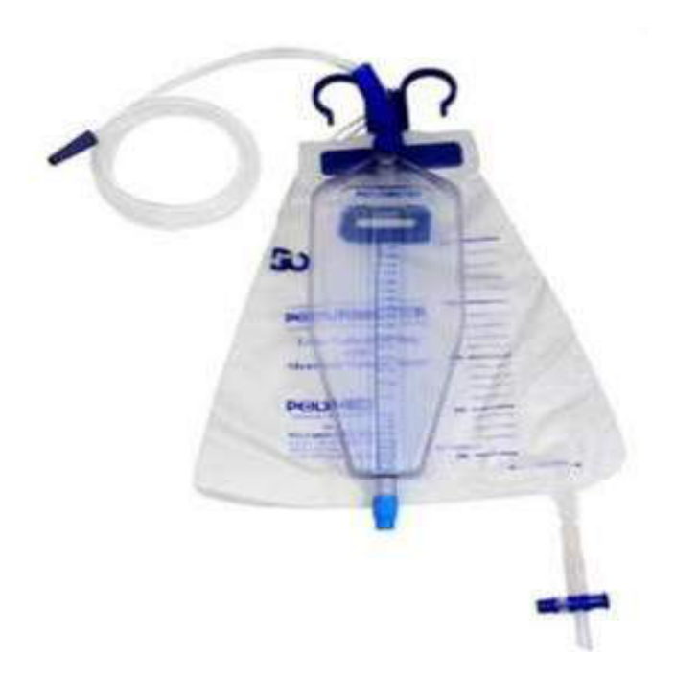  Identify the image:
Type | multiple_choice
Option | ICD bag
Option | Uro bag
Option | -
Option | Uro meter
Answer | 1
Solution | Rationale: ICD (Intercoastal Drain) bag/chest drainage system collects air and fluid from the pleural space. It uses a three-chamber system: collection, water seal, and suction control. Key Clues: Three-chamber system, connects to chest tube, underwater seal Why Not Others: B-Uro bag collects urine; D-Urometer measures urine output Exam Trap: ICD vs urinary drainage - ICD goes to chest, uses underwater seal principle PNC Pearl: ICD nursing care: Keep below chest level, never clamp without order, monitor bubbling (air leak), output color/amount. Water seal at 2cm H·O.
Positive Marks | 1
Negative Marks | 0.33

Question | 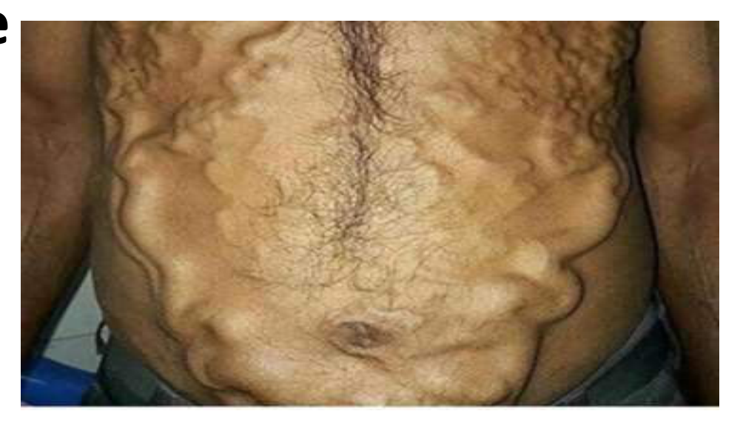  Identify the image:
Type | multiple_choice
Option | Vericocele
Option | Caput medusae
Option | Ascites
Option | Vericose vein
Answer | 4
Solution | Rationale: Varicose Veins: Dilated, tortuous superficial veins, commonly in the lower extremities. Caused by incompetent venous valves, leading to blood pooling. Risk factors: standing, obesity, pregnancy. Key Clues: Dilated tortuous veins in legs, valve incompetence Why Not Others: B-Varicocele is in scrotum;C-Caput medusae is periumbilical;D-Ascites is fluid in abdomen Exam Trap: Varicose veins vs varicocele - varicose veins are in legs, varicocele is in spermatic cord PNC Pearl: Varicose veins: Treatment: compression stockings, sclerotherapy, laser ablation, surgery. Complications: thrombophlebitis, ulceration, bleeding. Nursing: elevate legs, compression, avoid prolonged standing.
Positive Marks | 1
Negative Marks | 0.33

Question | 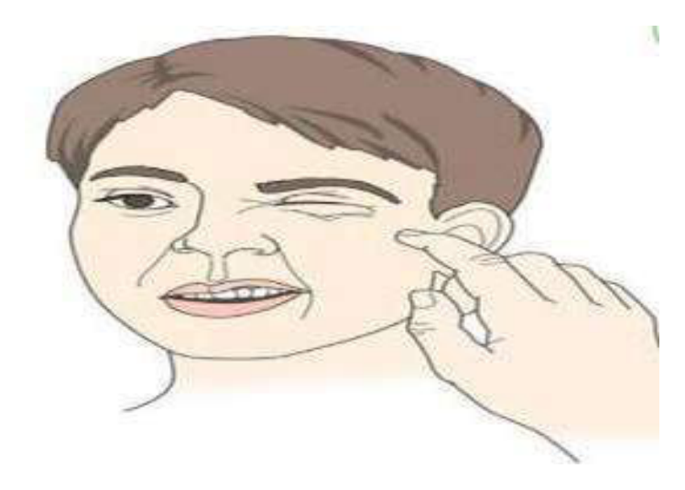  Identify the image:
Type | multiple_choice
Option | Bell·s palsy
Option | Ptosis
Option | Hypocalcemia
Option | Hypokalemia
Answer | 1
Solution | Rationale: Bell's Palsy: Lower motor neuron facial nerve palsy affecting one side of the face. Shows drooping of the mouth, inability to close eye, loss of forehead wrinkles on affected side. Unlike stroke, spares forehead. Key Clues: One-sided facial drooping, forehead involvement, inability to close eye Why Not Others: A-Ptosis is drooping eyelid only;B-Hypocalcemia shows Chvostek/Trousseau signs;C-Hypokalemia shows muscle weakness Exam Trap: Bell's vs stroke - Bell's affects entire half of face (including forehead), stroke spares forehead (UMN) PNC Pearl: Bell's palsy: Idiopathic LMN facial nerve palsy. Prednisolone within 72 hours. Eye care (artificial tears, taping at night). Usually recovers in weeks-months. Must rule out stroke.
Positive Marks | 1
Negative Marks | 0.33

Question | 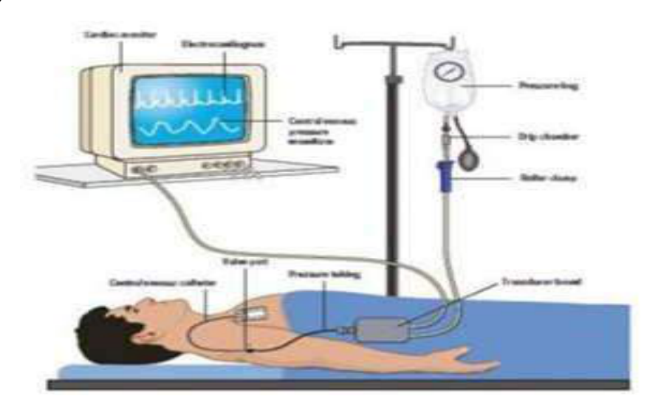  Identify the image:
Type | multiple_choice
Option | All of above
Option | Transducer CVP
Option | Manometer CVP
Option | Pressure monitor
Answer | 1
Solution | Rationale: CVP Monitoring Device: Can use transducer (electronic, continuous) or manometer (manual, intermittent) for measuring central venous pressure. Both connected to central venous catheter. Key Clues: Transducer or manometer for CVP measurement Why Not Others: A-Transducer is one method;B-Manometer is another;C-Pressure monitor is generic Exam Trap: All options A, B, and C are types of CVP monitoring devices - answer D (All of above) is correct PNC Pearl: CVP monitoring: Transducer = continuous, more accurate. Manometer = manual, intermittent. Both require zeroing at phlebostatic axis. Normal CVP: 2-6 mmHg.
Positive Marks | 1
Negative Marks | 0.33

Question | 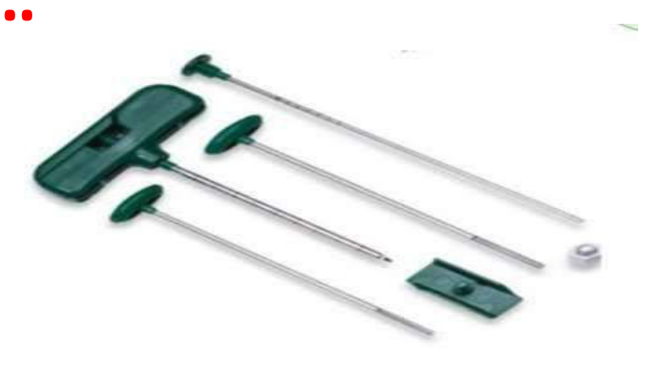  Identify the image:
Type | multiple_choice
Option | LP needle
Option | BMP needle
Option | Biopsy gun
Option | Menghini gun
Answer | 3
Solution | Rationale: Biopsy Gun: A spring-loaded device used to obtain core tissue samples. The needle is propelled rapidly into the tissue to obtain a core sample. Used for liver, kidney, prostate, and breast biopsies. Key Clues: Spring-loaded, core needle, for tissue sampling Why Not Others: A-LP needle is for lumbar puncture;B-BMP needle is for bone marrow;D-Menghini is aspiration needle Exam Trap: Biopsy gun vs Menghini - biopsy gun takes core samples (preserves architecture), Menghini aspirates cells PNC Pearl: Biopsy gun: Spring-loaded mechanism ensures consistent core length. Sizes: 14G-18G. Used for: liver, kidney, breast, prostate, thyroid. Post-procedure: monitor for bleeding, pain.
Positive Marks | 1
Negative Marks | 0.33

Question | 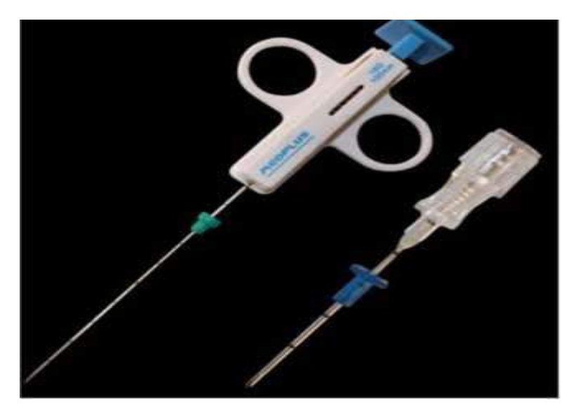  Identify the image:
Type | multiple_choice
Option | LP needle
Option | BMP needle
Option | Menghini gun
Option | Biopsy gun
Answer | 4
Solution | Rationale: Biopsy Gun (Core Needle Biopsy): Same as Q44 - spring-loaded device for obtaining core tissue samples. Provides histological architecture preservation for accurate pathological diagnosis. Key Clues: Spring-loaded, tissue core, preserves architecture Why Not Others: A-LP is lumbar puncture;B-BMP is bone marrow;D-Menghini is aspiration Exam Trap: Core biopsy vs FNA - core gives tissue architecture, FNA gives individual cells PNC Pearl: Biopsy gun technique: Under USG/CT guidance. Local anesthesia. Patient holds breath during firing. Post-procedure: ice pack, monitor vitals, watch for hemorrhage.
Positive Marks | 1
Negative Marks | 0.33

Question | 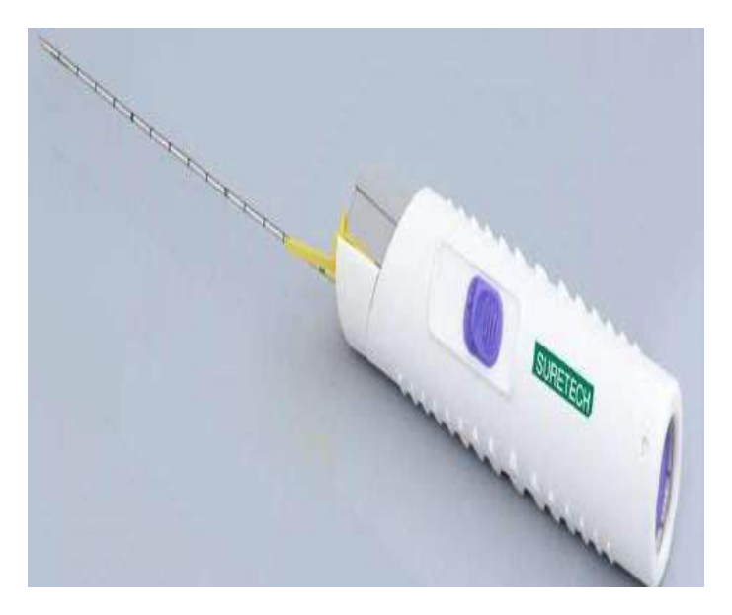  Identify the image:
Type | multiple_choice
Option | LP needle
Option | Menghini gun
Option | BMP needle
Option | Biopsy gun
Answer | 2
Solution | Rationale: Menghini Needle: A single-cut aspiration needle used for percutaneous liver biopsy. The needle has a side hole near the tip for tissue aspiration. Simpler and safer than cutting needles. Key Clues: Aspiration type, side hole, for liver biopsy Why Not Others: A-LP needle is for spinal tap;B-BMP is for bone marrow;C-Biopsy gun is spring-loaded Exam Trap: Menghini vs Vim-Silverman - Menghini is aspiration, Vim-Silverman is cutting PNC Pearl: Menghini needle: Quick aspiration technique. 1-2 seconds. Lower complication rate than cutting needles. Patient: supine, right arm overhead. Post-procedure: right lateral position, monitor 4-24 hours.
Positive Marks | 1
Negative Marks | 0.33

Question | 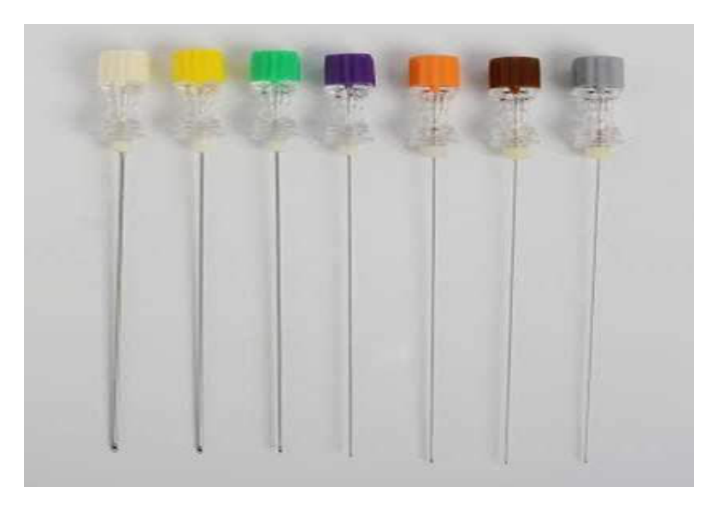  Identify the image:
Type | multiple_choice
Option | LP needle
Option | Menghini gun
Option | BMP needle
Option | Biopsy gun
Answer | 2
Solution | Rationale: Menghini Needle: An aspiration-type biopsy needle designed for rapid percutaneous tissue sampling. Single pass technique with minimal tissue trauma. Used primarily for liver biopsy. Key Clues: Rapid aspiration, single pass, liver biopsy Why Not Others: A-LP for CSF;B-BMP for bone marrow;C-Biopsy gun for core Exam Trap: Menghini advantage: Quick (1-2 sec), less bleeding risk, good for coagulopathy patients PNC Pearl: Menghini vs true-cut - Menghini is aspiration (cells only), true-cut gives core (tissue architecture).
Positive Marks | 1
Negative Marks | 0.33

Question | 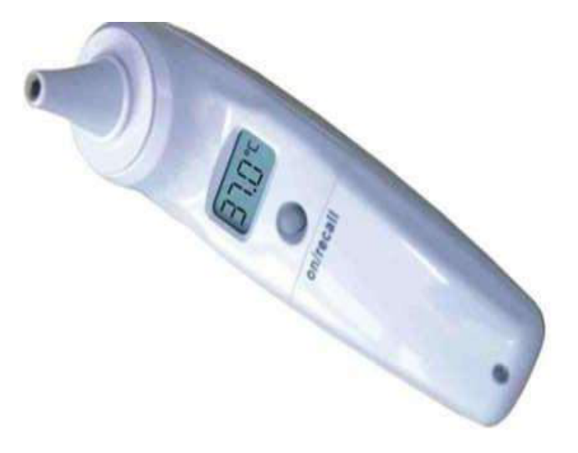  Identify the image:
Type | multiple_choice
Option | Otoscope
Option | Proctoscope
Option | Infrared thermometer
Option | TM thermometer
Answer | 3
Solution | Rationale: Infrared Thermometer: A non-contact thermometer that measures temperature by detecting infrared radiation emitted by the body. Used for quick temperature screening without physical contact. Key Clues: Non-contact, infrared detection, temperature measurement Why Not Others: A-Otoscope examines ear;B-Proctoscope examines rectum;D-TM thermometer uses tympanic membrane Exam Trap: Infrared vs tympanic - infrared is non-contact (forehead), tympanic is in-ear PNC Pearl: Infrared thermometer: Point at center of forehead. Press and hold trigger. Read display. Advantage: no cross-infection risk, fast reading. Less accurate than core methods.
Positive Marks | 1
Negative Marks | 0.33

Question | 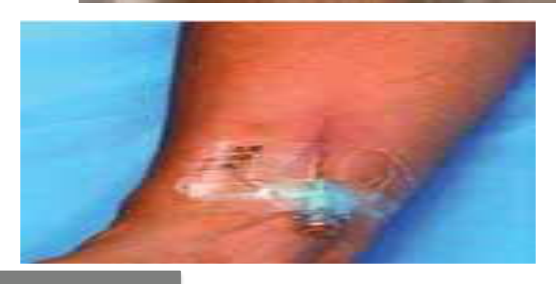  Identify the image.:
Type | multiple_choice
Option | Phlebitis
Option | Exravassation
Option | Infiltration
Option | Venous ulcer
Answer | 1
Solution | Rationale: Phlebitis: Inflammation of a vein, commonly caused by IV cannulation. Shows redness, warmth, pain, and swelling along the vein. Graded 0-4 based on severity. Key Clues: Vein inflammation, red/warm/painful along vein track Why Not Others: B-Extravasation is drug leakage;C-Infiltration is fluid leakage;D-Venous ulcer is on lower leg Exam Trap: Phlebitis vs infiltration - phlebitis is vein inflammation, infiltration is fluid in surrounding tissue PNC Pearl: Phlebitis grading: 0=None, 1=Mild (pain, no redness), 2=Moderate (pain + redness), 3=Severe (pain + redness + streak), 4=Suppurative. Remove IV, warm compress, elevate.
Positive Marks | 1
Negative Marks | 0.33

Question | 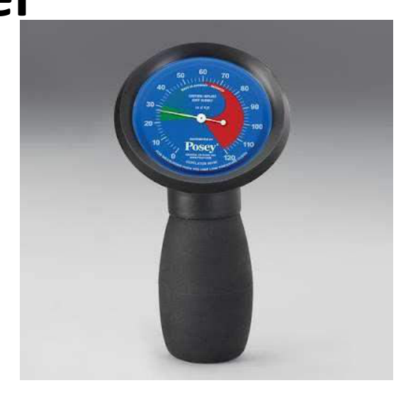  Identify this instrument?
Type | multiple_choice
Option | Speedometer
Option | ETCO2 monitor
Option | Suction apparatus
Option | ET cuff pressure manometer
Answer | 4
Solution | Rationale: ET Cuff Pressure Manometer: A device used to measure the inflation pressure of the endotracheal tube cuff. Optimal pressure is 20-30 cmH·O to prevent tracheal mucosal damage while maintaining seal. Key Clues: Measures cuff pressure, 20-30 cmH·O optimal Why Not Others: A-Speedometer measures speed;B-ETCO2 measures end-tidal CO·;D-Suction apparatus removes secretions Exam Trap: Cuff pressure manometer vs sphygmomanometer - manometer is for ET cuff, sphygmo is for blood pressure PNC Pearl: ET cuff pressure: Optimal 20-30 cmH·O. >30 cmH·O = mucosal ischemia risk. <20 cmH·O = aspiration risk. Check q4-8h. Use handheld manometer. Always check before and after repositioning.
Positive Marks | 1
Negative Marks | 0.33

Question | 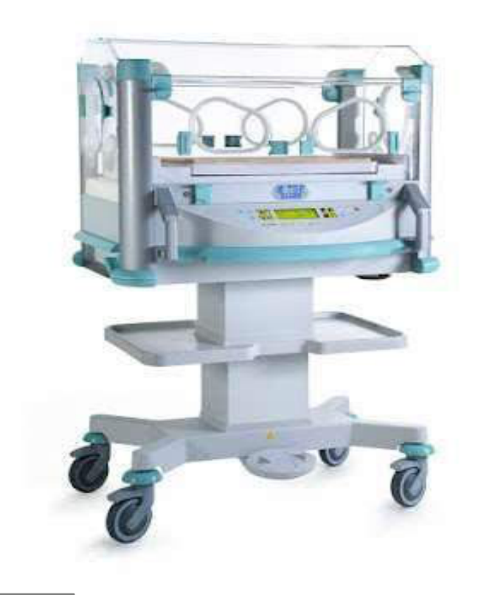  Identify this Machine?
Type | multiple_choice
Option | Dialysis machine
Option | Portable ventilator
Option | Mechanical ventilator
Option | Infant incubator
Answer | 3
Solution | Rationale: Mechanical Ventilator: An electronic device that provides mechanical ventilation by delivering controlled breaths to patients who cannot breathe adequately. Has multiple modes (SIMV, AC, CPAP, etc.). Key Clues: Delivers controlled breaths, multiple modes, bedside Why Not Others: A-Dialysis machine filters blood; C-Portable ventilator is smaller; D-Infant incubator is for neonates Exam Trap: Ventilator vs CPAP - ventilator provides full support, CPAP provides continuous positive pressure only PNC Pearl: Ventilator modes: AC (full support), SIMV (partial support), CPAP (spontaneous), PS (pressure support). Always monitor: tidal volume, respiratory rate, FiO·, PEEP.
Positive Marks | 1
Negative Marks | 0.33

Question | 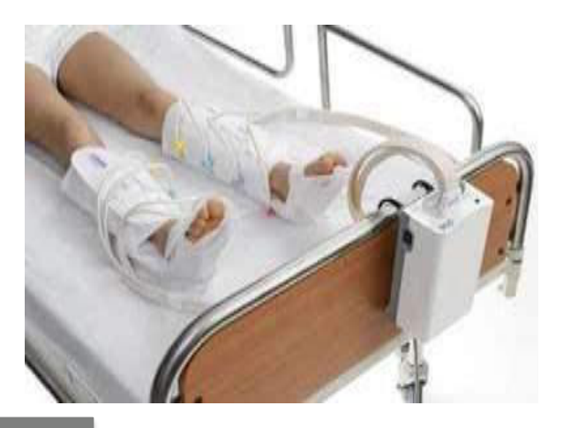  Identify the image:
Type | multiple_choice
Option | Pressure device
Option | Massager
Option | Negative suction device
Option | Sequential Compressive device
Answer | 4
Solution | Rationale: Sequential Compression Device (SCD): An inflatable wrap placed around the legs that inflates and deflates in sequence to promote venous blood flow and prevent deep vein thrombosis (DVT). Key Clues: Inflatable leg wraps, sequential inflation, DVT prevention Why Not Others: A-Pressure device is generic;B-Massager is for relaxation;C-Negative suction is for wound drainage Exam Trap: SCD vs compression stockings - SCDs are mechanical (inflatable), stockings are passive compression PNC Pearl: SCDs: Alternate inflation from ankle to thigh (12-second cycle). Use 18-22 mmHg pressure. Apply to both legs. Monitor skin integrity. Contraindicated in: DVT, peripheral vascular disease, skin breakdown.
Positive Marks | 1
Negative Marks | 0.33

Question | 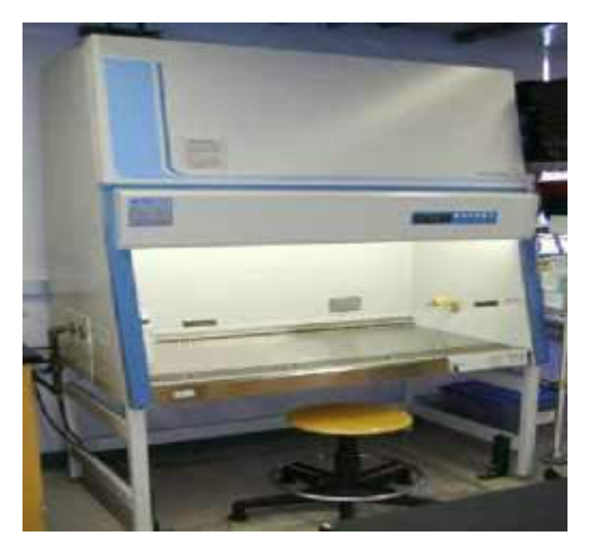  Identify the image:
Type | multiple_choice
Option | Warmer
Option | UV Radiation Chamber
Option | laboratory table
Option | Laminar flow
Answer | 2
Solution | Rationale: UV Radiation Chamber (Phototherapy Unit): A device that emits ultraviolet light used for disinfection of equipment and surfaces. Also used in dermatology for treating skin conditions like psoriasis. Key Clues: UV light emission, for disinfection/treatment Why Not Others: A-Warmer heats items;C-Laboratory table is workspace;D-Laminar flow is air filtration Exam Trap: UV chamber vs autoclave - UV uses light for surface disinfection, autoclave uses steam for sterilization PNC Pearl: UV chamber: Used in NICU for equipment disinfection and phototherapy for neonatal jaundice. UV-C (254nm) for germicidal. Exposure time varies. Never look directly at UV light.
Positive Marks | 1
Negative Marks | 0.33

Question | 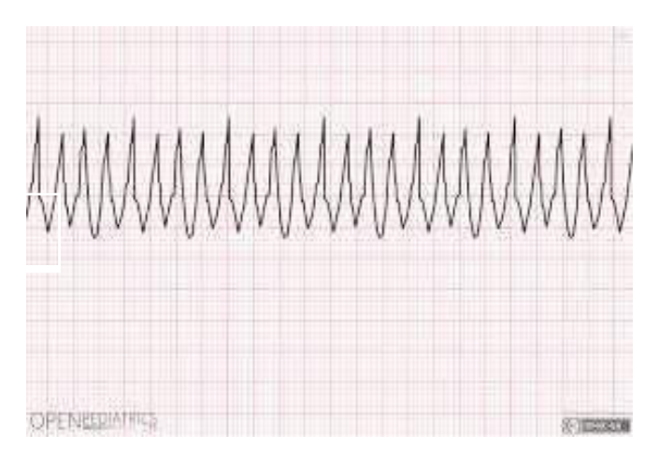  Identify the image:
Type | multiple_choice
Option | Atrial fibrillation
Option | Ventricular fibrillation
Option | Sinus tachycardia
Option | Venous tachycardia
Answer | 2
Solution | Rationale: Ventricular Fibrillation: Totally disorganized electrical activity with no effective cardiac output. The ECG shows chaotic, irregular oscillations with no identifiable complexes. Key Clues: No P waves, no QRS, no T waves, chaotic baseline Why Not Others: A-AF has irregularly irregular narrow QRS; C-Sinus tachycardia has normal P-QRS-T; D-Venous tachycardia is not standard term Exam Trap: VF vs VT - VT has some organization, VF is completely disorganized PNC Pearl: VF survival decreases 7-10% per minute without defibrillation. Chain of survival: Early access, Early CPR, Early defibrillation, Early ACLS.
Positive Marks | 1
Negative Marks | 0.33

