Question | 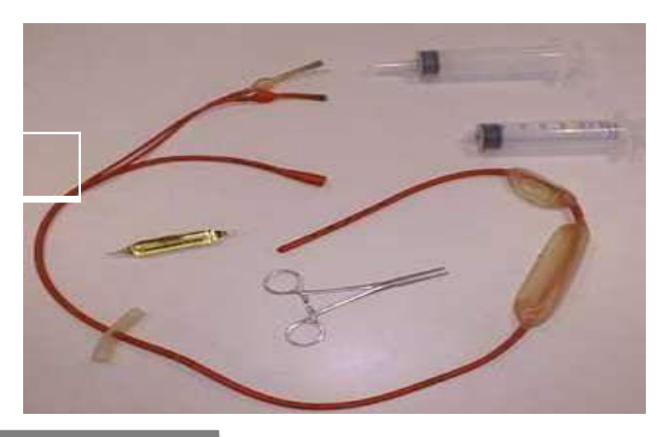  Identify the image:
Type | multiple_choice
Option | NG tube
Option | Gastric levage tube
Option | Sengstaken Blakemore tube
Option | Double lumen PICC catheter
Answer | 3
Solution | Rationale: Sengstaken-Blakemore Tube: A multi-lumen tube with gastric and esophageal balloons used to control acute upper GI bleeding from esophageal and gastric varices. Applies tamponade pressure. Key Clues: Gastric and esophageal balloons, for variceal bleeding Why Not Others: A-NG tube is single purpose;B-Gastric lavage tube is simpler;D-PICC is for vascular access Exam Trap: SBT vs Minnesota tube - SBT has gastric + esophageal balloons, Minnesota adds esophageal suction PNC Pearl: SBT: Gastric balloon 150-250ml air, Esophageal balloon 30-45 mmHg. Maximum 24-48 hours. Keep scissors at bedside (emergency deflation). Continuous monitoring.
Positive Marks | 1
Negative Marks | 0.33

Question | 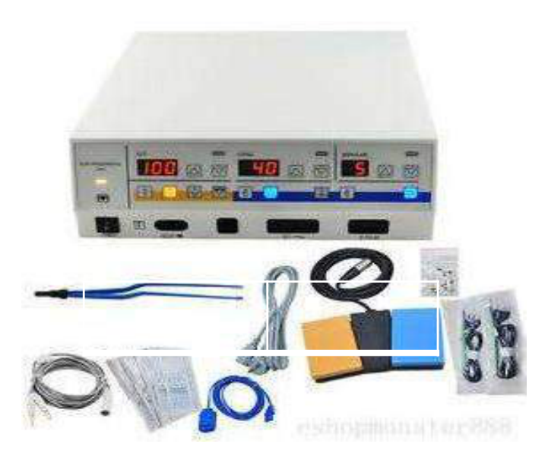  Identify the image:
Type | multiple_choice
Option | EEG machine
Option | Diathermy machine
Option | EMG machine
Option | Cardiac monitor
Answer | 1
Solution | Rationale: EEG Machine (Electroencephalograph): A device that records electrical activity of the brain using scalp electrodes. Used to diagnose epilepsy, sleep disorders, encephalopathy, and brain death. Key Clues: Records brain electrical activity, scalp electrodes Why Not Others: A-Diathermy uses electrical current for cutting/coagulation;B-EMG records muscle activity;D-Cardiac monitor records heart Exam Trap: EEG vs EMG - EEG records brain activity, EMG records muscle activity PNC Pearl: EEG: 10-20 electrode placement system. Records: alpha, beta, theta, delta waves. Used for: epilepsy diagnosis, seizure characterization, sleep studies, brain death determination.
Positive Marks | 1
Negative Marks | 0.33

Question | 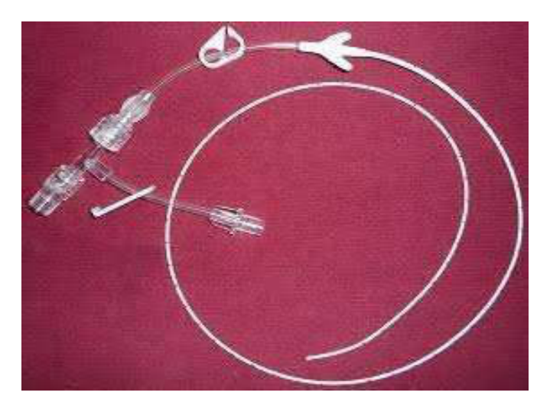  Identify the image:
Type | multiple_choice
Option | Epidural catheter
Option | Ventriculostomy catheter
Option | PICC catheter
Option | Dialysis catheter
Answer | 2
Solution | Rationale: Ventriculostomy Catheter (External Ventricular Drain/EVD): A catheter inserted through the skull into the lateral ventricle for CSF drainage and intracranial pressure monitoring. Used in hydrocephalus and traumatic brain injury. Key Clues: Inserted into ventricle, for ICP monitoring and CSF drainage Why Not Others: B-Epidural catheter is for pain;C-PICC is peripheral;D-Dialysis catheter is for blood filtering Exam Trap: Ventriculostomy vs lumbar drain - ventriculostomy drains from brain, lumbar drain from spine PNC Pearl: Ventriculostomy/EVD: Monitor ICP continuously. Drain CSF to maintain ICP <20 mmHg. Keep drainage bag at tragus level. Risk: infection (ventriculitis), hemorrhage. Strict aseptic technique.
Positive Marks | 1
Negative Marks | 0.33

Question | 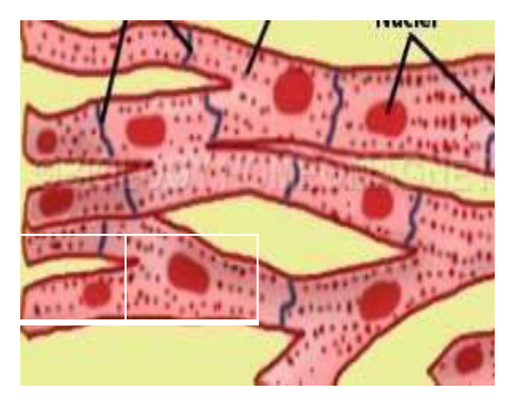  Identify the image:
Type | multiple_choice
Option | Smooth muscle
Option | Voluntary muscle
Option | Skeletal muscle
Option | Cardiac muscle
Answer | 1
Solution | Rationale: Smooth Muscle: Involuntary, non-striated muscle found in walls of hollow organs (blood vessels, GI tract, bladder, uterus). Controlled by autonomic nervous system and hormones. Key Clues: Non-striated, involuntary, in organ walls Why Not Others: A-Voluntary is skeletal;B-Skeletal is striated voluntary;C-Cardiac is striated involuntary Exam Trap: Smooth vs cardiac - both involuntary, but smooth is in hollow organs, cardiac is heart only PNC Pearl: Smooth muscle: Found in blood vessels (vasoconstriction/dilation), GI tract (peristalsis), uterus (contractions), bladder. Controlled by autonomic NS, hormones, and local factors.
Positive Marks | 1
Negative Marks | 0.33

Question | 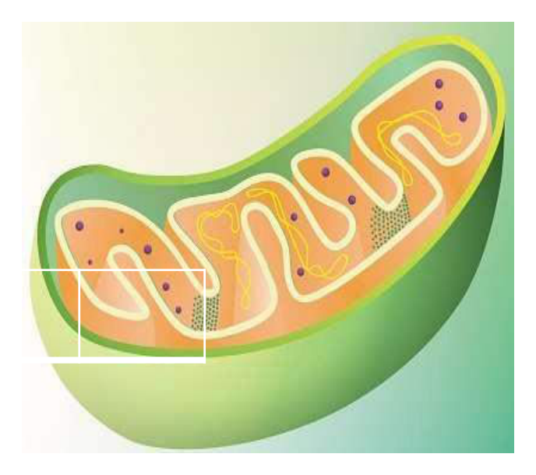  Identify the image:
Type | multiple_choice
Option | Golgi bodies
Option | Mitochondria
Option | Lysosome
Option | Endoplasmic reticulum
Answer | 2
Solution | Rationale: Mitochondria: The powerhouse of the cell. Double-membraned organelle that generates ATP through aerobic respiration. Contains its own DNA. Site of oxidative phosphorylation and citric acid cycle. Key Clues: Double membrane, ATP production, aerobic respiration Why Not Others: B-Golgi bodies modify/sort proteins;C-Lysosomes digest waste;D-ER is for protein/lipid synthesis Exam Trap: Mitochondria vs ER - mitochondria make energy, ER makes proteins/lipids PNC Pearl: Mitochondria: 2 membranes (outer smooth, inner folded into cristae). Matrix contains enzymes for Krebs cycle. Cristae contain electron transport chain. Maternal inheritance of mtDNA.
Positive Marks | 1
Negative Marks | 0.33

Question | 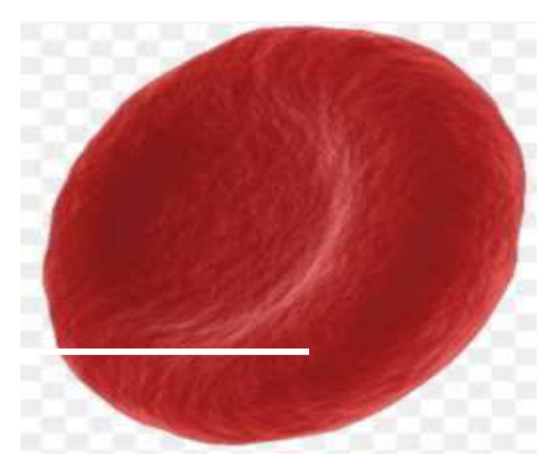  Identify the image:
Type | multiple_choice
Option | Erythrocyte
Option | Leuckocyte
Option | Basuphil
Option | Thrombocyte
Answer | 4
Solution | Rationale: Thrombocyte (Platelet): Small, anucleate blood cells involved in hemostasis and clot formation. Normal count 150,000-400,000/mm³. Produced from megakaryocytes in bone marrow. Key Clues: Small, no nucleus, clot formation, 150-400K Why Not Others: A-Erythrocyte is red blood cell;B-Leukocyte is white blood cell;D-Basophil is type of WBC Exam Trap: Platelets vs RBC - platelets are much smaller, no nucleus, involved in clotting PNC Pearl: Platelets: Normal 150-400K/mm³. Life span 8-10 days. Thrombocytopenia <150K. Risk of bleeding <50K. Spontaneous bleeding <20K. Test: Platelet count, bleeding time, clotting time.
Positive Marks | 1
Negative Marks | 0.33

Question | 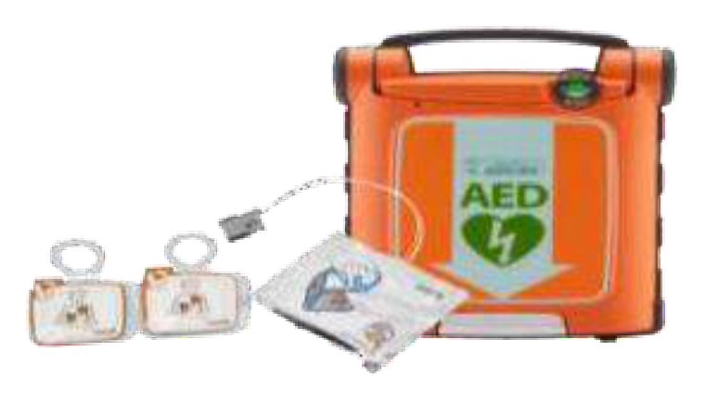  Identify the image:
Type | multiple_choice
Option | Advanced external defibrillator
Option | Assisted external defibrillator
Option | Appropriate external defibrillator
Option | Automated external defibrillator
Answer | 4
Solution | Rationale: Automated External Defibrillator (AED): A portable, automated device that analyzes heart rhythm and delivers shock if needed. Designed for use by anyone, with voice prompts guiding the operator. Key Clues: Automated rhythm analysis, voice prompts, public access Why Not Others: A-Advanced;B-Assisted;D-Appropriate are not correct terminology Exam Trap: AED: Automatic = no operator discretion needed. Semi-automatic = operator confirms shock. PNC Pearl: AED: Attach pads · device analyzes · voice prompt. If shock advised · ensure clear · press shock. If no shock · resume CPR. Check for water/metal/pacemaker on chest.
Positive Marks | 1
Negative Marks | 0.33

Question | 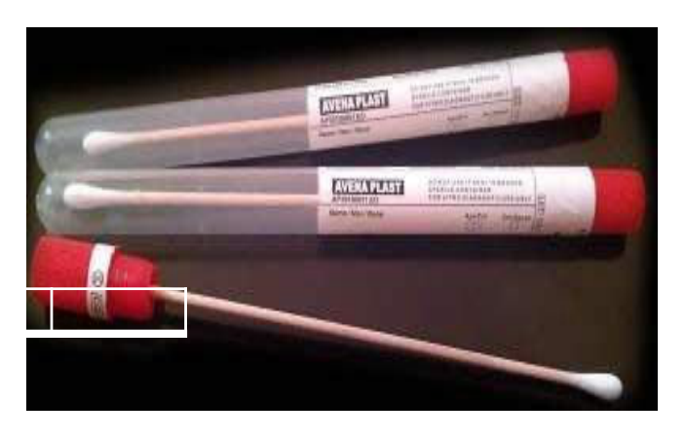  Identify the image:
Type | multiple_choice
Option | Blood culture tube
Option | Swab stick culture tube
Option | Tissue culture tube
Option | Swab stick
Answer | 2
Solution | Rationale: Swab Stick Culture Tube: A sterile tube containing transport medium (Amies or Stuart's) with a swab stick for collecting wound, throat, or other site cultures for microbiological examination. Key Clues: Swab stick with transport medium, for culture collection Why Not Others: A-Blood culture is for blood;B-Tissue culture is for tissue;C-Swab stick alone has no medium Exam Trap: Swab culture vs blood culture - swab is for surface cultures, blood culture is for bloodstream PNC Pearl: Swab culture: Collect before antibiotics. Clean area with saline (not antiseptic if culture needed). Place swab in transport medium. Label with site, date, time. Transport to lab within 2 hours.
Positive Marks | 1
Negative Marks | 0.33

Question | 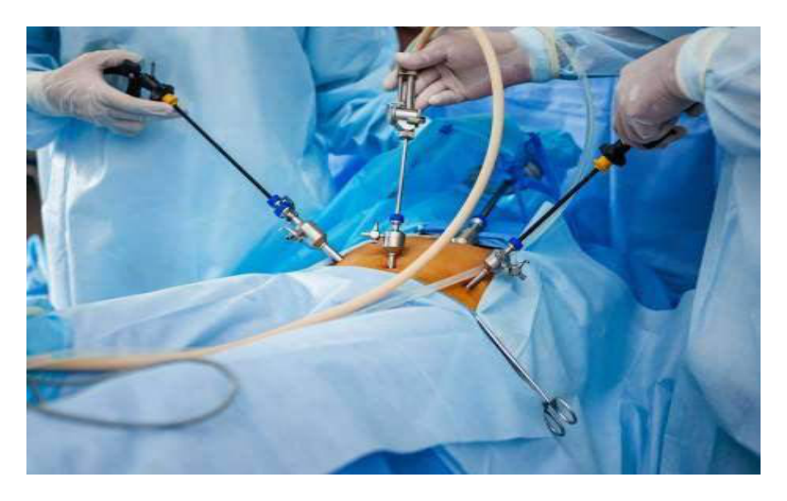  All are true about Instrument:
Type | multiple_choice
Option | Pneumoperitoneum never
Option | Safe in obesity
Option | Low post-operative pain
Option | Incision is smaller
Answer | 1
Solution | Rationale: Laparoscopic surgery advantages: Smaller incisions, less post-operative pain, faster recovery, less infection, better cosmesis. Does NOT guarantee no pneumoperitoneum complications. Key Clues: Less pain, faster recovery, smaller incisions Why Not Others: A-Safe in obesity is relative;B-Low pain is true;D-Smaller incision is true Exam Trap: Laparoscopy advantages: Reduced recovery time, less pain, better cosmesis, fewer adhesions. Complications: pneumoperitoneum, gas embolism, trocar injury. PNC Pearl: Laparoscopy advantages: Reduced recovery time, less pain, better cosmesis, fewer adhesions. Complications: pneumoperitoneum, gas embolism, trocar injury.
Positive Marks | 1
Negative Marks | 0.33

Question | 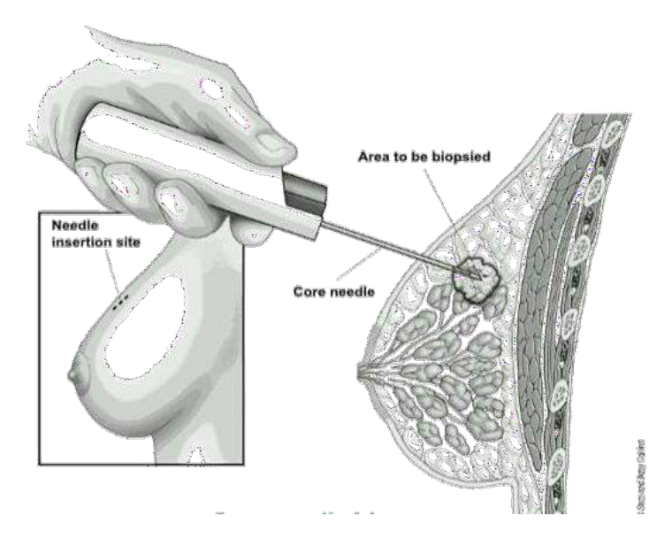  Which are the following:
Type | multiple_choice
Option | Infection
Option | All of above
Option | Swelling
Option | Pneumothorax
Answer | 2
Solution | Rationale: Complications of central venous catheter insertion include: infection, swelling (hematoma), pneumothorax, hemothorax, air embolism, and malposition. Key Clues: Infection, swelling, pneumothorax - all possible Why Not Others: A-Infection is complication;B-Swelling is complication;C-Pneumothorax is complication Exam Trap: All listed complications are possible with central line insertion - D (all of above) is correct PNC Pearl: Central line complications: Pneumothorax (subclavian > IJ), hematoma, infection, thrombosis, air embolism, malposition. Always confirm position with CXR before use.
Positive Marks | 1
Negative Marks | 0.33

Question | 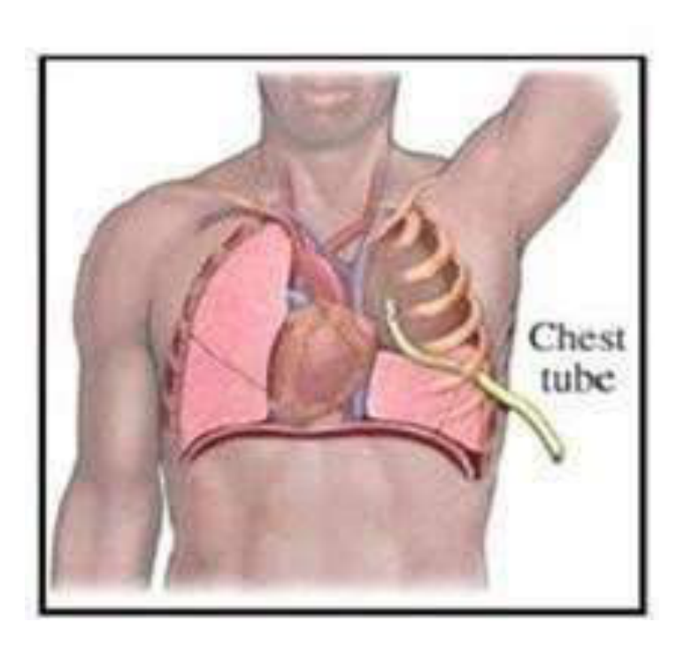  Procedure shown in:
Type | multiple_choice
Option | Pleural aspiration
Option | Chest tube drainage
Option | Peri cardial aspiration
Option | ECG
Answer | 1
Solution | Rationale: Pleural Aspiration (Thoracentesis): A procedure to remove fluid from the pleural space using a needle and syringe. Performed for diagnostic or therapeutic purposes in pleural effusion. Key Clues: Needle in pleural space, removes fluid, for pleural effusion Why Not Others: A-Chest tube drainage is continuous;B-Pericardial aspiration is for pericardial space;D-ECG is cardiac monitoring Exam Trap: Pleural aspiration vs chest tube - aspiration is single/intermittent, chest tube is continuous drainage PNC Pearl: Thoracentesis: Patient sits upright leaning forward. Insert 7th-8th ICS mid-axillary. Remove ·1.5L to prevent reexpansion pulmonary edema. Monitor: pneumothorax, bleeding, infection.
Positive Marks | 1
Negative Marks | 0.33

Question | 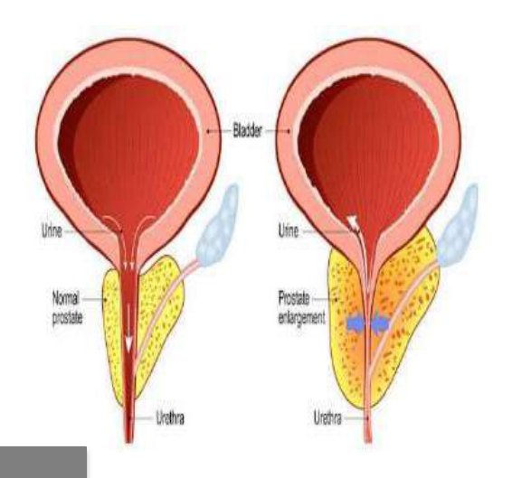  Most important marker for:
Type | multiple_choice
Option | PLAP.
Option | NSE.
Option | PAP.
Option | PSA.
Answer | 4
Solution | Rationale: PSA (Prostate Specific Antigen): The most important tumor marker for prostate cancer screening and monitoring. Elevated levels suggest prostatic pathology. Key Clues: PSA for prostate cancer Why Not Others: A-PLAP is for germ cell tumors;B-NSE is for small cell lung cancer;D-PAP is less specific Exam Trap: PSA: Normal <4 ng/mL. Elevated in: BPH, prostatitis, prostate cancer. Free/total PSA ratio helps differentiate. PNC Pearl: PSA: Normal <4 ng/mL. Elevated in: BPH, prostatitis, prostate cancer. Free/total PSA ratio helps differentiate.
Positive Marks | 1
Negative Marks | 0.33

Question | 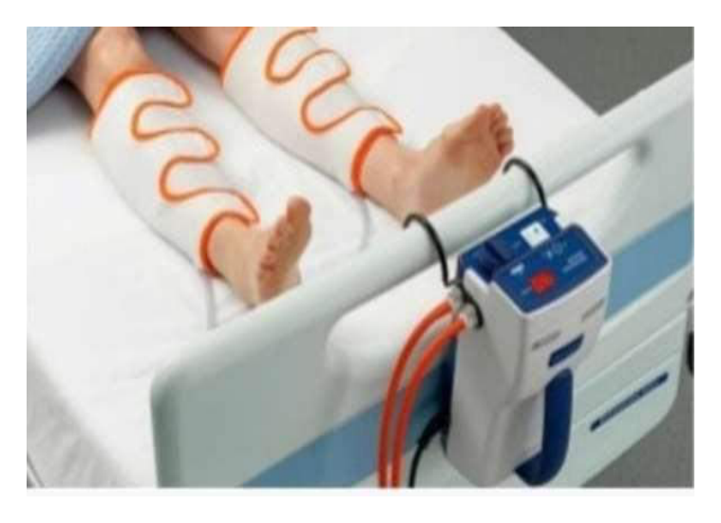  The given below device is used for:
Type | multiple_choice
Option | Varicose vein
Option | Hypothermia
Option | Pneumatic compression stockings to
Option | Cellulites
Answer | 3
Solution | Rationale: Pneumatic Compression Stockings: Inflatable leg wraps that inflate and deflate cyclically to promote venous return and prevent DVT. Used for DVT prophylaxis in post-surgical and immobilized patients. Key Clues: Inflatable wraps, DVT prevention Why Not Others: B-Varicose vein treatment is different;C-Hypothermia treatment is different;D-Cellulitis is infection Exam Trap: SCD/pneumatic compression: Inflatable wraps that compress from ankle to thigh. Promote venous return. Use in: post-surgery, immobility, DVT prophylaxis. PNC Pearl: SCD/pneumatic compression: Inflatable wraps that compress from ankle to thigh. Promote venous return. Use in: post-surgery, immobility, DVT prophylaxis.
Positive Marks | 1
Negative Marks | 0.33

Question | 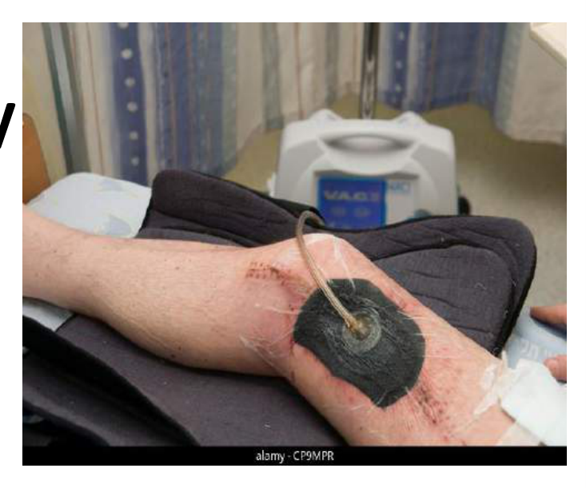  Identify the image:
Type | multiple_choice
Option | Wound therapy
Option | Psychotherapy
Option | Rewarming therapy
Option | Muscle stimulator therapy
Answer | 3
Solution | Rationale: Rewarming Therapy: Treatment for hypothermia using various methods (warm blankets, warm IV fluids, warm humidified oxygen, heated peritoneal lavage). Used when body temperature drops below 35 degC. Key Clues: Treatment for hypothermia Why Not Others: A-Wound therapy treats wounds;B-Psychotherapy treats mental health;D-Muscle stimulator treats weakness Exam Trap: Rewarming methods: Passive (blankets), Active external (warm water), Active internal (warm IV fluids, peritoneal lavage) PNC Pearl: Rewarming: Monitor for afterdrop (temperature continues to fall during rewarming). Rewarm core first. Monitor for arrhythmias. Target: >35 degC.
Positive Marks | 1
Negative Marks | 0.33

Question | 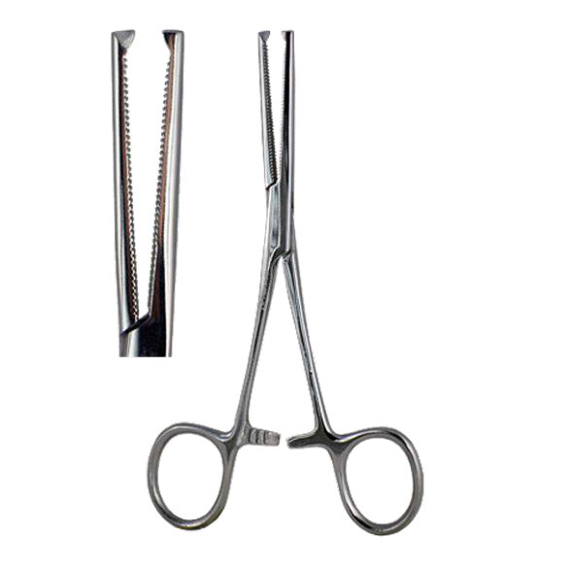  Identify the image:
Type | multiple_choice
Option | Cord cutting scissors
Option | kocher forceps
Option | Stitch removing suture
Option | Tooth forceps
Answer | 3
Solution | Rationale: Stitch Removing Scissors (Suture Removal Scissors): Specialized scissors with a small hook/blade at the tip to slide under sutures and cut them. Designed for safe and efficient suture removal. Key Clues: Hooked tip, for suture removal Why Not Others: A-Cord cutting scissors are for umbilical cord;B-Kocher forceps grasp tissue;D-Tooth forceps grasp tissue Exam Trap: Suture removal scissors vs regular scissors - suture scissors have hooked tip to slide under stitches PNC Pearl: Suture removal: Sterilize area. Slide hook under suture. Cut at skin level. Pull suture through. Check wound strength. Timeline: Face 5-7 days, Extremities 10-14 days, Joints 14 days.
Positive Marks | 1
Negative Marks | 0.33

Question | 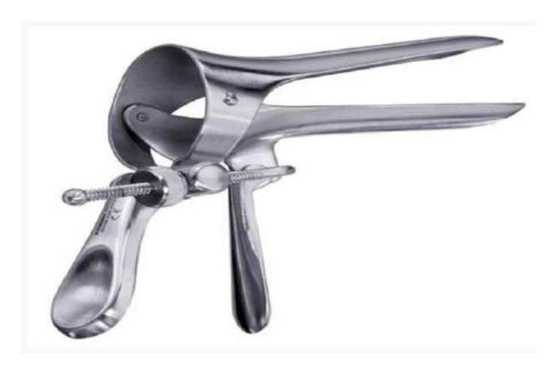  Which of the following is not true about the:
Type | multiple_choice
Option | It is a self retaining speculum
Option | It is used for cervical and vaginal
Option | Handles are slightly concave to collect drained
Option | It should not be used during Pap smear
Answer | 4
Solution | Rationale: The instrument should NOT be used during Pap smear (incorrect statement). The speculum used for Pap smear is the Graves speculum, not the type shown. Pap smear requires visualization of cervix. Key Clues: Not for Pap smear (Graves speculum is used) Why Not Others: A-Self-retaining speculum is for vagina;B-Cervical/vaginal exam is correct;D-Handles collect drainage is correct Exam Trap: C is the incorrect statement - this instrument IS used for cervical/vaginal exam, but the statement about Pap smear is false PNC Pearl: Pap smear uses Graves speculum (wider blades for nulliparous) or Pedersen speculum. The Cusco speculum is self-retaining and commonly used.
Positive Marks | 1
Negative Marks | 0.33

