Question | 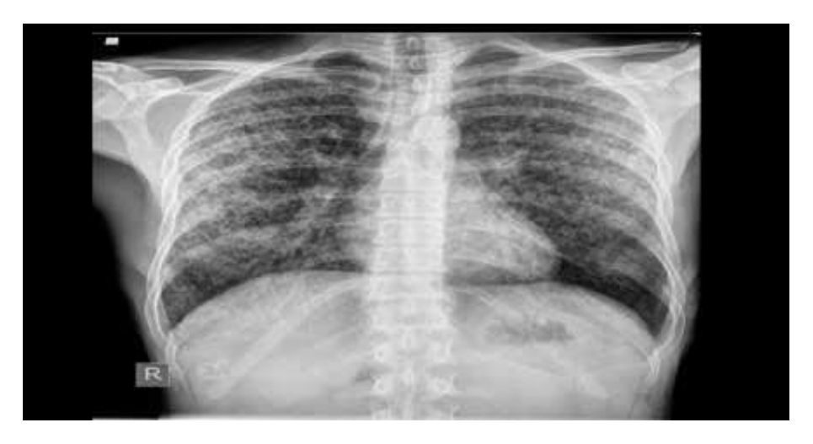  Identify the image:
Type | multiple_choice
Option | Normal lung
Option | Silicosis
Option | Pneumonia
Option | Tuberculosis
Answer | 4
Solution | Rationale: Tuberculosis on Chest X-ray: Shows upper lobe infiltrates, cavitation, tree-in-bud pattern, and calcified nodules. Common findings include apical lesions and hilar lymphadenopathy. Key Clues: Upper lobe infiltrates, cavitation, calcified nodules Why Not Others: A-Normal lung has clear fields; C-Silicosis shows diffuse nodular opacities; D-Pneumonia shows lobar consolidation Exam Trap: TB vs pneumonia on CXR - TB favors upper lobes, pneumonia favors lower lobes PNC Pearl: TB CXR: Classic = upper lobe cavity with surrounding infiltrate. Primary TB = hilar lymphadenopathy. Reactivation TB = apical cavitary lesions. Always correlate with sputum AFB.
Positive Marks | 1
Negative Marks | 0.33

Question | 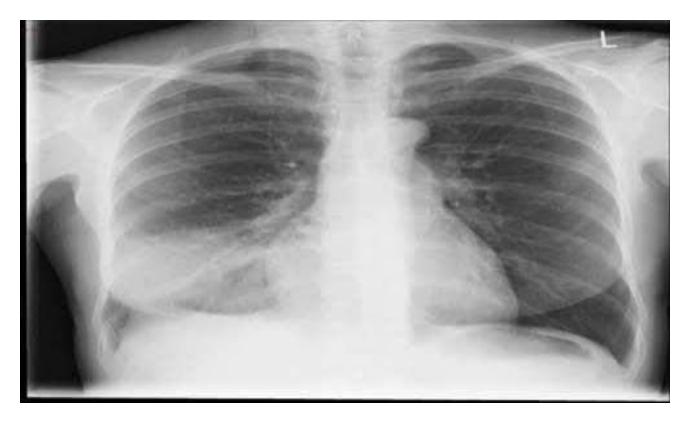  Identify the image:
Type | multiple_choice
Option | Normal lung
Option | Silicosis
Option | Pneumonia
Option | Tuberculosis
Answer | 4
Solution | Rationale: Tuberculosis on Chest X-ray: Characteristic findings include upper lobe infiltrates, cavitary lesions, fibrotic changes, and calcified granulomas. May show pleural effusion. Key Clues: Upper lobe preference, cavitation, fibrotic changes Why Not Others: A-Normal lung is clear; C-Silicosis has eggshell calcification;D-Pneumonia shows air bronchograms Exam Trap: TB typically affects upper lobes (apical and posterior segments) PNC Pearl: TB CXR patterns: Primary = lower/middle lobe. Post-primary/Reactvation = upper lobe. Miliary = diffuse tiny nodules. Always compare with old films.
Positive Marks | 1
Negative Marks | 0.33

Question | 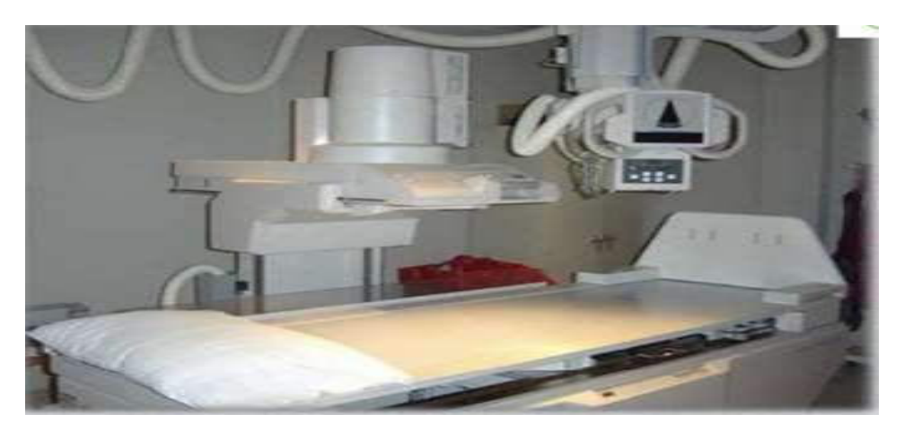  Identify the image:
Type | multiple_choice
Option | CT scan
Option | Myelogram
Option | C ray machine
Option | MRI
Answer | 1
Solution | Rationale: CT Scan (Computed Tomography): Uses X-rays and computer processing to create detailed cross-sectional images. Shows soft tissue detail better than plain X-ray. Used for head, chest, abdomen, and whole body imaging. Key Clues: Cross-sectional images, detailed soft tissue, multiple slices Why Not Others: A-Myelogram uses contrast in spinal canal; B-X-ray is 2D; D-MRI uses magnetic resonance Exam Trap: CT vs MRI - CT is faster, better for bone/bleed; MRI is better for soft tissue/brain PNC Pearl: CT scan: Uses ionizing radiation. Contrast can cause allergic reaction and nephrotoxicity. Always check creatinine before contrast. CT head = most common imaging for head trauma.
Positive Marks | 1
Negative Marks | 0.33

Question | 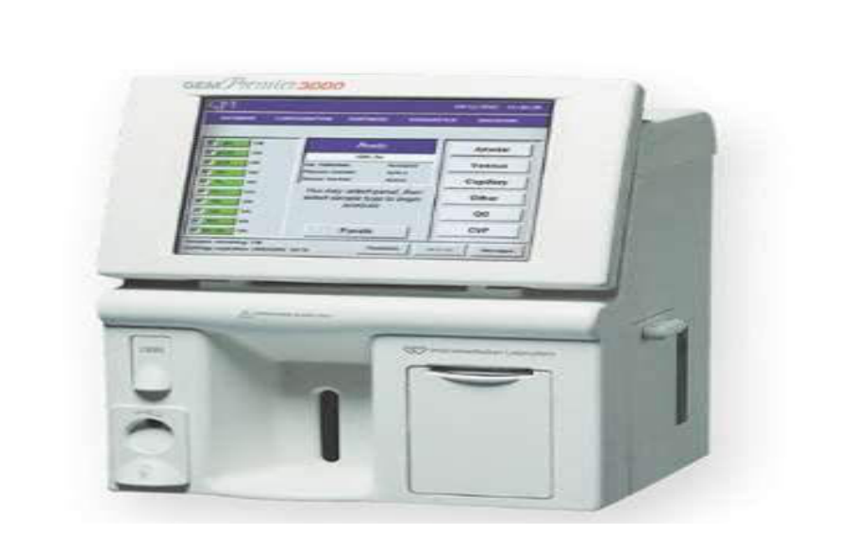  Identify the image:
Type | multiple_choice
Option | Haemoglobin meter
Option | ECG machine
Option | ABG machine
Option | Elisa reader
Answer | 3
Solution | Rationale: ABG Machine (Arterial Blood Gas): Analyzes arterial blood for pH, PaCO·, PaO·, HCO··, and base excess. Used to assess respiratory and metabolic function, ventilator settings, and acid-base balance. Key Clues: Analyzes blood gases, pH, PaCO·, PaO·, HCO·· Why Not Others: A-Hb meter measures hemoglobin; B-ECG machine records rhythm;C-ELISA reader is for immunoassays Exam Trap: ABG vs VBG - ABG measures PaO· (arterial), VBG measures PvO· (venous) PNC Pearl: ABG normal values: pH 7.35-7.45, PaCO· 35-45 mmHg, PaO· 80-100 mmHg, HCO·· 22-26 mEq/L. Radial artery most common site. Allen test before radial artery sampling.
Positive Marks | 1
Negative Marks | 0.33

Question | 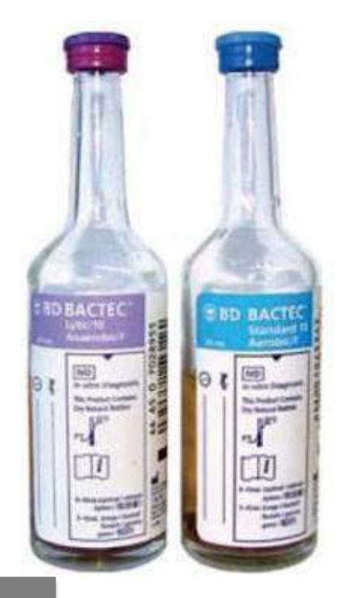  Identify this sample bottle?
Type | multiple_choice
Option | Urine bottle
Option | CSF culture bottle
Option | Blood culture bottle
Option | Citrate bottle
Answer | 3
Solution | Rationale: Blood Culture Bottle: A sterile container with growth medium used to detect bacteria in the blood. Collected during febrile episodes to identify bacteremia/septicemia. Two bottles (aerobic + anaerobic). Key Clues: Growth medium, for blood culture collection Why Not Others: A-Urine bottle is for urine;C-CSF bottle is for cerebrospinal fluid;D-Citrate tube is for coagulation Exam Trap: Blood culture collection: Two sets from different sites, before antibiotics PNC Pearl: Blood culture: 2 sets (4 bottles) from 2 different sites. 20ml per adult (10ml per bottle). Before antibiotics. Clean with chlorhexidine/alcohol. Incubate 5-7 days.
Positive Marks | 1
Negative Marks | 0.33

Question | 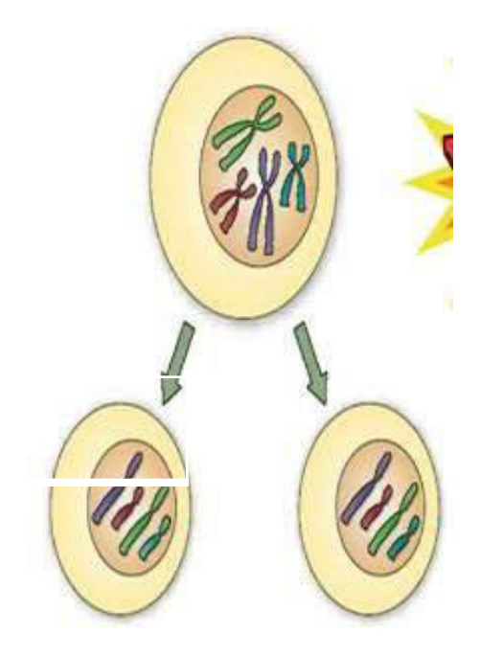  Identify the image:
Type | multiple_choice
Option | Mitosis
Option | Meiosis
Option | Prophase
Option | Metaphase
Answer | 1
Solution | Rationale: Mitosis: Cell division that produces two identical daughter cells with the same chromosome number as the parent cell. Used for growth, repair, and asexual reproduction. Phases: prophase, metaphase, anaphase, telophase. Key Clues: Two identical daughter cells, same chromosome number Why Not Others: B-Meiosis produces gametes (4 cells, half chromosomes);C-Prophase is a phase of mitosis;D-Metaphase is a phase Exam Trap: Mitosis vs meiosis - mitosis makes 2 identical cells (2n), meiosis makes 4 different cells (n) PNC Pearl: Mitosis phases: Prophase (chromatin condenses), Metaphase (chromosomes align), Anaphase (chromatids separate), Telophase (nuclear membranes reform). Cytokinesis follows.
Positive Marks | 1
Negative Marks | 0.33

Question | 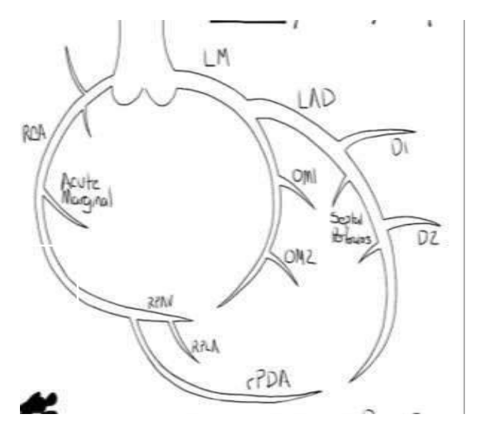  Identify the image:
Type | multiple_choice
Option | Carotid artery
Option | Circle of Willis
Option | Coronary artery
Option | Femoral artery
Answer | 2
Solution | Rationale: Circle of Willis: An arterial anastomosis at the base of the brain formed by the internal carotid and vertebral arteries. Provides collateral circulation to protect against ischemia. Key Clues: Arterial ring at brain base, collateral circulation Why Not Others: A-Carotid is a single artery;B-Coronary supplies heart;D-Femoral is in thigh Exam Trap: Circle of Willis: Forms hexagonal ring. Components: AComm, ACom, PCOM, basilar bifurcation. Protects brain from single vessel occlusion. PNC Pearl: Circle of Willis: Forms hexagonal ring. Components: AComm, ACom, PCOM, basilar bifurcation. Protects brain from single vessel occlusion.
Positive Marks | 1
Negative Marks | 0.33

Question | 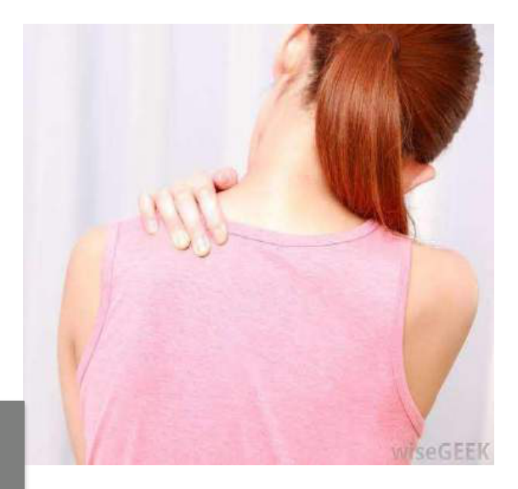  Identify the sign as represented in the:
Type | multiple_choice
Option | Cullen's sign.
Option | Kehr's sign.
Option | Turner's sign.
Option | None of the above.
Answer | 2
Solution | Rationale: Kehr's Sign: Left shoulder pain (referred pain) caused by splenic injury with blood irritating the diaphragm. The phrenic nerve (C3-C5) carries pain signals to the shoulder. Key Clues: Left shoulder pain = splenic injury Why Not Others: B-Cullen sign is periumbilical;C-Turner sign is flank;D-None is incorrect Exam Trap: Kehr's sign: Left shoulder pain after trauma = think splenic injury. Part of FAST assessment. Associated with left upper quadrant tenderness and hemodynamic instability. PNC Pearl: Kehr's sign: Left shoulder pain after trauma = think splenic injury. Part of FAST assessment. Associated with left upper quadrant tenderness and hemodynamic instability.
Positive Marks | 1
Negative Marks | 0.33

